**PHOTO-CATALYTIC REDUCTION OF DINITROGEN**

B. Viswanathan

29TH April,2025

1. **Introduction**

The science of carbon dioxide molecule is interesting and important to society due to its physical properties which is essentially goes under the name Green-house Effect according to which the average temperature of the universe will increase if carbon dioxide concentration increases due to modernization beyond the current levels of around 420 ppm.. One of the important reactions of the 20th century is the thermo-catalytic process, namely, Ammonia Synthesis by Haber and Bosch. Molecular nitrogen is chemically and biologically inert due to its extremely strong, nonpolar short triple bond (109 pm) (225 kcal/mol or 945.33 kJ/mol) as well as the large ionization potential (15.85 eV) comparable to that of Ar low proton affinity (1.90 eV), absence of dipole moment or non-polarity character. and wide HOMO(σg2p)-LUMO(*ᴫg2p) gap (22.9 eV). The industrial ammonia synthesis known as Haber-Bosch process requires drastic reaction conditions of temperatures, (400−500 ℃) and high pressure (100−200 atm) over iron catalysts, consuming about 1–2% of the world’s power source and generating more than 300 million tons of carbon dioxide.

Since the discovery of the first light induced nitrogen reduction on Titania based semiconductors by Schrauzer and Guth in 1977 [3], a great deal of efforts have been devoted to develop this green and economical ammonia synthesis route that is capable of working under mild conditions. Various semiconductor photocatalysts, have been studied that could convert atmospheric nitrogen to ammonia under light irradiation. However, the obtained ammonia concentrations by most of these photo-catalysts were only in the micro molar quantities, which is far away from the commercial demand. This dissatisfactory ammonia yield mainly arises from the difficult activation of inert nitrogen molecule on these catalysts, which is an uphill reaction process involved the generation of high-energy intermediate (N2H, N2H2 ).. For example, the reduction potential of the N2H formation is as negative as −3.2 V vs. NHE via

N2 + H+ + e− → N2H.

Through a two electron reduction process via

N2 + 2H2O 4H+ + 2e−→ 2NH3OH+

the reduction potential (-1.83 V vs. NHE) is still energetically impossible for most of traditional semiconductors in the absence of any organic scavengers or precious-metal co-catalysts. Applying a multi-electron reduction process via

N2 + 5H+ + 4e− → N2H 5 + (-0.23 V vs. NHE)

or N2 + 8H+ + 6e− → 2NH4+ (0.274 V vs. NHE),

In principle, may avoid the generation of high energy intermediates and decrease the thermodynamic barrier for ammonia production. However, this multi-electron photoreduction of nitrogen is extremely difficult from a kinetic point and has not been reported. Recently, Zhang et al.[4] found localized electrons in oxygen vacancy could effectively activate the adsorbed nitrogen by electron donation and decrease the kinetic barrier for nitrogen photo-reduction.. In general it is believed species which has high has high electron-donating power, works as an efficient catalyst for industrial ammonia synthesis thus showing the unique advantage of electron-rich systems for nitrogen activation and reduction. Multi-electron nitrogen reduction may be realized by increasing the concentration of localized electrons in a semiconductor.

In general, either the photophysical, surface properties or a combination of both are modified to achieve high performance by e. g. introduction of surface defects,  plasmonic sensitization, doping, addition of cocatalysts, or the development of heterojunctions.  Normally in photocatalytic process the photons are utilized to produce an electron hole pair which is subsequently made to perform the redox reaction. The schematic of this process and the values of reduction potentials for the various possible intermediates in the process of photo-reduction of dinitrogen are shown in Fig.1.

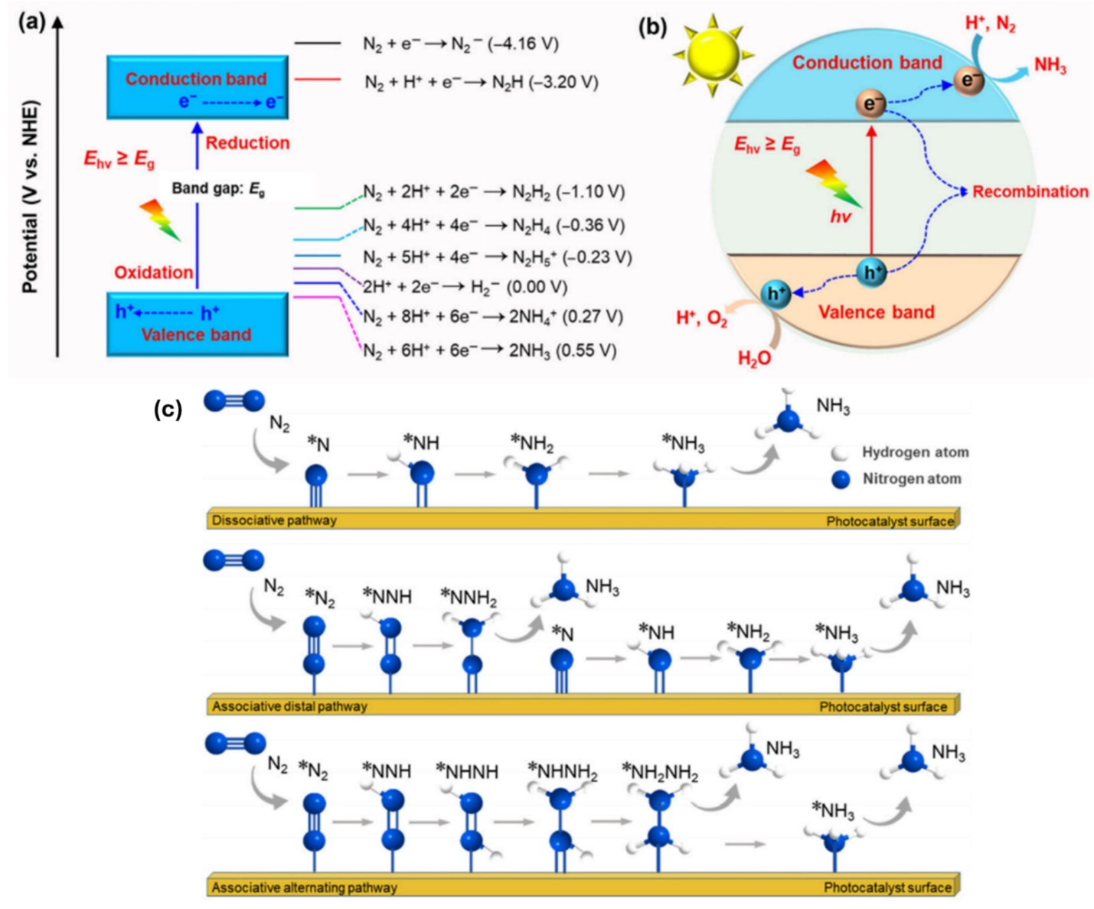

Fig.1. Schematic energy diagram for dinitrogen reduction and (b) Pictorial representation of the overall photo-catalytic dinitrogen  reduction to ammonia over semi-conductor-based photocatalysts, and (c) proposed mechanisms for dinitrogen reduction to produce ammonia.

**2.Molecular Orbital Diagram of Dinitrogen**

The molecular orbital of dinitrogen is shown in Fig.2. With nitrogen, ome can see the two molecular orbitals mixing and the energy repulsion. The σ from the 2p is more non-bonding due to mixing, and same with the 2s σ. This also causes a large jump in energy in the 2p σ* orbital. The bond order of diatomic nitrogen is three, and it is a diamagnetic molecule.

The bond order for dinitrogen (1σg21σu22σg22σu21πu43σg2) is three because two electrons are now also added in the 3σ MO. The MO diagram correlates with the experimental photoelectron spectrum for nitrogen. The 1σ electrons can be matched to a peak at 410 [eV](https://en.wikipedia.org/wiki/Electronvolt) (broad), the 2σg electrons at 37 eV (broad), the 2σu electrons at 19 eV (doublet), the 1πu4 electrons at 17 eV (multi-plets), and finally the 3σg2 at 15.5 eV (sharp).

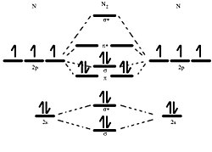

Fig 2 The frontier molecular orbital of dinitrogen [6]

It is conceived that the backdonation of electrons from the catalyst surface to unfilled antibonding orbitals of nitrogen may facilitate the dissociation of nitrogen molecule. This route is considered as the dissociative route. This postulate implies the following taking place in the adsorbed nitrogen molecule. The band length of N-N should be increased from the equilibrium distance. The catalyst system should have occupied electron levels with energy values almost comparable to that of the antibonding orbital of nitrogen molecule. This may or may not be taking place. Generally, in the catalysts system based on metals it will have energy values comparable to the work function and in the case of oxides, it will be from the filled valence band which will have energies contributed by the p orbital of the oxide species.

**Perspectives**

This reaction involves the adsorption of N2 (associatively or dissociatively ) to activate for reduction, photon absorption and hydrogen transfer from water and desorption of ammonia molecule from the catalyst surface. In addition, this reaction can be considered as the greener and promising route to surrogate the energy-intensive Haber Bosch method. The essential steps in this reaction can be stated as follow:

(i) N2 and H2O are used as basic material for NH3 synthesis, which is budget-friendly and surfeit in the environment; (ii) Nitrogen reduction reaction with zero-carbon release can assuage the environmental problems; (iii) This reaction requires photons to trigger the fixation reaction and (iv) it can lead a potential way to store clean and renewable energy.

{1] Intrinsic inertia or non-polar nature of nitrogen molecules, multi-electron/proton involvement, and weak binding of the molecules over catalysts horizon are some of the connected imperfections of photocatalytic NH3 synthesis. Additionally, the production of molecular hydrogen and hydrazine is being accompanied by ammonia production which is a diminution aspect, ultimately results in very low NH3 selectivity and yield. Furthermore, assessing the photocatalytic NRR reactions faces substantial scientific and practical heat. For example, ammonia is present everywhere i.e. in air, experimental consumables, N-atom containing catalyst, and even in human breathe, therefore it is hard to conclude that the quantified ammonia is generated from NRR reactions or stemmed from exogenous contaminations. Again, the capping agents used for catalysts syntheses such as [thioacetamide](https://www.sciencedirect.com/topics/chemistry/thioacetamide) (TAA) and [hexamethylenetetramine](https://www.sciencedirect.com/topics/chemistry/hexamethylenetetramine) (HMTA) decomposes easily upon irradiation and hence leads to error in NH3 detection. Therefore, the indispensable blank/control experiments, e.g. in the Ar/15N streams, are enjoined to certify that the detected NH3 is produced from the supplied N2 gas reduction.

(ii) Further, there are several ways for ammonia quantification, out of which spectrophotometric assay, ion-chromatography, ion-selective electrode, and NMR spectroscopic techniques are frequently used. Spectrophotometrically, ammonia is quantified by the use of Nessler’s reagents and indo-phenol blue techniques. The pH, ionic strength, and sacrificial agents may interfere with the accuracy of spectrometric quantification of ammonia. Ion-chromatography and NMR technique mostly provides accurate ammonia results.

(iii) Moreover, it is very essential to unveil the fundamental mechanism of molecular nitrogen conversion to ammonia. NRR is a complicated multi-step electron-proton coupled reaction and as a result, the scientific groups from different corners of the globe were unable to predict and explain a proper mechanistic pathway for N2 photo-reduction, which needs to be uncovering properly. Therefore, a combination of theoretical exploration and experimental data is an authoritative tactic to find out the appropriate underlying mechanism and pathways for NRR. In this topic, prior attention should be given to building models that are nearer to the actual reaction mechanisms.

(iv) For achieving commendable NRR performance there is a need of creating chemical bond channels between nitrogen molecules and the catalyst surface. Hence, there is a necessity to design and develop new technologies for the material synthesis of different compositions and morphologies. It is being believed that morphological oriented nanomaterials have a synergistic effect in enhancing the photocatalytic N2 fixation. Besides, surface engineering, defect creation, composite formation, crystallographic tailoring, and chemical alternation, and so on are found to be competent strategies for enhancing the N2 photo-reduction. Specifically, a defective photocatalyst exhibits better NRR results compared to that of bulk materials. Similarly, the introduction of dopants and vacancies in the catalysts leads to good NRR activity by increasing the catalyst adsorption and activation ability for inert N2 resulting in diminishing the NN triple bond order by electron back donation to the anti-bonding orbital of nitrogen. Another way for enhancing the NRR reaction is the utilization of a co-catalyst. But due to competition between two-electron for HER and six-electron for NRR, the metal and non-metal based co-catalysts are being preferred for N2 photoreduction over noble metal-rooted co-catalyst. It has been also visualized that a combination of defective co-catalyst and engineered heterojunction could help to magnify the ammonia production rate. Because of the high activity of single metal atoms, designing a heterogeneous single-atom catalyst could be an important aspect of promoting NRR. For example, the Ru-single atom catalyst shows enhanced ammonia yield and selectivity. Furthermore, a single-atom catalyst can be derived from metal-organic frameworks or complexes.

(v) The active sites, reaction intermediates along with interactions with catalysts in NRR, and changes in textural properties on the surface of the catalyst were monitored by advanced characterization techniques such as spherical aberration-corrected  (ACTEM), *in-situ*  (SR) techniques, *in-situ* X-ray photoelectron spectroscopy (XPS), *in-situ* diffuse reflectance Fourier transform infrared spectroscopy (DRFTIRS), and *in-situ*  (EPR). The more advanced characterization tool such as surface-enhanced infrared spectroscopy (SEIRS) and high-resolution electron energy loss spectroscopy (HREELS) are also being used to gather depth understanding and knowledge of the NRR mechanism.

Although several catalyst modification methods, detection techniques, advanced instrumentation, and computation studies are followed to touch the set NRR efficiency benchmark we are yet to report the best NRR photocatalyst that can replace the traditional HB process, and hence their still exist many possibilities for boosting their dinitrogen photofixation abilities. We hope that all of the above-discussed dinitrogen fixation fundamentals and reported articles own illimitable potential and possibilities, which need to be meticulously studied and cherished. The group also believes that this review will be endowing valuable information to the readers who are quite fascinated by N2 photofixation reaction, material science, and nanotechnology.

|  |  |  |  |
| --- | --- | --- | --- |
|  |  |  |  |
|  | | |

produce ammonia electrochemically), even if 100\% faradaic efficiencies are obtained. The volcano plot shows that no catalytic activity is expected above −0.5 V for the metal surfaces considered. This already equals an energy input of 288 kJ mol−1 and thus leaves very little room to spare.

**2. References**

[1] B. Viswanathan, Ruthenium based Catalysts for Ammonia Synthesis, Chemical Industry Digest, 40-45.(2017).

[2] Habers process chemistry. India: Arihant publications. 2018. p. 264. ISBN 978-93-131-6303-9. [3] G.N. Schrauzer and T.D. Guth,, Photolysis of Water and Photoreduction of Nitrogen on Titanium Dioxide, J. Am. Chem. Soc., 99,(22),7189-7193, (2002). [4] H. Li, J. Shang, Z. Ai, L. Zhang, Efficient Visible Light Nitrogen Fixation with BiOBr Nanosheets of Oxygen Vacancies on the Exposed {001} Facets, J. Am. Chem. Soc., 137 (2015), pp. 6393-6399.

[5] Yakubu Adekunle Alli, Funeka Matebase, Soulaima Chkirida, Nokuthula E.Magida, Adeniyi Ogunlaja,    Enobong Hanson,  Chukwuebuka Nwakile,  Mustafa Kemal Bayazit, Unveiling the potential of step-scheme and Type II photocatalysts in dinitrogen reduction to ammonia, Science of the Total Environment, Vol.957, 20 December 2024, 177903..

[6] Sriram Mansingh, Kundan Kumar Das, Sabiha Sultana,  and Kulamani Parida, Recent advances in wireless photofixation of dinitrogen to ammonia under the ambient condition: A review, Journal of Photochemistry and photobiology, C: photochemistry Reviews, Vol47, , June 2021, 100402.

|  |  |
| --- | --- |
|  |  |

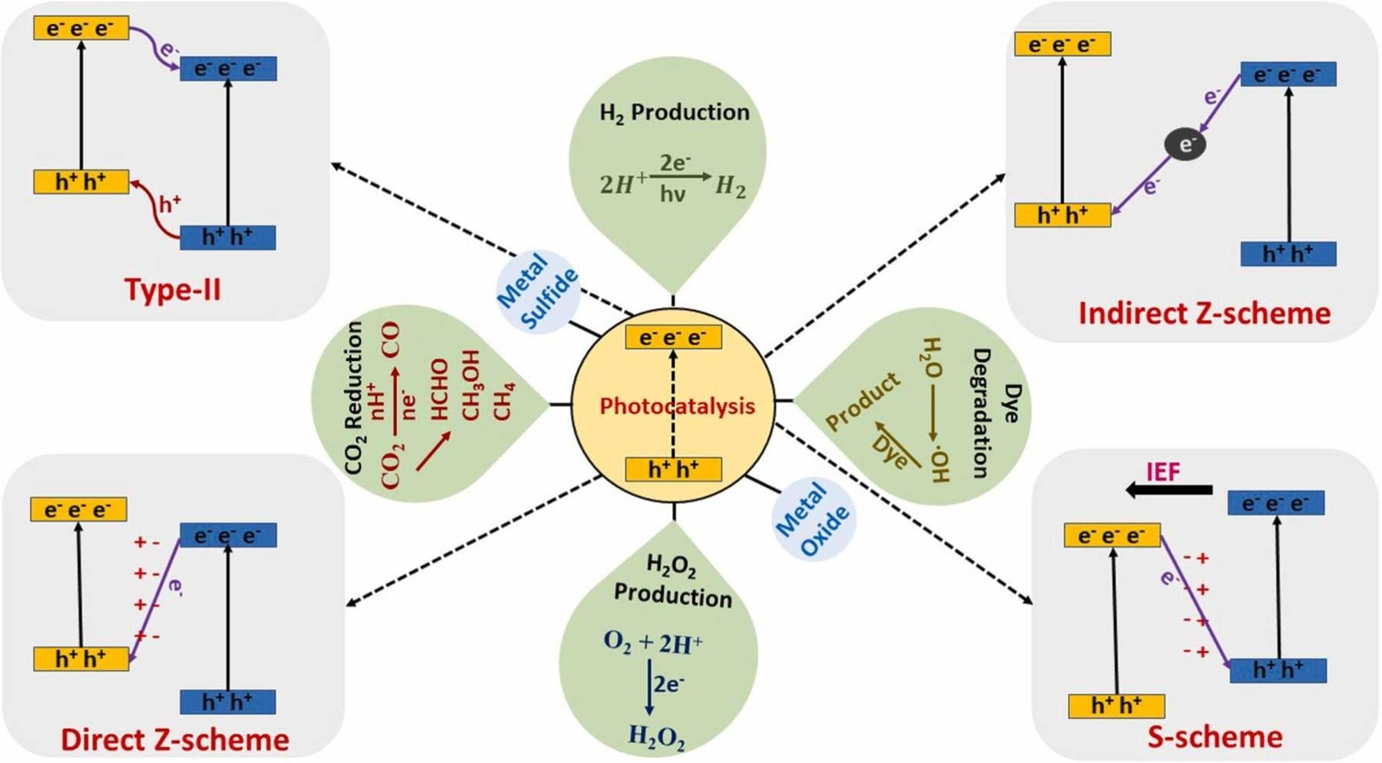

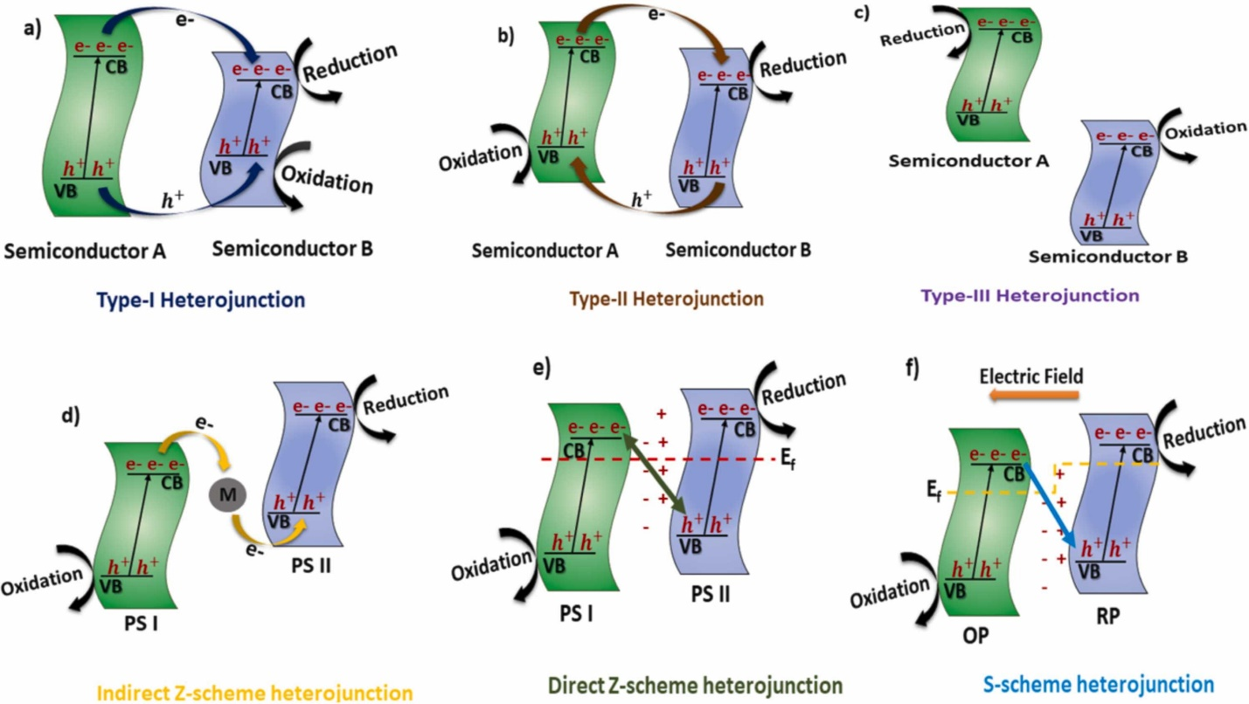

Fig. Schematic Illustration of different types of separation of electron-hole pairs in light responsive heterojunction photocatalysts: a) Type-I, b) Type-II, c) Type-III, d) Indirect Z-scheme, e) Direct Z-scheme, and f) S-scheme heterojunctions

|  |  |  |  |
| --- | --- | --- | --- |
|  |  |  |  |
| |  | | --- | |  | | | |