Chapter

Titanium dioxide as a photocatalyst

**Introduction**

It is recognized that almost one third of the publications on photocatalysis deal with titanium dioxide as the photocatalysis. There can be many reasons for this choice. In fact, to compare the activities of new photocatalysts, it is often referred to the scale reported for Degussa P 25 a commercial sample (which is 4:1 anatase-rutile combination). A second reason could be that solar radiation absorption by TiO2 is optimum among the known material so far.

Twelve polymorphs of Titanium dioxide (TiO2­) have been recognized in literature [1]. The well -known polymorphs are rutile, anatase and brookite. There are two more akaogiite and riesite. In addition, three metastable phases can be produced synthetically namely assuming monoclinic, tetragonal, and orthorhombic structures and four high-pressure forms with structures of α-PbO2-like, Cotunnite-like, orthorhombic and cubic phases are known.

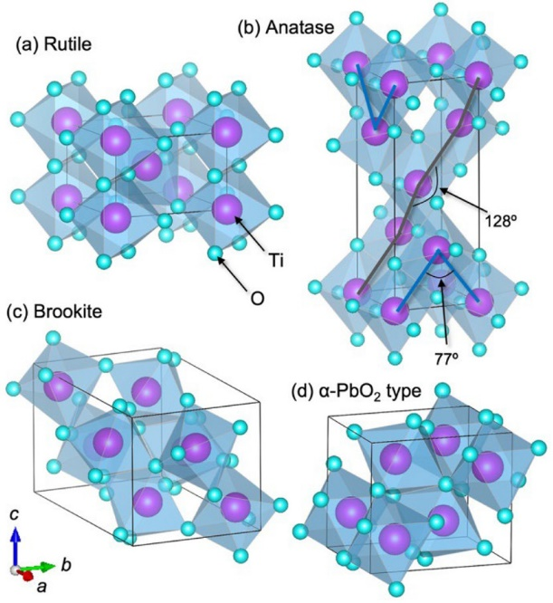

Fig. 1. Crystal structures of four TiO2 polymorphs based on their unit cells: (a) rutile; (b) anatase; (c) brookite; (d) α-PbO2 type. . Each unit cell is viewed from the same perspective, with the *c* axis oriented vertically. The Ti ions contained in the unit cell, as well as their coordination octahedra made of six oxide ions, are depicted. In anatase, two types of zigzag Ti chains occur: one parallel to the [100] or [010] direction with a Ti–Ti–Ti angle of 77.0°, and another parallel to the [111] direction or another symmetry-equivalent direction with a bond angle of 127.7°.

Why TiO2 prominent Photocatalyst?

There are some aspects of the Photo-catalysis that are taken for granted. In this short presentation, we intend to look into some simple aspects which have been always assumed to be valid for the studies in Photo-catalysis. These stated in simple terms are:

1. TiO2 is the best Photo-catalyst so far known and considered so
2. All the efficient photo-catalysts have to be centred on TiO2 like SrTiO3andother titania-based materials
3. Between the two phases of TiO2, it is the Anatase that is preferred for studies on Photo-catalysis and not the Rutile.

The statements may seem simple and most often one does not even question why it is so?

However, it is necessary that one seeks some answers to these profound and applicable statements on Photo-catalysis. It is generally believed that the percentage of photon absorption may be higher in the case of TiO2 and substances of this kind. This can be true but this cannot be the only reason for using this material so exclusively for studies on photo-catalysis. It is known that TiO2 absorbs only Ultra-violet photons (energy around 3 eV depending on the nature of the substance).

But in photo-catalysis it is not only the generation of the excited electron and hole (which results from absorption of photons) but also their use for subsequent chemical reactions. This means the reduction capacity of the electron in the conduction band and the oxidizing power of the hole in the valence band decides how many or how effective the system is for carrying out the redox reaction. It should also be remembered that the situation will be ideal if one can use both the electron in the conduction band and the hole in the valence band so that the effectiveness of the redox reaction is considerably increased. This implies the oxidation potential and reduction potential of electrons and holes in TiO2 have appropriate values for a number of substrates and hence it is capable of promoting simultaneously both the reactions of the substrate. In fact, the positions of the bottom of the conduction band ( measure of reducing power)and the top of the valence band ( (measure of the oxidizing power) are usually depicted for semiconductors in relation to the reduction potential of protons and oxygen evolution reaction from the decomposition of water. This only means both the redox reactions of the substrate has to be promoted by the same semiconductor so that the effective use of the photons can be achieved. This situation seems to be available in the case of TiO2 or in systems where the valence band is composed of 2p wave functions of oxide ions and the conduction band wave functions have the 3d character of the Ti ions.

**The other aspect is why anatase and not rutile?**

Even though one may be tempted to extend the argument given, it should also be necessary to consider a few other aspects. The issues in this case are: (i) the relative percentage of the photons that can be absorbed or scattered (ii) the crystalline nature of rutile may give rise to a situation for less exposed area. (iii) The extent of the ionic character of the Ti-O bond and (iv) the flexibility of the system (Anatase is more amenable for doping and other kinds of sensitization compared to Rutile).

More on Degussa P 25 (the most exploited photocatalyst)

The extensive exploitation of Degussa P25 (TiO2) for studies in photo-electrochemical splitting of water and photo-catalysis has to be rationalized even though, the objective of its use in reported studies is mainly for comparison purposes. Its remarkable reproducibility has to be recognized. It is presumed that P25 is a model core-shell system with anatase and rutile (4:1 weight ratio) and possibly the relative thickness of the core and shell of this system is most appropriate for its behaviour as a photocatalyst. It is necessary that one recognizes the relative values of surface energy of the polymorphs of TiO2 in order to recognize the type of core shell configuration this system can adopt. The values of the surface energies of the three polymorphs of TiO2 are given in Table 1.

**Table 1 Surface free energies of three conventional polymorphs of titania**

|  |  |
| --- | --- |
| Polymorphs of TiO2 | Surface energy/J/m2 |
| TiO2 (Rutile)  TiO2 (Brookite)  TiO2 (Anatase) | 2.2 ± 0.2  1.0 ± 0.2  0.4 ± 0.1 |

Core/shell model

A few remarks on this system are appropriate. These are:

(1) The core shell structure possibly alters the relative electronic structure of the system so as to be facile for photo-catalytic reaction and for charge separation and transfer.

(2) The thickness of the shell (Anatase) may be optimum so as to provide adequate amount of surface adsorption and activation sites.

(3) There are two possible routes for the electron transfer either from anatase core conduction band to Rutile conduction band or Rutile conduction band to Anatase trap states. The correct electron transfer route has to be established.

The readers are referred to the following publications in this connection2-7 wherein the superior photo-catalytic activity of hetero-junctions has been demonstrated over that of pure anatase or rutile in different reactions. Shi et al., have stated that the combination of anatase and rutile “demonstrates magic effects on carrier transfer in photo-catalytic application8

Another aspect of the studies on TiO2 deals with doping with hetero atoms like C, N, S and others, in these studies it has been reported that the reason for doping with these elements is to shift the photon absorption to visible region. This aspect has been examined recently in a review9. These studies must be considered in the light of the observations recorded that the coexistence of Rutile and Anatase phases and the depth of Rutile core and Anatase shell can be tuned by adjusting the “thickness of TiOxCy (x < y) and TiOxCy (x > y) in the precursor composite by a change of the calcinations temperature”1. It is necessary that one recalls the repeated reports in literature on the improvement of photo-catalytic activity due to metallization of TiO211 In a recent publication, Wu et al 121 reported studies on TiO2 single crystals with different percentages of{001} facets and have shown the higher is the percentage of {001} facets, the higher photo-oxidation reactivity and possibly also dependent of the size of the crystal. They postulate that this may be one of the important criteria for many of the oxides in photo-catalytic processes.

The Energetics of Hetero-junction of Titania

The energetics of this hetero-junction has been considered by Deak et al13. They postulate on the basis of their computations that both the bands (VB and CB) lie higher than those of Anatase and in this situation, the electrons accumulate in the anatase phase and holes are concentrated in the Rutile phase. This kind of charge separation can have the following consequences:

(i)This configured system can possibly facilitate the hydrogen (reduction reaction) evolution from water decomposition

(ii) The effective of charge separation may account for the unusual photo activity for water decomposition especially for hydrogen evolution so far reported on TiO2 system

(iii) The holes accumulated on Rutile core may facilitate oxygen evolution and possibly account for the non-stoichiometric amount of oxygen evolution observed experimentally.

These authors have also proposed that the patterning of the photo-catalytic systems can selectively tune the properties of one of the components of the multi-component system by the various modes of sensitization (doping, metallization and other means of sensitization) and the structured configurations may also facilitate directional transfer of charges.

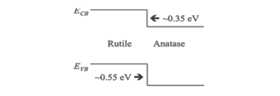

Fig.2 Schematic representation of the band line up between rutile and anatase reproduced from ref11.

A few other remarks are appropriate at this stage. Even though in this short presentation only titania system is considered, it may be equally applicable to other photo-catalytic and PEC systems. The generation of core shell configuration in titania systems have been attempted in a number of ways, like vapour phase hydrolysis8, {Shi, 2012 #24}as well as in caramelized sucrose (organic or inorganic) matrix followed by hydrothermal process generating capped systems which ultimately yields the core shell configuration of the same component namely titania in this case. Since the introduction of these hetero atoms favours core shell configuration, it is natural systems prepared using the precursors containing hetero-atoms will exhibit increased photo-catalytic and PEC activity. Liu et al.2 have also claimed that the depth of the rutile core in the Anatase shell can be tuned by adjusting the thickness of TiOxXy (X being the hetero/metal atom and x< or > y). There can be alternate methods of generating core shell configurations. It may be possible that the presence of hetero atoms or metallic species may be inducing/retarding the phase transformation of anatase to rutile 13-15 and the extent of these species inducing the phase transformation and the conditions employed may be responsible for this core shell configuration being formed in TiO2.

PEC and Photo-catalytic Activity

The core shell configuration together with the inducing species may be providing the necessary energetics for the charge transfer. It has been claimed in a recent communication15 that at the interface the metallic species absorbs photons to undergo Plasmon excitations and these energized charges are responsible for effective transfer to the substrate at the contact site. It is possible that the interface sites are appropriate for photo catalytic behaviour for charge transfer including hydrogen evolution from water splitting by PEC. As stated earlier, it is possible that in this core shell configuration one may have alternate charge transfer routes in addition to possibly increasing the life time of the exciton which may be responsible for the observed changes in photo-catalytic or PEC applications. The charge transfer routes can be from rutile to anatase or to the trap states in anatase with or without the involvement of the phase transferring agent.

It is possible that many of the photo-catalysts or the materials employed in PEC applications have this patterned configuration. Those systems that do not fit to the patterned configurations may not exhibit perceptible photo-catalytic activity or may not find use in PEC application. Further studies alone will provide answer to this important aspect.

It is necessary to understand how these dopants promote the phase transformation and how the patterned configuration is generated in titania system. This aspect requires an understanding of the crystal structure of both anatase and Rutile forms. Even though both the forms have titanium ions in six-fold coordination of oxide ions the arrangements of the oxide ions are different as shown in Fig.3.

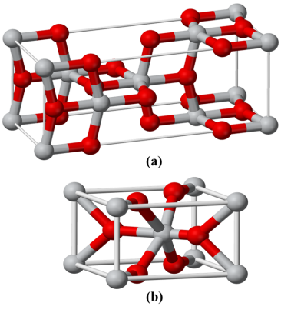

Fig.3 The atomic arrangement in a). Anatase, b). Rutile

Accordingly, the unit cell parameters also differ. At this stage a few remarks may be appropriate. Normally, depending on the magnitude of rearrangement of atoms required for phase transitions, the conventional variables of temperature and pressure are fixed. However, it is known that certain additives also can induce the phase transition possibly by inclusion in the lattice such that lattice contraction or alteration can be easily achieved. In the case of Anatase to Rutile transformation, the inclusion of hetero-atoms or even possibly certain metallic species may favour this phase transition in a facile manner. This could be one of the reasons that titanium dioxide samples prepared in the presence of hetero-atom containing precursors especially C or N could have both the phases.

There are still some questions which have to be answered. These include:

(i)Is there a possibility of controlling the extent (in terms of %) of simultaneous phases present in a given sample of Titania?

(ii) How the core shell model generates active sites for the photo-electrochemical decomposition of water?

It has been claimed in a recent communication15 that at the interface the metallic species absorbs photons to undergo Plasmon excitations and these energized charges are responsible for effective transfer to the substrate at the contact site. It is possible that the interface sites are appropriate for photo catalytic behaviour for charge transfer including hydrogen evolution from water splitting by PEC. As stated earlier, it is possible that in this core shell configuration one may have alternate charge transfer routes in addition to possibly increasing the life time of the exciton which may be responsible for the observed changes in photo-catalytic or PEC applications. The charge transfer routes can be from rutile to anatase or to the trap states in anatase with or without the involvement of the phase transferring agent.

It is possible that many of the photo-catalysts or the materials employed in PEC applications have this patterned configuration. Those systems that do not fit to the patterned configurations may not exhibit perceptible photo-catalytic activity or may not find use in PEC application. Further studies alone will provide answer to this important aspect.

It is necessary to understand how these dopants promote the phase transformation and how the patterned configuration is generated in titania system. This aspect requires an understanding of the crystal structure of both anatase and Rutile forms. Even though both the forms have titanium ions in six-fold coordination of oxide ions the arrangements of the oxide ions are different as shown in Fig.4



Fig.4 The atomic arrangement in a). Anatase, b). Rutile

Accordingly, the unit cell parameters also differ. At this stage a few remarks may be appropriate. Normally, depending on the magnitude of rearrangement of atoms required for phase transitions, the conventional variables of temperature and pressure are fixed. However, it is known that certain additives also can induce the phase transition possibly by inclusion in the lattice such that lattice contraction or alteration can be easily achieved. In the case of Anatase to Rutile transformation, the inclusion of hetero-atoms or even possibly certain metallic species may favour this phase transition in a facile manner. This could be one of the reasons that titanium dioxide samples prepared in the presence of hetero-atom containing precursors especially C or N could have both the phases.

There are still some questions which have to be answered. These include:

(i)Is there a possibility of controlling the extent (in terms of %) of simultaneous phases present in a given sample of Titania?

(ii) How the core shell model generates active sites for the photo-electrochemical decomposition of water?

(iii)Why these sites are more active than the active sites normally present on single phase materials? These aspects need careful consideration in future.

In order to elucidate further, DFT calculations have been carried out on typical units representing pure anatase, pure rutile and anatase-rutile combination in an assumed configuration as shown in Fig. 3(a). The configuration shown in the combination may be considered as representing a core shell model. The density of states per unit of building block is considered and the results obtained is shown in Fig.3(b). It is seen that the valence band density of states for the core shell configuration is particularly altered with respect to that of either pure anatase or pure rutile. Wu et al.10 have shown that the absorption edge has red shifted as the crystal size is decreased. They have postulated that the band gap of anatase is nearly independent with different percentage of reactive facets while the band gap is narrower with smaller particle size. The width of the valence band is the same for uniform particle size with different percentage of facets ( of the order of 6.42 eV) while systems with varying particle size with the same percentage of facets showed decreasing band width. They concluded that the crystal size is an important factor for the electronic and band structure of anatase. However, there are no reports on the effect on these parameters by the presence of another phase along with anatase. It is generally known that the added phase can alter the phase transfer characteristics of the original anatase phase. It is also possible that the size control that will inherently take place in the core shell model can also alter the wave functions of both valence and conduction band of the resulting system and also create additional active sites at the interface. Against these results, the calculations lead to the following points:

1. Pure anatase shows higher density of states at the valence band as compared to pure rutile or anatase-rutile combination. This will have implications for the observed photo-activity of anatase phase as compared to other phases.

2. The valence band width (~2.5 eV) appears to be greater for the rutile-anatase combination rather than the other two pure phases. This could be the reason why the combination system exhibits higher photo-activity. This can result in higher photon absorption cross section and thus facilitate facile electron hole pair formation.

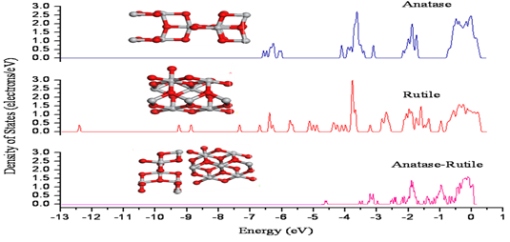

Fig 5 (a)Density of states for pure anatase, rutile and anatase-rutile combination calculations on representative cluster size of M9O18 for both systems

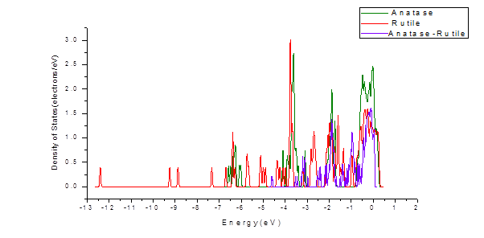

Fig.5 (b) - Density of states for three systems anatase, rutile and anatase-rutile combination

3. The observation certain facets of titania is more active as compared to other facets may imply that in the presence of both polymorphs may induce these active phases to be predominant in the combined system.

4. It is also possible that the interface sites (anatase-rutile) may be differently active and their electronic structure of the interface may be favourable for the combined system to be better photoactive.

It is necessary that the postulates presented need further experimental verification and it is hoped that not only core shell model but other combination configurations may be also similarly active.

As discussed, various semiconductors are being considered/utilized for photocatalysis applications like in the purification of water and air, for self-cleaning, self-sterilization process, antifogging and antimicrobial activity, and many others. This is a separate subject and it will be taken up . In these domains, the Titanium dioxide (TiO2) photocatalyst has attained so much recognition and attention due to its higher catalytic efficiency, its chemical stability, being economical, having low toxicity, and reasonable adjustment with conventional building materials. TiO2 is also applicable for destructing microorganisms, such as bacteria and viruses. It is even useful in inactivating some cancer cells, and for the photo-splitting of water for hydrogen gas production; that is termed as the fuel of the future.

In wastewater treatment processes various binary as well as ternary semiconductors are being utilized as photocatalysts. The titanium dioxide (TiO2) and zinc oxide (ZnO) photocatalysts are often being utilized in the purification of wastewater. Zinc oxide photocatalysis is an excellent oxidation substance that is largely used in the treatment of wastewater in industries like in pharmaceuticals, printing press and dyeing, paper and pulp industry, etc. The titanium dioxide (TiO2) nanotubes also known as (TNTs) are very favorable photocatalysts for the photocatalytic decontaminating of water. Studies by Benjwal et al. (2015)17 show that the graphene oxide–TiO2/Fe3 O4- based ternary nanocomposites are of prospective implementations in the treatment of wastewater.

Some of the trace elements like mercury (Hg), chromium (Cr), and lead (Pb), as well as other metals, are exceedingly hazardous to human health. By utilizing the heterogeneous photocatalysis for the purpose of maintaining the quality of water as well as human health, such toxicities of metals can successfully be removed, even at the lower level of concentrations like parts per million (**ppm**).

For the reaction of water splitting various species such as sulfides, oxides and selenides have been produced as the photocatalysts. Titanium dioxide (TiO₂) nanoparticles, several semiconductors (coupled) like Ca Fe204 /TiO₂, heterojunction WO3 /BiVO4, as well as core or shell nanofibers like CdS/ZnO, and many more, provide very useful ways for hydrogen production from water.

The Titanium dioxide (TiO₂) photocatalyst has attained a lot of recognition as a useful photo-functional substance, the reason is that the cleaning of glass and tile surfaces require chemical detergents, depletion with high energy, and it’s expensive too. The self-cleaning surface based on titanium dioxide makes the inorganic as well as organic molecules to remain absorbed and degraded on it effortlessly. Afterwards, it becomes easy to wash with water because of high hydrophilicity of TiO₂ film. The said outcome of TiO₂ becomes functional on this condition; when the rate of absorbed organic pollutants on the surface of material is lesser than that of incident solar photons per unit time. The coating, paint materials for the walls of buildings and construction processes are much exposed to bad weather conditions such as natural rainfalls and harsh sunlight, so titanium dioxide (TiO₂) is the best utilization for self-cleaning for above mentioned processes.

Antifogging being one of the superhydrophilic technologies that possess an extraordinary wide range of applications. When the air with higher level of humidity comes under contact to the surfaces of materials such as glasses and mirrors, the phenomenon of fogging occurs with the formation of a lot of tiny water droplets, which in general results the scattering of light on these surfaces. Contrary to this, when there is a highly hydrophilic surface, it prevents the formation of water droplets, whereas a thin and uniform water film is formed, resulting the prevention of fogging. When the surface develops a highly hydrophilic state, it stays in that condition unchanged for many days to come, at least for a week. This new and economical technology has been used with easy and convenient processing to produce several types of eyeglasses, mirrors and other glass products. Now a days antifogging superhydrophilic side view mirrors are being installed in various Japanese made cars.

Matsunaga et al. (1985)18 made an observation for the antibacterial effects of titanium dioxide (TiO₂) based photocatalysis. They gave this novel concept of utilization of photochemical sterilization with titanium dioxide (TiO₂) semiconductor using the irradiation of metal halide lamp. Titanium dioxide (TiO₂) inactivated various microbial toxins (like microcystins, brevotoxins, lipopolysaccharide endotoxin, etc.) as well as killing a broad range of organisms that include viruses, bacteria, algae, fungi and even to the extent of cancer cells. The coatings of simple titanium dioxide (TiO₂) and doped TiO₂ are now in utilization for inhibition of not only the bacteria’s reproduction, but also to decompose the cells of bacteria under mild conditions at the same time.  For antimicrobial applications using UV light, precise composite of TiO2 and Ag- TiO2 nanofilms have been prepared, because Sliver (Ag) is one of the good antibacterial materials.

In order to add antimicrobial properties in interior paints in building and constructions the photocatalytic material TiO₂ is commonly used as one of the best applications for this purpose. Moreover, a nanosized photocatalytic TiO₂ and ZnO mixture gives very useful antimicrobial effects. A Japanese Arc-Flash industry utilized technology of photocatalyst fixation that directly sprayed the photocatalysts on the surface. The titanium dioxide (TiO₂) nanoparticles were the prime component of those coatings; such coatings are extremely effective and efficient in sterilizing as well as sanitizing the hospitals, kitchens, schools, floors, etc. and killing bacteria with a 98% efficiency, ultimately enhancing the hygiene standards around.

Photocatalysis is characterized as the alteration of a process’ reaction rate in the presence of light and a photocatalyst. Various applications are developed, such as treatment of water, disinfection system, removal of **volatile organic compounds** (VOCs) and **nitrogen oxides** (NOx), production of hydrogen gas H2, and conversion of CO2, , even with some of them approaching to commercial levels. In order to generate homogeneous as well as heterogeneous photocatalysis processes, various types of light sources that range from ultraviolet to solar (sources) are being utilized. The applications and utilizations of photocatalysis processes at ambient temperature and pressure, and the ability to activate the catalyst using sunlight, makes it appealing for low-cost and convenient usage, additionally for the usage in passive situations. In contrast to traditional catalysis, photocatalysts usually do not have active sites in a conventional sense, and rate is also determined by exposure or intensity of irradiation light.

References

1. Zenji Hiroi, Inorg. Chem., 61,8393 (2022).

2. G. Liu, X. Yan, Z. Chen, X. Wang, L. Wang, G. Q. Lu and H.-M. Cheng, *J. Mater. Chem.*, 2009, **19**, 6590.

3. T. Kawahara, Y. Konishi, H. Tada, N. Tohge, J. Nishii and S. Ito, *Angew. Chem., Int. Ed.*, 2002, **41**, 2811.

4. Z. Liu, X. Zhang, S. Nishimoto, M. Jin, D. A. Tryk, T. Murakami and A. Fujishima, *Langmuir*, 2007, **23**, 10916.

5. T. Ohno, K. Tokieda, S. Higashida and M. Matsumura, *Appl. Catal., A*, 2003, **244**, 383.

6. T. Kawahara, T. Ozawa, M. Iwasaki, H. Tada and S. Ito, *J. Colloid Interface Sci.*, 2003, **267**, 377.

7. Q. Zhang, L. Gao and J. Guo, *Appl. Catal., B*, 2000, **26**, 207.

8. F. Shi, Y. Li, Q. Zhang and H. Wang, *J. Am. Ceram. Soc.*, 2012, **95**, 1927.

9. B. Viswanathan and K. R. Krishanmurthy, *International Journal of Photoenergy*, 2012, **2012**, 10.

10. M. Sathish, B. Viswanathan and R. P. Viswanath, *Int. J. Hydrogen Energy*, 2006, **31**, 891.

11. Q. Wu, M. Liu, Z. Wu, Y. Li and L. Piao, *J. Phys. Chem. C*, 2012, **116**, 26800.

12. P. Deák, B. l. Aradi and T. Frauenheim, *J. Phys. Chem. C*, 2011, **115**, 3443.

13. I. H. Tseng, W.-C. Chang and J. C. S. Wu, *Appl. Catal., B*, 2002, **37**, 37.

14. Z.-h. Yuan, J.-h. Jia and L.-d. Zhang, *Mater. Chem. Phys.*, 2002, **73**, 323.

15. H. E. Chao, Y. U. Yun, H. U. Xingfang and A. Larbot, *J. Eur. Ceram. Soc.*, 2003, **23**, 1457.

16. D. Tsukamoto, Y. Shiraishi, Y. Sugano, S. Ichikawa, S. Tanaka and T. Hirai, *J. Am. Chem. Soc.*, 2012, **134**, 6309.

17. P Benjwal and Kamal Kar, H Environmental Chemistry, 3,2076 (2015).,

## 18. Tadashi Matsunaga, Ryozo Tomoda, Toshiaki Nakajima, and Hitoshi Wake, FEMS Microbiology Letters, 29,211 (1985).