**CHAPTER ONE**

**Photocatalysis - Definition and Perspectives**

* 1. **Introduction Free Energy - G**

It has been already known that solar energy can be harnessed and converted into many other forms of energy and also for environmental protection. Thus, photocatalysis opens up a way to transform solar energy into value added chemicals and dispose environmental pollutants. Briefly, in 1921, Baly et al., employed the term photocatalysis to describe a photochemical synthesis process in the living plant. In 1938, Goodeve and Kirchner discovered that titanium dioxide could act as a photosensitizer for bleaching dyes in the presence of oxygen [2]. In 1972, Fujishima and Honda reported the semiconductor electrochemical photolysis phenomenon [3]. A more detailed account of history of this phenomenon can be seen in ref.[4]. Subsequent to this, a spate or research activities have been reported on a variety of topics like water splitting to produce fuel hydrogen, carbon dioxide conversion to value added chemicals, reduction of dinitrogen, degradation of contaminants in water and air and also for organic synthesis.

* 1. **Definition of Photocatalysis**

In photocatalysis, the process has to be properly comprehended since photons are consumedin these processes, and hence the term Photocatalysis appears to be a misnomer. In essence, this may be termed as Photon assisted catalysis.

According to the definition of the international Union of Pure and Applied Chemistry (IUPAC) “ Photocatalysis act as a change in the rate of a chemical reaction or its initiation under the action of ultraviolet, visible or infrared radiation in the presence of a substance –the photocatalyst - that absorbs light and involved in the chemical transformation of the reaction partners” [5]. In essence, reactions promoted under this category are driven by light, though it may imply that light acts as the catalyst. The term before catalysis can be regarded as the environmental condition ( so called field) in which the catalytic process takes place.

In addition, some researchers perceived that if photocatalysis is a catalytic process, the existence of catalyst should change the kinetic rate rather than thermodynamic limits of the photochemical process. Based on this contention, these people classified these photochemical reactions into photocatalytic and photosynthetic process according to the thermodynamic spontaneity of the chemical reactions.

As shown in Fig.1, a photochemical process with reaction ∆G > 0 (uphill)

is attributed to photosynthesis, including the overall water photolysis, CO2 reduction, and the natural photosynthesis while the process with reaction ∆G < 0

(downhill) is actually the photocatalysis, such as hydrogen evolution reaction with sacrificial reagents. The differences between photosynthetic devices and photocatalytic processes have been discussed by Osterloh [6] and by Rajeshwar et al [7].

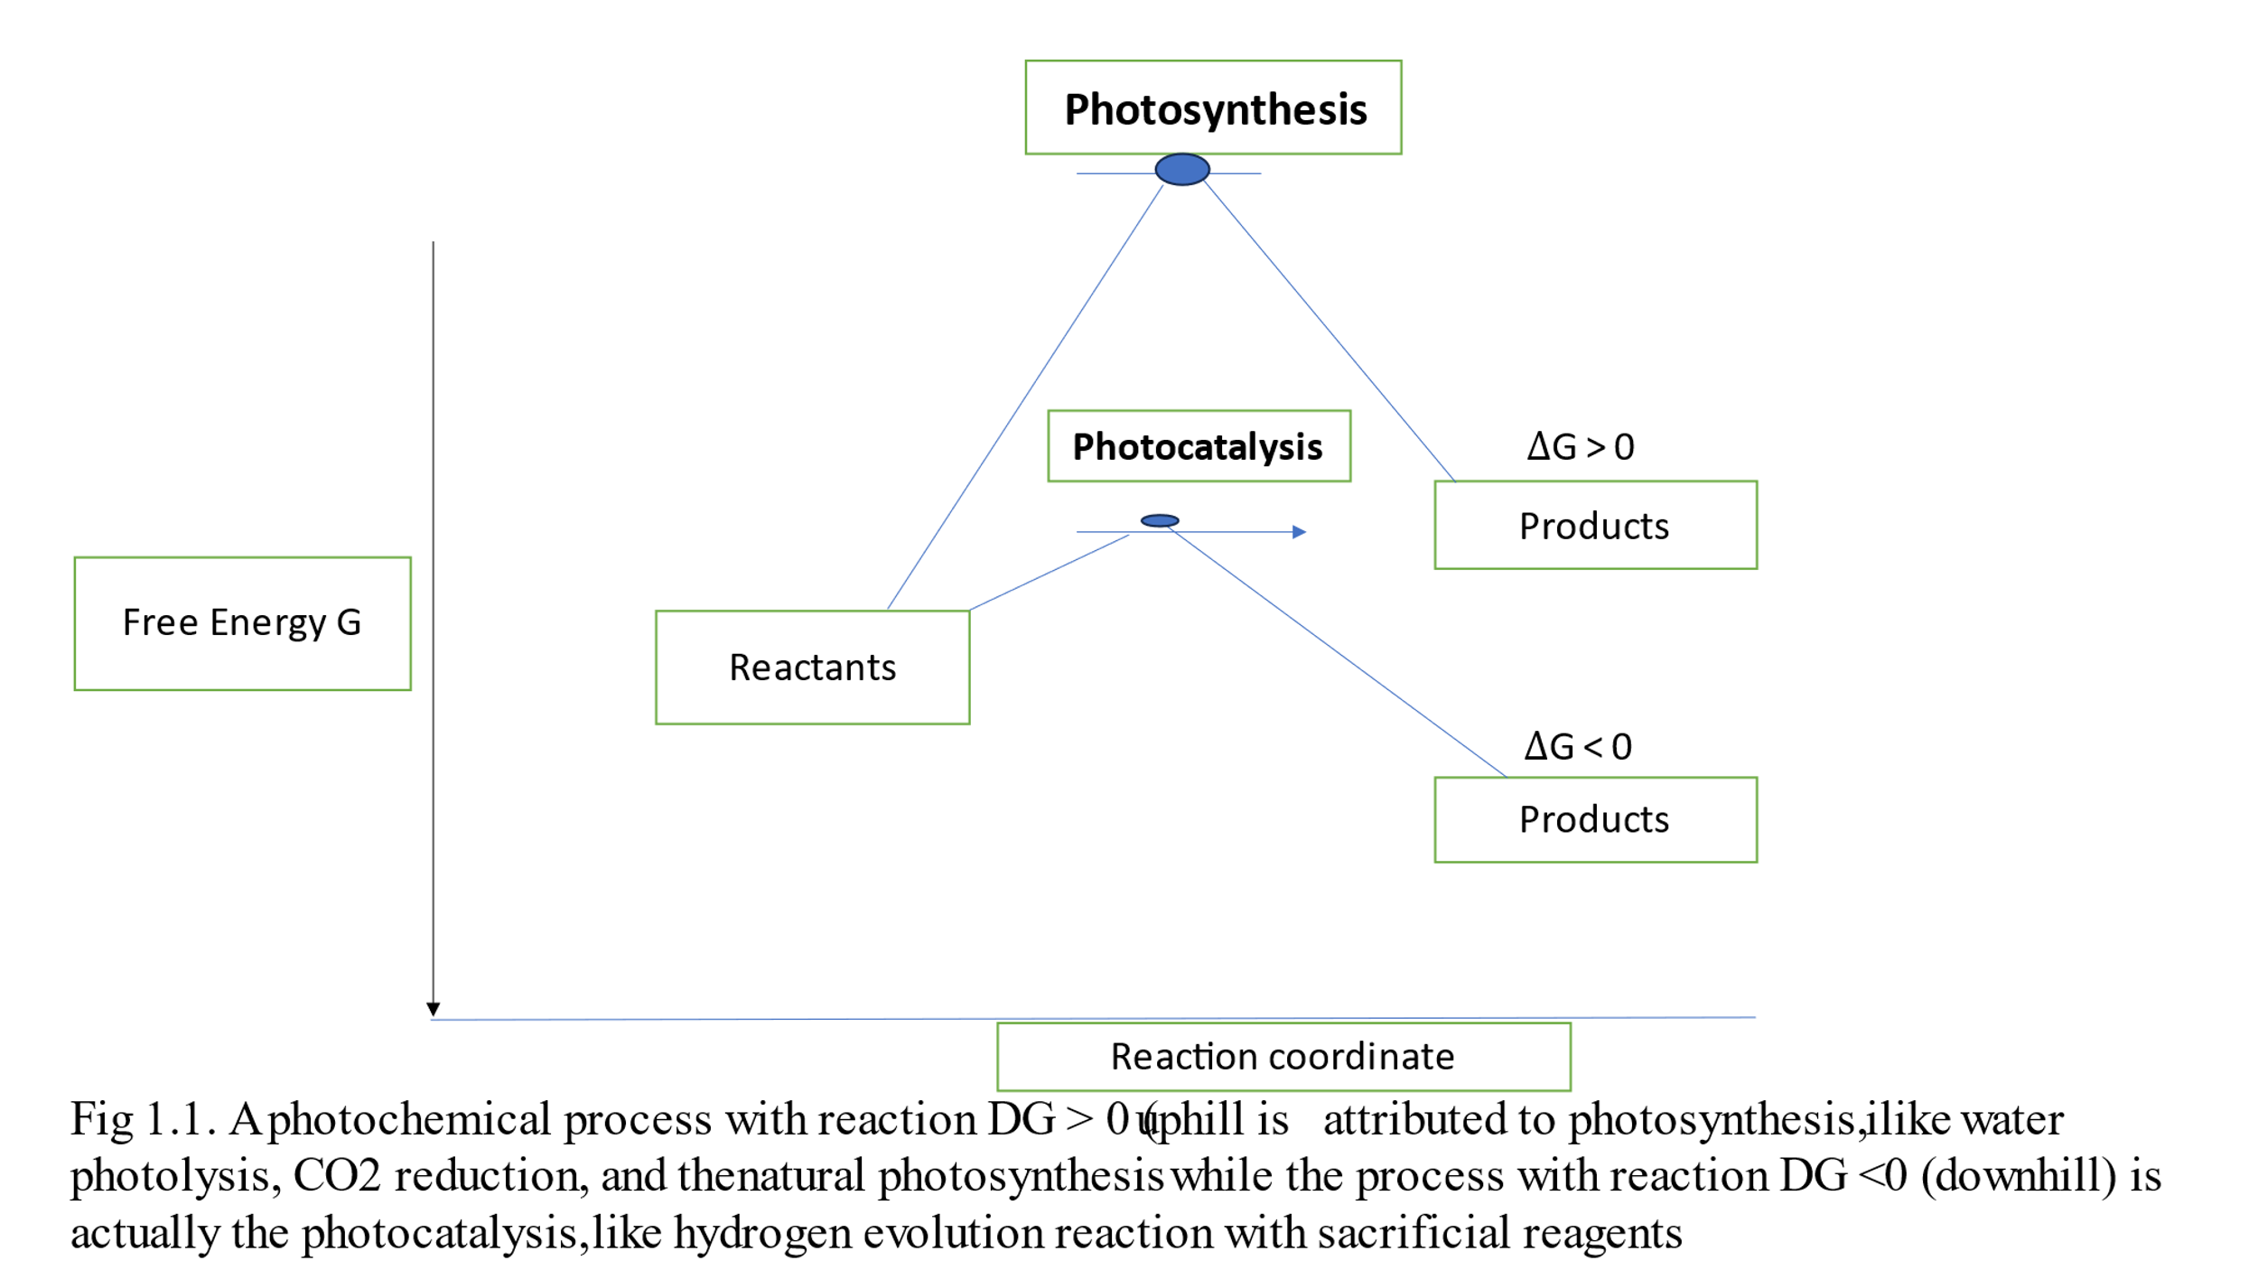

In classifying the chemical reactions in terms of thermodynamic fields like Temperature. Pressure, and the effects of other physical fields like electric field, magnetic field and so on to reflect the spontaneity.

**Electrocatalytic splitting of water**

Electrocatalytic water decomposition is a non-spontaneous reaction

H2O → H2 + ½ O2 ∆G > 0

In the electrolysis cell a bias Vapp is applied between two electrodes and the electrolyte is considered to be acidic. The ∆ G 0  of this reaction can be written as the sum of two terms – one is the free energy of the reaction and the second term arises due to the applied potential V.

∆G0 = ∆G0 - 2FVapp

The electrolysis of water reaction can proceed spontaneously when the applied bias is large enough to make the net free energy change is negative. This situation is pictorially represented in Fig.1.2.

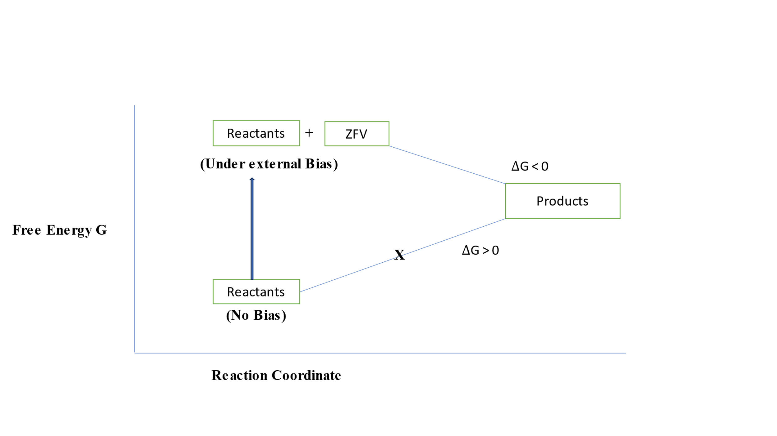

Fig.1.2. Schematic picture of electrocatalytic water splitting process in this figure the free energy change is with consideration of electrochemical potential.

The corresponding situation in the presence of photon field is pictorially represented in Fig.1.3.

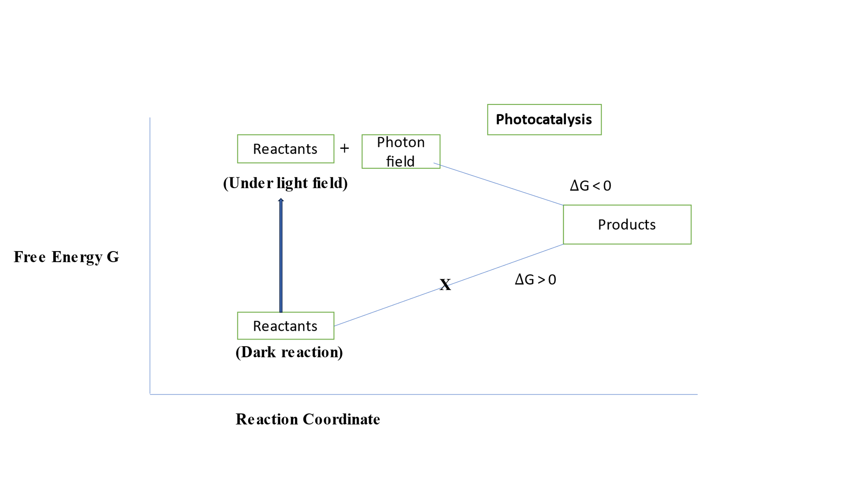Fig.1.3.Schematic representation of photocatalytic water splitting – Gibbs free energy change when considering photons as the reactant of photocatalytic water splitting.

* 1. **Final Remarks**

The controversies on photocatalysis and photosynthesis have been focusing on the thermodynamic spontaneity of only he chemical reactions involved in the process. This type of argument only considers the free energy of the reactants while in electrocatalysis or photocatalysis the electric potential or photons are also involved in the reaction. These situations are pictorially shown in Figs.1.2 and 3. In this consideration the electrochemical potential or photon field are considered for considering the free energy change in the electro (photo) catalysis. Thus, the so called photocatalytic and photosynthetic processes are both spontaneous reactions in the corresponding photon field. It has to be recognized that the type of field involved has to be considered along with other reactants. In photocatalysis,, the solid catalyst only acts as mediator between the reactants and the photons to accelerate the kinetics of the process.

In essence, the controversy appears to be genuine and it may still persist. There can be alternate definitions of photocatalysis and may still be presented, however the difference should be based on the parameter control is either thermodynamic or kinetics.

[1] Baly, ECC, Heilbron, IM, and Barker, WF, Journal of the Chemical Society Transactions, 119, 1025-1035 ( 1921).

[2] Goodeve, CF, and Kirchner, JA, Trans Faraday Soc.,34,570-579 (1938)

[3] Fujishima, A and Honda, K., Nature, 238,37-39 (1972).

[4] Viswanathan B and Scibioh MA., Photo-electrochemistry, Principles and practice, Narosa Publishing House, (2014).

[5] Braslavsky, SE. Braun, AM, Cassano, AE, Emeline, AV, Litter, MI, Palmisano, L, Parmon VN, Serpone, N, Pure Appl. Chem.,83, 931-1014 (2011).

[6] Osterloh FE, ACS Energy Lett., 2,445-453 (2017).

[7] Rajeshwar, K., Valli, A., de Brito, JE, Boldrin Zanoni, MV, ACS Energy lett., 6,2187-2201 (2021).

[8] Jiazhe Wu, Wenyu Zheng and Yubin Chen, Current opinion in Green and sustainable chemistry, 33, 100580 (2022).,