**Catalysis at the Crossroads of Science and Technology**

**B. Viswanathan National Centre for Catalysis Research Indian Institute of Technology, Madras.**

**[Balasubramanian Viswanathan is an honorary faculty of the National Centre for Catalysis Research at the Indian Institute of Technology, Madras]**

**Abstract**

This presentation aims to analyse the primary focal points in catalysis that will be the subject of research and development in the current and upcoming decades The emphasis in this field will be on energy conversion and environmental concerns. However, there will also be a significant focus on enhancing the intrinsic activity of active sites and extending the lifespan of catalysts, whether in a single atom configuration or through cluster size control.

1. **Introduction**

As a branch of science and technology, catalysis has significantly contributed to the growth and sustainability of life processes on our planet. The development of catalyst technology has been instrumental in converting and storing energy from conventional and non-conventional sources such as hydrogen, electricity, and other forms. For instance, the discovery of substantial lithium reserves in one of India's states bodes well for the country's rapid advancements in energy conversion and storage technologies. Additionally, the emergence of nano-catalysis technology and the identification of single-atom active sites are expected to increase the output of chemical industries. Despite the vast potential for knowledge generation in this field, there are certain hurdles to implementing this technology, such as the agglomeration of active single or cluster sites and the economic design of active sites on industrial catalysts. While instrumental techniques have enabled us to decipher surface processes down to the molecular level, there remains a fundamental gap in our understanding of the catalytic force and how it can be manipulated. Theoretical treatments of surface processes, such as density functional theory calculations, can provide some molecular-level information, but the optimization of catalytic processes remains beyond our reach, although some suggestions are possible. Therefore, this presentation aims to address these issues and outline strategies for extending the life of a catalyst, evaluating the performance of new-generation catalyst systems under actual manufacturing conditions, and enhancing the catalytic power of solid catalysts.

Over the past few decades, there have been significant advancements in all scientific fields, including catalysis. However, since this branch of science plays a crucial role in the global economy, the progress achieved thus far falls short of what is necessary and expected. In most industrial catalytic processes, pressure and temperature are the primary variables to maximize economic benefits and yield. As a result, current technologies have been developed with a heavy emphasis on these two variables.

1. **Change in raw material inventory in the hydrocarbon industry**

The hydrocarbon conversion industry relies heavily on the use of various catalysts. However, due to the need to find alternative raw materials to crude oil, this process of converting hydrocarbons to high-energy fuels and industrial chemicals, including drugs and other health-related products, must now look beyond traditional sources. The figure illustrating the approximate energy demand of the world highlights the dependence on fossil fuels, such as petroleum, coal, and natural gas. As a result, the use of renewable biomass has emerged as a viable alternative [1]. Biomass refers to "any organic matter available on a renewable or recurring basis, including dedicated energy crops and trees, agricultural food and feed crop residues, aquatic plants, wood and wood residues, animal wastes, and other waste materials." The most common biomass sources used in biorefineries include energy crops, agricultural and forestry waste and residues, and industrial and municipal waste, which are currently discarded and pose health hazards.

As the demand for alternative raw materials increases, existing oil refining industries must quickly adapt and reorient themselves to produce value-added chemicals from these so-called waste resources while learning how to convert waste into wealth. This shift may help solve the energy crisis and alleviate some environmental concerns associated with fossil fuel use.

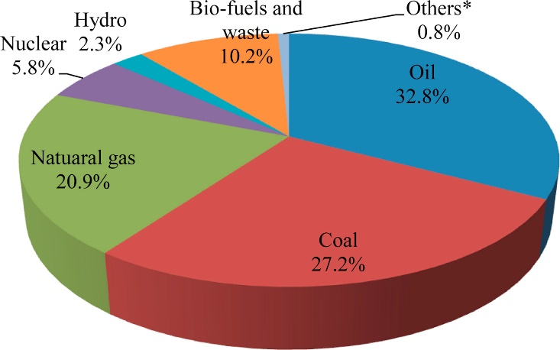

Figure 1. Approximate global energy scenario [Reproduced from Reference 1]

1. **The concept of single-atom catalysis**

In recent years, the objective of heterogeneous catalysis has been to replicate metalloenzymes, organometallic complexes, and open framework structures. The area of single-atom catalysis has become a highly interdisciplinary field of research within the last decade, intending to synthesize, characterize, and apply single-atom catalysts for challenging reactions such as Oxygen Reduction Reaction (ORR) and Water-Gas Shift Reaction (WGSR), which are crucial to understanding life processes and energy conversion. The timeline of the growth of single-atom catalysis is illustrated in Figure 2 [2]. To commercially exploit these highly active systems, the design of molecular or cluster sizes and their stability are critical factors. One way to improve the intrinsic activity of the active sites is to prevent their reconstruction by appropriately anchoring them without altering their electronic and geometric configuration. It is anticipated that this advanced technology will soon be developed.

Figure 2. The timeline in the growth of the science of single-atom catalysis [Reproduced from Reference 2].

1. **Fine Chemicals Industry**

Fine chemicals are single, pure chemicals with low turnover (<1000 tons per year) and high value (>Rs.1000 per Kg), mainly serving as pharmaceuticals, life sciences, agrochemicals and photochemical products. In recent years, the production and business of fine chemicals have undergone a significant shift towards sustainability, green chemistry and engineering tools, and innovative production models. The leading technologies for producing fine chemicals are bio-based (biotransformation process) chemical production from renewable sources like carbohydrates, oils, fats and lignin, petrochemical-based fine chemicals, and high-value fine chemicals by the technology of blow waste valorisation and carbon dioxide reduction process. However, the major challenge is to achieve the required selectivity for chemicals of relevance. The catalytic conversion of biomass-derived molecules like carbohydrates and lignocellulosic biomass to value-added chemicals is a process that awaits commercial exploitation. The reactions mainly employed are dehydration, hydrolysis, isomerization, hydrogenation, hydrogenolysis and c-c coupling. The synthesis of value-added chemicals from carbohydrates mainly includes dihydro-levoglucosenone, 1,6-hexanediol, furan-dicarboxylic acid, terephthalic acid, lactic acid, and lactide. The ultimate goal in catalyst development is to design and synthesize a solid catalyst that can achieve 100% selectivity and high activity under mild reaction conditions, similar to the conditions employed in enzyme catalysis. To achieve this, it is necessary to understand the structure-performance relationships and the capability to design and architect the expected performance. The initial platform chemicals from biomass are summarized in Fig.3 [3].

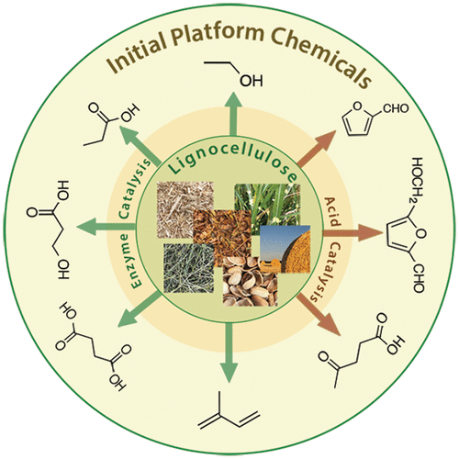

Figure 3. The possible initial platform chemicals from lignocellulose [Reproduced from reference 3]

1. **The Exploitation of Small Molecules like Carbon dioxide and Dinitrogen**

As society continues to develop and the world's population increases, energy demand has continued to rise. One potential solution for this issue is the solar-driven reduction of carbon dioxide to produce low-carbon fuels or small organic compounds. This process helps reduce CO2 emissions and serves as a form of energy storage, which can be valuable in mitigating energy shortages and global environmental crises [4,5].

Among the various methods for CO2 conversion, photo-electrocatalysis has emerged as a promising approach in recent years, as it combines the benefits of photocatalysis and electrocatalysis. The photo-electrocatalytic CO2 reduction system can be classified into several categories, including 1) dark anode and p-type photocathode; 2) dark cathode and n-type photoanode; 3) p-type photocathode and n-type photoanode; and 4) a novel tandem device that integrates solar cells to provide voltage and a continuous flow of CO2 to reduce CO2 on the surface photocathode with appropriate selectivity.

Although the effect of all the influencing parameters has been investigated, controlling the process's material properties, thermodynamics, and kinetics must be fully understood to improve its efficiency. Some of the critical challenges and issues that must be addressed include the following:

* Low conversion efficiency and product selectivity of CO2 for practical application.
* The lack of a comprehensive and reliable detection system and process standardization.
* The need for advanced in situ characterizations to understand surface transformations in detail.
* Advanced computational methods, such as Density Functional Theory (DFT), are required to predict suitable photoelectrodes.

Hopefully, these challenges and issues will be addressed in the future, allowing for the successful implementation of photo-electrocatalysis in reducing CO2.

One area that urgently requires attention is developing an energy-efficient synthesis process for ammonia. The Photo-electrochemical Nitrogen Reduction Reaction (PEC-NRR) is a challenging but promising approach for producing green ammonia, which utilizes direct solar energy and water as a proton source. It can be accelerated with an external potential to overcome the kinetic barriers commonly encountered during synthesis [5, 6]. In this regard, economically viable materials such as carbon-based materials with heteroatom substitution, especially nitrogen, are expected to emerge as suitable alternatives soon.

The development of sustainable and energy-efficient ammonia production for use in fertilizer and fuel has the potential to have a global impact in this century similar to that of the Haber-Bosch process 100 years ago. The complexity of the six-electron, six-proton reduction involved in ammonia synthesis makes it challenging to achieve by traditional electrochemistry. However, multiple photons and electrical potential activations may be a possible and deliverable technology. Regarding selectivity and energy efficiency, the strategy should focus on catalyst features such as defects, edges, and steps that offer low overpotential pathways close to or above the Reversible Hydrogen Electrode Potential (RHE).

Theoretical studies on the mechanistic side can provide clues for identifying these possibilities, particularly in the search for specific surface features that provide low-energy pathways.

1. **Photocatalysis Production and Destruction of Fine Chemicals**

Photocatalysis is a process that alters the rate of a chemical reaction involving the absorption of light by one or more of the reacting species or added substances (catalysts) that participate in the chemical reaction. Energy transfer from the photon-absorbed catalyst can trigger exotic oxidation, epoxidation, and other hydro-treatment reactions to produce fine chemicals. Additionally, photocatalysis can be widely utilized to degrade environmentally polluting chemicals (by facile oxidation) like dyes and other biomolecules. However, finding the appropriate materials that can function as visible translucent materials capable of harvesting almost all ranges of solar incidence remains a challenge. Moreover, it is necessary to improve the efficiency of charge separation and transport while reducing recombination reactions. Ensuring that this process enables multielectron redox reactions with improved kinetics is essential. Progress in this area is expected to shed light on the efficient natural process of photosynthesis (which has so far eluded understanding) and enable the artificial generation or conversion of energy [7]. To illustrate the research direction, Fig. 4 shows a schematic representation of the understanding of this process.

Figure 4. Optical absorption and electron transfers according to the Z-scheme of photosynthesis. [Reproduced from Reference 7]

1. **Interface Science**

When substrate molecules interact with the potential force of a surface, they undergo distortion that can influence the direction and selectivity of the reaction. The intrinsic surface potential is determined by various factors such as active sites' location and coordination geometry, defects in the solid, and inherent surface heterogeneity. This potential force can reach up to 107 V/Å or higher, which is strong enough to facilitate bond formation or breakage.

Photo-electrochemical production of green fuel (hydrogen) source in spite of five decades of intense research could not achieve the desired level of conversion mainly because of two reasons. They are: 1.The choice of suitable semiconducting electrode material and its design are yet to be formulated effectively so that the semiconducting system will absorb almost all the UV and visible radiation of solar spectrum. 2. Our knowledge of the structure and manipulation of the electrode/electrolyte interface at the molecular level and effective and efficient electron transfer are not adequate enough still. At least these two aspects can be expected to gain attention in the coming decades.

**Epilogue**

This article aims to highlight key developments expected in the field of catalysis. Extending the catalyst's lifespan and enhancing the activity of its active sites for increased conversion rates are ongoing goals. To achieve this, preserving single atom or cluster geometry until the end of the catalyst's lifetime is a promising area of research that is expected to advance in the coming decades.

**Some Key Links**:

[1] Sunil K Maity, Opportunities, recent trends and challenges of integrated biorefinery: Part I, Renewable and sustainable energy review, 43,1427-1445, 2015.

[2] Sunil K Maity, Opportunities, recent trends and challenges of integrated biorefinery: Part II, Renewable and sustainable energy review, 43,1446-1466, 2015.

[3] Sharon Mitchell and Javier Perez-Ramirez, Single-atom catalysis: a decade of stunning progress and the promise for a bright future, Nature communications, 11, 4302, 2020.

[3] Laszlo T Mike, Edit Csefalvay and Aron Nemeth, Catalytic conversion of carbon hydrates to Initial Platform Chemicals (IPC): Chemistry and sustainability, Chem. Rev., 118,525-613 (2018).

[4] Fang Wang et al., Technologies and perspectives for achieving carbon neutrality, The Innovation, 2(4), 100180, 2021.

[5] Bryan H R Suryanto, Hoang-Long Du, Dabin Wang, Jum Chem, Alexandr N Simonov and Douglas R, MacFarlane, The challenges and prospects of the Catalysis in electroreduction of nitrogen to ammonia, Nature Catalysis, 2, 290-296, 2019.

[6] Wang, L et al., Greening ammonia toward solar ammonia refinery, Joule, 2 (6), 1055-1074, 2018.

[7] Martin Stutzmann, Christoph Csoklich, Graduate Texts in Physics, The Physics of Renewable Energy, Springer 2023.