**Nitrogen Incorporation in Carbon Matrix**

**B. Viswanathan**

**National Centre for Catalysis Research**

**Indian Institute of Technology, Madras Chennai 600 036**

**Abstract:**

Material selection and design are the important endeavors in scientific pursuit for various applications. Energy conversion and storage and environmental protection are the important components of research and the one of the materials that will receive attention in these times is nitrogen containing carbon materials since they are being examined as alternate electrode material for a variety of electrochemical reactions like oxygen reduction reaction (ORR), hydrogen evolution reaction (HER) and for materials for hydrogen storage in addition to creation of active surface sites and surface characteristics like altering the hydrophobicity and hydrophilicity.. These important applications have been mainly based on noble metals (especially Pt), but the advent of nitrogen containing carbon materials have changed the situation thus paving the way for noble metal alternatives. The reasons for these energy conversion applications have to be elucidated. The questions either the electronic structure of these materials or the active centers created in these materials are the factors responsible for these applications? This presentation attempts to focus on two important applications of this new class of materials namely supercapacitor applications and also its use for ORR the understanding of this reaction is necessary for realizing the life process. There are many other important applications of this material like HER and hydrogen storage and each of these applications may require separate treatments and hence they will only be mentioned.

**Introduction**

Most of the energy conversion processes have been centered around the element ‘carbon’ apart from noble metals like Pt. The scientific pursuit is concerned to find substitutes for noble metals like Pt for various reactions including hydrocarbon conversion reactions and electrochemical transformations for various reasons including the availability and cost. The element carbon has many manifestations starting from graphite, diamond, carbon nanotubes, graphene sheets and the list of these materials is ever increasing. There are various characteristics of carbon materials like the ease of production from various sources, (biomass, or fossil sources) cost of production, and ease of fabrication possibilities make these materials receiving considerable attention [1,2]. These materials have low cost, high surface area, and good mechanical and electrical properties. Moreover, these materials display high chemical and electrochemical stability [3,4]. Generally, the carbon surfaces can be considered to be equi-potential surfaces and hence inherently there are no a priori active sites except the defect sites and edge and corner sites and none on the flat surface and this is the reason that there have been attempts to generate active sites on this surface so that specific activity can be expected from these substituted materials. Among the various possibilities, incorporation of hetero atoms especially nitrogen appears to be feasible from the point of view of size and also charged state because of the electronic configuration difference between the elements carbon and nitrogen. This could be one of the reasons why carbon nitride namely C3N4 have evolved as one of the active materials employed for a variety of applications. This is now evolving an area of intense research [4a]. In addition, the incorporation of heteroatoms in the normally homogeneous surface can alter the hydrophilic character of the surface. These developed materials may find various other applications including in the development of supercapacitors [5,6], in other energy storage and conversion devices,[7] and also promote sluggish reactions like Oxygen Reduction Reaction (ORR) [8-13] in energy conversion devices like fuel cells. Electrochemical capacitors (EC) are going to play an important role in portable electronic devices and also to provide power density to hybrid electric vehicles. Efforts have been directed in improving the energy output of ECs. Although, enhancement of energy output of ECs is one of the aims, at the same time keeping the high-power density is the aim of the investigations in these materials in recent times. Even though, many materials like metal oxides, conducting polymers and new carbon materials have been consistently evaluated as electrode materials in ECs, in recent times, nitrogen containing carbon materials are evolving as an alternate material suitable for EC applications and in turn as energy storage devices.

Even though, the nitrogen containing carbon materials have, as mentioned above, found many applications, the reasons for this choice is not yet explicitly clear. Also, in literature, how these materials or similar materials which can function as substitutes for noble metals like Pt can be designed is not clear. These observations lead to questions how these heteroatoms substituted carbon materials appear to be substitutes for noble metal like Pt in reactions like HER or ORR. Does this mean, that the structure of the frontier density of states (DOS) of these materials is similar to that of Pt? Or the new active sites created in a homogeneous surface function as sites for activating these species, is so in what manner? There are many more questions that arise and it is necessary that one finds answers to such questions.

Towards this aim, this presentation attempts to elucidate the following aspects on this new class of materials.

1. How the incorporation of nitrogen species in carbon matrix alter the chemical characteristics of the normally homogeneous carbon surface?
2. In what manner the created new active centres function in this material? The altered behaviour is electronic in origin or geometrical in nature?
3. What are the synthetic options available to generate these materials?

In addition to these questions, there are a few aspects on which our understanding has to improve so that one can exploit these materials effectively.

Even though a variety of structural analytical and chemical analysis can be employed to characterize these materials, this presentation is mainly focused on the elucidation of the chemical state of the nitrogen incorporation in these materials by employing XPS technique though conventional chemical analysis and diffraction techniques can also be they may not give direct evidence on the alteration of the chemical state of introduction of these heteroatoms in carbon matrix. The application of these techniques is also important to ascertain the introduction and extent of introduction of heteroatom in carbon matrix, but those aspects are not the min focus of this presentation.

The textural modifications have been examined in various publications and their variations have been exploited in a number of applications. In conventional materials like oxides and other binary systems, doping and solid solution formation are some of the methods to alter the geometric or electronic property of the parent substance. The choice material to be doped has to be made on the basis of various factors like ionic or atomic sizes involved in both the dopant and the doped material and also the solubility in the solid state. Even then, there will be multiple possibilities for the doping ions to occupy in the lattice of the doped material. Two of these possibilities have been extensively exploited like substitution site and interstitial site. Depending on the position, the doped species takes in the lattice, it will alter the basic electronic property of the base material. These aspects have been extensively considered for developing many functional semiconductors for specific applications in industry.

However, the science of doping in carbon materials is unique since the doped atoms mainly take substitution positions in the lattice. There is another special feature of doping in carbon materials is that the doped atoms can be incorporated in carbon materials by the synthesis methods adopted or the precursor materials employed. This gives unique possibilities for the location of the doped species in carbon materials. This special feature will incorporate in the doped carbon materials not only electronic property changes, but also the geometric arrangement of the doped species and they can also give rise to specific functionality. These are the unique features of doping in carbon materials. Among the various elements (heteroatoms) that can be doped in carbon materials, nitrogen occupies an important and unique place. Even its doping in conventional binary semiconductors like TiO2 has given rise to questions (doped in lattice position or in interstitial site) and this has been debated in the literature [14].

Among the heteroatom-doped carbon-based materials, nitrogen doped carbon materials are particularly interesting from the point of materials and their applications. These systems exhibit a variety of properties like altered electrical conductivity, specific active sites for surface transformations, and other properties necessary for exploitation as solid-state materials for devices in energy storage and conversion. In order to explore the full potential of these materials, it is necessary the local structure of the so-called active sites should be known and in N-doped carbon materials there are variety of such active sites**.** The interest in functionalization strategies have been promoted by the wide application potential for these materials. The state of the nitrogen atoms in the carbon materials have been identified from the values of the binding energy of 1s level of nitrogen by X-ray photoelectron spectroscopy (XPS) as well as (as stated above) deduced from chemical analysis and their structural variations if any can be identified by diffraction techniques.

The prime issue to identify the electronic state of substituted nitrogen atom in carbon matrix and also the extent of substitution. The chemical analysis of nitrogen often revealed that the nitrogen content in substituted carbon materials cannot exceed more than 8%, this limit may be due to limitations of stability of the lattice and also nitrogen clustering may not yield the required material. Among the techniques that can probe the chemical state of substituted atoms in carbon matrix, XPS appears to be one of the techniques that have been extensively employed.

In XPS analysis, the pyridinic configuration is associated with the emission around binding energy values 398-399 eV. The pyrrolic species and other defect components are usually identified by emission centered around 399.5-400.5 eV. The nitrogen in graphitic configuration centered at binding energy values 400-401 eV [15,16]. At higher binding energies with respect to graphitic nitrogen the observed signals are usually associated to graphitic valley N [17]. Nitrogen species at an electronegative environment like linked to oxygen gives rise to signal at higher binding energies [18]. Other nitrogen species like N-adatoms or multi-fold coordinated nitrogen species may give rise to signals near the pyrrolic nitrogen at around 400 eV. These identified species are pictorially represented in Fig.1.The binding energy values and the species associated with each of these binding energies are those that are reported in literature but however, there can be other alternate assignments.

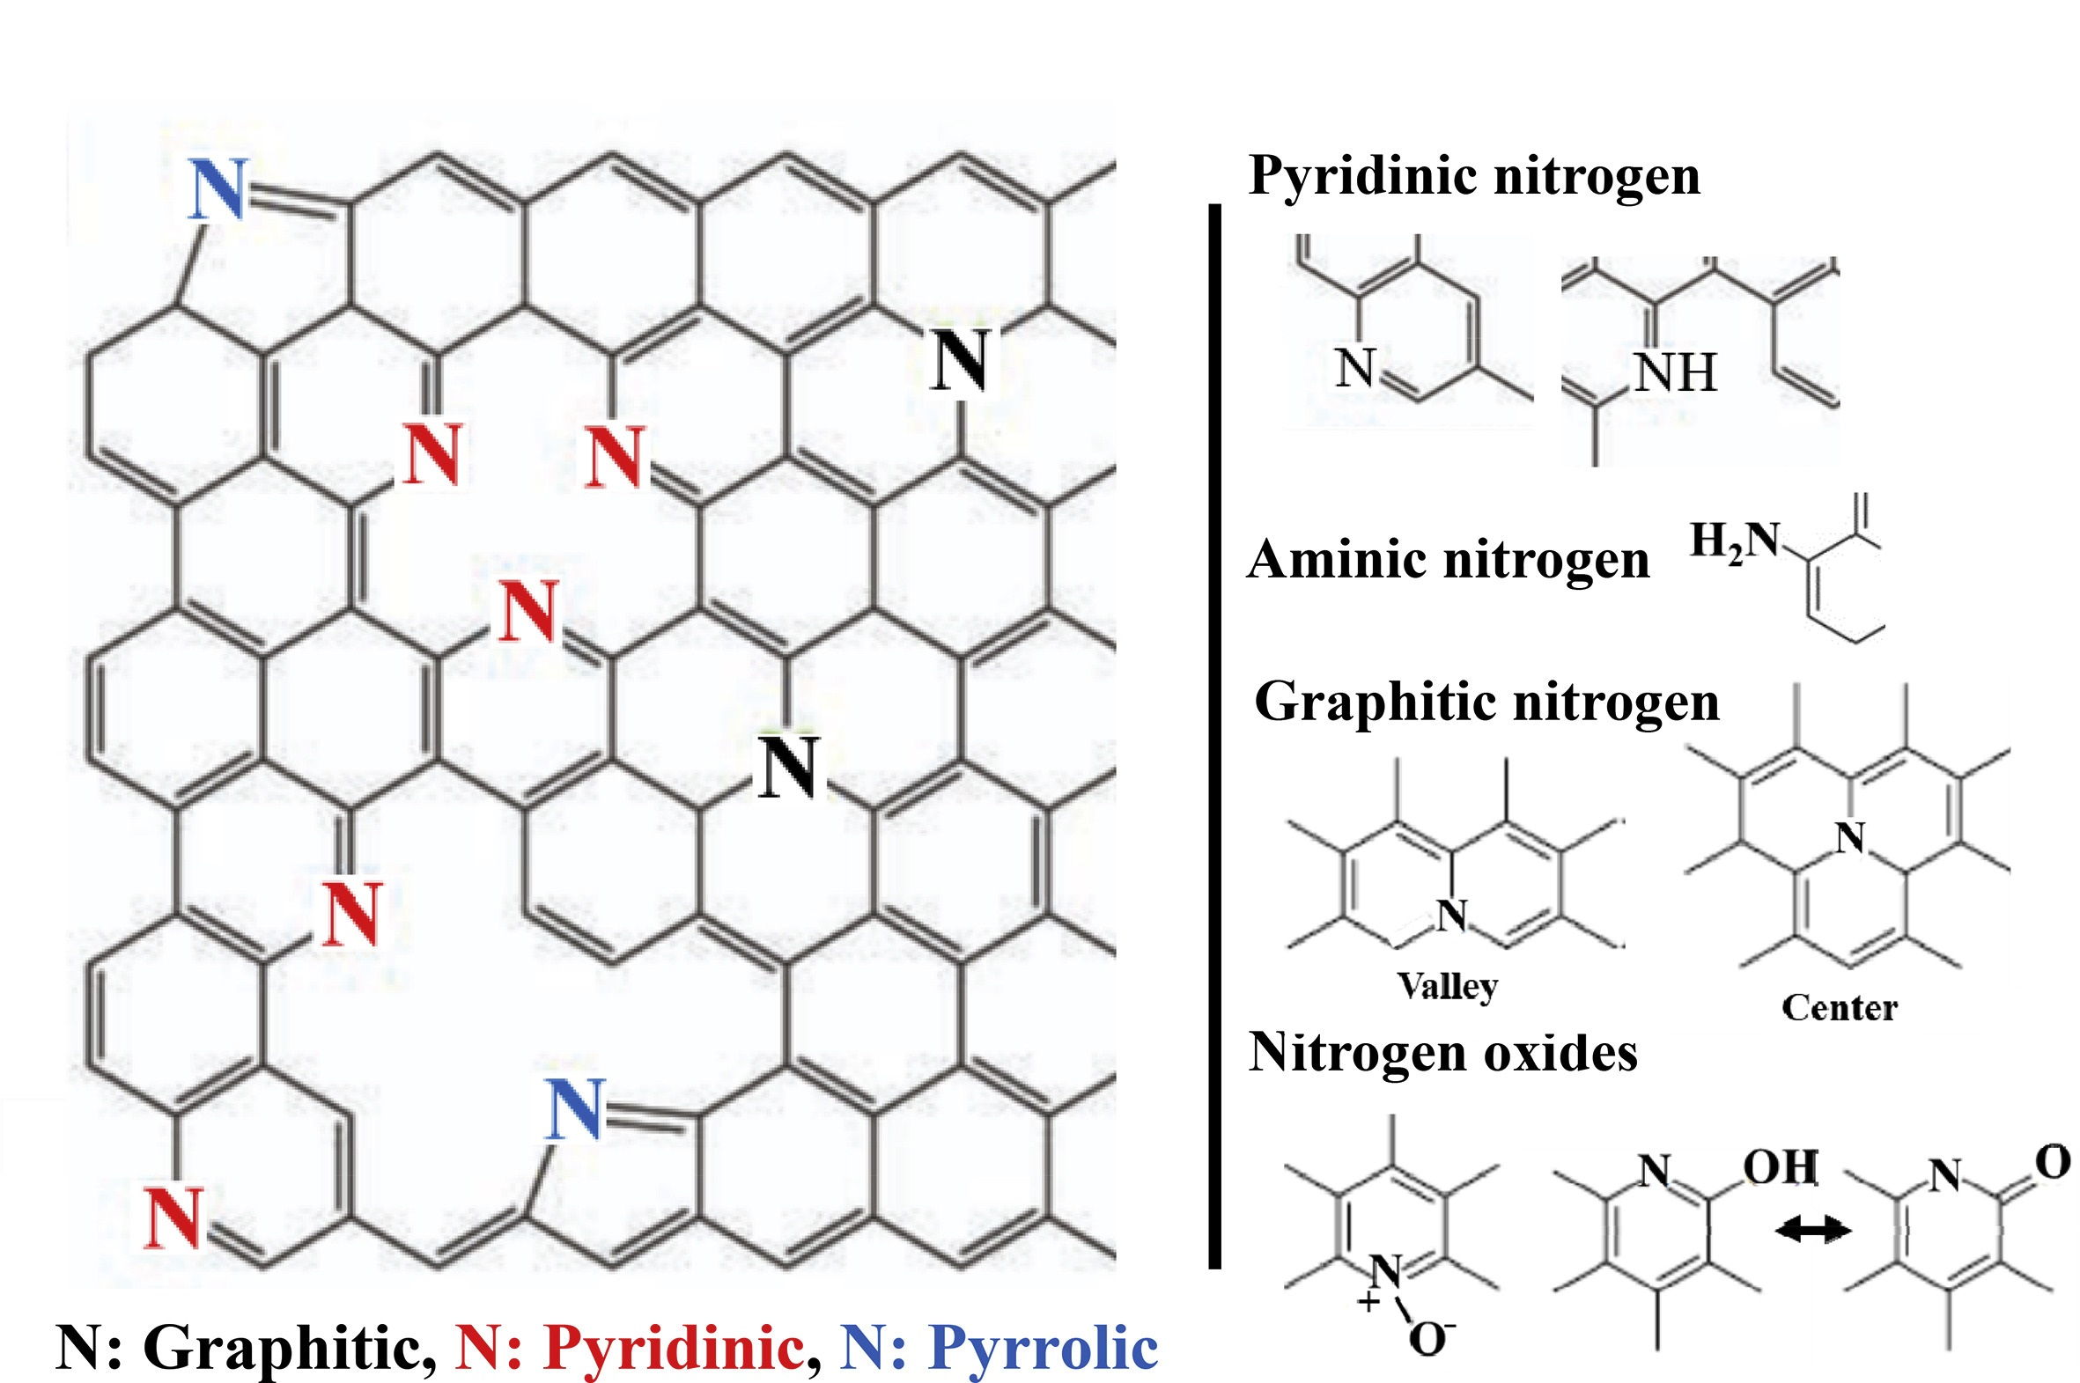

Fig.1. The possible nitrogen species in carbon materials. [Figure adopted from references 19, 22].

It is usually conceived that nitrogen doping in carbon materials can change the charge distribution in the backbone of the carbon skeleton in addition to creation of active sites with altered/.increased charge density.. In addition, the specific locations in five or six membered rings can function as active centers suitably charge modulated by the skeleton. Because of the various possibilities of the active centers, the identification of specific active site for a chosen function by carbon materials like for ORR and other reactions is still difficult. In fact, in literature no single specific site has been specifically identified for a chosen reaction on N-doped carbon materials due to the simultaneous presence of multiple nitrogen species, the inherent surface heterogeneity, the attendant alterations in the work function of the material at the interface, the morphology of the resultant material and other resultant changes in the structural parameters including the lattice parameter. In addition, thermal treatments can change pyrrolic N into pyridinic N and also ultimately in to the quaternary N [20,21] and hence it will be difficult to identify the exact active sites as these changes can take place in situ. The synthesis and characterization of nitrogen doped carbon materials need sophisticated probing techniques which could unambiguously identify the nature of the active sites and facilitate the elucidation of the mechanism of the reactions.

It is normally conceived that nitrogen doping in carbon materials alter mainly the electronic property of the material. This may be true and in most cases it can be so. However, the functional character of these nitrogen species in carbon skeleton and the consequent geometric factor cannot be ignored. There can be attendant strain in the carbon skeleton and this stress can also be another activated state for the resultant activity. It may be necessary to consider the system as a whole different from the simple skeleton of graphitic nature. There can be other changes other than simple electronic property change. This aspect requires further introspection. It is necessary at this time to examine if this material will find applications in strategic areas. The extent of nitrogen in these materials never exceeded a single digit percentage as revealed from the chemical analysis and the reasons may be due to stability considerations of the resulting material and also the alteration of the dimensionality of the material since low dimensional materials especially I or 2 D materials are preferred for electrode applications.

2. **Synthetic approaches for the preparation of N-containing carbon materials**

Essentially, two synthetic strategies are practiced to generate nitrogen doped carbon materials. The synthetic approach employed depends on what type of carbon materials are required. The two strategies commonly employed is using in situ precursor materials or post treatment of the carbon material obtained. The precursors with nitrogen and carbon atoms like acetonitrile, [23] melamine [24] and polyacrylonitrile [25] were mostly employed to synthesize N-doped carbon nanomaterials. For the posttreatment strategy, carbon nanomaterials were treated in the presence of various nitrogen sources, and the nitrogen atoms replaced certain carbon atoms [26,27]. Each of these strategies have their advantages and disadvantages. The *in-situ* doping method offers uniform distribution of nitrogen atoms with a well-defined structure, whereas the post-treatment strategy may change the structure of the carbon precursors, such as the texture and morphology. However, the in-situ doping method often requires high temperatures and complex processes, and the chemical reagents used may be poisonous. The yield and the rates of N-doped carbon materials produced have not been well considered in literature. In contrast to the post-treatment strategy with a surplus supply of nitrogen, in-situ doping is more effective because the synthesis of carbon nanomaterials and the N-doping takes place at the same time. Therefore, the in-situ approach shows relatively higher yield rates, which represent easy reactions which deserve more research. Though the synthetic procedures are broadly classified into two, the detailed methodology [28] can be further subdivided into some subsections as follows:

1. Carbonization of a nitrogen-containing precursor (such as pyridine, melamine, and polyaniline and others), this can be followed by chemical of physical activation.
2. Hydrothermal carbonization of nitrogen containing compounds like glucosamine, cyanuric acid.
3. Templating methodology using nitrogen-containing precursor followed by thermal treatment
4. Post-thermal treatments of a material synthesized previously with a nitrogen containing reactant either in gas or liquid phase.

Among these methods, precursor-based method is most often employed especially using polyaniline as the starting material [29]. The materials derived by this method showed remarkable catalyst supports and also exhibited considerable activity for OR reaction [11]. The main reason for this remarkable feature is due to the functionality that can be inherently present in this procedure [30].

A second methodology employed for N-doped carbon materials with high texture is based on chemical treatments through organic reactions at low temperatures [31,32]. In addition to the texture of the resultant material, the surface functionalities also are specific, and hence these materials are amenable for further changes in the functionalization. This can result in the extent of doping. In this connection, the exact limit of doping is yet to be ascertained. The establishment of the extent doping may pave the way for the synthesis of these materials.

The texture functionalization of pure carbon materials can be modified by suitable chemical treatments and this has been already discussed in detail [1,2]. Some general statements on the post-treatment method may be in order at this point. In addition to employing nitrogen-containing precursors, which results in functionalized nitrogen in a carbon matrix, other comparatively drastic physical treatment procedures like hydrothermal carbonization [33] annealing [34] plasma [35] or arc discharge [36] are also employed on a variety of carbon materials like activated carbons, carbon nanotubes (CNTs), graphene oxide (GO) and its reduced form, and other forms of carbon. In addition to the nitrogen containing precursors already mentioned others like ammonia [37], urea [38], melamine [39], cyanamide 40], dicyandiamide [41], polyaniline (PANI) and polypyrrole (PPy) [42] have also been used. It can be remarked that plasma and arc discharge methods have been less employed since the extent of the heteroatom (namely nitrogen) incorporation in carbon materials are generally less compared to the precursor methods.

Among the various methods considered like hydrothermal carbonization, annealing, plasma or arc discharge, the precursor method is mostly adopted due to various reasons like ease of the method, energy consideration, and also possible control of the extent of incorporation. However all these methods have their own limitations and hence the desirable levels of incorporation could not be reached due to harsh synthetic methods and also other thermodynamic limitations. As of now, the method employing the appropriate precursor appears to be mostly adopted due to various considerations including the energy requirements.

**3**. **The State of Nitrogen (both electronic and geometric) Atoms in N-doped Carbon Materials**

There are various techniques that can be employed to identify the state of nitrogen in carbon frame work. **The extent of nitrogen content can be determined by chemical analysis and other structural characterization techniques.** Among these, photoelectron spectroscopy and temperature programmed desorption have been extensively utilized and considered in this presentation. This does not mean that other methods are not important. In X-ray Photoelectron Spectroscopic technique (XPS) the value of the binding energy of 1s core level of nitrogen is in the energy range 398-404 eV. Typical wide scan spectrum of nitrogen substituted in carbon materials treated at two temperatures are given in Fig.2.



Fig.2. Nitrogen 1s core level XPS spectra for N-CNT samples treated at (a)NCNT-L;823K(b) NCNT-H;1023 K (N1 Pyridinic N; N2pyrrolitic N; N3 graphitic N; N4 pyridine-N-oxide and N5 chemisorbed nitrogen oxide) [Figure reproduced with permission from ref.43].

The assignments of the XPS peaks to various nitrogen species appear to follow the general principles of electron density around the atom. If the electron density around the atom considered was to increase, it will result in a decrease in binding energy of the core level due to electron-electron shielding and repulsion. The assignments given (N1 to N5) are the general species that can be expected by substitution of N in the carbon framework. However, there can be other types of nitrogen environments when nitrogen substituted carbon materials are prepared from precursor materials. This also shows that the carbon 1s spectrum of carbon species adjacent to the nitrogen substituted site needs careful examination. These aspects need attention in future research. Another possibility is that the other nitrogen species may not give emission signals very different from neutral atom and hence they may not be able to be identified through XPS. One has to resort to other analytical techniques which depend on the nature of the species and not the electronic environment alone.

It is also noticed from the spectra shown in Fig 2 that as a function of heat treatment temperature, the binding energy of the 1s core level of nitrogen changes to lower binding energy value showing the net charge density increases around the heteroatom. These changes can be due to charge density changes or environmental changes as a result of heat treatment. This aspect has not yet received full attention. If the temperature effect were to be sintering of the solid, then it should also reflect in the valence band spectrum of the solid.

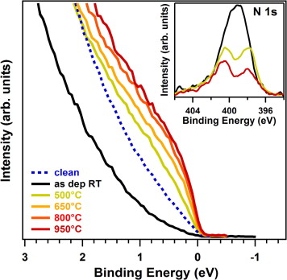

Fig.3.Valence band spectra near the Fermi energy level for pure, nitrogen functionalized (as dep RT) and annealed nitrogen functionalized N-CNTs. In the inset the nitrogen 1s core level XP spectra are also shown. [reproduced with permission from Ref.44].

The observation that the Fermi level shifts towards the less negative values shows that the density of states (DOS) is altered at the Fermi level and this shift is a function of the annealing temperature (see the variation of the spectrum at the Fermi level). What does this mean? The reductive behavior of these materials is enhanced and possibly accounts for the special place N-doped carbon materials occupy in electrochemical energy storage and also for its remarkable activity towards ORR. This aspect needs further analysis and deduction. Secondly the shift in the Fermi level can also alter the redox potential of the catalyst and these changes can have consequences in the electrochemical properties of the material especially when used as electrodes.

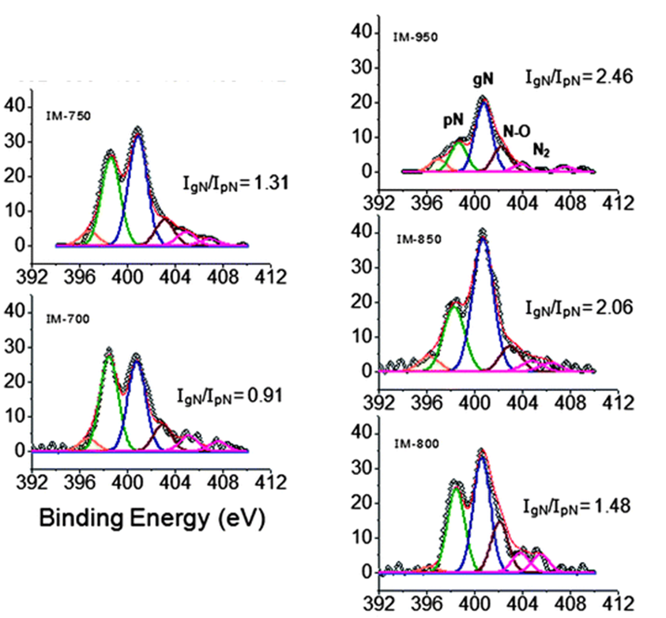

Fig.4. The N1s spectra of CNx samples grown at 700,750,800, 850 and 9000 C. It is seen that a variety of nitrogen species is present in these materials and also the relative amounts of graphitic to pyridinic N in these samples vary with temperature [Reproduced from Ref 45]

It is seen that there are more than the four nitrogen species that can be present on N-substituted carbon materials. This aspect has not yet been fully explored in literature.

Nitrogen incorporated carbon materials have been frequently as stated above analyzed by XPS to identify the electronic state of N-atom in the carbon matrix and various types of nitrogen species have been identified [46-51].

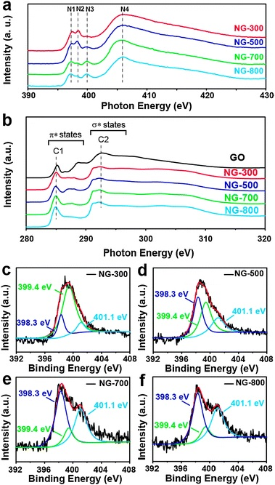

Fig. (5) N K-edge XANES spectra of NG-300, NG-500, NG-700 and NG-800. (b) O K-edge XANES spectra of GO, NG-300, NG-500, NG-700 and NG-800, respectively. (c), (d), (e) and (f) High resolution N 1s XPS of NG-300, NG-500, NG-700 and NG-900, respectively [reproduced from ref 52].

XANES spectra of nitrogen containing carbon materials treated at different temperatures are shown in Fig5 a and b. Four different types of nitrogen species and carbon in σ and π state of species have been indicated in these spectra. It is also seen the π states have specified values while the σ states energy values are not unique thus showing that different types of carbon species are also present in these systems. The analysis of XANE spectra have to be still carefully analyzed. The XP spectra of the nitrogen 1s level of the nitrogen substituted carbon materials treated at various temperatures are shown in Fig 5 c-f. At least three different types of nitrogen species can be discerned between binding energy values 398 to 402 and the proportion of these different types of nitrogen species varies with the temperature treatment. These results need further careful analysis.

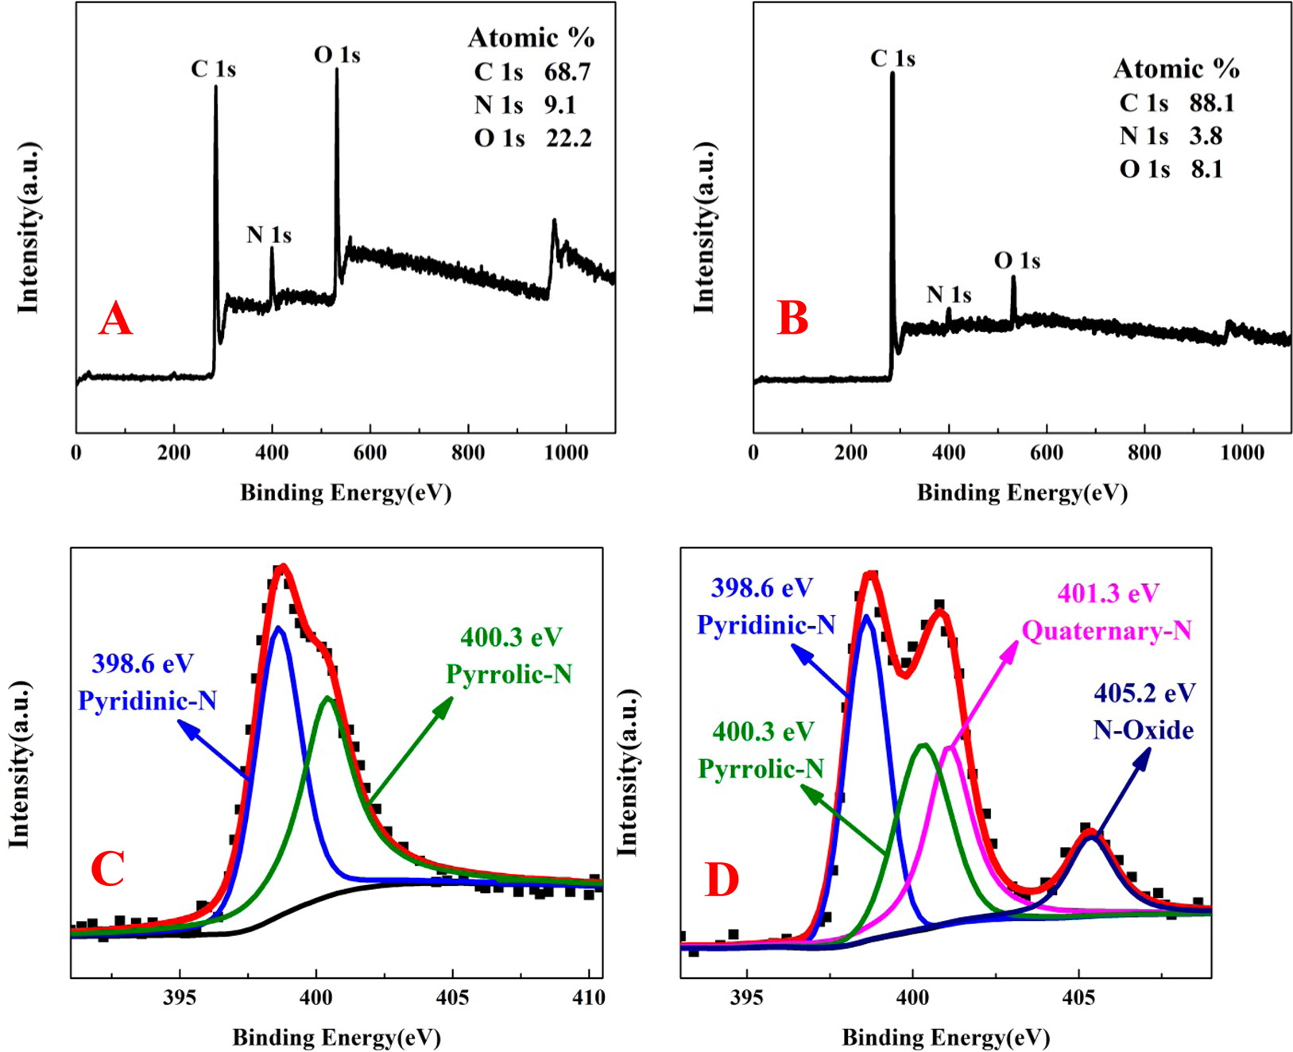

Fig 6 XP spectra of two nitrogen containing carbon materials prepared from polymer source and carbon source from EDA with different amounts of nitrogen source [From ref. 53].

Similarly, the XP spectrum (both wide and narrow scan) of nitrogen containing carbon materials prepared from polymer source are given in Fig.6 [53]. Depending on the extent of nitrogen, the species differ mostly pyridinic and pyrrole like and also in electronegative environment like near nitrogen being situated near oxygen containing species (N-O).

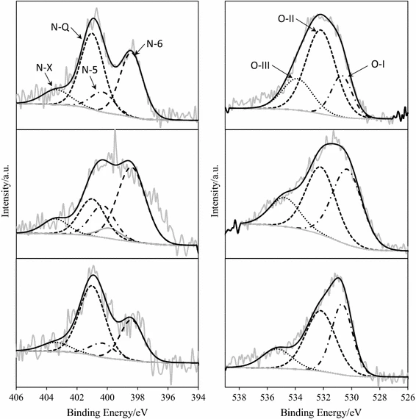

Fig.7. N1s and O 1s XP spectra of chitosan based Activated carbons [Reproduced from ref 54]

Chitosan based activated carbons with varying nitrogen contents (ref Fig.7) were obtained by the physical activation and these materials showed superior to that of the commercial activated carbons. The contribution to pseudo-capacitance was identified due to the presence of pyridinic and pyrrolic and quinine nitrogen groups. In addition to high capacity 134-147 F g-1, these materials contained quaternary nitrogen and also exhibited good stability.

4. **Energy Conversion and Energy Storage Applications**

One of the prominent applications of carbon materials is their use as electrode materials. Among the various possibilities, electrode materials for supercapacitor applications assume an important place. Electrochemical capacitors (EC) are considered complementary to batteries for energy storage mainly due to their high-power density, extremely long cycle life and more reliable safety features. ECs have been widely applied in portable electronics, power back-up devices and hybrid electric vehicles (HEVs) to provide the cranking power. An Electrical double layer capacitor (EDLC) generally composed of two electrodes made of activated carbon, which are soaked in a nonaqueous or aqueous electrolyte and separated by a porous membrane separator [55].

Nitrogen-doped carbons (NCs) have recently demonstrated to be promising to improve the capacitance via surface Faradaic reactions without sacrificing the high rate capability and long cycle life. The new NCs show good electronic conductivity, and they can be easily prepared at low cost. Nitrogen has been the most studied doped heteroatom (among B, P, S and N) for carbonaceous electrode materials over the past several years.

In the recent years there have been many review papers [56-65] focusing on different fields of carbon-based materials for energy storage, including supercapacitors, H2 storage, and catalysis, such as oxygen reduction reaction for fuel cells. For example, in 2010, Inagaki and coworkers [56] reviewed the development of carbon materials used for Electrical Double Layer capacitors (EDLC). These authors suggested that carbonization, ammoxidation and steam activation could be employed to prepare nitrogen doped carbons. They proposed two kinds of preparation methods, the first group was obtained by the carbonization of melamine foam or polyaniline, while the second group was prepared by carbonizing nitrogen containing polymers and organic compounds with various templates.

For applications in supercapacitors, nitrogen containing carbon materials are attractive because the nitrogen-enabled functionalities contribute to the pseudo-capacitance, enhance the conductivity of the materials, and increase the active surface area accessible to the electrolyte by improving the wettability of the electrodes. While nitrogen has been proven to play an important role in supercapacitors, the detailed mechanisms of how nitrogen affects the capacitive behavior are yet to be confirmed owing to at least two factors: (1) the types of nitrogen in NCs and their relative populations have yet to be controlled well by the synthesis routes, calcination temperature/time and the nitrogen precursors; (2) the effects of the four most predominant nitrogen functionalities (pyrrolic-, pyridinic-, quaternary-/graphitic-N and N-oxides with pyridine) on their contribution to the capacitive performances, such as pseudo-capacitance, specific capacitance as well as rate and cycle performance, in different electrolytes are complicated. This will result in in contradictory results from the studies of NCs for applications in supercapacitors.

Even though N-doped carbon materials (NCs) have been exploited for supercapacitor applications, still the exact role played by the doped nitrogen atoms to the exhibited properties especially the redox behavior at certain potential ranges and also the Coulombic efficiency have yet to be ascertained. The additional capacitive mechanism which accounts for the observed capacitance values with N-doped carbon materials has to be identified. There are a variety of synthetic strategies ranging from simple heat-treatment of carbons with nitrogen containing complexes to carbonization of nitrogen containing complexes under inert atmosphere or hydrothermal treatment have been reported in literature but the control of nitrogen content in the resulting material and also the variation of nitrogen content with different preparation conditions could not be precisely predicated. Another aspect regarding these materials is the changes in the values of surface area as a result of nitrogen incorporation in carbon matrix, though it is known that with high nitrogen content results in a low surface area. It is realized that there is still need for further investigations in the development of synthesis procedures so that the NCs can be prepared with high porosity keeping the high nitrogen content. Also, control of the nature of nitrogen in these materials should be achieved so that electronic and chemical properties can be tuned as well as a priori predicted. For supercapacitor applications, NC-based materials are attractive because the nitrogen-enabled functionalities contribute to the pseudo-capacitance, increase the conductivity of the materials, and increase the active surface areas accessible to the electrolyte by improving the wettability of the electrodes. While nitrogen substitution in carbon materials plays an important role in supercapacitor applications, however, the detailed mechanism of how nitrogen substitution affects the capacitive behavior is yet to identified. The effects of the dominant nitrogen functionalities like pyrrolic-, pyridinic-, quaternary-/graphitic-N and N-oxides with pyridine on their contribution to the capacitive values, such as pseudo-capacitance, specific capacitance as well as rate and cycle performance, in different electrolytes have yet to identified.

Another aspect on which the literature is not explicit is the extent of doping in carbon matrices. In the literature, any value between ~0.3 to 8.9 atomic per cent is reported either in the precursor based or after treatment procedures. These values are tabulated in reference [66]. The nitrogen bonding configuration of ammonia-grown nitrogen containing carbon materials investigated by XPS and most of the nitrogen has been identified as graphitic-N configuration [67-70], although there are reports of the nitrogen being in the pyridinic-N and pyrrolic-N configurations. There are three methods used to introduce nitrogen into a pristine graphene lattice: exposure to ammonia at elevated temperatures, bombardment with an ion-gun, and exposure to nitrogen containing plasma.

In nitrogen containing carbon materials, the actual role of different N-functional groups (pyridinic, pyrrolic, graphitic and extent crystallinity) and other characteristics like porosity, surface area, extent of graphitic nature and extent of crystallinity in supercapacitor applications has not been clearly demarked in spite of so many publications in this direction. The virtue of nitrogen-containing functional groups in electrolytes with different pH values, the redox behavior in certain potential ranges, and the coulombic efficiency in a two-electrode system still unclear.

The mechanisms of pseudo-capacitance in N-enriched carbons have yet to be confirmed, although initial studies indicate that the presence of nitrogen atoms on the edges of graphene sheets may play a crucial role [71-75]. Seredych et al. [76] suggested strong dependence of capacitance on the chemistry of surface groups as well as on the porosity of NCs in acidic electrolytes. Furthermore, correlations were found between the number of basic groups and the gravimetric capacitance, and between the normalized capacitance in micropores and the distribution of quaternary and pyridinic-N-oxide nitrogen species on the surface of the micropores, particularly at high current loads. At the same time, pyridinic and pyrrolic nitrogen groups (along with quinone oxygen groups) have the largest effect on capacitance [76]. However, ammonia treated low surface-area non-porous carbon materials prepared from melamine–mica composites demonstrate excellent cyclability and capacitance three times higher than the untreated composites. Materials oxidized prior to ammonia treatment, with higher nitrogen content, larger concentration of pyrrole-like nitrogen groups, showed improved pseudo-capacitance [77,78] Subsequently, other reports are available [78] on pseudocapacitive effects in the presence of pyrrole and/or pyridine species as detected at XPS binding energies in the range of 398.0–400.5 eV. These studies have been already referred to.

These studies led to the postulate that pseudo-capacitance in nitrogen containing carbons is due to negatively charged groups located at the edges of the carbons, like pyrrolic-N and pyridinic-N, while the positive charge on quaternary-N and pyridine-N-oxide does not have any effect on the pseudo-capacitance, but only helps in electron transport in carbon. However, this contention is still debatable as some other investigations suggest that the presence of quaternary-N could introduce some pseudo-capacitance by interacting with protons in acidic electrolyte, or by interacting with the anions in alkali electrolyte.

The electrochemical performance of Polypyridine (PNs) nanospheres, and carbon nanospheres (CNs) calcined at different temperatures, and microporous carbon nanospheres derived by the chemical activation of nitrogen containing carbon materials has been investigated. It was found that PNs and CNs with low surface areas displayed poor capacitive performance although they contained abundant N containing functional groups. The presence of nitrogen functionalities can get protonated in acidic electrolytes and this will give rise to reversible specific capacitance of around 200 F g-1. The mechanism regarding the redox reaction of N-containing functional groups was proposed, that is the redox reaction between pyridone-and pyridinic-N and the redox reaction between N–O and pyridinic-N are responsible. The dependence of capacitance on the porosity of NCs has been documented; however, the correlation between the number of basic groups and the capacitance has not been demonstrated. Though there are attempts to correlate the number of basic groups and the observed capacitance, these correlations have no predictive value. The treatment of carbon materials in KOH has been shown to affect the exposed surface area of the resultant material [2], however the nitrogen content in these materials changed depending on the nature of nitrogen species in these materials.

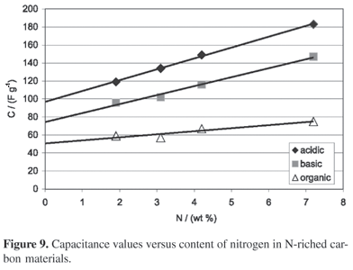

Fig.8 capacitance versus nitrogen content in nitrogen containing carbon materials {reproduced from ref 79]

It is proposed that comparable capacitance values can be expected in carbon materials containing nitrogen even if the surface area of the resulting material is moderate. Secondly the calcination temperature of these materials can also contribute to this phenomenon that is materials obtained at 973 K calcination will show better capacitance values as compared to the material calcined at 1173 K this observation can be due to two effects namely the change in surface area (this is due to accessibility to solvent) and also the nitrogen content. The presence of heteroatoms can additionally contribute due to pseudo-Faradaic effect.

Nitrogen (N)*–*doped carbon materials exhibit high electrocatalytic activity for the oxygen reduction reaction (ORR), which is essential for several renewable energy systems. The ORR active site is not yet explicitly identified. The ORR active site has been identified by using newly designed graphite (highly oriented pyrolitic graphite) model catalysts with well-defined *p* conjugation and well-controlled doping of N species. The ORR active site is created by pyridinic N. Carbon dioxide adsorption experiments indicated that pyridinic N also creates Lewis basic sites. The specific activities per pyridinic N in the HOPG model catalysts are comparable with those of N-doped graphene catalysts. Thus, the OR active sites in N-doped carbon materials are carbon atoms with Lewis basicity next to pyridinic N.

Nitrogen-containing polyaniline-based carbon nanospheres (C-PANI) with about 6.7% nitrogen content could achieve a capacitance of 360 Fg-1 at a current density of 1 Ag-1 in 6 M aqueous KOH electrolyte and also this material showed excellent rate capability [80].

By pyrolysis and activation of novolac beads with ammonia at different temperatures (750-9500C), highly porous carbon with nitrogen-doping was obtained. Three different electrolytes (aqueous, organic, and an ionic liquid) were tested. The specific capacitance in a symmetrical supercapacitor reached up to 173 F g-1 and was dependent on the porosity of the electrode material and the kind of electrolyte [81]. Nitrogen containing porous carbon fiber sheets (PNCFs) were prepared and systematically the process parameter variations have also been studied. The synergistic combination of the micro porous texture, high surface area, nitrogen content (~5.6%) leads to this material enhanced electrochemical performance inflexible supercapacitor [82]. Carbon frameworks obtained from cotton with 12.1% nitrogen content showed values of specific capacity of 308 and 200 F g-1 in KOH electrolyte at current densities of 0.1 and 10 A g-1 respectively [83].

Nitrogen-containing (~5.4%) activated carbons have been prepared from chitosan, obtained from bio-polysaccharide and were tested in two- and three-electrode supercapacitors using an aqueous electrolyte (1 M H 2SO4 ), and exhibited pseudo-capacitance compared to a commercial activated carbon with a negligible nitrogen content and similar micro-porosity [84].

Designing and developing new electrocatalysts to be able to surmount the energy crisis is the important task in these days. In this effort, supercapacitor technology possibly complimenting the lithium-ion batteries may be the possible route identified. Heteroatom doped graphitic structures prepared in different approaches mentioned have been proving to be materials with unique and suitable properties for supercapacitor applications. However, the efforts should be directed towards devising methods to control the doping levels with reproducibility especially nitrogen in carbon matrix appears to be necessary for capacitor applications [85]. In spite of these developments, the fundamental understanding of the energy storage mechanisms has yet to fully elucidated.

Heteroatom doped carbon (HDC) has been receiving attention as promising supercapacitor materials with long term stability and excellent resistance to cross over effects in oxygen reduction. The base treated samples showed good performance in capacitor as compared to other carbon materials [86]. A number of reviews on this topic has been published in recent times on this class of materials. [87-97]. In many of these publications, the essential points mentioned include: (1) the extent of heteroatom incorporation and how to control its inclusion in carbon matrix (2) The ORR activity is related to the nature of chemical bonding of nitrogen to the carbon matrix. (3) The diffusion and the nature of nitrogen (ionic?) species in carbon matrix and its role in electrochemical performance of the resulting material needs further investigation. (4) The impact of doping in carbon is still not yet fully clear, though doped carbon materials provide opportunities to meet the energy density gap between supercapacitor and battery. (5) Carbon nitride materials and their composites provide great opportunity as supercapacitor electrode materials for energy storage application.

Even though the factors like the type of nitrogen species, the extent of doping and the synthetic strategies employed are important in supercapacitor applications, the electrochemical energy storage is governed by the potential range of application and this becomes a variable parameter in nitrogen incorporated carbon materials [55] due to various types of nitrogen species.. The durability and stability under the electrochemical conditions make these materials suitable for supercapacitor applications.

5. Catalytic Applications of Nitrogen Containing Carbon Materials

Oxygen Reduction Reaction is one of the important reactions of many energy conversion devices. There have been many attempts in the past to find a suitable material which can promote ORR reaction effectively. In fact., one of the reasons why fuel cells have not become economically desirable energy conversion device is the absence of a suitable electrode material for OR reaction. Possibly the nitrogen containing carbon materials may fulfill this gap in that it will provide the necessary active sites and also provide necessary reduction potential for the oxygen reduction reaction. The oxygen reduction reaction (ORR) as stated above is a core reaction for many electrochemical energy technologies such as fuel cells and metal–air batteries. ORR catalysts have been so far limited to platinum, which exhibits the required high activity and durability. Over the last few decades, a variety of materials have been tested as non‐Pt catalysts, from metal–organic complex molecules to metal‐free catalysts. In particular, nitrogen‐doped graphitic carbon materials, including N‐doped graphene and N‐doped carbon nanotubes, have been extensively studied [98]. Still, the understanding of the reaction mechanism is not yet complete and there are conflicting views on the catalytic active sites. It should be recognized that carbon‐based catalysts are still under the development stage. In addition to the catalytic viewpoint, ORR is mass transport controlled. Any design scheme has to take into account this important aspect. In these days, the importance of pyridinic N as the active sites for ORR because of charge state. In addition, the requirement of hydrophobicity on the active sites can be met in these systems. The possibility of preparing nitrogen containing carbon substrate by bottom-up preparation provides an opportunity to invoke catalytic sites for activating and reduction the oxygen species. Another aspect that is mentioned above is how the frontier density of states in energy and symmetry-wise of nitrogen containing carbon materials is similar to that of Pt? The changes in Fermi level both energy and population have to be correlated with the observed activity. This statement is applicable for other electrochemical reactions like HER.

From the foregoing presentation, it is clear that nitrogen containing carbon materials will find applications as catalysts and catalyst supports.[99] The modified charge distributions of these materials induces novel active sites both electronically and geometrically and activation modes, which have enabled these materials as metal-free catalysts with enhanced catalytic oxidation activities. To understand the performance of N-substituted carbon materials quantum mechanical calculations have been made in literature. These studies reveal that nitrogen atoms in carbon matrix produce a higher positive charge density on the carbon atoms around substituted nitrogen atom to counterbalance the strong electron affinity of the nitrogen atom [100]. This charge delocalization changes the O2 adsorption on carbon surface from end-on type to side-on type, which effectively weakens the O–O bonding and oxygen reduction is thus facilitated.

It should be pointed out at this point that the importance of designing nitrogen containing carbon-based electrocatalysts for ORR with efficient active sites has been realized.[101]. For all these reactions like HER or ORR, usually the selection of materials is based on the so-called volcano relationships which is familiar in heterogeneous catalysis. The descriptor-based selection of materials [102] is usually emphasize the importance of frontier DOS which must have some similarity to noble metals like Pt. In fact, the predications of certain systems like molybdenum sulphide as suitable electrode materials were possible due to this type correlations.

6. Hydrogen storage applications

Similarly, in storage applications especially for hydrogen, though there are various attempts reported in literature, storage capacity namely 6.25 weight percent has not realized under ambient conditions though this is desirable.[103]. Heteroatom like N, P, and B substituted carbon materials have been proposed as alternative materials for this application and more research efforts are required in this direction to achieve the desired goal[104]. These applications are topics on their own.

There are various solid-state hydrogen storage materials like metals, intermetallics, porous solids, complex hydrides and carbon materials [105-110] but none of them could store hydrogen to the extent stipulated by Department of Energy (DOE) for economically competitive to the cost of other available forms of fuel for transportation purpose. For carbon materials, it has been postulated that these materials should have active centres for hydrogen dissociation and recent DFT calculations have shown that heteroatom sites in carbon materials will function as activation centres [104]. The essential conclusions of these studies can be summarized as follows:

1. The hydrogen storage capacity of carbon materials has a linear relationship with the total surface area and also directly related to the microporous structure of the carbon materials.
2. Thermal pretreatments and loading with metals have affected the storage capacity of carbon materials. The storage capacity possibly may reach the targeted value of 6.5 weight percentage if the process is carried out at cryogenic temperatures. The storage capacity measured by adsorption at room temperature still could not reach the specified value of 6.5 wt%.
3. Various theoretical studies based on molecular modeling or Density functional theory indicate that the configuration and defect structure of the carbon materials influence the hydrogen storage capacity. Nano-state of carbon materials like CNTs show different adsorption capacities. There are various claims on the extent of hydrogen storage in various kinds of carbon materials like SWCNT or MWCNTs but most of these results are not fully reproduced. There is a considerable disparity between the theoretical prediction and experimentally realized values.
4. Even though the theoretical studies predict that heteroatom substitution in carbon materials may alter the hydrogen storage capacity at room temperature, it is still not yet experimentally realized. There can be various reasons for this discrepancy in terms of the active site configuration and defect site density. It is necessary that more controlled synthesis techniques have to be adopted to make this material as a suitable hydrogen storage material. It may be necessary an appropriately suitable and accurate measurement procedures have to be developed. It is hoped that this may be realized in the near future.

7.. Conclusion

Materials Science has been undergoing many transformations in the form of new hybrid materials for solar cell applications, porous materials like MOF for many unconventional applications like CO2 ­ storage and conversion and so on but the energy storage and conversion in the form of electrochemical devices like batteries, super capacitors and fuel cells are attractive options. These devices mainly depend on materials which can withstand potential and also perform as efficient conductors with appropriate active sites the stability under application of potential and wide potential window and to perform under interface conditions are the requirements of the hour. Nitrogen incorporated carbon materials may fulfill this need. These materials may provide many desirable characteristics like altered conductivity, appropriate potential for carrying out the desired electrochemical oxidation and reduction reactions, the desirable hydrophilicity or altered hydrophobicity amenable for electrochemical interface, changed energy state of (HOMO or LUMO) the electronic state by the presence of nitrogen, altered extent of ionicity and hence these materials will become one of the alternative electrode materials for many of todays’ energy conversion devices.

**The aspects that are considered in this presentation include**

1. **Among the various substitutions in carbon matrix, the incorporation of nitrogen appears to occupy a unique place these substituted systems show altered electrical, structural and catalytic properties.**
2. **However, the exact nature of the substituted species is not yet clear though the available experimental evidences show that the nitrogen species will behave like typical heterocyclic systems like pyridinic or pyrrole type based on the binding energy values of the 1s photo-emission from the nitrogen atom. However, these identifications must also account for the observed altered activity. These aspects need further study.**
3. **The exact site of these nitrogen species in carbon matrix has to be clarified further.**
4. **The extent of incorporation of nitrogen has to be unequivocally established though various estimates are reported in literature. The upper value of the extent of incorporation needs to be evaluated.**
5. **There are other heteroatoms like Sulphur, Phosphorus and Boron which can be incorporated in carbon matrix. The relationship between the properties exhibited by these systems has to be established.**
6. **The nature of nitrogen species is usually identified by obtaining the binding energy value of photoemission of 1s electron of nitrogen. The credibility of this approach has to be ascertained.**

**There are a few other aspects, this presentation does not provide a conclusive answers and they are:**

1. **Nitrogen incorporated carbon materials is one or the or the only materials with the unique properties of promoting reactions like ORR, HER and hydrogen storage.**
2. **Apart from conventional techniques and XPS, this presentation does not provide alternate possibilities to identify the nature of nitrogen species in carbon matrix. This may be important to understand and exploit these materials for some of the vital applications mentioned.**
3. **The alterations in electronic property of the incorporated system is usually explained based on charge density distribution either localized or otherwise. The exact distribution of charge though can be identified by theoretical calculations, the extent of delocalization and its relationship with respect to the backbone of carbon matrix has to be evaluated.**

**References**

[1] Lozano-Castelló, D.; Lillo-Ródenas, M.A.; Cazorla-Amorós, D.; Linares-Solano, A. Preparation of activated carbons from Spanish anthracite: I. Activation by KOH. Carbon **2001**, 39, 741–749.

[2] B. Viswanathan, P. Indraneel, and T.K. Varadarajan, Development of Carbon Materials for Energy and Environmental Applications, Catalysis Surveys Asia, Vol. 13, 2009, pp. 164-183.

[3] Samanta, A.; Ohsaka, T.; Mondal, S.; Noh, S.H.; Raj, C.R.; Okajima, T. Emerging new generation electrocatalysts for the oxygen reduction reaction. J. Mater. Chem. A **2016**, 4, 11156–11178.

[4]. Kundu, S.; Nagaiah, T.C.; Xia,W.;Wang, Y.; Van Dommele, S.; Bitter, J.H .; Santa, M.; Grundmeier, G.; Bron, M.; Schuhmann, W.; et al. Electrocatalytic activity and stability of nitrogen-containing carbon nanotubes in the oxygen reduction reaction. J. Phys. Chem. C **2009**, 113, 14302–14310.

[4a] KS Lakhi, DH Park, K Al-Bahily, W Cha, B Viswanathan, JH Choy, A Vinu, [Mesoporous carbon nitrides: synthesis, functionalization, and applications](https://pubs.rsc.org/doi/c6cs00532b), Chemical Society Reviews, 46 (1) 72-101 (2017).

[5] Yuanfu Deng, Ye Xie, Kaixiang Zou and Xiulei Ji, Review on recent advances in nitrogen-doped carbons: preparations and applications in supercapacitors, J. Mater. Chem. A, 1144 (2016).

[6] Zhenhui Li, Ke Xu and Yusheng pan, Recent Development of supercapacitor Electrode based on carbon materials, Nanotech Rev.,8,35 (2019).

[7] Jingxia Wu, Zhiyong Pan, Ye Zhang, Bingjie Wang and Huisheng Peng, The recent progress of nitrogen-doped carbon nanomaterials for electrochemical batteries, J. Mater. Chem. A, 6,12932 (2018).

[8] Santosh K Singh, Kotaro Takeyasu and Junji Nakamura, Active sires and mechanism of oxygen reduction reaction electrocatalysis on nitrogen doped carbon materials, Adv.Mater., 31,1804397 (2019).

[9] Donghui Guo, Riku Shibuya, Chisato Akiba, Shunsuke Saji, Takahiro Kondo, Junji Nakamura, Active sites of nitrogen-doped carbon materials for oxygen reduction reaction clarified using model catalysts, Science,351,361 (2016).

[10] Donghun Kim, Niels P. Zussblatt, Hoon T. Chung, Shona M. Becwar, Piotr Zelenay,

and Bradley F. Chmelka, Highly Graphitic Mesoporous Fe,N-Doped Carbon Materials for

Oxygen Reduction Electrochemical Catalysts, ACS Appl.Mater.Interfaces, 10,25337 (2018).

[11]María José Mostazo-López, David Salinas-Torres, Ramiro Ruiz-Rosas, Emilia Morallón and Diego Cazorla-Amorós, Nitrogen-Doped Super porous Activated Carbons as Electrocatalysts for the Oxygen Reduction Reaction, Materials, 12, 1346 (2019).

[12] Qing Lv, Wenyan Si, Jianjiang He, Lei Sun, Chunfang Zhang, Ning Wang, Ze Yang, Xiaodong Li, Xin Wang, Weiqiao Deng, Yunze Long, Changshui Huang and Yuliang Li, Selectively nitrogen-doped carbon materials as superior metal-free catalysts for oxygen reduction, Nature communications, 9,3376(2018).

[13] [Chitturi Venkateswara Rao](https://www.scirp.org/(S(351jmbntvnsjt1aadkposzje))/journal/articles.aspx?searchCode=Chitturi+Venkateswara+Rao&searchField=authors&page=1&SKID=0), [Lingam Hima Kumar](https://www.scirp.org/(S(351jmbntvnsjt1aadkposzje))/journal/articles.aspx?searchCode=Lingam+Hima+Kumar&searchField=authors&page=1&SKID=0), [Balasubramanian Viswanathan](https://www.scirp.org/(S(351jmbntvnsjt1aadkposzje))/journal/articles.aspx?searchCode=Balasubramanian+Viswanathan&searchField=authors&page=1&SKID=0), [Iron and Nitrogen containing Carbon Catalysts with Enhanced Activity for Oxygen Reduction in Proton Exchange Membrane Fuel Cells](https://www.scirp.org/(S(351jmbntvnsjt1aadkposzje))/journal/paperinformation.aspx?paperid=4987), [**Open Journal of Physical Chemistry**](https://www.scirp.org/(S(351jmbntvnsjt1aadkposzje))/journal/AllArticle.aspx?JournalID=589), 1,May19,2011.

[14] B.Viswanathan and K R Krishnamurthy, Nitrogen Incorporation in TiO2: Does It Make a Visible Light Photo-Active Material?, International journal of photon energy, July 2012.

[15] J. P. Paraknowitsch, B. Wienert, Y. Zhang and A. Thomas, Intrinsically Sulfur- and Nitrogen-Co-doped Carbons from Thiazolium Salts, Chem.–Eur. J., 18, 15416–15423 (2012).

[16] Z. L. Li, G. L. Li, L. H. Jiang, J. L. Li, G. Q. Sun, C. G. Xia and F. W. Li, Ionic Liquids as Precursors for Efficient Mesoporous IronNitrogen-Doped Oxygen Reduction Electrocatalyst, Angew. Chem., Int. Ed., 2015, 54, 1494–1498.

# [17] S. G. Zhang, K. Dokko and M. Watanabe, Direct Synthesis of Nitrogen-Doped Carbon Materials from Protic Ionic Liquids and Protic Salts: Structural and Physicochemical Correlations between Precursor and Carbon, Chem. Mater., 26, 2915–2926 (2014).

[18] D. C. Guo, J. Mi, G. P. Hao, W. Dong, G. Xiong, W. C. Li and A. H. Lu, [Ionic liquid C 16 mimBF 4 assisted synthesis of poly (benzoxazine-co-resol)-based hierarchically porous carbons with superior performance in supercapacitors](javascript:void(0)) Energy Environ. Sci., 6, 652–659 (2013).

[19] Ni Zhou, Nan Wang, Zexing Wu and Liqui Li, Probing active sites on metal-free nitrogen doped carbons for oxygen electroreduction: A Review, catalysts, 8,509 (2018).

[20] C. Panomsuwan, N.Saito, and T.Ishizaki, Nitrogen-doped carbon nanoparticles derived from acrylonitrile plasma for electrochemical oxygen reduction, Phys.Chem.Chem.Phys., 17,6227 (2013).

[21] K.Stanczyk, R.Dziembaj, Z.Piwowarska, and S.Witkowski, Transformation of nitrogen structures in carbonization of model compounds determined by XPS, Carbon, 33,1383 (1995).

[22] Michio Inagaki, Masahiro Toyoda, Yaushi Soneda and Takahiro Mlrishita, Nitrogen doped carbon materials, Carbon, 132,104 (2018).

# [23] A. L. M. Reddy, A. Srivastava, S. R. Gowda, H. Gullapalli, M. Dubey and P. M. Ajayan, Synthesis of nitrogen-doped graphene films for lithium battery application, ACS Nano, 2010, 4, 6337–6342.

[24] X. C. Liu, S. M. Li, J. Mei, W. M. Lau, R. Mi, Y. C. Li, H. Liu and L. M. Liu, From melamine–resorcinol–formaldehyde to nitrogen-doped carbon xerogels with micro- and meso-pores for lithium batterie J. Mater. Chem. A, 2014, 2, 14429–14438.

[25] A. D. Roberts, S. X. Wang, X. Li and H. F. Zhang, Hierarchical porous nitrogen-rich carbon monoliths via ice-templating: high capacity and high-rate performance as lithium-ion battery anode materialsJ. Mater. Chem. A, 2014, 2, 17787–17796.

# [26] Z. S. Wu, W. Ren, L. Xu, F. Li and H. M. Cheng, Doped graphene sheets as anode materials with superhigh rate and large capacity for lithium ion batteries, ACS Nano, 2011, 5, 5463–5471.

# [27] J. L. Liu, C. K. Poh, D. Zhang, L. Lai, S. H. Lim, L. Wang, X. Liu, N. G. Sahoo, C. Li, Z. X. Shen and J. Y. Lin,Improved synthesis of graphene flakes from the multiple electrochemical exfoliation of graphite rod, Nano Energy, 2013, 2, 377–386.

[28] Deng, Y.; Xie, Y.; Zou, K.; Ji, X. Review on recent advances in nitrogen-doped carbons: Preparations and applications in supercapacitors. J. Mater. Chem. A 4, 1144–1173 (2015).

[29] Gabe, A.; Mostazo-López, M.J.; Salinas-Torres, D.; Morallón, E.; Cazorla-Amorós, D. Synthesis of Conducting Polymer/Carbon Material Composites and Their Application in Electrical Energy Storage. In Hybrid Polymer Composite Materials: Processing; Woodhead Publishing: Duxford, UK, 2017; pp. 173–209.

[30] Quílez-Bermejo, J.; Morallón, E.; Cazorla-Amorós, D. Oxygen-reduction catalysis of N-doped carbons prepared: Via heat treatment of polyaniline at over 1100 _C. Chem. Commun. **2018**, 54, 4441–4444.

[31] Quílez-Bermejo, J.; Morallón, E.; Cazorla-Amorós, D. Oxygen-reduction catalysis of N-doped carbons prepared: Via heat treatment of polyaniline at over 1100 _C. Chem. Commun. **2018**, 54, 4441–4444.

[32] Mostazo-López, M.J.; Ruiz-Rosas, R.; Morallón, E.; Cazorla-Amorós, D. Nitrogen doped super porous carbon prepared by a mild method. Enhancement of supercapacitor performance. Int. J. Hydrogen Energy **2016**, 41, 19691–19701.

[33] X. W. Wang, G. Z. Sun, P. Routh, D. H. Kim, W. Huang and P. Chen, Chem. Soc. Rev., 2014, 43, 7067–7098.

[34] D. Long, W. Li, L. Ling, J. Miyawaki, I. Mochida and S. H. Yoon, Langmuir, 2010, 26, 16096–16102.

[35] H. M. Jeong, J. W. Lee, W. H. Shin, Y. J. Choi, H. J. Shin, J. K. Kang and J. W. Choi, Nano Lett., 2011, 11, 2472–2477.

[36] L. S. Panchakarla, K. S. Subrahmanyam, S. K. Saha,A. Govindaraj, H. R. Krishnamurthy, U. V. Waghmare and C. N. R. Rao, Adv. Mater., 2009, 21, 4726–4730

[37] X. L. Li, H. L. Wang, J. T. Robinson, H. Sanchez, G. Diankov and H. J. Dai, J. Am. Chem. Soc., 2009, 131, 15939–15944.

[38] Z. Y. Lin, G. Waller, Y. Liu, M. L. Liu and C. P. Wong, Adv.Energy Mater., 2012, 2, 884–888.

[39] Z. H. Sheng, L. Shao, J. J. Chen, W. J. Bao, F. B. Wang and X. H. Xia, ACS Nano, 2011, 5, 4350–4358.

[40] S. C. Hou, X. Cai, H. W. Wu, X. Yu, M. Peng, K. Yan and D. C. Zou, Energy Environ. Sci., 2013, 6, 3356–3362.

[41] C. H. Choi, M. W. Chung, S. H. Park and S. I. Woo, RSC Adv., 2013, 3, 4246–4253.

[42] L. F. Lai, J. R. Potts, D. Zhan, L. Wang, C. K. Poh, C. H. Tang, H. Gong, Z. X. Shen, J. Y. Lin and R. S. Ruoff, Energy Environ. Sci., 2012, 5, 7936–7942.

[43] Mattia Scardamaglia and Carla Bittencourt, Metal free catalysts based on N-doped carbon nanomaterials: a photoelectron spectroscopy point of view, Beilstein Journal of Nanotechnology, 9,2015 (2018).

[44] M.Scardamaglia, C. Struzzi, F.J. Aparicio Reboilo, P. De Marco, P.R. Mudimela, J.F.Colomer, M.Amati, L.Gregoratti, L.Petaccia, R.Snyders, C.Bittencourt, Carabon, 83,118 (2015).

[45] Kaushik Ghosh, Mukul Kumar, Takashiro Maruyama and Yoshinori Ando, Controllable growth of highly N-doped carbon nanotubes from Imidazole: a structural, spectroscopic and field emission study, J Material Chem., 20,4128 (2010).

[46] Z. Li, L. Zhang, B. S. Amirkhiz, X. H. Tan, Z. W. Xu, H. L. Wang, B. C. Olsen, C. M. B. Holt and D. Mitlin, Adv.Energy Mater., 2012, 2, 431–437.

[47] M. Zhou, F. Pu, Z. Wang and S. Y. Guan, Carbon, 2014, 68,185

[48] W. Kim, M. Y. Kang, J. B. Joo, N. D. Kim, I. K. Song, P. Kim, J. R. Yoon and J. Yi, J. Power Sources, 2010, 195, 2125–2129.

[49] Y. J. Kim, I. Y. Jang, K. C. Park, Y. C. Jung, T. Oka, S. Iinou,Y. Komori, T. Kozutsumi, T. Hashiba, Y. A. Kim and M. Endo, Electro-chim. Acta, 2010, 55, 5624–5

[50] D.W.Wang, F. Li, L. C. Yin, X. Lu, Z. G. Chen, I. R. Gentle, G.Q. LuandH.M. Cheng, Chem.–Eur. J., 2012, 18, 5345–5351.

[51] D. Hulicova-Jurcakova, E. Fiset, G. Q. M. Lu and T. J. Bandosz, ChemSusChem, 2012, 5, 2188–2199.

[52] Le-Sheng Zhang, Xian-Qing Liang, Wei-Guo Song and Zi-Yu Wu, Identification of the nitrogen species on N-doped graphene layers and Pt/NG composite catalyst for direct methanol fuel cell, *Phys. Chem. Chem. Phys.,* 2010, **12**, 12055–12059.

[53] Nilantha P.Wikramaratne, Jiantie Xu, Min Wang, Lin Zhu, Liming Da and Mietek Jaromiec, Nitrogen enriched porous carbon spheres: Attractive materials for supercapacitor electrodes and CO2 adsorption, Chemistry of Materials, 26,2820 (2014).

[54] Agata Sliwak, Noel Diez, Ewa Miniach and Grazyna Gryglewicz, Nitrogen containing chitosan based carbon as electrode material for high performance supercapacitors, J Appl.Electrochem., 46,667 (2016).

# [55] M.Aulice Scibioh and B.Viswanathan, Materials for Supercapacitor Applications, Elsevier 2020.

# [56] M. Inagaki, H. Konno and O. Tanaike, J. Power Sources, 2010, 195, 7880–7903.

[57] Y. Zhai, Y. Dou, D. Y. Zhao, P. F. Fulvio, R. T. Mayes and S. Dai, Adv. Mater., 2011, 23, 4828–4850.

[58] H. J. Choi, S. M. Jung, J. M. Seo, D. W. Chang, L. M. Dai and J. B. Baek, Nano Energy, 2012, 1, 534–551.

[59] L. Hao, X. L. Li and L. J. Zhi, Adv. Mater., 2013, 25, 3899– 3904.

[60] M. Sevilla and R. Mokaya, Energy Environ. Sci., 2014, 7, 1250–1280.

[61] K. N. Wood, R. O'Hayre and S. Pylypenko, Energy Environ. Sci., 2014, 7, 1212–1249.

[62] N. Mahmood, C. Z. Zhang, H. Yin and Y. L. Hou, J. Mater. Chem. A, 2014, 2, 15–32.

[63] H. B. Wang, T. Maiyalagan and X. Wang, ACS Catal., 2012, 2, 781–794.

[64] W. Z. Shen and W. B. Fan, J. Mater. Chem. A, 2013, 1, 999– 1013.

[65] G. C. Marjanovi´c, I. Paˇsti and S. Mentus, Prog. Mater. Sci., 2015, 69, 61–182.

,

[66] Tomotaroh Granzier-Nakajima, Kazunori Fujisawa, Vivek Anil, Mauricio Terrones and Yin-Ting Yeh, Controlling Nitrogen Doping in Graphene with Atomic Precision: Synthesis and Characterization, Nanomaterials, 2019, 9, 425, (2019).

[67] Wei, D.; Liu, Y.; Wang, Y.; Zhang, H.; Huang, L.; Yu, G. Synthesis of N-Doped Graphene by Chemical Vapor Deposition and Its Electrical Properties. Nano Lett. **2009**, 9, 1752–1758.

[68] Zhao, L.; He, R.; Rim, K.T.; Schiros, T.; Kim, K.S.; Zhou, H.; Gutierrez, C.; Chockalingam, S.P.; Arguello, C.J.; Palova, L.; et al. Visualizing Individual Nitrogen Dopants in Monolayer Graphene. Science **2011**, 333, 999–1003.

[69] Sui, Y.; Zhu, B.; Zhang, H.; Shu, H.; Chen, Z.; Zhang, Y.; Zhang, Y.; Wang, B.; Tang, C.; Xie, X.; et al. Temperature-dependent nitrogen configuration of N-doped graphene by chemical vapor deposition. Carbon **2015**, 81, 814–820.

[70] Schiros, T.; Nordlund, D.; Pálová, L.; Prezzi, D.; Zhao, L.; Kim, K.S.; Wurstbauer, U.; Gutiérrez, C.; Delongchamp, D.; Jaye, C.; et al. Connecting Dopant Bond Type with Electronic Structure in N-Doped Graphene. Nano Lett. **2012**, 12, 4025–4031.

[71] Z. Li, L. Zhang, B. S. Amirkhiz, X. H. Tan, Z. W. Xu, H. L. Wang, B. C. Olsen, C. M. B. Holt and D. Mitlin, Adv. Energy Mater., 2012, 2, 431–437.

[72] M. Zhou, F. Pu, Z. Wang and S. Y. Guan, Carbon, 2014, 68, 185–194.

[73] W. Kim, M. Y. Kang, J. B. Joo, N. D. Kim, I. K. Song, P. Kim, J. R. Yoon and J. Yi, J. Power Sources, 2010, 195, 2125–2129.

[74] Y. J. Kim, I. Y. Jang, K. C. Park, Y. C. Jung, T. Oka, S. Iinou, Y. Komori, T. Kozutsumi, T. Hashiba, Y. A. Kim and M. Endo, Electrochim. Acta, 2010, 55, 5624–5628

[75] D. W. Wang, F. Li, L. C. Yin, X. Lu, Z. G. Chen, I. R. Gentle, G. Q. Lu and H. M. Cheng, Chem.–Eur. J., 2012, 18, 5345–5351.

[76] M. Seredych, D. Hulicova-Jurcakova, G. Q. Lu and T. J. Bandosz, Carbon, 2008, 46, 1475–1488.

[77] D. Hulicova-Jurcakova, M. Kodama, S. Shiraishi, H. Hatori, Z. H. Zhu and G. Q. Lu, Adv. Funct. Mater., 2009, 19, 1800– 1809.

[78] ] D. Hulicova-Jurcakova, E. Fiset, G. Q. M. Lu and T. J. Bandosz, ChemSusChem, 2012, 5, 2188–2199.

[79] Elzbieta Frakowiak, supercapacitors based on carbon materials and ionic liquids, J.Braz.chem.soc., 17,1074 (2006).

[80] Hui Peng, Guofu Ma, Kanjun Sun, Jingjing Mu, Xiaozhong Zhou and Ziqiang Lei, A novel fabrication of nitrogen-containing carbon nanospheres with high rate capability as electrode materials for supercapacitors, RSC Adv., 2015, 5, 12034

.

[81] Benjamin Krüner Anna Schreiber Aura Tolosa, Antje Quade, Felix Badaczewski,

Torben Pfaff, Bernd M. Smarsly, Volker Presser, Nitrogen-containing novolac-derived carbon beads as electrode material for supercapacitors, Carbon, 132, 220-231 (2018).

[82] Da He1, Ling Wu, Yucen Yao, Jiang Zhang, Zheng-Hong Huang, Ming-Xi Wang, A Facile Route to High Nitrogen-containing Porous Carbon Fiber Sheets from Biomass-Flax for High-performance Flexible Supercapacitors, <https://doi.org/10.1016/j.apsusc.2019.145108>, Applied surface Science (2019).

[83] Li-Zhen Fan1, Tian-Tian Chen1, Wei-Li Song1, Xiaogang Li1 & Shichao Zhang, Scientific Reports, DOI:10.1038/Srep15388.

[84] Agata S ´ liwak, Noel Dı´ez, Ewa Miniach and Gra_zyna Gryglewicz, Nitrogen-containing chitosan-based carbon as an electrode material for high-performance supercapacitors, J Appl Electrochem (2016) 46:667–677.

[85] Nanjundan Ashok Kumar and Jong-Beom Baek, Doped graphene supercapacitors, Nanotechnology, 25 (2015) DOI10.1088/0957-4484/26/49/492001.

86] Hui Zhu, Jiao Yin, Xiaolei Wang, Hongyu Wang and Xiurong Yang, Microorganism-derived Heteroatom-doped carbon materials for oxygen reduction and supercapacitors, Advanced function materials, 23,1305 (2013).

87] Mostafa Ghaemmaghami and Rahim Mohammadi, carbon nitride as a new way to facilitate the next generation of carbon-based supercapacitors, Sustaine energy and Fuels, 3,2176 (2019).

88] Noha A.Elessawy, J.El Nady, W.Wazeer and A.B.Kashout, Development of high performance supercapacitor based on a novel controllable green synthesis for 3D nitrogen doped graphene, Scientific Reports, 9:1129 (2019).

[89] Zhenhui Li, Ke Xu and Yusheng pan, Recent development of supercapacitor electrod based on carbon materials, Nanotechnology Reviews, 8:35 (2019).

[90] Nilantha P Wickramaratne, Jiantie Yu, Min Wang, Lin Zhu, Liming Dai and Mietek Jaroniec, Nitrogen enriched porous carbon spheres: attractive materials for supercapacitor electodes and CO2 adsorption, Chemistry of Materials, 26,2820 (2014).

[91] Hui Ynag, Shewen Ye, Jiaming Zhou and Tongxiang Liang, Biomass derived porous carbon materials for supercapacitor, Frontiers in chemistry, 7,274 92019).

[92] vasile V.N. Obreja, [Supercapacitors specialities - Materials review](https://aip.scitation.org/doi/abs/10.1063/1.4878482), [AIP Conference Proceedings](https://aip.scitation.org/journal/apc) **1597**, 98 (2014); <https://doi.org/10.1063/1.4878482>

[93] G. Yu, X. Xie, L. Pan, Z. Bao and Y. Cui, Nano Energy 2, 213–234 (2013).

[94] S. Bose, T. Kuila, A.K. Mishra, R. Rajasekar, N. H. Kim and J. H. Lee, Journal of Materials Chemistry 22, 767–784 (2012). 119

[95] A. Ghosh and Y.H. Lee, ChemSusChem, 480–499 (2012).

[96] G. Wang, L. Zhang and J. Zhang, Chemical Society Reviews 41, 797–828 (2012).

[97] H. Jiang, P. S. Lee and C. Li, Energy & Environmental Science 6, 41–53 (2013)

# [98] Santosh J Singh, Kotaro Takeyasu and Nakamura, Active Sites and Mechanism of Oxygen Reduction Reaction Electrocatalysis on Nitrogen‐Doped Carbon Materials, Advanced Materials, 31, 1804297 (2018).

# [99] Li, M., Xu, F., Li, H., & Wang, Y. (2016). *Nitrogen-doped porous carbon materials: promising catalysts or catalyst supports for heterogeneous hydrogenation and oxidation. Catalysis Science & Technology, 6(11), 3670–3693.* doi:10.1039/c6cy00544f.

# [100]<https://www.sciencedirect.com/topics/materials-science/nitrogen-doped-carbon-material>.

* [101] Qing Ly, Wenyan Si, Jianjiang He, Lei Sun, Chunfang Zhang, Ning Wang, Ze Yang, Xiaosong Li, Xin Wang, Weigiao Deng, Yunze Long, Changshu Huang and Yuliang Li, Selectively nitrogen-doped carbon materials as superior metal-free catalysts for oxygen reduction, *Nat Commun* **9,**3376 (2018). <https://doi.org/10.1038/s41467-018-05878-y>

# [102] Sanjin J.Gutic, Ana S.Dobrota, Edvin Fako, NataliaV.Skorodumova, Nuria Lopez Igor A Pasti, Hydrogen Evolution Reaction-From Single Crystal to Single Atom Catalysts, Catalysts 2020, 10(3), 290; <https://doi.org/10.3390/catal10030290>

[103] M. Sankaran and B. Viswanathan, The role of heteroatoms in carbon nanotubes for hydrogen storage, Carbon, 14(13)2816-2621 (2005).

[104] M Sankaran, B Viswanathan, SS Murthy, [Boron substituted carbon nanotubes—How appropriate are they for hydrogen storage?](javascript:void(0)), International journal of hydrogen energy 33 (1), 393-403 (2008)

[105] P Selvam, B Viswanathan, CS Swamy, V Srinivasan, M[agnesium and magnesium alloy hydrides](https://scholar.google.co.in/scholar?oi=bibs&cluster=13735232610682472100&btnI=1&hl=en), International Journal of Hydrogen energy, 11,169-192 (1986).

[106] M Sankaran, B Viswanathan, The role of heteroatoms in carbon  [nanotubes for hydrogen storage](javascript:void(0)), Carbon , 44, 2816-2821 (2006).

[107] M Sankaran, B Viswanathan, [Hydrogen storage in boron substituted carbon nanotubes](javascript:void(0)). Carbon 45 (8), 1628-1635 (2007)

[108] M Sankaran, B Viswanathan, SS Murthy, [Boron substituted carbon nanotubes—How appropriate are they for hydrogen storage?](javascript:void(0)), International journal of hydrogen energy 33 (1), 393-403 (2008)

[109] Arjunan Ariharan, Balasubramanian Viswanathan, [Nitrogen Doped Graphene as Potential Material for Hydrogen Storage](javascript:void(0)), Graphene, 6, 41-60 (2017).

Hydrogen storage in carbon materials—A review

[110] Man Mohan, Vinod Kumar Sharma, E.Anil Kumar and V.Gayathri, Hydrogen storage in carbon materials – A review, Energy Storage (Wiley) 1-26 (2019).