CHAPTER - 7

Photo Electron Spectroscopy

Contents

- Introduction
1.1 Advantages and limitations of electrons for surface spectroscopy
1.2 UHV requirements
1.3 Basic principle and instrumentation
1.4 XPS spectra and description
1.4.1 Surface composition of the reference compounds
1.4.2 Resolution of the spectrometer
1.4.3 Photoelectron spectra and interpretation

2. Factors complicating XPS spectra
  - Spin orbit splitting
  - Multiplet splitting
  - Ghost peaks
  - Shake up and shake off satellites
  - Asymmetric metal and non metal core levels
  - Charging and sample damage
  - Surface plasmon loss peaks

3. Important features of the X-ray photo electron spectroscopy
3.1 Chemical shifts
3.2 Small area resolution
3.3 Depth profile
3.4 Imaging XPS
3.5 Angular effects
3.6 Electron kinetic energy variation effects
3.7 Pass energy variation effect

4. XPS in catalysis
4.1 Applications of XPS for the study of the catalysts
4.1.1 XPS analysis of supports and catalysts
4.1.2 Dispersion in supported metal catalysts
4.1.3 ESCA intensity ratio as a probe of catalyst structure
4.1.4 Effect of preparation methods
4.1.5 Correlation between the atomic ratios and the activities
4.1.6 Effect of promoter
4.1.7 Distribution of the various oxidation states of the active component
- Supported catalyst systems
- Transition metal ions in oxides
4.1.8 Electronic structure of the active species
4.1.9 Synergetic enhancement of activity by promoter and support
4.1.10 Metal support interaction
4.1.11 Surface growth of the active metal
4.1.12 Acidity of the catalysts
4.1.13 Cation distribution in spinels
4.1.14 Deactivation of the catalysts
4.1.15 Effect of pre-treatment of catalysts

4.1.16 Surface oxidation
4.1.17 Study of adsorption phenomena
4.1.18 Temperature effects in solid state materials

5. Ultra violet photo electron spectroscopy
5.1 Introduction and examples
5.2 Effect of He I and He II radiation
5.3 Effect of time on UP spectrum
5.4 Comparison of XPS and UPS
5.5 Angle resolved UPS with example

6. Perceptions

7. References

1. INTRODUCTION
Photo emission from solids is one of the methods that can be advantageously used for the characterization of the solid substrates especially catalysts and their surfaces. The phenomenon of photo emission is one of the direct proofs of the Einstein’s postulate. Three parallel endeavours led to the development of photo emission as a technique for characterization of solid state materials. They are: (i) Siegbahn and his group developed improved energy resolution of the electron spectrometers and combined it with X-rays [1-4]; (ii) Turner and his coworkers applied photoelectric effect to gases and by using ultra violet line from helium source; they could resolve vibrational fine structure of electronic levels [5-8]; (iii) Spicer measured photoelectron spectra from solid irradiated with UV light but the LiF window used cut off all the photons with energies greater than 11.6 eV and hence he could only get a small part of the valence band [9-13]. Eastman and Cashion extended the energy range of about 40 eV by differential pumping and windowless UV sources [14-18]. The availability of synchrotron sources has extended the photon energy range further such that all energies between the ultra violet and X-ray regime are available. The mean free path of electrons decides the depth to which the material can be probed. The mean free path (λ) of electrons in elemental solids depends on the kinetic energy of electrons in the range 15 – 1000 eV and the mean free path for this range is ∼ 0.5 nm and this is an ideal situation for surface sensitivity.

The zest to understand the surface chemistry such as surface chemical bonding and catalysis, made one to probe the types of atoms present on the surfaces, the phenomenon of adsorption, adsorption sites on the surfaces, adsorbed species and their bond strengths and the surface reactivity. All these properties can be probed by surface spectroscopic techniques. For the past 20 years, this type of spectroscopy has emerged as a key tool in surface analysis, mainly for:
1. Quantitative analysis
2. Information on the chemical nature and state of the detected elements
Electron spectroscopic studies have profound importance in the field of catalysis as it gives a thorough investigation of the electronic states of the elements concerned in any compound in any form under vacuum.

  - Advantages and Limitations of Electrons for Surface Spectroscopy

The main advantages of surface spectroscopy are:
1) The escape depth of electrons is only a few angstroms. Electrons are therefore suited to
probe electronic states in the surface region of a sample (e.g., surface states)
2) Electrons are easily focused and their energy is easily tunable by electric fields.
3) Electrons are easy to detect and to count.
4) Using electrostatic fields it is easy to analyze the energy and the angle of an electron (thus
determining the momentum). These instruments can be built small and handy, so that it can
easily be moved (e.g., in angle resolved studies).

5) Electrons vanish after they have been detected. This is an appreciable advantage compared
to ions or atoms, which are also used in surface physics.
Working with electrons involves some disadvantages also. They are:
- Ultra high vacuum is necessary for these experiments.
- The small escape depth of the electrons sometimes makes it difficult to distinguish
between surface and bulk properties of the sample.
A photon impinging on the sample liberates an electron via the photoelectric effect and this electron escapes into vacuum. The energy of the incoming photon can be in the ultraviolet regime (5 to 40 eV, UPS), in the soft X-ray regime (100 to 1000 eV, SXPS) or in the hard X-ray regime (> 1000 eV, XPS). Photoelectron spectroscopy utilizes photo-ionization and energy-dispersive analysis of the emitted photoelectrons to study the composition and electronic state of the surface region of a sample. In general, XPS is used for the analysis of the surfaces of the solids whereas UPS generally pertains to the gaseous samples.

1.2 UHV Requirement for Surface Spectroscopic Studies

When one considers solid surfaces with atomic description (not polycrystalline and pressed pellets), they need to be cut carefully to expose a particular crystal plane and maintain atomically clean during the experiment (20 - 100 minutes). The crystal surface gets contaminated due to the bombardment of reactive gas molecules. Therefore the crystals have to be kept under ultra high vacuum during experimental surface analysis. Due to the availability of vacuum technology, it is now possible to create and maintain routinely various degrees of vacuum. It can be classified as
Rough (low vacuum) : 1-10⁻³ Torr (remove adsorbed gases from the sample)
Medium vacuum : 10⁻³ – 10⁻⁵ Torr (eliminate adsorption of contaminants on the sample)
High vacuum : 10⁻⁶ – 10⁻⁸ Torr (prevent arching and high voltage breakdown)
Ultra high Vacuum : < 10⁻⁹ Torr (increase the mean free path for the electrons, ions and
photons)
UHV is also required to conduct low energy electron and ion based experiments without undue interference from gas phase scattering. From Kinetic theory of gases, the rate of surface bombardment by molecules or collision number (Z) is given by
Z = P / (2 × π × m × k × T) ^{1/2}
where P = ambient pressure in Pascal, m = molecular mass in Kg, T = absolute temperature (K), and k = Boltzman constant. Assuming the sticking probability as 1, one can estimate the value of Z for typical gaseous contaminant CO, at 300 K and 10⁻⁶ Torr as 3.82 ×10¹⁴ molecules per seconds per cm².
Typical atomic density of surfaces is of the order of 10¹⁵ cm⁻². Therefore the contamination rate can be calculated as 0.381 monolayers s⁻¹ and the time required to form one monolayer at 10⁻⁶ Torr is 2.6 s. At P =10⁻¹⁰ Torr, the formation of one monolayer takes several hours and reliable surface science experiments can be performed within this time.
Normally the unit for UHV exposure is the Langmuir (L), where 1 L = 10⁻⁶ Torr s⁻¹.
Sample surfaces in vacuum chamber can be cleaned by argon ion bombardment which is essentially the physical removal of surface material in layers. The energy of the argon ions used is in the range 100-3000 eV. After bombarding the surface with high energy ions, the surface needs to be annealed at temperatures close to the melting point to remove the surface defects [19].
Surface science experiments are carried out in high vacuum environment not only to keep the surfaces clean, but also to have the surface spectroscopic techniques operated as well. Surface spectroscopic techniques involve ions, atoms, or electrons whose mean free path in the vacuum environment must be greater than the dimensions of the apparatus so that these particles may travel to the surface and then to the detector without undergoing any interaction with residual gas phase molecules. In order to have reliable clean surfaces, the background gas pressure must be kept at minimum. For more reactive surfaces, it should be cleaned by physically removing the material from the surface in the preparation chamber.

1.3 Basic Principle and Instrumentation

The basic concept of photoelectric effect is that irradiated surfaces eject electrons which will carry information of the surface from where it is being ejected. This forms the basis of the photoelectron spectroscopy.
The energy of a photon is given by the Einstein’s relation:

E = hν
where h is Planck constant (6.62 x 10⁻³⁴ J s) and ν is the frequency (Hz) of radiation. Photoelectron spectroscopy uses monochromatic sources of radiation.
In XPS the photon is absorbed by an atom in a molecule leading to ionization and the emission of a core (inner shell) electron. By contrast, in UPS the photon interacts with valence levels of the molecule leading to ionization by removal of one of these valence electrons. The kinetic energy distribution of the emitted photoelectrons (i.e., the number of emitted photoelectrons as a function of their kinetic energy) can be measured using any appropriate electron energy analyzer and a photoelectron spectrum can thus be recorded.
One way to look at the overall process is:
A + hν = A⁺ + e⁻.
Conservation of energy then requires that:
E (A) + hν = E (A⁺) + E (e⁻).
Since the energy of electron is comprised solely as kinetic energy (KE) this can be written by the following expression.
KE = hν – (E (A⁺) – E (A)).
The final term in brackets, represents the difference in energy between the ionized and neutral atoms and is generally called the binding energy (BE) of the electron. This then leads to the following commonly quoted equation:
KE = hν – BE. The electron being ejected has to surmount the work function of the sample under study, to come out with certain amount of kinetic energy. If φ is the work function, the above equation can be written as KE = hν – BE – φ. For each and every element, there will be a characteristic binding energy associated with each core atomic orbital i.e., each element will give rise to a characteristic set of peaks in the photoelectron spectrum at kinetic energies determined from the photon energy and the respective binding energies. The presence of peaks at particular energies therefore indicates the presence of a specific element in the sample under study. Furthermore, the intensity of the peaks is related to the concentration of the element within the sampled region. Thus, the technique provides a quantitative analysis of the surface composition and is sometimes known by the alternative acronym, ESCA (Electron Spectroscopy for Chemical Analysis). Normally the sample and the spectrometer are in electrical contact if the sample is conducting. The Fermi level of these two systems will be the same. If an electron were to be ejected from the substance, say, a metal from the Fermi level, it is still bound to the metal. However the electrons coming from the Fermi level of the sample are detected with kinetic energy equal to hν - φ_{sp} where φ_{sp} is the work function of the spectrometer and not that of the sample. Removal of an electron from the Fermi level of the sample will require φ, the work function of the sample. The liberated electron is now at the potential outside the sample but not at the absolute vacuum level yet. Thus on the way to the analyzer, the electron is accelerated or decelerated by the work function difference which is the contact potential between the sample and the spectrometer [20].

The Basic Requirements for a Photoemission Experiment (XPS or UPS) are

- A source of fixed-energy radiation (an X-ray source for XPS or, typically, a He discharge lamp for UPS )
- An electron energy analyzer (which can disperse the emitted electrons according to their kinetic energy, and thereby measure the flux of emitted electrons of a particular energy)
- A high vacuum environment (to enable the emitted photoelectrons to be analyzed without interference from gas phase collisions) [20].

The Basic Instrument

The spectrometer schematic diagram of a typical spectrometer is shown in Fig. 7.1. It essentially consists of X-ray, UV and electron beam sources, sample preparation and analysis chambers, analyzer and detector systems. All these systems are maintained under ultra high vacuum (UHV).
The development of synchrotron radiation sources has enabled high resolution studies to be carried out with radiation spanning a wider and more complete energy range (5 - 5000 eV). It has a number of desirable properties as listed below:
- A continuous spectral distribution from the IR region to the X-ray region

- High intensity
- A high degree of collimation
- A high degree of polarization
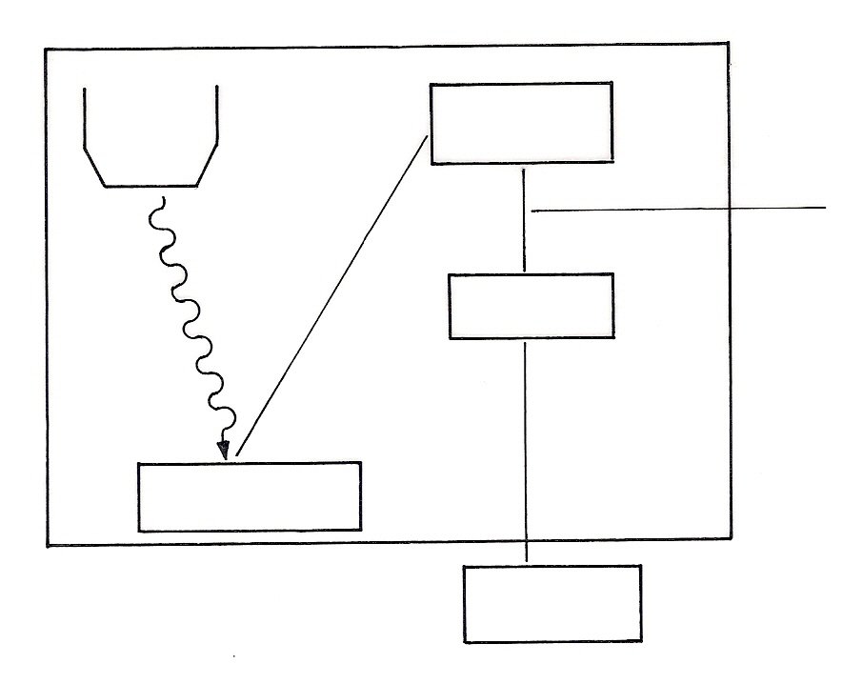
X-ray
source
hν
Electron energy
analyzer
Detector
Sample
Processing
computer
Electrons with chosen
kinetic energy
Fig. 7.1. Schematic arrangement of the basic elements of an X-ray photoelectrometer

An important source of both far ultraviolet and X-ray radiation is the storage ring of synchrotron radiation source (SRS). An electron beam is generated in a small linear accelerator. The pulse of these electrons are injected tangentially into a booster synchrotron where they are accelerated by 500 MHz radiation which also causes them to form bunches with a time interval of 2.0 ns between bunches. The electrons are restricted to a circular orbit by dipole bending magnets. When the electrons have achieved an energy of 600 MeV they are taken off tangentially into the storage ring where they are further accelerated to 2 GeV. Subsequently only a small amount of power is needed to keep the electrons circulating. The stored orbiting electrons lose energy continuously in the form of electromagnetic radiation which is predominantly plane polarized and emerges tangentially in pulses of length 0.17 ns and spacing 2 ns.The radiation is continuous from the far infra red to the X-ray region but the gain in intensity, compared to conventional sources, is most marked in the far ultra violet and particularly, the X-ray region where the gain is of a factor of 10⁵ - 10⁶. A monochromator must be used to select a narrow band of wavelengths.
But such a work is, and will remain, a very small minority of all photoelectron studies due to expense, complexity and limited availability of such sources.
The most commonly employed X-ray sources are:

Mg K_{α} radiation: hν = 1253.6 eV
Al K_{α} radiation: hν = 1486.6 eV
Comparison of x-ray photoelectron spectra from copper using both Al K_{α} and Mg K_{α} are given in the Fig. 2.
The emitted photoelectrons will therefore have kinetic energies in the range of
0 - 1250 eV or 0 - 1480 eV.
Since such electrons have very short lifetimes in solids, the technique is necessarily surface sensitive.

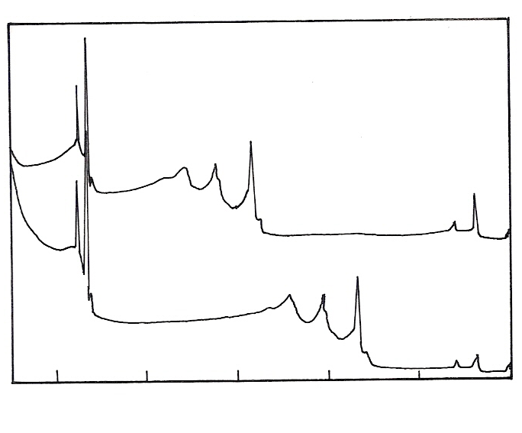
Cu 2p
Cu LMM
Auger line
Al anode
Cu 3p
Cu LMM
(Auger)
Mg anode
1000
800
600
400
200
Binding energy (eV)
Fig. 7.2. Comparison of XPS spectra from copper using Al K_{α} (upper) and Mg K_{α} (lower) radiation. (reproduced from ref. 22)

One can realise that on the BE scale of the XPS peaks remain at constant values for both the sources, but the X-AES transitions are shifted by ± 233 eV on switching between the two sources. The commonly used sources for Ultraviolet photoelectron spectroscopy are He I at 21.2 eV and He II line at 40.8 eV. For Auger electron spectroscopy electrons or X-rays of energy 1-10 keV are used as the common sources.

1.4 XPS Spectra and Description

In XPS spectrum, one measures the intensity of photoelectrons N(E) as a function of their kinetic energy or more often in terms of binding energy. The abscissa for photoelectron spectroscopy is the kinetic energy with its zero at the vacuum level of the sample
(KE = hν -BE - φ)
Experimentalists generally prefer to use BE as the abscissa. BE is the so-called binding energy of the electrons which in solids is generally referred to the Fermi level and in free atoms or molecules to the vacuum level. Fig. 7.3 shows a XPS spectrum obtained from a Pd metal sample using Mg K_{α} radiation.
The photoelectron peak designations are based on the quantum numbers of the levels from which the photoelectron is originating. Spin orbit splitting as well as binding energies of a particular electron energy level increases with increase in atomic number.

1. The valence band (4d, 5s) emission occurs at a binding energy of 0 - 8 eV (measured with respect to the Fermi level or alternatively at 4 - 12 eV if measured with respect to the vacuum level).
2. The emission from the 4p and 4s levels gives rise to very weak peaks at 54 and 88 eV respectively.

3. The most intense peak at 335 eV is due to emission from the 3d levels of the Pd atoms, whilst peaks at 534 and 561 are due to emission from 3p and the peak at 673 eV is due to the emission from 3s level.
4. The remaining peak is not an XPS peak at all! - It is an Auger peak arising from X-ray induced Auger emission. It occurs at a kinetic energy of 330 eV (in this case it is really meaningless to refer to an associated binding energy).

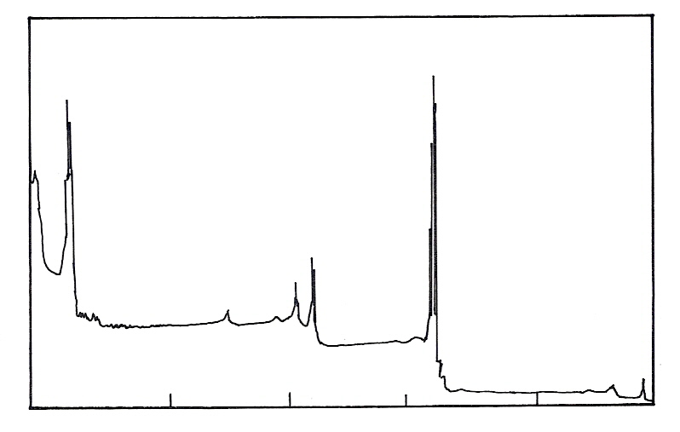
XPS
Sample : Pd
MNN
3s
3p
3d
1000
800
600
400
200
0
Signal
(cps)
Binding Energy (eV)
0
3E + 05
Mg K_{α} 1253.6 eV

Fig. 7.3. X-ray photoelectron spectrum of Pd sample using Mg K_{α} line (ref. 20)

1.4.1 Resolution of the Spectrometer

XPS is a surface-sensitive technique as the mean free path of photoelectrons is of the order of a few nanometers in a solid. Electrons originating further below the surface suffer energy loss through collisions and may not even escape the surface. XPS analyses between 2-10 atomic layers, but greater depths can be investigated using ion etching and depth profiling. XPS is sensitive to surface concentrations as low as 0.1 atomic percent and detects all elements except H and He. It offers the advantage over other surface-sensitive techniques of low beam damage and capability of analysis of insulating materials. Resolution decreases when the kinetic energy of the photo electrons is below about 5 eV. The highest resolution obtained in UPS is about 4 MeV (32 cm⁻¹). The resolution 0.2 eV of which XPS is typically capable of is too low for even the vibrational coarse structure accompanying ionization to be observed. In the recent UPS experiments at 20 eV kinetic energy, a resolution of 3 MeV and in XPS experiments at 500 eV kinetic energy, a resolution of 50 MeV with an angular resolution approaching 0.1° is observed.

1.4.2 Surface Composition of the Reference compounds

The surface sensitivity of photoemission technique is evident from the fact that the inelastic mean free path of electrons of 1000 eV kinetic energy is only about 1.2 nm. It is suitable to detect adsorbed molecules such as CO, O₂, N₂ and even to distinguish them in different adsorption sites on surfaces. The angular distribution of core level photoemission from adsorbed molecules can be analyzed to determine the orientation of molecules on the surfaces. Currently photoelectron spectroscopy has been employed to characterize surfaces of variety of materials that include metals, oxides, alloys, thin films, polymers, biomaterials, tree leaves, ceramics and various single crystal catalysts by in situ methods. It
is applied to many disciplines such as metallurgy, catalysis, corrosion, adhesion, tribology, micro electronics and polymer technology.

2.4.3. Photoelectron Spectra and Interpretation

Ionization energies of valence and core electrons: According to Koopman’s theorem, for a closed shell of molecule, the ionization energy of an electron in a particular orbital is approximately equal to the negative of the orbital energies calculated theoretically. PES gives orbital energies experimentally and hence the ionization energy. Interpretation of the spectrum is therefore easy, but it turned out that in many cases this is incorrect. This is principally because the orbital energy calculated is for the neutral molecule and the ionization energy observed is for the ionic state. The principal difference between the ionization energy and orbital energy is the relaxation energy. In addition, there can be correlation effects. Both of these aspects are not considered in Koopman’s approximation. There can be better theoretical approaches utilizing both relaxation and correlation effects, which leads to a full interpretation of the photoelectron spectrum.
XPS probes the first 5-10 nm of the surface and gives the following information
- Identification of all elements except (Hydrogen and Helium) present at concentrations greater than 0.1 atomic %
- Semi-quantitative information (± 5 %)
- Molecular environment (Oxidation state, bonding with other atoms)
- Lateral variations in surface compositions
- Non-destructive elemental depth profiles and surface heterogeneity (10 nm)
- Destructive elemental depth profiles (1 μm)
2. Factors Complicating the XPS Spectra

  - Spin-Orbit Splitting

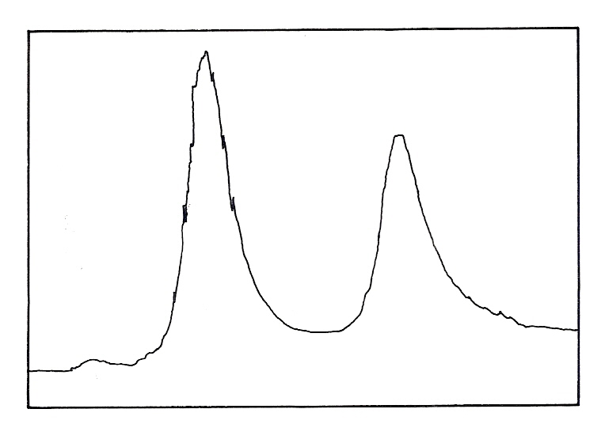
Signal
(cps)
2E + 05
BE (eV)
0.00
330.0
3d_{5/2}
3d_{3/2}

Fig. 7.4. Spin orbit splitting of Pd 3d levels (reproduced from ref. 20)

Closer inspection of the spectrum given in Fig. 7.3 shows that emission from some levels (most obviously 3p and 3d) does not give rise to a single photoemission peak, but a closely spaced doublet. The intensity ratio of the spin orbit split doublet peaks is determined by the multiplicity of the corresponding levels and is equal to 2J + 1 where J refers the multiplicity factor. The XPS spectrum of Pd sample is shown in Fig. 4. Similarly it is seen that 3d_{5/2} and 3d_{3/2} peaks will have an intensity ratio of 6:4 where as the 4f_{7/2} and 4f_{5/2} peaks have an intensity ratio 8:6 and the 2p_{3/4} and 2p_{1/2} will have an intensity ratio 4:2. One can see this aspect in the expanded spectrum for the 3d region of Pd shown in Fig. 7.4.
The 3d photoemission is in fact split into two peaks, one at 334.9 eV (BE) and the other at 340.2 eV (BE), with an intensity ratio of 3:2. This arises from spin-orbit coupling effects in the final state. The inner core electronic configuration of the initial state of the Pd is:
(1s) ² (2s) ² (2p) ⁶ (3s) ² (3p) ⁶(3d) ¹⁰ (4s)² (4p)⁶ (4d)¹⁰
with all sub-shells completely full.
The removal of an electron from the 3d sub-shell by photo-ionization leads to a (3d)⁹ configuration for the final state. Since the d-orbital (l = 2) have non-zero orbital angular momentum, there will be coupling between the unpaired spin and orbital angular momentum. Splitting can be described using individual electron L-S coupling. In this case the resultant angular momentum arise from the single hole in the d-shell; a d-shell electron (or hole) has l = 2 and s = 1/2, which again gives permitted J-values of 3/2 and 5/2 with the latter being lower in energy.

Table 7.1. Spectroscopic notations used in XPS and also in AES:

N | L | J | X-ray level | Electron level
1 | 0 | ½ | K | 1s
2 | 0 | ½ | L₁ | 2s
2 | 1 | ½ | L₂ | 2p_{1/2}
2 | 1 | ³/₂ | L₃ | 2p_{3/2}
3 | 0 | ½ | M₁ | 3s
3 | 1 | ½ | M₂ | 3p_{1/2}
3 | 1 | ³/₂ | M₃ | 3p_{3/2}
3 | 2 | ³/₂ | M₄ | 3d_{3/2}
3 | 2 | ⁵/₂ | M₅ | 3d_{5/2}
4 | 3 | ⁵/₂ | N₁ | 4f_{5/2}
4 | 3 | ⁷/₂ | N₂ | 4f_{7/2}

  - Multiplet Splitting

Multiplet splitting, also referred to as exchange or electrostatic splitting of core level peaks, can occur when the system has unpaired electrons in the valence levels. For example consider the case of the 3s electron in the Mn²⁺ ion. In the ground state, five 3d electrons are all unpaired and with parallel spins (denoted as ⁶S). After the ejection of the 3s electron a further unpaired electron is present. If the spin of the electron is parallel to that of the 3d electron (i.e., the final state ⁷S) then exchange interaction can occur, resulting in a lower energy than for the case of anti parallel spin (final state ⁵S). Thus the core level will be a doublet and the separation of the peaks is the exchange interaction energy given as E =

(2S +1) K3s-3d, where S is the total spin of the unpaired electrons in the valence levels (5/2 in this case) and K3s-3d is the 3s-3d exchange integral. The intensity (I) ratio for the two peaks is given by
I (S + ½)/ I(S- ¹/₂) = (S +1)/S
For the 3s in the Mn²⁺ this ratio is (⁵/₂ + 1) : ⁵/₂ or 1:1.4 and ΔE is calculated to be ≅ 13 eV. In the real case of MnF₂ the intensity ratio is 1:1.8 and the separation is ≅ 6.5 eV. This discrepancy is due to relaxation and configuration interaction effects, which complicate the simple model described.
The Mn 3s spectrum exhibits a doublet due to multiplet splitting. The energy separation of this doublet depends on the net spin of the Mn atom, providing a direct and element-specific measure of its magnetic moment. However the data for chromium compounds illustrates the fact that this model predicts the trends for changes in the spin state.

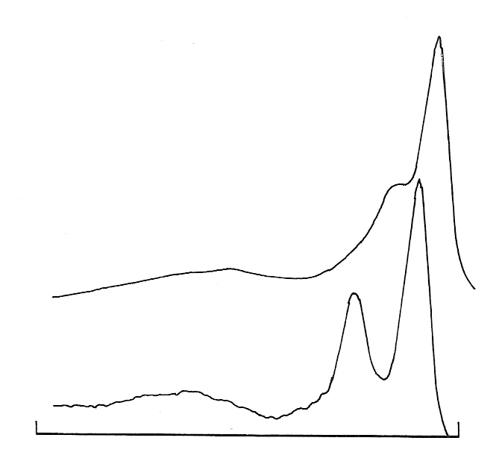
Mn
MnCO₃
3s
120
80
Binding Energy (eV)

Fig. 7.5. Multiplet splitting of Mn 3s (reproduced from ref. 23)

Multiplet splitting of the 3s peak from chromium compounds is shown in Fig. 7.6. Cr(CO)₆ is diamagnetic (no unpaired electrons); Cr(C₅H₅)₂ has two unpaired electrons in the e_{g} level; and Cr(hfa)₃ has three unpaired electrons in the t_{2g} level. It can be seen that the mean BE varies with electronegativity of attached ligands. Multiplet splitting for non s-levels is more complex because of the additional involvement of angular momentum coupling. Thus in Mn²⁺ the 3p level is split into four levels. Multiplet splitting is strongest when both the levels involved are in the same shell (as with 3s, 3p-3d). Multiplet splitting causes broadening (with asymmetry) in both 2p_{1/2} and 2p_{3/2} peaks leading to apparent variation in the separation which can be used diagnostically. Multiplet splitting is found strongly in the 4s levels of rare earth metals (unpaired electrons in the 4f valence levels) [24].

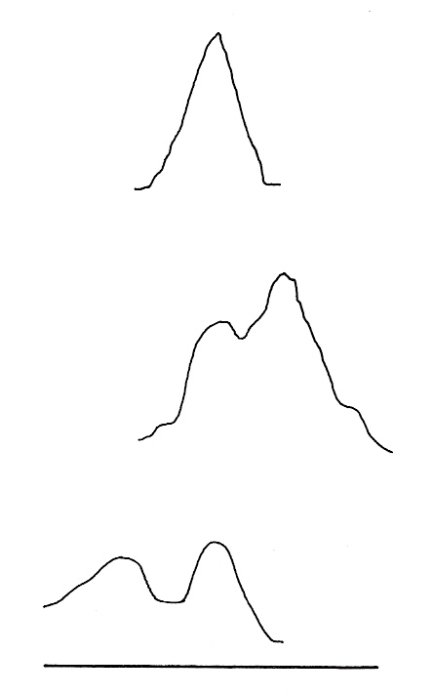
Cr (CO)₆
Cr (C₂H₅)₂
Cr (hfa)₃
BE (eV)
84
70

Fig. 7.6. Multiplet splitting in X-ray photoelectron spectrum (reproduced from ref. 24)

  - Ghost Peaks

Ghost peaks are due to standard X-ray sources which are not monochromatic. Besides the Bremmstrahlung radiation background to the principal K_{α1,2} line of magnesium and aluminium targets also produce a series of lower intensity lines, referred to as X-ray satellites. Satellites arise from low probable transitions e.g. K_{β}, valence band → 1s or transitions in a multiply ionized atoms e.g. K_{α3,4}. X-ray ghost peaks can also be due to excitations arising from impurity elements in the X-ray source. The most common ghost is Al K_{α1,2} from Mg K_{α} source. This arises from the secondary electrons produced inside the source hitting the thin aluminium window. This radiation will therefore produce weak ghost peaks which will appear in the 233 eV higher kinetic energy of those excited by the dominant Mg K_{α1,2}. Old or damaged targets can give rise to ghost peaks due to Cu L_{α} radiation the main line from the exposed copper base of the target. These peaks appear at 323.9 eV (556.9) to lower KE of Mg K_{α1,2} (Al K_{α1,2}) excited peaks. In dual anode X-ray sources, which are commonly being used with one anode capable of yielding high energy X-rays (e.g., zirconium, silver and titanium), misalignments inside the source can lead to cross-talk between filaments and anodes, which is an additional source of ghost peaks. X-rays emitted by the copper substrate of aged Mg or Al anodes are often responsible for ghost lines [21]. The spectrum observed is that of the sputtered aluminium sample. The sample was sputtered until the carbon and oxygen adsorbates were removed. The peak at 245 eV binding energy is due to implanted argon. The sample is normally mounted with double sided tape which allowed charging to occur. As a result, the binding energies have shifted approximately by 6 eV. There are ghost peaks present at 323 eV above the aluminium 2s and argon 2p peaks due to photons from the copper mount on the X-ray gun. For a copper source, the most intense peaks have ghost at 323 eV, in the higher binding energy. Similarly a peak at approximately 617 eV binding energy is a ghost resulting from the C (ls) peak at 290.4 eV binding energy [25].
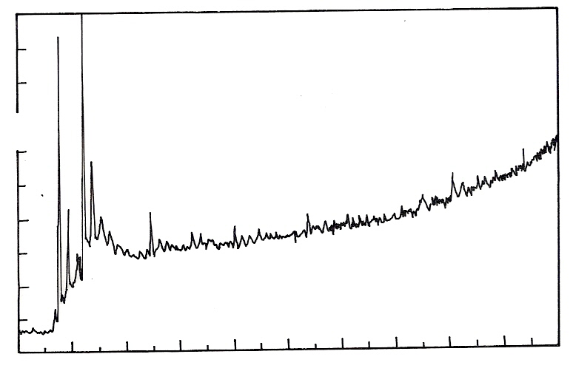
Intensity (a.u.)
Al (2s)
Al (2p)
Ar (2p)
Ghost peaks
Binding energy (eV)
0.0
100
200
300
400
500
600
700
800
900
1000
Fig. 7.7. XPS spectrum of a sputtered aluminium sample (ref. 25)

7.4 Shake up and Shake off satellites

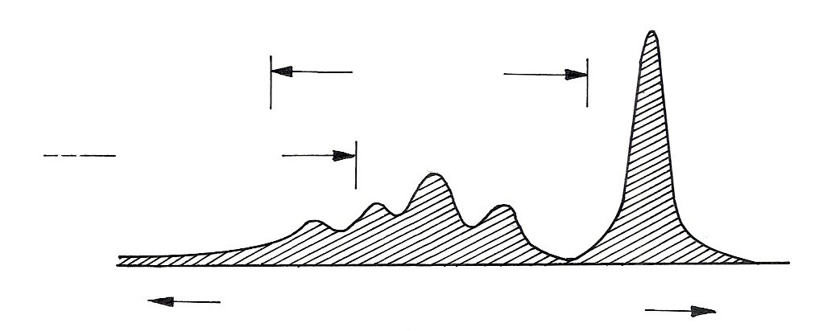
Primary electron peak
Shake up
Shake off
Binding energy
Kinetic energy
Fig. 7.8. Shake up and shake off peaks in XPS spectrum
To the valence electrons associated with an atom the loss of a core electron by photoemission appears to increase the nuclear charge. This perturbation gives rise to substantial reorganization of the valence electrons (referred to as relaxation), which may involve excitation of one of them to a higher unfilled level (shake up). Fig. 8 gives the approximate energy range that both shakeup and shake off will appear in the spectrum. The energy required for the transition is not available to the primary photoelectron and thus the two electron process leads to discrete structure on the low kinetic energy side of the photoelectron peak (shake up satellites). Strong satellites are observed for certain transition metal and rare earth compounds which have unpaired electrons in 3d or 4f shells respectively. The intensity of satellite peaks is usually higher than what would be expected for atomic –like shake-up and the reason

for this has led to a great discussion.

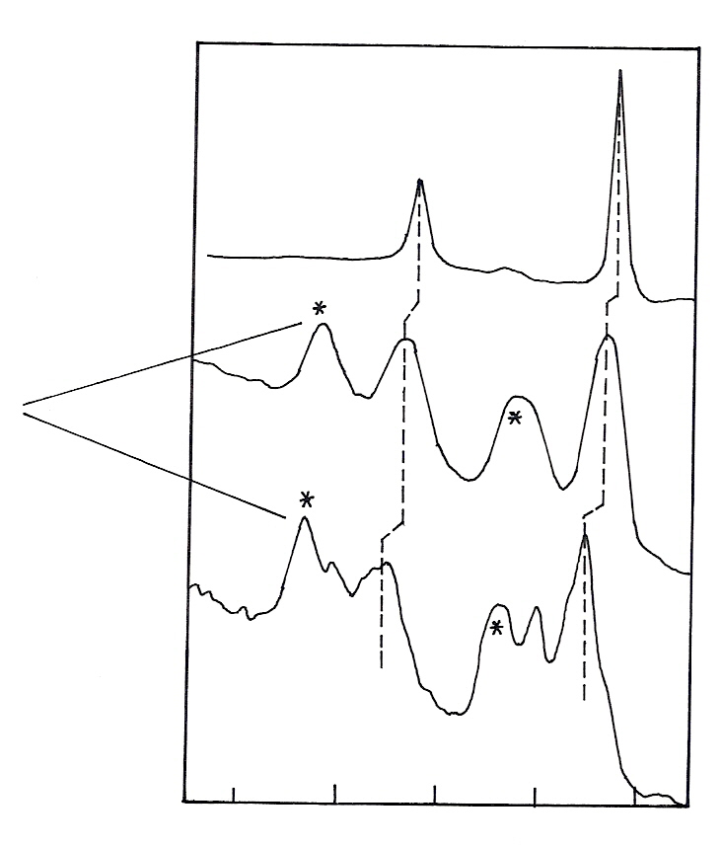
Cu
CuO
CuSO₄
2p_{1/2}
2p_{3/2}
970
960
950
940
930
Binding energy (eV)
Shake-up
lines
Fig. 7.9. Examples of shake-up lines (∗) of the copper 2p observed in copper compounds (reproduced from ref. 23)
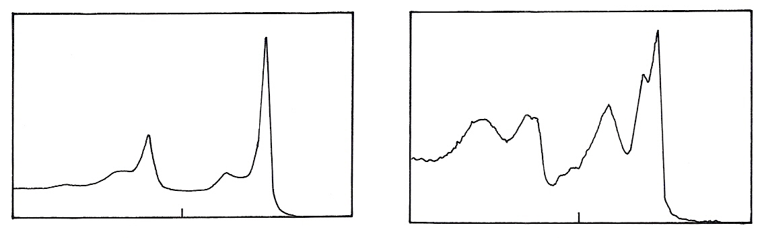
2p_{3/2} = 852.7 eV
Δ = 17.27 eV
2p_{3/2}
2p_{1/2}
Binding energy (eV)
890
865
840
Ni in NiO
2p_{3/2} = 853.8 eV
Δ = 17.49 eV
2p_{1/2}
2p_{3/2}
890
865
Binding energy (eV)
Fig. 7.10. Ni and NiO shake up peaks (reproduced from ref. 23)
The convincing explanation is that in the final state there is significant ligand to metal charge transfer such that an extra 3d or 4f electron is present compared to the initial state. This explains why closed shell systems e.g.: (Cu²⁺, 3d¹⁰) do not exhibit shake-up satellites, whereas open shell systems e.g., (Cu⁺,

3d⁹) do. A strong configuration interaction occurs in the final state due to relaxation [26]. Shake up lines observed for Cu 2p line in CuO and CuSO₄ are given in the Fig. 7.9. Similarly shake up satellite peaks for Ni 2p line in Ni and NiO are given in the Fig. 7.10.

Shake-off Satellites

In a process similar to shake-up, the valence electrons can be completely ionized i.e., excited to an unbound continuum state. This process is referred to as shake off, which leaves an ion with vacancies in both the core level and the valence level. Discrete shake off satellites are rarely discerned in the solid state because:
- The energy separation from the primary photoelectron peaks are greater than for shake–up satellites, which means the satellites tend to fall within the region of the broad inelastic tail.
- Transitions from discrete levels to a continuum produce onsets of increased intensity (i.e., broad shoulders) rather than discrete peaks.
Normally XPS is considered as a nondestructive technique. However, in some cases this may not hold good. Ultra high vacuum may produce a loss of water from the sample, which is a main issue in the case of biological systems. Radiation damages in the polymer systems and the Cu-S systems are also serious issues.

2.5 Asymmetry in Core Level Peaks

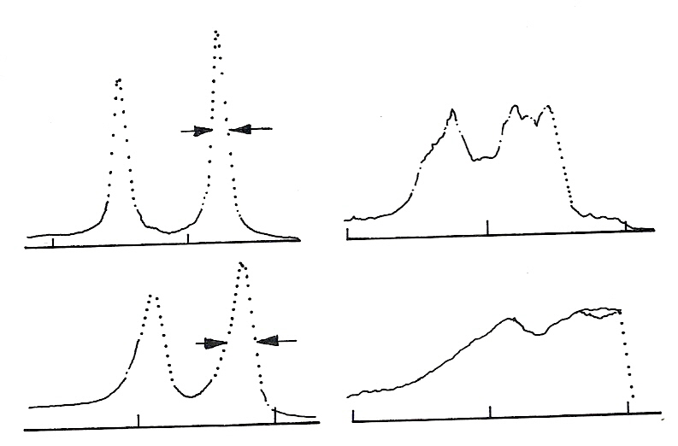
4f
0.52
Au
90
85
VB
10
5
0
Pt
1.05
75
70
BE. eV
10
5
0
Fig. 7.11. Core (4f) and valence (VB) photoelectron spectra of gold and platinum recorded using
monochromatic Al K_{α} radiation (ref. 24)

Asymmetry of Core Levels in Non Metals

In a solid metal there exists a distribution of unfilled one-electron levels above the Fermi energy, which are available for shake up type events following core electron emission. In this case, instead of discrete satellites to low kinetic energy of the primary peak, the expectation is for the core level itself to be accompanied by a low kinetic energy tail. The higher the density of states at the Fermi level, the more

likely is this effect to be observed. The relationship between the degree of core level asymmetry and the density of states can be seen from Fig. 7.11.
This effect, which is generally observed in the recorded spectra, obtained at the very highest energy resolution is illustrated by the C 1s spectrum from polyethylene (refer to Fig. 7.12). The marked asymmetry is due to vibrational fine structure. Core level ionization in a molecule leads to a redistribution of electronic charge and in general to decreased bond lengths and a narrower molecular potential curve. Thus core ionization is likely to result in vibrational excitation and a core level peak composed, in the harmonic approximation, of equally spaced components (vibrational energy level spacing) with decreasing intensity towards higher binding energy.
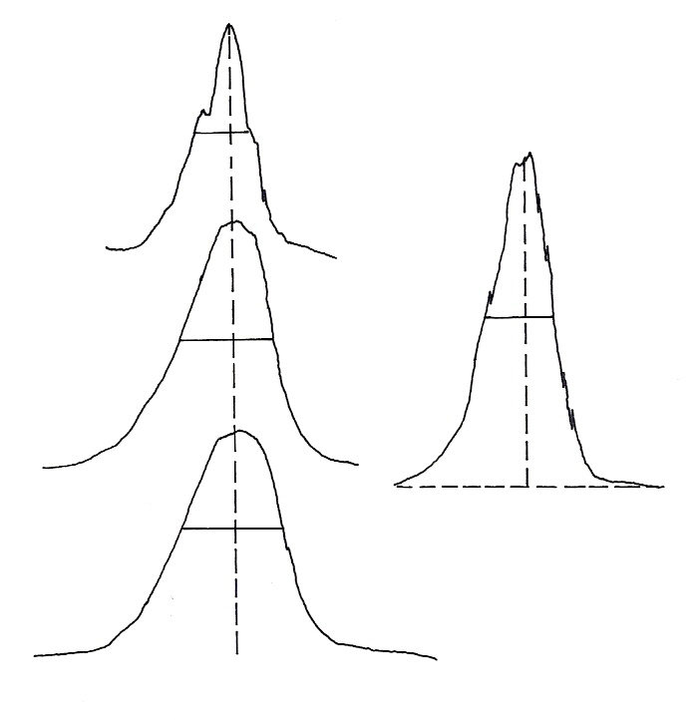
CH₄
0.58
0.84
0.83
0.55
-CO-OH
CH₃CO₂H
Low density
(polyethylene)
Fig. 7.12. C 1s core level spectra from gas phase methane and acetic acid and solid state insulating low density poly ethylene (ref. 24)

2.6 Charging and Sample Damage

Samples ejecting photoelectrons will lead to accumulation of charge. The potential acquired by the sample is determined by the photoelectric current of electrons leaving the sample, the current through the sample holder towards the sample and the flow of the Auger and secondary electrons from the source window onto the sample. Due to the accumulation of the positive charge on the sample, all XPS peaks in the spectrum shifts to the higher binding energies. Normally calibration is done using the binding energy of a known compound for example Si 2p in SiO₂ is taken as 103.4 eV or carbon 1s binding energy is considered as 284.4 eV. There are other substances which can be added and also used for calibration. In addition the shifting, peaks can also broaden and thus decrease the resolution with a low signal to noise ratio. Charging in supported catalysts is usually limited to a few eV in normal mode of operation but when monochromatic XPS is used it can be considerably higher. These effects can be minimized by using a flood gun which showers the low energy electrons on the sample or mounting the sample like powders in the indium foils.
Two additional approaches to charge compensation have emerged recently. One is the dual-beam charge neutralization system, which includes a low-energy electron beam and a low-energy ion

beam. The ion beam’s job is to neutralize any electrostatic charges on the sample that might repel the electron beam from the analysis area. The second approach is to place a magnetic immersion lens and a source of low-energy electrons at the entrance to the energy analyzer. The magnetic field traps the low-energy electrons between the bottom of the lens and the sample surface. Low-energy electrons are consumed until the charge on the surface is neutralized; at which point the remaining low-energy electrons are repelled and simply oscillate in the magnetic field [24].

2.7 Surface Plasmon Loss Features
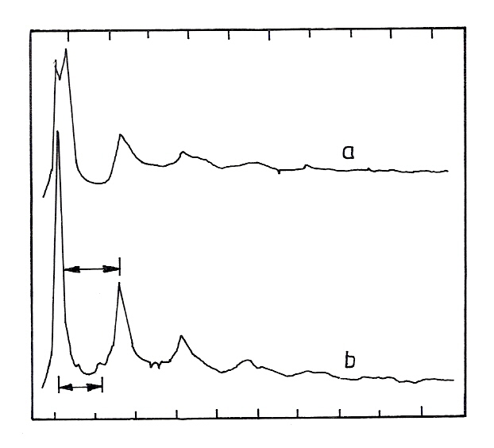
Binding energy (eV)
150
200
hω_{p}
15.2 eV
10.7 eV
1350
1300
Kinetic energy (eV)
Intensity
(a.u.)
hω_{p}
Al 2s
Fig. 7.13. Surface plasmon loss spectra of Al 2s , (a) Slightly oxidized aluminium b) Clean aluminium (ref. 27)

Surface plasmon loss peak arise when outgoing electrons of sufficient energy, originating in any way, lose energy by exciting collective oscillations in the conduction electrons in a solid. The oscillation frequency and hence the energy involved, is characteristic of the nature of the solid and is called the plasmon frequency. The plasmon loss determined by three dimensional nature of the solid is called a ‘bulk’ or ‘volume’ loss, but when it is associated with the two dimensional nature of the surface is called a ‘surface’ loss. Both types of plasmon loss from the Al 2s peak can be seen in Fig. 13 with a bulk loss of 15.2 eV and a surface loss of 10.7 eV. Theoretically the surface plasmon loss energy should be a factor of 2^{1/2} less than the energy of bulk plasmon loss. When there is a pronounced bulk loss as in a free electron – like metal such as aluminium, a succession of peaks can be found at multiples of the loss energy with progressively decreasing intensity as shown in Fig. 13. Spectrum (a) from slightly oxidized aluminium reveals the rapid quenching of the surface plasmon on oxidation and also shows a chemical shift in the Al 2s photoelectron peak. In the XPS spectrum from a solid a series of plasmon loss peaks is associated with prominent peaks. The fundamental or first plasmon loss is always discernable. Depending on the material and experimental conditions, several multiple plasmon losses of decreasing intensity may also become visible as can be seen from this example.

3. Important Features of the X-ray Photo Electron Spectroscopy

3.1 Chemical Shifts

In the investigation of molecules and solids, one is not usually interested in the absolute binding energy of a particular core level, but in the change in binding energy between two different chemical forms of the same atom. This energy difference is called the chemical shift.
The exact binding energy of an electron depends not only on the level from which photoemission is occurring, but also on: 1. The formal oxidation state of the atom, 2. The local chemical and physical environment. Changes in either (1) or (2) give rise to small shifts in the peak positions in the spectrum, so-called chemical shifts. Such shifts are readily observable and interpretable in XPS spectra. Atoms of a higher positive oxidation state exhibit a higher binding energy due to the extra coulombic interaction between the photo-emitted electron and the ion core. This ability to discriminate between different oxidation states and chemical environments is one of the major strengths of the XPS technique. In practice, the ability to resolve between atoms exhibiting slightly different chemical shifts is limited by the peak widths which are governed by a combination of factors; especially
1. The intrinsic width of the initial level and the lifetime of the final state.
2. The line-width of the incident radiation - which for traditional x-ray sources can only be
improved by using x-ray monochromators.
3. The resolving power of the electron-energy analyzer.
In most cases, the second factor is the major contribution to the overall line width.

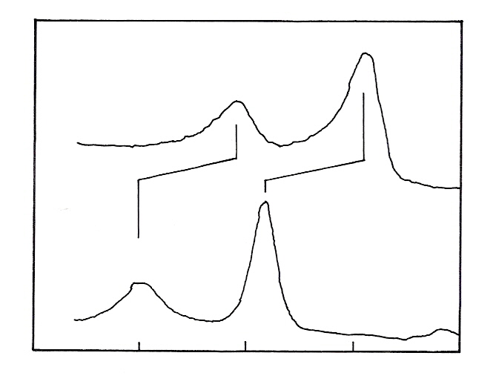
Ti 2p XP spectra
Mg K_{α}
Ti metal
TiO₂
470
465
460
455
450
Binding energy (eV)

Fig. 7.14. Oxidation States of titanium (ref. 20)

The two spin orbit components exhibit the same chemical shift. Titanium exhibits very large chemical shifts between different oxidation states of the metal; Ti 2p spectrum from the pure metal (Ti) is compared with a spectrum of titanium dioxide (TiO₂) in Fig. 7.14.

3.2 Small Area Resolution

Spectroscopy on small-area works essentially the same way, except that the XPS instrument zooms in on a few micrometer area of the sample. Decrease of the analysis area is made possible either by focusing the X-ray source to different spot sizes, so-called microprobe instruments or by restricting the analysis area with a physical aperture and an extra set of lenses in front of the energy analyzer.

Whereas a minimum analysis area of 20- 30 µm² was common five years ago, some current instruments can zoom in on an area of 10-15 µm².
Photo electron spectrum is a plot of the intensity of the photoelectrons as a function of electron kinetic energy. In photoelectron spectroscopy the electron kinetic energy that one normally encounters is of the order of 10 – 1000 eV. For electrons of this energy, the distance traveled before an inelastic encounter is of the order of 20-30 Å. This distance corresponds to about 10 atomic layers of the material, in most cases. Therefore, while analyzing kinetic energy of electrons, the electrons of maximum intensity which do not suffer energy loss due to inelastic collisions are principally coming from the very top of the surface and therefore, the technique is extremely surface sensitive. The distance in which the inelastic collisions do not occur is called the inelastic mean free path and is a quantity very difficult to measure. Normally what can be measured is attenuation length, which is a combination of both inelastic and elastic mean free path. For metals the attenuation length is of the order of 20 Å.

3.3 Depth Profile
Since XPS instruments have small-area analysis capability and improved sensitivity, they are more analogous to Auger instruments in terms of depth profiling. The universal method of destructive composition-depth profiling applied in AES and XPS is through the sputtering of thin sections of the sample surface by energetic ion bombardment. It has been done using a small analysis ion beam which can be focused on the sample and can etch the surface quickly. Compared to AES, depth profiling XPS is more quantitative, provides more chemical information, and has less difficulty with insulating films. A typical example is shown in Fig. 15. It can be seen that the intensity of emissions from the energy levels of gold (namely 4f, ad, 4p) is increased on Ar ion bombardment.
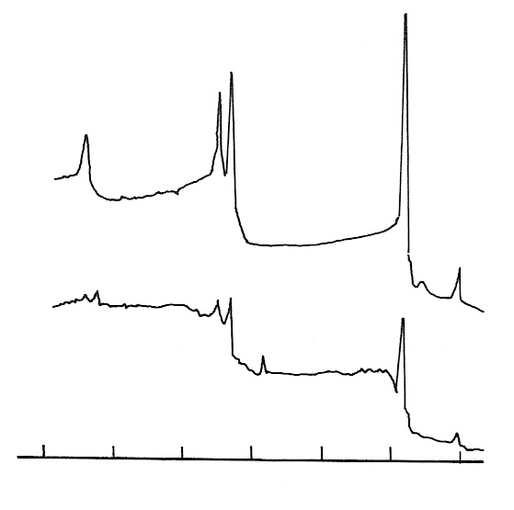
Au 4f
Au 4d
Au 4p
(a)
(b)
O
C
600
500
400
300
200
100
0
Fig. 7.15. Spectrum of a gold sample (a) before and (b) after Ar ion bombardment
Ar ion bombardment is used generally for cleaning the surface.

3.4 Imaging XPS (iXPS):

Another area where XPS instruments have improved significantly, according to the experts, is photoelectron imaging, which maps a sample surface. Images can be acquired in several ways. In point-by-point acquisition, the image is built one pixel at a time. One way to do this is to scan the X-ray beam across the surface of the sample. The other option is to keep the X-ray beam in place and change the area on the sample from which photoelectrons are extracted, either by moving the sample or by using a deflection lens system. Instead of point-by-point acquisition, some systems use parallel imaging also called direct or real-time imaging in which the spatial relationship of the photoelectrons coming off the sample is maintained, and the entire image field is collected at once. Generally speaking, parallel imaging systems can achieve a spatial resolution of ~ 2-3 µm, whereas a scanned microprobe system can achieve ~ 8-10 µm [21]. The inherent weakness in XPS has been the lack of spatial resolution. However some modern instruments offer the capability of parallel imaging, which provides positional information from dispersion characteristics of the hemispherical analyzer and produces photoelectron images with spatial resolution better than 5 mm. Also, the introduction of a magnetic objective lens has improved the sensitivity for a given spatial resolution. The capability of imaging XPS to obtain spatially-resolved chemical maps across the surface of very small features has been realized. The microscope allows imaging with chemical contrast (Imaging ESCA) by energy filtering of photoelectron images at kinetic energies upto 1.6 KeV, which are typical for XPS. As an additional effect the spatial resolution of the images is enhanced by the reduction of the chromatic aberrations, even when using threshold photoemission.
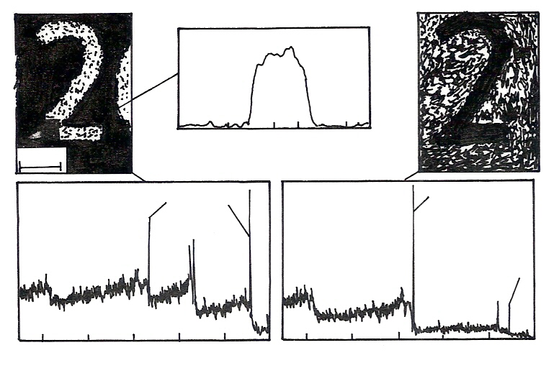
Au 4f Line scan
O 1s
Au 4f
On Au Feature
Off Au Feature
Distance (μm)
50 μm
Binding energy (eV)
1000
800
600
400
200
0
1000
800
600
400
200
0
O 1s
Au 4f
Si 2p
0
20
40
60
80
Binding energy (eV)
Si 2p
Fig. 7.16. Parallel XPS images from gold features on a glass substrate (ref. 22)

The resolution in the Au 4f and Si 2p images can be measured from the line scan to be about 3 μm. The images can be used to define small areas from which spectra can be acquired. In Fig. 16, XPS image of Au feature on a glass substrate is given.

3.5 Angular Effects

Photo electron spectra can be strongly influenced by the particular geometry employed in their measurement, i.e., the relative orientation of the source, sample and spectrometer (lens). Two types of

angular effects are important. The first involves the increase in surface sensitivity obtained at low angles of electron exit relative to the sample surface (take off angle) and is particularly important in XPS. The second is concerned with the single crystal materials.

Surface Sensitivity Enhancements by Variation of the Electron Take Off Angle

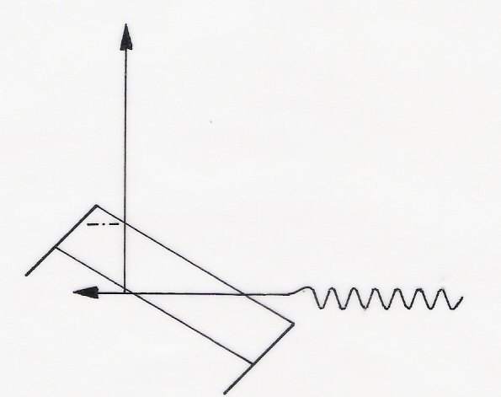
3λ
δ
α
d
d = 3λsin α
hυ
e⁻
Fig. 7. 17. Surface sensitivity enhancement by variation of electron take off angle (ref. 24)

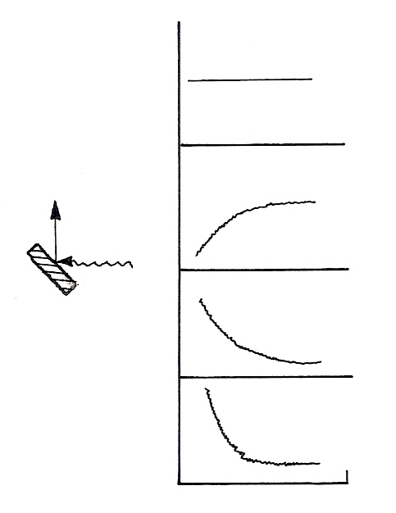
hυ
R
10°
90°
α
I_{o} / I_{s}
e⁻
Clean
Substrate
Over layer
I
I
I
Fig. 7.18. Theoretical angular dependent curves for a clean flat surface and a flatover layer/substrate surface (ref. 24)

If λ is the attenuation length (AL) of the emerging electron then 95% of the signal intensity is derived from a distance 3λ within the solid. The vertical depth sampled is given by d = 3λ sinα
The angular variation of intensities is given by
I_{s}^{d} = I_{s} exp (–d/λsinα)
I_{o}^{d} = I_{o} exp (1-exp –d/λsinα)
Where λ is the appropriate value of attenuation length for the observed photoelectron, α is the photoelectron take off angle, d is the vertical length sampled and I_{s}^{d}, I_{o}^{d} are the intensity of photoemission from substrate and over layer respectively. In the ideal situation these equations lead to curves of the type as shown in Fig. 18. However the real case is actually complicated by the fact that the system geometry imposes a response function also dependent on α. This complication is avoided by measurements of relative values of I_{o} / I_{s} so that the instrument response function is cancelled. Thus at low values of α, I_{o} / I_{s} increases significantly [24]. The change in the peak intensities when measured with a surface angle and bulk angle is given in the Fig. 7.19.

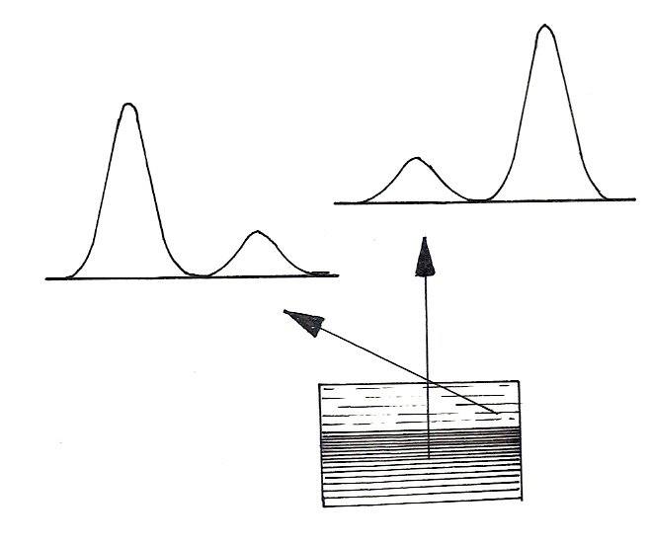
Surface Angle
Bulk Angle
Oxide
Metal
Binding energy
Photoelectron
Emission
Thin Oxide Layer
Metal
Metal
Oxide
Binding energy
Fig. 7.19. Illustration of XPS spectra taken from a thin oxide film (ref. 22)
Effect of variation of the take –off angle on the Si 2p spectrum from silicon with a passive oxide layer is shown in Fig. 20. It can be seen that the relative enhancement of the surface oxide signal is taking place at low angles.
A series of Si 2p photoelectron spectra are recorded for emission angles of 10-90º to the surface plane. The Si 2p peak of the oxide (BE ~ 103 eV) increases markedly in intensity at take off emission angles whilst the peak from the underlying elemental silicon (BE ~ 99 eV) dominates the spectrum at near-normal emission angles.
The major requirement for surface sensitivity enhancement is that the surface is flat. Surface roughness leads to an averaging of electron exit angles and also to shadowing effects (both of the incident X-ray and emerging effects). In most commercial spectrometers the angle between the incident X-rays and detected electrons (180-α-δ) is fixed. At very low delta there is also a surface sensitive enhancement effect due to rapid fall off in X-ray penetration depth as δ tends to grazing incidence. AES instruments are generally operated with large input apertures to maximize sensitivity, with consequent loss of angular resolution.

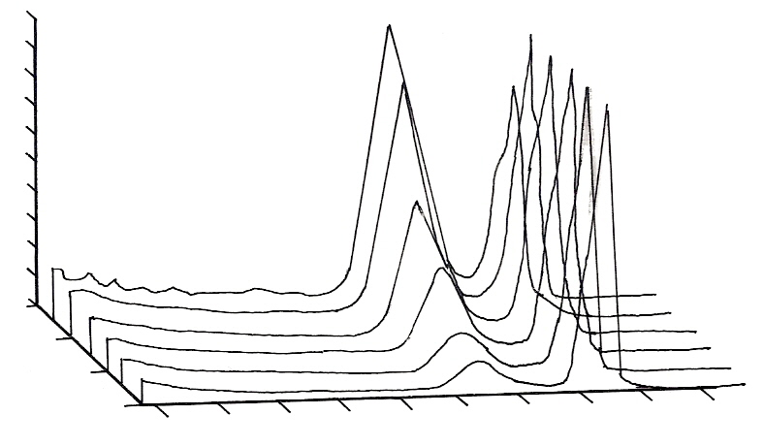
Si 2p
0
0.5
1
110
114
106
102
98
10°
90°
Binding energy (eV)
Fig. 7.20. Angle-dependent analysis of a silicon wafer with anative oxide surface layer (ref. 20)

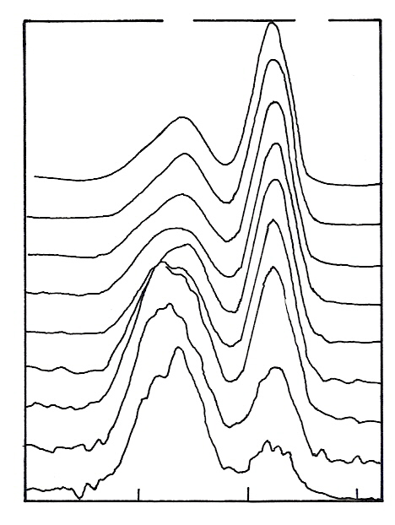
As 3d
As in Oxide
As in GaAs
Bulk
Surface
0°
10°
20°
30°
40°
50°
60°
70°
80°
50
46
42
38
Binding energy (eV)
Fig. 7.21. Angle resolved XPS data acquired by tilting the specimen. In this case the specimen is gallium arsenide with a thin layer of oxide at the surface. (ref. 22)
It is clear from Fig. 7.21 that the spectra of As 3d region is dominated by the oxide at the surface and falls off as the probing depth increases. This phenomenon is also repeated in the gallium part of the spectrum. Thus straightway one can conclude that the bulk GaAs is covered by a layer of material in

which the Ga and the As are oxidized. It is possible to determine the over layer thickness and over layer coverage from angle resolved XPS studies.
3.6 Electron kinetic Energy Variation Effects
An alternative way of obtaining in-depth information in a nondestructive manner is by examining electrons from different energy levels of the same atom. The inelastic mean free path varies with kinetic energy, and by selecting a pair of electron transitions which are both accessible in XPS but have widely separated energies; it is possible to obtain a degree of depth selectivity. The Ge 3d spectrum (KE = 1450 eV, λ ∼ 2.8 nm) given in Fig. 7.22 shows Ge⁰ and Ge⁴⁺ components with the oxide component being about 80 % of the elemental Ge. i.e., in Ge 3d spectrum given Ge (IV) contribution is the maximum since, almost 80 % of the intensity of a Ge⁰ peak comes from the Ge (IV) only. Similarly the spectrum recorded for the Ge 2p_{3/2} region (KE = 260 eV, λ ∼ 0.8 nm) one can notice that the elemental component is much smaller compared with the Ge⁴⁺ peak, thus confirming the presence of the oxide layer as a surface phase.
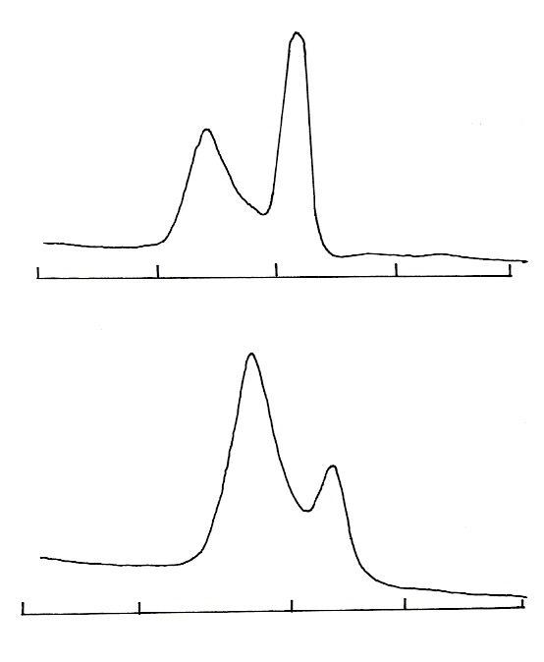
Ge 3d
Ge (IV)
Ge (0)
Ge (0)
Ge (IV)
40
30
20
35
25
1230
1225
1220
1215
1210
Ge 2p3/2
Binding energy (eV)
Fig. 7.22. Ge 3d and Ge 2p_{3/2} spectra showing variation of sampling depth with electron kinetic energy (ref. 22)

3.7 Effect of Pass Energy on XP Spectrum
The analyzer in X ray photoelectron spectrometer is set to pass a user defined fixed electron energy to the electrons ejected. The selected pass energy affects both the transmission of the analyzer and its resolution.
Selecting a low pass energy will result in high resolution whereas a high pass energy will provide higher transmission but poor resolution. As the pass energy remains constant throughout the electron kinetic energy range, the resolution (in electron volts) is constant across the entire width of the spectrum.
The XPS spectrum of silver recorded at a series of pass energies is shown in Fig. 7.23. The effect of pass energy on resolution can be seen. The spectra have been normalized, but the increase in noise with decrease in pass energy is a result of the decrease in sensitivity. In a typical XPS experiment, the

user will select a pass energy in the region greater than 100 eV for survey or wide scans and in the region of 20 eV for higher resolution spectra of individual core levels. These narrow scans are used to establish the chemical states of the elements present and for evaluating quantitative data. It is normal practice to collect XPS spectra in the constant analyzer energy mode, so that the energy resolution (in electron volts) remains constant across the spectrum.

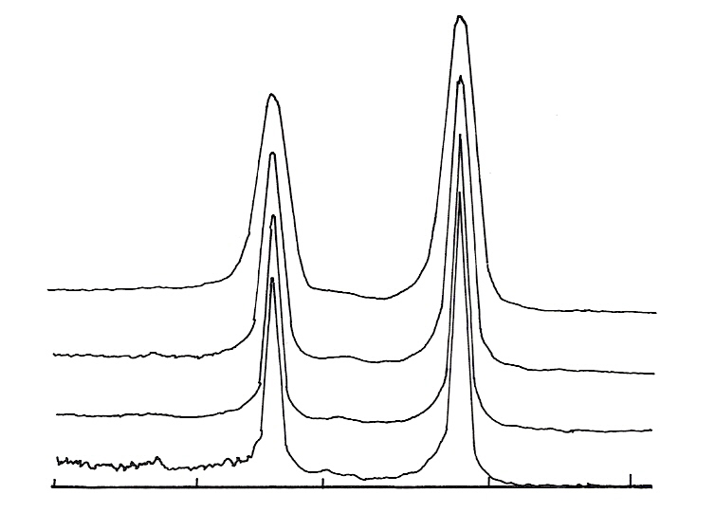
Pass energy
40 eV
20 eV
5 eV
2 eV
382
377
372
367
362
Binding energy (eV)
Fig. 7.23. XPS spectrum of silver showing the effect of pass energy upon the Ag 3d part of the spectrum (ref.27)

4. XPS in Catalysis

4.1 Applications of XPS for the Study of Catalysts

In fundamental catalytic research, it is often attractive to study the behaviour of non- supported catalysts in order to exclude the direct or indirect influence of the support on the catalyst performance. For XPS examination, such non-supported catalyst powders are attractive too, because different properties can be studied separately and the XPS signals are relatively strong. But a working catalyst is not as simple and the study of working catalyst system is a complex phenomenon in which a multitude of interesting variables intervene. The dispersion of metal catalyst on a nonmetallic porous medium has long been used in practical catalysis. It is convenient for obtaining a relatively large area which is resistant to sintering during its use, or regeneration. Supports are believed to be inert materials acting only to disperse physically the active component. It is rather difficult to find a totally inert support and the interaction of the support with the metal influences the properties of the catalysts. The physicochemical characteristics of the support also influence the distribution of the active metal and in turn, the catalytic activity. Other factors which influence the properties and activities of the catalysts are the preparation procedures and the pre-treatment conditions. Apart from this, the catalysts can undergo changes during the reaction. Hence an understanding of the catalyst from the preparation stage to spent stage helps in designing new catalysts with improved stability, activity and selectivity.

4.1.1 XPS Analysis of Supports and Catalysts
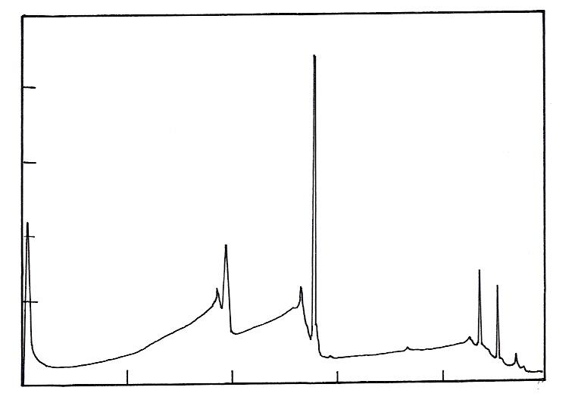
O-Auger
O (1s)
Al (2s)
Al (2p)
Kinetic energy (eV)
0
260
520
780
1040
1300
Intensity
Fig. 7.24. Wide scan XPS spectrum of an alumina support material showing an extremely pure surface. (ref. 29)
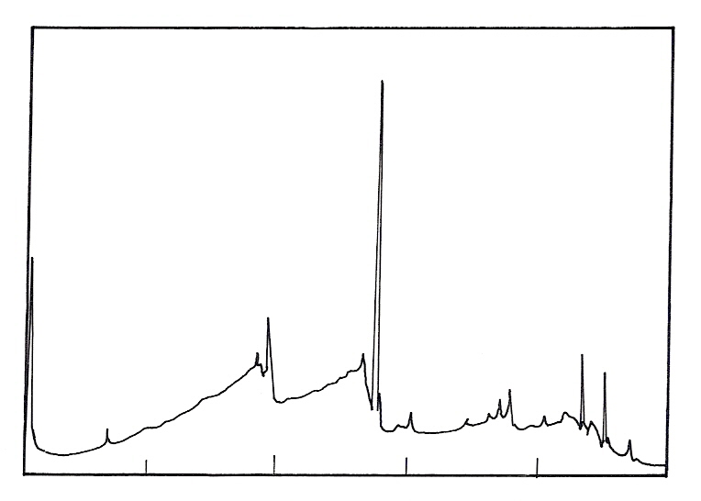
O (1s)
O-Auger
Ti
Ca
Na
C
Cl
Si
Si
Al (2s)
Al (2p)
260
520
780
1040
1300
0
Na
Kinetic energy (eV)
Fig. 7.25. Wide scan XPS spectrum of a contaminated alumina support materials (Ref: 29)
Impurities in the support can influence their interaction and also the catalytic activity. It is, therefore, desirable to identify the impurities by XPS analysis of the support as well as of catalyst. Wide scan

XPS spectra of two different support samples are shown in the Fig. 24 and 25. As can be seen from the spectrum, (Fig. 7.24) the sample is extremely pure as no impurity or carbon was detected. However the other sample (Fig. 7.25) differs from the first one and contaminating elements such as Na, Ti, Ca, C, Cl and Si were detected.

4.1.2 Dispersion in Supported Metal Catalyst

The activity of supported metal catalyst is frequently determined by the degree of dispersion of the active species which have been deposited on the carrier
Dispersion D may also be defined as:

Number of surface metal atoms per unit weight of catalyst
Total number of metal atoms per unit weight of the catalyst

Dispersion in some cases (e.g., metals) can be directly monitored by selective adsorption of suitable gases. In other cases, e.g., oxides or sulphides, where no such selective adsorption is known, indirect physicochemical methods have to be employed. XPS intensity measurements have been used in this connection and several authors have developed the theoretical basis of the quantitative interpretation of the data. Care must be exercised in the interpretation of XPS intensity measurements, applied to the study of dispersion of catalysts. Inhomogenisation and repartition of active species affect the intensity measurements. For an accurate interpretation, a structural model of the surface layer is required. For a homogeneous solid with a flat surface, the following relation has been proposed:
I = k σ n λ F

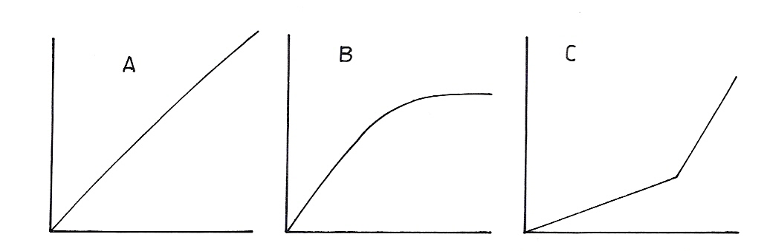
Fig. 7.26. Typical plots of ESCA intensity ratios vs. metal loading for heterogeneous catalysts, (A) high surface area; constant dispersion; (B) medium surface area, changing dispersion; (C) medium surface area, pore filling and repartition. Im /Is = ESCA intensity ratio of supported metal (Im) to support (Is) (ref. 29)
I_{m} / I_{s}
% M
% M
% M

Where k is a spectrometer constant; σ, the photo electron cross section for a given solid; n, the concentration of atoms undergoing photo electron ejection; F, the X-ray flux; and the λ, the electron mean free path for inelastic collision. In the case of porous materials such as supported metal catalysts, the model leading to the integrated intensity should take into account metal crystallite size distribution of metal within the pore structure and the effect of surface roughness. Some simplified models for the quantitative analysis of supported catalysts have been proposed. Many of the various factors involved in the expression of the integrated intensities cancel out when the ratios of the intensities of the two key components are compared. For a uniform monoatomic dispersed material, the ratio I_{metal} / I_{support} derived from the integrated areas corrected for cross section should be proportional to the ratio of the number of metal atoms per unit area of the support. If the intensity ratio is higher than expected from the metal

surface density, it indicates migration of the metal to the external surface. If it is lower it shows particle growth or preferential deposition in small pores not easily seen from the exterior of the particle. In the case of bimetallic catalysts, the integrated intensity ratios, corrected for photoelectron cross sections, can be compared with atomic ratios of the metals as loaded in the catalysts. Deviation from initial stoichiometry would suggest surface enrichment of one metal in preference to the other. Typical plots of ESCA intensity ratios vs. metal loading for heterogeneous catalysts are shown in the Fig. 7.26. I_{m} / I_{s} is the ESCA intensity ratio of supported metal (I_{m}) to support (I_{s}). In the Fig. 7.26 (A) represents high surface area support with considerable dispersion, (B) represents medium surface area with changing dispersion and (C) represents medium surface area with pore filling and repartition.

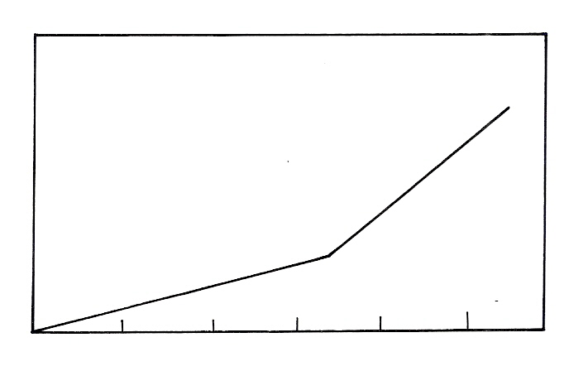
I (Ni) / I (Al)
% Ni
0
5
10
15
20
25

Fig. 7.27. ESCA intensity plot for Nickel on alumina catalyst of varying nickel content (ref. 30)

The plot of Ni/Al ESCA intensity vs. their bulk metal content for a series of nickel containing catalysts is shown in Fig. 27. A linear variation is observed between 0 and 17 wt % of Ni, but shows a deviation around 17 wt % and the slope increases. In 0-17 wt % range, nickel binds to the alumina lattice in a highly dispersed fashion. At percentages higher than 17 wt %, crystallites of NiO begin to form on the surface. Hence, the intensity variation with composition shows two linear regions. This analysis has enabled to detect the change in the nature of the Ni species present on the catalyst.
Consider a catalyst system where crystallite growth of metal particles takes place not just by agglomeration but due to sintering at high temperature treatment. A correlation can be expected between I_{m} / I_{s} intensity ratio (by XPS) and the metal crystallite size measured by XRD. Measurements were made on catalysts containing the same percentage of metal but treated at different temperatures to produce metal crystallites of different sizes. As the metal particles become larger, I_{m} / I_{s} ratio measured by ESCA decreases. This is consistent with interpretation that more of the metal dispersed over the surface in small particles can be seen by the spectrometer than for large particles. Not all photoelectrons ejected from metal atoms can escape from the large particles; where as most of the electrons can escape from the small particles.

4.1.3 ESCA Intensity Ratio as a Probe of the Catalyst Structure

One of the unknowns in the studies of heterogeneous catalysis is the manner in which the catalytically active component interacts with the physical structure of the support material. Since ESCA is a tool for the surface characterization, the intensities of the observed electron lines reflect surface structure of the supported metals and oxides. Information on the depth of metal (Rh) penetration into the pores of the

carbon supports of different physical properties was obtained from ESCA measurements on Rh/C catalysts by Brinen and Schmitt [31].

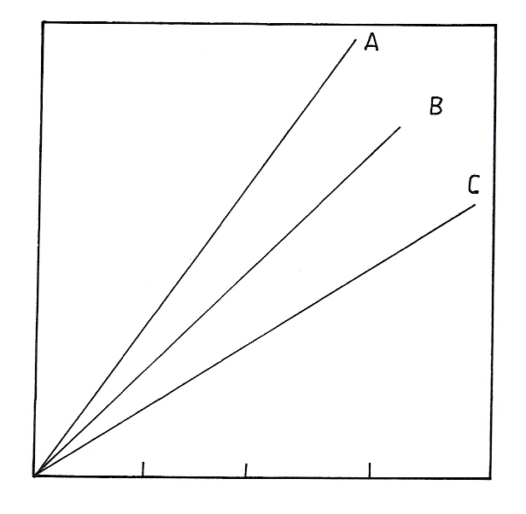
Rh / wt %
I Rh / I C
Fig. 7.28. Variation of I_{Rh} / I_{C} for various loadings of rhodium on three different carbons. carbon A = 10 m²/g; carbon B = 850 m²/g with average pore radius 11 Å; carbon C = 560 m²/g with average pore radius 53 Å
(ref. 29)

Intensity ratios vary directly with metal loading for three catalyst supports A, B and C. However intensity ratios are different for different carbon supports and cannot be explained on the basis of surface area alone, since large surface area carbon B (850 m²/ g) has intensity ratio (I_{Rh} / I_{C}) intermediate between carbon A (10 m²/g) and carbon C (560 m²/g). The difference can be attributed to the pore structure, since surface area of carbon A is low, Rh on impregnation can form 5-6 atomic layers on the support and a large fraction of Rh is accessible to ESCA. Carbon B is microporous and Rh is preferentially deposited in the outer portion of the pores during catalyst preparation and is expected to be non-uniform. The effect is less important for carbon C since Rh particles are easily coated on the large pores and the intensity variation is uniform throughout the support and may also represent high dispersion. These results suggest that the understanding of the physical structure of the support is required for the proper interpretation of the ESCA spectra of metals loaded on porous supports. In the case of reactions such as hydrogenation of benzene, which is a facile reaction the activity is directly dependent on the accessible metal surface, and hence a direct correlation between the catalytic activity and intensity ratio (I_{m} / I_{s}) is possible.

    - Effect of preparation methods:

Au supported on CeO₂ is a good catalytic system for the oxidation of the volatile organic compounds. When two different methods such as deposition precipitation (DP) and precipitation deposition (PD) are used for the preparation of Au/CeO₂, both showed different activities. X-ray photo electron spectra of these two samples are given in Fig. 7.29.
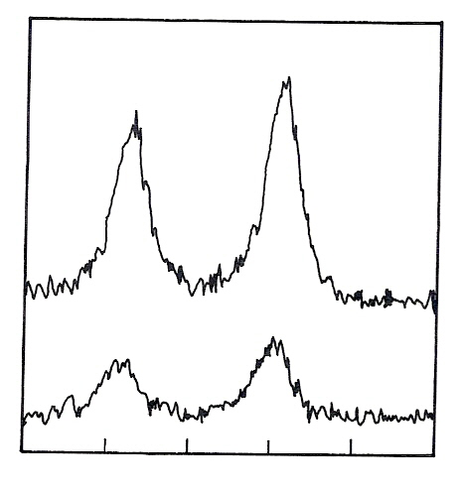
4f_{5/2}
4f_{7/2}
Au/CeO₂ (DP)
Au/CeO₂ (CP)
Binding Energy (eV)
90
88
86
84
80
82
Intensity (a.u.)
Fig. 7.29. XPS spectra of Au/CeO₂-prepared by coprecipitation (CP) and deposition -precipitation (DP) (ref. 32, 33)
It can be seen that the metallic gold on the ceria support is more if the preparation method is deposition precipitation (DP). So the Au/CeO₂ (DP) will exhibit better catalytic activity since higher amounts of active species is present on the surface.

4.1.5 Correlation Between the Atomic Ratios and the Activities

A highly dispersed Ta in a mesoporous like matrix was used for the liquid phase sulfoxidation of 4, 6-dimethyl-2-thiomethylpyrimidine to the corresponding sulfoxide. Ta₂O₅–SiO₂ catalysts were prepared by a sol–gel method using tetraethyl orthosilicate (TEOS) and tantalum (V) ethoxide as the sources of silicon and tantalum, respectively. Two families of quaternary ammonium salts were used as surfactants, [C_{n}H_{2n+1}(CH₃)₃N] Br (n = 14, 16, 18) and [(C_{n}H_{2n+1})₄N] Br (n = 10, 12, 16, 18), with the catalysts that formed were denoted as Ta-n and Ta-4-n, respectively. Tantalum on MCM-41 (Ta- MCM) was prepared using an MCM-41 support. Deposition of tantalum was carried out by grafting from an alcoholic solution of tantalum (V) ethoxide. All catalysts contained 15 wt% Ta₂O₅ as determined by ICP-AES.
As expected, the binding energies corresponding to Ta 4f_{7/2} level exhibit typical values for Ta⁵⁺ for Ta-n, Ta-4-n, and Ta-MCM catalysts. A significant difference between the bulk and surface Ta/Si atomic ratios was found (refer Table 2), with materials showing surface enrichment of tantalum in all cases. In addition, for both Ta-n and Ta-4-n catalysts, as the chain of the directing agent was lengthened, the surface Ta/Si ratio also increased, with those formed from [(C_{n}H_{2n+1})₄N] Br showing significantly higher ratios than those prepared using [C_{n}H_{2n+1}(CH₃)₃N] Br. It is not clear whether the increase in the Ta/Si ratio observed is due to the decreased tantalum found in the pores of the catalyst or to the higher dispersion of tantalum over the surface, resulting in smaller Ta₂O₅ clusters. Both scenario would result in a higher Ta/Si ratio. The slightly higher Ta/Si XPS atomic ratio found for Ta-MCM cannot be compared with the ratios found for the Ta-n or Ta-4-n catalysts because of the significant difference in preparation method. For example, the grafting method used in the synthesis of Ta-MCM is more likely to lead to multilayer of tantalum oxide compared with the sol–gel method.

Table 7.2. XPS binding energies of Ta 4f_{7/2} and Si 2p_{3/2} levels and comparative XPS and chemical Ta/Si atomic ratios determined by ICP-AES (ref. 34)

Catalyst | XPS binding energy (eV) |  | Ta/Si atomic ratio ×10³
Catalyst | Ta 4f_{7/2} | Si 2p_{3/2} | Chemical analysis | XPS
Ta-14 | 26.4 | 103.2 | 1.15 | 6.4
Ta-16 | 26.4 | 103.2 | 1.15 | 6.9
Ta-18 | 26.5 | 103.2 | 1.15 | 7.5
Ta-4-10 | 26.4 | 103.2 | 1.15 | 10.2
Ta-4-12 | 26.5 | 103.2 | 1.15 | 13.4
Ta-4-16 | 26.4 | 103.2 | 1.15 | 18.8
Ta-4-18 | 26.4 | 103.2 | 1.15 | 19.4
Ta-MCM | 26.5 | 103.4 | 1.15 | 23.4

4.1.6 Effect of Promoter
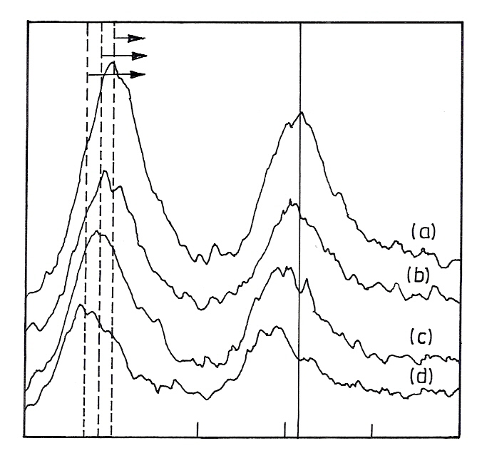
334.9 eV
334.6 eV
334.2 eV
Binding energy (eV)
335
340
345
Relative
intensity
Fig. 7.30. XPS of Pd 3d_{5/2} for sample catalysts. (a) Pd/SiO₂/ 573 K, (b) Pd–Ti/SiO₂/573 K,
(c) Pd–Ti/SiO₂/773 K, (d) Pd–10Ti/SiO₂/773 K (ref. 35)

The performance of TiO₂ modified Pd catalysts containing TiO₂ either as an additive or support in acetylene hydrogenation is well studied. The origin of the selectivity promotion by the Ti species can be understood from the following XPS results. The peak representing the binding energy of Pd 3d_{5/2} appears almost at the same position for Pd/SiO₂/573 K and Pd – Ti /SiO₂ / 573 K but is shifted to lower binding energy for Pd – Ti /SiO₂ / 773 K. The peak shift is larger for Pd–10 Ti/ SiO₂ / 773 K. Charging effects have been minimized using an electron gun shower and the observed peak positions have been adjusted in reference to the C 1s peak. The shift in binding energy is influenced not only by the electronic interaction of the metal with other components but also by the size of the metal crystallites.Takasu et al. [36] observed in their study of Pd particles which were deposited on SiO₂ showed that the binding energy of Pd 3d_{5/2} decreased by 1.6 eV when the Pd particle size increased

within a range smaller than 5 nm. The average Pd particle sizes of Pd/ SiO₂/573 K and Pd/ SiO₂ /773 K are estimated to be 23 and 33 A° respectively, based on the H/ Pd ratio. In other words, the peak is shifted to lower binding energy because Pd particles grow after reduction at 773 K. However, the above interpretation does not explain the large peak shift observed for Pd–0Ti/SiO₂/773 K because the shift should be to the same extent as that for Pd– Ti/ SiO₂ /773 K if it is solely dependent on Pd particle size. The XPS results also allow us to estimate the relative concentrations of Ti and Pd on the catalyst surface. The Ti/Pd ratio for the Pd–Ti/SiO₂ catalyst increases when the reduction temperature is raised from 573 to 773 K, suggesting that the Pd surface is covered with larger fractions of the Ti species after reduction at 773 K. The Ti/Pd ratio is significantly large for Pd – 10Ti / SiO₂ /773 K, which contains an excess amount of Ti species.

4.1.7 Distribution of the Various Oxidation States of the Active Components

X-ray photo electron spectroscopy has also been used extensively for elucidating a number of properties of materials like polymers, oxidic materials and other inorganic solids. Both supported systems of active species as well as in oxidic materials, the oxidation states, density of states and cation distributions of the transition metals in various types of geometric interstitials can be explained by the XPS studies.

a) Supported Catalyst Systems

Transition metal nitrides and carbides have been extensively studied because their catalytic properties resemble those of noble metals. The incorporation of nitrogen or carbon atoms into the lattice of a transition metal leads to an increase of d electron density at the Fermi level, and the property of the metal shifts towards those of noble metals. The similarity in chemical properties between transition metal nitrides and noble metals suggests that the former could be catalytically effective for NO elimination. A series of zeolite (H-ZSM-5)-supported molybdenum nitride catalysts with Mo loading ranging from 2 to 30 wt.% were synthesized and nitrided in a flow of ammonia. With increase of Mo loading from 2 to 30 wt. %, the degree of nitridation increased linearly with increase of Mo loading. It is observed that a catalyst with higher Mo loading exhibited higher initial activities. The nitrided 2 wt. % Mo/H-ZSM-5 catalyst was the most stable. NO conversion to N₂ remained unchanged within a test period of 15 h. For the catalysts with Mo loading above 2 wt.%, catalytic activity decreased with time on stream. After 15 h, the nitrided 2 wt.% Mo/H-ZSM-5 catalyst was the most active among the tested catalysts.
The Mo 3d spectra of the nitrided 2–30 wt.% Mo/H-ZSM-5 samples measured by XPS are shown in the Fig. 31. The relative intensities of spin-orbit doublet peaks are given by the ratio of their respective degeneracy, and the I (3d_{5/2}) /I (3d_{3/2}) intensity ratio for the Mo 3d_{5/2} –Mo 3d_{3/2} doublet is 3/2. A splitting of 3.13 eV is expected for the doublet. By means of curve-fitting, the distribution of molybdenum oxidation states was estimated. There are two oxidation states of surface Mo, the peak at binding energy of 232.6 ± 0.2 eV is assigned to the Mo 3d_{5/2} component of MoO₃, while that at 229.1 ± 0.2 eV is assigned to the Mo 3d_{5/2} component of Mo₂N. The value (229.1 ± 0.2 eV) is higher than that of Mo²⁺ (228.5 ± 0.2 eV) but slightly lower than that of Mo⁴⁺ (229.6 ± 0.2 eV). Accordingly, the Mo species of Mo₂N is denoted as Mo^{δ+}, where 2 < δ < 4. The XPS analysis of the Mo 3d binding energy shows that even at a Mo loading of 2 wt.%, there is nitrided molybdenum (Mo₂N) coexisting with MoO₃ on the surface of the zeolite. On the other hand, the proper deconvolution of the broad Mo 3d spectra of nitrided molybdenum samples, the XPS technique can provide information on the oxidation states of molybdenum species. Olivers et al. [38] studied the distribution of surface molybdenum ions as related to molybdenum loading. Based on the results of XPS measurements, and correlating Mo loading with the degree of nitridation, one can see a linear dependence between the two parameters. The Mo⁺/ (Mo² ⁺ + Mo⁶⁺) ratio increased from 0.27 to 0.68 when the Mo loading increased from 2 to 30 wt. %. At a Mo loading of 2 wt.%, 27 % of the molybdenum was nitrided. With increase of Mo loading on the zeolite, there is a clear rise in the degree of nitridation. At a Mo loading of 30 wt.%, 65 % of molybdenum was nitrided. One can deduce that the strong interaction between Mo

species and the zeolite support hinder the complete nitridation of the supported molybdenum oxide. By curve-fitting the Mo 3d profiles of the nitrided 2–30 wt.% Mo/H-ZSM-5 catalysts, the degree of nitridation was estimated (as Mo^{δ+}/(Mo^{δ+} + Mo⁶⁺) ratio); the results are summarized in Table 3. When the Mo loading on the zeolite was increased from 2 to 30 wt.%, the value of Mo^{δ+}/(Mo^{δ+} + Mo⁶⁺) increased from 0.27 to 0.68, indicating that the degree of nitridation increased with increasing Mo loading.

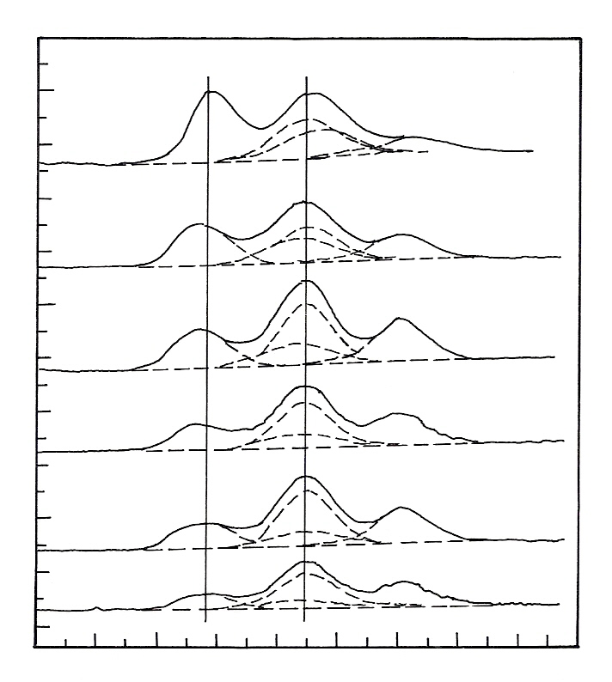
Mo 3d
229.6
232.6
30 wt%
20 wt%
15 wt%
10 wt%
6 wt%
2 wt%
Binding energy (eV)
224
226
228
230
232
234
236
238
240
242
Intensity
(a.u.)
Fig. 7.31. Mo 3d spectra of the nitrided 2–30 wt.% Mo/H-ZSM-5 catalysts recorded in XPS study (ref: 37)

Table 3: Mo 3d_{5/2} binding energies and ratios of Mo^{δ+}/ (Mo^{δ+} + Mo⁶⁺) measured by XPS for the nitrided 2–30 wt.% Mo/H-ZSM-5 samples
Mo loading (wt.%) | Mo 3d_{5/2} Mo₂N (Mo^{δ+}) | MoO₃ (eV) | Mo^{δ+}/(Mo^{δ+} + Mo⁶⁺)
2 | 229.2 | 232.6 | 0.27
6 | 229.2 | 232.6 | 0.32
10 | 229.0 | 232.5 | 0.37
15 | 229.1 | 232.6 | 0.42
20 | 229.1 | 232.6 | 0.53
30 | 229.2 | 232.7 | 0.68

b) Transition Metal ions in Oxides

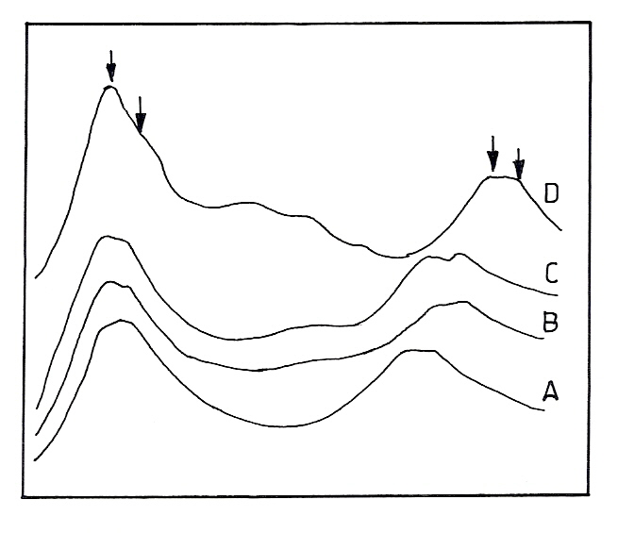
2p_{3/2}
2p_{1/2}
Binding energy (eV)
Fig. 7.32. XP spectra of typical mixed valence states of oxide ion (A) La_{0.5}Co_{0.5} MnO₃ (B) SrFeO₃₋₈ (C) Eb_{0.6} Sr_{0.4} FeO₃ (D) Nd_{0.5}Sr_{0.5} CoO₃ (ref. 39)
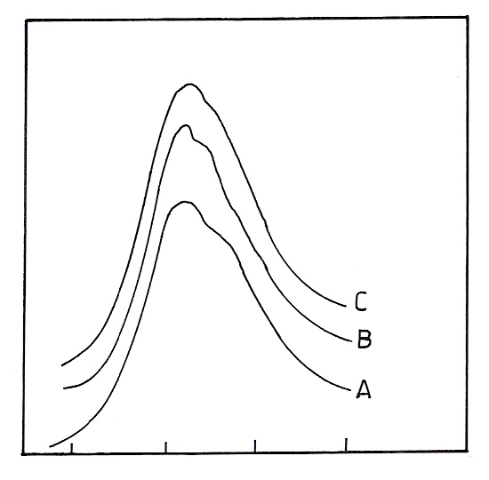
45
48
51
54
Binding energy (eV)
Fig. 7.33. Mn 3p bands showing 3+ and 4+ states (A) LaMnO₃ (B) La_{0.5}Co_{0.3} MnO₃ (ref. 39)

The XP spectra of a few typical mixed valence oxides (substituted LaMnO₃, SrFeO₃ and SrCaO₃) reproduced from reference 39 are given in Fig. 7.32. It is seen that both the 2p_{1/2} and 2p_{3/2} emissions are

doublets with lower energy emission arising from the +3 state and the higher energy line arising from the +4 state. Transition metal 3p emissions also show +3 and +4 ions distinctly as shown for a few typical manganese oxides (Fig. 7.33). The valence bands also show the presence of multiple oxidation states although the assignments are not as straight forward due to closeness of bands arising from different final state effects. Table 4, the values of core level binding energy of a number of mixed valence oxides along with those of some reference oxides are assembled to show how well XPS can identify the different oxidation states. This is particularly true for cobaltites since oxidation state Co³⁺ and Co⁴⁺ which could not be identified even by MossBauer spectroscopy, could be identified by XPS which has a time scale of 10⁻¹⁶ sec wherein complications due to electron hopping do not arise.

Table 74. Core level binding energies (eV) of Mn, Fe and Co in mixed valence Oxides (ref. 29)

Compound |  | 2p_{3/2} | 2p_{1/2} | 3p
LaMnO₃ | Mn³⁺ | 640.9 | 652.9 | 48.3
 | Mn⁴⁺ | 642.1 | 654.1 | 49.4
La_{0.7}Ca_{0.3}MnO₃ | Mn³⁺ | 640.8 | 652.7 | 48.2
 | Mn⁴⁺ | 641.8 | 653.8 | 49.4
La_{0.5}Ca _{0.5}MnO₃ | Mn³⁺ | 641.1 | 652.6 | 48.4
 | Mn⁴⁺ | 642.0 | 653.7 | 49.4
Mn₂O₃ |  | 641.2 | 652.9 | 48.3
MnO₃ |  | 641.9 | 653.5 | 49.5
SrFeO_{3-x} | Fe³⁺ | 710.0 | 723.2 | 55.4
 | Fe⁴⁺ | 711.0 | 724.2 | 56.2
Eu_{0.6}Sr_{0.4}FeO₄ | Fe³⁺ | 709.6 | 723.1 | 54.9
 | Fe⁴⁺ | 710.8 | 724.0 | 56.0
Fe₂O₃ | Fe³⁺ | 710.3 | 723.6 | 55.2
SrCoO | Co³⁺ | 779.8 | 795.3 | 60.4
 | Co⁴⁺ | 780.6 | 795.8 | 61.2
Nd _{0.6}Sr _{0.4}CoO₃ | Co³⁺ | 780.0 | 795.0 | 60.6
 | Co⁴⁺ | 781.0 | 796.0 | 61.6
NdCoO₃ | Co³⁺ | 780.1 | 795.5 | 60.5

4.1.8 Electronic Structure of the Active Species

Nanometer Au particles deposited on different supports of mesoporous Al₂O₃ via Homogeneous Deposition Precipitation method (HDP) has been used as highly active/selective and reusable catalysts for epoxidation of styrene. The dispersion and average size of the gold particles are dependent on the number of surface basic sites on the supports.
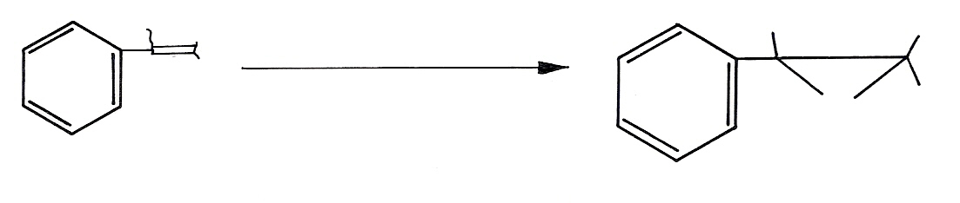
TBHP
Au / meso- Al₂O₃ catalyst
H
H
H
O
H
H
H
Scheme 1. Styrene epoxidation reaction using the Au/Al₂O₃ catalyst

Although the catalytic activity of gold catalysts in the low temperature CO oxidation has been intensively studied during the last decade, the nature of the active species is still discussed. It has been suggested that the role of the metal oxide is the stabilization of the gold nanoparticles and that the reaction takes place on the gold surface. Some authors proposed that the reaction takes place at the gold/metal oxide interface and that the metal oxide could act as a source of oxygen. Also the electronic structure of gold in active catalysts is unclear, but most of other authors suggest metallic gold to be the active species. The XPS spectra of Au 4f region (Au 4f_{7/2} and Au 4f_{5/2}) are employed to investigate the state of gold on the different supports. The results indicated that only a binding energy of 83.8 eV for the Au 4f_{7/2} emission and 87.5 eV for the Au 4f_{5/2} electron (ΔE = 3.7 eV) with the change of supports for the fresh samples. The binding energy indicates exclusively Au⁽⁰⁾-particles without any trace of higher oxidized species on the four kinds of Al₂O₃ surface. The surface basicity of the support has no effect on the state of gold if the Au catalysts prepared under the conditions of HDP method [37].

4.1.9 Synergetic Enhancement of Activity by Promoter and Support

The nature of surface cesium compounds in cesium-modified ruthenium-sibunit (a new class of porous carbon-carbon composite materials combining advantages of graphite (chemical stability and electric conductivity) and active coals (high specific surface area and adsorption capacity)) catalysts for ammonia synthesis was studied by X-ray photoelectron spectroscopy. It was found that, on the reduction of promoted catalysts, cesium was incorporated into the micropores of sibunit to form quasi-intercalation cesium-carbon bonds. In this case, the chemical state of cesium was close to its state in cesium sub oxides. The subsequent interaction with atmospheric oxygen resulted in the oxidation of cesium, which occurred as cesium peroxide and cesium superoxide in the oxidized samples. Ruthenium occurred in a metallic state in the reduced samples. The activity of a Ru-Cs⁺/C (1) sample was higher than that of inactive Ru-Cs⁺/C (2). This is a consequence of the higher surface concentration of ruthenium, which is most likely due to an increase in the dispersity of metal particles, as well as of the higher probability of the interaction between the promoter and the active component due to a symbiotic increase in the surface concentrations of both ruthenium and cesium [40].

4.1.10 Metal Support Interaction

a) Nickel-Alumina System

Catalysts containing about 8 wt % of the metal, prepared by impregnation of nickel nitrate onto, alumina were calcined at different temperatures (873 – 1673 K) in air for 6 h. Hydrogen absorption was rather difficult to measure on majority of the samples. XPS measurements were carried out on these samples and the binding energy value along with full width at half maximum are listed in Table 5. All the samples have Ni 2p_{3/2} primary peaks around 857 eV as well as satellite peaks around 863 eV. Even after reduction there was no appreciable change in the intensity or binding energy values of these samples or FWHM. This indicated that there was no new nickel species formed after reduction. Comparison of the binding energy values of these samples with the standard values for the Ni⁰, NiO and NiAl₂O₄ suggests the presence of nickel aluminate, (surface spinel) which is difficult to reduce in all the calcined samples. Apart from the surface nickel aluminate, bulk spinel was also formed as was

evidenced from XRD. This may suggest the interaction between nickel and alumina support when calcined at temperatures greater than 873 K.

Table 7.5. Binding energy values of Ni/Al₂O₃ calcined in air at different temperatures [41]

Sample | Temp K | Ni 2p_{3/2} | Sat | ΔE_{sat} | O 1s | Al 2p
1 | 873 | 856.6  (3.8) | 863.6 | 7.0 | 531.4  (3.6) | 74.2  (3.0)
2 | 1073 | 857.4  (3.7) | 864.2 | 6.8 | 532.2  (3.6) | 75.2  (2.8)
3 | 1273 | 856.3  (3.5) | 863.4 | 7.1 | 531.2  (3.5) | 74.2  (2.3)
4 | 1373 | 856.0  (3.8) | 863.1 | 7.1 | 530.9  (3.4) | 74.0  (2.7)
5 | 1473 | 856.6  (3.2) | 863.2 | 6.6 | 531.9  (3.1) | 74.9  (2.6)
6 | 1673 | 856.2  (3.8) | 862.4 | 6.2 | 531.3  (3.1) | 74.2  (2.5)
Ni⁰ | --- | 852.6  (2.4) | --- | --- | --- | ----
NiO [42] | --- | 854.2  (3.6) | 861.0 | 6.8 | 533.6  (3.4) | ----
NiAl₂O₄  [43] | --- | 857.0  857.2 | 863.1  --- | 6.1  --- | 530.6  --- | ---  ---

Samples 1-6 refer to calcinations at different temperatures given in column 2. Values in the parenthesis represent FWHM.

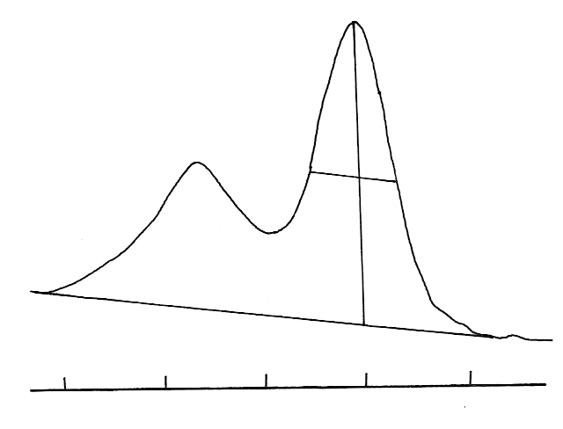
FWHM = X +Y
α = X / Y
E_{b}
Ni 2p_{3/2}
X
Y
868
864
860
856
852
Binding energy (eV)
Fig. 7.34. Ni 2p parameters used in this study, E_{b} binding energy; FWHM = peak width at half maximum, α = asymmetry factor (ref. 29)
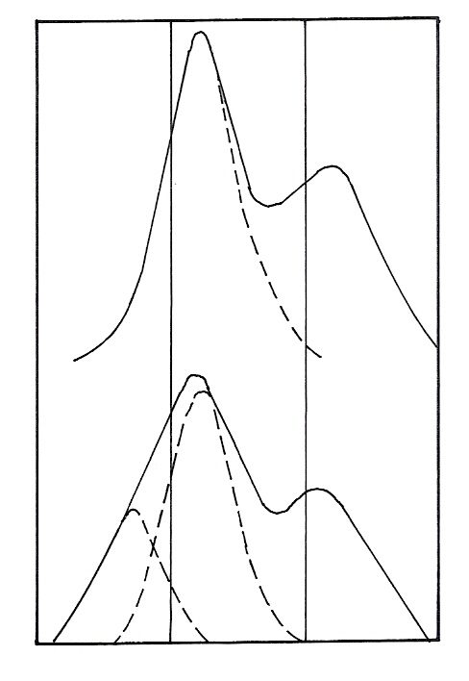
850
856
862
868
Ι
ΙΙ
Ι
Intensity (a.u.)
Binding energy (eV)

Fig. 7.35. XP spectra of a fresh and reduced nickel mordenite (ref. 43)

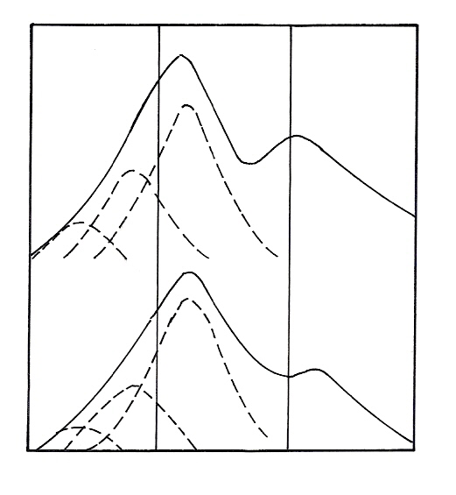
Ι
ΙΙ
ΙΙΙ
Ι
ΙΙ
ΙΙΙ
850
856
862
868
Binding energy (eV)
Intensity (a.u.)
Fig. 7.36. XP spectra of reduced samples of NiNaM (ref. 43)

b) Nickel Mordenite

Ni²⁺ ion in zeolite system is not easily reducible and it depends on several factors. It is rather difficult to get a homogeneous dispersion of the metal. The problem of reduction of Ni ions incorporated by ion- exchange in mordenite (zeolite) can be understood with the help of XPS studies. The XPS spectra of fresh (unreduced) and reduced nickel mordenite are shown in Fig. 35. The fresh catalyst has a primary peak at 857.2 eV with FWHM of 3.8 eV and a satellite peak at 863.2 eV. On reduction, the primary peak broadened with the appearance of a shoulder around 854 eV, indicating a new species. Deconvolution of the peak shows two species of Ni peaks I and II, corresponding to binding energy 857.4 eV (FWHM, 3.8 eV) and 854.2 eV (FWHM, 3.4 eV) respectively. A perusal of the XP spectrum in Fig. 36, for other reduced samples of NiNaM also shows that spectra are broad and unsymmetrical with FWHM greater than 6 eV. Deconvolution of the peaks and comparison of the binding energies for various nickel species revealed that a multiple species of Ni (Ni⁰, Ni ⁺, Ni²⁺) are present in the reduced sample. It is also clear that the contribution of the Ni species to the total spectra is relatively small. XPS peaks along with hydrogen adsorption measurements on Ni mordenite catalysts confirm the difficulty of reduction of Ni²⁺ ions to Ni⁰. When Ni²⁺ is supported on zeolite, incomplete reduction is responsible for low dispersion of the metal. The data used for the identification of various species on nickel mordenite by XPS after various reduction treatments are summarized in Table 7.6.
Values in parentheses give FWHM in eV. ΔE sat = primary to satellite line separation. F and R represent unreduced (fresh) and reduced samples of NiNaM. 3 to 10 refer to nickel mordenite prepared with varying concentrations of nickel nitrate.

Table 7.6. Binding energies of various species in different Ni- Mordenite catalysts

Catalyst | Ni 2p_{3/2} | sat | ΔEsat | Si 2p | O 1s | Ref.
3 (F) | 857.2 (3.8) | 863.2 | 6.0 | 103.7 (2.4) | 532.5 (2.4) | 43
3 (R) | 857.4 (3.8)  854.2 (3.4) | 862.8 | 5.4 | 103.3 (2.4) | 532.3 (2.4) | 43
4(R) | 857.2 (3.8)  854.8 (3.2)  852.4 (2.2) | 862.6 | 5.4 | 103.3 (2.4) | 532.2 (2.4) | 43
5 (R) | 857.4 (3.8)  855.0 93.2)  852.6 (2.2) | 863.2 | 5.8 | 103.4 (2.4) | 533.1 (2.5) | 43
6 (R) | 857.2 (3.8)  854.8 (3.2)  852.4 (2.2) | 862.8 | 5.6 | 103.2 (2.4) | 532.3 (2.4) | 43
7 (R) | 857.4 (3.8)  855.0 (3.2)  852.2 (2.2) | 862.8 | 5.4 | 103.3 (2.4) | 532.4 (2.4) | 43
10 (R) | 857.4 (3.6)  854.4 (3.2) | 863.4 | 6.0 | 103.3 (2.4) | 532.4 (2.4) | 43
Ni (0) | 852.8 (2.0) | 858.6 |  |  |  | 44
NiO | 854.2  854.8 (4.2)  854.2 | 861.0 |  |  | 529.7 | 43  45
Ni₂O₃ | 856.9 | 862.8 |  |  |  | 46
NiNl₂O₄ | 855.2  857.0  857.2 | 863.1 |  |  | 530.6 | 45  46  47
Ni(OH)₂ | 856.0  856.3 (4.1)  855.6 | 862.2 |  |  |  | 43  48

4.1.11 Surface Growth of the Active Metal

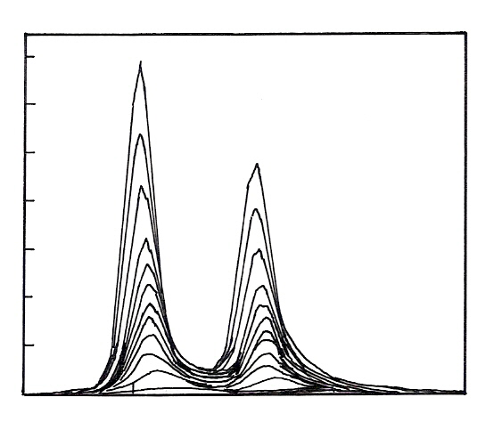
Binding energy (eV)
330
335
340
345
350
2000
4000
6000
8000
10000
12000
14000
0
Intensity
Pd 3d_{5/2} (arb. U.)
Fig. 7.37. Variation of the Pd 3d_{5/2} photoelectron signal during the Pd layer growth on γ-Al₂O₃ substrate (ref. 49)

From successive XPS measurements it is possible to observe the over layer growth on the support as can be seen directly from the XPS spectrum given in Fig. 7.37. It shows typical variations of Pd 3d_{5/2} signal during the layer growth on the substrate. Beside the intensity enhancement, two effects can be seen. The binding energy E_{B} is shifted to higher values for smaller particles, and the FWHM of peaks decreases during the growth. FWHM parameter variations are usually associated with mean coordination number of cluster atoms.

4.1.12 Acidity of the Catalysts

12- Tungsto phosphoric acid and its salts were prepared and calcined at 573 K and their acid strength distributions were evaluated using visible Hammett indicators. In view of the observed gradation in the acidity of HPW and its salts, the oxygen 1s lines of these compounds was scanned and are shown in Fig. 38.The spectra obtained from the acid and its salts of Al and Na are given. It is seen that the oxygen 1s peak of the Na salt is at a lower binding energy as compared to that of the free acid or the aluminium salt. It is also to be noted that the oxygen 1s peak of sodium salt is asymmetric which could be due to the contribution from low binding energy oxygens which are more negatively charged as compared to the majority of other oxide ions of the PW₁₂O₄₀³⁻ anion. Eventhough one could guess the least acidic nature of the Na salt from the absolute binding energy values of the oxygen 1s peak, it is not clear whether this approach can be used for comparative evaluation of acidity of a number of heteroploy acids as the observed shift and the asymmetry of the oxygen 1s peak is small. Similarly XPS peaks of 4f level of W are shown in Fig. 39. It can be concluded that though in principle the relative acidity of the salts of heteropoly acids should be reflected in the binding energy shifts of the cation of the salt and oxide ions, these shifts are too small to be monitored directly. The relative acid strength distribution between the various salts can probably be deduced from XPS measurements only when one considers the difference between the peak positions of the cation and anion. The difference between the oxygen 1s line and the tungsten 4 f line was found to be 495.5 eV for the free acid, 495.4 eV for the aluminium salt and 495.1 eV for the sodium salt which reflects the order of acidity of these substances.
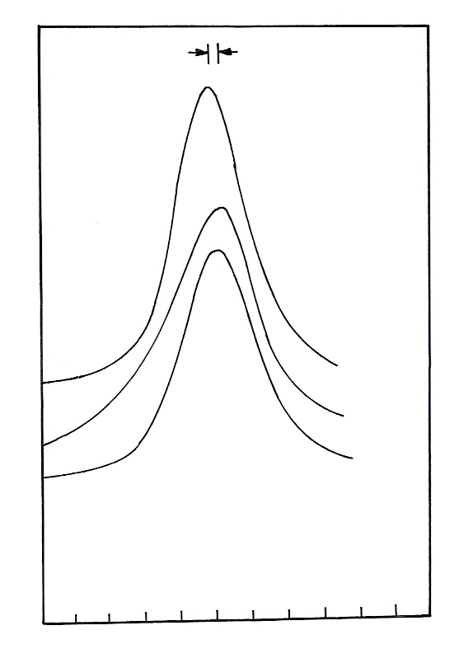
525
530
535
Na
H
Al
Binding energy (eV)
N (E) arbitrary
units
Fig. 7.38. O 1s XP spectra of heteropoly acid and its salts (ref. 50)
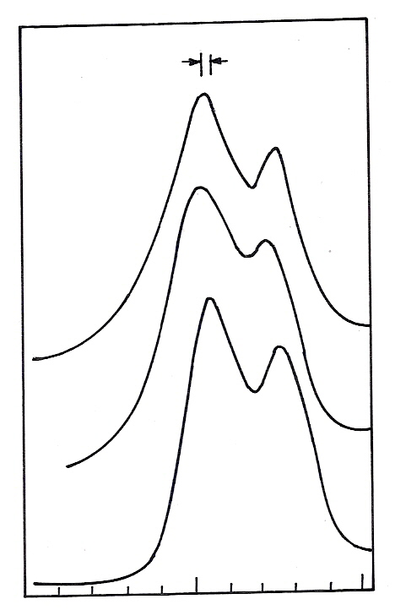
H
Al
Na
N (E) (a.u.)
30
35
40
Binding energy (eV)
Fig. 7.39. 4f XP spectrum of heteropoly acid along with spectra of its Al and Na salts (ref. 50)

4.1.13 Cation Distribution in Spinels:

Nickel magnetite annealed at 673 K in vacuum can have either of the two cation distributions.
(1) (Ni ²⁺_{0.1} Mn ³⁺ _{0.9} ) _{t} [Ni ²⁺ _{0.9} Mn ³⁺ _{1.1}]O₄
(2) (Ni ²⁺ _{0.1} Mn²⁺ _{0.9}) _{t} [Ni²⁺_{0.9}Mn ³⁺_{0.2} Mn ⁴⁺ _{0.9}]O₄
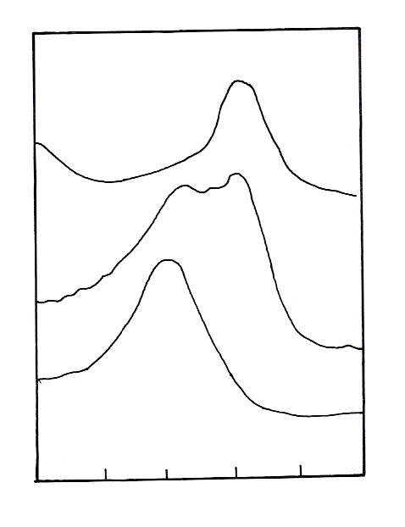
54
52
50
48
46
44
Intensity
(a.u.)
A
B
C
Binding energy (eV)
Fig. 7.40. Comparison of Mn 3p of NiMn₂O₄ (B) with that of MnFe₂O₄ (C) and NiMnZnO₄ (A) (ref. 51)

In configuration (1); trivalent manganese is present in tetrahedral as well as octahedral sites and the only effect on the core level may be caused by the site differences. The effect of site difference upon binding energies of core levels is small and may be of the order of a few tenth of an electron volt. In configuration (2), the main portion of the octahedral manganese ions is tetravalent and the ions at the tetrahedral sites are divalent which may result in the shift of binding energies by about 2 eV. As the ligands are oxygen ions for both the lattice sites, and since the covalency effects are supposed to have only minor effect, the core levels of Mn²⁺ and Mn⁴⁺ ions must be distinguishable. The 3p levels of manganese in NiMn₂O₄ are shown in Fig. 40 together with those of MnFe₂O₄ and NiMnZnO₄. The separation into 3p_{1/2} and 3p_{3/2} is not seen in the ferrite or in the zinc compound, although the energy difference is of the order of 1 eV. The Mn 3p lines have a FWHM of 1.8 and 2.8 eV for the ferrite and zinc compound respectively. In the case of zinc compound, the larger FWHM value could be caused by the reduction of some manganese ions in the spectrometer. However the majority of the Mn ions in MnFe₂O₄ and MnNiZnO₄ are supposed to be di and tetravalent respectively. Comparing the 3p spectra in NiMn₂O₄ with those in MnFe₂O₄ and MnNiZnO₄, one can say that the NiMn₂O₄ spectrum is a superposition of the other two spectra. This shows the simultaneous presence of Mn²⁺ ions (tetrahedral as in MnFe₂O₄) and octahedral Mn⁴⁺ ions (as in NiMnZnO₄). The binding energy values for the 2p levels for Mn⁴⁺ ions in NiMn₂O₄ and NiMnZnO₄ were shifted by 1.5 to 1.9 eV to higher values with respect to the 2p levels of the Mn²⁺ ions in other spinels. The 2p_{3/2}-2p_{1/2} separation has a value 12 eV, though splitting of lines due to the presence of Mn²⁺ and Mn⁴⁺ was not observed. The presence of these

ions (Mn²⁺ and Mn⁴⁺) in NiMn₂O₄ could be deduced from the FWHM values (4.5 eV) as compared to a value of 3 eV for other compounds where there is no combination of Mn⁴⁺ and Mn²⁺ ions.

4.1.14 Deactivation of the Catalysts

a) Oxychlorination Catalysts

Copper chloride on alumina is used as catalyst for oxychlorination of ethylene. The oxidation states of copper in the catalyst system influences the catalytic activity. The reason for catalyst activation was monitored by analyzing and comparing binding energy values of copper in fresh and spent catalysts. Cu²⁺ species show typical satellite due to shake up electrons associated with 2p_{1/2} and 2p_{3/2} energy levels, whereas these satellites are absent for Cu⁺ species. The absence of satellite indicates the absence of Cu²⁺ species, whereas the presence of them indicates copper to be in a mixture of +2 and +1 states or +2 states only. A look at the XP spectra of the catalysts in the region of Cu 2p_{1/2} and Cu 2p_{3/2} binding energies and comparison with that of the pure compounds suggests that the core of the spent catalyst contains only Cu⁺ phase as indicated by the absence of satellite , whereas the shell contains Cu⁺ and Cu²⁺ species. The copper binding energies of 932.8 eV (2p_{3/2}) and 952.8 eV (2p_{1/2}) correspond to Cu⁺ from the compound CuAl₂O₂. Formation of such an irreversible phase under reaction conditions may upset the redox equilibrium between Cu⁺ and Cu²⁺ states and contribute to the catalyst deactivation.
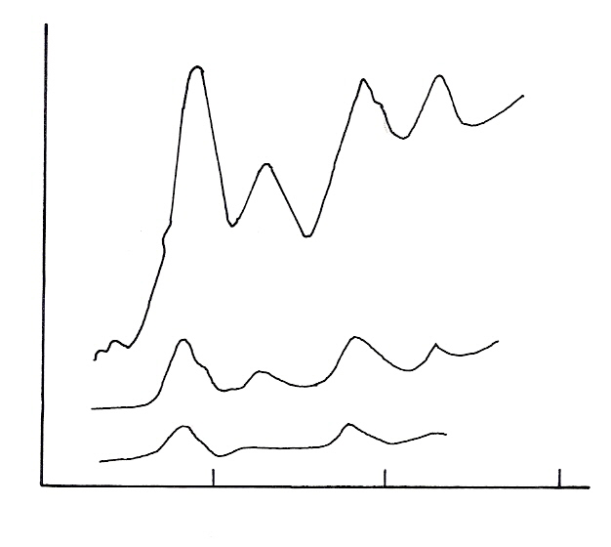
Fresh
Used Shell
Used core
915
935
955
Binding energy (eV)
Intensity
(CPS)
975

Fig. 7.41. XP spectra of oxychlorination catalyst in region of copper (ref. 52)

b) ZSM-5 - MTG Ccatalysts

ZSM-5 is an important catalyst for the conversion of methanol to gasoline and carbon deposits gradually during the reaction and deactivates catalyst to the point where it becomes inactive. ZSM-5 has an internal channel with a surface area of about 400 m²/g and an external area of 5 m²/g. This catalyst has been deliberately coked with carbonaceous residues to various loadings in the range 0-17 wt % of C by reacting with methanol feed for different durations. If carbon deposits only internally then fractions of the carbon in the outer 5-10 nm of the crystallite would be visible by XPS. On the

other hand, if C deposits on the external 5 m²/g surface, XPS would detect the rapid build up of surface coke. As seen from Fig. 42 it is clear that below 10 wt % coke, the majority of zeolite crystals fill their internal pores with coke and above 15 wt %, carbon begins to precipitate on the external surface, resulting in a dramatic increase in surface carbon levels.
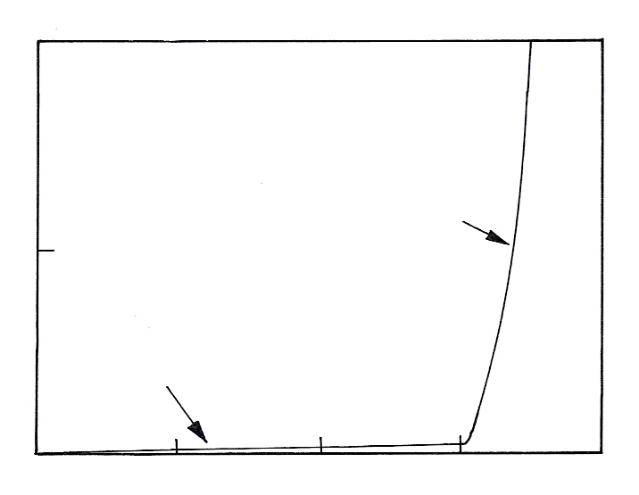
XPS Surface
C/Si
0
20
40
5
10
15
Surface coking
Channel filling
Wt % Carbon
0
20

Fig. 7.42. XPS – derived surface C/Si ratios vs. coke loading for ZSM-5 zeolites, coked by reacting in a methanol feed for different durations. Comparison of calculated C/Si ratios for two different mechanisms: (a) Channel filling and (b) coking on the external crystal surfaces indicates that the channels become full at 15.0 ± 0.5 wt % C. Beyond this point surface coking predominates and the silicon signal is rapidly attenuated by the external carbon over layers. (ref. 53)

4.1.15 Effect of Pretreatment of Catalysts

The effect of successive reduction treatments on a hydrodesulphurization catalyst, cobalt-molybdenum – alumina is shown in Fig. 7.43. The change in the Mo 3d spectra is very well pronounced as the time of the heat treatment increases. The air fired catalyst in spectrum a contains entirely Mo (VI) at the surface, but with repeated hydrogen reduction the spectrum changes radically and can be curve resolved into Mo (VI) (V) and (IV) contributions. The chemical state of the surface in spectrum (f) contains approximately equal proportions of the three oxidation states [54].

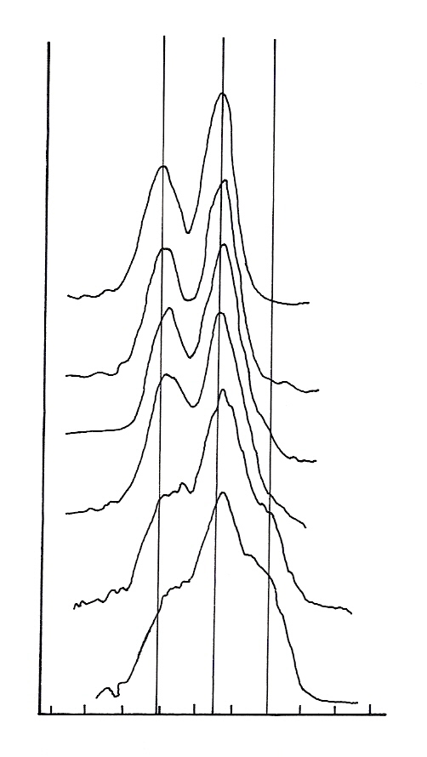
Binding energy (eV)
236.1
233.0
229.9
242
238
234
230
226
a
b
c
d
e
f
Intensity
(a.u.)
Fig. 7.43. The changes in Mo 3d XPS spectrum from a cobalt – molybdenum – alumina catalysts during successive reduction treatments in hydrogen at 500 °C. a) Air- fired catalyst; b) Reduction time 15 min. ; c) 50 min.; d) 60 min.; e) 120 min. ; f) 200 min. (ref. 27)

4.1.16 Surface Oxidation

The oxidation of metallic surfaces by oxygen is illustrated by considering nickel as example. At low oxygen exposures, emission from a level characteristic of adsorbed oxygen is observed at 5 eV below the Fermi energy, in addition to the emission from the metallic d bands of the Ni within 3 eV of the Fermi energy. Further exposure results in the spectrum losing its metallic character and becoming insulator-like; in other words the density of states at the Fermi energy has nearly vanished. By comparison with the spectrum of bulk NiO in Fig. 7.44, one can identify the levels for oxidized Ni near 2 eV and 5 eV with contributions of the d-electrons of oxidized nickel and with surface oxide p bands. Thus the spectra show that oxidized Ni is similar to bulk NiO.
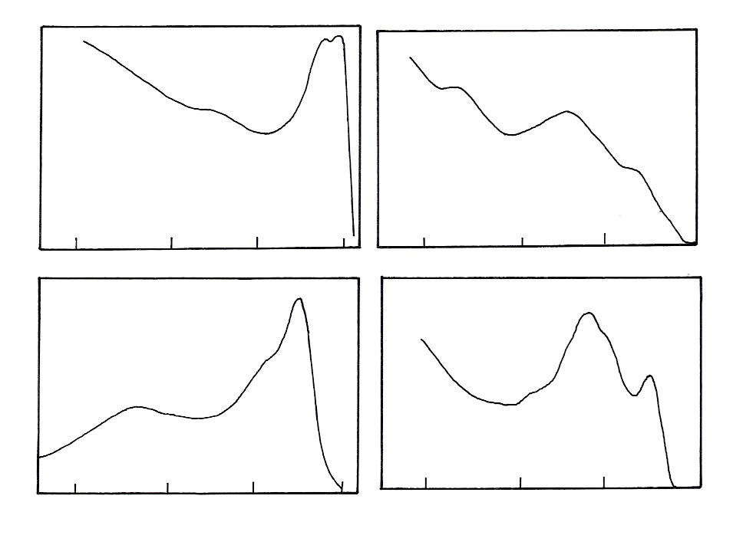
12
8
4
0
Intensity
Binding energy (eV)
(b)
(a)
(c)
(d)
12
8
4
0
Fig. 7.44. (a) UPS spectra for clean Ni and for Ni with a half monolayer of chemisorbed oxygen (b) Spectrum of surface oxide formed by oxygen exposure. This spectrum shows features similar to that of bulk (100) – single crystal NiO (c) Ni²⁺ 3d state emission and oxide p-band emission (d) XPS for bulk NiO showing the Ni²⁺ 3d state emission (ref. 55)

4.1.17 Study of Adsorption Phenomena

The X-ray photoelectron spectra obtained for the adsorbed CO on Ni (100) at 77 K are shown in the Fig. 45 (a)Spectrum in this figure corresponds to the 2 σ (C (1s)) level region and b) to 1 σ O ((1s)) level region. In both cases, in addition to the main emission at 286 eV and 532 eV respectively, shoulders appear at ∼ 291 eV and ∼ 537 eV with respect to Fermi level. The separation between the shoulder and main peak is almost 6 eV in both the cases. The corresponding spectra obtained for CO adsorbed on Ni (100) at 100 K are shown in the same Fig. 45 for two coverages namely 0, 3L, and 7.0 L of CO. The positions of the peaks are at 285.4 eV and 531.1 eV at 0, 3 L exposure, while they are at 285.5 eV and 531.2 eV at 7.0 L exposure. The shift in the binding energy with coverage is very small.
The positions of the peaks due to 2 σ or 1σ emissions are around ∼ 286 eV and ∼ 531 eV referenced to E_{F}. These positions are approximately 2 eV higher than those observed for atomic adsorption of C and O on these surfaces. In addition to these main peaks, peaks appear around 290 eV, which is considered to be due to shake – up process. The satellite structure observed in the core level excitations for adsorbed CO is usually considered in terms of screened and unscreened states. These situations are based on the assumption that the 2 π level of CO is pulled down below the Fermi level of the adsorbent. Another possibility is that the satellite peak at ∼ 6 eV with respect to the main core level emission peak is due to simultaneous excitations of the 5 σ or 1 π to 2 π levels occurring together with the ejection of the photoelectrons.

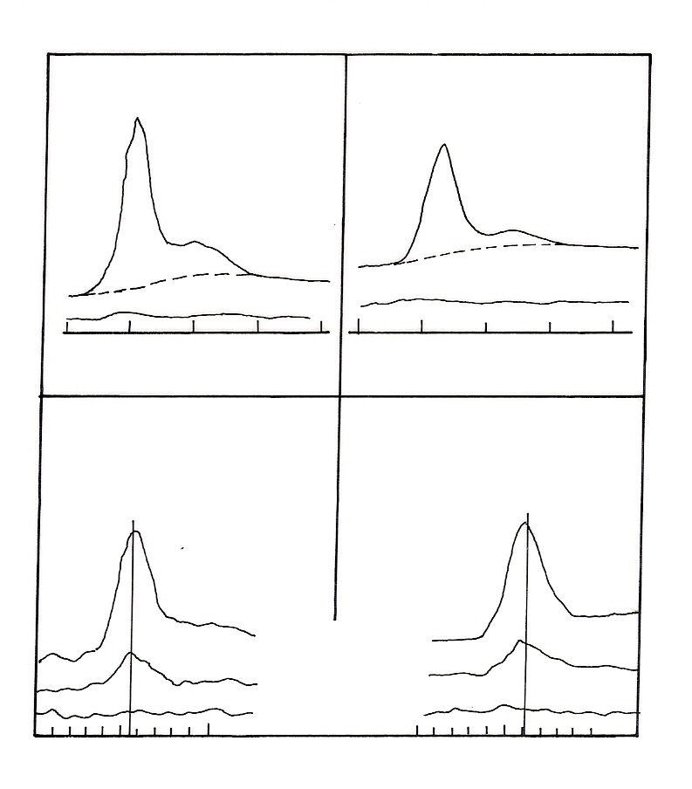
(a)
(b)
(a)
(b)
C (1s)
O (1s)
C (1s)
O (1s)
280
285
290
295
300
525
530
535
540
545
E^{F}_{B} (eV)
CO / Ni (100)
T = 77 K
CO / Ni (100)
T = 100 K
(x4) clean
Clean
(x4)
(x1)
E^{F}_{B} (eV)
E^{F}_{B} (eV)
E^{F}_{B} (eV)
280
285
290
530
525
535
(a) clean
(b) 0.3 L CO
(c) 7.0 L CO
Fig. 7.45. X-ray photo electron spectra of adsorbed CO on Ni (100): (a) after adsorption at 77 K (ref: 56) b) after adsorption at 100 K (ref. 57)

4.1.18 Temperature Effects in Solid State Materials

It is possible that the electron generated by the source and heat produced can sometimes decompose the complex i.e., the organometallic complexes used as the precursors for catalysts. In such cases one has to interpret the spectra obtained taking all these secondary effects that can occur inside the spectrometer like reduction of the sample in vacuum, the charging, the decomposition of the species due to heat and electrons and all other side effects due to operating conditions. In supported catalysts depending on the dispersion and the particle size of the supported phase, the intensity ratio of I_{p} / I_{s} due to the emission from the supported phase and the support, can be small when the support is exposed and the dispersion is small or can be large if the dispersion is good and the support phase is not exposed and covered by the supported phase. This simple explanation will not hold good if the supported phases were to occupy and spread inside the pores of the support or the particles were to take different geometries, or if the supports were to function as stratified layers. Monolayer of Mg formed on the Ag (100) surface shows an alloy formation at elevated temperatures, which can be understood from the XPS studies. The Mg monolayer on the surface of Ag (100) is stable only upto a temperature of 300 K, above which a desorption sets in and finally at 420 K a Mg concentration equivalent to 0.5 monolayer remains, which forms a disordered Mg–Ag alloy with the topmost silver layers, as concluded from X-ray induced AES.
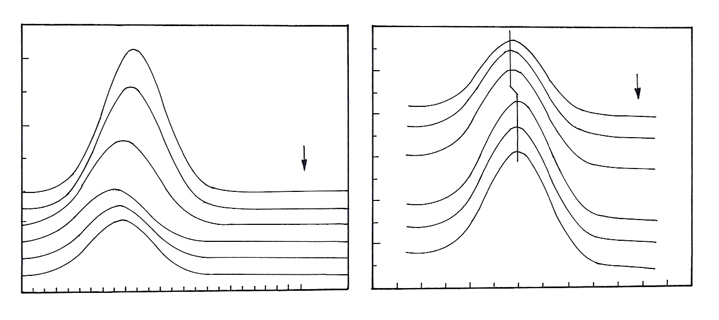
Al Kα
T
300 K
350 K
385 K
420 K
480 K
520 K
Al Kα
300 K
350 K
385 K
420 K
480 K
520 K
T
Θ_{initial} = 4 ML
Mg 1s
Binding energy (eV)

Binding energy (eV)
-375
-373
-371
-369
-367
-365
-363
Ag 3d_{5/2}
-1309
-1306
-1303
-1300
-1297
Intensity
(a.u.)
Fig. 7.46. Temperature dependent chemical shifts for Mg 1s and Ag 3d levels
Vanadium dioxide is an insulator at room temperature but undergoes a structural change at 339 K and becomes a metallic conductor. Fig. 7.47 shows that the gap created at the lower temperature, which results in the lower conductivity.
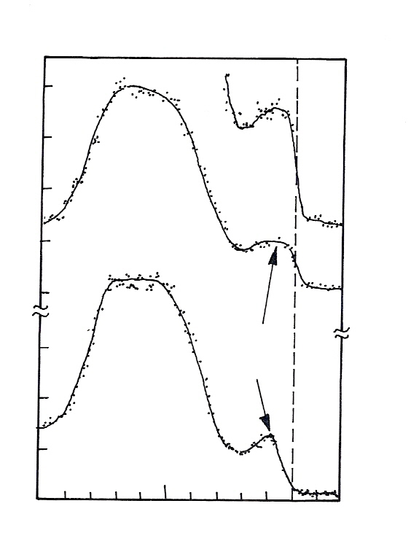
Metallic
Insulating
VO₂
V 3d
band
x 2.5
10
5
0 = E^{F}
0
0.5
1.0
1.5
2.0
0
0.5
1.0
1.5
10³ counts
per channel
Fig. 7.47. XPS valence bands of VO₂ at temperatures above and below the metal-insulator transition temperature (ref. 24)

The microscopic origin and the mechanism stabilizing the low-temperature structural order is still a matter of debate. At metal insulator transition temperature (T_{MI} = 339 K) the structure changes on cooling from a metallic tetragonal rutile structure to an insulating distorted rutile structure with monoclinic symmetry. It is visible in the E_{F} region of the XPS, the change in density of states of VO₂ when it is undergoing a metal to insulator transition.

5. Ultraviolet Photoelectron Spectra of Atoms

5.1. Introduction and Examples

The commonly used sources such as He I ( 21.2 eV) and He II (40.8 eV) are at low energies, only valence electrons can be ejected and this spectroscopy is restricted to probing bonding in metals, molecules and in adsorbed states. It is these electrons which form a chemisorption bond and knowledge of electronic density of states at a surface are of vital importance in attempts to understand the formation of chemical bonds between solid surfaces and adsorbed atoms or molecules. It is clear that the electron coming from the Fermi level has a kinetic energy E_{k} = hν - φ and the slowest electrons with E_{k} = 0 with the highest binding energy since the kinetic energies of the electrons in UPS is low between 5 to 15 eV and since the final state of the photoelectron is still in the region of the unoccupied part of the density of states of the metal, this spectrum can be considered at joint density of states of both occupied and unoccupied states. If the photon energy were to increase then the final states will be in the range corresponding to entirely free electrons in vacuum. If the photon energy increases then one can probe the true density of sates of the metals. In XPS also one probes the true density of states of the metals, but it is at a lower resolution due to broader line width of the X-ray source. UPS is most often used to study single crystals and to probe the molecular orbitals of chemisorbed molecules. UPS can provide further information on the system if the emitted electrons are both energy and spatially analyzed. This is known as angle resolved UPS (ARUPS). Using ARUPS, the band structures of clean and adsorbate covered surfaces have been determined. By changing the angle of incidence and angle of detection, the electronic orbitals from which the photoelectrons are ejected can be identified. In addition, ARUPS provides detailed information on the surface chemical bond including the direction of the bonding orbitals and the orientation of the molecular orbitals of the adsorbed species on the surface. In general UPS can be used to obtain the electronic structure of solids (complete band structure) and to study the adsorption of simple molecules such as CO and N₂ on metals. One can obtain information on chemisorption bonding by compairing the molecular orbitals of the adsorbed species with those of both the isolated molecule and with model calculations [24].

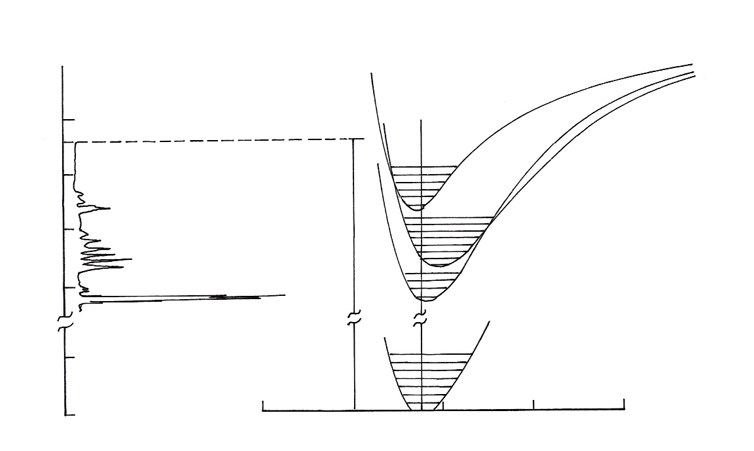
B^{2Σ}_{u}⁺
N₂⁺
A^{2Π}_{u}
X^{2Σ}_{g}⁺
X^{1Σ}_{g}⁺
N₂
0.04
0.08
0.12
0.16
0.20 nm
hν
0
22
20
18
16
2
eV
2sσ_{u}
2pσ_{g}
2p Π_{u}
21.22 eV

Fig. 7.48. Photo electron spectrum of N₂ (ref. 58)

Photoelectron spectrum of nitrogen molecule showing that it is a reflection of the potential energy curves.
The spectrum corresponds to three different transitions. These three different transitions correspond to three different electronic states of ionized nitrogen. The potential energy curves of these ionic states are shown in Fig. 48 with vibrational levels in them. Each of the peaks shows vibrational excitations. In fact the photoelectron spectrum is a reflection of the potential energy curves of the system. By 21.22 eV photon, it is possible only to access these three levels. If one has sufficiently energetic photons, it could have been possible to look at other deeper layers. From the photoelectron spectrum, it is also possible to get an idea on the kind of energy levels involved in the ionization process. These levels actually correspond to orbitals, which participate in bonding. Ionization from these levels can give information on the kind of bonding possible in the system. In this particular case, the first excitation corresponds to the removal of electron from a non-bonding orbital. The second corresponds to removal of an electron from a bonding orbital. The third corresponds to removal of an electron from a weakly anti-bonding orbital. It is clear that a vibrational spacing of the first ionic state is similar to that of the ground state. For the second one the vibrational spacing is smaller than that of the ground state. For the third one the vibrational spacing is larger than that of the ground state. If an electron is removed from a non-bonding orbital, obviously the bonding characteristics of the molecule are not disturbed. Therefore, inter-nuclear distance remains unchanged and vibrational separation is largely the same. If one removes an electron from a bonding orbital, the state that is created has less bonding character, inter-nuclear distance can increase and therefore, the vibrational quantum may be reduced. If one removes an electron from an anti-bonding orbital, the state that is created has more bonding character and therefore the vibrational quantum is larger. It is also reflected in the equilibrium internuclear distance which is unaffected in the first state and is shifted to the right in the second case and is shifted to the left in the third case. Thus photoelectron spectrum gives a qualitative idea of the kind of bonding.

5.2 Effect of He I and He II Radiation
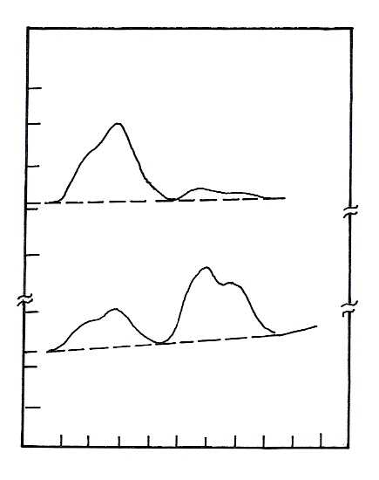
CuCl
Cu 3d
Cl 3p
hω
40.8 eV
21.2 eV
0
2
4
6
8
10
Binding energy (eV)
0
0
0
2
2
Intensity
Cl 3p
Fig. 7.49. Effect of He I and II on the UP spectra of CuCl (ref. 58)

In the photo excitation process using photons of two different frequencies with increase in final state energy an increase of overlap of the final state wave function with those of higher angular momentum initial states are expected (i.e., going from He I to He II radiation as shown in the Fig. 7.49 the overlap of valence bands increases). This is a useful property which can be employed to analyze complicated spectra. Fig. 7.49 presents a comparison spectra taken with He I (21.2 eV) and He II (40.8 eV) radiation for the valence band of CuCl. One sees that the signal from the Cu 3d emission increases relative to the signal strength from the Cl 3p electrons in going from He I to He II radiation.

5.3 Effect of Time on UP Spectra

It is still in doubt, whether this technique is non destructive or not. The spectrum of Cu (100) measured in equal time intervals between 0 and 10 hours after surface preparation with constant illumination of the sample during the time of the experiment, the signal increases in width and falls in intensity with time. This shows that the technique is in principle destructive. But at higher temperatures, there is no such deterioration of the signal with time; hence it is not clear whether it is due to radiation damage or due to the adsorption of residual gases. The corresponding spectra are given in Fig. 7.50.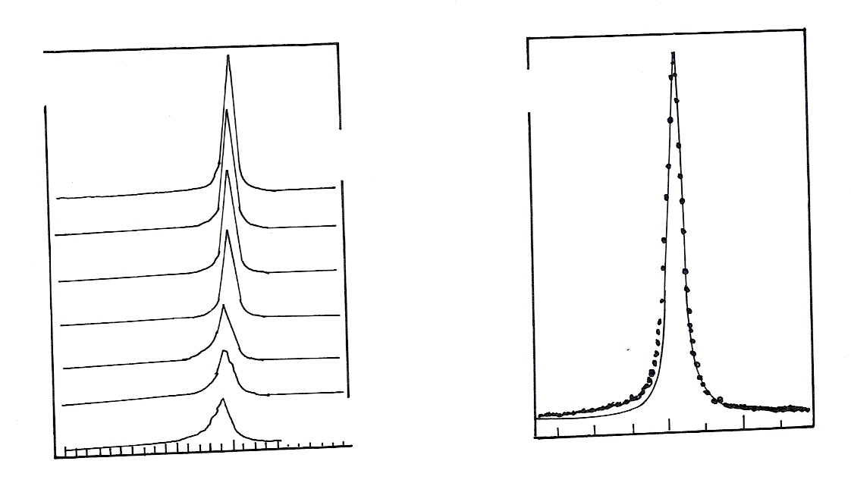
Cu (100)
Tamm surface states
He I
T = 10 K
time resolution
1st experiment
0 hrs
Last experiment
10 hrs
1.95
1.90
1.85
1.80
1.75
1.70
Intensity
(a.u.)
Cu (100)
Tamm surface states
T = 10 K
He I
data
__
e
1.86
1.80
1.76
Binding energy (eV)
Binding energy (eV)

Fig. 7.50. Variation of UP spectra with time for Cu (100) at 10 K (ref. 58)

5.4 Comparison of XPS and UPS Spectra
(a) NiO
In the XPS spectrum, the O 2p contribution was estimated from a comparison of XPS spectra with that of the UPS of the transition metal oxide. In the UPS spectrum the O 2p band is visible. In both cases a distinct satellite is evident. It is assigned to a 3d⁷ satellite peak (final state). The zero is the experimental Fermi energy, which is very close to the top of the valence band. So by comparison of

UPS and XPS it is possible to estimate quantitatively the passive oxide layers formed on the surface. The relevant data are given in the Fig. 7. 51.
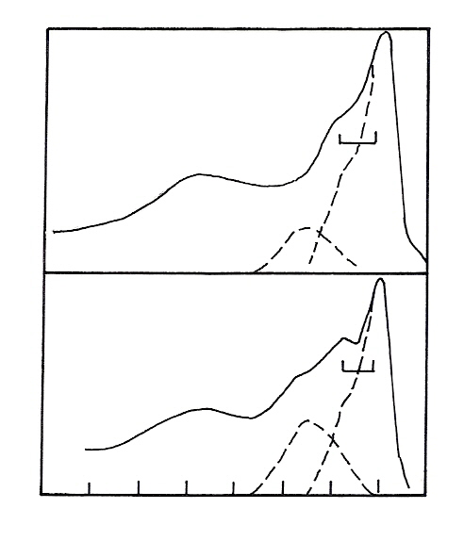
NiO (3d)
XPS (Mg Kα)
NiO (100)
UPS (hω = 7 BeV)
3d⁷
O2p
Ni 3d
Satellite
Intensity
(a.u.)
Binding energy (eV)
E_{B} (eV)
L
(3d⁶L⁻¹)
0
2
4
6
8
10
12
14
(3d⁶L⁻¹)
L
Ni 3d
Satellite
3d⁷
O2p
Fig. 7.51. Comparison of XPS and UPS spectra of NiO (ref. 58)

(b) CuO and Cu₂O

A comparative study of valence bands of polycrystalline samples of Cu₂O and CuO taken with He I, He II, Mg-K_{α} shows that in Cu₂O, O 2p and Cu 3d states are separated and with Mg-K_{α} in the XPS only metal 3d density of states are predominant. With UV sources, the spectrum gives a fair representation of the combined O 2p and Cu 3d density of states. In the case of CuO valence band studies in a similar way shows that the separation between the O 2p and Cu 3d orbitals is no longer so pronounced, indicating a stronger hybridization between the ligands and the metal d electrons. The data are given in the Fig. 7.52.
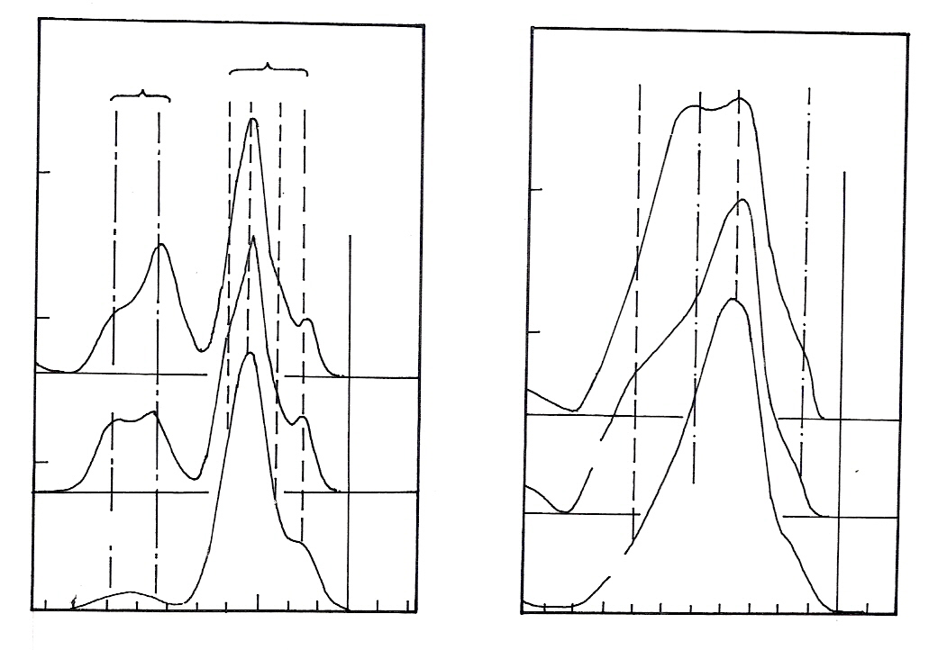
Cu₂O Valence bands
CuO valence bands
O -2p
Cu – 3d
E_{F}
(a) He I
(b) He II
(c) Mg K_{α}
0
1
2
3
Binding energy (eV)
0
1
2
3
2
1
0
0
1
2
Binding energy (eV)
O -2p
Cu – 3d
E_{F}
(a) He I
(b) He II
(c) Mg K_{α}
Counts per
channel (a.u.)
Counts per
channel (a.u.)
Fig. 7.52. Comparison of photo electron spectra of Cu₂O and CuO with He I, II and Mg K_{α} as the sources (ref. 58)
(c) XPS and UPS of Ni- Zr alloys

Amorphous alloys produced by the melt quenching method are promising precursors of oxide-supported catalysts because of the easy preparation and the unique selectivity and reactivity in several reactions. The as-quenched amorphous alloys are usually inert to catalytic reactions, and special activation processes, such as oxidation, reduction or in situ catalytic reactions must be performed to generate the active sites. The pretreatments at crucial stages to activate the amorphous catalysts usually give rise to remarkable changes of the chemical composition and morphology, as well as of the crystalline structure of the alloy surface. Amorphous Ni–Zr alloys as typical amorphous catalysts show significant catalytic activities in the hydrogenation or dehydrogenation of olefins. It was found that the high activity was always obtained after cycles of oxidation in oxygen followed by reduction with hydrogen. The oxidation behavior of the amorphous Ni–Zr alloys with various alloy compositions, such as Ni₆₄Zr₃₆ and Ni₉₁Zr₉, has been studied extensively using XPS and UPS. Ni 2p and Zr 3d spectra under different environments are given in the Fig. 7.53.
The XPS studies on the oxidized amorphous Ni₆₄Zr₃₆ alloy revealed that the oxidation in air at elevated temperatures resulted in a significant enrichment of zirconium due to the formation of a zirconia layer on the surface. Similarly the oxidized sample followed by reduction enhances the Ni on the alloy surface. From the XPS we can understand that the oxidized sample is showing higher peak area for Zr than that of Ni.

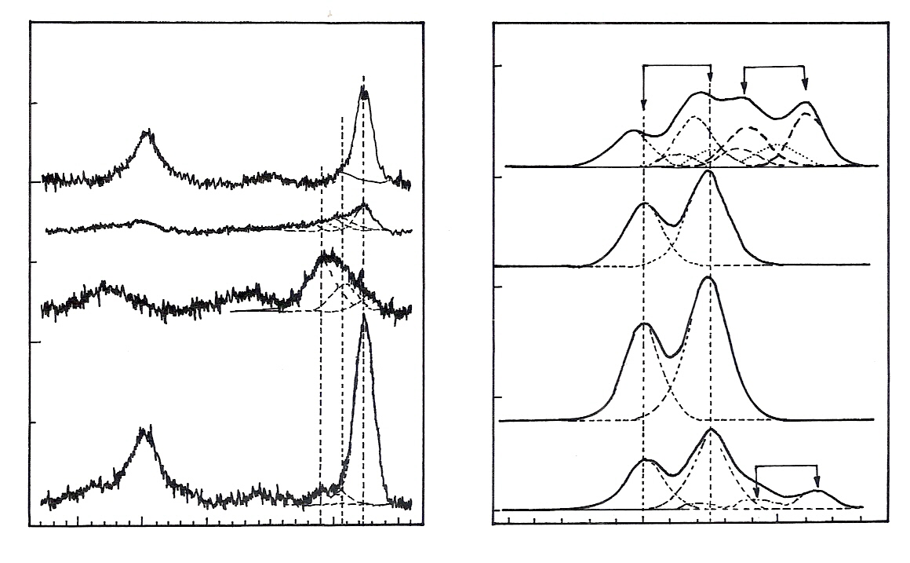
Ni⁰
852.7
Ni 2p
875
870
865
860
855
850
0
1
2
3
Intensity
(x 10⁴ cps)
Intensity
(x 10⁵ cps)
a
b
c
d
Zr 3d
Zr⁴⁺
ZrC
Zr⁰
190
185
180
178.7
179.1
Ni²⁺
Ni³⁺
854.4
856.1
Binding energy (eV)
4
Binding energy (eV)
0
1
2
3
Fig. 7.53. Zr3d and Ni2p XPS data of Ni–Zr alloys. (a) As-quenched amorphous Ni₃₆Zr₆₄ alloy; (b) sample (a) oxidized in 500 mbar O₂ at 523 K for 30 min. ; (c) as-quenched amorphous Ni₂₄Zr₇₆ alloy oxidized under the same condition as (b); (d) sample (b) annealed at 773 K for 20 min. (ref. 59)

UPS data of the Ni₃₆Zr₆₄ alloy:
The changes of the valence band structures of the amorphous Ni₃₆Zr₆₄ alloy due to different treatments have been studied by UPS. The spectra generated by using HeI (21.2 eV) as the exciting source are shown in Fig. 54. The valence spectrum of the as-quenched Ni₃₆Zr₆₄ exhibited a dominant peak at about 6 eV below the Fermi level (trace a). Similar peaks have been observed in UPS investigations of transition metal oxides, and have been attributed to emission from O 2p states interacting with the d-bands of metals. Combined with the corresponding XPS results, the main peak in trace ‘a’ can be assigned to surface ZrO₂. The shoulder centered at about 11 eV can be correlated with surface OH or C-related species, which are commonly present on untreated metal surfaces. Annealing to 773 K, however, gave rise to significant changes of the valence band spectrum, such as the emergence of the Fermi edge and a peak at about 3 eV below the Fermi level. Additionally, the intensity of the peak at 6 eV decreased strongly, as shown in Fig. 54. The appearance of the Fermi edge proves the metallic character of the annealed surface. Both the Fermi edge and the peak at 3 eV below the Fermi level can be assigned to ZrC at the surface. In the valence band spectrum of clean ZrC, a Fermi edge and a large structure distribution distributed between 0 and 5 eV were observed originating from hybridized Zr 4d and C 2p states.

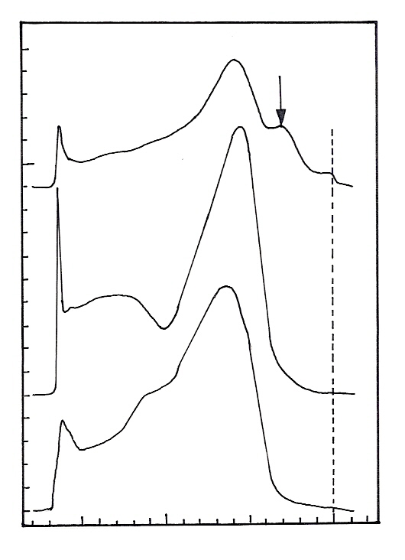
He I UPS
Ni₃₆Zr₆₄
3.0
E_{F}
a
b
c
0
0.5
1
1.5
2
15
10
5
0
Intensity
(x 10⁶ cps)
Binding energy (eV)
Fig. 7.54. (a) As-quenched amorphous alloy; (b) sample (a) oxidized in 500 mbar O₂ at 523 K for 30 min; (c) sample (b) annealed at 773 K for 20 min (ref. 59)

5.5 Angle Resolved Ultra Violet Photoelectron Spectroscopy with Example

The UPS spectra of CO on Cu are similar to the spectra obtained on other transition metals, i.e., the peak at ∼ 8 eV is assigned to overlapping emission from 5 σ and 1 π, while the peak at ∼ 11 eV is due to emission from 4 σ level. A typical spectra for CO adsorbed on Cu (111) at 77 K are shown in Fig. 55. The shoulder at the higher binding energy side of the peak due to 4 σ is considered to be a shake up structure.

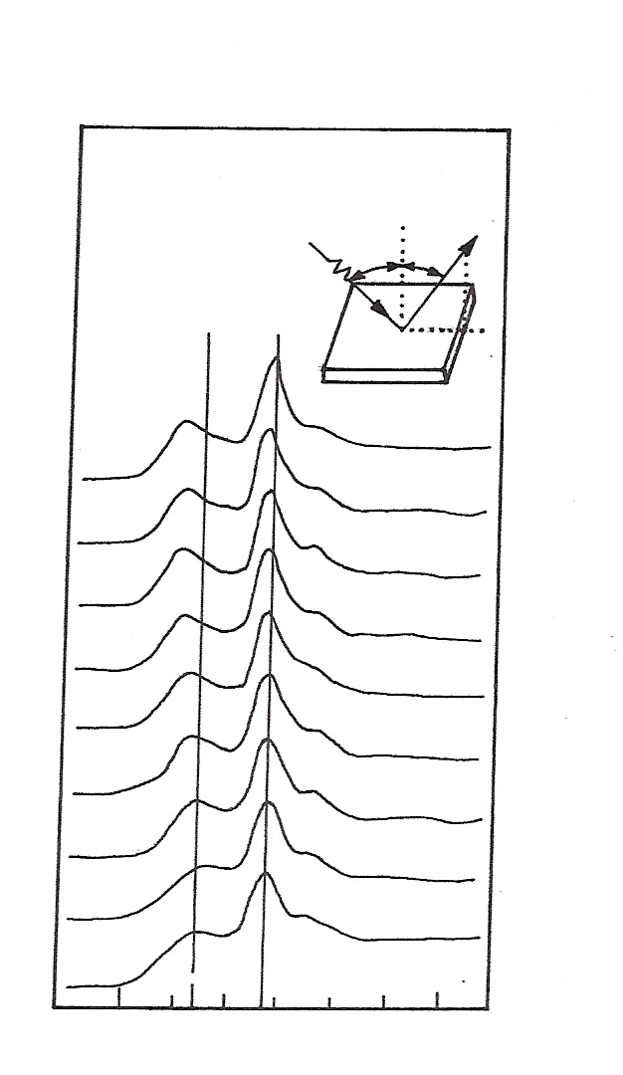
CO / Cu (111)
T = 77 K
hυ = 40 eV
P₁
P₂
θ = 45°
θ_{k}
θ_{k}
6
8
10
12
14
16
18
S.U.
40°
35°
30°
25°
20°
15°
10°
5°
0°
hν
Binding energy (eV)
Fig. 7.55. UV photoelectron spectra in the angle –resolved mode for the adsorption of CO on Cu (111) at 77 K. The angular mode is shown at the top of the figure (ref. 60)

6. Perceptions

Wherever the properties of a solid surface are important, it is also important to have the means to measure those properties. The surface of solids plays an overriding part in a remarkably large number of processes, phenomena and materials of technological importance. These include not only catalysis but also corrosion, passivation, adhesion, tribology, metals, ceramics, micro electronics, composites, polymers, protective coatings, semiconductors, superconductors, interfaces and even grain boundaries. Photoelectron spectroscopy is one of the exciting and rapidly growing branches in solid state physics, chemistry and biology contributing its maximum for the study of these solid surfaces. Photoelectron spectroscopy can give information on the Fermi energies and the density of states in the valence bands of metals, alloys and semiconductors and to detect the chemisorption levels which are of vital importance in understanding the nature of chemisorption which is responsible for the surface reactions.
It is clear that the photo electron spectroscopy can be suitably exploited for studying a variety of processes in catalysis. These include (I) Identification of the active sites (II) The mode of generation of active sites (III) the pores present in active systems (IV) the mode of deactivation of a catalyst and the activation procedures required for the degeneration of the catalysts and so on. It should also be mentioned that many other properties of the catalyst solids, like their magnetic behaviour, electrical conduction, and extent of iconicity or covalency can also be deduced by suitable and appropriate photoelectron spectroscopic measurements. The examples of this system given in this presentation are representative ones and they need not be the appropriate model system for the phenomenon discussed. The reader is referred to many other

innumerable references that have been reported in literature for an extensive understanding of the phenomenon that can effectively studied by PES.

7. REFERENCES
- K. Siegbahn, Nobel lecture; Physics (1981) 63.
- K. Siegbahn, C. Nordling, A. Fahlman, H. Hamrin, J. Hedman,G. Johansson, Bergmark T, Karlsson S E, Lindgren. J and Lindberg B, Electron Spectroscopy for Chemical Analysis. Atomic, Molecular and Solid State Structure Studies by Means of Electron Spectroscopy (Uppsala: Almquist andWiksells) (1967).
- K. Siegbahn et al. ESCA Applied to Free Molecules (Amsterdam: North-Holland) (1969).
- C. Nordling , E. Sokolowski and K. Siegbahn, Phys. Rev. 105 (1957)1676–7
- D.W.Turner, C.Baker, A.D.Baker and C.R. Brundle, Molecular Photoelectron Spectroscopy (London: Wiley-Interscience) (1970).
- D.W.Turner and M.I. Al-Joboury, J. Chem. Phys. 37 (1962)3007–8.
- Friedrich Reinert and Stefan Hufner, New J. Phys. 7 (2005) 97.
- J C Green, Annual Review of Physical Chemistry, 28 (1977)161-183.
- W.E.Spicer and C.N.Berglund, Phys. Rev. Lett. 12 (1964) 9–11.
- C.N.Berglund and W.E. Spicer, Phys. Rev. 136 (1964) 1030.
- http://mason.gmu.edu/~jschreif/728/728-Surface%20Techniques.pdf
- W.F. Krolikowski, W.E. Spicer, Phys. Rev.B 1 (2) (1970) 478.
- W. E. Spicer, Phys. Rev. 112, (1958)114.
- B J Mulder, J. Phys. E: Sci. Instrum. 10, (1977) 490-492.
- D. E. Eastman, J. J. Donelon, N. C. Hien, and F. J. Himpsel, Nucl. Instrum. Methods 172 (1980) 327.
- D.E. Eastman, Phys. Rev. B 25 (1982) 7388.
- D.E. Eastman and J.K.Cashion, Phys. Rev. Lett. 27 (1971)1520.
- D.E. Eastman, and J.K.Cashion, Phys. Rev. Lett. 24 (1970) 310.
- B.Viswanathan, S.Sivasankar and A.V.Ramaswamy, Catalysis Principles and Applications, Chapter 10, Narosa publishing house, New Delhi, (2002)163-183.
- http://www.chem.qmw.ac.uk/surfaces/scc/scat5_3.htm
- A.R Chourasia and D.R.Chopra, Chapter 42-43, Frank Settle, Handbook of Instrumental Techniques for Analytical Chemistry, Prentice Hall PTR, Upper saddle River, NJQ (1997) 791-827.
- C.R.Brundle, J.F.Watts, J.Wolstenholene Ewing’s Analytical Instrumentation Handbook, (3 rd edition) edited by Jack cazes, Maral Dekker, New York (2005) 399 – 427.
- augustus.scs.uiuc.edu/ nuzzogroup/PPT/XPS%20Class%2099.PPT
- M. P. Seah, Practical Surface Analysis, Chapter 1, (Eds., D. Briggs and
M. P. Seah, Wiley, New York, (1990)
- http://www.aps.anl.gov/Facility/Technical_Publications/lsnotes/ls172/ls172.html
- B.E. Koel, D.E. Peebles and J.M.White, Surf. Sci., 125 (1983) 739.
- John C. Riviere and SverreMyhra, Handbook of Surface and Interface Analysis, methods for problem solving; Chapter 27, Marcel Dekker Ltd, (January 27, 1998) 851-888.
- A. Frank, Pico-The Omicron NanoTechnology Newsletter, 7 (2003) 1.
- S.Narayanan and B.Viswanathan, J Sci Ind Res., 48 (1989) 229 – 239.
- D.M.Hercules, Trends in Analyt Chem., 3 (1984)125.
- Brinen J.S. and Schmitt J.L, J. Catal., 45 (1976) 274.
- J.S.Brinen and J.L.Schmitt, J. Catal., 45 (1976) 274.
- S.Scire, S.Minico, C. Crisafulli, C.Satriano and A.Pistone. Appl. Catal. B: Environ. 40 (2003) 43–49.
- V.Cimpeanu, V.Parvulescu, V.I.Parvulescu, M.Capron, P.Grange, J.M.Thompson and C. Hardacre, J.catal. 235 (1) (2005) 184 – 194.

- Jung Hwa Kang, EunWoo Shin, Woo Jae Kim, Jae Duk Park, and Sang Heup Moon1, J. Catal., 208 (2002)310–320.
- Y.Takasu, R.Unwin, B.Tesche, and A.M.Bradshaw, Surf. Sci. 77, (1978) 219
- C. Shi, A.M. Zhu, X.F. Yang and C.T. Au, Appl. Catal. A: Gen., 28 (2005) 83-90.
- I. Olivelos, M.J.P. Zurita, C. Scott, M.R. Goldwasser, J. Goldwasser, S. Rondon, M. Houalla, D.M. Hercules, J. Catal. 171 (1997) 485
- W.H.Madhusudhan, S. Kollali, P.R. Sarode, M.S.Hegde, P. Ganguly and C N R Rao, Pramana, 12 (1979) 317
- Yu. Larichev, I. Prosvirin , D. Shlyapin, N. Shitova, P. Tsyrul’nikov, V. Bukhtiyarov, Kinetics and Catalysis, 46( 4)( 2005) 597-602 (6)
- S. Narayanan and Uma. K, J Chem. Soc. Faraday Trans. I, 81 (1985) 2733.
- S. Narayanan, J. Scient. Ind. Res; 44 (1985) 319
- S. Narayanan, Zeolites, 4 (1984) 231.
- G. Ertl, R. Hierl, H. Knoezinger, N. Thiele & H.P. Urbach, Appl. Surf. Sci., 5 (1980) 49.
- R.D.Srivatsava, J. Onuferko, J.M.Schulz, G.A. Jones, K.N. Rai & R. Athappan, Ind. Engng. Chem. Fundamn., 21 (1982) 457.
- NgKT and D.M.Hercules, J. Phys. Chem., 80 (1976) 2094.
- P. Dufresne, E. Payen, J. Grimbolt and O J P Bonnelle, J. Phys. Chem., 85 (1981) 2344.
- J C Vedrine, G. Hollinger and T.M. Duc, J. Phys. Chem., 82 (1978) 1515.
- N. Tsud, V. Johanek, I. Stara, K. Veltruska and V. Matolin, Surf.Sci. 467 (1-3) (2000) 169-176.
- B.Viswanathan, M.J Omana and T.K. Varadarajan, Cat. Lett. 3 (1989) 217 – 222.
- V A M Brabers, F M Van Setten and P S A Knapen, J. Solid State Chem., 49 (1983) 93.
- R. Vetrivel, K Seshan, K.R. Krishnamurthy and T S R Prasada Rao, Bull. Materials Sci., 9 (1987) 75.
- B.A. Sexton, Materials forum, 10 (24) (1987) 134.
- Ch.Papadopoulou, J. Vakros, H. K. Matralis, Ch. Kordulis and A. Lycourghiotis,J Colloid Interface Sci., 261-1(2003) 146-153.
- D. E. Eastman and M. I. Nathan, Phys. Today, 28 (1975) 44-51.
- C.R Brundle, P.S.Bagus, D.Menzel, and K. Hermann K, Phys. Rev., B 24 (1981) 7041.
- J.Michael Hollas, Modern spectroscopy, 4th edition, John Wiley & sons, New York, January 2, (2004).
- S. Hufner, Photoelectron Spectroscopy - Principles and Applications, Springer-Verlag, Berlin, (2003).
- Z. Song, X. Bao, U. Wild, M. Muhler and G. Ertl, Appl. Surf. Sci., 134 (1-4) (1998) 31-38.
- Shin-ichi Ishi and Yuichi Ohno and B.Viswanathan, J.Sci.Ind.Res., 46 (1987) 541 – 567.

