APPLICATION OF METAL NANO PARTICLES FOR SELECTIVE HYDROGENATION REACTIONS
SYNOPSIS SUBMITTED TO BHARATHIDASAN UNIVERSITY FOR THE AWARD OF THE DEGREE OF

DOCTOR OF PHILOSOPHY
IN
CHEMISTRY
By
A.SARANYA M.Sc.,
Ref.No:16836/Ph.D.K2/Chemistry/Full-Time/July-2013
UNDER THE GUIDANCE OF
Dr.G.VIVEKANANDAN, M.Sc., M.Phil., Ph.D., PDF.
Associate Professor


DEPARTMENT OF CHEMISTRY
A.V.C.COLLEGE (AUTONOMOUS)
MANNAMPANDAL-609 305, MAYILADUTHURAI,
INDIA
February-2019

Title of the Thesis

Application of metal nano particles for selective hydrogenation reactions

2. Briefdescription of the State of the Art of the Research Topic

Synthesis, characterization and application of metal nano particles as catalysts have attracted tremendous interest since they bring in several fold increase in activity and selectivity towards desired products (1-4). Development of synthesis techniques (5-9) to obtain metal nano particles, especially within narrow size range of 1-10 nm, with different morphologies (nano tubes, rods, needles, wires, sheets) and shapes (spherical, cubic, octahedral, tetrahedral) and the advent of advanced characterization techniques at nano/atomic levels, have enormously expanded their application potential. While nano particles, (metals, oxides, sulfides etc) in general, are being used gainfully and extensively in number of catalytic reactions, metal nano particles in particular, are of direct relevance in catalytic hydrogenation reactions (10). Hydrogenation reactions normally require activation of hydrogen as well as the substrate molecules, wherein both geometric, electronic and structural factors in the supported metal catalysts contribute towards observed overall activity. Crystallite size, crystal faces exposed, electronic structure and geometry of metal nano particles, nature of support and metal-support interactions play vital role in the catalytic cycle. Bimetallic nano particles with well-defined composition and structure (as alloys, bimetallic clusters or with core-shell architecture) display superior activity, selectivity and stability compared to monometallic catalysts (11). Selective hydrogenation of alkynes to alkenes (12, 13) and chemo-selective hydrogenation of α, β unsaturated aldehydes (14, 15) are the two important classes of reactions that find wide applications in petrochemical, pharmaceutical and fine chemical industries. Bimetallic nano particles, wherein the second metal acts as promoter,display superior performance vis-à-vis mono metallic catalysts in terms of activity, selectivity and stability,are being used extensively for such hydrogenation processes (16). The present work brings out the specific role played by the promoters and the synergistic effect in bi-metallic catalysts for the selective hydrogenation of alkynes (1-heptyne) and α, β unsaturated aldehydes ( cinnamaldehyde).

3.0 Objectives and Scope of the Research Work

Though the advantages of bimetallic nano particles for selective hydrogenation processes have been well-established, several aspects related their modes of action are not clear. Pd based catalysts promoted by Cu, Ag and Au have been studied extensively for selective hydrogenation of 1-heptyne (17-28) and cinnamaldehyde (29-32). However,a thorough understanding of the factors responsible for the improvements observed in activity and selectivity in terms of the properties of the catalysts have not been established yet. Similarly, the synergistic effects observed in the case of bimetallic catalysts (containing noble metals or non-noble metals) have not been explained completely. A better in-sight into the role of promoters and the factors responsible for the synergistic effects would be highly helpful in the design of superior catalysts. Hence the, main objectives of the thesis are to:

Carryout systematic investigations on the role of second elements/promoters in improving the performancein a series of palladium based bimetallic catalysts supported on titania P-25

Arrive at the optimum composition for Pd-Au and bi-metallic catalysts

rationalize the activity/selectivity patterns interms of the properties of the catalysts

understand the synergetic effect between the two metals in the case of a series of bimetallic catalysts based on cobalt and nickel supported on titania P-25.

study the selective hydrogenation of heptene-1 and cinnamaldehyde as model reactions to illustrate the effect of promoters and synergistic effects.

In accordance with the objectives, the scope of the research work includes the following experimental plan:

Preparation of two series of palladium based mono- and bi-metallic nano particles, Pd_{(1-x)}Au_{x}(x= 0.1,0.12,0.15 and 0.2 ) and Pd_{m}M_{n} (M=Cu/Ag/Au- m, n- 0.9, 0.1) supported on TiO₂-P-25, by adopting chemical reduction of PdCl₄ in alkaline medium with PVP as the stabilizer for nano particles (33)

Studies on the liquid phase selective hydrogenation of 1-heptyne on the two series of Pd based catalysts at atmospheric pressure and in the temperature range 293-313K

Studies on liquid phase selective hydrogenation of cinnamaldehyde on Pd based mono- metallic and bi-metallic catalysts-Pd-M/TiO₂ with M= Cu, Ag & Au

Preparation of nano-size bimetallic Co-Ni catalysts in the composition range Co_{(1-x)}Ni_{x} with x= 0.0,0.2, 0.3, 0.4,0.5,0.6, 0.8 and 1.0, with total metal loading of 15%w/w and supported on TiO₂-P25, by chemical reduction of the metal acetates by glucose in aqueous alkaline medium

Characterization of the Pd based and Co-Ni based catalysts by X-ray diffraction (XRD), Diffuse Reflectance Spectroscopy (DRS), Transmission Electron Microscopy (TEM), X-ray Photo-electron Spectroscopy (XPS), Temperature Programmed Reduction (TPR) and Temperature Programmed Desorption (TPD) of hydrogen techniques.

Studies on liquid phase selective hydrogenation of cinnamaldehyde on Co-Ni based mono metallic and bi-metallic catalysts

Understanding the correlations between activity and selectivity patterns for hydrogenation of 1-heptyne and cinnamaldehyde in terms of the characteristics of Pd and Co-Ni based catalysts

4.0 Results and Discussions

Chapter I contains Introduction to the thesis. Starting with a very brief description on the principles of Catalysis and Catalytic reactions, the Chapter contains the details on the importance of nano particle in catalysis, methods for preparation of metal nano particles, catalytic hydrogenation reactions, selective hydrogenation processes and their importance in chemical industry, hydrogenation catalysts, the mechanistic pathways in hydrogenation reactions and the influence of several characteristics of the catalysts on hydrogenation activity and selectivity. Brief review of the literature on the selective hydrogenation of cinnamaldehyde and 1-heptyne on different catalysts and the developments so far in the respective processes have been outlined. The objectives for the thesis work and the scope of the investigations have been defined.

Chapter II on Experimental methods presents the details on the methods adopted for the preparation of the catalysts, different catalyst characterization techniques employed and methods for measurements, description of the reaction set-up for studying selective hydrogenation of cinnamaldehyde and 1-heptyne, details on the analysis of reactant and product streams and all associated calculation details.
Chapter III on Palladium based bimetallic catalysts-Pd-M (M= Cu,Ag & Au) for selective hydrogenation of 1-heptyne brings out the optimum promoter loading required and a comparative study on the effect of promoters, Cu,Ag & Au.Two series of palladium based bi-metallic catalysts, Pd_{(1-x)}Au_{x}(x= 0.1,0.12,0.15, 0.2 and 0.00) and Pd_{m}M_{n} (M=Cu/Ag/Au- m, n- 0.9, 0.1) supported on TiO₂-P-25 have been prepared and characterized by XRD, DRS, TEM, XPS and TPR. DRS and XPS studies indicate formation of nano scale alloys involving redistribution of charges within the metals. Changes in binding energy values in both series of
Table.1 XPS binding energy data for Pd _{(1-x)} Au_{x} and Pd_{m}-M_{n} series of catalysts
Catalysts | Pd 3d_{5/2}  (eV) | Au 4f _{7/2}  (eV) | Ag 3d _{5/2}  (eV) | Cu 2p _{3/2}  (eV)
Pd | 335.8 | - | - | -
Pd_{0.9} Au_{0.1} | 335.6 | 84 | - | -
Pd_{0.88} Au_{0.12} | 334.5 | 83.8 | - | -
Pd_{0.85} Au _{0.15} | 334.9 | 83.7 | - | -
Pd_{0.8} Au _{0.2} | 334.4 | 82.5 | - | -
Pd_{0.9} Ag_{0.1} | 334.5 | - | 366.6
Pd_{0.9} Cu_{0.1} | 334.6 | - | - | 932.6

catalysts, complied in Table 1 indicate charge transfer from Cu, Ag and Au to Pd. TEM data (Table.1) indicate the formation of spherical bimetallic Pd-M nano particles in the size range 5-6 nm. TPR patterns for the two series of catalysts display the Pd hydride decomposition peaks in the temperature range 60-70°C, with varying intensity indicating that the formation of bi-metallic Pd-M alloys alter the stability of Pd hydride.
Selective hydrogenation of 1-heptyne in liquid phase has been studied on these catalysts at atmospheric pressure and in the temperature range 293 -313 K. In the Pd_{(1-x)}Au_{x} series (Table 2), the catalyst composition Pd_{0.9}Au_{0.1} displays maximum activity, expressed as TOF.
Table.2Characterization and activity data for Pd _{(1-x)} Au_{x} series of catalysts
Catalysts | Cryst.Size  (nm) | T_{max}  (°C) | Rate  (10⁻⁶Moles/sec) | TOF  (X10⁻³Sec⁻¹)
Pd | 5.4 | 64.7 | 0.9 | 16.0
Pd _{0.9} Au _{0.1} | 6.0 | 66.2 | 2.4 | 65.0
Pd_{0.88} Au _{0.12} | 5.7 | 65.2 | 1.2 | 29.0
Pd _{0.85} Au _{0.15} | 5.5 | 66.0 | 0.96 | 26.0
Pd _{0.8} Au _{0.2} | 3.9 | 60.4 | 1.6 | 30.0
(Rates of hydrogenation calculated at 20±1 % 1- heptyne conversion at 313K)

Activity pattern in Pd_{m}M_{n} series (Table.3) follows the trend, Pd-Au>Pd-Ag=Pd-Cu>Pd. Selectivity for heptene formation is maintained at > 95% on all catalysts up to 60 min. reaction time. Interplay of both ensemble as well as ligand effects influence the adsorption and activation of 1-heptyne, leading to higher activity on Pd-Au bimetallic catalyst vis-à-vis other bimetallic and mono metallic catalysts.
Table.3 Characterization and activity data for Pd_{m}M_{n} series of catalysts
Catalysts | Cryst.size(nm) | T_{max}(°C) | Rate (10⁻⁶ moles/sec) | TOF(X10⁻³Sec⁻¹)
Pd | 5.4 | 64.7 | 0.74 | 19
Pd _{0.9} Au _{0.1} | 6.0 | 66.2 | 1.72 | 47
Pd _{0.9} Ag _{0.1} | 5.0 | 69.7 | 0.87 | 20
Pd _{0.9} Cu _{0.1} | 5.7 | 67.1 | 0.87 | 22
(Rates of hydrogenation calculated at 20±1 % 1- heptyne conversion at 303K)

Chapter IV on Palladium based bimetallic catalysts-Pd-M (M= Cu, Ag & Au) for chemoselective hydrogenation of cinnamaldehyde (CAL) describes the role of promoters, Cu, Ag & Au. The reaction was carried out in liquid phase, at 10 bar hydrogen pressure in the temperature range 393-413K for 1 hr. on mono metallic Pd, Cu, Ag &Au and bi-metallic Pd-M (M= Cu,Ag &Au) catalysts.

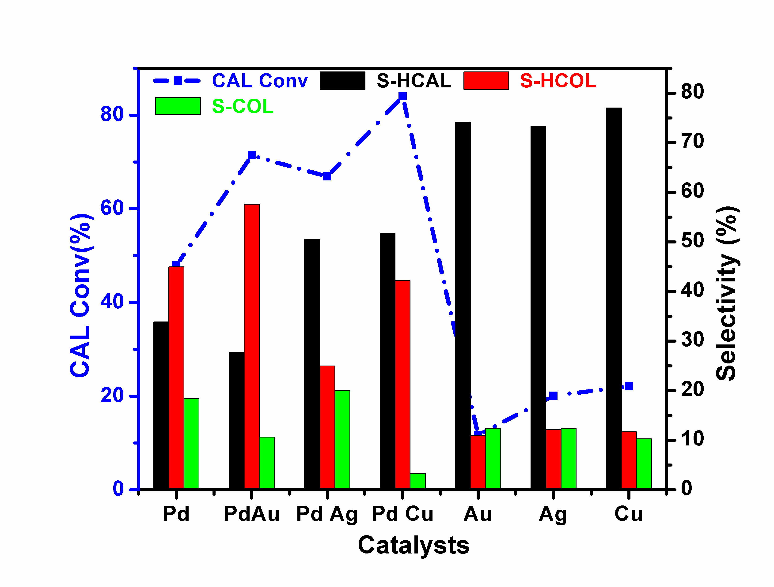
Fig.1. Activity and selectivity for hydrogenation of cinnamaldehyde at 413K on mono metallic and bimetallic Pd-M (M=Cu,Ag,Au). Cinnamaldehyde-2.4g, Solvent-15g Isopropanol+1.65g water, Catalyst wt-40mg, H₂ -10 bar, Reaction time-1 hr, Agitation-600 rpm.

Activity for the conversion of CAL and selectivity for different products, namely, hydrocinnamaldehyde (HCAL), cinnamyl alcohol(COL) and hydrocinnamyl alcohol(HCOL) for all the catalysts at 413K on mono metallic Pd/TiO₂ and bi-metallic Pd-M catalysts are presented in Fig.1. While all the three bimetallic catalysts display higher activity compared to monometallic Pd, the product selectivity patterns are different. Pd-Cu catalyst displays maximum activity in terms CAL conversion, lowest selectivity towards COL and maximum selectivity towards HCAL. Pd-Ag on the other hand,shows relatively higher selectivity towards COL and maximum selectivity again for HCAL. Pd-Au however displays maximum selectivity for HCOL Other monometallic Cu, Ag & Au catalysts display very low CAL conversion and maximum selectivity for HCAL. As revealed by XPS data, addition of Cu, Ag & Au to Pd results in the redistribution of charges as indicated by the changes in binding energy values. Besides, introduction of atoms with different sizes, Ag (144pm), Au (144pm) and Cu (128pm), into Pd (138pm) lattice induces lattice strain in Pd metal (34). Such electronic as well as geometric effects alter the d-band character of Pd and consequently the adsorption and activation of CAL. Hence bimetallic Pd-Cu, Pd-Ag and Pd-Au display higher activity for hydrogenation of CAL.

Temperature programmed hydrogen desorption (H₂-TPD) studies reveal that the chemisorbed hydrogen desorbs at the lowest temperature (391K) on Pd-Cu in comparison with the higher desorption temperatures for Pd-Au (446K), Pd-Ag (466K) and monometallic Pd (403K). Availability of active surface hydrogen is responsible for the maximum activity displayed by Pd-Cu bimetallic catalyst.

Interestingly, Pd-Au catalyst displays maximum activity for hydrogenation of 1-heptyne, while it is Pd-Cu for hydrogenation of CAL. Adsorption of heptyne plays crucial role in heptyne hydrogenation, which takes place at lower temperature, 293-313K, with the involvement of hydrogen chemisorbed in the same temperature range. Since the hydrogenation of CAL takes place in the temperature range 393K to 413K, availability of active hydrogen in this temperature range is essential for the reaction, which is facilitated on Pd-Cu surface
Chapter V covers the Studies on bimetallic Co-Ni/TiO₂ catalysts for selective hydrogenation of cinnamaldehyde (CAL). Bimetallic catalysts, in general [35], and noble metal (Pt,Ru) catalysts with promoters like Co, Sn etc display high activity and COL selectivity in the hydrogenation of CAL [36-39]. Non-noble metal based bimetallic catalysts containing Co, Ni and Cu have also been studied extensively [40-44]. Considering the higher cost of noble metal based catalysts, attempts have been made to develop bimetallic catalysts based on Ni and Co [45-47]. While titania supported Ni catalyst [48] displays high activity for CAL conversion with high selectivity for HCAL, the corresponding cobalt catalyst displays lower conversion and good selectivity for COL [49]. Bimetallic catalysts with optimum Co-Ni composition could lead to higher activity and selectivity and this aspect has not been explored so far. A systematic study involving the whole range of Co-Ni composition is needed to arrive at the optimum one. Accordingly, mono and bi-metallic Co-Ni catalysts in the composition range Co_{(1-x)}Ni_{x} with x=0.0,0.2, 0.3, 0.4,0.5,0.6, 0.8 and 1.0, supported on TiO₂-P25, have been explored to arrive at compositions that would give high CAL conversions, comparable to that of noble metal catalysts and good selectivity for COL.
The catalysts have been prepared by chemical reduction of the metal acetates by glucose in aqueous alkaline medium (50) and characterized by XRD, TEM, TPR and H₂-TPD techniques.
Selective hydrogenation of CAL to HCAL, COL and HCOL has been investigated at 20 bar pressure, in the temperature range 393-413K. Co/Ni nano particles in the size range 6.0 ±1 nm are observed by TEM. TPR, results indicate the formation of nano scale Co-Ni alloys, which tend to weaken M-H bond strength, as revealed by H₂-TPD measurements. Ni/TiO₂ displays very high conversion of CAL (86.9%) with high selectivity (78.7%) towards HCAL formation at 413K (Fig.2). Co/TiO₂, on the other hand, exhibits relatively lower CAL conversion (55%) and higher selectivity (61.3%) for COL formation at the same temperature. However, bi-metallic
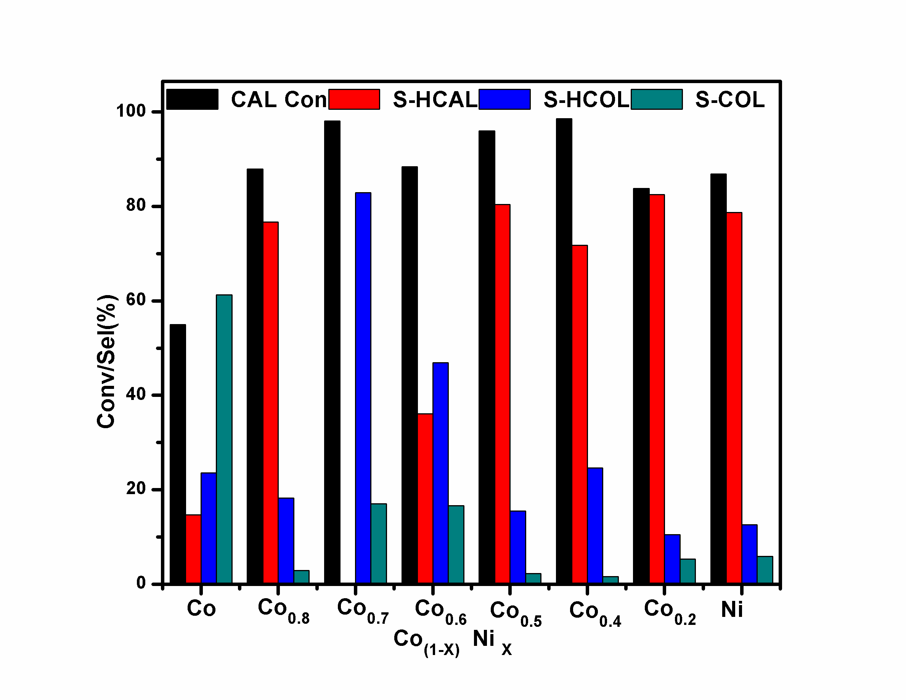
Fig.2. Conversion and selectivity patterns for the hydrogenation of cinnamaldehyde on Co_{(1-x)}Ni_{x} series of catalysts at 413K.
Co-Ni catalysts in the composition range x= 0.3-0.6 display very high conversion (>98%) due to alloy formation and weakening of M-H bonds. Bimetallic Co_{0.7}Ni_{0.3} catalyst displays high conversion of CAL (98.1%) and high selectivity (82.9%) towards HCOL. Crystallite size and TOF values for Co-Ni catalysts are given in Table.4. Maximum TOF value is observed for the catalyst with the composition Co_{0.5}Ni_{0.5}
Table.4 Crystallite size and TOF values for catalystson Co _{(1-x)}Ni_{x} series of catalysts for.
hydrogenation of cinnamaldehyde at 413K
Catalysts | Cryst.sizeª  (nm) | Cryst.size^{b}  (nm) | TOFx10⁻¹  (h⁻¹)^{c}
Co₁ | 8.0 | 6.5 | 1.08
Co _{0.8} Ni _{0.2} | 5.6 | 5.5 | 1.44
Co _{0.7} Ni _{0.3} | 5.5 | 5.1 | 1.54
Co _{0.6} Ni _{0.4} | 8.1 | 7.0 | 1.58
Co _{0.5} Ni _{0.5} | 11.0 | 6.4 | 1.80
Co _{0.4} Ni _{0.6} | 7.4 | 5.0 | 1.44
Co _{0.2} Ni _{0.8} | 6.2 | 6.1 | 1.51
Ni₁ | 10.0 | 6.9 | 1.69
- XRD ; ^{b}- TEM ; ^{c}Reaction conditions: Temp-413K, Pressure-20 bar,
15g isopropanol+1.65g water, Catalyst- 150mg and 1.2g CAL)
Thus, a synergetic effect, originating from an appropriate composition of base metal catalysts and optimum reaction conditions, could result in hydrogenation activity comparable with noble metal based catalysts
4.0 Summary and Conclusions
Chapter VI gives a compilation of the summary of the results, inferences and conclusions. Synthesis, and characterization of two sets of bimetallic nano particles Pd-M (M=Cu, Ag, Au) and Co-Ni supported on titania (P-25) and their applications in two selective hydrogenation reactions, of heptyne and cinnamaldehdye (CAL) have been investigated. The salient features of the investigations are:
- In the case of bi-metallic Pd-M with M= Cu, Ag and Au, an optimum atomic ratio of Pd:M is essential to achieve the best performance for selective hydrogenation of heptyne.
- An optimum composition of Pd_{0.9}Au_{0.1}.is observed for Pd-Au catalysts
- Amongst the bimetallic catalysts, Pd_{0.9}Au_{0.1} displays maximum activity in comparison with Pd_{0.9}Ag_{0.1} and Pd_{0.9}Cu_{0.1}. Nano scale alloy formation resulting in electronic charge re-distribution and associated ensemble effects lead to higher activity and selectivity in bi-metallic catalysts. Pd_{0.9}Au_{0.1}catalyst, in which these effects are maximum, displays highest activity and selectivity.
- The same set of bimetallic catalysts, Pd-M with M= Cu, Ag and Au, display different activity pattern for selective hydrogenation of CAL.
- Pd-Cu exhibits higher activity vis-à-vis Pd-Ag and Pd-Au. Aavailability of active hydrogen in the reaction temperature range of 393-413K is crucial. Hence, Pd-Cu, which displays lowest desorption temperature for hydrogen, exhibits highest activity.
- Bi-metallic Co_{(1-x)}Ni_{x}catalysts in the composition range x= 0.3-0.6 display very high conversion of CAL (>98%) compared to mono-metallic Ni/ TiO₂ or Co/TiO₂. Formation of nano scale Co-Ni alloys, weakening of M-H bonds as revealed by XRD, TPR and H₂-TPD studies are responsible for the observed increase in CAL hydrogenation activity
- While heptyne hydrogenation on Pd based catalysts takes place at lower temperature (293-313K), hydrogenation of CAL on the same set of Pd catalysts requires higher temperature, (393-413K) to achieve significant conversions. Facile adsorption and higher reactivity of heptyne vis-à-vis CAL is responsible for the low temperature activity of heptyne.
- Due to high inherent high activity of Pd based catalysts, Pd loading of 1% (w/w) is sufficient for hydrogenation of CAL. To achieve similar levels of activity, higher loading of Co-Ni (15% w/w total) is essential. However, due synergetic effect of bi-metallic Co & Ni, originating from an appropriate composition of two base metals and reaction conditions, CAL hydrogenation activity comparable with noble metal based Pd catalysts is feasible.

References
- K. Philippot in “Nanomaterials in Catalysis”, Ed.Philippe Serp and KarinePhilippot. Wiley-VCH Verlag GmbH &Co.Weinheim, Germany (2013), Chapter 1 p.1
- D.Astruc, (2008) Nano particles and Catalysis (Ed. D. Astruc), Wiley-VCH, Verlag GmbH, Weinheim, Germany, p. 1
- R. Jin, Nanotechnology Reviews, 2012, pp. 31.
- F. Tao, L. Nguyen, S. Zhang , RSC Catalysis Series No. 17 ( Ed. F.Tao), Chapter.1, 1,The Royal Society of Chemistry, 2014
- B. R. Cuenya, Thin Solid Films, Vol. 518, No. 12, 2010, pp. 3127-3150 Z.
- Peng, H.Yang, Nano Today, 4 (2009) 143-164.
- B. Lim, J. Wang, P.H.C. Camargo, M. Jiang, M.J. Kim, Y. Xia, Nano Letters, 8 (2008) 2535-2540.
- T.S. Rodrigues, M. Zhao, T.H. Yang, K.D. Gilroy, A.G.M. da Silva, P. H. C. Camargo, Y. Xia, Chem. Eur. ,24(2018) ,1 – 21
- R. Narayanan, M.A. El-Sayed, Journal of Physical Chemistry B, 109 (2005) 12663-12676.G.Berhault, AU Uzio, Denis, Catalysis Reviews, 52 (2010) 106-131.
- D. Uzio ,G. Berhault, Catalysis Reviews: Science and Engineering, 2010, 52:1, 106-131
- B. Coq, F. Figueras, Coordination Chemistry Reviews,178–180 (1998) 1753–1783
- M. Crespo-Quesada, F.Cárdenas-Lizana, A.L. Dessimoz, L. Kiwi-Minsker, ACS Catalysis, 2 (2012) 1773-1786.
- C. Lederhos, C. Betti, D. Liprandi,E.Cagnola , M. Quiroga Chapter.2, Intech,2017
- D. Richard, P.Gallezot, Catalysis Reviews, 40 (1998) 81-126.
- Giroir-Fendler, D.Richard, P. Gallezot, In. Stud. Surf.Sci. Catal. Ed.M. Guisnet, J. Barrault, C. Bouchoule, D. Duprez, C. Montassier, G. Pérot, Eds. Elsevier. Amsterdam, 41(1998) 171-179
- V. Ponec, Applied Catalysis A: General, 149 (1997) 27-48.
- P.InsornK.Suriyaphaparkorn, B.Kitiyanan, Chem .Engg. Tran, 32(2013) 847-852.
- C.R. Lederhos, J.M. Badano, M.E. Quiroga, P.C. L'Argentière, F. Coloma-Pascual, Química Nova, 33 (2010) 816-820.
- E.A. Karakhanov, A.L. Maximov, A.V. Zolotukhina, N. Yatmanova, E. Rosenberg, Applied Organometallic Chemistry, 29 (2015) 777-784
- C.R. Lederhos, J.M. Badano, N. Carrara, F. Coloma-Pascual, M.C. Almansa, D. Liprandi, M. Quiroga, The Scientific World Journal,528453 (2013)1-9
- C.R. Lederhos, P.C. L'Argentière, N.S. Fígoli, Industrial & Engineering Chemistry Research, 44 (2005) 1752-1756.
- S. Putdee, O.Mekasuwandumrong, A. Soottitantawat, J. Panpranot, 13(4) (2013)3062-3067.
- C.R. Lederhos, P.C. L’Argentière, F. Coloma-Pascual, N.S. Fígoli, Catal. Lett,110(2006) 23-28
- P. Kittisakmontree, H.Yoshida,S.i.Fujita, M.Arai, J.Panpranot, Catalysis Communications, 58 (2015) 70-75.Sirikajorn, O.Mekasuwandumrong, P.Praserthdam, J.G. Goodwin, J. Panpranot, Catal. Lett, 126(2008) 313-318.
- N. Carrara, J.M. Badano, C. Betti, C. Lederhos, I. Rintoul, F. Coloma-Pascual, C. Vera, M. Quiroga, Catalysis Communications, 61 (2015) 72-77.
- P. Kittisakmontree, B. Pongthawornsakun, H. Yoshida, S.i.Fujita, M. Arai, J. Panpranot, Journal of Catalysis, 297 (2013) 155-164
- F. Klasovsky, P. Claus, D. Wolf, Top. Catal,52( 2009) 412-423
- B. Pongthawornsakun, S.i. Fujita, M. Arai, O. Mekasuwandumrong, J. Panpranot, Appl. Catal.A: Gen, 467(2013)132-141. M. Mavrikakis, B. Hammer, J.K. Nørskov, Physical Review Letters, 81 (1998) 2819-2822.
- V.I. Pârvulescu, V. Pârvulescu, U. Endruschat, G. Filoti, F.E. Wagner, C. Kübel, R. Richards, Chemistry – A European Journal, 12 (2006) 2343-2357.
- R. Li, W. Yao, Y. Jin, W. Jia, X. Chen, J. Chen, J. Zheng, Y. Hu, D. Han, J. Zhao, Chemical Engineering Journal, 351 (2018) 995-1005.
- M. Lashdaf, A.O.I. Krause, M. Lindblad, M. Tiitta, T. Venäläinen, Applied Catalysis A: General, 241 (2003) 65-75.
- S. Mahmoud, A. Hammoudeh, S. Gharaibeh, J. Melsheimer, Journal of Molecular Catalysis A: Chemical, 178 (2002) 161-167
- L.J. Chen, C.C. Wan, Y.Y. Wang, Journal of Colloid and Interface Science, 297 (2006) 143-150.
- M. Mavrikakis, B. Hammer, J.K. Nørskov, Physical Review Letters, 81 (1998) 2819-2822.
- M.G. Prakash, R. Mahalakshmy, K.R. Krishnamurthy, B. Viswanathan, Catalysis Today, 263 (2016) 105-111.
- W. Yu, Y. Wang, H. Liu, W. Zheng, Journal of Molecular Catalysis A: Chemical, 112 (1996) 105-113.
- B. Coq, P.S. Kumbhar, C. Moreau, P. Moreau, M.G. Warawdekar, Journal of Molecular Catalysis, 85 (1993) 215-228.
- B. Coq, P.S. Kumbhar, C. Moreau, P. Moreau, F. Figueras, Journal of Physical Chemistry, 98 (1994) 10180-10188.
- R.Basale,PhD Thesis, Tech.Univ.Eindhoven,The Netherland,(2013)
- P. Mäki-Arvela, L.P. Tiainen, M. Lindblad, K. Demirkan, N. Kumar, R. Sjöholm, T. Ollonqvist, J. Väyrynen, T. Salmi, D.Y. Murzin, Applied Catalysis A: General, 241 (2003) 271-288.
- X. Yuan, J. Zheng, Q. Zhang, S. Li, Y. Yang, J. Gong, AIChE J. 60 (2012) 1036.
- E. Asedegbega-Nieto, B. Bachiller-Baeza, A. Guerrero-Ruíz,I. Rodríguez-Ramos Applied Catalysis A: General, 300 (2006) 120-129.
- H. Noller, W.M. Lin, Journal of Catalysis, 85 (1984) 25-30.
- S.A. Ananthan, V. Narayanan, Int. J. Chem. 3 (2011) 55-66
- B.M. Reddy, G.M. Kumar, I. Ganesh, A. Khan, Journal of Molecular Catalysis A: Chemical, 247 (2006) 80-87.
- L.I. Hui, M.A. Chun-Jing, L.I. He-Xing, ActaChimicaSinica, 64 (2006) 1947-1953
- L.J. Malobela, J.Heveling, W.GAugustyn, L.M. Cele, Industrial & Engineering Chemistry Research, 53 (2014) 13910-13919.
- W. Lin, H. Cheng, L. He, Y. Yu, F. Zhao, Journal of Catalysis, 303 (2013) 110-116.
- K. J. A. Raj, M. G. Prakash, T. Elangovan, B.Viswanathan, Catal. Lett, 2011, 142, 87-94
- M. Vasseem, N. Tripathy, G. Khang, Y. Halm, RSC Adv. 3 (2013) 9698-9704
Papers Published
- Bimetallic Co–Ni/TiO₂ catalysts for selective hydrogenation of cinnamaldehyde
Saranya Ashokkumar, Vivekanandan Ganesan, Krishnamurthy K. Ramaswamy and
Viswanathan Balasubramanian, Res Chem Intermed (2018) 44: 6703.
- Studies on palladium based bimetallic catalysts-Pd-M/TiO2 (M=Cu, Ag & Au):

I- Selective hydrogenation of 1-heptyne, Accepted manuscript Article ID-IJCA-2421 LIST OF PAPERS PRESENTED IN NATIONAL AND INTERNATIONAL CONFERENCES

Selective hydrogenation of 1-Heptyne on Pd-Au Bimetallic nano particles supported on Titania ,22nd national symposium on Catalysis, CSIR-Central Salt & Marine Chemicals Research Institute, Bhavnagar, Gujarat, January 7-9, 2015.

Partial hydrogenation of 1-Heptyne over bimetallic Pd-Au catalyst-Influence of catalyst preparation method, 10th Mid-Year Chemical Research Society of India (CRSI) Symposium in chemistry, NIT-Trichy, July 23-25, 2015.

Selective hydrogenation of cinnamaldehyde over Co-Ni bimetallic catalysts, RSC –NIT Symposium, NIT-Trichy, Nov-5, 2016..

Palladium based bimetallic catalysts (Pd-M, M=Cu, Ag & Au)for selective hydrogenation of 1-heptyne, 7th Asia-Pacific Congress on Catalysis (APCAT-7), The Lalit Mumbai, Mumbai, January 17-21, 2017.

Ni-Co bimetallic catalysts for selective hydrogenation of cinnamaldehyde 23rd National Symposium on Catalysis, Royal Orchid Yelhanka, Bengaluru, January 17-19, 2018.

