Modern Methods in Heterogeneous Catalysis Research:
Theory and Experiment

Adsorption I

W. Ranke
Fritz-Haber-Institut der MPG, Faradayweg 4-6, 14195 Berlin,
+49-30-8413-4523, ranke@fhi-berlin.mpg.de

Adsorption, desorption, adsorption isotherms and isobars

Literature:
R.I. Masel, Principles of adsorption and reaction on solid surfaces, Wiley, New York
(1996).
K. Christmann, Surface physical chemistry, Steinkopff, Darmstadt (1991).
G.A. Somorjai, Introduction to surface chemistry and catalysis, Wiley, New York
(1994).
M. Henzler, W. Göpel, Oberflächenphysik des Festkörpers, Teubner, Stuttgart (1991).
W. Ranke and Y. Joseph, Determination of adsorption energies and kinetic parameters
by isosteric methods, Phys. Chem. Chem. Phys. 4 (2002) 2483.

Terms you should be able to explain after this lecture:
- adsorption, desorption, adsorbent, adsorbate, substrate, accomodation, sticking, sticking coefficient, monolayer, multilayer;
- physisorption, chemisorption, hardness, hard/soft acid/base;
- potential curve;
- adsorption: molecular, dissociative, non-activated, activated, reversibel and irreversible;
- adsorption sites: linear, on-top, bridgebound, triply coordinated, threefold hollow site;
- adsorption-desorption equilibrium, isotherm, isobar, isosteric heat of adsorption;
- rates of ads. and des.,order of ads. and des., frequency- or pre-factor;
- Langmuir adsorption, mobile precursor;
- transition state;
- BET isotherm.

Contents

1. Some definitions and concepts
2. Physisorption and chemisorption
3. Energetics: Potential curves
4. Adsorption-desorption-equilibrium: Isotherms and isobars
5. A-D energetics: Isosteric heat of adsorption
6. A-D kinetics: The shape of isotherms/isobars

7. The magnitude of ν: Entropy of the activated state
8. Further isotherms for monolayer and multilayer adsorption

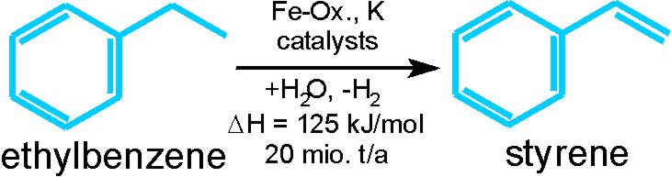 | Example: Dehydrogenation of ethylbenzene
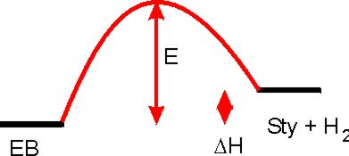 | 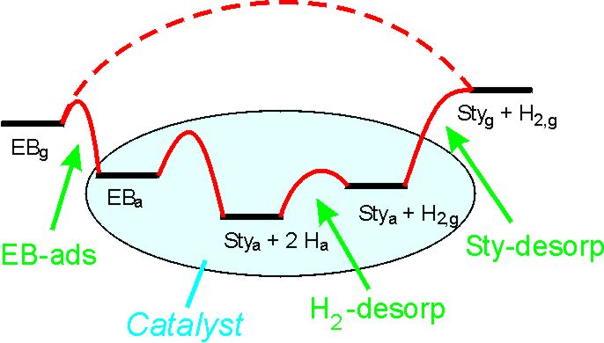
Homogeneous reaction; E activation energy; ΔH reaction enthalpy | Catalytic reaction, role of adsorption and desorption processes

1. Some definitions and concepts

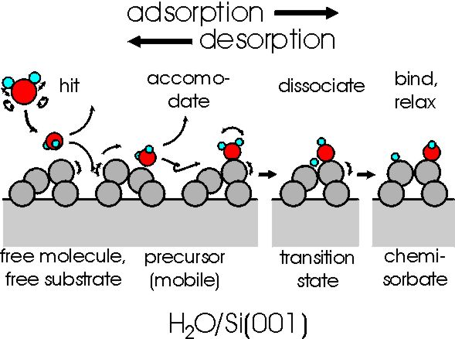
The sticking process. Example: Dissociative adsorption of H₂O on Si(001).
The Si(001) surface relaxes in order to minimize the number of unsaturated (“dangling”) bonds by formation of asymmetric dimers. Relaxation is changed upon adsorption.

(Review on water: M.A. Henderson, Surf. Sci. Reports 46 (2002) 1; calculations: A. Vittadini et al. Phys. Rev. B 52 (1995) 5885)

Adsorption is a process where molecules from the gas phase or from solution bind in a condensed layer on a solid or liquid surface. The molecules that bind to a surface are called the adsorbate while the substance that holds the adsorbate is called the adsorbent. The process when the molecules bind is called adsorption. Removal of the molecules from the surface is called desorption (Masel, p. 108).
Accomodation and sticking:
In order to be bound to the surface, an incoming particle has to get rid of its translational and rotational energy and has to assume a spatial configuration suitable for bonding. Also the surface may have to rearrange in order to bind the particle favorably. This process is often called accomodation. After that the particle may stick. The sticking coefficient or sticking probability is the ratio of particles being bound compared to those hitting the surface.

According to kinetic gas theory, the flux of incoming particles is
$$j_{s} = ρ_{g} \sqrt{\frac{R T}{2π M}} = 2\text{.}\text{63}⋅{\text{10}}^{\text{22}} \frac{p}{\sqrt{M T}} ({\text{cm}}^{−2} s^{−1}) p \text{in} \text{mbar}$$
ρ_{g} density of particles in the gas; R gas constant; T temperature; M mass number of particle; p pressure.

Monolayer and multilayer adsorption
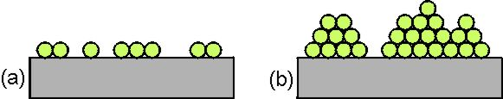 | Monolayer (a) and multilayer (b) adsorption.

Growth modes for 3D growth:
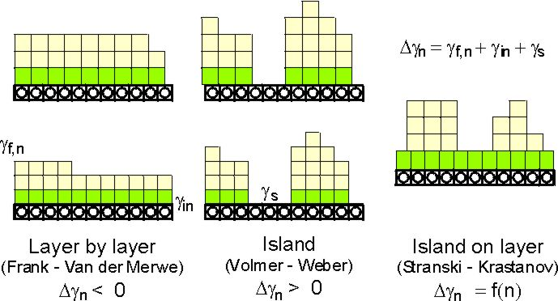 | Multilayer incommensurate  SK-growth: 1st layer commensurate,  further layers incommensurate  Multilayer commensurate
γ_{s} free energy of bare substrate; γ_{f,n} free energy of adlayer-film of thickness n; γ_{in} free energy of interface; commensurate growth for first layer assumed; misfit causes strain

2. Physisorption and chemisorption

2.1 Physisorption (Masel p.126 ff)

Nonpolar gases on nonpolar surface:
Van-der-Waals (induced-dipole – induced-dipole) interaction. Starting from the Lennard-Jones 6-12 potential for the interaction between single atoms or molecules(see e.g. Atkins),
V(R)=4ε [(σ/R)¹² – (σ/R)⁶],
ε depth of potential minimum; σ =0.891 R_{e} (equilibrium distance).
the London-equation,
$$E_{\text{Ms}}(z_{M}) = ρ_{s}π C_{\text{Lond}}\left(\frac{0\text{.}2(r_{e}^{s})^{6}}{z_{M}^{9}} −\frac{ 1}{z_{M}^{3}}\right)$$
ρ_{s}: density of surface atoms; C_{Lond}: London constant, depends on polarizabilities and ionization potentials of adatom and surface; r_{e}^{s}: equ. distance when the adatom interacts with one atom only; z_{M}: distance of adatom from surface. (Masel equ.3.7, p.127)
was derived for nonpolar gases on non-polar non-conducting surfaces. The bond minimum is >2Å from surface; the bond is weak: ΔH_{ad} 1.4 kJ/mol (He/graphite) – 42 kJ/mol (C₅H₁₂/graphite).
Non-polar gas on conducting surface: Same functional dependence as London-equ.

Characteristic for Physisorption:
Electronic structure, bond lengths and angles (almost) undisturbed. Substrate and adsorbate separable.

2.2 Chemisorption
Electronic structure, bond lengths and angles strongly affected. Substrate and adsorbate not separable. Simple models do not exist. The whole system (substrate + adsorbate) has to treated quantum mechanically which has become possible during the last years.

Bond distance 1 – 1.5 Å; ΔH_{ad} up to several hundred kJ/mol.

Covalent - (Ex: H₂O/Si(001)., see above.

Ionic - (Ex: Alkali adsorption)

Acid-base - (Ex: H₂O/Fe₃O₄(111))

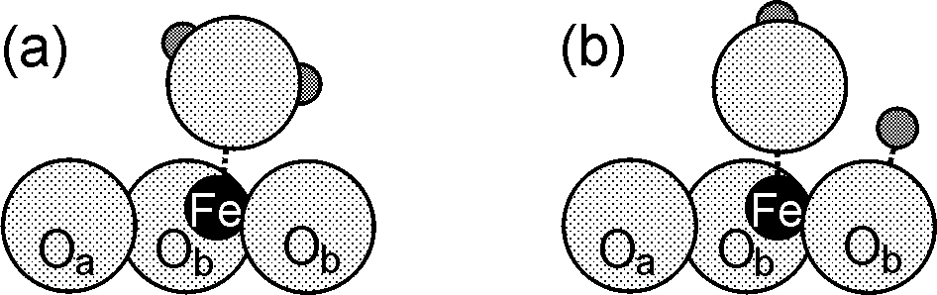 | Model for the interaction and dissociation of water on an acidic Fe-site on the surface of Fe₃O₄(111); the Fe is formally Fe³⁺  (Y. Joseph et al. Chem. Phys. Lett. 314 (1999) 195).

Hardness (Pearson) η:
Measure of the capability to share electrons.
Soft (η small): Species that form strong covalent bonds;
Hard (η large): Species that form strong ionic bonds;
Medium: Species that form mixed covalent and ionic bonds;

Depending on whether a species tends to accept or to donate electronic charge, they are called acids or bases.
Strong interaction between a hard acid and a hard base or
a soft acid and a soft base.
Weak interaction between a hard acid and a soft base.

A selection of hard, soft and borderline acids and bases (Masel, table 3.8, p. 145)
Hard acids | H⁺, Li⁺, Mg²⁺, Cr³⁺, Co³⁺, Fe³⁺, Al³⁺, Al(CH₃)₃, bulk Si
Soft acids | Cu⁺, Ag⁺, Pd²⁺, Pt²⁺, Ga(CH₃)₃, O, Cl, N, RO, ROO, metallic atoms,  metal clusters
Borderline acids | Mn²⁺, Fe²⁺, Co²⁺, Ni²⁺, Cu²⁺, Ru²⁺, Os²⁺, Ir³⁺, Rh³⁺
Hard bases | F⁻, Cl⁻, H₂O, NH₃, OH⁻, CH₃COO⁻, RO⁻, ROH, O⁻
Soft bases | I⁻, CO, C₂H₄, P(C₆H₅)₃, C₆H₆, H⁻, H₂S, metal surfaces
Borderline bases | C₅H₅N, NO₂⁻, SO₃²⁻, C₆H₅NH₂

3. Energetics: Potential curves

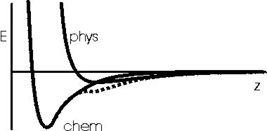 | Potential curves for approach of a non-dissociating particle to a surface: physisorption, chemisorption and sum curve (dotted).

ΔH_{phys} << ΔH_{chem} , typically ΔH_{phys} =20 – 80 kJ/mol, ΔH_{chem} > 100 kJ/mol.
But: Magnitude of ΔH_{ad} is not a sufficient criterion for the distinction.

3.1 Molecular and dissociative adsorption

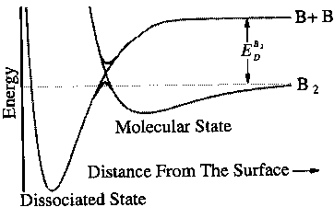 | Potential curve for the dissociative adsorption of a B₂ molecule on a surface (Masel fig. 3.8, p.119.)

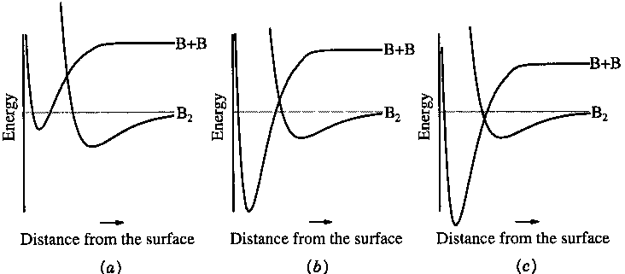
Potential curves for (a) pure molecular adsorption, (b) activated dissociative adsorption and (c) unactivated dissociative adsorption (Masel fig. 3.9, p.119)

3.2 Dissociative adsorption, several sequential steps

Example: C₂H₄ decomposition on Pt(111)
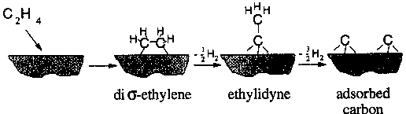 | The mechanism of ethylene decomposition on Pt(111). (Proposed by Kesmodel et al. [1979] and confirmed by Ibach and Lehwald [1979], Masel fig. 3.10, p.121).

This is also an example for “irreversible” adsorption. Irreversible is not strictly the correct term. It is irreversibel under usual experimental conditions where a part of the formed species (here hydrogen in the form of gaseous H₂) is removed from the system.

3.3 Adsorption site:

Surfaces are inhomogeneous and the interaction with certain sites is stronger than with others.

The intrinsic inhomogeneity of the periodic atomic structure results in ordered adsorbate structures
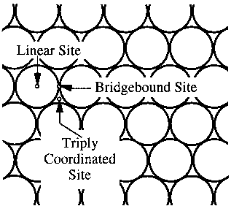 | Different adsorption sites on a close-packed surface: Linear or on-top site, bridgebound site and triply coordinated or threefold hollow site (Masel fig. 3.13, p.123 ).

Ex: CO/Pt(111),
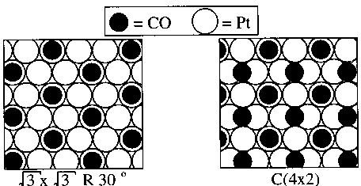 | Binding sites for CO on Pt(111): Two ordered adsorption arrangements assumed sequentially with increasing coverage: Θ_{r} = 0.33 and 0.5 (Masel fig. 3.14, p.123).

Ex: H₂O/Fe₃O₄(111),
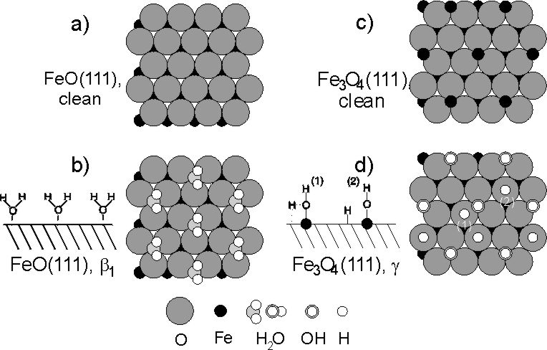
Clean and water covered surfaces of FeO(111) and Fe₃O₄(111). Coverages and kind of adsorbed species deduced from UPS measurements. FeO(111) is O-terminated. The interaction is weak but still determined by the position of Fe in the second layer. Fe₃O₄ is terminated by ¼ ML of Fe. Water dissociates. The coverage is compatible with OH being adsorbed on the Fe sites and H binding to O-sites. Site (1) in (d) is the proposed transition state. (Y. Joseph et al. J. Phys. Chem. B 104 (20002) 3224).

Extrinsic inhomogeneity from defects (steps, domain boundaries, kinks, adatoms, vacancies, contaminants…)

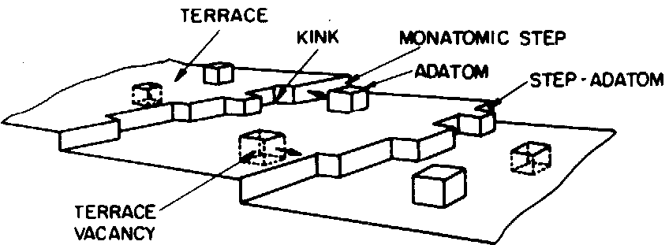 | Model of a heterogeneous surface with different surface sites. They are distinguished by their number of nearest neighbours.  (G.A. Somorjai, Introduction to surface chemistry and catalysis, Wiley, New York (1994),fig. 2.6, p. 41.)

ΔH_{ad} = f(substrate, Θ).
- material dependence
- site dependence
- ads.-ads.-interaction: repulsive or attractive
- ads.-subs.-interaction may induce structural changes in substrate (reconstruction, relaxation)

4. Adsorption-Desorption-Equilibrium: Isotherms and isobars

When a surface is exposed to a gas at a certain pressure p and temperature T, the adsorption rate will depend on p, T and possibly an activation energy E_{a} which has to be overcome in the adsorption process. Usually it will decrease when the coverage Θ increases:
r_{a} = r_{a}(p, s₀, n, T, E_{a}, Θ). (s₀ : initial sticking coefficient, n : reaction order for adsorption ;
E_{a}: activation energy for desorption, Θ : coverage)
At the moment when Θ>0, also desorption will start at a rate
r_{d} = r_{d}(ν, n, T, E_{d}, Θ), (ν : frequency- or prefactor for desorption; n: reaction order for
desorption; E_{d}: activation energy for desorption)
which increases with Θ. After a while, when
r_{a} = - r_{d} ,
an equilibrium coverage Θ_{eq} will establish which may be measured.
Usually, curves Θ_{eq}(T)_{p} is measured with variable T and constant p: isotherms or
Θ_{eq}(p)_{T} with variable p and constant T: isobars.

The activation energies E_{a} and E_{d} determine the adsorption energetics while s₀, n and ν determine the kinetics. The aim is to measure Θ(p,T) and to deduce the energetic and kinetic parameters from it.

It is more usual to measure sets of isotherms but sets of isobars contain the same information.

The shape of isotherms has been classified by Brunauer into 5 types:

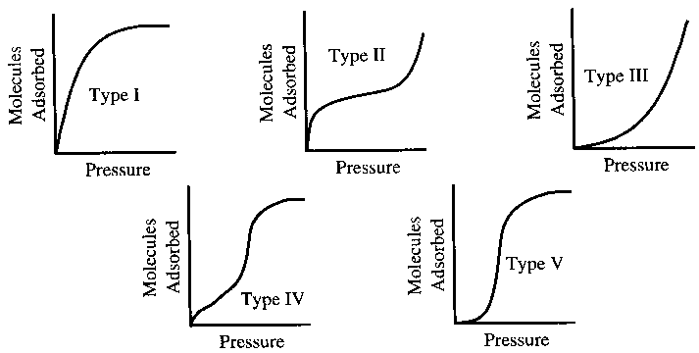 | The fife types of adsorption isotherms described by Brunauer[1945] (Masel fig. 4.4, p.238).

Type of isotherm | Where to be found
I | monolayer adsorption
II | multilayer adsorption, BET isotherm
III | island or droplet nucleation necessary for adsorption
IV | pore filling, followed by outer-surface adsorption
V | pore filling with nucleation (like III), followed by outer surface adsorption

How to determine Θ ?
High surface area (powders, pellets…): pressure decrease by adsorption (e.g. BET), TDS.
Low surface area (single crystals): Δφ, LEED, IRAS, UPS, TDS.

5. A-D energetics: Isosteric heat of adsorption

Measure a set of isotherms or isobars, deduce p-T-pairs for Θ_{eq}=const, plot p(T)_{Θeq} ,
calculate d(ln p)/d(1/T), use Clausius-Clapeyron equation

d(ln p)/d(1/T) = - ΔH/R or
ln p = - ΔH/RT + const.

or, since ΔH may be Θ-dependent,
ΔH(Θ) = q_{st} = isosteric heat of adsorption;
isosteric means: for constant coverage.

The applicability of CC for strongly interacting systems is questionable since the adsorbate cannot be considered as a system independent of the substrate. However, an equivalent equation can be derived using a kinetic description of the A-D-process, as long as the corresponding rates follow the general Arrhenius law r=C exp(-E_{act}/RT) (W. Weiss, W. Ranke, Prog. Surf. Sci. 70 (2002) 1).

q_{st} is one key quantity to describe an adsorption system. It characterizes the energetics.
Advantage of CC-analysis: CC is deduced from equilibrium thermodynamics and therefore independent of adsorption-desorption kinetics.

Disadvantage: Possible only if
- adsorption is reversible. If not: => calorimetric methods (S. Cerny, Surf. Sci. Rep. 26 (1996) 1), now even developed for single crystal surfaces in UHV (C.E. Borroni-Bird et al. (D.A. King-group) Phem Phys. Lett 183(1991) 516; J.T. Stuckless et al. (C.T. Campbell-group), J. Chem. Phys. 107 (1997) 5547)
- both adsorption and desorption are sufficiently fast so that equilibrium can be established within reasonable time.
Surprisingly, not many systems were investigated so far using isosteric methods.

Examples:
1. Adsorption on a metal: CO/Pd(100), first measurement on a single crystal surface by Tracy and Palmberg, 1969.
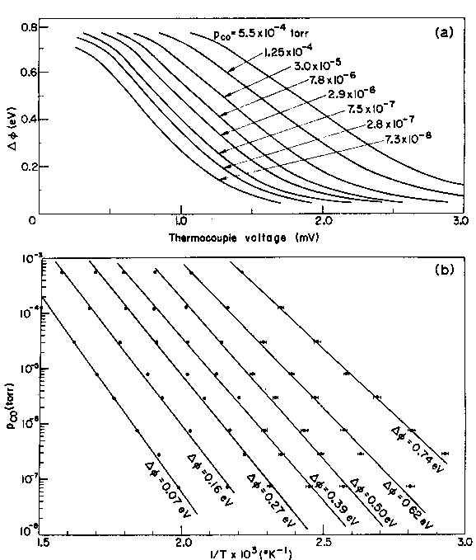 | 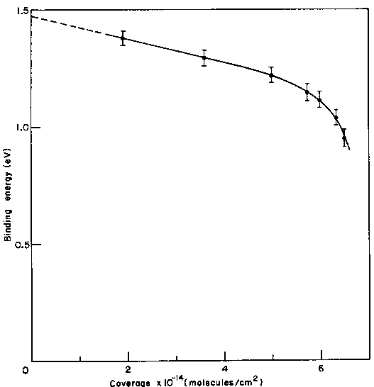
a) Isobars for CO adsorption on Pd(111). As a measure for the coverage, the work function change Δφ was used. In special cases, Δφ is proportional to Θ.  b)Arrhenius-plots ln p vs. 1/T for different coverages (in terms of Δφ). | Coverage dependence of q_{st} deduced from the slopes of the curves in (b).  (J.C. Tracy, P.W. Palmberg, Surf. Sci. 14 (1969) 274).

2. Adsorption on a semiconductor: NH₃/Ge (W. Ranke, Surf. Sci. 342 (1995) 281; W. Ranke, J. Platen, Phys. Rev. B 54 (1996) 2873)

3. Adsorption on an ionic material: Ethylbenzene/FeO(111), Fe₃O₄(111) (W. Weiss, W. Ranke, Progr. Surf. Sci. 70(2002) 1, Figs. 54, 56, 57, 58b)

Adsorption of ethylbenzene (EB) is studied in connection with the investigation of its catalytic dehydrogenation to styrene.

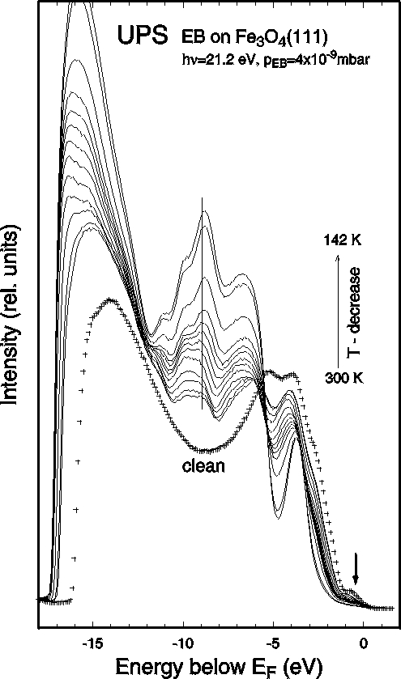 | 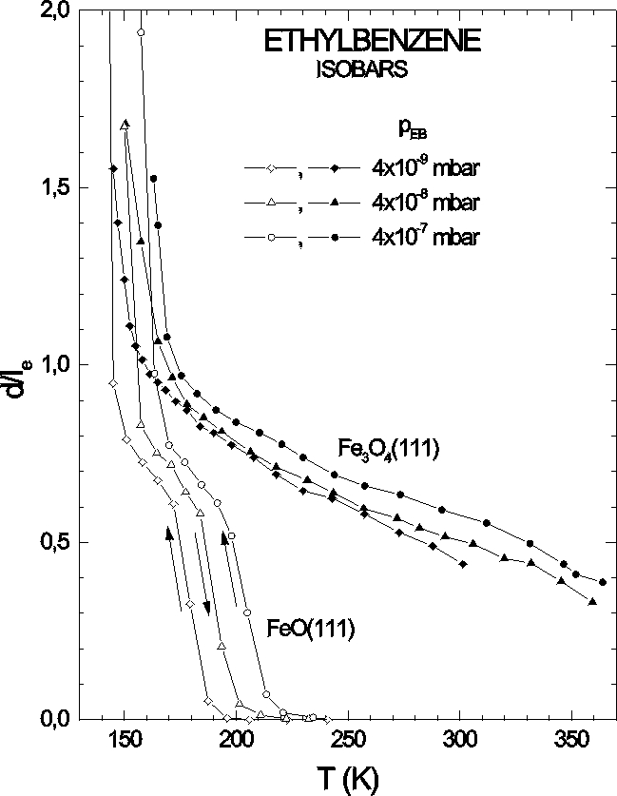
Photoelectron spectra of clean Fe₃O₄(111) and after equilibrium coverage by EB at p_{EB}=4x10⁻⁹mbar and different T. | Adsorption isobars deduced from UPS measurements of EB on FeO(111) and Fe₃O₄(111) for three values of p_{EB}. d/l_{e} is proportional to the coverage.

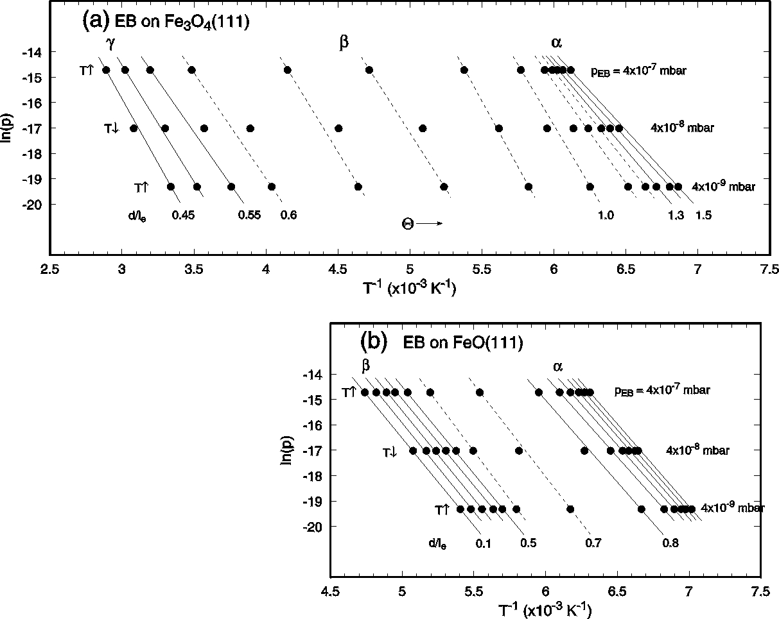 | 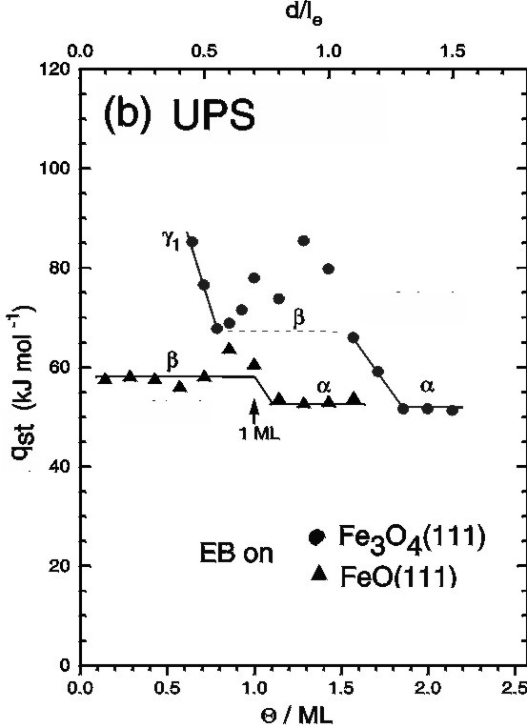
For different coverages (in terms of d/l_{e}), p-T- values are taken from the isobars. ln(p) vs. 1/T yields mostly straight lines. Their slope yields q_{st}. | Coverage dependence of q_{st} deduced from the CC-analysis of isobars.

(An alternative method is => TDS (TPD), a transient method, evaluation depends on kinetics.)

6. A-D kinetics: The shape of isotherms/isobars

Kinetics of adsorption and desorption
$r_{a}=\frac{σ_{A} {\text{dΘ}}_{r}}{\text{dt}}=\frac{p}{\sqrt{2π \text{mkT}}}s_{0} \text{exp}(−E_{a}\text{/kT}) f(Θ_{r})$ $= A f(Θ_{r})$,
$r_{d}= \frac{σ_{A} {\text{dΘ}}_{r}}{\text{dt}} =−ν_{n} σ_{A}^{n}\text{exp}(−E_{d}\text{/kT}) Θ_{r}^{n}$ $= −B Θ_{r}^{n}$.
E_{a}, E_{d}: activation energies for adsorption and desorption; s₀: initial sticking Probability: σ_{A}: density of adsorption sites; Θ_{r} =Θ /Θ_{sat}: relative coverage (0<Θ_{r}<1); ν_{n}: the frequency factor for reaction order n; n: reaction order. I follow the convention that r_{d} is negative since dΘ/dt is negative for desorption.

The function f(Θ_{r}) describes the dependence of the sticking probability s on the coverage,
s = s₀ f(Θ_{r}).

Immobile (Langmuir) ads./des. kinetics and mobile precursor (Kisliuk) kinetics:

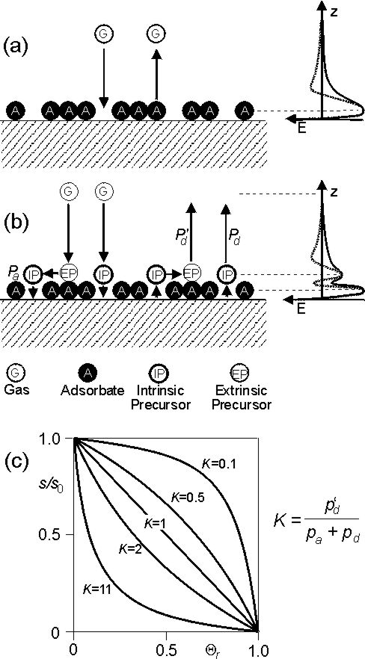 | Langmuir:  Sticking only if unoccupied site is hit.  1st order (molecular): f(Θ_{r}) = 1-Θ_{r} .  2nd order (dissociative): f(Θ_{r}) = (1-Θ_{r})².  Mobile precursor kinetics:  (G) may hit an empty site where it first is in the intrinsic precursor state (IP) which may be mobile and either transform into the adsorbate state (A) (probability p_{a}) or desorb (probability p_{d}).  If (G) hits an occupied site, it transforms into an extrinsic precursor (EP) which may either migrate to an empty site, transform into an (IP) and adsorb (see above) or desorb directly (probability p_{d}’ ).  Kisliuk has treated this case and found that the sticking behavior is determined by a constant K which depends on these probabilities only (P. Kisliuk, J. Phys, Chem. Solids, 3 (1957) 95). If p_{d}’ is small (stable (EP)), the sticking coefficient may be quite high almost until saturation (Θ_{r} =1).  1st order: $f(Θ_{r})=\frac{1−Θ_{r}}{1+Θ_{r}(K−1)}$ with K>0.  K=1 corresponds to Langmuir case.  (W. Ranke, Y. Joseph, Phys. Chem. Chem. Phys. 4 (2002) 2483)

Check of kinetics: determine s(Θ ). Example: H₂O/Si(001):

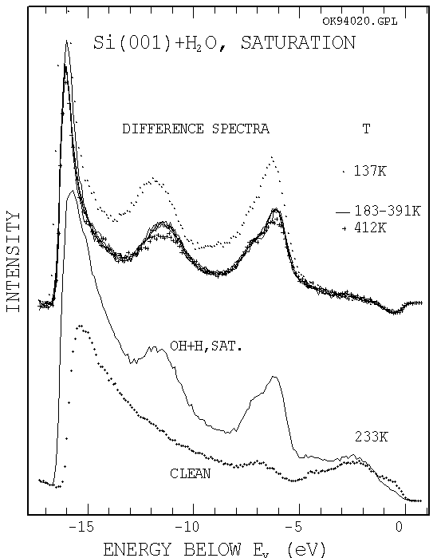 | Left:  UP-spectrum (hν=21.2 eV) of Si(001), clean and after saturation with H₂O which adsorbs dissociatively as OH+H. The species and saturation coverage is equal for 183≤T≤391 K. At 137 K, condensation of H₂O occurs, at 412 K, saturation is not yet reached.  Lower left:  Adsorption curves. Intensity increase of the –6.2 eV peak of OH with exposure time for p_{H2O}=2x10⁻⁹mbar for the same values of T.  Lower right:  The first derivative of the adsorption curves represents the sticking coefficient s(Θ). The wiggles originate from pressure adjustments in the adsorption curves.  (W. Ranke, Surf. Sci. 369 (1996) 137)
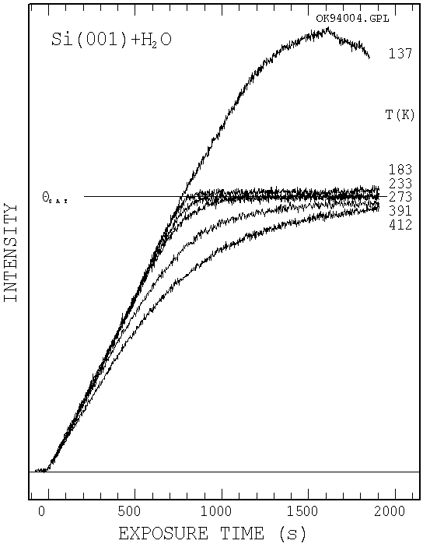 | 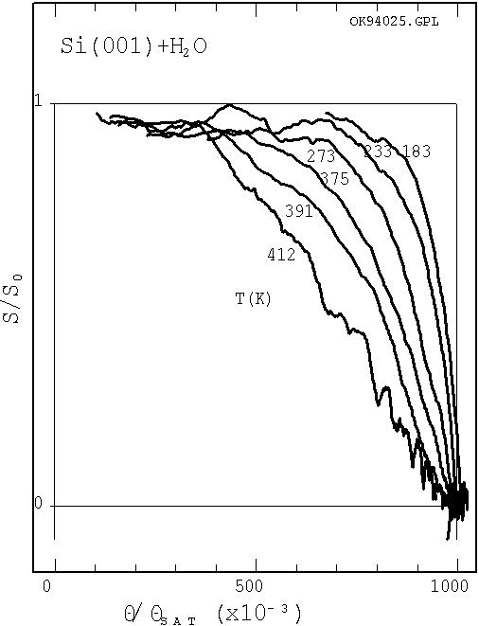

In adsorption-desorption equilibrium we have
r_{a} + r_{d} = 0.
We had
r_{a} = A(p,T) f(Θ_{r}) ,
r_{d} = -B(p,T) Θ_{r}^{n} .
Inserting and resolving for Θ_{r} yields the equations for isotherms/isobars:
Langmuir 1st order:
$Θ_{r}(\text{T,p})=\frac{b_{1}(T) p}{1+b_{1}(T) p}$ with n = 1, f(Θ_{r}) = 1-Θ_{r} ,
Langmuir 2nd order:
$Θ_{r}(\text{T,p})=\frac{\sqrt{b_{2}(T) p}}{1+\sqrt{b_{2}(T) p}}$ with n = 2, f(Θ_{r}) =(1-Θ_{r})² .
Holds not only if the adsorption sites for the dissociation products are equivalent but also for inequivalent sites as long as their site concentrations are equal.
Langmuir 2nd order adsorption, quasi-1st order desorption (dissociated species immobile):
$Θ_{r}(T,p)=\frac{1+2 b_{1}(T) p−\sqrt{1+4 b_{1}(T) p}}{2 b_{1}(T) p}$ with n = 1, f(Θ_{r}) =(1-Θ_{r})² .
Kisliuk 1st order:
$Θ_{r}(T,p)=\frac{1+b_{1}(T) p−\sqrt{[1−b_{1}(T) p]^{2}+4 K b_{1}(T) p}}{2 (1−K)}$,
with n = 1, : $f(Θ_{r})=\frac{1−Θ_{r}}{1+Θ_{r}(K−1)}$
Kisliuk 2nd order:
not analytically solvable.

The functions b₁(T) and b₂(T) are
$b_{1}(T)=\frac{s_{0} \text{exp}({q_{\text{st}}}/{\text{kT}})}{ν_{1} σ_{A}\sqrt{2π \text{mkT}} }$ , (7)
$b_{2}(T)=\frac{s_{0} \text{exp}({q_{\text{st}}}/{\text{kT}})}{ν_{2} σ_{A}^{2}\sqrt{2π \text{mkT}}}$ . (8)
Here q_{st} = E_{d} -E_{a} is the isosteric heat of adsorption.

What should these isobars look like?

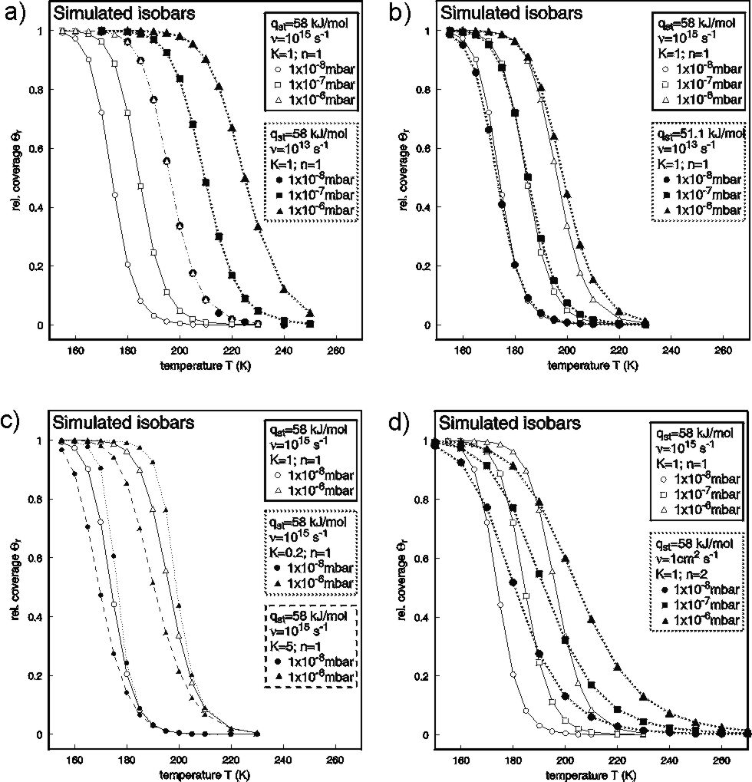 | Assumption: Langmuir 1st order (n = 1), ν₁ = 10¹⁵ s⁻¹, q_{st} = 58 kJ/mol (both independent of Θ, data for ethylbenzene physisorbed on FeO(111)). Pressures as indicated.  a) comparison: ν₁ varied (→ 10¹³ s⁻¹);  b) comparison: ν₁ → 10¹³ s⁻¹, q_{st} adjusted to yield best-possible agreement;  c) comparison: Kisliuk kinetics (mobile precursor), K varied;  d) comparison: Langmuir 2nd order.  (W. Ranke, Y. Joseph, Phys. Chem. Chem. Phys. 4 (2002) 2483).

Example: Ethylbenzene / FeO(111), Fe₃O₄(111)

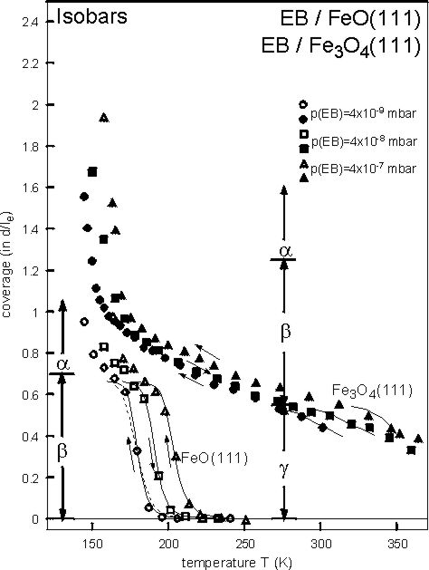 | Same measurement as shown above, lines: fitted isobars.  FeO(111),  β-range: q_{st} = 58 kJ/mol, ν₁ = 4.75x10¹⁴ s⁻¹.  Dotted: Langmuir 1st order gives too smooth curves.  Lines: Kisliuk 1st order, K = 0.2.  Fe₃O₄(111),  γ-range: q_{st} = 94…74 kJ/mol, ν₁ = 5x10¹²…2x10¹⁰ s⁻¹ (Θ-dependent);  Langmuir or Kisliuk possible.  β-range: Fit impossible  reason: phase transitions in adlayer.  (W. Ranke, Y. Joseph, Phys. Chem. Chem. Phys. 4 (2002) 2483).

7. The magnitude of ν: Entropy of the activated state

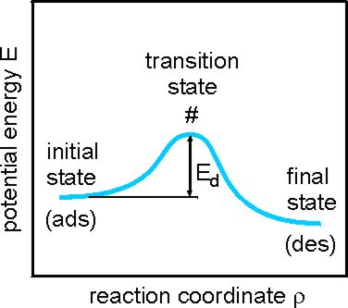 | The transition state theory starts from the assumption that the molecule is in thermodynamic equilibrium with its environment, even during the desorption reaction.

It can be shown that (for 1st order desorption)
$ν_{\text{des}}≈\frac{\text{kT}}{h} \frac{q^{}}{q_{\text{ad}}} ≈\frac{\text{kT}}{h} \text{exp}\left(\frac{{ΔS}^{}}{R}\right)$ (see e.g. Christmann, p.27ff).
If the partition function q# in the transition state and q_{ad} in the adsorbed state are equal, ν_{des} at T=300K turns out to be ≈10¹³ s⁻¹. If, however, the adsorbed state is immobile and the transition state is mobile and may even rotate freely, q# and consequently ν_{des} may get several orders of magnitude larger. Also the opposite may happen, if the transition state requires a complicated or “demanding” configuration which has a low probability of realization. Although the agreement between measured values of ν_{des} and values calculated using transition state theory is poor, it gives at least an idea why ν_{des} values vary so strongly.

Experimentally, ν_{des} values between about 10¹⁰ s⁻¹ and 10¹⁹ s⁻¹ have been observed while values around 10¹³ s⁻¹ do not appear to be especially probable.

8. Further isotherms for monolayer and multilayer adsorption

8.1 Other isotherms / isobars for monolayer adsorption:

Isotherm | Advantages | Disadvantages
Langmuir | Best one-parameter isotherm | Ignores adsorbate-adsorbate interactions
Freundlich, Toth | Two parameters | No physical basis for equation
Multisite | Many parameters | Good for inhomogeneous surfaces. Wrong physics for single crystals
Tempkin Fowler  Slygin-Frumkin | Account for adsorbate-adsorbate interactions in an average sense | Does not consider how the adsorbate layer is arranged
Lattice gas | Complete description of adsorbate-adsorbate interactions for commensurate layers  Predicts arrangement of adsorbed layer | Requires a computer to calculate isotherm  Assumes commensurate adsorption  Parameters used in the model are difficult to determine
(R.I. Masel, table 4.1, p.246).

8.2 Multilayer adsorption: The BET isotherm (Brunauer-Emmett-Teller)

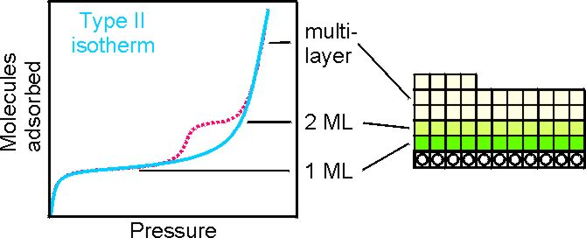 | Multilayer adsorption with different ΔG₁, ΔG_{m} and ΔG₁, ΔG₂, ΔG_{m}, respectively.

Analysis:
Either:
Consider each step in the isotherm separately with its own n, ν, s₀, q_{st}, add isotherms (e.g. Langmuir) for 1st, 2nd … layer. Problem: Multilayer condensation.
Or:
Develop an isotherm for multilayer adsorption: Brunauer-Emmett-Teller, BET-isotherm.
$$\frac{V}{V_{M}} = \frac{c_{B} x_{B}}{(1−x_{B}) [1+(c_{B}−1) x_{B}]}$$
(V : total volume of adsorbed gas; V_{M} : volume gas in 1st layer (monolayer saturation));
x_{B} = p/p_{sat}
(p the gas pressure and p_{sat} the saturation vapor pressure of the gas at the temperature of the measurement).
c_{B} = K₁/K_{m} ratio of equilibrium constants for 1st layer and multilayer adsorption:
$$c_{B}=\frac{K_{1}}{K_{m}}=\frac{\text{exp}(−{{ΔG}_{1}}/{\text{RT}})}{\text{exp}(−{{ΔG}_{m}}/{\text{RT}})}=\text{exp}[−({ΔG}_{1}−{ΔG}_{m})/{\text{RT}}]$$

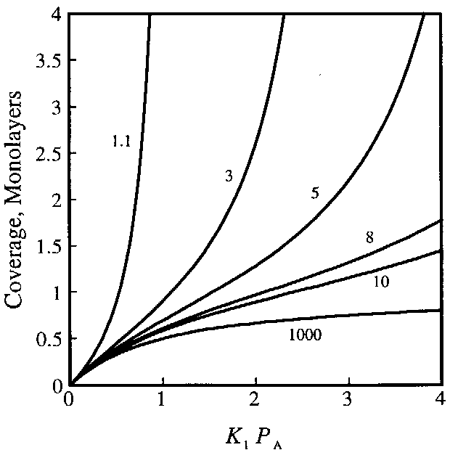 | A plot of adsorption isotherms predicted by the BET equation for various values of c_{B}.  (Masel fig. 4.30, p.302)

In fact, the BET isotherm does in general not very well fit measuered isotherms. However, in the environment of ML saturation it usually does. If, however, ML.saturation can be unambiguously be identified in the isotherm by step structure, the ML capacity can directly be taken from the isotherm.

