Hydrothermal synthesis and LPG sensing ability of SnS nanomaterial
A Muthuvinayagamª & B Viswanathan^{b,} *
ªDepartment of Physics, National Institute of Technology Calicut 673 601, India
^{b}NCCR, Indian Institute of Technology Madras, Chennai 600 036, India
Email: bvnathan@iitm.ac.in
Received 19 December 2014; accepted 29 January 2015
The preparation of nanoparticles of tin sulfide is reported employing the hydrothermal method. The X-ray diffraction results of tin sulfide nanopowder confirm its orthorhombic crystalline structure. Transmission electron micrographs show that the as-prepared SnS nanoparticles are spherical in shape with the average size of 3-5 nm. Control over the particle size and size distribution have been achieved by optimizing the experimental parameters such as precursor concentration, water concentration, reaction time and temperature. The scanning electron micrographs suggest the presence of spherical aggregates of smaller as well as larger sizes. Thermal stability of these nanoparticles is investigated by thermogravimetric analysis and differential scanning calorimetry. The prepared nanomaterial shows good gas sensing response for liquefied petroleum gas at low operating temperatures. The high crystallinity and control over the particle size make the
as-synthesized SnS an ideal candidate for LPG sensing.
Keywords: Nanoparticles, Semiconductors, Gas sensors; Hydrothermal method, Tin sulphide

Nanostructures with controlled morphology and sizes are promising candidates for different applications. Nanostructured materials find attractive applications as sensors and devices^{1, 2}. Devices using nanostructures with defined as well as improved properties have found application in many fields of technology and science³. Till now, metal chalcogenides, such as CdS, CdSe, PbS, and PbSe are being used. However, wider applications of these metal chalcogenides (semiconductors) are limited because of their toxicity. Tin sulfide (SnS) on the other hand, is non-toxic and has a band gap that is close to the optimum value required for the efficient solar light absorption. SnS is thus a potential candidate for non-toxic and
non-expensive photo-absorber materials⁴. In addition, SnS has high absorption coefficient of >10⁴ cm⁻¹ and is more efficient (~25%) than materials such as, CdTe and CuInSe₂^{5, 6, 7}. Both the electrical and optical properties like mobility of hole and optical band gap in SnS were found to vary in an orderly manner, but nonlinear as a function of composition⁸. These considerations enhance the feasibility of tailoring the physical, electrical and optical properties⁹. Further, SnS possesses uniqueness in crystal structure, since the semiconductor type can be varied from p-type to n-type by altering the concentration of tin atoms in a controlled manner¹⁰.
In recent times, SnS has received attention due to its application potential. SnS is used in photovoltaic cells, photodetectors, solid-state batteries, medical diagnostics, sensors, capacitors, near-infrared detector, holographic recording medium and a promising visible light driven photocatalytic material due to its favourable physical and chemical properties^{8, 11, 12}. SnS has been introduced into the field of biomedicine, especially in the image resolving issues with enhancement in image contrast¹³.These applications have aroused great interest in synthesis of SnS nanostructures in recent years. Until now, different methods for the synthesis of SnS nanostructures have been developed, which include aqueous solution method , polyol route, reflux assisted polyol route, microwave assisted polyol synthetic method, mechano-chemical method, laser ablation, solution dispersion method, successive ionic layer adsorption and reaction method (SILAR, ethanol thermal route and solvothermal/hydrothermal method) ^{10, 14}. In spite of these studies on the preparation of SnS nanoparticles, a thorough scan on literature indicates that there are only a few reports that present synthetic methodologies for forming SnS nanoparticles (NPs) with well defined optical properties and narrow size distribution. Since the discovery of the quantum confinement effect in semiconductor nanomaterials, particular interest has been shown for synthesizing semiconductor nanocrystals exhibiting a gradual reduction from higher to lower dimensionalities while keeping a constant composition¹⁵.
Hydrothermal technique is a common method for advanced materials processing, particularly owing to its advantages in the processing of nanostructural materials for a wide variety of applications such as, optoelectronics, catalysis, ceramics, magnetic data storage, biomedical, bio-photonics, etc. In contrast to other techniques, hydrothermal method is a promising approach in the preparation of complex oxides/chalcogenides/nitrides at relatively low reaction temperatures but with high quality of the obtained crystals, and in some cases, reduction in particle size of the product¹⁷.
The controlled synthesis of well defined structures via a simple and trustworthy process is still a challenging task in the field of nanotechnology. An attempt has been made in the present study to employ the hydrothermal method for producing SnS nanocrystallites. Though there are a few reports on the synthesis of SnS by solvothermal/hydrothermal procedure, the obtained size and quality were not encouraging. Panda et al.18 have used water solvent as well as mixed solvent of ethylene diamine-water to prepare SnS NPs with tin foil and thiourea as the sources of Sn and S respectively. However, the obtained SnS nanoflakes were of thickness 100 nm and width 1-2 μm.
A variety of external factors have a strong impact on the solvothermal growth of crystals. These can be grouped into chemical factors and thermodynamic factors17. The main chemical factor is the choice of precursors and solvents for a particular process. The thermodynamic factors include the experimental conditions, such as temperature and pressure. This is quite true in the case of nanocrystalline SnS, where the nanoparticles with different morphologies like flakes, sheets, granules and rods had been successfully synthesized by selecting different solvents via a solvothermal/hydrothermal routes¹⁸. Considering green chemistry, water is an ideal medium for the solution route, which drives one to synthesize nanoscale tin sulfides in aqueous solution under mild conditions. In the present study, SnS NPs are precipitated through the reaction between SnCl₂.2H₂O and thiourea in an aqueous solution. SnS NPs have been synthesized in the size range of 3-5 nm by adopting a one-step hydrothermal method. The striking feature is that the synthesis does not involve any template or surface protecting additives such as, thiols or phosphanes and does not require the use of inert atmosphere. The
as-prepared SnS NPs are characterized by powder XRD to identify the structure and grain size. The SEM and TEM studies show the morphology, growth features and particle size. The gas sensing property of the SnS nano-powder was ascertained in pellet formwith varying concentration of LPG.

Materials and Methods
The precursors, tin(II) chloride dihydrate of GR grade (SnCl₂.2H₂O) and thiourea were obtained from Merck. Milli-Q water was used as the medium for the preparation of SnS. A Teflon-lined autoclave was thoroughly cleaned with ethanol and water and dried completely before use.

Synthesis and characterisation of SnS nanoparticles
In a typical experiment to synthesis nanocrystalline SnS, SnCl₂.2H₂O (4.511 g) and thiourea [CS(NH₂)₂] (9.026 g) were dissolved in a stoichiometric ratio of 1:2 in water. The content was stirred vigorously for about 2 h. After stirring, the resulting solution was transferred into a Teflon-lined autoclave of 200 mL capacity, with some more water added so as to fill up to 80% of the total volume. The autoclave was heated in an electrical furnace with the temperature maintained at 200 °C for 8 h. After the heat treatment, the autoclave was allowed to cool down to room temperature naturally. The resulting brownish precipitate was collected from the reaction vessel through centrifugation and washed several times with absolute ethanol and Milli-Q water. The final product was dried in the open atmosphere in the temperature range of 60-70 °C for 2 h.
Powder XRD analysis was carried out using the Rich Seifer XRD instrument with monochromatic nickel filtered Cu-K_{α} (λ = 1.5461 Å) radiation. The sample used for the TEM analysis was subjected to ultrasonication for 30 min in ethanol before use. The TEM analysis was carried out by a JEOL JEM 3010 operating at 200 kV. For SEM analysis, a Jeol JSM 6310 instrument operated at 15 kV was used. Gas sensing properties were investigated using a Keithley electrometer (model 2400) with a sensing chamber and the measurements were made by a two-point probe technique.
Gas sensing studies
In order to make pellets, the SnS nanopowder was first thoroughly mixed with PVA as a binder with the help of mortar and pestle and then cold pressed in a hydraulic press using a dye of 1 cm diameter and applying a pressure of 5 ton/mm². The thickness of the pellet was around 5 mm. The pellet was sintered at 300 ºC for nearly 1 hour for proper physical strength. The pellet was then removed from the furnace and allowed to cool naturally before using it as a sensor. Ohmic contact was made with the help of silver paste to form the sensing element. The gas sensing study was carried out in a static gas chamber to sense LPG in air ambient. The sensor was kept directly on a heater in the gas chamber and the temperature was varied. The temperature of the sensor was monitored by a chromel-alumel thermocouple which was kept in contact with the sensor. A known volume of the LPG was introduced into the gas chamber prefilled with air and was maintained at atmospheric pressure. Before exposure to the LPG, the sensor was allowed to establish equilibrium inside the gas chamber for about one hour at operating temperature. The experiment was repeated several times to measure the sensitivity as a function of the operating temperature.
The electrical resistance of the sensor was measured employing a (model 2400) Keithley electrometer before and after exposing it to the LPG. The exposure time of the gas was maintained as
10 min for all the measurements. The response time was found to vary between 50 and 60 s and the corresponding recovery time was around 80-90 s. To investigate the gas sensing properties of SnS NPs, the fabricated sensor was tested at different temperatures ranging from 200 to 400 ºC in steps of 50 ºC to optimize the working temperature. The sensitivity was measured with LPG at concentrations of 500, 1000, 1500 and 2000 ppm.

Results and Discussion
Charaterisation
Figure 1 shows the XRD pattern of SnS NPs. The diffraction peaks for the as-prepared nanopowder match with those of the bulk SnS. The peaks are indexed to the orthorhombic crystal structure with space group (P_{bnm}) and the lattice parameters
a = 0.429 nm, b = 1.191 nm and c = 0.388 nm are in agreement with the JCPDS data (No. 39-0354). The diffraction peaks corresponding to any kind of impurities were not observed in the XRD pattern of SnS. The peaks are broader and sharper, thereby confirming the reduced size of the crystallites. The average crystallite size was calculated as around 2 nm using the Sherrer’s formula.
The thermal behavior of the as-prepared SnS NPs was examined using thermogravimetric analysis (TG) and differential thermal analysis (DTA) in N₂
ambient atmosphere. The temperature range for
the analyses was between 30 and 870 ºC at a heating rate of 10 ºC/min (Fig. 2). TG results confirm
that there is no sharp weight loss, indicating that no phase change has taken place. However, the desorption of solvent molecules are discernable in
the thermal traces.
SEM images (Fig. 3) of SnS indicate that the surface of the spheres is moderately smooth, and a few degrees of aggregation of primary SnS NPs are also seen. The micrographs further suggest the presence of size controlled spherical aggregates of smaller as well as larger sizes. At a higher magnification, the SEM image (Fig. 3c) confirms that the size of tiny spherical aggregates are in the range of 50-60 nm and the size of the larger spherical aggregates is around 500-600 nm.

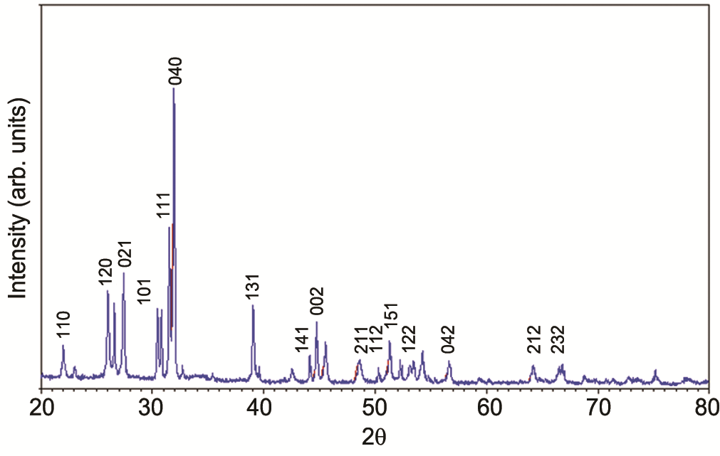
Fig. 1 – Powder XRD pattern of SnS nanoparticles.

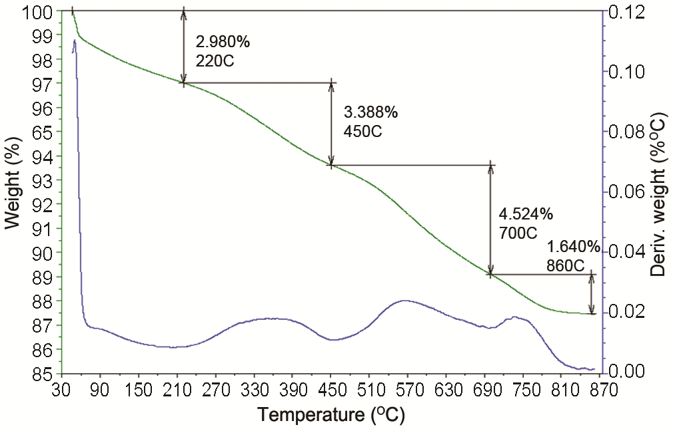

Fig. 2 – TGA and DTA analysis.
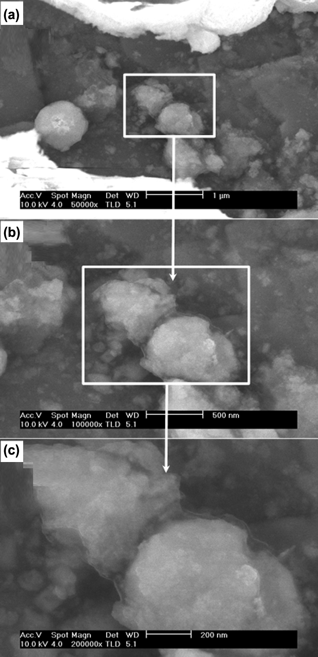

Fig. 3 – SEM images of SnS NPs at different magnifications.
The as-prepared samples of SnS NPs in high resolution TEM show the presence of clusters of size 100-150 nm (Fig. 4a) with individual particles of average size between 3-5 nm. The hydrothermally synthesized SnS are monodispersed with a size distribution typically less than 10%. The portions of the images with less transparency are due the overlapping of small particles over each other. From the micrograph, it is evident that the SnS NPs are agglomerated among themselves. This kind of agglomeration is quite common in SnS nanopowders and the same has been reported by various research groups^{19, 20}.
The HRTEM analysis reveals the predominance of particles with a spherical shape. The lattice planes visible in the HRTEM images of the particles confirm the crystallinity of the samples (Fig. 4b). In the HRTEM image of SnS nanoparticle, the interplanar distance was found to be 0.292 nm, which agrees with the (101) lattice fringe of orthorhombic SnS . Selected area electron diffraction (SAED) pattern image (Fig. 4c) shows the electron diffraction rings for SnS that are assigned to (101), (201), (011), (211), (311), (102) and (121) crystal planes.

Gas sensing properties
Ozin’s group²¹ reported that nanoporous SnS₂ materials show excellent sensor properties for NH₃, H₂S and alcohols. SnS₂ nanostructures were synthesized using a mild hydrothermal condition and its gas sensing properties were reported by Shi et al.²² Room temperature gas sensing measurements showed that the 3D SnS₂ nanostructures could serve as sensor materials for the detection of NH₃. However, a thorough scan of literature indicates that in the tin sulfide family, the gas sensing properties of SnS NCs are surprisingly unfamiliar. To the best of our knowledge, gas sensing properties of SnS NCs with LPG has reported for the first time in this study.
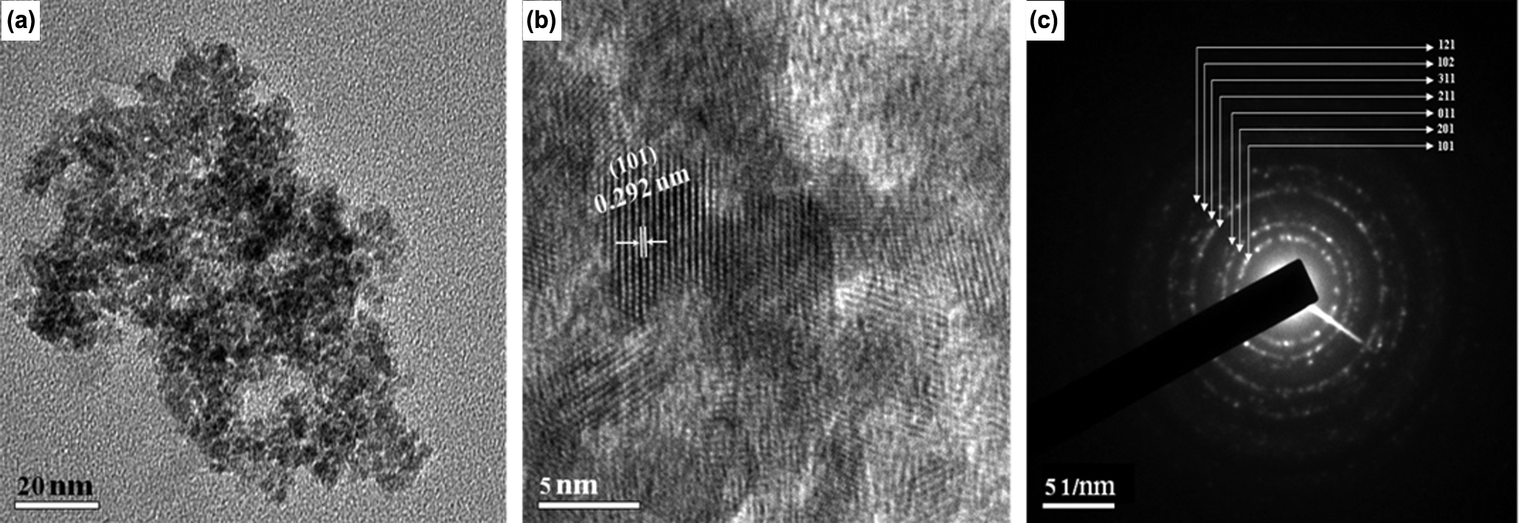

Fig. 4 – (a) TEM images of SnS NPs, (b) HRTEM images of SnS NPs, and, (c) SAED pattern of SnS NPs.
Figure 5(a) shows the sensitivity of SnS nanoparticles for LPG as a function of operating temperature. The gas response increases with increase in the operating temperature and attains a maximum at around 340 ºC, followed by a decrease in the sensitivity with further increase in the operating temperature. The bell-shaped distribution of gas response against the operating temperature indicates that optimum performance is achieved at 340 ºC for LPG. The formation of bell shaped response of the sensor is identical to those reported for SnO₂ based sensor for LPG^{23, 24}. Interestingly, the observed optimum temperature of 340 ºC is almost the same with varying concentration of LPG.
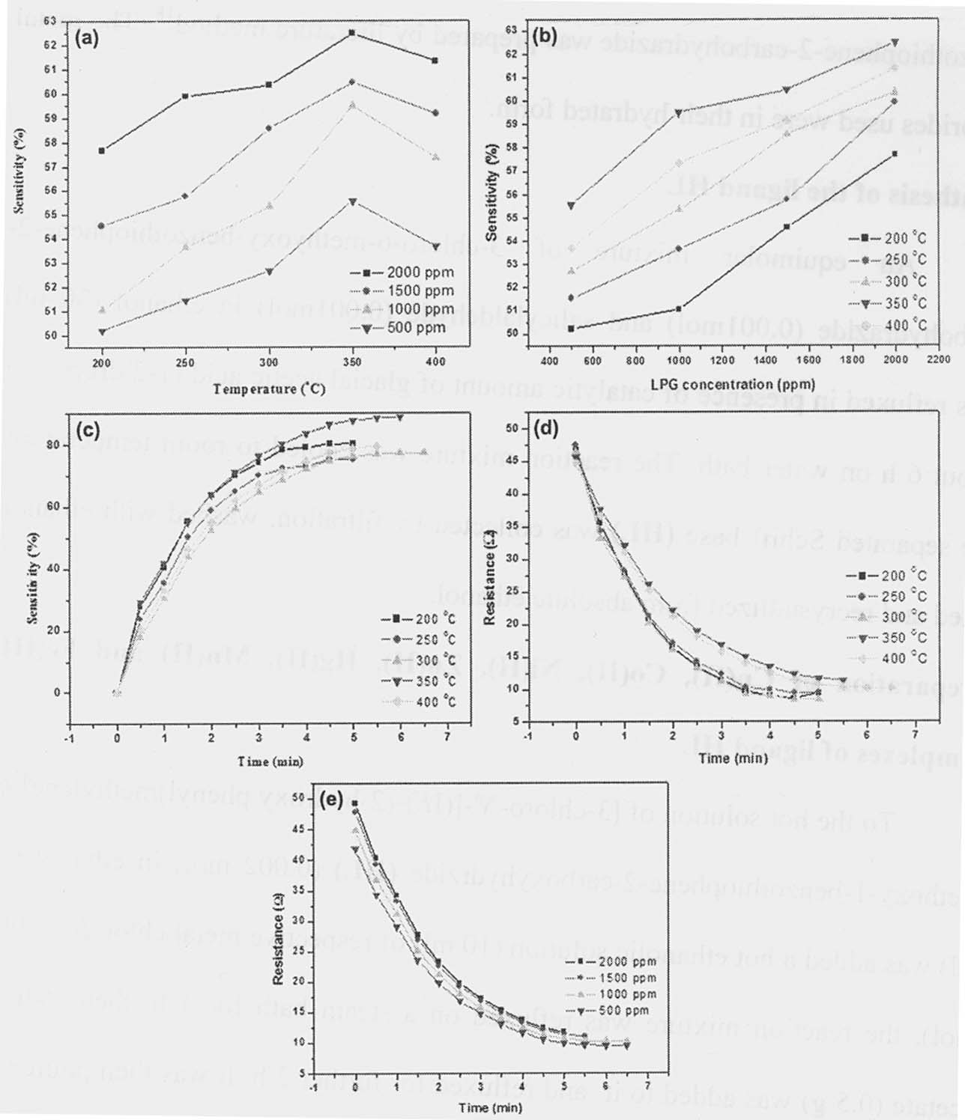

Fig. 5 – (a) Sensitivity as a function of operating temperature for SnS NPs, (b) Relationship between sensitivity and LPG concentration, (c) Relationship between sensitivity and exposure time at 1000 ppm, Variation of resistance with exposure time for SnS pellet. [(d) at 1000 ppm; (e) at 300 ºC].
The dependence of the sensitivity of the SnS NPs on the LPG concentration at different operating temperatures is shown in Fig. 5(b). The response increases almost linearly as the LPG concentration increases from 500 ppm to 2000 ppm. The variation of sensitivity and exposure time is shown in Fig. 5(c). The variation of resistance of the SnS pellet with time under 1000 ppm as afunction of time is shown in Fig 5d and at the samevariation at the same concentration at 300 ⁰ C is shown in Fig.5e. These resuts show the sensing ability of this material for LPG under varying experimental conditons.

Conclusions
Tin sulfide NPs were prepared via a hydrothermal route using a single-step and cost effective approach. The crystalline nature and particle size were confirmed by powder XRD analysis. The SEM results indicate that the spherical aggregates are composed of numerous nanoparticles. Thermogravimetric analysis and differential scanning calorimetric analysis are carried out to study the thermal behavior of SnS. The low resolution TEM confirmed the agglomeration of the spherical particles. The HRTEM analysis revealed the formation of SnS NPs. The results of LPG sensing properties of the SnS NCs have been reported and the optimum temperature was found to be 340 ºC which is comparable with other well known gas sensors based on nanostructures.

References
- Brus L.E, Appl. Phys. A. 53 (1991) 465-474.
- Ghazali A, Zainal Z, Hussein M.Z and Kassim A, Solar Energy Materials and Solar Cells. 55 (1998) 237-249.
- Wu S, Cao H, Yin S, Liu X and Zhang X, J. Phys. Chem. C. 113 (2009) 17893-17898.
- Tsukigase H, Suzuki Y, Berger M.H, Sagawa T and Yoshikawa S, J. Nanosci. Nanotechnol.11 (2011) 1914.
- Koktysh D S, McBride J R & Rosenthal S, Nanoscale Res Lett, .2 (2007) 144.
- Ferekides C.S, Balasubramanian U, Mamazza R, Viswanathan V, Zhao H & Morel D.L, Sol Energy, 77 (2004) 823.
- Noufi R, Souza P& Osterwald C, Sol Cells, 15 (1985) 87.
- Reddy K, Devika M, Ashanulhaq Q & Gunasekhar K R, Cryst Growth Des, 10 (2010) 4769.
- Pierson H O, Principles, technology and applications, (1992) Handbook of Chemical Vapor Deposition (CVD), Noyes Publications, Park Ridge, NJ.
- Kang J G, Ko Y D, Choi K J, Park J G & Kim DW, Appl Phys A, . 103 (2011) 505.
- Tang P, Chen H, Cao F, Pan G, Wang K, Xu M & Tong Y, Mater Lett, 65 (2011) 450.
- Paul G S, Gogoi P & Agarwal P, J Non-Cryst Solids, 354 (2008) 2195.
- Boppart S A, Oldenburg A L, Xu C Y & Marks D L, J Biomed Optics, 10 (2005) 1.
- Niasari M S, Ghanbari D & Davar F, J Alloys Compd, 492 (2010) 570.
- Xu X, Zhuang J & Wang X, J Am Chem Soc, 130(2008)12527.
- Goicoechea J, Arregui F.J,& Matias I.R, Quantum dots for sensing, Sensors Based on Nanostructured Materials, Springer.
- Demazeau G, J, Mater Sci, 43(2008)2104/
- Panda S K, Gorai S & Chaudhuri S, Mater Sci Eng, B 129 (2006) 265.
- Sohila S, Rajalakshmi M, Ghosh C, Arora A K & Muthamizhchelvam C, J Alloys Compd, 509 (2011) 5843.
- Wang Z, Qu S, Zeng X, Liu J, Zhang C & Tan F, J Alloys Compd, 482 (2009) 203.
- Jiang T, Ozin G A, Verma A & Bedard R L, J Mater Chem, 8 (1998) 1649.
- Shi W, Huo L, Wang H, Zhang H, Yang J & Wei P, Nanotechnology, 17 (2006) 2918.
- Thong L V, Loan L T N & Hieu N V, Sens. Actuators B Chem, 150 (2010) 112.
- Garje A D, Inamdar A & Aiyer R C, Int J Appl Ceram Technol, 17 (2010) 1.

