**CO2 Utilization Techniques**

**Introduction**

CO₂ is primarily a raw material in the synthesis of high value chemicals, biofuels and petroleum feedstock. Thus the very use of in a technology which would foster the production of viable basic chemicals, plastics, and biofuels is probably some of the best news around. Thereby, CO2 which has been shown to be the globe’s worst offender as a greenhouse gas is no longer seen as a waste product with dangerous environmental effects. Even in a world where fossil resources are completely depleted, the research laboratories provide an alternative path in securing a constant supply of carbon atoms to the industrial chemistry sector via CO2 utilization.

**Unique Properties of CO2**

A potential green feedstock of fuels, polymers and chemicals:

* Carbon dioxide is non-flammable.
* It is relatively non-toxic.
* Itcannot be oxidized.
* CO2is an aprotic solvent.
* It is generally immune to free radical chemistry.
* CO2is miscible with gases in all proportionsabove 304K.
* It exhibits solvent properties that allowmiscibility with both fluorous and organic materials.
* It exhibits a liquid viscosity (only 1/10 that of water

**Green house gas**:

A greenhouse gas (GHG) is a gas in the atmosphere that [absorbs](http://en.wikipedia.org/wiki/Absorption_(electromagnetic_radiation)) and [emits](http://en.wikipedia.org/wiki/Emission_(electromagnetic_radiation)) radiation within the [thermal infrared](http://en.wikipedia.org/wiki/Infrared#Heat) range. This process is the fundamental cause of the [greenhouse effect](http://en.wikipedia.org/wiki/Greenhouse_effect). Without this natural “greenhouse effect”, temperatures would be much lower than they are now, and life as known today would not be possible. Instead, thanks to green house gases, the earth’s average temperature is a more hospitable at 60° F. However, problems may arise when the atmospheric concentration of greenhouse gases increases. Such as carbon dioxide, methane, nitrous oxide, and ozone along with hydro fluorocarbons (HFCs), perfluorocarbons (PFCs), and sulfur hexafluoride (SF6) increases.

Among the other gaseous resources, CO2 contributes to 26 % next to methane with 9 % and ozone with 7 % in the atmosphere. Its effect is indicated by the global warming potential and life time in years. CO2 has a life time of 30-95 yrs when compared to methane of 12 yrs. The direct radiative effect of a mass of methane is about 72 times stronger than the same mass of carbon dioxide over a 20-year time frame but it is present in much smaller concentrations and its effect is smaller, in part due to its shorter atmospheric lifetime. This is not so for the case of CO2 and hence stabilization measures are needed.

**Structure of CO2:**

Carbon dioxide is very stable linear molecule in which oxygen atoms are weak Lewis base and the carbon is electrophilic. Reactions are dominated by nucleophilic attack at the carbon, which result in the bending of the O-C-O bond.



Lewis

acid

πcomplexes

Lewis base

Two oxygen atoms and one carbon atom will share each electron to form one covalent bond and make a carbon dioxide molecule. By sharing 4 electrons, carbon and oxygen can count 8 electrons in the outer shell. Thefull outer shells with shared electrons are now stable and CO2molecule will not further react with oxygen or carbon atoms. Each electron pair is one bond and two bonds lies between carbon and oxygen atom called double bond. Each double bond is comprised of one sigma bond and one π bond. They are equivalent with C-O bond distance of 116.3 pm with no electrical dipole. They are not ionic since the bond is shared not transferred. The description of structure of molecule does not end without molecular orbital theory.

**Applications of CO2**:

CO2 has several general and industrial applications which are summarized in the table below.

|  |  |
| --- | --- |
| **Processes** | **Applications** |
| Chemicals | CO2 is used under supercritical conditions for purifying or dying polymer, animal or vegetable fibers.  CO2 is used for controlling reactor temperatures.  Supercritical CO2 can be used as a reactant and solvent. |
| Pharmaceuticals | CO2 is used for making chemicals such as salicylic acid and aspirinsupercritical fluid extraction of drugs.  CO2 is used for product transportation/storage at low temperature. |
| Foodstuffs | Packaging of foodstuffs to increase the shelf life.  Temperature control during the storage and distribution of foodstuffs. |
| Beverage | Carbonation of beverages such as soft drinks, mineral water or beer.  CO2 is used as shielding gas for preserving drink quality.  Propellant gas for emptying tanks of drinks. |
| Healthcare | As respiratory stimulant to promote deep breathing for the operation of artificial organs. |
| Environment | CO2 is an excellent alternative to sulfuric acid for pH balance control  CO2 is also employed to neutralize alkaline effluents. |
| Pulp and paper | CO2 can be used in the Tall Oil neutralization and for increasing the performance of paper machines.  Calcium carbonate obtained from CO2 and CaO is used as a whitener for the paper industry. |
| Electronics | CO2 can be used to add conductivity to ultrapure water.  CO2 is usually used as a cooling medium in environmental testing of electronic devices.  CO2 can also be used as an environmentally friendly supercritical fluid. |
| Metals industry | Special grades of CO2 are used in CO2 lasers.  CO2 is typically used as an inert gas or for environment protection.  CO2 is used for fume suppression during ladle transfer of matte in the non ferrous metallurgy. |
| Safety | CO2 is used as carbon dioxide snow for fire extinguishers. |
| Coolant | Carbon dioxide is used in chemistry for controlling reactor temperatures. |
| Laboratory and analysis | Supercritical CO2 is the mobile phase in both chromatography and extraction applications. |

**Utility of CO2**:

Briefly, processes in which CO2 is of utility are two in number. They are:

1. **Low energy processes**: Leads to the production of chemicals in which C maintains its +4 oxidation state
2. **High energy processes**: Leads to the generation of fuels where the oxidation state of C is lowered by at least two units below +4.

The preferable catalyst for the conversion of CO2 to hydrocarbons is TiO2 modified by doping with metals. Metals such as Pt,Cu, Ru and Ag are used to improve hydrocarbon yields. The following figure shows how CO2 can be employed in various reactions to result in the production of various chemicals.

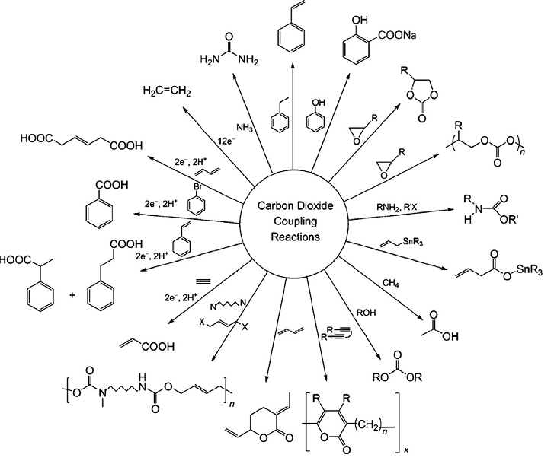

Fig 1: Fixation of CO2to various chemicals

**Techniques for CO2 reduction:**

**The ways and means by which CO2 can be utilized are schematically represented below**

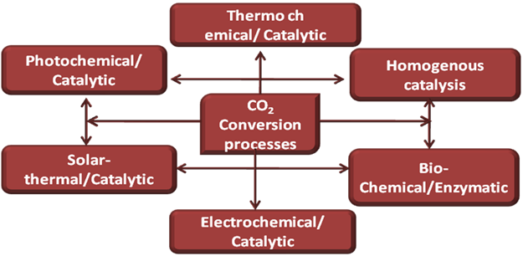

* CO2 reforming
* Catalytic membrane reactors for syngas production are an environmentally benign solution to counter the escalating global CO2 concerns.  In the study carried out by Kathiraser et al.(year ), the oxidative CO2 reforming of methane reaction was successfully tested. High CH4 andCO2 conversions of 94​% and 73​% were obtained with O2 flux.
* **Designing Photobioreactors:**

Biomass production could be enhanced if correct approach to algae utilization is implemented. When this happens about 30% of biofuels derived from algae might complement that which comes from terrestrial sources for substitution with fossil fuels for mobility. The production of microalgae in open ponds or photobioreactors is a technology that may contribute to recycle large volumes of CO2.

* **Supercritical CO2:**

It is used as an essential solvent for the creation of essential oils and herbal distillites, for dry cleaning and also in pharmaceutical uses.

* **Photoelectrocatalysis:**

The first report of the photo-electrochemical reduction of CO2was made by Halmann in 1978. In this study, p-type gallium phosphate (p-GaP) was used as the photocathode with part or all of the energy, supplied by light. The products were found to be formaldehyde (HCHO), formic acid (HCOOH), and methanol (CH3OH).The cathodic reduction of CO2 may involve a two-step electron transfer for the formation of formic acid and is as follows:

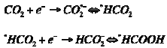

Fig. 2 shows the reactor design proposed originally by Hitachi Green Center researchers in a view to commercialize this technique.

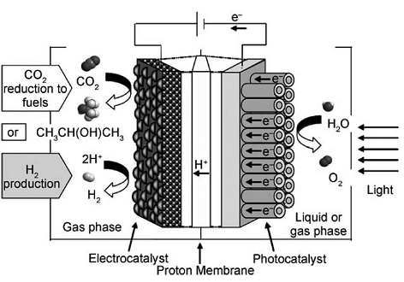

**Fig. 2**Thephotoelectrochemical (PEC) device proposed for the CO2 reduction to fuels and the H2 production using solar energy.

At the anode, the water is photooxidized to oxygen and produce electrons and protons, which electrocatalytically reduce CO2 to liquid fuels at the cathode. An added advantage of this technique is that the energy required for the reduction is supplied by solar irradiation (energy source) and water (hydrogen source) rather than an external source (e.g., fossil fuel power plant).

The yields/rates of the various products formed largely depend upon many variables such as catalyst, catalyst modification, electrolyte/reductant, lamp (photon) source (mercury-, xenon-lamps, etc.), temperature/pressure, etc.

* **Electrochemical process:**

The electrochemical reduction of CO2 has been studied on various metal electrodes, gas diffusion electrodes, semiconductor electrodes, macrocyclic complexes and conducting polymers. The reaction rate and product distribution depend on the nature of the electrocatalysts, the reaction conditions, kinetics of electron transfer, adsorption/desorption at the electrode surface, and diffusion of CO2 to the electrode surface (Ogura et al., 2010) .The electrodes should have the property of adsorbing CO2 on the surface as CO and should easily desorbs forming hydrocarbon. The transition group metals which come under this category are Cu and Zn. Cu is known to be a versatile hydrogenating catalyst and Zn helps in chemisorptions of CO2 near the electrode surface (Gattrell et al.,2006). In the same way, the selection of electrolyte is based on its conductivity and the ability of the solvent to retain CO2. Many aqueous electrolytes like KCl, KHCO3 have been tried for reducing CO2, chosen based on the solubility. The specifically adsorbed halide ion (X-) could suppress the adsorption of protons and Cu-X as the catalytic layer aids in electron transfer from the electrode to CO2 (Ogura et al., 2010).

Among the metals investigated, Cu and Zn provide promising results with its medium hydrogen overvoltage and can reduce CO2 by converting electrical energy back to chemical energy stored in the chemical bonds of fuels (Ohya et al., 2010). Hence they are comparable to the anode reaction occurring in the fuel cells .The electrochemical method is aqueous and room temperature operated process, offers a convenient method to store electrical energy without increasing CO2 emissions. In spite of this intensive research, the process has not been commercialized and the mixture of gas like hydrogen, methane, methanol ethane and CO obtained from the reduction can be used as alternative to the existing fuel (Gattrell et al.,2006).

**Illustration of electro conversion of CO2:Production of methanol**

Methanol is a primary feedstock for many organic compounds, as well as a vital intermediate for various chemicals used in daily life products such as silicone, paint, and plastics. Being the perfect green chemical alternative with a volumetric energy density relatively similar to that of gasoline (methanol: 15.6 MJ/L; gasoline: 34.2 MJ/L), methanol is an ideal fuel for combustion, and transportation (Olah et al., 2006). Methanol is also currently used in Direct Methanol Fuel Cell, an electrochemical device that directly converts chemical energy of fuels into electrical energy. Most importantly, in its liquid form, methanol presents an excellent way to store energy conveniently and safely. Methanol is originally produced from synthetic gas (a mixture of carbon monoxide, carbon dioxide and hydrogen) in large scale industrial plants for commercial purposes at millions of tons per year (Olah et al., 2006). Methanol can also be produced from methane conversion such as through selective oxidation of methane, catalytic gas phase oxidation of methane, liquid phase oxidation of methane, mono-halogenation of methane, and microbial or photochemical conversion of methane (Olah et al., 2006). Ultimately, methanol conversion from carbon dioxide reduction provides a highly attractive solution by recycling carbon dioxide from industrial exhaust into useful energy storage simultaneously with saving diminishing natural resources.

Thermodynamically, it is possible to electrochemically reduce carbon dioxide to methanol; however, carbon dioxide’s reduction potential is only 20 mV positive of water reduction, which results in hydrogen generation. Therefore, an ideal catalyst should have a high hydrogen overpotential which allows the reduction reaction of carbon dioxide to achieve high selectivity and rates well before water reduction occurs.



Copper oxides, specifically Cu(I), and copper based zinc oxide are chosen as working electrodes in this work. Results with oxidized copper show methanol yields are directly related with Cu(I) intensities; however, the reaction is dynamic and the electrodes loose activity during reaction indicating unstable electrodes. Copper and copper oxides supported on zinc oxide electrodes show relatively more stable results over longer reaction time as well as reusable catalyst’s surface; however, reproducible methanol yields are difficult to establish. While surface structure and morphology are crucial in determining methanol yields, there are many challenge barriers such as the operating conditions of temperature, pressure, and local pH near the electrode surface (Hori, 2008).