Application of photo catalysis for mitigation of Carbon dioxide
V. Jeyalakshmi^{a,b}, K. Rajalakshmiª, R. Mahalakshmy^{b}, K.R Krishnamurthyª and
B. Viswanathan^{a*}
ª National Centre for Catalysis Research, Indian Institute of Technology, Madaras,Chennai,600036,India
^{b} Department of Chemistry, Thiagarajar College, Madurai Kamaraj University, Madurai,
625021, India
Abstract
Photo catalytic reduction of carbon dioxide by water or artificial photosynthesis to yield hydrocarbons (methane and methanol etc. termed as solar fuels), is being studied extensively, with the twin objectives of developing it as one of the effective means of containing atmospheric CO₂ levels and evolving a sustainable alternative route for the production of fuels and chemicals. This short review attempts to bring out the origin, thermodynamic and kinetic features of the process, basic photo catalytic principles involved, rationale behind the choice of different catalysts and their performance, influence of process parameters and structural & photo physical properties of the different catalyst systems on their performance, mechanistic pathways, surface transformations, challenges involved in the practical application of the process and future directions for research.

Key words: Photo catalysis, photo catalytic reduction, CO₂ mitigation, structure-photo physical properties- performance relationships.

*Author for correspondence

Full descriptive title
Application of photo catalysis for mitigation of Carbon dioxide
Short title
Photo catalytic reduction of CO₂
List of authors, affiliations & addresses
- Ms. V. Jeyalakshmi, Department of Chemistry, Thiagarajar College, Madurai Kamaraj University, Madurai,625021, India; E-mail: vmjeya@gmail.com
- Ms. K. Rajalakshmi, National Centre for Catalysis Research, Indian Institute of Technology, Madras, Chennai-600036,India; E-mail: raji2807@gmail.com
- Prof. R.Mahalakshmy, Department of Chemistry, Thiagarajar College, Madurai Kamaraj University, Madurai,625021, India; E-mail: mahabioin@yahoo.com
- Dr. K. R. Krishnamurthy, National Centre for Catalysis Research, Indian Institute of Technology, Madras, Chennai-600036,India; E-mail: krkm@iitm.ac.in
- Prof. B. Viswanathan, National Centre for Catalysis Research, Indian Institute of Technology, Madras, Chennai-600036,India; E-mail: bvnathan@iitm.ac.in

APPLICATION OF PHOTOCATALYSIS FOR MITIGATION OF
CARBON DIOXIDE
1.0 HETEROGENEOUS PHOTO CATALYSIS
The consistent study of photo catalytic reactions was initiated in 1970’s. The concept and the term “heterogeneous photo catalysis” were introduced and developed in Lyon to describe the partial oxidation of alkanes and olefinic hydrocarbons. Heterogeneous photo catalysis is defined as “a catalytic process during which one or more reaction steps occur by means of electron–hole pairs photo-generated on the surface of semiconducting materials illuminated by light of suitable energy” [1].This pathway differs from the usual thermal reaction sequence and leads to reaction product selectivity patterns different from those of the thermal/catalyzed reactions.
1.1 Principles and elementary steps
Electronic structure of bulk solids is best described by the classical band theory of solids. The two outer most energy levels, called as valence band (VB) and conduction band (CB), hold the key for the solid state properties, conductivity and reactivity. The highest energy band in which all energy levels are occupied by electrons, is called VB whereas CB is the lowest energy band without electrons. The energy interval (ΔEg) between VB and CB is the “band gap”, which is the characteristic for the electronic structure of a semiconductor. According to the band gap model (Scheme.1) for photo catalysis proposed by Demeestere et al. [2], VB electrons are transferred to
Scheme.1
the CB when the semiconductor is illuminated with photons having an energy content equal to or higher than the band gap, creating electron–hole pairs (1). After migration to the semiconductor surface (2), electron–hole pairs may take part in redox reactions with adsorbed surface species having suitable redox potentials (3). From a thermodynamic point of view, VB holes can oxidize adsorbed species if the redox potential of the VB is more positive than that of the adsorbed species. Similarly, CB electrons can reduce adsorbed species if they have a higher negative redox potential than that of adsorbed species. In the absence of such reactions with the surface species, electron–hole pair recombination occurs with release of thermal energy and/or light (4).
The rate of a photo catalytic reaction especially depends on the type of the photo catalytic semi-conductor and on the light radiation that it used in its initiation [3]. Further factors that influence a photo catalytic reaction are:
- pH of the medium with which the semiconductor surface is in contact;
- concentration of the substrate influencing the reaction kinetics;
- stream of photons, as oversupply of light accelerates electron–hole recombination;
- temperature, higher temperatures cause frequent collision between the semiconductor
and the substrate
1.2 Applications of photo catalysis
A variety of applications, ranging from anti-fogging, anti-microbial and self-cleaning surfaces, to water and air purification and solar induced hydrogen production, have been developed and many of these have made their way into commercial products. However, extensive research continues to further optimize this technology and to widen the spectrum of potential applications, especially in the following areas namely,
• Conversion of water to hydrogen gas by photo catalytic water splitting.
The ultimate target of water splitting is to provide clean H2 fuel through the utilization of solar
energy. Considerable efficiencies for solar water splitting have been reported for the photo-voltaic–photo electrolytic device of Khaselev and Turner and for the photo voltaic–electrolytic device of Licht [4].
• Conversion of carbon dioxide into hydrocarbons using water.
In this case, photo catalysis provides a way to mimic photosynthesis by employing a semiconductor catalyst to absorb and utilize solar energy to convert CO₂ into fuels and chemicals.
• The application of illuminated semiconductors for the remediation of contaminants has been used successfully for a wide variety of compounds such as alkanes, aliphatic alcohols, aliphatic carboxylic acids, alkenes, phenols, aromatic carboxylic acids, dyes, Polychlorinated biphenyl’s (PCB), simple aromatics, halogenated alkanes and alkenes, surfactants, and pesticides as well as for the reductive deposition of heavy metals (e.g., Pt⁴⁺, Au³⁺, Rh³⁺, Cr^{(VI)}) from aqueous solution to surfaces [5].
Use of titanium dioxide in self-cleaning glass. Free radicals generated from TiO2 oxidize organic matter. Photo catalytic surfaces have the potential to act against a variety of air pollutants and
odours such as microbes, volatile organic carbons (VOC), formaldehyde, ammonia and inorganic gaseous substances such as nitrogen- or sulphur-oxides (NOX, SOX).
• Disinfection of water by titanium dioxide photo catalysis.
1.3 Components of a photo catalyst
In addition to the photo catalyst, whose primary function is to absorb light energy, several other components can be added to modify the photo catalyst system based on their application and improve overall efficiency[6].
1.3.1 Photo catalytic systems based on semiconductors and sensitizers
The large group of the light-sensitive materials that have been investigated as photo catalysts includes fairly wide-band semiconductors, mostly metal oxides that absorb UV light. One method of extending their light sensitivity to the visible region of the spectrum is the use of colored substances/dyes or sensitizers. (Scheme. 2).
Scheme. 2
Sensitization by light harvesting dyes/ macrocyclic ligands like phthalocyanins (Pc) and porphyrins (Pr) involves transfer photo generated electrons directly into the conduction band of the semiconductor, TiO₂ in this case [7,8]. Such macrocyclic ligands are good candidates for sensitization because of their high absorption coefficient in the visible region of the solar spectrum and good chemical stability. Since photoelectrons are directly transferred to the conduction band of titania, charge carrier separation is very effective. (Pr)-titania composites display excellent activity for photo-catalytic degradation of Rhodamin-B in visible light and titania incorporated with Fe-(Pr) is active in UV range [9,10]. Zhihuan et al. [11] and Shaohua et al.[12] observed that phthalocyanins (Pc) containing Zn & Co prepared by sol-gel technique were active photo catalytic reduction of CO₂. Few more examples are described in Section 4.4.
1.3.2 Photo catalytic systems based on semiconductor hetero structures
In binary systems based on narrow-band and wide-band semiconductors, the absorption of visible light by the narrow-band component leads to the injection of an electron into the wide-band semiconductor. The hole remains spatially separated from the electron and interacts with the electron donor (Scheme.3)
Scheme.3
One of the elegant examples of hetero-structured semiconductors or coupled semiconductors is Cu₂O-TiO₂ system illustrated (Fig.1) by Huang et al.[13]. Cu₂O, with a band gap of 2.0 eV, is a
Fig.1
typical narrow band semiconductor with both conduction and valence bands located above those of TiO₂, a state which thermodynamically favours the transfer of excited electrons and holes between them. This state of energy levels facilitates all the four charge transfer processes indicated in Fig.1, in UV as well as in visible regions. While processes 1 & 2 can proceed with UV as well as visible radiation, processes 3 & 4 require UV radiation. All four processes together constitute highly effective coupled semi-conductor system, with very high efficiency. Hetero structures with 30 % and 70 % Cu₂O, both under UV &VIS radiation, display 6 times and 27 times higher activity respectively, compared to the base material, P-25 [13].
Fig. 1
Examples wherein narrow band semiconductors like PbS, CdS and CdSe are used to form effective hetero structures with TiO₂ are known [14-16]. Inherent drawbacks with such systems are photo-corrosion and charge carrier recombination. In such cases electron donors like sulfide or sulfite are added as hole scavengers.
1.3.3. Photo catalyst systems based on semiconductors doped with metal cations
The doping of wide-band semiconductors with transition metals creates local states in the forbidden band. The excitation of electrons from those local states by visible light leads to the transfer of electrons into the conduction band (Scheme.4).
Scheme.4
Doped metals act as electron traps, facilitating charge separation and preventing recombination. Experimental evidence towards this effect was presented by Anpo et al. [19] in their studies on Pt loaded on TiO₂. As shown in Fig.2, pure titania, when irradiated with UV light, exhibits ESR signals attributed to Ti³⁺ formed by the photo generated electrons. On loading the TiO₂ with Pt, the intensity of the ESR signal due to Ti³⁺ falls sharply due to the transfer of electrons from titania to Pt, while the holes remain in TiO₂, resulting in charge separation.
Fig.2
Effect of metal ion doping on the characteristics of titania and improvements observed in photo-catalytic activity for a variety of reactions has been studied extensively [17-27]. A comprehensive study on the effects of the doping of 21 metal ions on titania has been reported by Choi et al.[23] who observed that doping significantly influences photo reactivity for CHCl₃ degradation, charge carrier recombination rates, and interfacial electron-transfer rates. Doping titania with Fe³⁺, Mo⁵⁺, Ru³⁺,Os³⁺, Re⁵⁺, V⁴⁺and Rh³⁺at 0.1-0.5 at. % significantly increases the photo catalytic activity for both oxidation and reduction reactions while Co³⁺ and Al³⁺ doping decreases. Photo reactivity increases with the relative concentration of trapped charge carriers and appears to be a complex function of the dopant concentration, the energy level of dopants within the TiO₂ lattice, their “d” electronic configuration, the distribution of dopants, the electron donor concentration and the light intensity.
1.3.4. Photo catalyst systems based on semiconductors doped with anions
One of the approaches to narrowing of the forbidden band in oxide semiconductors was partial substitution of the oxygen by other elements (nitrogen, carbon, and sulfur), which makes it possible to realize “band design,” i.e., intentional shift of the valence band of the photo catalyst by virtue of the fact that the p orbitals of the impurity are situated in the valence band above the p orbitals of the oxygen, thereby narrowing the forbidden band without substantially moving the bottom of the conduction band (Scheme 5) .
Scheme.5
Introduction of anions like N, S in TiO₂ results in narrowing of band gap due to mixing of p states of dopants (N,S) with Oxygen 2p states in the valance band of TiO₂ and creation of impurity states above the valence band of titania [7,8]. Such changes in the electronic structure of TiO₂ facilitate visible light absorption. Though a number of anions from C, N, F, P & S have been used for doping titania, studies on doping with nitrogen has been predominant [17-22]. According to Asahi et.al.[28,29] substitutional type of doping is possible, by mixing of the 2p states of oxygen from titania with the 2p states of N resulting in intra-band states, which in turn can effectively narrow down the band gap, and thereby facilitating visible light. Interstitial type doping is found to be ineffective.
In contrast, Valentin et al.[30,30a,31] propose absorption of nitrogen in substitutional state is more effective in the formation of localized levels within the band gap and conclude that both substitutional and interstitial nitrogen may exist with energy levels as shown in Fig.3, depending
Fig.3
on the preparation conditions. Two N1s XPS peaks observed for N-doped titania, one at 396 eV for substitutional and the other at 400 eV for interstitial nitrogen species lend credence to this theory¹³. While the assignment of the XPS peak at 396 eV for susbstitutional N species has been corroborated by other researchers [32,33] there is a raging controversy on the proposed peak due to interstitial N species at 400 eV and is attributed to different species like, N-O-Ti-O or O-N-Ti-O [34,35].
The main features of these modifications and the implications in the properties of titania, applicable in any typical semiconductor, are summarized in the Table.1.
Table.1
2.0 MITIGATION OF CARBON DIOXIDE
2.1 CO₂- The greenhouse gas
CO2 occurs in nature and serves as source of carbon for photosynthesis of plants and crops. It is present in atmosphere with a volumetric concentration of 0.039 % (389 parts per million by volume, ppmv). The emission of carbon dioxide into the atmosphere, released mainly by the burning of fossil fuels is one of the most serious problems with regard to the greenhouse effect. All human activity generates about 37 billion tons (37 Gt) of CO2 emissions each year, with about 30 Gt of this coming from energy-related emissions.
Total emissions were less than 25 Gt twenty years ago, and under the current scenario, emissions are projected to rise to over 50 Gt in twenty years from now. Burning 1 t of carbon in fossil fuels releases more than 3.5 t of carbon dioxide [36]. The Earth’s surface temperature has risen by approximately 0.6 K in the past century, with particularly significant warming trends and changes in weather conditions over the past two decades. Hence CO2 reduction and management (capture, storage and sequestration) has become a key issue in controlling global warming.
2.2 Approaches towards reduction in CO₂emission
The reduction in CO2 emissions can be achieved by three different approaches[22]:
(1) Efficient use of carbon-based energy sources,
(2) Use of alternative or carbon-free energy sources,
(3) Use of a post treatment carbon-capture technology.
While efforts on these approaches are being pursued globally, carbon capture technology has gained prominence. Carbon capture refers to the removal of CO2 from industrial flue gas by a gas separation process prior to release to the atmosphere. Captured and stored CO₂ could be recycled by conversion into useful chemicals and fuels.
2.3 Carbon Sequestration
Carbon sequestration (storage) is the isolation of carbon dioxide (CO2) from the earth's atmosphere. Sequestration can play a significant role in preventing continued CO2 build up in the atmosphere.
Geological sequestration involves storing CO2 underground in rock formations that can retain large quantities of CO2 for long periods of time. The CO2 would be held in small pore spaces inherent in rocks. It is possible that CO2 injection into coal seams and mature oil fields could assist in the extraction of coal bed methane or oil that would otherwise be left in the ground, which could help offset the costs of sequestration.
2.4 Other carbon capture technologies
Currently, technologies such as gas absorption into chemical solvents, permeation through membranes, cryogenic distillation, and gas adsorption onto a solid sorbent are available for the capture of CO2 from flue gas. However these are not economically feasible [22].
2.5 CO₂ conversion
CO2 is the most oxidized form of carbon, and therefore the only chemical transformation at normal energies that would be possible is to reduce it. A wide range of CO2 conversion techniques are under investigation [37] which include:
- Chemical Reduction by metals which occur at relatively at high temperatures
(1)
(2)
(3)

ii. Thermo chemical Conversion
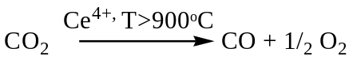 (4)
iii. Radio chemical Method
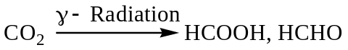 (5)
iv. Photo-Chemical Conversion
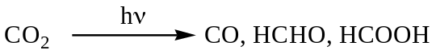 (6)
v. Bio-Chemical Conversion
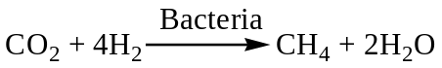 (7)
The bacteria Methanobacterium thermoautotrophicum can be immobilized in a fixed bed or on hollow fibres, and feeding stoichiometric ratios for the reaction attains 80% of the theoretical yield.
vi. Electro-Chemical Conversion
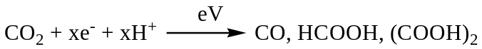 (8)
vii. Bio Photochemical conversion
The bio part of the energy consists in catalysis and information content of an enzyme
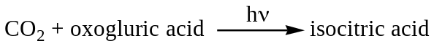 (9)
viii. Electro photochemical conversion
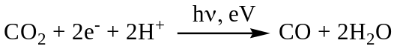 (10)
Conventional catalytic reduction of CO2 to chemicals (formic acid, methanol, methane etc.) with external hydrogen is feasible [38] but hydrogen has to be produced via renewable resources to render it viable and sustainable.
3.0 PHOTO CATALYTIC CO₂ REDUCTION
3.1The challenge
The CO2 reduction process is thermodynamically uphill as illustrated by its standard free energy of formation (ΔG° = -394.359 kJ/mol) [39]. Economical CO₂ fixation is possible only if renewable energy, such as solar energy, is used as the energy source. Equally difficult is the reduction / splitting of water to yield hydrogen and hence requires similar combination of activation steps. The most ideal and desirable process would then be the simultaneous reduction of CO2 and water to yield hydrocarbons, which essentially works out to artificial photosynthesis.
The utilization of solar energy via chemical storage can be achieved by photo catalytic or photo-electrochemical activation of light-sensitive catalytic surfaces. When comparing the two systems, photo catalytic system is simpler, easy to construct and operate. Photo catalytic process occurs via the direct absorption of photons with energy greater than or equal to the band gap of the photo catalyst to generate electron-hole pairs. The initial excitation and electron energy transfer to the adsorbed reactants on the photo catalyst make chemical reactions in the photo catalytic process possible.
3.2 Thermodynamics
There are two conceptual routes to produce renewable carbon containing fuels using solar
energy [39].
• Direct photo reduction of CO2 using water as a reductant
• Photolysis of water to generate hydrogen and further reaction of this hydrogen with carbon
dioxide forming C1–C2 fuels.
The first route, mimic of natural photosynthesis, is the preferred one. Water splitting and carbon dioxide reduction processes take place simultaneously on the photo catalyst/co-catalyst surface, and thermodynamic requirements of these processes put constraints on the band gap of the materials used as photo catalysts. Hydrogen formation from water involves a free energy change (ΔG0) of 237 kJ/mol and an enthalpy change (ΔH0) of 285 kJ/mol; the corresponding values for CO formation from CO2 are 257 and 283 kJ/mol at 25°C (1atm). Hence, the minimum energy required for water and CO2 splitting processes are, 1.229 and 1.33 eV (per photon) respectively. In theory, the band gap of a photo catalyst used for co-splitting of CO2 and water should be at least 1.33eV [39]. One, two, four, six and eight electron reduction potentials (vs. NHE) for CO2 reduction and H2O oxidation at pH 7 and 25°C assuming unit activities for all gaseous and aqueous species are given below [39].
Reaction E⁰_{redox} . V vs NHE
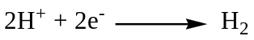 -0.41 (11)
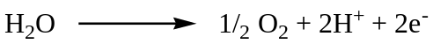 -0.82 (12)
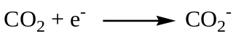 -1.9 (13)
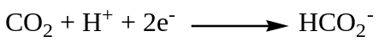-0.49 (14)
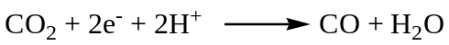 -0.53 (15)
-0.48 (16)
-0.38 (17)
-0.24 (18)
From the above scheme it is clear that CO2 photo reduction is not a single-step reaction. Upon transfer of one electron, the structure changes from linear to bent configuration, which results in irreversible reduction [37]. Additionally, single electron transfer to CO2 is highly endergonic, because of the negative adiabatic electron affinity ofCO2.
The initial step in the photo catalytic reduction of CO2 is the generation of electron-hole pairs upon absorption of photons of energy greater than or equal to the band gap of the photo catalyst. The time scale of this electron-hole recombination is two to three orders of magnitude faster than other electron transfer processes. Therefore, any process which inhibits electron-hole recombination would greatly increase the efficiency and improve the rates of CO2 photo reduction. The kinetics of CO2 photo reduction are also dependent upon many other factors such as incident light intensity, fraction of the incident light absorbed by the photo catalyst, the specific surface area of the photo catalyst absorbing the light, etc.
3.3 Choice of catalysts-Guiding principles
It is essential that the photo generated electrons should possess requisite energy, as indicated by the thermodynamic criteria, to facilitate the reduction of CO₂. This means that the conduction band bottom energy level of the photo catalyst has to be more negative with respect to the energy CO₂ reduction and the valence band top has to be more positive with respect to the energy for oxidation of water. Thus, the choice of the catalyst for CO₂ photo reduction with water is determined by the relationship between energy levels of conduction and valence bands vis-a-vis the energies for CO₂ reduction and water oxidation. Pioneering studies on photo electro catalytic reduction of CO₂ on various semiconducting oxides has brought out the basic criteria for the catalytic activity. This guiding principle has been illustrated effectively by Inoue et al.[40] in the relationship between the energy levels of conduction and valence bands and the those of the
redox couples as depicted in Fig.4.
Fig.4
Semiconductors like SiC, GaP, CdS, ZnO&TiO₂, which satisfy the above criteria are active for photo reduction of CO₂ while oxides like WO₃& SnO₂ whose conduction band levels are below that for CO₂ reduction, have failed to perform. Energy levels of conduction and valence band Vs those for redox couple and the life time of charge carriers, prolonged by reduced recombination rates, are the two fundamental criteria to be considered for the selection of the catalyst for CO₂ photo reduction.
Large-band-gap semiconductors are the most suitable photo catalysts for CO2 reduction, because they provide sufficient negative and positive redox potentials in conduction bands and valence bands, respectively. The disadvantage of using wide band-gap semi-conductors is the requirement for high energy input.
Although many semiconductors have smaller band gaps and absorb in the visible range (e.g. CdS and Fe2O3 with band-gap values of 2.4 and 2.3 eV, respectively), just a few of them are catalytically active because the energy levels of either the conduction or valence bands are unsuitable for CO2 reduction and/or water oxidation (Fig.4). This limitation, together with poor photo-corrosion stability of many semiconductors, limits significantly the number of potential photo catalytic materials for CO₂photoreduction.
3.4. CO₂ photo reduction- Effect of process parameters
3.4.1 Effect of wavelength and light intensity
Semiconductors absorb light radiation with the threshold wavelength that provides sufficient photon energy to overcome the band gap between the valence and conduction bands. This threshold wavelength, required to promote the excited state, corresponds to the minimal photon energy and depends on the band-gap energy, e.g. for TiO2 anatase with band gap energy 3.2 eV it is 387.5 nm [2].
Irradiation using the light with shorter wavelength (254 nm) is significantly more effective for the CO2 reduction using TiO2 than that with the longer wavelength (350 nm) [41]. The wavelength (λ) of the light used influences the yield of products as observed by Fan et.al [42] in their studies on N (4% w/w) and Ni (6% w/w) co-doped titania for CO₂ reduction with water. For this catalyst formulation, Fan et al. [42] observed methanol yields of 482, 253.5 and 120.5 (all in μ moles/g-cat) with radiations of wavelength 254 nm, 365 nm and 400-780 nm respectively, thus clearly bringing out the influence of the wavelength of the light used.
Electrons in excited states are produced via electronic transitions the probability of which depends on the light intensity. At low light intensities, the CO2 reduction rate increases linearly with the light intensity, at mid-range light intensities, the photo catalytic reaction rate is dependent on the square root of light intensity; and at high light intensities the rate is independent of the light intensity [2].
Variations in the wavelength of radiation used can also affect the rate of formation of products as observed by Liu et al.[43] on BiVO₄ catalysts (Table.2). Monoclinic BiVO₄ is found to be more active than the tetragonal form. Selective formation of ethanol is observed using 300 W UV radiations, with and without UV cut-off filter. But with 36 W lamp, both alcohols are formed at nearly same rate, though overall conversion is much less.
Table.2
3.4.2 Influence of reaction pressure
Mizuno et al. [44] observed that CO₂ photo reduction with water containing dispersed TiO₂ increased with the increase in CO₂ pressure. Increase in the solubility of CO₂ in the liquid phase (water as well as aqueous 0.2N NaOH solution) at elevated pressure and the consequent increase in the concentration CO₂ in the solution phase is responsible for the observed increase in CO₂reduction (Fig.5) Similar observations on the effect of pressure has been observed by Hisao Hori et al.[45]
Fig.5
3.4.3 Influence of titania particle size, shape and morphology
Kaneco et al. [46, 47] studied the CO2 photo reduction using TiO2 powders in liquid CO2 medium. Carbon dioxide has limited solubility in water. Also reduction of CO2 competes with hydrogen formation reaction via water. To overcome this disadvantage liquid CO2 system has been explored. The protonation reaction was performed using water after the end of illumination. The main reduction product was exclusively formic acid. Tan et al. [48] studied the photo catalytic reduction of carbon dioxide using TiO₂ pellets. Pellet increased the contact areas and adsorption capacity. Their yield was significant when compared to thin film coating technique.
Koci et al. [49] studied the effect of TiO2 particle size on photo catalytic reduction of carbon dioxide. As the particle size decreased, higher yields of methanol and methane over the TiO2 nano particles under the illumination of light were obtained. The optimum particle size corresponding to the highest yields of both products was 14 nm (Fig.6). For particles with
crystallite sizes smaller than 14 nm, conversions dropped due to a combination of electronic (increase in recombination rates) and optical properties. The observed optimum particle size was a result of competing effects of specific surface area, charge–carrier dynamics and light absorption efficiency.
Fig.6 A&B
3.4.4. Influence of type of photo reactors and reaction media
Koci et al. [50] studied the influence of reactor geometry on photo reduction of carbon dioxide using two annular batch reactors. The dependence of products yields on the reactor diameter and on the volume of the liquid phase confirmed the fact that the requirement of perfect mixing is difficult with the annular configuration of the reactor. The highest yields of the photo catalytic reduction were achieved in a configuration where the lamp just touches the surface of the liquid in the reactor and the configuration of the reactor was not annular.
Wu et.al [51] applied an optical fibre reactor to the photo reduction of CO2 with H2O using TiO₂, Cu/TiO₂, Ag/TiO₂, Cu–Fe/TiO₂–SiO₂ and dye-sensitized Cu–Fe/P25 coated on optical fibres. Compared with a traditional packed-bed reactor, an optical fibre provides a medium to transmit light uniformly throughout a reactor and hence higher conversion (Table.3). In addition, a higher processing capacity is possible because the photo catalyst can be dispersed on the optical fibers with large surface area in a given reactor volume.
Table.3
When CO2 present in the atmosphere dissolves in water it is mostly present in the form of carbonate. Many authors have studied photo catalytic reduction of carbonate to form various chemicals. Ku et al. [52] studied the photo catalytic reduction of carbonate in aqueous solution by the UV/TiO2 process. The photo catalytic reduction of carbonate proceeded faster in acidic solutions than in alkaline solutions. The main products of the photo catalytic reduction of carbonate by the UV/TiO2 reduction process were found to be methanol and methane. A Langmuir–Hinshelwood type kinetic equation was developed for modeling the photo catalytic reduction of carbonate.
Sayama et al. [53] investigated the effect of carbonate salt addition on the photo catalytic decomposition of liquid water over Pt–TiO2 catalyst. It has been found that an addition of carbonate salts to Pt-loaded suspensions led to highly efficient stoichiometric photo- catalytic decomposition of liquid water into H₂ and O₂. Neither the pH nor cation directly contributes to the water splitting .The presence of a high concentration of carbonate ions is essential for the catalytic photo decomposition of water. The carbonate ion affects both the Pt particles and the TiO2 surface. The Pt was covered with some titanium hydroxide compounds and therefore, the rate of the back reaction (H2O formation from H₂ and O₂) on the Pt was suppressed effectively in the presence of carbonate ions. On the other hand, the TiO2 surface was readily covered with several types of carbonate species. It is considered that these carbonate species aid desorption of O₂ from the TiO2 surface.
In the place of pure water as the medium for dispersion of the catalysts, in some cases aqueous solution of KHCO₃ [50] or NaOH has been used. Use of NaOH is beneficial since OH⁻ ions act as hole scavengers, thereby retarding electron-hole recombination and simultaneously, alkaline solution increases solubility of CO₂ vis-à-vis pure water [54]
3.4.5 Photo reduction with other reductants
Some researchers have attempted to replace water with other reductants. This provides a high reaction yield and high selectivity to desired products by changing the mechanism. Liu et al. [55] conducted an experiment with CdS in various solvents including water, methanol, ethanol, and 1-propanol with dielectric constants of 80, 33, 24.3, and 20.1, respectively. The results indicated that, if low-dielectric constant solvents or low-polarity solvents are used, CO2 ⁻anion radicals can be strongly adsorbed on the surface through the carbon atom of another CO2⁻anion radical pre-sorbed on surface Cd sites because these radicals are not completely solvated by low-polarity solvents. Here, CO is produced as the major reduction product of CO2. If a high-dielectric-constant solvent is used (e.g., water), the CO2⁻anion radicals can be greatly stabilized by the solvent, resulting in weak interactions with the photo catalyst surface. Similar effects of solvents have been observed on titania embedded in SiO₂ matrices [56]. Subsequently, the carbon atom of the radical tends to react with a proton to produce formic acid. Kaneco et al. [57] and later Dey [58] showed that photo-catalytic reduction of CO2 using TiO2 suspension in aqueous solutions containing 2-propanol as a hole scavenger leads to the preferential formation of methane.
- PHOTO CATALYTIC REDUCTION OF CO₂ WITH WATER- STATE OF THE ART
4.1 On semiconducting oxides
Inoue et al. [40] were the first to report the photo catalytic reduction of CO2 in aqueous solutions to produce a mixture of formaldehyde, formic acid, methanol and methane using various wide-band-gap semiconductors such as tungsten trioxide (WO3), titanium dioxide (TiO2), zinc oxide (ZnO), cadmium sulfide (CdS), gallium phosphide (GaP), and silicon carbide (SiC). These semiconductors were activated by both xenon and mercury lamp irradiation. Formaldehyde and methyl alcohol yields were the highest in the presence of SiC, a behavior attributed to the relative position of the SiC conduction band with respect to the HCHO/H2CO3 redox potential. The SiC conduction band edge lies at a higher position (more negative) than the HCHO/ H2CO3 redox potential, which is believed to be responsible for the high rates of product formation. The absence of methyl alcohol when WO3 was used as catalyst, with a conduction band at a position lower than the HCHO/H2CO3 redox potential, further indicates the influence of band-edge positions on CO2 reduction (Fig.4).
Investigations related to the photosynthesis reaction of CO2 with water vapor to form CH₄ over metal-loaded SrTiO3 have also been conducted. Due to its higher conduction band edge position compared to the redox potential of CH3OH/H2CO3, strontium titanate could effectively reduce carbon dioxide dissolved in an aqueous electrolyte [59,60]. Halmann et al. [59] studied the doping of transition and noble metals such as Ru, V, Cr on TiO2 and observed that production rate of organic compounds such as formic acid, formaldehyde and methanol increased when TiO2 was doped with RuO2.
4.2 Titania and titania loaded with metals/oxides as co-catalysts
Anpo et al. [61] studied the photo catalytic reduction of CO2 with H2O on various titanium oxide catalysts. The anatase-type TiO2 catalyst with large band gap and numerous surface-OH groups showed high efficiency for the formation of methane. The yields of the photo catalytic reactions depended strongly on the kind of catalyst, the ratio of CO2 to H2O and the reaction temperature. The best mole ratio of H2O/CO2 for the conversion of carbon dioxide was observed [61] to be 5. (Fig.7)
Figure.7
Addition of Pt to the TiO2 led to increased methane yield compared to methanol formation. Anpo et al. [61,62] have studied in detail the use of highly dispersed titanium dioxide on glass for the photo catalytic reduction of carbon dioxide. From the direct detection of intermediate species using various spectroscopic techniques, they proposed that methane formation resulted from the reaction between surface carbon radicals and atomic hydrogen (Scheme.6).
Scheme.6
The use of Cu as a co-catalyst was reported by Adachi et al. [63] in which Cu-loadedTiO2 powder was suspended in a CO2 pressurized solution at ambient temperature, with methane and ethylene produced under Xe lamp illumination. Tseng et al. [54] also studied the effect of copper loading on titania. The methanol yield of 2.0 wt.% Cu/TiO2 was 118 μ mol/g following 6 h of UV illumination. The yield was much higher than those of sol–gel TiO2 and Degussa P25. The redistribution of the electric charge and the Schottky barrier of Cu and TiO2 facilitates electron trapping via supported Cu. The photo catalytic efficiency of Cu/TiO2 was markedly increased due to the lowering the re-combination probability for hole–electron pairs. The highest quantum and energy efficiencies achieved were 10 and 2.5%, respectively. Slamet et al.[64] suggested that CuO may be the most active dopant compared to the other copper species. Because Cu₂O has the highest positive redox potential value of Cu⁺, Cu₂O dopant should effectively act as an electron trapper to prohibit electron–hole recombination. However, owing to the relatively strong interaction between TiO2 and the dopant particle implanted in the vacant sites of TiO2, the dopant with more positive redox potential exceedingly catches electron from conduction band edge. Consequently the dopant-trapped electrons are more difficult to be transformed to the adsorbed species on catalyst surface and hence it may play a role as a center of electron–hole recombination.
Titania per se is active for photo catalytic reduction of CO2 with H2O, but the rates are extremely low since its conduction band edge is not suitable for water and CO2 reduction, though it can
readily oxidize water [65]. Promotion with co-catalysts like Pt [66] (Fig.8), Ru [67], Rh [68], Ni [42] and Ag [69] (Fig.9) vastly enhances the rate in several ways, like, charge separation, retarding re-combination and trapping of charge carriers, besides activation of CO2 and water reduction and facilitating further surface transformations leading to hydrocarbon products.
Figure.8
Figure.9
Effects of bi-metallics on TiO2 were also studied by Luo et al. [70] for CO2 reduction on Copper and Cerium co-doped titanium dioxide. Photo catalytic copper and cerium co-doped titanium dioxide were prepared via the equivalent-volume incipient wetness impregnation method. The methanol yield could reach up to180.3 μ mol/g-cat rapidly. Ce atoms activated H2O and CO2 molecules, while Cu atoms act as the channel of photoelectrons in real time and prevent the recombination of electrons and holes.
A significant breakthrough in the photo catalytic reduction of gas phase CO2 by solar radiation has recently been achieved by Varghese and co-workers [65], using nitrogen doped TiO2 nano tube arrays co-catalyzed with copper and/or Pt nano particles, in which CO₂ and water vapor was reduced to methane and other hydrocarbons under natural sunlight. The yield of methane was reported to be 111 ppm cm⁻²hr⁻¹(160μL/g-h) with quantum efficiency of 0.74% (Fig.10). The high rate of CO₂ conversion is due to the high surface area and nano scale wall thickness of the
Figure.10
nano tubes, enabling the surface species to readily receive both charge carriers generated near the surface due to the wave function overlap and those generated deep inside the wall via diffusion.
4.3. Titanates with layered structure
Guan et al. [71] studied the reduction of CO2 with water over a hybrid catalyst, in which a Pt-loaded K2Ti6O13 photo catalyst was combined with a Fe-based catalyst supported on a de-aluminated Y-type zeolite (Fe-Cu-K/DAY). In this reaction system, Pt/K2Ti6O13 catalyst decomposes water to produce H2 and the Fe-Cu-K/DAY catalyst reduces CO2 with the resulting H2 into organic compounds. When the reaction temperature is increased from room temperature to 600K by concentrating the solar irradiation, the product yield of hydrogen increased from 13.7μ mol/g-h to 20.5μmol/g-h. Also additionally, formic acid, methanol and ethanol were obtained. Guan et al. [72] also reported the use of Pt-loaded K2Ti6O13 photo catalyst combined with a CO₂ hydrogenation catalyst Cu/ZnO. When the composite catalyst was used under concentrated sunlight, CH3OH was successfully formed in addition to the above products. Guan et al. [73] also investigated reduction of CO2 over zero-valent Fe⁰ and Fe⁰–based composites in an aqueous solution at room temperature. It was found that H2 can be effectively evolved from water over zero-valent Fe⁰ in the presence of gaseous CO2 together with a small amount of hydrocarbons. When the Fe⁰ was combined with Cu, K and Al components, hydrocarbons such as CH4 and C3H8 and alcohols such as CH₃ OH and C2H5OH were also effectively produced. The XPS, XRD and photoemission yield measurements revealed that the Fe⁰ surface as well as the bulk was oxidized to Fe3O4 and other possible oxides during the reaction. This corrosion process is promoted by the dissolution of CO2 in water and the resultant protons oxidize Fe⁰ to evolve H2. Moreover, the evolved H2 serves as the reactant for the CO2 hydrogenation on the active site of Fe⁰, especially for the Fe⁰–K–Al and Fe⁰–Cu–K–Al composites.
4.4 Titania dispersed on different meso/nano porous & macrocyclic matrices
Ulagappan et al. [74] used Ti-silicalite molecular sieves as a catalyst for 266 nm UV laser radiation induced reduction of CO2 and H2O gas mixtures, obtaining HCOOH, CO and HCOOCH3. Origin of the products was studied by IR spectroscopy, indicating that CO originated from the secondary photolysis of HCOOH, while HCOOCH3 was the result of spontaneous Tishchenko reaction of CH2=O.
Photo catalysts prepared within the zeolite cavity and frame-work have a unique local structure and high selectivity in photo reduction. The titanium oxide species embedded within the zeolite frame work have been found to exist as isolated tetrahedral titanium oxide species. These Ti-containing zeolite catalysts exhibited high photo catalytic efficiency and selectivity for the formation of methanol. Anpo et al.[75] carried out the CO2 photo reduction using TiO₂ in well-dispersed isolated state in Y-zeolite cavities in tetrahedral co-ordination and observed high selectivity for methanol formation, while aggregates of titania in octahedral state on zeolites and bulk TiO₂ resulted in methane formation. Surface structure/surface co-ordination of titania (determined by EXAFS) has profound influence on the selectivity CO₂ photo reduction to methanol as shown in Figs.11. Ti-MCM-48 meso porous zeolite with large pore and three dimensional channels exhibited higher activity and selectivity for methanol formation compared to Ti-MCM-41 (Fig.12) with one dimensional pore structure [76,77].
Figure.11
Figure.12
Macro cyclic ligands like phthalocyanins (Pc) and porphyrins (Pr) possess high absorption coefficient in the solar spectrum, especially in visible region and good chemical stability and hence are preferred for sensitization of titania and other semiconductors [7-12]. Liu et al [78] reported photo catalytic reduction of carbon dioxide using sol–gel derived titania-supported CoPc catalysts. In-situ synthesis route results in the formation of isolated CoPc species (within the confined space of meso porous titania), which effectively absorb visible light enabling ultrafast injection of electrons from the excited state into the conduction band of the titania support, thus helping charge carrier separation and increase photo-conversion efficiency [78]. Since the reported band gap for TiO₂ is 3.22 eV.Vs.2.14eV for CoPc, such a sensitization process is highly feasible. CO₂ photo reduction data presented in Table.4 show that in-situ CoPc/TiO₂ catalyst is more active than a simple mechanical mixture of CoPc and TiO₂ indicating a co-operative effect between dispersed CoPc and titania surface for the effective transfer of photo-generated electrons.
Table.4
Xia et al [79] studied the reduction of CO2 with H2O using multi-walled carbon nano tube supported [MWCNT] TiO2.The catalysts were prepared by both sol gel and hydrothermal method. Using the sol–gel method, the MWCNTs were coated with anatase TiO2 nano particles, and by the hydrothermal method, rutile TiO2 nano rods were uniformly deposited on the MWCNTs. The composite catalysts prepared by the sol–gel method resulted mainly in the formation of C2H5OH, while HCOOH is found to be the major product on the sample prepared by the hydrothermal method. It is likely that the preparation methods adopted may expose surface titania in different co-ordination/ environment, that facilitate surface transformations via different pathways, leading to changes in product distribution/selectivity [80].
4.5 CO₂ photo reduction using external hydrogen
Many researchers have studied the photo catalytic reduction of CO2 using external hydrogen. Lo et al. [81] studied the photo reduction of carbon dioxide with H2 and H2O over TiO2 and ZrO2 in a circulated photo catalytic reactor. Experimental results indicated that the highest yield for the photo reduction of CO2 was obtained using TiO2 with H2+H2O and ZrO2 with H2. Photo reduction of CO2 over TiO2 with H2+H2O formed CH4, CO, and C2H6 with the yield of 8.21, 0.28, and 0.20 μ.mol/g, respectively, while the photo reduction of CO2 over ZrO2 with H2 formed CO at a yield of 1.24 μ mol/g. The detected reaction products supported the proposition of two reaction pathways for the photo reduction of CO2 over TiO2 and ZrO2 with H2 and H2O, respectively. A one-site Langmuir–Hinshelwood (L–H) kinetic model was applied to simulate the photo reduction rate of CO2.
4.6 Mixed metal oxide catalysts for CO₂ photo reduction.
Tsuneok et al [82] performed this over MgO, CaO, ZrO2, Ga₂O₃, and Al2O3. Ga2O3 exhibited the highest photo catalytic activity in this process, and CO gas was selectively generated at room temperature and atmospheric pressure. The amount of CO gas evolved depended not only on the amount of CO2 adsorbed but also on the amount of H₂ adsorbed on Ga2O3 (Scheme.7). The
Scheme.7
chemisorbed CO2 species involved in the photo catalytic reduction of CO2 over Ga2O3 was not the bi-dentate bicarbonate species but the mono-dentate bicarbonate species. The dissociatively adsorbed hydrogen on Ga2O3 reduced the mono-dentate bicarbonate to the bi-dentate formate under photo irradiation (Fig.13). The bi-dentate formate, which was an intermediate in the photo catalytic reduction, decomposed to CO. Langmuir-Hinshelwood-type mechanism is proposed for
Figure.13
photo catalytic reduction of CO2 over Ga2O3, which is not the case for ZrO2 or MgO.
Teramura et al. [83] carried out the photo catalytic reduction of CO2 using H2 as reductant over ATaO3 photo catalysts [A = Li, Na, K]. Only CO gas was generated overall samples under photo irradiation. The photo catalytic activity was higher in the order corresponding to LiTaO3 > NaTaO3 > KTaO3 (Fig.14). The order of the photo catalytic activities was consistent with that of
Figure.14
the Eg [band gap] values. The amount of evolved CO gas almost strongly depends on the amount of chemisorbed CO2 in the case of ATaO3 [A =Li, Na, K]. In addition, the photo catalytic activity increased with increasing the calcination temperature of LiTaO3. This means that a smooth charge separation in LiTaO3 photo catalyst and chemisorption of CO2 on the surface contribute to effective reduction of CO2 in the presence of H2.
4.7 Catalyst systems other than TiO2
Watanabe et al. [84] studied the photosynthesis of methanol and methane from CO2 and H2O molecules on a ZnO surface. The photo chemical synthesis of methanol and methane from CO2 and H2O molecules was observed at 5°C by irradiating ZnO powder with visible light under high pressures of 25 to 35 kg/cm2 of CO2, gas. The best conversion efficiency was found to be about 6% with respect to reactant H2O molecules using a 75 W Xe lamp.
M Kanemoto et al. [85] studied the photo reduction of Carbon dioxide over ZnS Quantum Crystallites. The dissolution of CO2 in water gives an aqueous solution of pH 3.7 under a pressure of 1 atm. ZnS is unstable under acidic conditions, decomposing intoH2S and Zn²⁺ by the reaction with acid. Freshly prepared colloidal ZnS suspensions effectively catalyze photo reduction of CO2 in water at pH 7 with NaH2PO2 in the co-existence of Na2S under UV irradiation. Wang et al. [86] carried out the photo catalytic H2 evolution from water in presence of carbon dioxide over NiO/Ca2Fe2O5. It is believed that CO2 may react with water to form HCO₃⁻ and CO3²⁻, which promote the scavenging of holes by OH, and thus enhance the photo catalytic activity. At the same time, a portion of CO2 is photo catalytically reduced to formic acid.
Ahmed et al [87] studied the photo catalytic conversion of carbon dioxide into methanol using zinc–copper–M[III] [M=Al, Ga] layered double hydroxides (LDH). These LDH compounds were applied as photo catalysts to convert gaseous CO2 [2.3 kPa] to methanol or CO under UV–visible light using hydrogen. Zn-Al LDH was the most active for CO2 photo reduction and the major product was CO, formed at a rate of 620 nmol h⁻¹g⁻¹cat, whereas methanol was the major product formed by the inclusion of Cu in the LDH photo catalysts, e.g., at a formation rate of 170 nmol h⁻¹g⁻¹cat using Zn-Cu-Ga photo catalyst.
Yan et al. [88] studied the CO2 photo reduction using meso porous ZnGa2O4. A reactive templating route to prepare meso porous ZnGa2O4 at room temperature has been reported. By using RuO2 as co-catalyst, the as-prepared meso porous ZnGa2O4 shows high photo catalytic activity for converting CO2 into CH4 under light irradiation, because of strong gas adsorption and large specific surface area of the meso porous photo catalyst.
5.0 Kinetics and Mechanism of CO₂ photo reduction with water
Formation of different transient surface species and their transformations on TiO₂ during
photo catalytic reduction of CO₂ by water was traced by Anpo et al. [61] using ESR, EXAFS and other spectroscopic techniques. Ti³⁺, H, C & CH₃ radicals were detected by ESR studies carried out at 77K. The charge transfer excited state, (Ti³⁺-O⁻)^{3*} with Ti in tetrahedral co-ordination, formed by absorption of light energy, was proposed as the active site on which CO₂ gets reduced to CO and C, which on addition of active surface hydrogen forms hydrocarbons. Further mechanistic pathways in this case, have been elucidated in Scheme.6.
These observations find support in a recent publication by Dimitrijevic et al.[89], wherein detailed low temperature ESR measurements on TiO₂ nano particles dispersed in aqueous alkaline solutions, have indicated the formation of H atoms and*OH radicals in addition to methyl (.CH₃) and methoxy (.CH₃O) radicals on the surface. However the formation of surface formate species is proposed as the initial step according to the Scheme.8 below
CO₂ + 2e⁻ + H⁺ HCOO⁻ ------------- (22)
Scheme. 8.
Based on in-situ IR spectroscopic studies Wu [90, 91] has proposed a different route, as illustrated in Scheme.9, involving HCOOH as the primary intermediate. IR absorption bands due to bicarbonate, carbonate, formate, formaldehyde and methoxy species on TiO₂ surface have been observed, thereby indicating transformation pathways in the same order (Scheme.9).
Accordingly, methanol is formed through surface methoxy species. Earlier, Subrahmanyam et al. [92] (for mixed oxides of titania) and Sasirekha et al. [67] (for Ru supported on TiO₂ dispersed on SiO₂) have proposed similar surface reaction pathways.
Scheme.9.
While the formation of C₁ hydrocarbons could be explained to a reasonable level of acceptability, the understanding on the pathways leading to the formation of C₂ and >C₂ hydrocarbons was not clear. Dimerization of surface C₁species was proposed as the possible route for the formation of C₂ hydrocarbon products [93], though direct experimental evidence to this effect was lacking.
Ulagappan and Frei [74] carried out a mechanistic study of the reaction with methanol as electron donor on Ti silicalite using in-situ FT-IR spectroscopy and traced the reaction pathway using isotopic labelling studies with C¹⁸ O₂, ¹³ CO₂ and ¹³ CH₃OH. HCOOH was identified as the primary product, which on pyrolysis gives CO. In the absence of methanol water was confirmed as the electron donor.
A recent publication by Yang et al.[94] on the photo catalytic reduction of CO₂ using Ti-SBA-15 deals with the investigations on the effects of varying feed composition on the product patterns, with a view to understand the reaction mechanism. In particular, addition of CO, H₂ in the place of H₂O, methanol and formaldehyde was studied in detail. While CH₄, C₂H₄ and C₂H₆ could be observed with CO+ H₂O with reasonable rates, with CO+H₂ mixture, the reaction rates were very low. It was concluded that H₂O was a more efficient reductant with CO₂ or CO than H₂. CH₃OH was not a significant product and when added with the feed, it did not increase the reaction rate. Similarly added formic acid also did not enhance product formation. These observations rule out methanol or formic acid as intermediates in the formation of hydrocarbons on Ti-SBA-15. However, added formaldehyde underwent facile conversion to hydrocarbon products. Based on the detailed analysis of the products, it was proposed that CO₂ photo reduction proceeds through the formation of CO in the initial stages, followed by its conversion to formaldehyde, which in turn gets converted to other hydrocarbon products. Ti-OH site, which on photo activation gets converted to [Ti(III)-O]* is considered as the active site [74]. A reaction mechanism (Scheme.10) that does not involve formic acid as intermediate is proposed.
Scheme.10
Yang et al.[94] observe that the backward reaction, ie, oxidation of hydrocarbons back to CO₂ and water, proceeds to a significant extent. This implies that the oxygen produced by the splitting of water, which is responsible for the backward reaction, has to be removed effectively to increase hydrocarbon yields. Means of separating physically the oxidation and reduction sites would be crucial in this respect. It is clear that the reaction mechanism is quite complex and depends on the type of the catalysts/active sites.
An in-depth understanding of the reaction mechanism and the fast deactivation of the photo catalyst would be helpful in the development of superior catalysts for this process that has the potential to emerge as a sustainable route for the production of fuels and chemicals.

Kinetic models for photo catalytic reduction of CO₂ with water on titania have been reported by Lo et al. [81] and Tan et al. [95]. Both authors have applied single site Langmuir- Hinshelwood [L-H] type kinetic model to simulate the process. Lo et al. [81] could successfully validate their model with the experimental data with a pseudo first order reaction rate equation. Tan et.al [95] adopted the reaction scheme involving the formation of surface carbon radicals as proposed by Anpo et al. [61] and could predict rates of formation of methane and hydrogen. Koci et al. [96] while applying the L-H model have checked the suitability of the two reaction mechanisms proposed, ie., one by Anpo [61] and the other by Wu [90] and observed that their model supports Anpo’s mechanism wherein CO is proposed as the primary intermediate.
6.0 Deactivation of catalysts
In some cases [66, 67, 97, 98] the catalysts reported for photo reduction of CO₂ tend to get deactivated within short period, while in few cases activity beyond 20 hrs. has been reported. Transformation of photo activated CO₂ to hydrocarbons proceeds through several hydrocarbon intermediates, whose identity or nature is yet to be established. Accumulation of these intermediates on the catalyst surface and blocking of the active sites is one of the major reasons for the catalyst deactivation. In the case of catalyst nano particles dispersed in liquid media, coagulation and reduction in light absorption power [67] and changes in the oxidation state of metal ions [97] may lead to catalyst deactivation. Regeneration with air helps in restoring the activity. However the phenomenon of catalyst deactivation in this process needs further study, especially when large scale applications of this process are desired.
7.0. CO₂ photo reduction in homogeneous phase using metal complexes
Use of transition metal complexes as catalyst for CO₂ photo reduction [99] has several advantages like, facile synthesis routes, possess well defined structure which can be easily tuned to suit the application, metal centres amenable to redox processes, ability to activate CO₂ and above all, could be photo active by itself, though an external sensitizer could be used if need be. Homogeneous catalyst systems useful for this process can be divided into several groups:
(1) Ru(bpy)₃²⁺ based catalysts that can act both as a photo sensitizer and a catalyst
(2) Ru(bpy)₃²⁺ based catalysts as a photo sensitizer and another metal complex as a catalyst
(3) Ru(bpy)₃²⁺&Ru(bpy)₃²⁺-type complexes as photo sensitizers in micro heterogeneous systems
(4) ReX(CO)₃(bpy) or a similar complex both as a photo sensitizer and a catalyst;
(5) Porphyrins both as photo sensitizer and catalyst
(6) Organic photo sensitizers and a metal complex as catalysts.
The additional advantage with these type of catalysts is that they are amenable to comprehensive spectroscopic characterization at various stages of the process, which could help in tracing the reaction pathways and devise means of improving the process efficiency. Bipyridyl complexes of Ru& Re,(complexes of the type Ru(bpy)₂(CO)Xn- (bpy_2,2-bipyridine, X=CO, Cl, H, etc.) and Co macrocycles,(CoHMD)²⁺- (HMD_5,7,7,12,14,14-hexamethyl-1,4,8,11-tetra azacyclo tetra deca 4,11-diene) have been explored extensively for CO₂ photo reduction. Typical examples of Ru, Re Co and Fe complexes, macrocycles studied for photo reduction are given in Table 5
Table.5
Most of the catalysts facilitate reduction of CO₂ up to CO or/and formate only and some of them generate hydrogen, though formation of C₁& C₂ hydrocarbons has been observed in presence of metallic colloids. Willner et al.[100] observed that Ru & Os colloids, in homogeneous phase, with Ru (bpy)₃²⁺ as photo-sensitizer, tri-ethanolamine, as electron donor, and N,N'-dimethyl 2,2'-bipyridinium as charge relay, lead to the conversion of CO₂ to methane, ethylene and hydrogen. However, changing over to Ru(II) tris(bipyrazine) as sensitizer results in methane, ethylene and ethane but with no evolution of hydrogen. H₂evolution is thus inhibited by addition of bipyrazine, while methane formation is inhibited by addition of thiols. Tuning the products selectivity is possible with proper selection of photo-sensitizer, charge relay and metallic colloids. However, several inherent limitations like, poor stability of the metal complexes during reaction, deactivation of the catalyst, low conversion levels and reaction rates (typically, TON <300 and TOF < 20 hr⁻¹), reaction pathways are yet to be established, absorption of light in a limited region of the solar spectrum, need to shift from noble metal based (Ru, Re) to transition metal based (Fe, Co & Ni) catalysts, avoiding the use of sacrificial donors and coupling with water oxidation catalysts [101]. A recent perspective on these issues by Grills and Fujita [102] brings forth some of the developments like conducting reactions with supra molecular catalyst systems in super critical CO₂ (scCO₂) or in scCO₂-ionic liquid mixtures.
8.0 Recent trends
Developing alternative catalysts, improving hydrocarbon yields and arresting catalyst deactivation are the focal points for current research efforts in this area. A notable development is the application of nano-sized titania dispersed on meso porous silica matrix with large surface area and pore volume as catalysts for photo catalytic reduction of CO₂ with H₂O [67, 97, 98]. Meso porous structure is expected to facilitate faster electron transfer within the matrix and retard charge recombination, both factors leading to increased photo-catalytic activity. One-pot sol-gel method [97, 98] and evaporation driven self-assembly route in a furnace aerosol reactor (FuAR) have been adopted to prepare Cu-TiO₂-SiO₂ catalysts for photo-reduction of CO₂ to methane & CO as products. Catalyst preparation technique adopted has resulted in very high dispersion as well as effective synergy between the active phases, TiO₂ and Cu oxide, in meso porous silica matrix, thereby increasing the rate for photo catalytic reduction of CO₂ to CO & methane. As shown in Table.6 below, Ying Li et.al [97] observed a distinct synergy effect between the components when Cu-TiO₂-SiO₂ prepared by one-pot sol-gel method is used for CO₂ photo reduction. While the nominal effects of dispersion of TiO₂ on SiO₂ (increase in CO formed from 8.1 to 22.7 μ mol/g TiO₂/hr) and Cu loading on TiO₂ (increase in CO formed from 8.1 to11.8 μ mol/g TiO₂/hr and additional methane formation of 1.8μmol/g TiO₂/hr) could be observed separately, the synergistic effect in the composite catalyst is observed by the significant increase in CO (60μ mol/gTiO₂/hr) and methane formation (10 μ mol/gTiO₂/hr). Specific catalyst preparation techniques thus facilitate positive interaction between the components of the composite leading to improved performance.
Table.6
Pioneering work carried out by Anpo and co-workers on dispersion of titania as isolated nano sized and molecular sized particles on micro-porous zeolite and meso porous silica matrices has demonstrated that the local structure (surface coordination, tetrahedral Vs octahedral) and electronic states undergo significant modifications, affecting the photo catalytic activity. Such a strategy for preparation of dispersed active phases, as described in a recent review [103], would be highly useful for design of improved catalysts.
Several novel catalyst systems like, Ni@NiO/InTaO₄[104], NiO/Co₃O₄-InNbO₄ [105], niobates in different forms, Pt/NaNb₃O_{8,} HNb₃O₈nano belts [106] , Pt/HNb₃O₈[107,108], silica pillared HNb₃O₈[109] Ag loaded layered titanates, ALa₄Ti₄O₁₅ (A=Ca, Sr, Ba) [110] ,CuGaO₂ and CuGa_{(1-x)}Fe_{x}O₂[111] with significant CO₂ reduction capabilities have been explored. Pt/meso porous ZnGe Oxynitride (ZGON) [112], and heterojunction photo catalysts like,-FeTiO₃/TiO₂[113], CdS(Bi₂S₃)TiO₂ [114] and meso porous Ga₂O₃ form another set of promising catalysts that deserve further investigation. Few other notable developments in this area are the preparation and characterization of novel hetero structures based on ZnO-Fe₂O₃ [115], meso porous TiO_{2-x}N_{x} with unique worm-hole type morphology [116] adopting solution combustion method and investigations on synergistic effects of N & S co-doping on titania [117].
Given the fact that backward reaction of CO₂ reduction products reduce overall yield of hydrocarbons, efforts are under way to device a reactor system where in anode oxidation and cathode reductions are carried out in different compartments separated by a proton conducting membrane [118]. In the processes that use a sacrificial electron donor, methods have been worked out for regeneration and recycling of the donor so that process efficiency could be improved [119]. Kim et al.[120] have observed improvement in photo catalytic reduction of CO₂ after the introduction of a thin Nafion layer on Pd/TiO₂ catalyst. Nafion layer is expected to promote local proton activity within the layer, stabilize the intermediates during CO₂ reduction and inhibit the re-oxidation of the reduction products.
9.0 Future directions-
Photo catalytic reduction of carbon dioxide with water to fuels/chemicals (methane, methanol, etc.,) is an emerging area of research towards utilizing the abundant sunlight. Though the process has the potential to become a viable and sustainable alternative energy source to fossil fuels, it has thrown up several tough challenges to the scientists and technologists, which are yet to be tackled, namely,
- Facilitating the activation of two thermodynamically most stable molecules, CO₂ and H₂O
- Conversions achieved so far are extremely small, < 1 %, occurring at very slow rate
- Catalysts tend to get deactivated over short period
- CO₂ photo reduction process is highly complex, involving multi electron transfer and non- selective, leading to a range (C₁-C₃) of hydrocarbon products- reaction pathways have not been established yet
- Design of catalysts consisting of photo active phase/support and co-catalysts aided by metal ion and /or anion doping and light harvesting components/sensitizers, as a functionally integrated composite, is equally complex.
- Ideal catalysts are expected to display maximum efficiency towards solar energy absorption and possess requisite band energy level characteristics to drive the redox reactions.
- The process involves two steps, spitting of water and reduction of carbon dioxide, which is thermodynamically more favourable. Since the second step involves multi-electron transfer, the rates are very slow relative to the first. These two steps are to be synchronized to achieve higher yields of hydrocarbons.
- Multiple and complex surface reaction pathways that involve several carbon containing ion radicals, render the selective formation of methane or methanol a difficult task.
- Further decomposition of the products and promotion of backward reactions also contribute towards lower yields.
- Catalyst deactivation proceeds through the formation of carbonaceous species on the surface. This implies that the metal function responsible for the hydrogenation of carbonaceous species needs to be improved though availability of hydrogen via water splitting may not be the issue.
- Though the primary objectives behind the wide range of modifications in the form of titania namely, promoting visible light activity, retarding the recombination of charge carriers by effective physical separation (by doping with metals, anions & cations), facilitating their transport through titania surface, isolation of titania sites by dispersion on high surface area supports and incorporation of suitable active elements to bring out required redox reactions, have been realized to a significant extent, the expected improvement in activity has been moderate, an increase by 2-4 times, which is too low for any possible practical applications.
- In-depth investigations on the surface reaction pathways by in-situ spectroscopic methods, supported by sound theoretical studies on the activation and surface transformations of CO₂ and other aspects for investigation, as detailed in the earlier section, would be helpful in controlling deactivation and achieving higher conversions.
Nevertheless, research efforts on these fronts are being pursued with the objectives of designing of efficient catalyst systems to achieve higher yields of desired products and improving catalyst life.
Efforts in future have to be towards the development of alternative catalysts, based on various semiconducting metal oxides/sulfides/nitrides/phosphides, layered titanates, binary and ternary oxides of Nb, Ta, Ga & In in conjunction with alkaline, alkaline earth and rare earth oxides and with a host of co-catalysts and sensitizers.[1,3,7,8,18,19-22,39,93,118,121-123]
Especially, the following areas/aspects are worth exploring further:
- A number of binary and ternary oxides of Bi, V, Nb & Ta with Gr IIIA elements like, Al, Ga & In are known to be efficient catalysts for photo catalytic splitting of water in the visible region [124,125]. These systems with suitable co-catalysts like NiO could be excellent catalysts for CO₂ photo reduction
- Most of these oxides are synthesized by high temperature solid state reaction with very low surface area. Soft chemistry routes could be explored to get high surface area samples. However, in such cases, the contribution due to residual carbon on the catalysts is to be accounted for.
- These compounds possess well-defined crystal structure and hence their solid state and photo- physical properties could be fine-tuned to derive maximum performance
- Performance of such photo catalysts could be improved further by forming composites with advanced materials like CNT [126], graphene [127] and Nafion [120] which facilitate free and fast transfer of charge carriers could be another way to improve performance.
- Studies on modes of adsorption and activation of CO₂ on metals, metal oxides, which act as co-catalysts- experimental as well as theoretical approaches are to be pursued.
- Use of different co-catalysts, single as well as bi-component systems
- Elucidation of the mechanistic pathways for the transformation of transient surface species and formation of C₂ and higher carbon number products
- Modes of deactivation of catalysts and possibilities for regeneration
It is expected that the use of photo electrochemical cells (PEC) for conversion of CO₂ to methanol [128-130] would add another dimension to the process, to get improved yields of hydrocarbons. Additionally, development of novel and more efficient catalyst systems and prevention of re-oxidation of products could help in improving the efficiency of the process.
Acknowledgements
Authors gratefully acknowledge the Department of Science & Technology, Govt. of India for the grant towards establishing NCCR at IIT, Madras and M/s Hindustan Petroleum Corporation Limited, Mumbai for a funding the project on photo-catalytic conversion of CO₂.

References
- L. Palmisano, A. Sclafani Thermodynamics and kinetics for heterogeneous photo catalytic processes. In: Schiavello, M. (ed.), Heterogeneous photo catalysis. Wiley
& Sons, Chichester, 109
- K. Demeestere, J. Dewulf, H. V. Langenhove, Critical Rev. in Environ. Sci. & Technol. 37, 489 (2007).
- K. Kočí, L. Obalová, Z. Lacný , Chemical Papers 62, 1 (2008).
- A. Fujishima, X. Zhang, T.A. Tryk, Int. J. Hydrogen Energy 32, 2664 (2007).
- M. R. Hoffmann, S. T. Martin, W. Choi, W. Detlef, Chem. Rev. 95, 69 (1995).
- L. Stroyuk, A. I. Kryukov, S. Y. Kuchmii, V. D. Pokhodenko, Theoretical & Expt. Chem.45, 209 (2009).
- M. PengfeiJi, Takeuchi, T.M. Cuong, J. Zhang, M. Matsuoka, M. Anpo, Res. Chem. Intermed, 36, 327 (2010).
- Y. Yang, H. Zhong, C. Tian, Res Chem. Intermed, 37, 91 (2011).
- H. Huang, X. Gub, J. Zhou, K. Ji, H. Liu, Y. Feng, Catal. Commun, 11, 58 (2009).
- J. Premkumar, R. Ramaraj, J. Photochem. & Photobiol A: Chem., 110, 53 (1997).
- Z. Zhihuan, F. Jimin, W. Zhizhong, J Cleaner Prodn, 15, 1894 (2007).
- L. Shaohua, Z. Zhihuan, W. Zhizhong, Photochem Photobiol Sci, 6, 695 (2007).
- L. Huang, F. Peng , H. Wang, H. Yu H, Z. Li, Catal. Commun, 10, 1839 (2009).
- B. R. Hyun, Y. W. Zhong, A. C. Bartnik, L. Sun, H. D. Abruna, F. W. Wise, J. D. Goodreau, J. R. Matthews, T. M. Leslie, N. F. Borrelli, ACS Nano, 2, 2206 (2008).
- C. Wang, K.W. Kwon, M. L. Odlyzko, B. H. Lee, M. Shim, J Phys Chem C, 111, 11734 (2007).
- C. Wong, R. L. Thompson, J. Baltrus, C. Matranga, J Phys Chem. Lett. 1, 48 (2010).
- A. Zaleska, Recent Pat Engg, 2, 157 (2008).
- A. Fujishima, X. Zhang, D.A. Tryk, Surf Sci Rep, 63 515 (2008).
- M. Anpo, M. Takeuchi, J Catal, 216, 505 (2003).

O. Ishitani, C. Inoue, Y. Suzuki, T. Ibusuki, J. Photochem. Photobiol A, 72, 269 (1993).

M. A. Malati, W. K. Wong, Surf Tech, 22, 305 (1984).
- P. Usubharatana, D. McMartin, A. Veawab, P. Tontiwachwuthikul, Ind Engg Chem Res, 45, 2558 (2006).

W. Choi, A. Termin, M. R. Hoffmann, J Phys Chem, 98, 13669 (1994).
- J.C. Colmenares, M.A. Aramendı´a, A. Marinas, J.M. Marinas, F. Urbano, J Appl. Catal A, 306, 120 (2006).
- M. Bellardita, M. Addamo, A. Di Paola, L. Palmisano, Chem. Phys, 339, 94 (2007).
- Jacinto Sá, Marcos Fernández-García, J.A. Anderson, Catal. Commun, 9, 1991 (2008).
- U.G. Akpan, B.H. Hameed, Appl. Catal A, 375, 1 (2010).
- R. Asahi, T. Morikawa, T. Ohwaki, K. Aoki, Y. Taga, Science, 293, 269 (2001).
- T. Morikawa, R. Asahi, T. Ohwaki, A. Aoki, Y. Taga, Jpn J Appl. Phys, 20, L-561 (2001).
- C.D. Valentin, G. Pacchioni, A. Selloni, S. Livraghi, Giamello, J Phys Chem B, 109, 11414 (2005).
- C.D. Valentin, E. Finazzi, G. Pacchioni, A. Selloni, S. Livraghi, M.C. Paganini, E. Giamello, Chem. Phys, 339, (2007) 44.
- T.L. Diwald, T. Thompson, E.G. Zubkovc, S.D. Goralski, S.D. Walck, J.T. Yates, J PhysChem B,108, 52 (2003); T.L. Diwald, E.G. Thompson, S.D. Goralski, J.T. Walck, and J. Yates, J PhysChem B, 108, 6004 (2004) .

X. Chen, C. Burda, J Phys Chem B, 108, 15446 (2004).

C. S. Gopinath, J Phys Chem B, 110, 7079 (2006).

M. Satish, B. Viswanathan, R.P. Viswanath, C.S. Gopinath, Chem Mater, 17, 6349 (2005).
- E.J. Maginn, J. Phy. Chem. Lett.1, 3478 (2010).
- M.A. Scibioh, B. Viswanathan, Proc. Ind. National Sci. Acad.70A, 407 (2004).
- S.S. Nam, H. Kim, G.Kishan, M.J. Choi , K.W. Lee, Appl. Catal. A. Gen. 179, 155 (1999).
- V.P. Indrakanti, J.D. Kubicki, H.H. Schobert, Energy Environ. Sci. 2, 745 (2009).
- T. Inoue, T, M. Fujishima, S.Konishi, K. Honda, Nature 277, 637 (1979).
- R.W. Matthews, S.R. McEvoy, J. Photochem. Photobiol. A: Chem. 66, 355 (1992).
- J. Fan, E. Z. Liu, L. Tian, X-Y. Hu, Qi He, T. Sun , J. Environ. Engg. 137, 171 (2011).
- Y. Liu ,B. Huang, Y. Dai ,X. Zhang, X. Qin ,M. Jiang,M. Whangbo, Catal. Commun. 11, 210 (2009).
- T. Mizuno, K. Adachi, K. Ohta, A. Saji, J. Photochem. Photobiol. A: Chemistry. 98, 87 (1996).
- H. Hori, K. Koike, Y. Suzuki, M. Ishizuka, J. Tanaka, K. Takeuchi, Y. Sasaki
J. Mol. Catal. A: Chem. 179, 1 (2002).
46. S. Kaneco, H. Kurimoto, K. Ohta, T. Mizuno, Akira, J. Photochem. Photobiol. A:
Chem.109, 59 (1997).
- S. Kaneco, H. Kurimoto, Y. Shimizu, K. Ohta, T. Mizuno, Energy, 24, 21 (1999).
- S. S. Tan, L. Zou, E. Hu, Catal. Today,115, 269–273 (2006); S. S. Tan, L. Zou, E. Hu, Sci. Technol. Adv. Mater. 8, 89 (2007).
- K. Kocˇ, L. Obalova´ , L. Mateˇjova´ , D. Placha´ , Z. Lacny´ , J. Jirkovsky´ , O. Sˇolcova´, Appl.Catal. B: Environ. 89, 494 (2009).
- K. Kocí, MartinReli, O. Kozák, Z. Lacny, DanielaPlachá, PetrPraus, LucieObalov, Catal. Today (2010) doi:10.1016/j.cattod.2010.12.054
- T-V Nguyen, J C S Wu, and Chiou, C-H, Catalysis Comm., 9, 2073–2076 (2008).
- Y. Ku, W-H Lee, W-Y Wang, J. Mol. Catal. A: Chemical, 212, 191 (2004).
- K. Sayama, H. Arakawa, J. Chem. Soc. Faraday Trans. 93, 1647 (1997).
- I.H. Tseng, W.C. Chang, J. C. S. Wu, Appl. Catal.B: Environ. 37, 37 (2002).
- B. J. Liu, T. Torimoto, H. Yoneyama, J. Photochem.Photobiol. A: Chem. 113, 93 (1998).
- B.J. Liu, T. Torimoto, H. Matsumoto, H. Yoneyama, J. Photochem. Photobiol. A: Chem. 108, 187 (1997).
- S. Kaneco, Y. Shimizu, K. Ohta, T. Mizuno J. Photochem. Photobiol. A: Chem. 115, 223 (1998).
- G.R. Dey, J. Natural Gas Chem,16, 217 (2007); G.R. Dey, A.D. Belapurkar, K. Kishore, J. Photochem. Photobiol. A: Chem, 163, 503 (2004).
- M. Halmann, M. Ulman, B.A. Blajeni, Sol. Energy 31, 429 (1983).
- M. Halmann,V. Katzir, E. Borgarello,E. Kiwi, J. Sol.Energy Mater. 10, 85 (1984).
- M. Anpo, H. Yamashita, Y. Ichihashi, S. Ehara, J. Electroanal. Chem. 396, 21–26 (1995).
- M. Anpo, K. Chiba,J. Mol. Catal.74, 207 (1992).
- K. Adachi , T. Mijuma, Sol. Energy, 53, 187 (1994).
- Slamet, H.W. Nasution, E. Purnama, S. Kosela and J. Gunlazuardi, Catal. Commun. 6, 313 (2005).
- M. Varghese, O. K. Paulose, T. J. Latempa, Nanolett. 9, 731 (2009).
- Q.H. Zhang ,W. D. Han, Y.J. Hong, J. G. Yu, Catal. Today 148, 335 (2009).
- N. Sasirekha, S. J. S. Basha ,K. Shanthi ,Appl. Catal. B: Environ. 62, 169 (2006).
- Y. Kohno, H. Hayashi, S. Takenaka, T. Tanaka,T. Funabiki, S. Yoshida, J. Photochem.
Photobiol. A: Chem. 126, 117 (1999).
- K. Koci, K. Mateju,L. Obalova, S. Krejcikova, Z. Lacny, D. Placha,L. Capek L, A. Hospodkova, O.Solcova, Appl.Catal B: Environ. 96, 239 (2010).
- D. Luo , Y. Bi, W. Kan, N. Zhang, S. Hong , J. Mol. Structure (2011)doi: .1016/j.molstruc.2011.03.044.
- G. Guan, T. Kida, T. Harada, M. Isayama, A. Yoshida, App. Catal. A:Gen. 249, 11 (2003).
- G. Guan, T. Kida, T. Ma, K. Kimura, E. Abe , A. Yoshida , Green Chem. 5, 630–634 (2003).
- G. Guan, T. Kida, A. Yoshida, App. Catal., B:Environ. 41, 387 (2003).
- N. Ulagappan, H. Frei, J. Phy. Chem. A 104, 7834 (2000); W. Lin, H. Han and H. Frei, J Phys. Chem. B 108, 18269 (2004).
- M. Anpo, H. Yamashita, Y. Ichihashi, Y. Fujii, M. Honda , J. Phys. Chem. B 101, 2632 (1998).
- M. Anpo, M. Takeuchi, J. Catal. 216, 505 (2003) and references 125 to 140 therein
- M. Anpo, H. Yamashita, K. Ikeue ,Yu. Fuji, S. G. Zhang, Y. Ichihashi, D.R. Park , Y. Suzuki, K. Keilko, T. Tatsumi, Catal. Today 44, 327 (1998).
- S. Liu, Z. Zhao, Z. Wang , Photochem. Photobiol .Sci 6, 695 (2007). Z. Zhao, J. Fan, M. Xie, Z. Wang, J. Cleaner Prodn., 17, 1025 (2009).
- X-H. Xia, Z-J Jia, Y. Yu, Y. Liang, Z. Wang, L-L .Ma, Carbon, 45, 717 (2007).
- K. Rajalakshmi, V. Jeyalakshmi, K. R. Krishnamurthy, B. Viswanathan , Ind. J. Chem., 51A, 411 (2012).
- C.C. Lo, C.H. Hung, C.S. Yuan, J.F. Wu, Sol. Energy Mater. Sol. Cells 91, 1765 (2007).
- H. Tsuneoka, K. Teramura, T. Shishido, T. Tanaka, J. Phy. Chem. C, 114, 8892 (2010).
- K. Teramura, S.Okuoka, H. Tsuneoka, T. Shishido, T. Tanaka T, Appl. Catal. B: Environ. 96, 565 (2010).
- M. Watanabe, Surf. Sci. Lett. 279, 236 (1992).
- M. Kanemoto, T. Shiragami, C. Pac, S. Yanagida , J. Phy. Chem. C 96, 3521 (1992)
- Y. Wang, Y. Wang, Y. Gao , Reaction Kinetics Mechanics Catal. 99, 485 (2010).
- N. Ahmed, Y. Shibata, T. Taniguchi, T. Izumi J. Catal. (2011) doi:10.1016/j.jcat.2011.01.004.
- S.C Yan , S.X. Ouyang, J. Gao, M. Yang, J.Y. Feng, X.X. Fan, L.J. Wan, Z.S. Li, J.H. Ye, Y. Zhou, Z.G. Zou , Angew. Chem. Int. Ed. 49, 6400 (2010).
- N.M. Dimitrijevic, B.K. Vijayan, O.G. Poluektov, T. Rajh, K. A. Gray, H. He, and P. Zapol J. Amer. Chem. Soc. 133, 3964 (2011).
- J.C.S. Wu, Catal. Surv. Asia, 13, 30 (2009).
- J.C.S. Wu and C.W. Huang, Front. Chem. Eng. China, 4(2) 120 (2010).
- M. Subrahmanyam, S. Kaneco, N. Alonso-Vante , Appl Catal B: Environ. 23, 169 (1999)
- .M.R. Hoffmann, J.A. Moss, M.M. Baum, Dalton Trans. 40, 5151 (2011).
- C-C. Yang, J. Vernimmen, V. Meynen, P. Cool, G. Mul, J. Catalysis, 284, 1 (2011); C-C. Yang, Ph. D Thesis, University of Twente, Twente, The Netherlands (2011)
- S. S. Tan, L. Zou, E.Hu, Catal. Today, 131, 125 (2008).
- K. Koci, L. Obalova, O. Solcova, Chem. & Process Eng. 31, 395 (2010).
- W. Wang, J. Park, P. Biswas, Catal. Sci. & Technol. 1, 593 (2011)
- Y. Li, W. Wang, Z. Zhan, M. Woo, C. Wu, P. Biswas, Appl. Catal. B: Environ. 100, 386 (2010).
- E. Fujita, Coordination Chemistry Reviews 185–186, 373 (1999).
100. I. Willner, R. Maidan, D. Mandler, H. Dum, G. Dorr, K. Zengerle, J Amer Chem
Soc, 109, 6080 (1987).
101. A. J. Morris, G. J. Meyer and E. Fujita, Acc. Chem Res. 42, 1983 (2009).
102. D. C. Grills, E. Fujita, J. Phys. Chem. Lett. 1, 2709 (2010).
103. K. Mori, H. Yamashita, M. Anpo, RSC Advances 2, 3165 (2012).
104. C. W. Tsai, H. M. Chen, R. S. Liu, K. Asakura, T. S. Chan, J. Phys. Chem. C, 115,
10180 (2011).
105. D.S. Lee, H. J. Chen, Y. W. Chen, J. Phys. Chem. Solids 73, 661 (2012).
106. X. Li, H. Pan, W. Li, Z. Zhuang, Appl. Catal. A: Gen, 413– 414, 103 (2012).
107. H. Shi, T. Wang, J. Chen, C. Zhu, J. Ye, Catal. Lett, 141, 525 (2011).
108. Peng Li, S. Ouyang, G. Xi, T. Kako, J. Ye, J. Phys. Chem. C 116, 7621 (2012).
109. X. Li, W. Li, Z. Zhuang, Y. Zhong, Q Li, L. Wang, J. Phys. Chem. C. (2012) DOI:
10.1021/jp303365z
110. K. Iizuka, T. Wato, Y. Miseki, K. Saito, A. Kudo, J. Am. Chem. Soc. 133, 20863 (2011).
111. J. W. Lekse, M. K. Underwood, J. P. Lewis, C. Matranga, J. Phys. Chem. C, 116
1865 (2012).
112. N. Zhang, S. Ouyang, T. Kako, J. Ye, Chem. Commun. 48, 1269 (2012).
113. Q.D. Truong, J. Y. Liu, C. C. Chung, Y. C. Ling, Catal. Commun. 19, 85 (2012).
114. X. Li, H .Liu, D. Luo, J. Li, Y. Huang, Y. Fang, Y. Xu, L. Zhu, Chem. Engg. Journal,
180, 151 (2012).
115. G.K. Pradhan, S. Martha, K.M. Parida, ACS Appl. Mater. Interfaces 4, 707 (2012).
116. K. Sivaranjani, C.S. Gopinath, J. Mater. Chem. 21, 2639 (2011).
117. B. Naik, K. M. Parida, C. S. Gopinath, J. Phys. Chem. C 114, 19473 (2010).
118. Y.Izumi, Coord. Chem. Rev. (2012) http://dx.doi.org/10/.1016/j.ccr.2012.04.018
119. J. Michl, Nat.Chem.3, 268 (2011); R. D. Richardson, E. J. Holland, B. K.
Carpenter Nat.Chem. 3, 301 (2011).
120. W. Kim, T. Seok, W. Choi, Energy Environ. Sci., 5, 6066 (2012)
121. Z. Jiang, T. Xiao , V.L. Kuznetsov, P.P. Edwards, Phil. Trans. R. Soc. A 368,
3343 (2010)
122. K. Li, D. Martin, J. Tang, Chin. J. Catal, 32, 879 (2011)
123. O. K. Varghese, M. Paulose, T.J. Latempa, C.A. Grimes, Nano Lett. 9, 731 (2009).
124. W. Junhu, Z. Zhigang, Ye. Jinhua, J. Alloys and Compds. 377, 248 (2004)
125. J. Ye, Z. Zou, H. Arakawa, M. Oshikiri, M. Shimoda, A. Matsushita and T. Shishido, J.
Photochem. & Photobiol. A: Chemistry 148, 79 (2002).
126. X-H .Xia, Z-J.Jia, Y. Yu, Y. Liang, Z. Wang, L-L. Ma, Carbon, 45, 717 (2007).
127. Y. T. Liang, B. K. Vijayan, K. A. Gray, M. C. Hersam, Nano Lett, 11, 2865 (2011).
128. G. Seshadri, C. Lin and A. B. Bocarsly, J. Electroananl.Chem, 372, 145 (1994).
129. I. Ganesh, Mater Sci. & Applns. 2, 1407 (2011).
130. Y.R. Smith, V. Subramanian and B. Viswanathan,“ Photo-electrochemical and Photo
catalytic conversion of carbon dioxide, Chapter 9, in Photo-electrochemistry and photo
biology for sustainability 1,217-242 (2010). (Eds.S.Kaneco, B.Viswanathan and
H Katsumata), Bentham Science.

Schemes
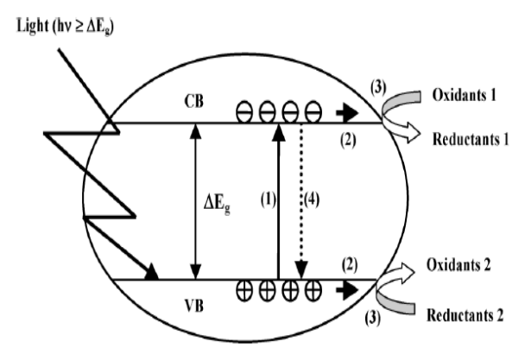

Scheme 1.

Scheme. 1
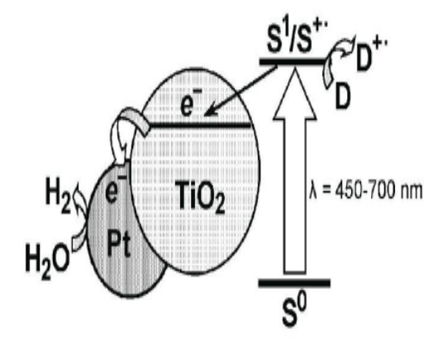

Scheme. 2
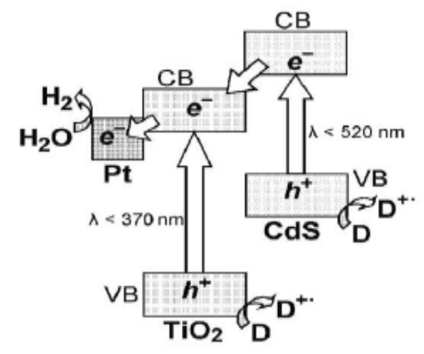

Scheme. 3

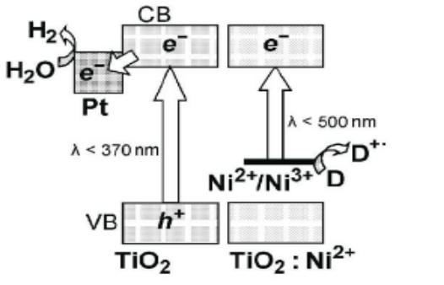

Scheme 4

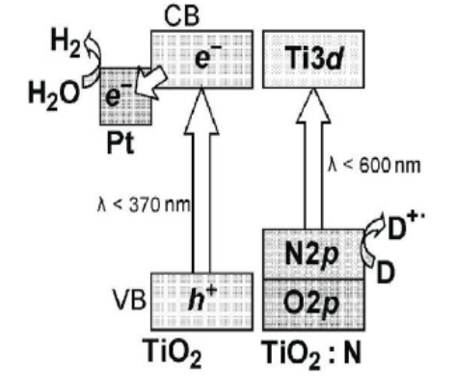

Scheme 5
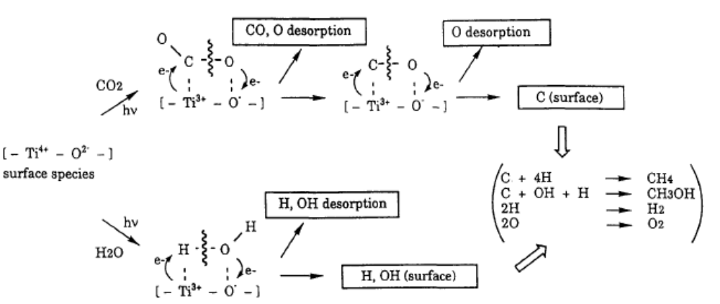

Scheme 6
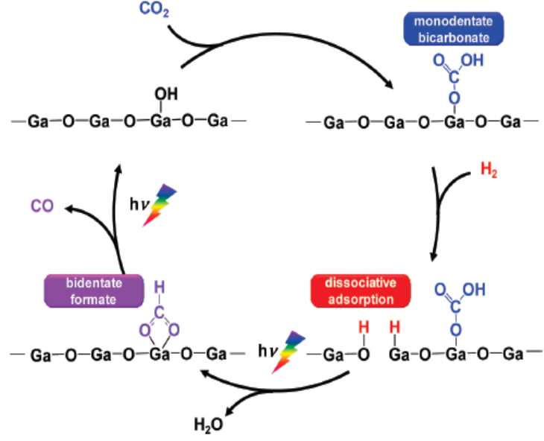

Scheme 7

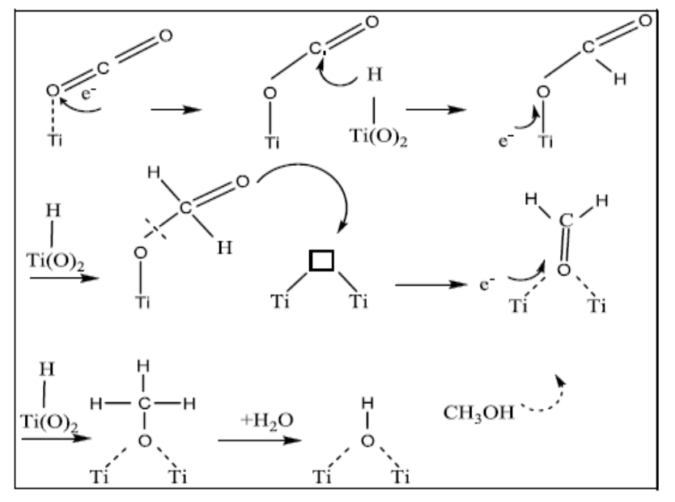

Scheme 8

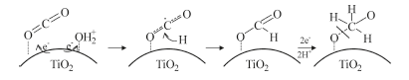

Scheme.9

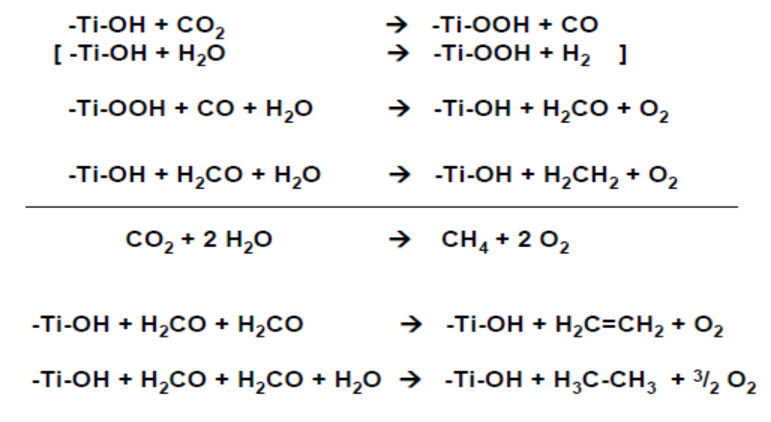

Scheme.10

Figures

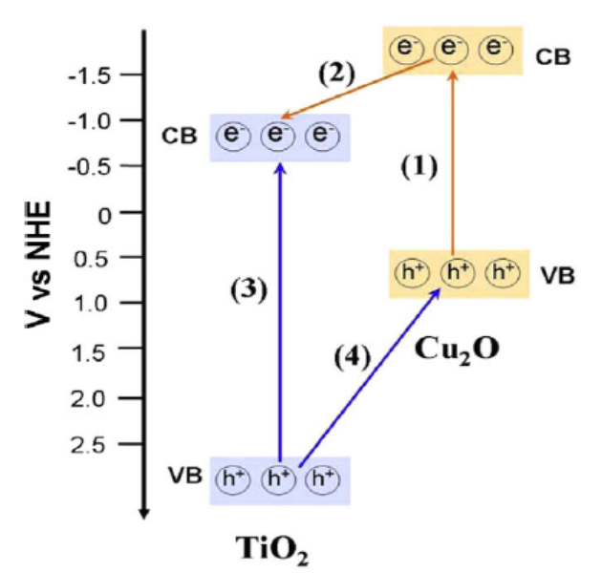

Fig.1

Fig.1

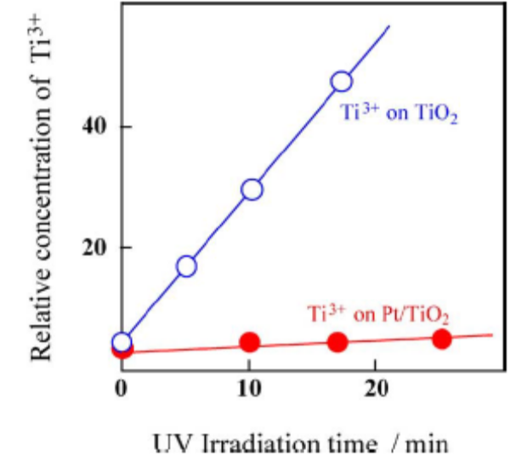
Fig.2

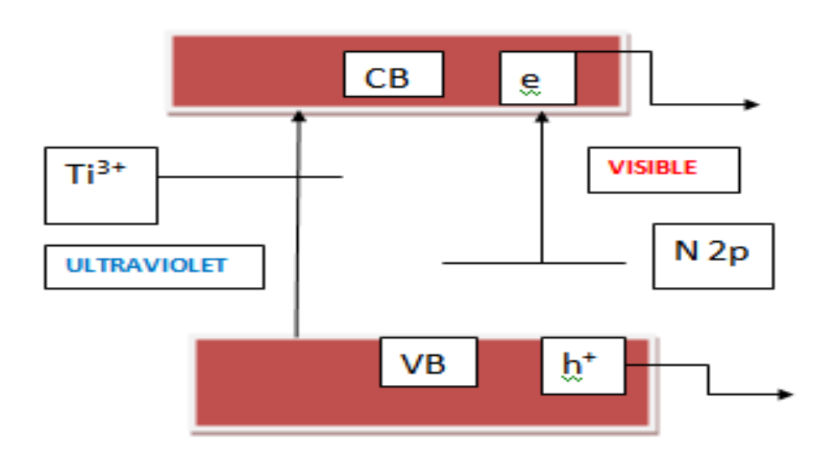
Fig.3

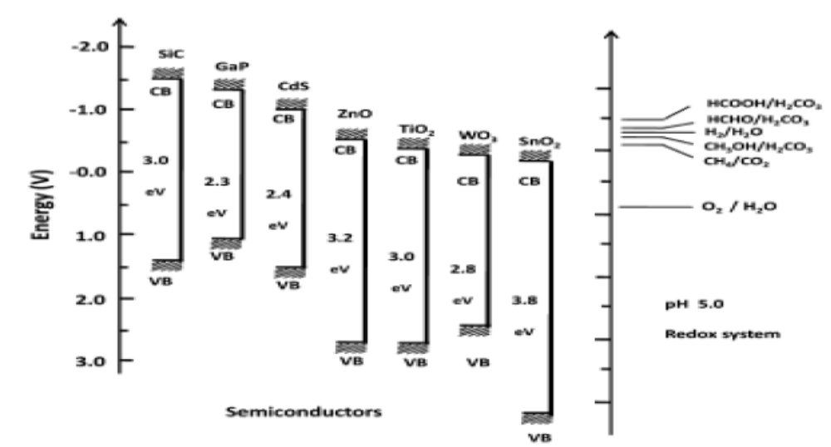

Figure 4.

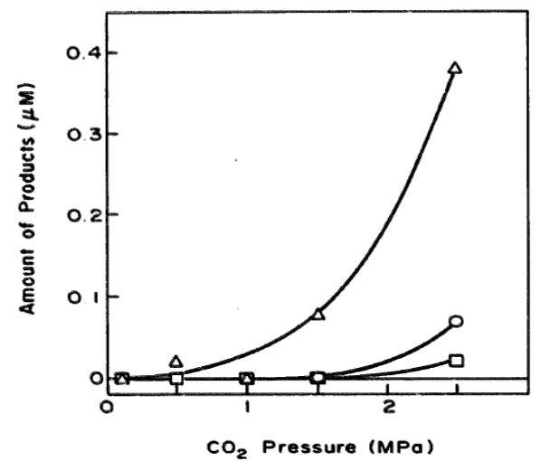

Fig.5

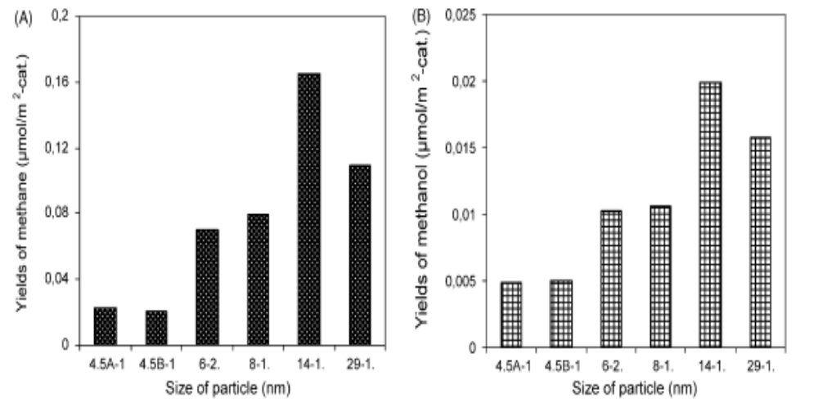

Fig.6

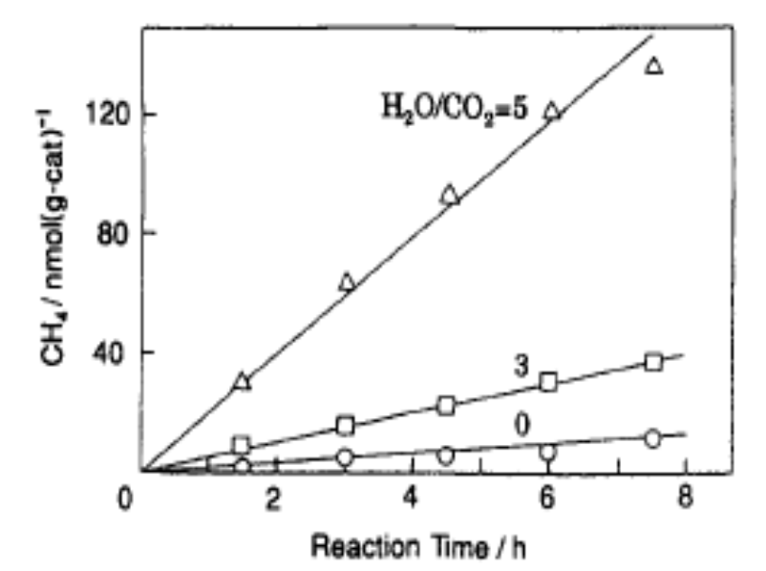

Figure 7

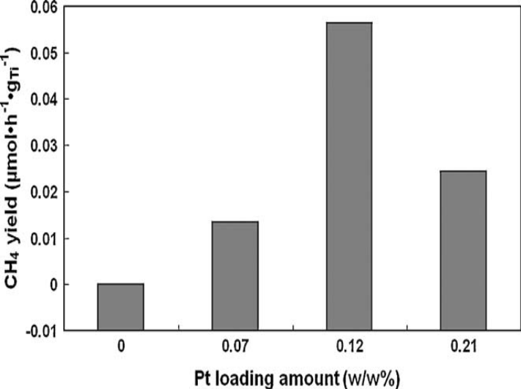

Figure 8

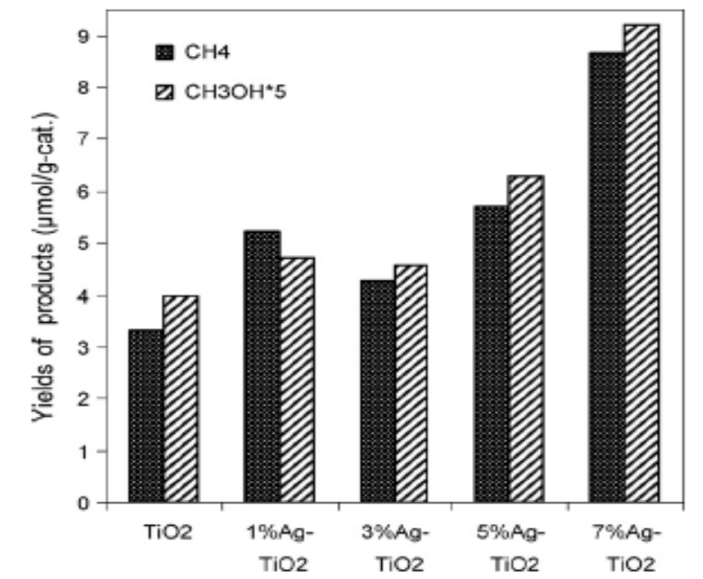

Fig.9
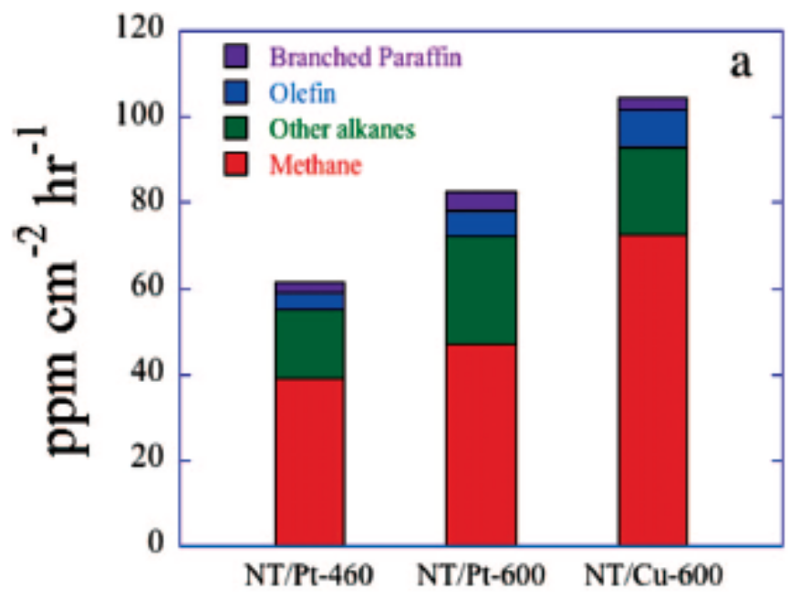

Figure 10

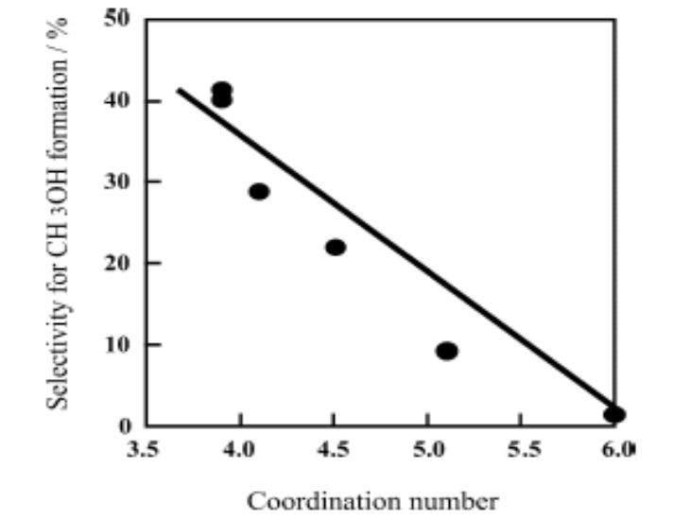

Fig.11

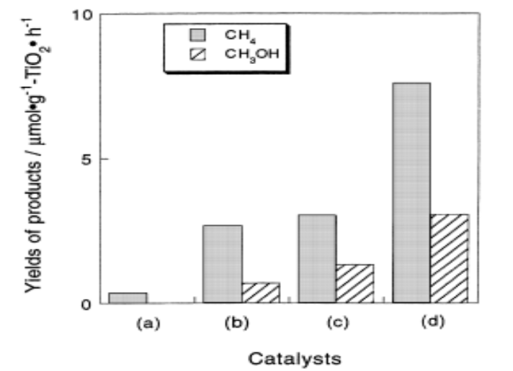

Fig.12

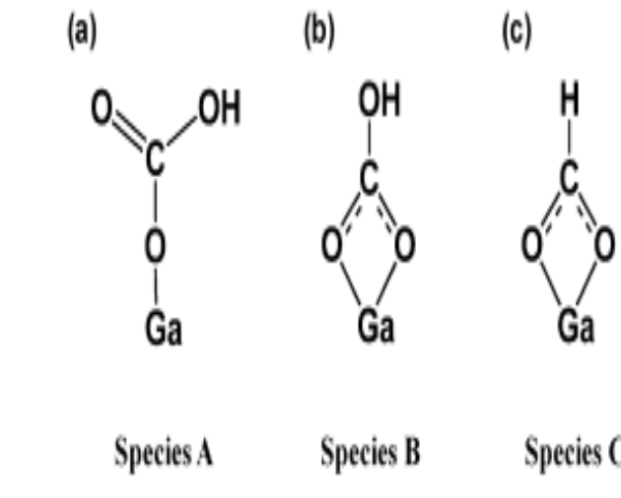

Fug.13

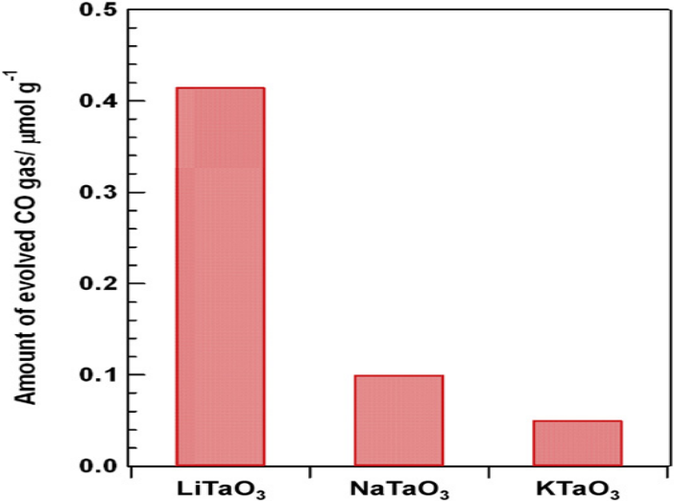

Fig.14

Captions for Schemes

Scheme.1. Schematic representation of the “band gap model”(1) Photo induced electron–hole
pair creation; (2) charge migration to the surface; (3) redox reactions;
(4) recombination. VB and CB represent valence band and conduction band,
respectively.(Reproduced from Ref.2 with permission from Taylor & Francis
Ltd.,Copy right 2007)

Scheme.2. Diagram of the operation of the photo catalytic system for the release of hydrogen
from water based on metal–semiconductor structures and a dye–sensitizer.
Legend: S0, S1, and S+are the sensitizer in the ground, excited, and one electron
oxidized states of the dye, respectively.(Reproduced from Ref.6 with permission
from Springer Science & Business Media, Copy right 2009)

Scheme.3. Diagram of the spatial separation of the photo generated charges in the CdS/TiO₂
hetero structure and the formation of hydrogen during the action of visible light.
(Reproduced from Ref.6 with permission from Springer Science & Business
Media, Copy right 2009)

Scheme.4. Diagram of the operation of the Photo catalytic system for the release of hydrogen
from an aqueous solution of electron donor D with the participation of titanium
dioxide doped with Ni²⁺ (TiO2:Ni²⁺). (Reproduced from Ref.6 with permission from
Springer Science & Business Media, Copy right 2009)

Scheme.5. Diagram of the operation of the Photo catalytic system for the release of hydrogen
from an aqueous solution of electron donor D with the participation of titanium
dioxide doped with nitrogen (TiO₂:N). (Reproduced from Ref.6 with permission from
Springer Science & Business Media, Copy right 2009)

Scheme.6.Schematic representation of the photo catalytic reduction of CO₂ with H₂O on
anchored titanium dioxide. (Reproduced from Ref.61 with permission from Elsevier,
Copy right 1995)

Scheme.7. Mechanism of photo catalytic reduction of CO₂ over Ga₂O₃in presence of hydrogen.
(Reproduced from Ref.82 with permission from American Chemical Society, Copy
right 2010)

Scheme.8. Proposed mechanism of photo catalytic CO₂ reduction over TiO₂.(Reproduced from
Ref.90 with permission from Springer Science & Business Media, Copy right 2009)

Scheme.9 Proposed mechanism of photo catalytic transformation of CO₂ to methoxy radical over
TiO₂ in presence of dissociated/bound water. (Reproduced from Ref.89 with
permission from the American Chemical Society, Copy right,2011)

Scheme.10. Mechanism for photo catalytic reduction of CO₂ with water on Ti-SBA-15.
(Reproduced from Ref.94 with permission from Elsevier, Copyright 2011)

Captions for Figures

Fig.1. Photo generation and separation of charge carriers in Cu₂O-TiO₂ hetero-structure in UV &
Visible regions.(Reproduced from Ref. 13 with permission from Elsevier, Copyright,
2009)
Fig.2. Growth of the ESR signal intensity (at 77K) of the photo formed Ti³⁺active site on Pt-
loaded and unloaded on TiO₂ (Reproduced from Ref. 19 with permission from Elsevier,
Copyright, 2003)
Fig.3. Schematic energy level diagram for nitrogen substituted TiO2 [Bare semiconductor
absorbs UV radiation while the localized energy levels of nitrogen above valence band
facilitates the visible light absorption] (Reproduced from Ref. 30a Hindawi Publishing
Corporation-Open journal)
Fig.4. Conduction band and valence band potentials of semiconductor photo catalysts relative to
energy levels of the redox couples in water.(Reproduced from Ref.40 with permission
from Macmillian Publisher Limited, Copy right 1979)

Fig.5. Effect of CO₂ pressure on its photo reduction (medium, purified water; irradiation time,
24h; catalyst, TiO₂): ∆- CH₄, ○-C₂H₄, □- C₂H₆. (Reproduced from Ref.44 with permission
from Elsevier, Copy right 2009) Fig.6. (A &B) Dependence of product yields on particle
size of titania (after 24 hrs irradiation)
(Reproduced from Ref.49 with permission from Elsevier, Copy right 2009)

Fig.7. The time profiles of the photo catalytic reaction of CO₂ (0.05 mmolg⁻¹) and H₂O to
produce CH₄ on titanium dioxide anchored on PVG and the effect of H₂O to CO₂ ration on
the yields of the products. Numbers represent the ratio of H₂O to CO₂. (Reproduced from
Ref.61 with permission from Elsevier, Copy right 1995)

Fig.8. Effect of Pt metal content in Pt/TO-NP on methane yield for photo catalytic reduction of
CO₂ after 7-h irradiation at 323K H₂O/CO₂=0.02.(Reproduced from Ref.66 with
permission from Elsevier, Copy right 2009)

Fig.9. Dependence of product yields on Ag content in Ag/TiO₂ (after 24 hrs).
(Reproduced from Ref.69 with permission from Elsevier, Copy right 2010)

Fig.10. N doped TiO₂ nan otube arrays with Pt (NT/Pt) & Cu (NT/Pt) co-catalysts, 460 or 600°C
annealed as indicated- Hydrocarbon generation rate. (Reproduced from Ref.65 with
permission from American Chemical Society, Copy right 2009)

Fig.11. The relationship between the selectivity of methanol formation in the reduction of CO₂
with H₂O and the co-ordination number of TiO₂ species determined by XAFS
investigation. (Reproduced from Ref.61 with permission from Elsevier, Copy right 2003)

Fig.12. Yields of CH₄ and CH₃OH in the photo catalytic reduction of CO₂ with H₂O on TiO₂
powder (a), TS-1 (b), Ti-MCM-41 (c) &Ti-MCM-48 (d) zeolite catalysts.
(Reproduced from Ref.77 with permission from Elsevier, Copy right 1998)

Fig.13. Adsorbed CO₂ species on Ga₂O₃-A-Mono-dentate bicarbonate B-Bi-dentate bicarbonate
C-Bi-dentate formate. (Reproduced from Ref.82 with permission from American
Chemical Society, Copy right 2010)

Fig.14. Amount of evolved CO gas for the photo photo catalytic reduction of CO₂ with external
H₂ as a reductant over ATaO3 (A = Li, Na, K) after 24 h of photo irradiation.
(Reproduced from Ref.83 with permission from Elsevier, Copy right 2010)

Tables

Table.1
Modifications | Implications/Mode of action
Doping of metals/metal ions | - Act as electron traps and facilitate charge carrier separation  - Introduce impurity states and induce visible light absorption  - Absorb visible light via surface Plasmon resonance
Doping of anions | - Narrowing of band gap due to mixing of p states of dopants (N,S) with O 2p states in the valance band of TiO₂  - Introduce impurity states above the valence band of titania  - Both states induce visible light absorption
Coupling with semi-conductors | - A narrow band gap semiconductor, with appropriate energy levels, absorbs visible light and transfers excited electrons into the conduction band of titania. UV light source not needed  - Besides visible light activity, effective separation of charge carriers is achieved
Sensitization with light harvesting components /dyes | - Light absorbing components can absorb visible light and inject photo-excited electrons into the conduction band of titania.  - Besides visible light activity, effective separation of charge carriers is achieved

Table 2
BiVO₄ | Production rate ª/μmolh⁻¹ | 300W Xe arc lamp with UV cut off filter | 300 W Xe arc lamp without UV cut off filter | 36W fluorescent lamp
Monoclinic | Ethanol | 21.6 | 406.6 | 2.3
 | Methanol | 0 | 0 | 1.8
Tetragonal | Ethanol | 1.1 | 4.9 | 0.6
 | Methanol | 0 | 0 | 0.6
ª The rate was determined on the basis of the average production
rate after 80 min of irradiation

Table 3

 | Production rateª [μmol(gcat)⁻¹ h⁻¹]
 | Ethylene | Methane
Cu(0.5 wt%)-Fe(0.5 wt%)₂/glass plate | 0.049 | 0.060
Cu(0.5 wt%)-Fe(0.5 wt%)/TiO₂/optical fiber | 0.575 | 0.914
N3-dye- Cu(0.5 wt%)-Fe(0.5 wt%)/TiO₂/glass plate | 0.033 | 0.148
N3-dye- Cu(0.5 wt%)-Fe(0.5 wt%)/TiO₂/optical fiber | 0.562 | 0.847
ª Production rates were determined on the basis of the average value after 4h of irradiation. The artificial light was in the wavelength range of 320-500 nm with intensity of 225 mW cm⁻².

Table.4

Catalyst | Product yield (μ moles/g. catalyst)
 | HCOOH | CH₃OH | HCHO | Total organic carbon
TiO₂ | 221 |  | - | 221
1wt%CoPc/TiO₂ | 450.6 | 12.1 | 38.5 | 501.2
0.7% in-situ  CoPc/TiO₂ | 1487 | 93 | 134.3 | 1714

Table.5.

Sensitizer | Catalyst or relay | Donor | Product(s) | Ф^{b} mol Einstein⁻¹
Ru(bpy)₃²⁺ |  | TEOA | HCOO⁻ | 0.049^{c}
Ru(bpy)₃²⁺ |  | TEOA | HCOO⁻ | 0.096^{d}
Ru(bpy)₃²⁺ | MV²⁺ | TEOA | HCOO⁻ | 0.01
Ru(bpy)₃²⁺ | Co²⁺/bpy | TEA | CO, H₂
Ru(bpy)₃²⁺ | Co²⁺/Me₂phen | TEA | CO, H₂ | 0.012(CO) 0.065 (H₂)
Ru(bpy)₃²⁺ | Ru(bpy)₂(CO)₂²⁺ | TEOA | HCOO⁻ | 0.14
Ru(bpy)₃²⁺ | Ru(bpy)₂(CO)₂²⁺ | BNAH | HCOO⁻, CO | 0.03(HCOO⁻) 0.15(CO)
Ru(bpy)₃²⁺ | Ru(bpy)₂(CO)(H)⁺ | TEOA | HCOO⁻ | 0.15
Ru(bpy)₃²⁺ | Ru(bpy)₂(CO)(X)^{n+},X=Cl and CO | TEOA | HCOO⁻
Ru(bpy)₃²⁺ | CoHMD²⁺ | H₂A | CO, H₂
Ru(bpy)₃²⁺ | Nicyclam²⁺ | H₂A | CO, H₂ | 0.001 (CO)
Ru(bpy)₃²⁺ | NiPr-cyclam²⁺ | H₂A | CO, H₂ | ca. 0.005 (CO)
Ru(bpz)₃²⁺ | Ru colloid | TEOA | CH₄ | 10⁻⁴ (CH₄)^{e}
Ru(bpy)₃²⁺ | Bipyridinium⁺,Ru or Os colloid | TEOA | CH_{4,} H₂ | 10⁻⁴ (CH₄)^{e} 10⁻³(H₂)^{e}
ReCl(bpy)(CO)₃ |  | TEOA | CO | 0.14
ReBr(bpy)(CO)₃ |  | TEOA | CO | 0.15
[ReP(OEt)₃(bpy)(CO)₃]⁺ |  | TEOA | CO | 0.38
p-Terphenyl | Cocyclam³⁺ | TEOA | CO,HCOO⁻,H₂ | 0.25e (CO+HCOO⁻)
p-Terphenyl | CoHMD²⁺ | TEOA | CO,HCOO⁻ ,H₂
Phenazine | Cocyclam³⁺ | TEOA | HCOO⁻ | 0.07e
FeTPP |  | TEA | CO
CoTPP |  | TEA | HCOO⁻ , CO

a Abbreviations used: TEOA_triethanolamine, MV2__ methylviologen, TEA_triethylamine, bpy_2,2%-bipyridine, Me2phen_2,9-Dimethyl-1,10-
phenanthroline, BNAH_1-benzyl-1,4-dihydronicotinamide, H2A_ascorbic acid, cyclam_1,4,8,11-tetraazacyclotetradecane and Pr-cyclam_6-((NR)
pyridin-4-yl)methyl-1,4,8,11-tetraazacyclotetradecane where R_p-methoxybenzyl and benzyl, TPP_5,10,15,20-tetraphenyl-21H,23H-porphine.
b Unless otherwise noted, the quantum yield of product formation is defined as the formation rate divided by the light intensity.
c With 15% water in DMF.
d With 15% water and excess bpy in DMF.
e Assuming two (or eight) photons produce one molecule of the product.

Table.6
Catalyst | CO formation  μmol/g TiO₂/hr | CH₄ formation  μmol/g TiO₂/hr
TiO₂ | 8.1 | -
TiO₂-SiO₂ | 22.7 | -
4% Cu/TiO₂ | 11.8 | 1.8
0.5% Cu/TiO₂-SiO₂ | 60.0 | 10

Captions for Tables

Table.1. Implications of different modifications in titania
Table.2. Rates of methanol & ethanol formation with radiations of different wavelengths
(Reproduced from Ref. 9 with permission from Elsevier, Copyright, 2009)
Table.3. Product profile for photo reduction of CO₂ on TiO₂-CoPc systems. (Reproduced from
Ref.78 with permission from Elsevier, Copyright, 2009)
Table.4. Production rate of methane and ethylene over TiO₂ based-catalysts under artificial light-
Influence of the type of photo reactor on reaction rate (Reproduced from Ref.51 with
permission from Elsevier, Copyright 2008)
Table.5. Metal complexes as catalysts for photo reduction of CO₂ (Reproduced from Ref.99 with
permission from Elsevier, Copyright 1999)
Table.6 CO and CH₄ formation on Cu/TiO₂ dispersed on meso porous silica catalysts-Synergy
effect [98]

