A conceptual formulation of photochemical CO₂ reduction catalyst system
B.Viswanathan

In a recent publication [1] the photosynthetic conversion of CO₂ to hydrocarbons ( methane and other higher hydrocarbons) on Pd /TiO₂ in conjunction with nafion has been reported. However, the photo conversion efficiency of the process is very low because the activation of the thermo chemically most stable CO₂ requires highly energetic electrons. Since the one-electron reduction of CO₂ ₊₍ the initial step in the reduction process) requires high potentials of the order of 2 Volt, a more favorable pathway is to reduce CO₂ though proton-coupled multiple-electron transfers (PCET). Nafion (per fluorinated polymer with sulfonate groups) coated Pd–TiO₂ particles (Nf/Pd–TiO₂) were prepared and their reactivity for the photo reduction of CO₂ was tested. The role of the Nafion layer is to enhance the local proton activity within the layer to facilitate PCET reactions and to stabilize intermediates and to inhibit the re-oxidation of the CO₂ reduction products. Nf/Pd–TiO₂ is more active than Pd–TiO₂ for the photo-production of hydrocarbons (e.g., methane, ethane, and propane). The photosynthetic activity of the Nf/Pd–TiO₂ catalyst was maintained through repeated cycles of photoreaction, which confirms the stability of the Nafion layer. The proposed Nf/Pd–TiO₂ should serve as a model of more practical catalysts for the artificial photosynthesis that is based on PCET reactions.
The conceptual design of the catalyst system employed in this study is shown in Fig [This figure is reproduced from this paper]
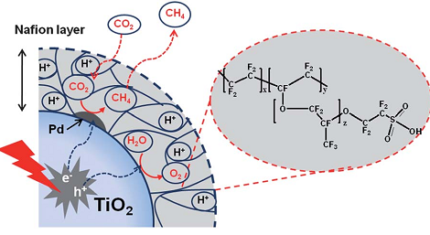
Fig.1 Pd/TiO₂ on Nafion catalyst system for the photochemical reduction of CO₂ [from ref 1]
In the light of this communication, the following is presented for conceptual analysis and possible adaptation. Essentially the points of relevance are:
- A direct proton source rather than from the decomposition of water is desirable so that the reduction of CO₂ is facilitated.
- It must be ensured that the species employed for proton source should not undergo any electrochemical reaction within the potential range for CO₂ reduction reaction.
- The reactivity of the proton should be as high as that in Nafion, where the Proton is in a highly electronegative environment of Fluorine atoms.
- The available protons should be capable of reacting with carbon dioxide directly promoted by the light absorbed in TiO₂ and reduction reaction should be carried out on some reactive metal sites.
- In order to overcome the low solubility of CO₂ the source is any carbonate which can in situ generate CO₂ and thus can sustain source.

Considering these aspects and also based on argumentative formulations it is possible that alternate PCET catalyst support systems which may sustain more acidic protons can be tried like heteropoly acids or super acids like sulphated zirconia.

Reference
[1] Wooyul Kim et al., Energy Environ. Sci., 5, 2012, 6066

