Clays: Types and Applications
Vivek Srivastava Applied Science, NIIT University, NH-8: Delhi- Jaipur Highway, Neemrana, Alwar, Rajasthan, India Email: vivek.srivastava.chem@gmail.com, Phone number:+91-08233180327
Cationic and anionic clays have attracted the greatest attention in the area of catalysis from the last decades. Clays are providing specific features like high versatility, wide range of preparation variables, use in catalytic amounts, ease of set-up and work-up, mild experimental conditions, easy work-up procedure, gain in yield and/or selectivity, low cost, recyclablity etc. These properties make them more applicable towards establishing environmentally benign technologies . Additionally, the possibility of upgrading these materials via intercalation process opens new and interesting standpoints, also considering possible shape selective advantages. In this report we are focusing types of clays (anionic/cataionc), their modified forms as well as catalytic applications of cationic and anionic clays for various organic transformations.
Keywords: Clay, Montmorillonite, Hydrotalcites, Organoclays, Organic reaction, Catalysis.
- Introduction
Clay minerals are aluminosilicates in nature that predominate in the clay fraction of earth materials at the intermediate stages of weathering. The clay minerals are structurally related to the common mineral mica, but with a more random pattern of isomorphic substitution, are sandwiches of tetrahedral and octahedral sheet structures.^{[1]} Their sheets, formed by the joining together of silica tetrahedra in a two-dimensional array, constitute the basic structural units. The deviations from the mica structure and the variations among clay minerals are due to the way the silica sheets are stacked with other chemical layers, and the degree of chemical substitution within both the original silica sheet and the added layers.^{[1-3]}
In this review we are discussing different types of clays (anionic and cationic) and their application in the area of catalysis and synthesis.
In the first part of the review we discussed the basic structure and the classification of that of natural clays. After that we discussed the most important Montmorillonite clay with its specific features and its application. Intercalated/pillared clays are a new class of materials and its modified form pillared exchanged clay are well known in the area of heterogeneous catalysis. This review is also focused some aspects of organoclay and hydrotalcites like preparation, features and the applications of these modified clays.

Basic structure of clay
The clay minerals are phyllosilicates or layer silicates in nature. Their softness generally ranges from 2 to 3 on the Mohs scale. Its color varies from yellow to pure white depending upon to the amount of iron into the structure. The four important classes of the clay mineral groups are kandites, illites, smectites and vermiculits. Kalonite where Montmorillonite are the most common clay minerals found in nature which belong to kaoline (montmorillonite K10) and smectite groups respectively.^{[1, 3]}
The basic structure of clay minerals made up by staking of two sheets: tetrahedral sheets and octahedral sheets separated by an interlayer. The combination of these two units and composition of sheets varies from clay to clay.^{[4]}

The tetrahedral sheet
Tetrahedron , is a basic unit of this layer, which contains normally one Si⁴⁺in the center with four O²⁻ at the corners. The tetrahedron linked to neighboring tetrahedral by sharing three oxygen atoms each to form a hexagonal mesh pattern. All the unshared corners with the apical oxygen atoms point in the same direction to form part of the adjacent octahedral sheet (Figure 1).
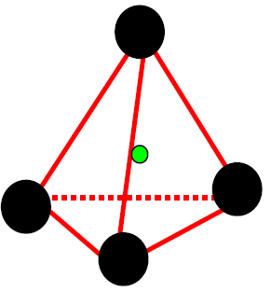  Single tetrahedron unit | 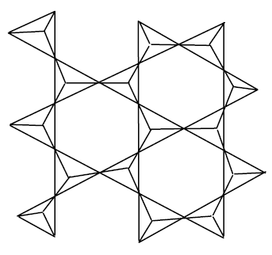  Corner linked tetrahedron sheet (top view)
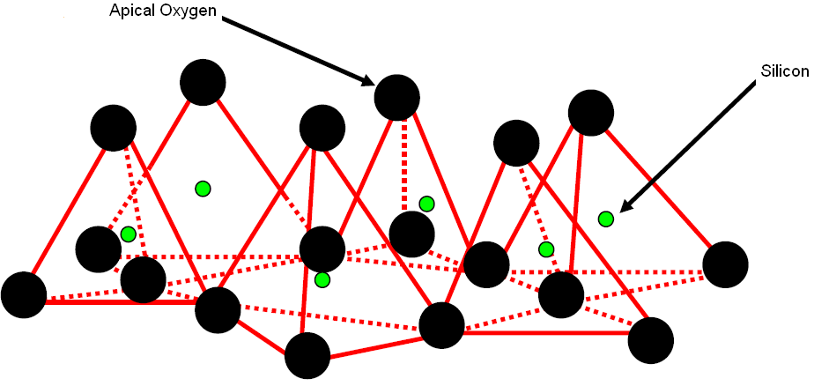
Tetrahedral sheet formed by joining of tetrahedral units (side view)
Figure 1: Different orientation tetrahedral sheet

The octahedral sheet
The basic unit of this layer is an octahedron, which contains mainly Al³⁺ or Mg²⁺ surrounded by six oxygen atoms or hydroxyl group. When the cations are trivalent, the sheet contains two per half unit cell and one vacancy, this structure is similar to gibbsite, Al (OH) ₃, and is known as a dioctahedral structure. When the cations are divalent, the sheet contains three cations per half unit cell and no vacancy. This is a structure similar to brucite, Mg (OH) ₂ and is known as a trioctahedral structure. Octahedral sheets can contain other cations including Li⁺, Fe⁺² and Fe⁺³.
The octahedral and tetrahedral sheets are covalently linked through the sharing of the apical oxygen atoms of the tetrahedral sheet with the octahedral sheet centering the metal cation (octahedral)-O-Si (tetrahedral) link as seen in Figure 2. The octahedral sheet is commonly slightly smaller than the tetrahedral sheet. To compensate for this difference, the tetrahedra in the tetrahedral sheet rotate resulting in a distortion sheet (Figure 2).
The cations in the tetrahedral and / or octahedral sheet can be replaced by other cations to cause a negative charge in the structure. The charge can be located in the tetrahedral and / or octahedral sheet and is very useful to identify different species of clay minerals.

Classification of clay
The clays are classified on the basis of their layer types.^{[5, 6]} The 1:1 layer type has alternating tetrahedral (T) octahedral sheets (O), e.g. Kaolinite group.^{[7, 8]} The interlayer is occupied by hydroxyl groups and oxygen atoms from the octahedral and tetrahedral sheets connected by weak hydrogen bonds. Members of those groups can be dioctahedral such as kaolinete, containing Al and Si with no substitutions, or trioctahedral such as containing chrysotite containing Mg and Si.

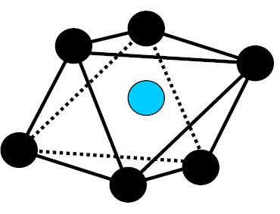  Single octahedral unit | 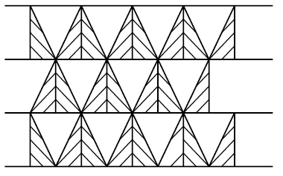  Edge linked octahedral sheet unit (Top view)
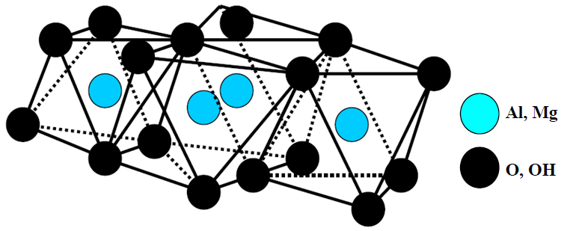
Octahedral sheet formed by joining of octahedral units (side view)
Figure 2: Different orientation of octahedral sheet
The 2:1 layer type has two tetrahedral sheets that sandwich an octahedral sheet (TOT) and the three mineral groups with this structure are illite, vermiculite and smectite (of which the most common is montmorillonite).^{[9, 10]} A third arrangement in which the three layers, TOT units alternate with a brucite layer (2:1:1) is chlorite.^{[11]} This group further divided in to two subgroups on the basis of Layer charge and exchangeable cations.
The subgroup 2:1 with no layer charge and no exchangeable cations mainly consist dioctahedral minerals like pyrophillite and trioctaherdral equivalent is talc, Mg₆Si₈O₂₀ (OH) ₄. The layer thickness of the octahedral and two trihedral sheets together is about 9.5Å.
In the sub group 2:1 with layer charge and exchangeable cations have smectites. The layer charge of the smectite group ranges from 0.4- 1.2 and the species of this group correspond to the most commercial clays known as bentonite. Member of this group have the ability to exchange interlayer cations and water with the surrounding environment.
Smectite belongs to 2:1layer minerals, either dioctahedral or tricoctahedral in nature, which can expand when water or organic molecules are introduced into the interlayer space. Montmorillonite and beidellite are dioctahedral smectites with mainly Al in the octahedral sheet, which have been formed by alteration of volcanic ash of tuffs; the trioctahedral smectites, such as saponite, hectorite and stevensite, contains mainly Mg⁺ (with or without Li⁺ or vacancies) in the octahedral sheet. The charge can be located in the tetrahedral sheet (saponite) or in octahedral sheet (hectorite).^{[12, 13]}

Properties of clays

Ion exchange
Isomorphous substitution of cations in the lattice by lower-valent ions, e.g. the substitution of aluminium for silicon, magnesium and/or ferrous ion for aluminum or sometimes lithium for magnesium, leaves a residual negative charge in the lattice that is balanced by other cations. These can be readily replaced by other cations when brought into contact with these ions in aqueous solution.^{[14, 15]}

Swelling
Many clay minerals absorb water between their layers, which move apart and the clay swells. For efficient swelling, the energy released by cations and/or layer solvation must be sufficient to overcome the attractive forces (such as hydrogen bonding) between the adjacent layers. In 1:1 (OT) clay minerals (kaolinite), water forms strong hydrogen bonds with hydroxyl groups of hydrophilic octahedral layers, allowing swelling to occur.^{[2]}
With 2:1 (TOT) clay minerals, the ability to swell depends on the solvation of interlayer cations and layer charge. Clays with 2:1 structures and low layer charge (e.g. talc and pyrophyllite) have very low concentration of interlayer cations and therefore do not swell readily. At the other extreme, those with very high layer charges (e.g. mica) have strong electrostatic forces holding alternate anionic layers and the interlayer cations together, thus preventing swelling. Those with univalent interlayer cations swell more readily and with divalent, trivalent and polyvalent cations, swelling decreases accordingly. The extent of swelling can be observed by measuring interlayer separations using powder X-ray diffraction.

Intercalation and cation-exchange
In swelling clay minerals, such as smectites, the interlayer cations (Na⁺) can undergo exchange with cations from external solutions. The concentration of exchangeable cations is called cation exchange capacity (CEC), usually measured in milliequivalents per 100 g of dried clay. Since smectites have the highest concentration of interlayer cations, they have the highest cation exchange capacities (typically 70–120 mequiv./100 g). Structural defects at layer edges give rise to additional CEC and a small amount of anion exchange capacity.^{[16, 17]}

Acidity
The acidity of clay minerals mainly depends upon the interlayer cations clay minerals. Some of these cations may be protons or polarizing cations (e.g. Na⁺, Al³⁺) which give rise to strong Brönsted acidity. The higher the electronegativity of M⁺, the stronger are the acidic sites generated. Brönsted acidity also stems from the terminal hydroxyl groups and from the bridging oxygen atoms.^{[18]}
In addition, clay minerals have layer surface and edge defects, which would result in weaker Bronsted and/or Lewis acidity, generally at low concentrations. The acid strength is usually expressed by the Hammett scale. On this scale, the acidity of clay minerals can be comparable to that of concentrated sulfuric acid. The surface acidity of natural clays with Na⁺ or NH₄⁺ as interstitial cations ranges from +1.5 to -3. Washing of the clay with mineral acid, such as HCl, brings down the Hammett (HO) function from -6 to -8, which is between concentrated HNO₃ (-5) and H₂SO₄ (-12).^{[18]}

Montmorillonite clay
The term "smectite" is used to describe a family of expansible 2:1 phyllosilicate clay minerals having permanent layer charge because of the isomorphous substitution in either the octahedral sheet (typically from the substitution of low charge species such as Mg²⁺, Fe²⁺, or Mn²⁺ for Al³⁺) or the tetrahedral sheet (where Al³⁺ or occasionally Fe³⁺ substitutes for Si⁴⁺). It is common for smectites to have both tetrahedral charge and octahedral charge. Montmorillonite consist of negatively charged, crystalline aluminosilicate platelets. These platelets form pseudo three-dimensional crystals consisting of regular stacks of parallel platelets held together by charge-balancing interlayer counter ions. Cohesion of clay structure is ensured by their hydrogen-bond network that makes the octahedral layer of one platelet stick onto the adjoining tetrahedral layer of another platelet stacked over it.^{[19]}
Montmorillonte (MMT), a naturally occurring 2:1 phyllosilicate as shown in Figure 3, which has same layered and crystalline structure as talc and mica but different layer charge.^{[20, 21]} The MMT crystal lattice consists of 1nm thin layers, with a central octahedral sheet of alumina fused between two silica tetrahedral sheets (in such a way, so that the oxygen from octahedral sheets also belong to the silica tetrahedron). Isomorphic substitution within the layers (for example Al³⁺is replaced by Mg²⁺ or Fe²⁺) generates a negative charge defined through the charge exchange capacity (CEC) and for MMT is typically 0.92-1.2-mEq/g depending on the mineral origin.^{[21, 22]} These layers organize themselves in a parallel fashion to form stacks with a regular Vander Waal gap between them, called interlayer or gallery. In the pristine form their excess negative charge is balanced by cations (Na⁺, Li⁺, Ca²⁺), which exist hydrated in the layer. ^{[23]}

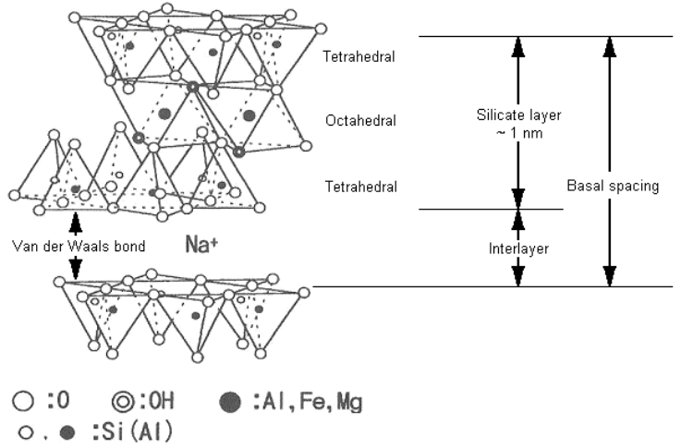
Figure 3: Na-Montmorillonite
Montmorillonite is the most important smectite used in catalytic applications.^{[24-26]} High cation-exchange capacity (CEC) and good swelling properties allow a wide variety of catalytically active forms of montmorillonite to be prepared (e.g. containing acidic cations, metal complexes, photocatalytically active cations, etc.)
Montmorillonites are most frequently used as Brönsted acid catalysts, where the exchangeable cations are either protons or polarizing cations (e.g. Al³⁺, Cr³⁺ or Fe³⁺).^{[27]} Acid site strength depends upon the type of interlayer cations present (H₃O⁺>Al³⁺>Ca²⁺>Na⁺).^{[27]} Higher acid strength generally leads to greater catalytic activity, but poorer product selectivity. Controlling the acid site strength by choice of interlayer cations proves to be useful for ‘fine-tuning’ the catalyst selectivity. When treated with mineral acids under harsh conditions (e.g. refluxing), montmorillonites undergo leaching of aluminum and, to a lesser extent, silicon.^{[28]} This leads to increased surface area and concentration of weak acid sites, but a decrease in concentration of strong acid sites. Acid leaching in montmorillonite is particularly useful for catalytic applications requiring only weak acid sites, where strong acid sites give rise to poor selectivity.^{[24-26, 29, 30]}

Pillared Clays
Intercalated/pillared clays are a new class of materials, in which a homogeneous distribution of micro-pores can be obtained with pore openings varying from 4 to 18 Å according to the type of pillars. These solids are attractive because they can absorb and convert larger molecules.^{[31, 32]}
Pillared clays constitute one of the most widely studied among the new groups of microporous materials developed by molecular engineering. These solids, also known as cross-linked clays or pillared interlayer clays (PILCs), are obtained by exchanging the interlayer cations of layered clays with bulky inorganic polyoxocations, followed by calcination.^{[31, 33]} The intercalated polycations increase the basal spacing of the clays and, upon heating, they are converted to metal oxide clusters by dehydration and dehydroxylation. These metal oxide clusters, named pillars, are inserted between the clay layers, yielding temperature stable oxide pillars that permanently keep the layers apart, preventing its collapse. As a result, an interlayer space of molecular dimensions, a two-dimensional porous network, is generated. After pillaring, the presence of this new porous structure and the incorporation of new active sites present several possible applications of these materials. The pillaring process is summarized in Figure 4.
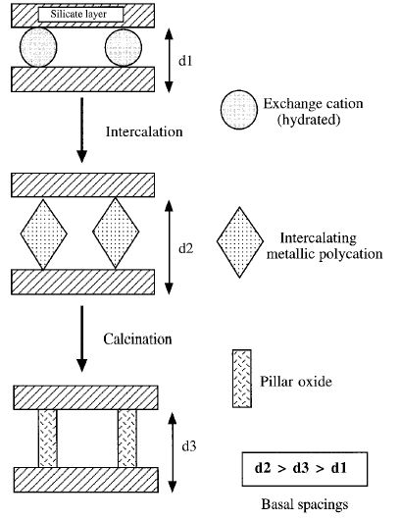
Figure 4: Schematic representation of the pillaring process
Several inorganic hydroxy species have been used for intercalation including those of aluminium, zirconium, chromium, iron, silicon, gallium, tantalum, nickel and titanium. Among the group of pillared clay materials, the most widely studied material is the aluminium-pillared clay synthesized by using [Al₃O₄ (OH) ₂₄(H₂O) ₁₂] ⁷⁺ Keggin ion as a pillaring agent.^{[32, 34, 35]}

Application of clay in organic transformations
Acid-treated and cation-exchanged montmorillonites possess the ability to catalyze organic reactions. During the thirties and forties, acid-treated montmorillonites were major catalysts used in petroleum processing, though they were later replaced by more thermostable zeolites. The modified montmorillonites are versatile heterogeneous catalysts for a wide variety of organic reactions.

Oxidation
Oxidative cleavage of olefins is one of the often used reactions in organic chemistry.^{[36]} Clay- anchored iron [N,N′-ethylen ebis(salicylideneaminato)] complex were synthesized by direct exchange to oxidise various olefins and chalcones in aqueous acetonitrile using hydrogen peroxide as terminal oxidant. Aldehyde and its derivatives are obtained as oxidation products by the cleavage of a C=C double bond (Scheme 1). In comparison with the catalysis by iron–salen complex in solution, the clay catalyzed pathway not only increases the rate of reaction significantly, but also provides selective oxidation toward the aldehyde. Some chalcones also give very good yield in water, compared to the solution and clay catalyzed pathways.^{[37]}
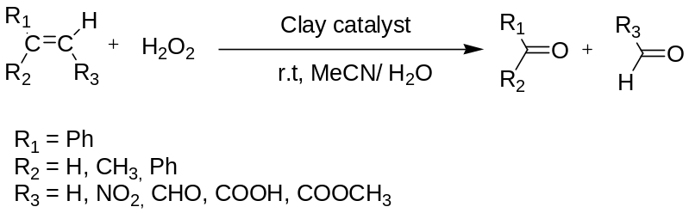
Scheme 1: Clay catalysed oxidation of olefins and chalcones
Choudary and coworkers ²³ have developed a simple and convenient method for allylic oxidation of cyclic and acyclic alkenes to the correspondingα,β-unsaturated carbonyl compounds in good yields using catalytic amount of chromia-pillared montmorillonite and equimolar quantity of tert-butyl hydroperoxide (Scheme 2).^{[38]} Chromia-pillared clay has also been used for selective oxidation of alcohols (Scheme 3).^{[39]}
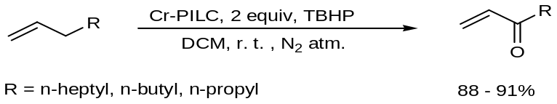
Scheme 2: allylic oxidation of cyclic and acyclic alkenes chromia-pillared montmorillonite
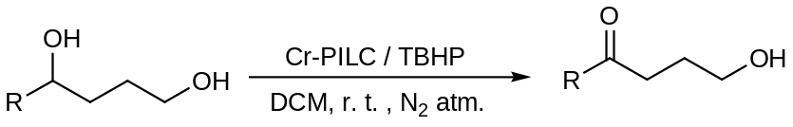
Scheme 3: Selective oxidation of alcohol
Recently, Tatibouet et al ²⁵ have studied the wet peroxide oxidation of phenol over iron containing clays, pillared by Al or mixed Al-Fe complexes.^{[40]} Sudalai et al reported mild and efficient Ru III-exchanged montmorillonite K10 catalysed benzylic oxidation of alkyl arenes to the corresponding tert. butyl aryl peroxides using as an oxidant in catalytic amount (Scheme 4).^{[41]}
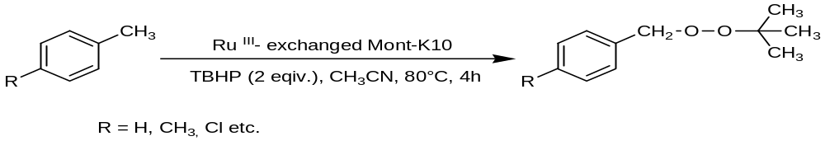
Scheme 4: Ru III-exchanged montmorillonite K10 clay catalysed benzylic oxidation of alkyl arenes
Bipyridylsilylated montmorillonite (abbreviated as bpy-mont) was prepared from H-montmorillonite and 6-(ethoxydimethylsilyl)-2, 2′-bipyridine. Treatment of the bpy-mont with [RuCl₂ (CO)₂]_{n} affords a novel clay catalyst including Ru(II)-bpy. The oxidation of aromatic alkenes with tert-BuOOH in the presence of the catalyst and Et₃N mainly produces vic-bis(tert-butyldioxy)alkanes. A similar oxidation of 2, 3-dimethyl-1, 3-butadiene affords 1, 4- and 1, 2-bis (tert-butyldioxy) alkenes. In the absence of Et₃N the oxidation of 1, 1-diphenylethylene gives 2-tert-butyldioxy-1-hydrodioxy-1, 1-diphenylethane as a major product (Scheme 5). This catalyst is easily separated after the reactions and can be reused for oxidation.^{[42]}
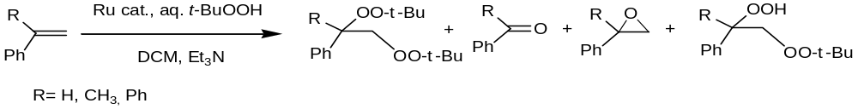
Scheme 5: Clay catalysed oxidation of aromatic alkenes

Diels alder reaction
Construction of the dihydropyran ring system via hetero-Diels-Alder reactions that employ aldehydes as dienophiles is well precedented and has been featured in the synthesis of a wide variety of natural products.^{[43, 44]} Clay minerals are most frequently used to promote Diels- alder reaction.^{[45]} Cation-exchanged K10 montmorillonite display a high Lewis/Bronsted acidity ratio, thus efficiently promote the reaction of (-) methyl acrylate with cyclopentadine (Scheme 6). Mayoral et al studied the Bronsted and Lewis acidity of cation-exchanged K10 montmorillonite and they reported that Bronsted acid site of clay are more active towards reaction.^{[46]}
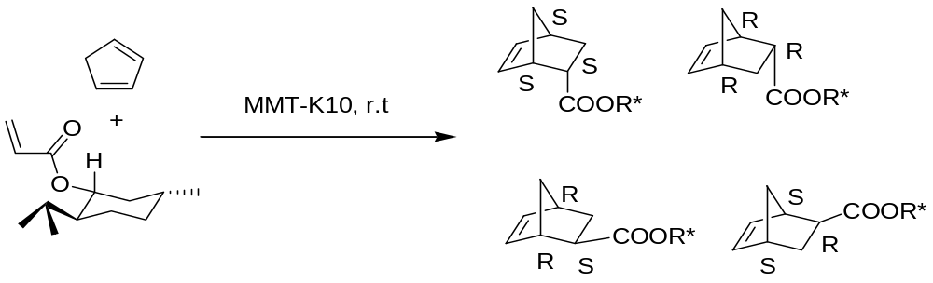
Scheme 6: MMT-K10 catalyzed hetero-Diels–Alder reactions
The biomimetic facile method for the generation and cycloaddition reaction of O-quinomethanes developed by Chiba et al and they claimed that a catalytic amount of wet montmorillonite in a LiClO₄–MeNO₂ solution efficiently generated O-quinomethanes by the dehydration of the corresponding o-hydroxybenzyl alcohol (Scheme 7). The reaction media showed a remarkable acceleration property in the generation and intermolecular cycloaddition of the unstable O-quinomethanes with various inactivated alkenes.^{[47]}
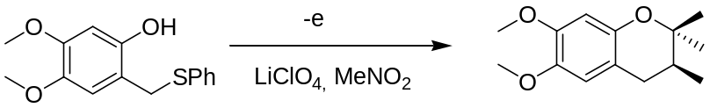
Scheme 7: Clay catalysed cycloaddition reaction
Dintzner et al demonstrated the utility of Montmorillonite clays for hetero-Diels–Alder reaction of 2,3-dimethyl-1,3-butadiene with anisaldehyde and other benzaldehyde derivatives with moderate yield and conversion (Scheme 8).^{[48]}
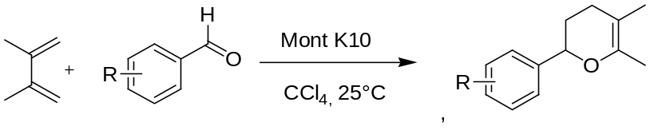
Scheme 8: Montmorillonite clays for hetero-Diels–Alder reaction
Kaneda et al synthesized chiral organocatalyst ((5S)-2,2,3-trimethyl-5-phenylmethyl- 4-imidazolidinone monohydrochloride) immobelised montmorillonite using a cation-exchange reaction , which further used as mont-entrapped organocatalyst for Diels–Alder reaction (Scheme 9).^{[49]}
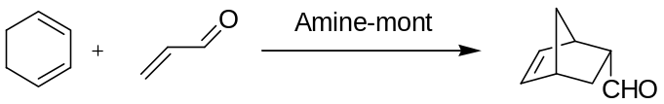
Scheme 9: Mont-entrapped organocatalyst for Diels–Alder reaction

Coupling Reaction
Sudalai et al reported preliminary results on the use of Pd and Cu exchanged montmorillonite K10 clay as a catalyst for the vinylation of aryl halides (X = Br, I) (Scheme 1) in high yields. Where theses clays were prepared by exchanging the clay with dilute aqueous PdCl₂, Cu (NO₃)₂ or a mixture of two respectively. The high activity of the catalyst is attributed to a synergistic effect produced by the presence of Pd and Cu species in the catalyst (Scheme 10).^{[50]}
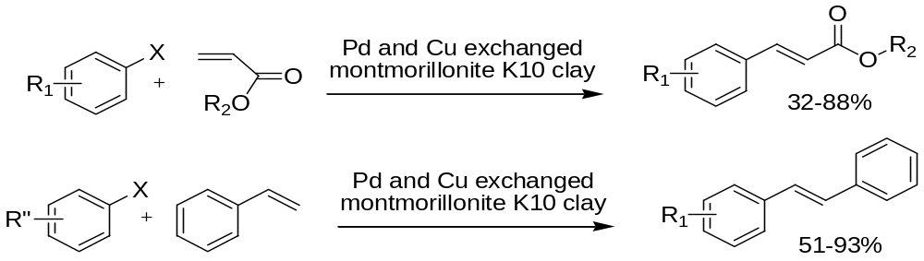
Scheme 10: Pd and Cu exchanged montmorillonite K10 clay catalysts for coupling reaction
Varma et al ²⁶ have prepared a new modified clay material by intercalating palladium chloride and tetraphenyl phosphonium bromide into K-10 clay. The heck reaction was catalysed using this protocol to afford trans-stilbenes in high yields (Scheme 11).^{[51]}
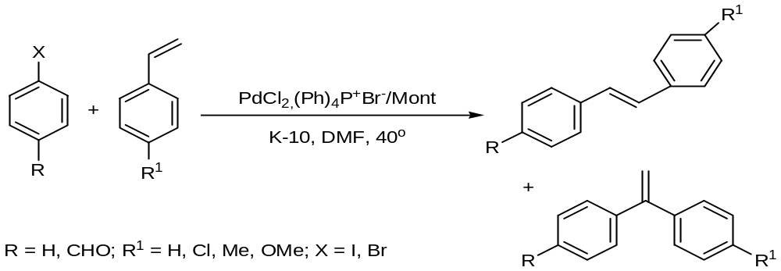
Scheme 11: Exchanged caly catalysed heck reaction
In the continuation of their work they prepared clay immobilized palladium phosphine-free catalytic system for Sonogashira coupling of alkynes with aryliodides and bromides. The immobilization of Pd (II) complexes onto clays gave beneficial effects on the recyclability of the catalytic activity over consecutive runs and also on the catalyst's stability, preventing it from Pd(0) formation.^{[52]}
They also developed a new method for the preparation of biaryl compounds from readily accessible aryl halides and arylboronic acids using palladium chloride/tetraphenyl phosphonium bromide intercalated clay as a new catalyst (Scheme 12).^{[53]}
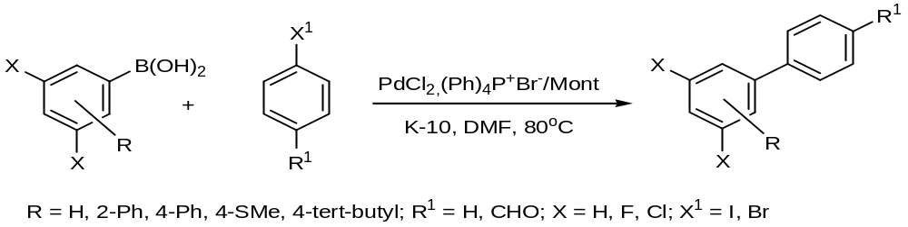
Scheme 12: Suzuki cross coupling reaction

Hydrogenation
Torii and Iwasaki invented a new hydrothermal method to synthesize trioctahedral smectite like clay minerals that are intercalated with small fragments of anisotropic silicate and have high surface area. They have produced various smectite- and hectorite-like minerals including different divalent cations for Mg²⁺ in octahedral sheets. They supported metals like platinum including different divalent cations of Ni²⁺, Co²⁺, Mg²⁺, and Zn²⁺ on smectite (SM). Their physical properties were characterized by temperature-programmed reduction and desorption, extended X-ray absorption fine structure, extraction of divalent cations, and other techniques. The activities of the metal supported catalysts were examined for n-butane hydrogenolysis and ethylene hydrogenation. The most active catalyst, Pt/SM (Ni), was strikingly different from the other catalysts in that its high activity was a result of mutual interactions between platinum and support. This catalyst includes reactive nickel sites, more active than platinum. That comes out from the support by platinum-catalyzed hydrogen reduction. The high activities of Pt/SM(Co) and Pt/SM(Mg) are attributable to enhanced degrees of platinum dispersion and little activity of Pt/SM(Zn) is due to a toxic effect of Zn₂C.^{[54]}
The catalytic performance of low-loaded, organophilic Pd-montmorillonites (Pd-Ms) prepared in a micellar system was investigated in the liquid-phase sterioselective hydrogenation of 1-phenyl-1-pentyne. Experiments were undertaken to determine the optimal reaction conditions for the predominant formation of the cis-alkene stereoisomer. The reactant: catalyst (R:C) ratio proved crucial effect on the product distribution and the highest cis-stereoselectivities were obtained by applying R:C ≥ 5000. The organophilic character of the catalysts was utilized to study the solvent effect. The experimental evidence indicated that both THF and toluene may be considered to be appropriate solvents for the above reaction, since they tend to increase the amount of active Pd atoms available for the reactants through swelling and disaggregation of the clay host. Whereas the cis-stereoselectivities observed on Pd-Ms in THF (85–88%) were comparable with that obtained for Lindlar Pd, it emerged that the activities of the Pd-Ms were substantially higher. The amount of a Pd-M required for a similar catalytic performance was therefore considerably lower than that of the Lindlar catalyst.^{[55]}
The hydrogenations of unsaturated carbonyl compounds belong to the most important reactions in the synthesis of fine chemicals used in the production of pharmaceuticals, flavorings and perfumes.^{[56-58]} Bartok et al studied liquid phase hydrogenation of crotonaldehyde using two different types of clay supported Pt catalysts (K-10 montmorillonite and Bentolite- H supported Pt) (Scheme 13). Over both catalysts, the unsaturated alcohol selectivity was increased (to 49%) compared to that obtained over platinum on conventional supports (maximum 20%).^{[59]}
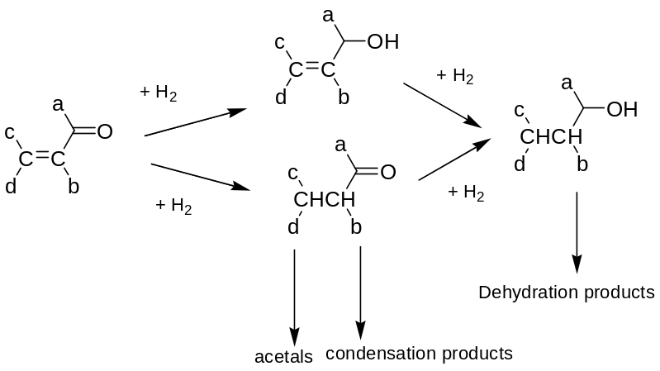
Scheme 13: Network of the hydrogenation of α, β-unsaturated carbonyl compounds
The hydrogenation of quinoline and its derivatives is of high industrial relevance, with applications in the petrochemical, fine chemical and pharmaceutical industries.^{[60-63]} Hydrogenation of quinoline to decahydroquinoline (DHQ) which was found to occur with two different reaction steps.^{[64]} The first one is the formation mainly of 1, 2, 3, 4-tetrahydroquinoline (py-THQ), while the second is the complete hydrogenation of py-THQ to DHQ. A novel highly dispersed Rh-containing catalyst (Rh, 2 wt %) was prepared by ion-exchange of a Mg/Al/Ce pillared montmorillonite and characterized by chemical analysis, X-ray diffraction analysis and H₂ chemisorption.
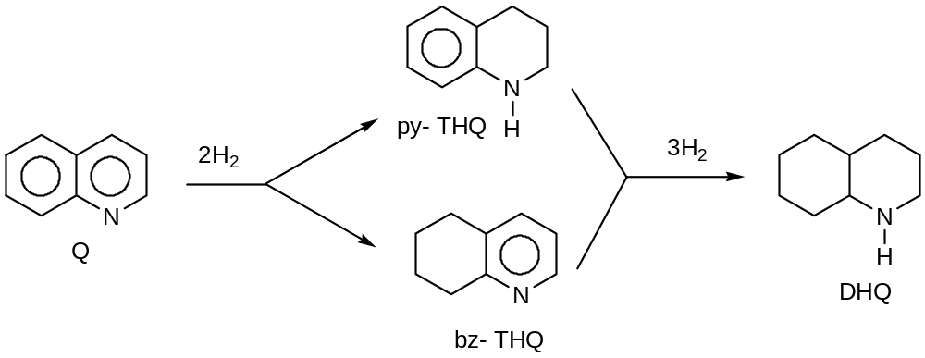
Scheme 14: Rh-containing pillared layered clay catalysed hydrogenation of quinoline
The catalytic behavior of this Rh-containing pillared layered clay (Rh–PILC) catalyst was investigated in the mild hydrogenation of quinoline (T = 373–473 K; PH2 = 2.0MPa) and compared with that of a commercial 5 wt% Rh on alumina (Rh–Al₂O₃) catalyst. At 373 K, both catalysts gave only partial hydrogenation to 1, 2, 3, 4-tetrahydroquinoline (py-THQ), although with a significantly lower conversion for Rh–PILC, attributable to its microporous structure and steric hindrance of quinoline (Scheme 14). However, when the temperature was increased to 473 K, Rh–PLC, unlike the commercial catalyst, was able to fully hydrogenate quinoline to decahydroquinoline, underlining the key role played by the metal particle size.^{[65]}
In the last two decades, pillared layered clays (PILCs) have been largely used as catalysts and/or supports for metal phases. Properties are complementary to those of zeolites, and can be modulated by carefully choosing the different parameters (pillaring agent, type of clay and particle size, pillaring procedure, thermal treatment), thus offering a very flexible way to design tailored catalysts.^{[32, 66]} Moreover, these materials are quite inexpensive, if compared to zeolites. An Al/Ce/Mg=50.0/1.0/1.0 pillared montmorillonite, with a high d₀₀₁ spacing and a bimodal pore distribution of micro- and mesopores, was used as support for noble metal pairs, to prepare the catalysts: 1.0 wt.% Pd/Pt=5.0 (CAT1) and 1.0 wt.% Pd/ Au=5.0 (CAT2). The evaluation of the surface acidity of the support by ammonia TPD shows that these materials have less and weaker acid sites than typical hydro treating catalysts (zeolites or SiO₂/Al₂O₃) and even activated Al-PILCs. Both catalysts show interesting performances in the hydrogenation of naphthalene at 6.0 MPa, associated with a good thiotolerance, checked feeding increasing amounts of DBT.^{[67]} Recently Aluminum pillared clay (Al-PILC) and platinum impregnated pillared clay (Pt/Al-PILC) were prepared, characterized and tested as catalysts in adipic ester hydrogenation. Results indicate that platinum species are partially occupying the inner porous network of the pillared clay, a solid with an amphoteric character, and these crystallites are small enough to occupy the solid inner micropores. Alumina and Al-PILC supports are active as catalyst, allowing an adipate conversion of 26.3% and 83.3% respectively, and the products distribution is very influenced by the solid surface acidity.^{[68]}

Friedel- Crafts acylation
Among the different applications of modified clays in catalysis, Laszlo et al. described their use in Friedel- Crafts acylation.^{[69-71]} The acid Fe-K10, obtained by exchanging K10 montmorillonite clay with Fe(III) ions, gave outstanding results in the acylation of mesitylene and para-xylene with benzoyl chloride or benzoic anhydride (arene / acylating agent ratio = 7) (98-100% yield) (Scheme 15).^{[72]} The catalyst is described as a material of low cost and low toxicity since the metal ions remain trapped in the double layer. In a comparative study on the acylation of mesitylene and anisole with benzoyl chloride promoted by Fe-K10, it was observed that mesitylene reacted faster when the reactions were carried out separately. However, when the two substrates were reacted jointly, competition favored anisole.
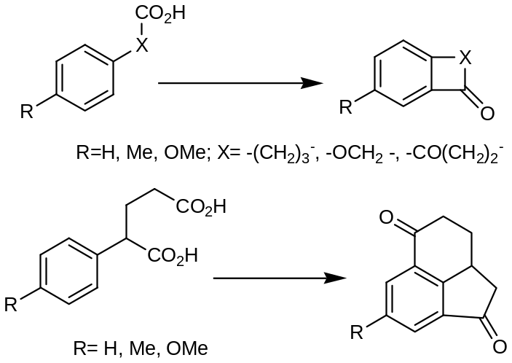
Scheme 15: Fe-K10 clay catalysed Friedel- Crafts acylation
A tentative explanation for this reversal activity could be based on the assumption that benzoylation of mesitylene and anisole follows two different mechanisms characterized by different levels of interaction of the catalyst surface with the aromatic substrate and the benzoyl cation, the actual electrophilic reagent. In particular, it must be taken into consideration that anisole interacts more strongly than mesitylene with the acid centers of the catalyst and, consequently, both its intrinsic higher reactivity toward the acyl cation can be dramatically lowered and the acid sites are less available for mesitylene acylation reaction. Cation-exchanged montmorillonites were utilized by Geneste et al. in the acylation of aromatics with carboxylic acids.^{[73]} As the clay acidity depends on the nature of the exchanged cation, a series of exchanged montmorillonites was studied in the model acylation of toluene with dodecanoic acid (toluene/dodecanoic acid ratio= 190). Best results were achieved with Al³⁺-exchanged montmorillonite (60% yield of the ortho-, meta-, and para-isomers).
Jha et al synthesized novel GaAlCl_{x}-grafted Mont.K-10 catalyst [with Cl/(Ga + Al) = 1]using liquid phase reaction of anhydrous GaCl₃ and AlCl₃ with the surface hydroxyl groups (with HCl evolution) of Mont.K-10 clay in dry CCl₄ under reflux. The catalyst showed high activity and stability in the Freidel-Crafts type benzylation and benzoylation (by benzyl chloride and benzoyl chloride, respectively) of benzene, naphthalene and substituted benzenes, even in the presence of moisture. It also showed good activity for the benzoylation of nitrobenzene (i.e. even in the presence of strong electron withdrawing group, like nitro group, attached to the benzene ring).^{[74]}

Transesterification reaction
β-Keto esters have considerable application in academic and industrial fields. The transesterification reaction of β-keto esters (Scheme 1) has been recognized as one of the most important processes in producing other β-keto esters.^{[75]} Although various catalysts have been already reported to catalyse the transesterification reaction, but due to environmental demand extended the use of clays for transesterification reaction.^{[76-78]} Modified clays, such as, kaolinite (montmorillonite K-10) ^{[79, 80]} was used as catalyst in transesterification. Ferreira et al studied transesterification reaction using different types of clay as a catalyst and he reported that smectite, atapulgite and vermiculite clays work as an active catalyst for transesterifications of β -keto esters and carbohydrate^{[81]}
Satsuma et al studied the catalytic activity of 14 types of metal ion-exchanged montmorillonite K-10 clay for the acetylation of cyclohexanol with acetic anhydride at room temperature.^{[82]} They reported that the activity of metal exchanged clays are depends on the increase in the charge/radius ratio of exchanged cation. The activity of Fe³⁺-mont was highest among all 14 metal exchanged catalyst and it was also higher than those of other Fe³⁺ catalysts like FeCl₃·6H₂O and FeCl₃/SiO₂, conventional acid catalysts, Al₂O₃ and HZSM₅, and homogeneous Lewis acid, Sc(OTf)₃. Fe³⁺⁻Mont exhibits a high turnover numbers (TON = 49,500) and can be recycled without a loss in activity. Prakash et al studied the acidic nature of Al³⁺ exchanged clay using DRIFTS (diffuse reflectance Fourier transform infrared spectra, using pyridine as probe molecule) and correlated the Brønsted acidity data obtained by FT-IR study for modified montmorillonite clay catalysts with the catalytic activity in the esterification reaction. Among the modified clay catalysts, Al³⁺-Mont and H⁺-Mont clay catalysts showed good activity and Al-PILC showed negligible activity in esterification. The inactivity of Al-PILC catalysts was attributed due to the absence of Brønsted acidity.^{[83]}

Multicomponent reaction
Multicomponent reactions (MCRs) are attracting the interest of organic chemists and other researchers working in medicinal chemistry, due to their significant potential for converting more than two adducts directly into respective products in quantitative yields in a one-pot reaction as compared to conventional strategies used in multi-step synthesis of various biologically active organic compounds.^{[84, 85]}
Since the inception of Green Chemistry, considerable interest has been drawn towards designing synthetic methodologies that involve the use of substances that possess little or no toxicity to human health and the environment. Thus, design of solvent-free reactions and use of alternative catalytic processes have received a lot of attention in recent times in the area of green synthesis. In continuation to towards developing green methodologies Maggi et al reported three-component reactions for the synthesis of substituted dihydropyrimidines , chromenes and tetrahydroquinolines in water and in the presence of a montmorillonite KSF clay (Scheme 16). The products, easily isolated from the reaction mixture by crystallisation, are obtained in high yield and selectivity and the catalyst can be recycled for many runs without losing its activity.^{[86]}
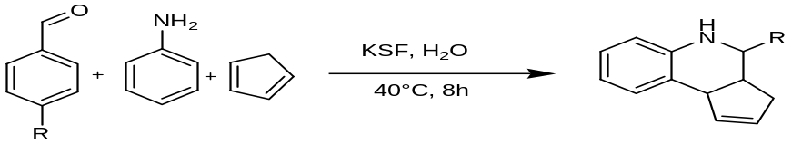
Scheme 16: KSF clay catalysed Multicomponent reaction
A novel protocol was developed by Singh et al for multicomponent one-pot synthesis of dihydropyrimidinones under solvent free conditions both by thermal and microwave heating using the Bronsted and Lewis acidity of Zr-PILC (Scheme 17).^{[87]}
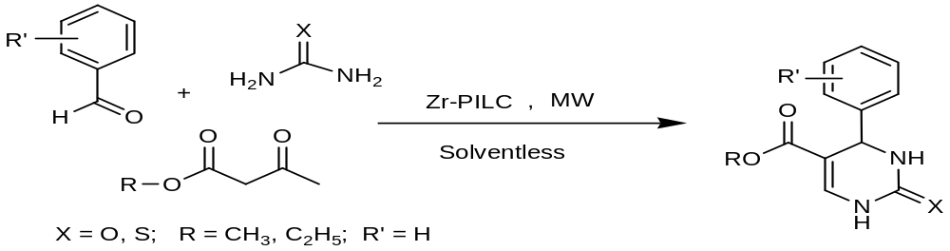
Scheme 17: Zr PILC catalysed one-pot synthesis of dihydropyrimidinones
By using same methodology they also synthesized the biologically active molecules nitractin and monastrol in 87 and 90%. Multicomponent domino cyclization-oxidative aromatization were studied by on a bifunctional Pd/C/K-10 catalyst: an environmentally benign approach toward the synthesis of pyridines.^{[88]}

Organoclay
Organically modified form of clay minerals called organoclay.^{[89-91]} There are several methods have been reported in order to modify the clay minerals surface of like adsorption, ion exchange with inorganic cations and organic cations, binding of inorganic and organic anions (mainly at the edges), grafting of organic compounds, reaction with acids, pillaring by different types of poly(hydroxo metal) cations, intraparticle and interparticle polymerization, dehydroxylation and calcination, delamination and reaggregation of smectites, and lyophilisation, ultrasound, and plasma.^{[89]}
Although hectorite, synthetic fluoro-hectorite, sepiollite, synthetic micas were use as a basic material for making organoclay but smectites, especially montmorillonite, have been widely used to prepare organoclays because of its excellent properties like high swelling behavior, cation exchange capacity, adsorption properties and large surface area.^{[89, 90, 92]}
The synthesis of orgnoclay mainly depends upon the displacement reaction. It occurs when the water molecule in the interlayer space of smectitet and vermiculite is displaced by an organic molecule. These organic molecules are neutral in nature and can make the complex with the interlayer cations. In smectite clay adsorption of neutral molecules takes place via different chemical interactions such as hydrogen bond, ion-dipole interaction, acid base reaction, chrge transfer and most important Van der Walls force. Although displacement reaction is the key factor in the synthesis of organoclay but cation exchange and grafting reactions also plays an important role in the organoclay synthesis.^{[89]} Like in case of cation exchange reaction interlayer cations can be easily exchanged by the organic cations in aqueous or organic solutions while in case of grafting reactions the formation of covalent bonds between reactive surface and organic species which makes the surface of clay minerals hydrophobic in nature. Only 2:1clay minerals attach with organic moiety using grafting reaction because they provide silanol and aluminol groups on the edge surface.^{[91, 93]}
Solid state reactions are also helpful to intercalate the organic moiety inside the clay minerals. This reaction proceeds via under solvent less condition which makes them more suitable for the environment and industries. Breawell et al used this method to intercalate quaternary akylammonium salt inside the clay.^{[90]} X-ray diffraction analysis confirmed the intercalation of quaternary akylammonium salt by increase in basal spacing in the range of 1.24-1.27 nm. Many solid-state reactions are based on the ion-dipole interaction where the polar part of organic molecule attached to the interlayer cations. The negative parts of molecules interact with cations on the surface and water molecules are displaced from interlayer cations. Many organoclays for polymer nanocomposites have been prepared by using this technique.^{[94]}
Lagaly et al studied the orientations of organic chains in clay minerals.^{[95]} They concluded that that arrangement of organic molecule between the interlayer spacing of clay mineral mainly depends on the chain length of organic molecules, layer charge of clay minerals (=layer charge equal to interlayer cation density = packing density of the alkylammonium ions ), geometry of the surface and the degree of exchange.^{[96-98]} As illustrated in Figure 5, the organic ions may lie flat on the silicate surface as a monolayer or bilayer, or depending on the packing density and the chain length an inclined paraffin-type structure, with the chains radiating away from the silicate surface can be formed. In the pseudotrimolecular layers, some chain ends are shifted above one another, so that the spacing is determined by the thickness of three alkyl chains.^{[95, 97, 99]}
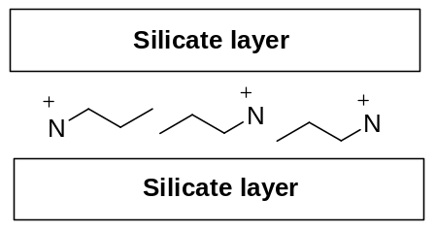  a | 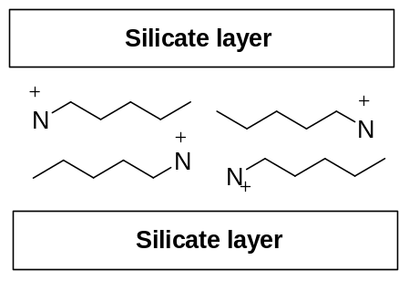  b
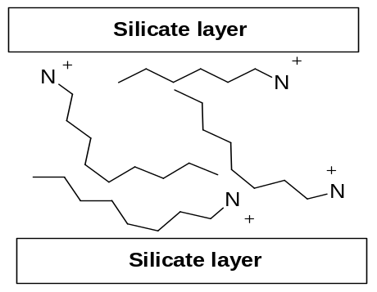  c | 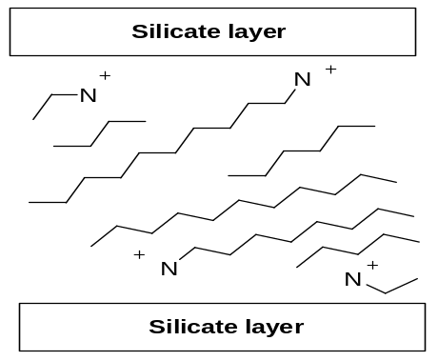  d

Figure 5: Orientations of alkylammonium ions in the galleries of layered silicates: (a) monolayer, (b) bilayers, (c) pseudotrimolecular layers, and (d) paraffin-type arrangements of alkylammonium ions with different tilting angles of the alkyl chains

These modified clays are also used in other applications such as adsorbents of organic pollutants in soil, water and air; rheological control agents; paints; cosmetics; refractory varnish; thixotropic fluids, etc.^{[89, 91, 96, 100, 101]} Organo-clays with organophilic clay surfaces by simple ion exchange reactions,^{[102]} accordingly, organoclays could be used as sorbents for contaminants in wastewater, which is contaminated by toxic organic chemicals. In the past, organoclays have been utilized in the manufacture of lubricants, paper, cosmetics, medicinal, and paints^{[103]} Recently, there has been much interests in using clays, particularly smectites, because of their high cation exchange capacity (CEC) and surface area, for removal of organic pollutants from water.^{[104]} Particularly, in the past 10 years, there has been much interests and advancements in the use of organoclays as sorbents to remediate organic contamination^{[105, 106]} Treatment of contaminated soils with organoclays to reduce leachable pentachlorophenol^{[107]} showed that the Hexadecyltrimethylammonium (HDTMA)-exchanged vermiculite, illite, and smectite clays were very effective sorbents for removing aromatic hydrocarbons from water. Bowman et al. discovered that HDTMA treatment of zeolites formed modified zeolites that effectively sorbed both nonionic organic contaminants (NOCs) and inorganic oxyanions such as chromate, selenate, and sulfates.^{[108]}

Basic Clays (anionic clays)
Designing and synthesis of anionic clays with properties that are the exact inverse of those of the cationic clays consist of a stacking of positively charged layers with anions intercalated in the interlayer region together with water molecules. The most well-known anionic clays are the hydrotalcite-like layered double hydroxides (LDHs).^{[109-113]} LDHs are derived from the structure of mineral brucite, Mg (OH)₂. Brucite consists of a hexagonal close-packing of hydroxyl ions in which alternate layers of octahedral sites are occupied by Mg²⁺ ions. This results in the stacking of charge-neutral hydroxide layers of the composition [Mg (OH)₂], held together by Waal’s interaction.^{[110, 111, 114]}
Such a structure throws open the possibility of performing interesting intercalation chemistry similar to that observed in the cationic clays. However, Mg (OH)₂ is not known to exhibit any interlayer chemistry. When a fraction, x, of the Mg²⁺ ions in brucite is substituted by trivalent cations such as Al³⁺, the resultant hydroxide layers having the composition [Mg_{1–x}Al_{x}(OH)₂]^{x+} acquire a positive charge and intercalate various anions, A^{n–}, in the interlayer region. This result in the expansion of the c-parameter from 4.8 Å seen in brucite to 7.6 Å observed in hydrotalcite (x = 0.25, A^{n–} = CO₃ ^{2–}) (Figure 6). Materials of this type exhibit anionic (hydroxyl ion) mobility, anion exchange and sorption properties in addition to surface basicity, making them attractive catalysts for base-catalysed reactions. Kamathn et al has reviewed ⁴⁰ many ways of making anionic clays.^{[110-113]}
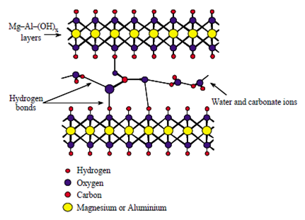
Figure 6: Basic structure of hydrotalcite clay
Layered double hydroxide (LDH) or hydrotalcites (HT) have been used for catalysis^{[109, 115]} and formation of bioactive nanocomposites and it is well reviewed many authers.They represent efficient basic catalyst system for epoxidation,^{[116-120]} cyanoethylation,^{[121-125]} nitroaldol reactions^{[126-128]} etc. Khan et al have studied the Knoevenagel condensation reaction^{[127]} as well as nitroaldol condensation reaction using hydrotalcite in ionic liquid.^{[127]} James et al have studied asymmetric epoxidation using sulfonato-salen-manganese(III)-pillared hydrotalcite catalysts of styrenes and cyclic alkenes.^{[129]} The hydrotalcite was used as a support for the palladium catalysts. The efficiency of various palladium salt (PdCl₂, Pd (AcO) ₂ and Na₂PdCl₄) as catalyst were tested in the Suzuki cross-coupling reaction (Scheme 18). The use of PdCl₂ supported on hydrotalcite as catalyst in the presence of potassium carbonate as base was found to provide the best results^{[130]}
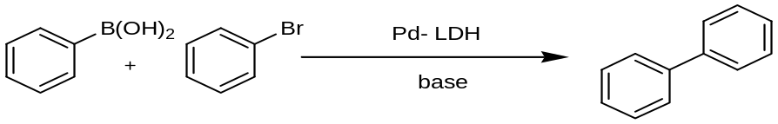
Scheme 18: Hydrotalcite supported palladium catalyst for Suzuki reaction
Ruiz et al studied the Suzuki cross-coupling reaction between bromobenzene and phenylboronic acid at room temperature in aqueous media containing K₂CO₃ as the base and solids consisting of Pd (II) supported on an Mg/Al hydrotalcite as catalysts. They also reported the use of sodium dodecylsulphate as surfactant which facilitate the dissolution of phenylboronic acid in water is required for the reaction to develop at room temperature.^{[131]} In the continuation of their work they also synthesized a catalyst consisting of a pyridine-Pd (II) complex immobilized on the surface of a layered double e hydroxide (LDH) to catalysed the Suzuki reaction. Which are highly active towards Suzuki reaction under very mild conditions (viz. a temperature of 55°C and atmospheric pressure); in fact, it provided conversion and selectivity which results surpassing those of existing heterogeneous phase catalysts and most homogeneous phase catalysts for the same purpose. ^{[132]} S. Sivasanker et al has carried out Heck reaction between aryl halides (X = Br, I) and olefins to give carbon–carbon coupled products using Palladium(II) containing hydrotalcite (Pd-HT) ^{[133]} (Scheme 19).
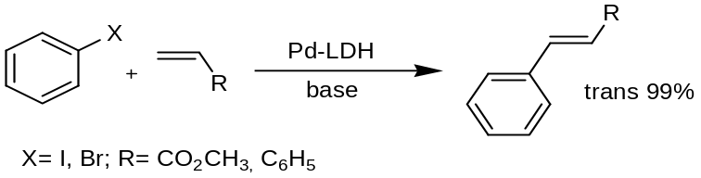
Scheme 19: Palladium (II) containing hydrotalcite catalysed heck reaction
The lamellae of LDHs are made up of infinite sheets of edge-sharing metal octahedra, where part of M(II) cations (e.g., Mg²⁺, Fe²⁺, Cu²⁺) are replaced by M(III) cations (e.g., Al³⁺, Fe³⁺, V³⁺).^{[114]} The interlayer distance depends on both the nature of anions and hydration state. Because of the large variety of anions that can be incorporated between the brucite-like layers, the high anionic exchange capacity of these materials, and the large surface area values, LDHs can be successfully used as matrices for tailoring specific organic-clay hybrid structures with new potential applications in pharmaceuticals or as new biocompatible materials.^{[134]} ^{[135]} Previous studies also suggested that the drugs-LDHs nano-hybrids could form the basis for developing a drug-release system. ^{[136]} Moreover, the incorporation of drugs between the metal metalhydroxide clay layers is able to isolate the molecules from the environment, and, thereby, to improve the long-term stability and storage of the drugs.
Nowadays, there is an increased interest to develop new biocompatible hybrid structures with tailored textural and adsorption–desorption properties for drugs-controlled target delivery. Additionally, the magnetic materials are preferred to the non-magnetic ones for bioengineering applications due to the ease of delivery onto the target. The recent studies have indicated interesting magnetic properties for novel drugs-anionic clay structures, strongly dependent on synthesis conditions, internal structure and the drug nature stability.^{[137]} Thus, the idea is to enhance the magnetic behavior of the LDHs-like derived nanocomposites for targeting drug delivery, but preserving their large surface area and specific mesoporous properties. Chiriac et al have succeeded preparing new layered partially substituted LDHs loaded with magnetic iron oxides or spinel structures.^{[138]} These structures were further used to develop new organic–inorganic composites, aspirin–hydrotalcite- like anionic clays, with large surface areas and interesting magnetic features. It has been shown that the magnetic behavior of the drug-clay structures as well as those of the magnetic loaded anionic clay matrices are strongly influenced by the preparation method and postsynthesis treatments. The preparation of layered double hydroxides–drugs nanocomposites with large surface area and interesting magnetic features open up new perspectives in using these structures to design new drug targeting systems, either by tailoring their macroscopic magnetic behavior or by choosing the proper drug for the specific biomedical applications. The work on the biocompatibility of these materials and their use in medical, biological or agricultural applications is in progress.

Conclusion
Clays (cationic or anionic) have attracted great attention the area of supported catalysis. Easy preparation steps, comfortable handling, wide substrate scope, isolation of product without contamination, reuse etc. make them more compatible for organic transformations. Not only metals but organic species also can intercalate in to the clays. Such types of organically modified clay are very useful as an adsorbent in petrochemical industries. Clays also used as support for drugs in the drug delivery system.

References
[1] W. E. Worrall, Clays: Their Nature, Origin, and General Properties, 1968.
[2] M. Samlley, Editor, Clay Swelling and Colloid Stability, 2006.
[3] F. Wypych, K. G. Satyanarayana, Editors, Clay Surfaces: Fundamentals and Applications. [In: Interface Sci. Technol.; 2004, 1], 2004.
[4] R. S. Varma, Tetrahedron 2002, 58, 1235.
[5] J. L. Sehgal, A. J. Sethi, P. N. Takkar, Bull., Indian Soc. Soil Sci. 1974, 9, 1.
[6] G. Pedro, Bull. Groupe Fr. Argiles 1967, 19, 69.
[7] G. N. White, J. B. Dixon, Soil Sci. Soc. Am. Book Ser. 2002, 7, 389.
[8] V. D. Shutov, A. V. Aleksandrova, S. A. Losievskaya, Sedimentology 1970, 15, 69.
[9] A. Meunier, B. Lanson, B. Velde, Clay Miner. 2004, 39, 317.
[10] H. Bergseth, Acta Agric. Scand. 1980, 30, 460.
[11] P. D'Arco, M. Causa, C. Roetti, B. Silvi, Phys. Rev. B: Condens. Matter 1993, 47, 3522.
[12] J. T. Kloprogge, S. Komarneni, J. E. Amonette, Clays Clay Miner. 1999, 47, 529.
[13] I. E. Odom, Philos. Trans. R. Soc. London, Ser. A 1984, 311, 391.
[14] M. K. Mohamed, A. G. I. Mitkees, Contribution of Clay, Silt and Organic Matter to the Potential Fertility of Egyptian Soils as Measured by their Cation Exchange Capacities, 1960.
[15] P. J. Loveland, I. G. Wood, A. H. Weir, Clay Miner. 1999, 34, 165.
[16] D. Laird, P. Fleming, Soil Sci. Soc. Am. Book Ser. 2008, 5, 485.
[17] F. Bergaya, G. Lagaly, M. Vayer, Dev. Clay Sci. 2006, 1, 979.
[18] K. A. Carrado, Handb. Layered Mater. 2004, 1.
[19] D. Siptak, Chem. Manuf. Cosmet. (3rd Ed.) 2002, 3, 857.
[20] A. Cornelis, P. Laszlo, M. W. Zettler, B. Das, K. V. N. S. Srinivas, e-EROS Encycl. Reagents Org. Synth. 2001, No pp given.
[21] K. G. Bhattacharyya, S. Sen Gupta, Adv. Colloid Interface Sci. 2008, 140, 114.
[22] P. Komadel, J. Madejova, J. Bujdak, Clays Clay Miner. 2005, 53, 313.
[23] H. G. Jeon, H. T. Jung, S. W. Lee, S. D. Hudson, Polym. Bull. (Berlin) 1998, 41, 107.
[24] C. C. Harvey, G. Lagaly, Dev. Clay Sci. 2006, 1, 501.
[25] S. Dasgupta, B. Torok, Org. Prep. Proced. Int. 2008, 40, 1.
[26] A. Vaccari, Appl. Clay Sci. 1999, 14, 161.
[27] K. Kaneda, Synlett 2007, 999.
[28] H. Palkova, J. Madejova, D. Righi, Clays Clay Miner. 2003, 51, 133.
[29] D. R. Brown, Geol. Carpathica--Clays 1994, 45.
[30] B. K. Banerjee, M. K. Sen, Bull., Indian Soc. Soil Sci. 1974, 9, 247.
[31] G. Poncelet, J. J. Fripiat, Handb. Heterog. Catal. (2nd Ed.) 2008, 1, 219.
[32] S. Maitra, S. Ray, N. Bandyopadhyay, Interceram 2006, 55, 12.
[33] F. Bergaya, A. Aouad, T. Mandalia, Dev. Clay Sci. 2006, 1, 393.
[34] N. K. Mitra, S. Maitra, Trans. Indian Ceram. Soc. 2001, 60, 121.
[35] A. Gil, L. M. Gandia, M. A. Vicente, Catal. Rev. - Sci. Eng. 2000, 42, 145.
[36] F. E. Kuehn, R. W. Fischer, W. A. Herrmann, T. Weskamp, Transition Met. Org. Synth. (2nd Ed.) 2004, 2, 427.
[37] A. Dhakshinamoorthy, K. Pitchumani, Tetrahedron 2006, 62, 9911.
[38] B. M. Choudary, A. D. Prasad, V. Swapna, V. L. K. Valli, V. Bhuma, Tetrahedron 1992, 48, 953.
[39] B. M. Choudary, A. Durgaprasad, V. L. K. Valli, Tetrahedron Lett. 1990, 31, 5785.
[40] J. G. Carriazo, E. Guelou, J. Barrault, J. M. Tatibouet, S. Moreno, Appl. Clay Sci. 2003, 22, 303.
[41] M. D. Nikalje, A. Sudalai, Tetrahedron 1999, 55, 5903.
[42] T. Nishimura, T. Onoue, K. Ohe, J.-i. Tateiwa, S. Uemura, Tetrahedron Lett. 1998, 39, 4359.
[43] D. E. Chavez, E. N. Jacobsen, Org. Synth. 2005, 82, No pp given.
[44] R. R. Schmidt, Acc. Chem. Res. 1986, 19, 250.
[45] J. M. Adams, Appl. Clay Sci. 1987, 2, 309.
[46] J. M. Fraile, J. I. Garcia, D. Gracia, J. A. Mayoral, T. Tarnai, F. Figueras, J. Mol. Catal. A: Chem. 1997, 121, 97.
[47] K. Chiba, T. Hirano, Y. Kitano, M. Tada, Chem. Commun. (Cambridge) 1999, 691.
[48] M. R. Dintzner, A. J. Little, M. Pacilli, D. J. Pileggi, Z. R. Osner, T. W. Lyons, Tetrahedron Lett. 2007, 48, 1577.
[49] T. Mitsudome, K. Nose, T. Mizugaki, K. Jitsukawa, K. Kaneda, Tetrahedron Lett. 2008, 49, 5464.
[50] R. K. Ramchandani, M. P. Vinod, R. D. Wakharkar, V. R. Choudhary, A. Sudalai, Chem. Commun. (Cambridge) 1997, 2071.
[51] R. S. Varma, K. P. Naicker, P. J. Liesen, Tetrahedron Lett. 1999, 40, 2075.
[52] E. Mas-Marza, A. M. Segarra, C. Claver, E. Peris, E. Fernandez, Tetrahedron Lett. 2003, 44, 6595.
[53] R. S. Varma, K. P. Naicker, Green Chem. 1999, 1, 247.
[54] M. Arai, S. L. Guo, M. Shirai, Y. Nishiyama, K. Torii, J. Catal. 1996, 161, 704.
[55] A. Mastalir, Z. Kiraly, G. Szollosi, M. Bartok, Appl. Catal., A 2001, 213, 133.
[56] S. Patai, Editor, The Chemistry of Functional Groups. Supplement A: The Chemistry of Double-Bonded Functional Groups, Vol. 2, Pt. 1, 1989.
[57] M. Neuenschwander, Chem. Double-Bonded Funct. Groups 1989, 2, 1131.
[58] S. Patai, Editor, The Chemistry of Functional Groups, Suppl. A, Pt. 2: The Chemistry of Double-Bonded Functional Groups, 1977.
[59] I. Kun, G. Szollosi, M. Bartok, J. Mol. Catal. A: Chem. 2001, 169, 235.
[60] S.-M. Lu, X.-W. Han, Y.-G. Zhou, J. Organomet. Chem. 2007, 692, 3065.
[61] A. Solladie-Cavallo, M. Roje, A. Baram, V. Sunjic, Tetrahedron Lett. 2003, 44, 8501.
[62] M. Campanati, A. Vaccari, O. Piccolo, J. Mol. Catal. A: Chem. 2002, 179, 287.
[63] Y. Miki, Y. Sugimoto, Appl. Catal., 1999, 180, 133.
[64] C. W. Curtis, D. R. Cahela, Energy Fuels 1989, 3, 168.
[65] M. Campanati, M. Casagrande, I. Fagiolino, M. Lenarda, L. Storaro, M. Battagliarin, A. Vaccari, J. Mol. Catal. A: Chem. 2002, 184, 267.
[66] G. Poncelet, J. J. Fripiat, Handb. Heterog. Catal. (2nd Ed.) FIELD Full Journal Title:Handbook of Heterogeneous Catalysis (2nd Edition) 2008, 1, 219.
[67] A. Louloudi, J. Michalopoulos, N. H. Gangas, N. Papayannakos, Appl. Catal., A 2003, 242, 41.
[68] F. C. A. Figueiredo, E. Jordao, W. A. Carvalho, Appl. Catal., A 2008, 351, 259.
[69] G. Sartori, R. Maggi, Chem. Rev. 2006, 106, 1077.
[70] R. V. Jasra, Prog. Catal. Res. 2005, 115.
[71] P. Metivier, Fine Chem. Heterog. Catal. 2001, 161.
[72] P. Laszlo, M. T. Montaufier, Tetrahedron Lett. 1991, 32, 1561.
[73] B. Chiche, A. Finiels, C. Gauthier, P. Geneste, J. Graille, D. Pioch, J. Mol. Catal. A: Chem. 1987, 42, 229.
[74] V. R. Choudhary, R. Jha, Catal. Commun. 2008, 9, 1101.
[75] A. P. Krapcho, ARKIVOC 2007, 54.
[76] E. Santaniello, S. Casati, P. Ciuffreda, Curr. Org. Chem. 2006, 10, 1095.
[77] J. Van Gerpen, G. Knothe, Biodiesel Handb. 2005, 26.
[78] D. R. Byrd, S. W. Matson, Mol. Microbiol. 1997, 25, 1011.
[79] D. E. Ponde, V. H. Deshpande, V. J. Bulbule, A. Sudalai, A. S. Gajare, J. Org. Chem. 1998, 63, 1058.
[80] H. Y. Chen, E. M. El-Malki, X. Wang, R. A. van Santen, W. M. H. Sachtler, J. Mol. Catal. A: Chem. 2000, 162, 159.
[81] F. C. da Silva, V. F. Ferreira, R. S. Rianelli, W. C. Perreira, Tetrahedron Lett. 2002, 43, 1165.
[82] K.-i. Shimizu, T. Higuchi, E. Takasugi, T. Hatamachi, T. Kodama, A. Satsuma, J. Mol. Catal. A: Chem. 2008, 284, 89.
[83] C. R. Reddy, Y. S. Bhat, G. Nagendrappa, B. S. Jai Prakash, Catal. Today 2009, 141, 157.
[84] B. Ganem, Acc. Chem. Res. 2009, 42, 463.
[85] L. A. Wessjohann, D. G. Rivera, O. E. Vercillo, Chem. Rev. (Washington, DC, U. S.) 2009, 109, 796.
[86] F. Bigi, S. Carloni, B. Frullanti, R. Maggi, G. Sartori, Tetrahedron Lett. 1999, 40, 3465.
[87] V. Singh, V. Sapehiyia, V. Srivastava, S. Kaur, Catal. Commun. 2006, 7, 571.
[88] O. De Paolis, J. Baffoe, S. M. Landge, B. Torok, Synthesis 2008, 3423.
[89] M. Jaber, J. Miehe-Brendle, Ordered Porous Solids 2009, 31.
[90] A. J. Patil, S. Mann, J. Mater. Chem. 2008, 18, 4605.
[91] E. Ruiz-Hitzky, A. van Meerbeek, Dev. Clay Sci. 2006, 1, 583.
[92] N. Sibold, C. Dufour, F. Gourbilleau, M.-N. Metzner, C. Lagreve, L. Le Pluart, P.-J. Madec, T.-N. Pham, Appl. Clay Sci. 2007, 38, 130.
[93] F. Bergaya, G. Lagaly, Dev. Clay Sci. 2006, 1, 1.
[94] D. Siptak, Chem. Manuf. Cosmet. (3rd Ed.) 2002, 3, 845.
[95] F. Bergaya, G. Lagaly, Appl. Clay Sci. 2001, 19, 1.
[96] K. A. Carrado, A. Decarreau, S. Petit, F. Bergaya, G. Lagaly, Dev. Clay Sci. 2006, 1, 115.
[97] G. Lagaly, S. Ziesmer, Adv. Colloid Interface Sci. 2003, 100-102, 105.
[98] S. Bertolino, G. Lagaly, Appl. Clay Sci. 2003, 24, 1.
[99] F. Bergaya, G. Lagaly, Editors, Special Issue: Surface Modification of Clay Minerals. (Selected Papers from the European Clay Conference (EUROCLAY '99), held in Krakow, Poland, 5-9 September 1999.) [In: Appl. Clay Sci., 2001; 19(1-6)], 2001.
[100] T. Takahashi, Y. Nagasaki, MML Ser. 2006, 7, 371.
[101] W. A. Reynolds, JCT CoatingsTech 2004, 1, 28.
[102] S. A. Boyd, M. M. Mortland, C. T. Chiou, Soil Sci. Soc. Am. J. 1988, 52, 652.
[103] M. M. Mortland, Advan. Agron. 1970, 22, 75.
[104] D. L. Sparks, Editor, Environmental Soil Chemistry, 1995.
[105] W. F. Jaynes, G. F. Vance, Soil Sci. Soc. Am. J. 1996, 60, 1742.
[106] H. J. Turin, R. S. Bowman, J. Environ. Qual. 1997, 26, 1282.
[107] J. Wagner, H. Chen, B. J. Brownawell, J. C. Westall, Environ. Sci. Technol. 1994, 28, 231.
[108] R. S. Bowman, G. M. Haggerty, R. G. Huddleston, D. Neel, M. M. Flynn, ACS Symp. Ser. 1995, 594, 54.
[109] J.-H. Choy, M. Park, Interface Sci. Technol. 2004, 1, 403.
[110] M. Rajamathi, G. S. Thomas, P. V. Kamath, Proc. - Indian Acad. Sci., Chem. Sci. 2001, 113, 671.
[111] M. Zikmund, K. Hrnciarova, Chem. Listy 1997, 91, 169.
[112] G. Alberti, U. Costantino, Compr. Supramol. Chem. 1996, 7, 1.
[113] F. Trifiro, A. Vaccari, Compr. Supramol. Chem. 1996, 7, 251.
[114] F. Cavani, F. Trifiro, A. Vaccari, Catal. Today 1991, 11, 173.
[115] D. Tichit, B. Coq, CATTECH FIELD 2003, 7, 206.
[116] E. Angelescu, O. D. Pavel, R. Birjega, M. Florea, R. Zavoianu, Appl. Catal., A 2008, 341, 50.
[117] M. D. Romero, J. A. Calles, M. A. Ocana, J. M. Gomez, Microporous Mesoporous Mater. 2008, 111, 243.
[118] S. P. V. Mahajanam, R. G. Buchheit, Corrosion (Houston, TX, U. S.) 2008, 64, 230.
[119] R. Maggi, C. Malmassari, C. Oro, R. Pela, G. Sartori, L. Soldi, Synthesis 2008, 53.
[120] D. Carriazo, S. Lima, C. Martin, M. Pillinger, A. A. Valente, V. Rives, J. Phys. Chem. Solids 2007, 68, 1872.
[121] E. Angelescu, O. D. Pavel, R. Zavoianu, R. Barjega, Rev. Roum. Chim. 2004, 49, 367.
[122] E. Angelescu, O. D. Pavel, M. Che, R. Birjega, G. Constentin, Catal. Commun. 2004, 5, 647.
[123] B. M. Choudary, M. Lakshmi Kantam, B. Kavita, Green Chem. 1999, 1, 289.
[124] P. S. Kumbhar, J. Sanchez-Valente, F. Figueras, Chem. Commun. 1998, 1091.
[125] K. Furuta, M. Kamezawa, M. Sato, (Tosoh Corp., Japan). Application: JP JP, 1990, p. 5 pp.
[126] A. Cwik, A. Fuchs, Z. Hell, J.-M. Clacens, Tetrahedron 2005, 61, 4015.
[127] F. A. Khan, J. Dash, R. Satapathy, S. K. Upadhyay, Tetrahedron Lett. 2004, 45, 3055.
[128] K. Akutu, H. Kabashima, T. Seki, H. Hattori, Appl. Catal., A 2003, 247, 65.
[129] S. Bhattacharjee, J. A. Anderson, Adv. Synth. Catal. 2006, 348, 151.
[130] R. S. Varma, K. P. Naicker, P. J. Liesen, Tetrahedron Lett. 1999, 40, 2075.
[131] M. Mora, C. Jimenez-Sanchidrian, J. R. Ruiz, J. Mol. Catal. A: Chem. 2008, 285, 79.
[132] C. Jimenez-Sanchidrian, M. Mora, J. R. Ruiz, Catal. Commun. 2006, 7, 1025.
[133] T. H. Bennur, A. Ramani, R. Bal, B. M. Chanda, S. Sivasanker, Catal. Commun. 2002, 3, 493.
[134] S.-Y. Kwak, W. M. Kriven, M. A. Wallig, J.-H. Choy, Biomaterials 2004, 25, 5995.
[135] S. Ohmori, Y. Ohno, T. Makino, T. Kashihara, Int. J. Pharm. 2004, 278, 459.
[136] M. Darder, M. Lopez-Blanco, P. Aranda, F. Leroux, E. Ruiz-Hitzky, Chem. Mater. 2005, 17, 1969.
[137] H. Zhang, K. Zou, H. Sun, X. Duan, J. Solid State Chem. 2005, 178, 3485.
[138] G. Carja, H. Chiriac, N. Lupu, J. Magn. Magn. Mater. 2007, 311, 26.

