Study of sulphonic acid functionalization of
Vulcan XC-72 carbon black support of Pt/Vulcan XC-72 catalyst for methanol electrooxidation

Sundar Chandravathanamª, B Kavithaª, Balasubramanian Viswanathan*^{b} & Y Yesu Thangamª,
ªDepartment of Chemistry, Jayaraj Annapackiam College for Women, (Autonomous), Periyakulam-625 601, Tamil Nadu, India.
^{b}National Centre for Catalysis Research, Indian Institute of Technology Madras, Chennai-600 036, Tamil Nadu, India.
Email: bvnathan@iitm.ac.in
Received 8 November 2011; Revised accepted

Sulphonic acid groups have been grafted onto the surface of Vulcan XC-72 carbon of the Pt/Vulcan XC-72 catalyst, to improve platinum utilization in methanol electrooxidation studies. The sulphonic acid modification has been carried out by reacting the Pt/Vulcan XC-72 catalyst with formaldehyde and sodium sulfite. The resultant sulphonated catalysts are characterized by x-ray diffraction, Fourier transform infrared spectroscopy and cyclic voltammetry. FT-IR spectra confirm the incorporation of the sulfonic acid group on the carbon black support of the catalyst. XRD shows better dispersion of the Pt nanoparticles upon sulphonic acid modification. The electrochemical measurement using cyclic voltammetry shows enhanced activity for methanol electrooxidation for the sulphonic acid modified catalyst as compared to the unmodified one.

Keywords: catalysts, sulphonated catalysts, electrooxidation, cyclic voltammetry, methanol oxidation, sulphonic acid, platinum

Direct methanol fuel cell (DMFC) is a promising candidate for future energy source because of convenient fuel feeding and easy operation at low temperature^{1, 2}. Among the liquid organic fuels, methanol has promising characteristics in terms of reactivity at low temperature, storage and handling. Compared to ethanol, methanol has the significant advantage of high selectivity to CO₂ formation in the electrochemical oxidation process³⁻⁵. Technological improvements in DMFCs are thus fuelled by perspectives on applications in portable, transportation and stationary systems, especially with regard to the remote and distributed generation of electrical energy^{6,7}. Despite these practical benefits, DMFCs are characterized by significantly low power density and lower efficiency than PEMFC operating with hydrogen because of the slow oxidation kinetics of methanol and methanol crossover from the anode to the cathode³⁻⁵.

Platinum is one of the best transition metals to be used in fuel cell technology^{8,9}. Platinum has high activity for methanol oxidation and has been used as anode electrocatalyst for many years. The slow dissociative adsorption (dehydrogenation) of methanol results in the formation of CO_{ad} species¹⁰, which poisons the Pt catalyst by blocking the surface. To date, efforts have been focused on the development of techniques to produce Pt catalyst with high surface area^{11, 12}. Supported Pt nanoparticles, have higher electrocatalytic activity is because of easier access to the catalytic surface as compared to the bulk metal or unsupported catalyst powder¹³. Carbon, as a support material has advantageous properties like high surface area, good electronic conductivity and lower catalyst agglomeration¹⁴. Vulcan-XC-72 is one of the well known electrocatalyst support^{8, 15}. It has been proved that the support materials in electrocatalyst also play an important role in the electrochemical performance of Pt¹⁶. Recently, new attempts have been focused on the modification of conducting supports towards increasing Pt utilization and enhancing the electrocatalytic properties.
In the carbon supported Pt catalyst, the three phases, viz., the electron conducting carbon support, the proton conducting ionomer and the catalyst nanoparticle need to co-exist (i.e. the three phase boundary) for the electrooxidation of H₂ and methanol to occur. Several studies have been focused on enhancing the catalyst utilization by extending the three phase boundaries¹⁷. Easton et al.¹⁸ and Xu et al.^{19, 20} have studied chemically attached sulphonated silanes and sulphonic acid or short chain sulphonic acid groups on to the surface of the carbon black supported platinum catalyst (Pt/C), and reported that the resulting sulphonated Pt/C catalyst not only showed much better performance than did the unsulphonated counterparts, but also less Nafion was required within the catalyst layers to achieve the best performance. Mizuhata et al.²¹ and Kuroki et al.¹⁷ proposed an electrode fabrication method based on the process of grafting polymerization of a proton conducting agent (acrylamide tertiary butyl and methyl sulphonic acid groups) onto the Pt/C catalysts prior to the conventional electrode fabrication process, a significant increase in the electrode activity was observed. Kim et al.²² functionalized the support of Pt/C catalysts with sulphonated polystyrene and the electrode with such catalyst showed 25 % improvement in performance as compared to the conventional electrodes with unsulphonated Pt/C catalyst.
Grafting of phenyl sulphonic acid on the Pt/C catalyst also shows better performance as seen from the studies of Selvarani et al.²³. The effects of sulphonation on the Pt/CNT catalysts were explored by Du et al.²⁴ and it was found that the electrodes with the Pt/CNT catalyst sulphonated by in situ radical polymerization of 4-styrenesulphonate showed much higher performance. Nano–sized Pt–Ru supported on

polyethylene dioxythiopene and polystyrene sulphonic acid was found to have higher mass activity than Pt-Ru /Vulcan XC-72 as seen from the studies of Tintula et al.^{25,26}. In the present study, the effect of sulphonic acid modification of the support on methanol electrooxidation was studied on Pt/Vulcan XC-72 catalyst. It is expected that the functionalization of the support can give rise better dispersion of the active metal and also improve on the stability of the electrode.

Experimental

The Pt loading of the Vulcan XC-72 carbon black support was carried out by impregnation method²⁷. The Vulcan XC-72 carbon black was impregnated with the required quantity (for 10 % Pt/Vulcan XC-72) of aqueous solution of 5 wt% hexachloroplatinic acid by stirring at 333-343 K and evaporated to dryness. Pt was reduced at 623 K for 4 h under hydrogen flow.

The grafting of sulphonic acid group on the carbon black support of the Pt/Vulcan XC-72 catalyst was carried out in two steps. In the first step the hydroxyl group was grafted on the carbon black support by the reaction of formaldehyde with the phenolic hydroxy group²⁷. Further reaction with sodium sulphite grafted the sodium salt of the sulphonic acid to the methylene of the hydroxymethyl group. Then, sulphonic acid group was regenerated by protonation with mineral acid. To the carbon supported platinum catalyst, distilled water, formaldehyde and sodium sulphite were added and refluxed at 383 K for 6 or 15 h. The resulting suspension was cooled to room temperature. Then it was washed with distilled water and protonated with 1 N HCl. It was further washed with distilled water and extracted with rota vapor to remove any sulphide by-product. Finally it was dried at 338 K in vacuum oven for 24 h²⁷.

XRD patterns of the Pt/C catalyst were recorded with a Rigaku miniflex (II) desktop X-ray diffractometer using a Cu-K_{α} (λ=1.5405 Ǻ) source, with Ni filter. The average crystallite sizes for the unsulfonated and sulfonated Pt/C catalyst were calculated from the line broadening of the diffraction peaks using Scherrer’s equation²⁸, d (nm) = 0.9λ/β_{1/2} cosθ, where d is the average particle size in nm, λ the wavelength of the X-ray, θ is the Bragg diffraction angle (high intensity reflections) in degrees and β_{1/2} is full width half maximum in radians. FT-IR spectra were recorded using Bruker FT-IR spectrophotometer in the form of KBr pellets.

The electrochemical measurements were carried out with BAS Epsilon Potentiostat. All the measurements were performed with electrodes made of glassy carbon (dia. = 0.3 cm, geomentrical surface area = 0.07 cm²) as the working electrode, Pt foil (1.5 cm²) as the counter electrode and Ag/AgCl as the reference electrode, at a scan rate of 25 mV/s. Methanol oxidation studies were carried out with 1 M methanol in 1 M sulphuric acid.
The working electrode was fabricated by dispersing 5 mg of the catalyst in 0.25 ml of distilled H₂O and ultrasonicated for 20 min. The dispersion (10 μl) was placed on 0.07 cm² of the glassy carbon electrode, and dried in air oven at 363 K for a few minutes. Then the resulting catalyst coating was covered with 5 μL of 5 wt% Nafion solution, followed by drying in air for a few minutes²⁷.
Results and discussion

FT-IR spectra for unsulfonated and methylsulphonic acid grafted (for 15 h reaction time) catalysts are shown Fig. 1. The signal at 1100 cm⁻¹ for the sulfonicacid modified catalyst is due to the S=O stretching vibration of the sulphonic acid group²⁷, which evidences the incorporation of the sulphonic acid group on the carbon black support of the catalyst. The sulphonic acid modification carried out for 6 h reaction time does not show the specific S=O stretching vibration (not included in the figure). Figure 2 shows the XRD patterns for unmodified and sulfonicacid modified Pt/Vulcan XC-72 catalysts. The crystallite sizes of the Pt nanoparticles in the modified and unmodified catalysts were determined with Debye-Scherrer equation using only the high intensity reflections in x ray diffraction patterns and are tabulated in Table 1. Comparison of the crystallite sizes values show a significant decrease in size upon sulphonic acid modification, similar to the studies reported earlier²⁷. This shows better dispersion of the Pt nanoparticles upon sulphonic acid modification.

The methanol oxidation current density with 1 M methanol in 1 M H₂SO₄ of the unmodified and sulfonic acid modified (for 15 h reaction time) catalysts is shown in Fig. 3. The sulphonic acid modification carried out for 6 h reaction time shows only very feeble methanol electrooxidation (not included in the figure). The methanol oxidation current density values are tabulated in Table 1. From the values it can be observed that the sulphonic acid modification shows an increase in methanol oxidation current density (1.8 times) as compared to the unsulfonated one as reported by Kuroki and Yamaguchi¹⁷ and Chandravathanam²⁷. The increase in methanol oxidation activity can be attributed to (i) the better dispersion of the Pt nanoparticles and (ii) the increased proton conductivity of the catalyst with the incorporation of sulphonic acid groups inside the Vulcan XC-72 support²⁷.

In order to improve the utilization of the Pt catalyst for methanol electrooxidation, in the present study the Pt/VulcanXC-72 catalyst was modified by the incorporation of sulphonic acid groups onto the carbon support of the catalyst. The reaction time of 6 h was found to be not sufficient for the sulfonic acid modification. The FT-IR spectrometric studies confirm the successful grafting of the sulphonic acid group on the carbon black support for 15 h reaction time. The decrease of Pt nanoparticle size upon sulphonic acid grafting on the carbon black support observed through XRD, is a measure of better dispersion of these particles upon sulphonic acid modification. The electrochemical measurement using cyclic voltammetry has shown enhanced activity for methanol electrooxidation for the sulphonic acid modified catalyst as compared to the unmodified one. The increase in activity can be attributed to better dispersion of the Pt nanopaticles and increased protonic conductivity due to the incorporation of sulphonic acid groups inside the Vulcan XC-72 support.

References
1. Hammett A, Catal Today, 38 (1997) 445.
2. Ren X, Wilson M S & Gottesfled S, J Electrochem Soc, 143 (1996) L12.
3. Wasmus S & Kuver A, J Electroanal Chemistry, 461 (1999) 14.
4. Arico A S, Srinivasan S & Antonucci V, Fuel cells, 1(2) (2001) 133 –161.
5. Lamy H, Leger J M & Srinivasan S, Direct Methanol Fuel Cells from a 20th Century Emerging Technology, in Modern Aspects of Electrochemistry, J O’ M.Bockris and B E Convey, (Plenum press, New York), 2000 p. 53.
6. Dillon R, Srinivasan S, Aricho A S & Antonucci V, J Power Sources, 127(1-2) (2004) 112.
7. Qian W, Wilkinson D P, Shen J, Wang H, & Zhang J, J Power Sources, 154(1) (2006) 202 – 213.
8. Gomez de la Fuente J L, Martinez Huerta M V, Rojas S, Terreros P, Fierro J L G & Pena M A, Catal Today, 116 (2006) 422.
9. Bolivar H, Izquierdo S, Tremont R & Cabrera C R, J Appl Electrochem,33 (2003) 1191.
10. Bagotzky V S, Vassiliev Y B, Khazova O A, J Electroanal Chem, 81 (1977) 229.
11. Wu G, Li L, Li J H & Xu B Q, J Power Sources, 155 (2006)118.
12. Dillon R, Srinivasan S, Arico A S & Antonucci V, J Power Sources, 127 (2007) 112.
13. Auer E, Freund A, Pietsch J & Tacke T, Appl Catal A, 173 (1998) 259.
14. Baturina O A, Aubuchon S R & Wynne K J Chem Mater, 18 (2006)1498.
15. Kim S & Park S J, Electrochim Acta, 52 (2007) 3013.
16. Carmo M, Paganin V A, Rosolen J M & Gonzalez E R, J Power Sources, 142 (2005) 169.
17. Kuroki H & Yamaguchi T, J Electrochem Soc, 153 (2006) A1417 – A1423.
18. Easton E B, Qi Z G, Kaufman A & Pickup P G, Electrochem Solid State. Lett, 4 (2001) A59.
19. Xu Z, Qi Z & Kaufman A, Electrochem Solid State Lett 6 (2003) A171.
20. Xu Z, Qi Z & Kaufman A, Electrochem Solid State Lett, 8 (2005) A313.
21. Mizuhata H, Nakao S & Yamaguchi T, J Power Sources, 138 (2004) 25.
22. Kim H, Lee W & Yoo D, Electrochim Acta, 52 (2007) 2620.
23. Selvarani G, Sahu A K, Choudhury N A, Sridhar P, Pitchumani S & Shukla A K, J Electrochimica Acta, 52 (2007) 4871.
24. Du C Y, Zhao T S & Liang Z X, J Power Sources, 176 (2008) 9.
25. Tintula K K, Pitchumani S, Shukla A K & Sridhar P, J Chem Sci,122(3) (2010) 381.
26. Tintula K.K., Pitchumani S, Sridhar P and Shukla A K, Bull mater Sci, vol.33(2) (2010) 157.
27. Chandravathanam S., Effect of pretreatment of Electrocatalyst for Direct methanol
Fuel cell applications, Ph.D Thesis, IITM, Chennai (2009).
28. Patterson A L, Phy Rev, 56 (1939) 978.

Fig 1)

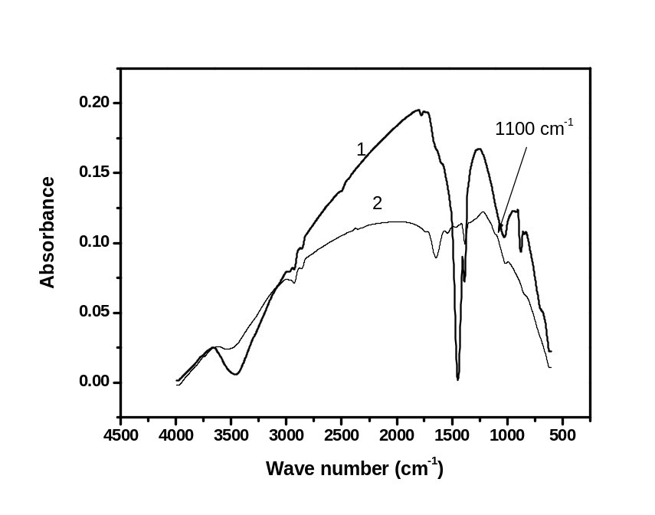

Fig 2)
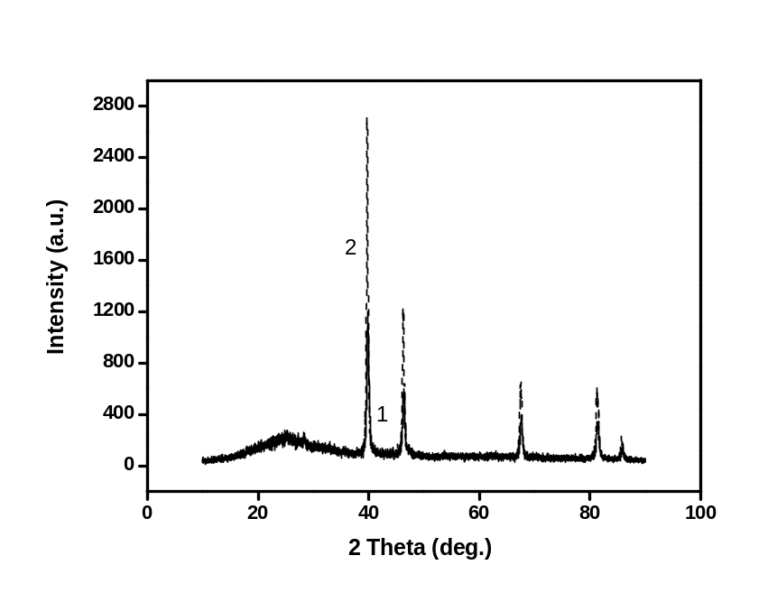

Fig 3)

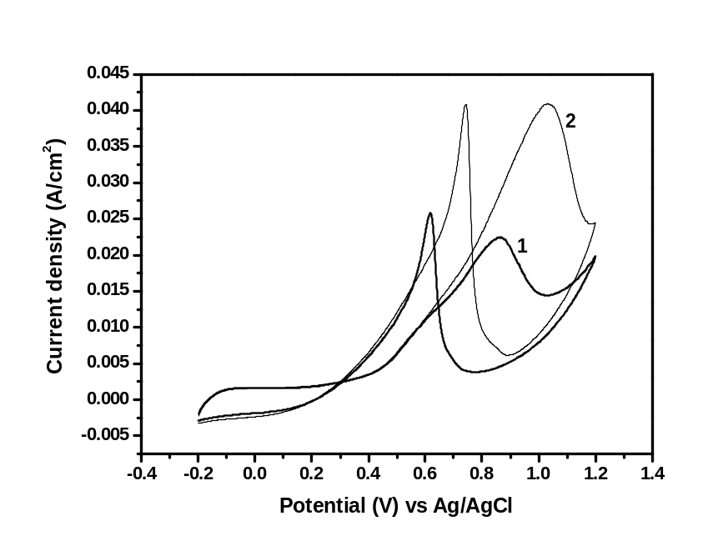

Figure Captions

- Fig. 1-FT-IR spectra of (1) unmodified and (2) methylsulfonic acid modified 10% Pt/Vulcan XC-72 catalyst [Arrow mark indicates the stretching vibration for S=O]
- Fig.2-XRD patterns of (1) unmodified and (2) methylsulfonic acid modified 10% Pt/Vulcan XC-72 catalyst
- Fig.3-Cyclic voltammograms of (1) unmodified and (2) methylsulfonic acid modified 10% Pt/Vulcan XC-72 catalysts with 1 M methanol in 1 M H₂SO₄ and at 25 mV/s

Table

Table 1-Average crystallite size and current density of unsulphonated and methylsulphonic acid modified 10% Pt/Vulcan XC-72 catalysts

S.No | Catalyst | Crystallite sizeª (nm) | Peak current density (mA/cm²)
1 | Unmodified 10 % Pt/Vulcan XC-72 | 24.4 | 22.5
2 | Methylsulphonic acid modified 10 % Pt/Vulcan XC-72 | 8.6 | 40.9
ª From XRD data by averaging the crystallite size obtained from Pt (220) and (311) planes

