Application of photocatalysis for mitigation of Carbon dioxide
V.Jeyalakshmi^{a,b}, K.Rajalakshmiª, R. Mahalakshmy^{b}, K.R Krishnamurthyª and B.Viswanathan^{a*}
ªNational Centre for Catalysis Research, Indian Institute of Tecchnology, Madaras,Chennai,600036,India
^{b}Department of Chemistry, Thiagarajar College, Madurai Kamaraj University, Madurai,
625021, India
Abstract
Photo catalytic reduction of carbon dioxide by water or artificial photosynthesis to yield hydrocarbons (methane and methanol etc. termed as solar fuels), is being studied extensively, with the twin objectives of developing it as one of the effective means of containing atmospheric CO₂ levels and evolving a sustainable alternative route for the production of fuels and chemicals. This short review attempts to bring out the origin, thermodynamic and kinetic features of the process, basic photo catalytic principles involved, rationale behind the choice of different catalysts and their performance, influence of process parameters and structural & photophysical properties of the catalyst on their performance, mechanistic pathways, surface transformations, challenges involved in the practical application of the process and future directions for research.

Key words: Photocatalysis, photocatalytic reduction, CO₂ mitigation, structure-photophysical properties- performance relationships.

*Author for correspondence

Full descriptive title
Application of photocatalysis for mitigation of Carbon dioxide
Short title
Photocatalytic reduction of CO₂
List of authors, affiliations & addresses
- Ms. V. Jeyalakshmi, Department of Chemistry, Thiagarajar College, Madurai Kamaraj University, Madurai,625021, India; E-mail: vmjeya@gmail.com
- Ms. K. Rajalakshmi, National Centre for Catalysis Research, Indian Institute of Technology, Madras, Chennai-600036,India; E-mail: raji2807@gmail.com
- Prof. R. Mahalakshmy, Department of Chemistry, Thiagarajar College, Madurai Kamaraj University, Madurai,625021, India; E-mail: mahabioin@yahoo.com
- Dr. K.R.Krishnamurthy, National Centre for Catalysis Research, Indian Institute of Technology, Madras, Chennai-600036,India; E-mail: krkm@iitm.ac.in
- Prof. B.Viswanathan, National Centre for Catalysis Research, Indian Institute of Technology, Madras, Chennai-600036,India; E-mail: bvnathan@iitm.ac.in

Application of photocatalysis for mitigation of
Carbon dioxide
1.0 Heterogeneous photo catalysis
The consistent study of photo catalytic reactions was initiated in 1970’s. The concept and the term “heterogeneous photo catalysis” were introduced and developed in Lyon to describe the partial oxidation of alkanes and olefinic hydrocarbons. Heterogeneous photocatalysis is defined as “a catalytic process during which one or more reaction steps occur by means of electron–hole pairs photo-generated on the surface of semiconducting materials illuminated by light of thsuitable energy” [1]. This pathway differs from the usual thermal reaction sequence and leads to reaction product selectivity patterns different from those of the thermal/catalyzed reactions.
1.1 Principles and elementary steps
Electronic structure of bulk solids is best described by the classical band theory of solids. The two outer most energy levels, called as valence band (VB) and conduction band (CB), hold the key for the solid state properties, conductivity and reactivity. The highest energy band in which all energy levels are occupied by electrons, is called VB whereas CB is the lowest energy band without electrons. The energy interval (ΔEg) between VB and CB is the “band gap”, which is the characteristic for the electronic structure of a semiconductor. According to the band gap model (Scheme.1) for photocatalysis proposed by Demeestere et al. [2], VB electrons are transferred to
Scheme.1
the CB when the semiconductor is illuminated with photons having an energy content equal to or higher than the band gap, creating electron–hole pairs (1). After migration to the semiconductor surface (2), electron–hole pairs may take part in redox reactions with adsorbed surface species having suitable redox potentials (3). From a thermodynamic point of view, VB holes can oxidize adsorbed species if the redox potential of the VB is more positive than that of the adsorbed species. Similarly, CB electrons can reduce adsorbed species if they have a more negative redox potential than the adsorbed species. In the absence of such reaction between the surface species, electron–hole pair recombination occurs with release of thermal energy and/or light (4).
The rate of a photo catalytic reaction especially depends on the type of the photo catalytic semi-conductor and on the light radiation that it used in its initiation [3]. Further factors that influence a photo catalytic reaction are:
- pH of the medium with which the semiconductor surface is in contact;
- concentration of the substrate influencing the reaction kinetics;
- stream of photons, as oversupply of light accelerates electron–hole recombination;
- temperature, higher temperatures cause frequent collision between the semiconductor
and the substrate
1.2 Applications of photocatalysis
A variety of applications ranging from anti fogging, anti-microbial and self-cleaning surfaces, through to water and air purification and solar induced hydrogen production, have been developed and many of these have made their way into commercial products. However, extensive research continues to further optimize this technology and to widen the spectrum of potential applications, especially in the following areas namely,
• Conversion of water to hydrogen gas by photo catalytic water splitting.
The ultimate target of water splitting is to provide clean H2 fuel through the utilization of solar
energy. Considerable efficiencies for solar water splitting have been reported for the photo-voltaic–photoelectrolytic device of Khaselev and Turner and for the photovoltaic–electrolytic device of Licht [4].
• Conversion of carbon dioxide into hydrocarbons using water.
In this case, photocatalysis provides a way to mimic photosynthesis by employing a semiconductor catalyst to absorb and utilize solar energy to convert CO₂into fuels and chemicals.
• The application of illuminated semiconductors for the remediation of contaminants has been used successfully for a wide variety of compounds such as alkanes, aliphatic alcohols, aliphatic carboxylic acids, alkenes, phenols, aromatic carboxylic acids, dyes, Polychlorinated biphenyl’s (PCB), simple aromatics, halogenated alkanes and alkenes, surfactants, and pesticides as well as for the reductivedeposition of heavy metals (e.g., Pt⁴⁺, Au³⁺, Rh³⁺, Cr^{(VI)}) from aqueous solution to surfaces [5].
Use of titanium dioxide in self-cleaning glass. Free radicals generated from TiO2 oxidize organic matter. Photocatalytic surfaces have the potential to act against a variety of air pollutants and
odours such as microbes, volatile organic carbons (VOC), formaldehyde, ammonia and inorganic gaseous substances such as nitrogen- or sulphur-oxides (NOX, SOX).
• Disinfection of water by titanium dioxide photo catalysis.
1.3 Components of a photo catalyst
In addition to the photo catalyst, whose primary function is to absorb light energy, several other components can be added to modify the photo catalyst system based on their application and improve overall efficiency [6].
1.3.1 Photocatalytic systems based on semiconductors and sensitizers
The large group of the light-sensitive materials that have been investigated as photocatalysts includes fairly wide-band semiconductors, mostly metal oxides that absorb UV light. One method of extending their light sensitivity to the visible region of the spectrum is the use of colored substances or sensitizers. In systems with sensitizers, the dye absorbs visible light and in the excited state injects electrons into the semiconductor (Scheme.2).
Scheme.2
1.3.2 Photo catalytic systems based on semiconductor hetero structures
In binary systems based on narrow-band and wide-band semiconductors the absorption of visible light by the narrow-band component leads to the injection of an electron into the wide-band semiconductor. The hole remains spatially separated from the electron and interacts with the electron donor (Scheme.3)
Scheme.3
1.3.3. Photo catalyst systems based on semiconductors doped with metal cations
The doping of wide-band semiconductors with transition metals creates local states in the forbidden band. The excitation of electrons from those local states by visible light leads to the transfer of electrons into the conduction band (Scheme.4).
Scheme.4
1.3.4. Photo catalyst systems based on semiconductors doped with anions
One of the approaches to narrowing of the forbidden band in oxide semiconductors was partial substitution of the oxygen by other elements (nitrogen, carbon, and sulfur), which makes it possible to realize “band design,” i.e., intentional shift of the valence band of the photocatalyst by virtue of the fact that the p orbitals of the impurity are situated in the valence band above the p orbitals of the oxygen, thereby narrowing the forbidden band without substantially moving the bottom of the conduction band (Scheme 5) .
Scheme.5

2.0 Mitigation of carbon dioxide
2.1 CO₂- The greenhouse gas
CO2 occurs in nature and serves as source of carbon for photosynthesis of plants and crops. It is present in atmosphere with a volumetric concentration of 0.039 % (389 parts per million by volume, ppmv).The emission of carbon dioxide into the atmosphere, released mainly by the burning of fossil fuels is one of the most serious problems with regard to the greenhouse effect [7]. All human activity generates about 37 billion tons (37 Gt) of CO2 emissions each year, with about 30 Gt of this coming from energy-related emissions.
Total emissions were less than 25 Gt twenty years ago, and under business as usual scenarios, emissions are projected to rise to over 50 Gt in twenty years from now. Burning 1 t of carbon in fossil fuels releases more than 3.5 t of carbon dioxide [8]. The Earth’s surface temperature has risen by approximately 0.6 K in the past century, with particularly significant warming trends and changes in weather conditions over the past two decades. Hence CO2 reduction and management (capture, storage and sequestration) has become a key issue in controlling global warming.
2.1 Approaches towards reduction in CO₂emission
The reduction in CO2 emissions can be achieved by three different approaches [9]:
(1) Efficient use of carbon-based energy sources,
(2) Use of alternative or carbon-free energy sources,
(3) Use of a post treatment carbon-capture technology.
While efforts on these approaches are being pursued globally, carbon capture technology has gained prominence. Carbon capture refers to the removal of CO2 from industrial flue gas by a gas separation process prior to release to the atmosphere. Captured and stored CO₂ could be recycled by conversion into useful chemicals and fuels.
2.2 Carbon Sequestration
Carbon sequestration (storage) is the isolation of carbon dioxide (CO2) from the earth's atmosphere. Sequestration can play a significant role in preventing continued CO2 buildup in the atmosphere.
Geological sequestration involves storing CO2 underground in rock formations that can retain large quantities of CO2 for long periods of time. The CO2 would be held in small pore spaces inherent in rocks. It is possible that CO2 injection into coal seams and mature oil fields could assist in the extraction of coal bed methane or oil that would otherwise be left in the ground, which could help offset the costs of sequestration.
2.3 Other carbon capture technologies
Currently, technologies such as gas absorption into chemical solvents, permeation through membranes, cryogenic distillation, and gas adsorption onto a solid sorbent are available for the capture of CO2 from flue gas. However these are not economically feasible [9].
2.4 CO₂conversion
CO2 is the most oxidized form of carbon, and therefore the only chemical transformation at normal energies that would be possible is to reduce it. A wide range of CO2 conversion techniques are under investigation [10] which include:
i.Chemical Reduction by metals which occur at relatively at high temperatures
(1)
(2)
(3)

ii. Thermo chemical Conversion
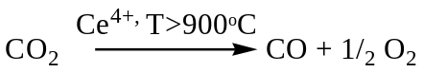 (4)
iii. Radio chemical Method
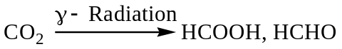 (5)
iv. Photo-Chemical Conversion
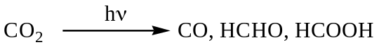 (6)
v. Bio-Chemical Conversion
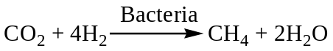 (7)
The bacteria Methanobacterium thermoautotrophicum can be immobilized in a fixed bed or on hollow fibres, and feeding stoichiometric ratios for the reaction attains 80% of the theoretical yield.
vi. Electro-Chemical Conversion
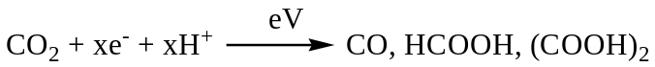 (8)
vii. Bio Photochemical conversion
The bio part of the energy consists in catalysis and information content of an enzyme
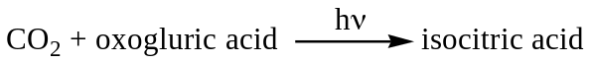 (9)
viii. Electro photochemical conversion
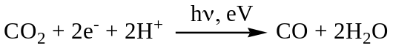 (10)
Conventional catalytic reduction of CO2 to chemicals (formic acid, methanol, methane etc.) with external hydrogen is feasible [11] but hydrogen has to be produced via renewable resources to render it viable and sustainable.
2.5 PhotocatalyticCO₂reduction
2.5.1The challenge
The CO2 reduction process is thermodynamically uphill as illustrated by its standard freeenergy of formation (ΔG° = -394.359 kJ/mol) [12]. Economical CO₂ fixation is possible only if renewable energy, such as solar energy, is used as the energy source. Equally difficult is the reduction / splitting of water to yield hydrogen and hence requires similar combination of activation steps. The most ideal and desirable process would then be the simultaneous reduction of CO2 and water to yield hydrocarbons, which essentially works out to artificial photosynthesis.
The utilization of solar energy via chemical storage can be achieved by photo catalytic or photo-electrochemical activation of light-sensitive catalytic surfaces. When comparing the two systems, photo catalytic system is simpler, easy to construct and operate. Photocatalytic process occurs via the direct absorption of photons with energy greater than or equal to the band gap of the photo catalyst to generate electron-hole pairs. The initial excitation and electron energy transfer to the adsorbed reactants on the photo catalyst make chemical reactions in the photo catalytic process possible.
2.5.2 Thermodynamics
There are two conceptual routes to produce renewable carbon containing fuels using solar
energy[11].
• Direct photoreduction of CO2 using water as a reductant
• Photolysis of water to generate hydrogen and further reaction of this hydrogen with carbon
dioxide forming C1–C2 fuels.
The first route, mimic of natural photosynthesis, is the preferred one. Water splitting and carbon dioxide reduction processes take place simultaneously on the photocatalyst/co-catalyst surface, and thermodynamic requirements of these processes put constraints on the band gap of the materials used as photocatalysts. Hydrogen formation from water involves a free energy change (ΔG0) of 237kJ/mol and an enthalpy change (ΔH0) of 285kJ/mol; the corresponding values for CO formation from CO2 are 257 and 283 kJ/mol at 25°C (1atm). Hence, the minimum energy required for water andCO2 splitting processes are, respectively, 1.229 and 1.33 eV (per photon). In theory, the band gap of a photocatalyst used for co-splitting of CO2 and water should be at least 1.33eV [12].One, two, four, six and eight electron reduction potentials (vs. NHE) for CO2 reduction and H2O oxidation at pH 7 and 25°C assuming unit activities for all gaseous and aqueous species are given below [12].
Reaction E⁰_{redox} . V vs NHE
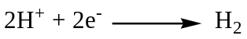 -0.41 (11)
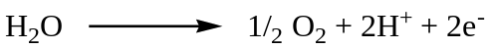 -0.82 (12)
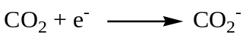 -1.9 (13)
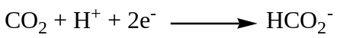 -0.49 (14)
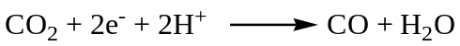 -0.53 (15)
-0.48 (16)
-0.38 (17)
-0.24 (18)
From the above scheme it is clear that CO2 photo reduction is not a single-step reaction. Upon transfer of one electron, the structure changes from linear to bent configuration, which results in irreversible reduction [10]. Additionally, single electron transfer to CO2 is highly endergonic, because of the negative adiabatic electron affinity of CO2.
The initial step in the photo catalytic reduction of CO2 is the generation of electron-hole pairs upon absorption of photons of energy greater than or equal to the band gap of the photo catalyst. The time scale of this electron-hole recombination is two to three orders of magnitude faster than other electron transfer processes. Therefore, any process which inhibits electron-hole recombination would greatly increase the efficiency and improve the rates of CO2 photo reduction. The kinetics of CO2 photo reduction are also dependent upon many other factors such as incident light intensity, fraction of the incident light absorbed by the photo catalyst, the specific surface area of the photo catalyst absorbing the light, etc.
2.5.3 Effect of wavelength, band gap, and light intensity
Semiconductors absorb light radiation with the threshold wavelength that provides sufficient photon energy to overcome the band gap between the valence and conduction bands. This threshold wavelength, required to promote the excited state, corresponds to the minimal photon energy and depends on the band-gap energy, e.g. for TiO2 anatase with band gap energy 3.2 eV it is 387.5 nm [2].
Irradiation using the light with shorter wavelength (254 nm) is significantly more effective for the CO2 reduction using TiO2 than that with the longer wavelength (350 nm) [13]. The wavelength (λ) of the light used influences the yield of products as observed by Fan et.al [14] in their studies on N (4% w/w) and Ni (6% w/w) co-doped titania for CO₂ reduction with water. For this catalyst formulation, Fan et al. [14] observed methanol yields of 482, 253.5 and 120.5 (all in μ moles/g-cat) with radiations of wavelength 254 nm, 365 nm and 400-780 nm respectively, thus clearly bringing out the influence of the wavelength of the light used.
Electrons in excited states are produced via electronic transitions the probability of which depends on the light intensity. At low light intensities, the CO2 reduction rate increases linearly with the light intensity, at mid-range light intensities, the photo catalytic reaction rate is dependent on the square root of light intensity; and at high light intensities the rate is independent of the light intensity [2].
Variations in the wavelength of radiation used can also affect the rate of formation of products as observed by Liu et al.[15] on BiVO₄ catalysts (Table.1). Monoclinic BiVO₄ is found to be more active than the tetragonal form. Selective formation of ethanol is observed using 300 W UV radiations, with and without UV cut-off filter. But with 36 W lamp, both alcohols are formed at nearly same rate, though overall conversion is much less.
Table.1
Large-band-gap semiconductors are the most suitable photo catalysts for CO2 reduction, because they provide sufficient negative and positive redox potentials in conduction bands and valence bands, respectively. The disadvantage of using wide band-gap semi-conductors is the requirement for high energy input [16].
Although many semiconductors have smaller band gaps and absorb in the visible range (e.g. CdS and Fe2O3 with band-gap values of 2.4 and 2.3 eV, respectively), just a few of them are catalytically active because the energy levels of either the conduction or valence bands are unsuitable for CO2 reduction and/or water oxidation (Fig.1). This limitation, together with poor
photo-corrosion stability of many semiconductors, limits significantly the number of potential photo catalytic materials for CO₂ photoreduction.
2.5.4 Photocatalytic reduction of CO₂ with water- State of the art
- On semiconducting oxides
Inoue et al.[17] were the first to report the photo catalytic reduction of CO2 in aqueous solutions to produce a mixture of formaldehyde, formic acid, methanol and methane using various wide-band-gap semiconductors such as tungsten trioxide (WO3), titanium dioxide (TiO2), zinc oxide (ZnO), cadmium sulfide (CdS), gallium phosphide (GaP), and silicon carbide (SiC). These semiconductors were activated by both xenon and mercury lamp irradiation. The formaldehyde and methyl alcohol yields were the highest in the presence of SiC, a behavior attributed to the relative position of the SiC conduction band with respect to the HCHO/H2CO3 redox potential. The SiC conduction band edge lies at a higher position (more negative) than the HCHO/ H2CO3 redox potential, which is believed to be responsible for the high rates of product formation. The absence of methyl alcohol when WO3 was used as catalyst, with a conduction band at a position lower thanthe HCHO/H2CO3 redox potential, further indicates the influence of band-edge positions on CO2 reduction (Fig.1).
Figure.1
Investigations related to the photosynthesis reaction of CO2 with water vapor to form CH₄ over metal-loaded SrTiO3 have also been conducted. Due to its higher conduction band edge position compared to the redox potential of CH3OH/H2CO3, strontium titanate could effectively reduce carbon dioxide dissolved in an aqueous electrolyte [18,19]. Halmann et al. [18] studied the effect of doping transition and noble metals such as Ru,V, Cr on TiO2. He found that the production rate of organic compounds such as formic acid, formaldehyde and methanol increased when TiO2 was doped with RuO2.
- Titania and titania loaded with metals/oxides as co-catalysts
Anpo et al.[7] studied the photo catalytic reduction of CO2 with H2O on various titanium oxide catalysts. The anatase-type TiO2 catalyst with large band gap and numerous surface-OH groups showed high efficiency for the formation of methane. The yields of the photo catalytic reactions depended strongly on the kind of catalyst, the ratio of CO2 to H2O and the reaction temperature. The best mole ratio of H2O/CO2 for the conversion of carbon dioxide was observed [7] to be 5. (Fig.2)
Figure.2
Addition of Pt to the TiO2 led to increased methane yield compared to methanol formation. Anpo et al.[7,20] have studied in detail the use of highly dispersed titanium dioxide on glass for the photo catalytic reduction of carbon dioxide. From the direct detection of intermediate species using various spectroscopic techniques, they proposed that methane formation resulted from the reaction between surface carbon radicals and atomic hydrogen (Scheme.6).
Scheme.6
The use of Cu as a co-catalyst was reported by Adachi et al [21] in which Cu-loaded TiO2 powder was suspended in a CO2 pressurized solution at ambient temperature, with methane and ethylene produced under Xe lamp illumination. Tseng et al [22] also studied the effect of copper loading on titania. The methanol yield of 2.0 wt.% Cu/TiO2 was 118 μmol/g following 6 h of UV illumination. The yield was much higher than those of sol–gel TiO2 and Degussa P25. The redistribution of the electric charge and the Schottky barrier of Cu and TiO2 facilitates electron trapping via supported Cu. The photocatalytic efficiency of Cu/TiO2 was markedly increased due to the lowering the re-combination probability for hole–electron pairs. The highest quantum and energy efficiencies achieved were 10 and 2.5%, respectively. Slamet et al.[23] suggested that CuO may be the most active dopant compared to the other copper species. Because Cu₂O has the highest positive redox potential value of Cu⁺, Cu₂O dopant should effectively act as an electron trapper to prohibit electron–hole recombination. However, owing to the relatively strong interaction between TiO2 and the dopant particle implanted in the vacant sites of TiO2, the dopant with more positive redox potential exceedingly catches electron from conduction band edge. Consequently the dopant-trapped electrons are more difficult to be transformed to the adsorbed species on catalyst surface and hence it may play a role as a center of electron–hole recombination.
Titania per se is active for photo catalytic reduction of CO2 with H2O, but the rates are extremely low since its conduction band edge is not suitable for water and CO2 reduction, though it can
readily oxidize water [24]. Promotion with co-catalysts like Pt [25], Ru [26], Rh [27], Ni [14] and Ag [28] vastly enhances the rate in several ways, like, charge separation, retarding re-combination and trapping of charge carriers, besides activation of CO2 and water reduction and facilitating further surface transformations leading to hydrocarbon products ( Fig.3 & 4).
Figure.3
Figure.4
Effects of bimetallics on TiO2 were also studied. Luo et al. [29] studied the CO2 reduction on Copper and Cerium Co-Doped Titanium dioxide. Photo catalytic copper and cerium co-doped titanium dioxide were prepared via the equivalent-volume incipient wetness impregnation method. The methanol yield could reach up to180.3 μmol/g-cat rapidly. Ce atoms activated H2O and CO2 molecules, while Cu atoms act as the channel of photoelectrons in real time and prevent the recombination of electrons and holes.
A significant breakthrough in the photocatalytic reduction of gas phase CO2 by solar radiation has recently been achieved by Varghese and co-workers [24], using nitrogen doped TiO2 nanotube arrays co-catalyzed with copper and/or Pt nanoparticles, in which CO₂ and water vapor was reduced to methane and other hydrocarbons under natural sunlight. The yield of methane was reported to be 111 ppm cm⁻²hr⁻¹(160μL/g-h) with quantum efficiency of 0.74% (Fig.5).The high rate of CO₂ conversion is due to the high surface area and nanoscale wall thickness of the
Figure.5
the nanotubes, enabling the surface species to readily receive both charge carriers generated near the surface due to the wave function overlap and those generated deep inside the wall via diffusion.
- Titanates with layered structure
Guan et al [30] studied the reduction of CO2 with water over a hybrid catalyst, in which a Pt-loaded K2Ti6O13 photo catalyst was combined with a Fe-based catalyst supported on a dealuminated Y-type zeolite (Fe-Cu-K/DAY). In this reaction system, Pt/K2Ti6O13 catalyst decomposes water to produce H2 and the Fe-Cu-K/DAY catalyst reduces CO2 with the resulting H2 into organic compounds. When the reaction temperature is increased from room temperature to 600K by concentrating the solar irradiation, the product yield of hydrogen increased from 13.7μmol/g-h to 20.5μmol/g-h. Also additionally, formic acid, methanol and ethanol were obtained. Guan et al [31] also reported the use of Pt-loaded K2Ti6O13 photo catalyst combined with a CO₂ hydrogenation catalyst Cu/ZnO. When the composite catalyst was used under concentrated sunlight, CH3OH was successfully formed in addition to the above products. Guan et al. [32] also investigated reduction of CO2 over zero-valent Fe⁰ and Fe⁰–basedcomposites in an aqueous solution at room temperature. It was found that H2 can be effectively evolved from water over zero-valent Fe⁰ in the presence of gaseous CO2 together with a small amount of hydrocarbons. When the Fe⁰ was combined with Cu, K and Al components, hydrocarbons such as CH4 and C3H8 and alcohols such as CH3OHand C2H5OH were also effectively produced. The XPS, XRD and photoemission yield measurements revealed that the Fe⁰ surface as well as the bulk was oxidized to Fe3O4 and other possible oxides during the reaction. This corrosion process is promoted by the dissolution of CO2 in water and the resultant protons oxidize Fe⁰ to evolve H2. Moreover, the evolved H2 serves as the reactant for the CO2 hydrogenation on the active site of Fe⁰, especially for the Fe⁰–K–Al and Fe⁰–Cu–K–Al composites.
- Influence of titania particle size, shape and morphology
Kaneco et al [33] studied the CO2 photoreduction using TiO2 powders in liquid CO2 medium. Carbon dioxide has limited solubility in water. Also reduction of CO2 is competitive with hydrogen formation via water. To overcome this disadvantage liquid CO2 system has been explored. The protonation reaction was performed using water after the end of illumination. The main reduction product was exclusively formic acid. Tan et al. [34] studied the photo catalytic reduction of carbon dioxide using TiO₂pellets. Pellet increased the contact areas and adsorption capacity. Their yield was significant when compared to thin film coating technique.
Koci et al [35] studied the effect of TiO2 particle size on photo catalytic reduction of carbon dioxide. As the particle size decreased, higher yields of methanol and methane over the TiO2 nano particles under the illumination of light were obtained. The optimum particle size corresponding to the highest yields of both products was 14 nm (Fig.6). For particles with crystal
Figure.6
sizes smaller than 14 nm, conversions dropped due to a combination of electronic (increase in recombination rates) and optical properties. The observed optimum particle size was a result of competing effects of specific surface area, charge–carrier dynamics and light absorption efficiency.
- Titania dispersed on different meso/nano porous & macrocyclic matrices
Ulagappan et.al [36] used Ti-silicalite molecular sieves as a catalyst for 266 nm UV laser radiation induced reduction of CO2 and H2O gas mixtures, obtaining HCOOH, CO and HCOOCH3. Origin of the products was studied by IR spectroscopy, indicating that CO originated from the secondary photolysis of HCOOH, while HCOOCH3 was the result of spontaneous Tishchenko reaction of CH2=O.
Photo catalysts prepared within the zeolite cavity and frame-work have a unique local structure and high selectivity in photo reduction. The titanium oxide species embedded within the zeolite framework have been found to exist as isolated tetrahedral titanium oxide species. These Ti-containing zeolite catalysts exhibited high photo catalytic efficiency and selectivity for the formation of methanol. Anpo et al.[37] carried out the CO2 photo reduction using TiO₂ in well-dispersed isolated state in Y-zeolite cavities in tetrahedral co-ordination and observed high selectivity form ethanol formation, while aggregates of titania in octahedral state on zeolites and bulk TiO₂ resulted in methane formation. Surface structure/surface co-ordination of titania (determined by EXAFS) has profound influence on the selectivity CO₂ photoreduction to methanol as shown in Figs.7 & 8. Ti-MCM-48 mesoporous zeolite with large pore and three dimensional channels exhibited higher activity and selectivity for methanol formation compared to Ti-MCM-41 (Fig.9) with one dimensional pore structure [38,39].
Figure.7
Figure.8
Macrocyclic ligands like phthalocyanins (Pc) and porphyrins (Pr) are good candidates for sensitization of titania because of their high absorption coefficient in the solar spectrum, especially in visible region and good chemical stability. Liu et al [40] reported photo catalytic reduction of carbon dioxide using sol–gel derived titania-supported CoPc catalysts. In-situ synthesis route results in the formation of isolated CoPc species (within the confined space of mesoporous titania), which effectively absorb visible light enabling ultrafast injection of electrons from the excited state into the conduction band of the titania support, thus helping charge carrier separation and increase photo-conversion efficiency [40]. Since the reported band gap for TiO₂ is 3.22 eV.Vs.2.14eV for CoPc, such a sensitization process is highly feasible. CO₂ photoreduction data presented in Table.2 show that in-situ CoPc/TiO₂ catalyst is more active than a simple mechanical mixture of CoPc and TiO₂ indicating a co-operative effect between dispersed CoPc and titania surface for the effective transfer of photo-generated electrons.
Table.2
Xia et al [41] studied the reduction of CO2 with H2O using multi-walled carbon nanotube supported [MWCNT] TiO2.The catalysts were prepared by both sol gel and hydrothermal method. Using the sol–gel method, the MWCNTs were coated with anatase TiO2 nanoparticles, and by the hydrothermal method, rutile TiO2 nanorods were uniformly deposited on the MWCNTs. The composite catalysts prepared by the sol–gel method resulted mainly in the formation of C2H5OH, while HCOOH is found to be the major product on the sample prepared by the hydrothermal method. It is likely that the preparation methods adopted may expose surface titania in different co-ordination/ environment, that facilitate surface transformations via different pathways, leading to changes in product distribution/selectivity [42].
- CO₂ photoreduction using external hydrogen
Many researchers have studied the photocatalytic reduction of CO2 using external hydrogen. Lo et al [43] studied the photo reduction of carbon dioxide with H2 and H2O over TiO2 and ZrO2 in a circulated photo catalytic reactor. Experimental results indicated that the highest yield for the photo reduction of CO2 was obtained using TiO2 with H2+H2O and ZrO2 with H2. Photo reduction of CO2 over TiO2 with H2+H2O formed CH4, CO, and C2H6 with the yield of 8.21, 0.28, and 0.20 m.mol/g, respectively, while the photo reduction of CO2 over ZrO2 with H2 formed CO at a yield of 1.24 m.mol/g. The detected reaction products supported the proposition of two reaction pathways for the photo reduction of CO2 over TiO2 and ZrO2 with H2 and H2O, respectively. A one-site Langmuir–Hinshelwood (L–H) kinetic model was applied to simulate the photo reduction rate of CO2.
Tsuneok et al [44] performed this over MgO, CaO, ZrO2, Ga2O3, and Al2O3. Ga2O3 exhibited the highest photo catalytic activity in this process, and CO gas was selectively generated at room temperature and atmospheric pressure. The amount of CO gas evolved depended not only on the amount of CO2 adsorbed but also on the amount of H₂ adsorbed on Ga2O3 (Scheme.7). The
Scheme.7
chemisorbed CO2 species involved in the photo catalytic reduction of CO2 over Ga2O3 was not the bi-dentate bicarbonate species but the mono-dentate bicarbonate species. The dissociatively adsorbed hydrogen on Ga2O3 reduced the mono-dentate bicarbonate to the bi-dentate formate under photo irradiation (Fig.9). The bi-dentate formate, which was an intermediate in the photocatalytic reduction, decomposed to CO. Langmuir-Hinshelwood-type mechanism is
Figure.9
proposed for photo catalytic reduction of CO2 over Ga2O3, which is not the case for ZrO2 or MgO.
Teramura et al [45] carried out the photocatalytic reduction of CO2 using H2 as reductant over ATaO3 photocatalysts [A = Li, Na, K]. Only CO gas was generated overall samples under photo irradiation. The photocatalytic activity was higher in the order corresponding to LiTaO3 > NaTaO3 > KTaO3 (Fig.10). The order of the photo catalytic activities was consistent with that of
Figure.10
the Eg [band gap] values. The amount of evolved CO gas almost strongly depends on the amount of chemisorbed CO2 in the case of ATaO3 [A =Li, Na, K]. In addition, the photo catalytic activity increased with increasing the calcination temperature of LiTaO3. This means that a smooth charge separation in LiTaO3 photo catalyst and chemisorption of CO2 on the surface contribute to effective reduction of CO2 in the presence of H2.
- CO₂ photoreduction with other reductants
Some researchers have attempted to replace water with other reductants. This provides a high reaction yield and high selectivity to desired products by changing the mechanism. Liu et al. [46] conducted an experiment with CdS in various solvents including water, methanol, ethanol, and 1-propanol with dielectric constants of 80, 33, 24.3, and 20.1, respectively. The results indicated that, if low-dielectric constant solvents or low-polarity solvents are used, CO2 ⁻anion radicals can be strongly adsorbed on the surface through the carbon atom of another CO2⁻ anion radical pre-sorbed on surface Cd sites because these radicals are not completely solvated by low-polarity solvents. Here, CO is produced as the major reduction product of CO2. If a high-dielectric-constant solvent is used (e.g., water), the CO2⁻ anion radicals can be greatly stabilized by the solvent, resulting in weak interactions with the photo catalyst surface. Subsequently, the carbon atom of the radical tends to react with a proton to produce formic acid. Dey [47] showed that photo-catalytic reduction of CO2 using TiO2 suspension in aqueous solutions containing 2-propanol as a hole scavenger leads to the formation of methane.
- Influence of type of photoreactors and reaction media
Koci et al [48] studied the influence of reactor geometry on photoreduction of carbon dioxide using two annular batch reactors. The dependence of products yields on the reactor diameter and on the volume of the liquid phase confirmed the fact that the requirement of perfect mixing is difficult to fulfill in the annular configuration of the reactor. The highest yields of the photo catalytic reduction were achieved in a configuration where the lamp just touches the surface of the liquid in the reactor and the configuration of the reactor was not annular.
Wu et.al [49] applied an optical fibre reactor to the photo reduction of CO2 with H2O using TiO2, Cu/TiO2, Ag/TiO2, Cu–Fe/TiO2–SiO2 and dye-sensitized Cu–Fe/P25 coated on optical fibers. Compared with a traditional packed-bed reactor, an optical fiber provides a medium to transmit
light uniformly throughout a reactor (Table.3). In addition, a higher processing capacity is
Table.3
possible because the photo catalyst can be dispersed on the optical fibers with large surface area in a given reactor volume.
When CO2 present in the atmosphere dissolves in water it is mostly present in the form of carbonate. Many authors have studied photo catalytic reduction of carbonate to form various chemicals. Ku et al [50] studied the photo catalytic reduction of carbonate in aqueous solution by the UV/TiO2 process. The photo catalytic reduction of carbonate proceeded faster in acidic solutions than in alkaline solutions. The main products of the photo catalytic reduction of carbonate by the UV/TiO2 reduction process were found to be methanol and methane. A Langmuir–Hinshelwood type kinetic equation was developed for modeling the photo catalytic reduction of carbonate.
Sayama et al [51] investigated the effect of carbonate salt addition on the photo catalytic decomposition of liquid water over Pt–TiO2 catalyst. It has been found that an addition of carbonate salts to Pt-loaded suspensions led to highly efficient stoichiometric photo- catalytic decomposition of liquid water into H2 and O2. Neither the pH nor cation directly contributes to the water splitting .The presence of a high concentration of carbonate ions is essential for the catalytic photodecomposition of water. The carbonate ion affects both the Pt particles and the TiO2 surface. The Pt was covered with some titanium hydroxide compounds and therefore, the rate of the back reaction (H2O formation from H2 and O2) on the Pt was suppressed effectively in the presence of carbonate ions. On the other hand, the TiO2 surface was readily covered with several types of carbonate species. It is considered that these carbonate species aid desorption of O2 from the TiO2 surface.
- Catalyst systems other than TiO2
Watanabe et al. [52] studied the photosynthesis of methanol and methane from CO2 and H2O molecules on a ZnO surface. The photochemical synthesis of methanol and methane from CO2 and H2O molecules was observed at 5°C by irradiating ZnO powder with visible light under high pressures of 25 to 35 kg/cm2 of CO2, gas. The best conversion efficiency was found to be about 6% with respect to reactant H2O molecules using a 75 W Xe lamp.
M Kanemoto et al [53] studied the photo reduction of Carbon dioxide over ZnS Quantum Crystallites. The dissolution of CO2 in water gives an aqueous solution of pH3.7 under a pressure of 1 atm. ZnS is unstable under acidic conditions, decomposing intoH2S and Zn²⁺ by the reaction with acid. Freshly prepared colloidal ZnS suspensions effectively catalyze photo reduction of CO2 in water at pH 7 with NaH2PO2 in the co-existence of Na2S under UV irradiation. Y. Wang et al [54] carried out the photocatalytic H2 evolution from water in presence of Carbon dioxide over NiO/Ca2Fe2O5. It is believed that CO2 may react with water to form HCO³⁻and CO3²⁻, which promote the scavenging of holes by OH, and thus enhance the photocatalytic activity. At the same time, a portion of CO2 is photo catalytically reduced to formic acid.
Ahmed et al [55] studied the photocatalytic conversion of carbon dioxide into methanol using zinc–copper–M[III] [M=Al, Ga] layered double hydroxides(LDH).These LDH compounds were applied as photo catalysts to convert gaseous CO2 [2.3 kPa] to methanol or CO under UV–visible light using hydrogen. Zn-Al LDH was the most active for CO2 photo reduction and the major product was CO, formed at a rate of 620 nmol h⁻¹g⁻¹cat, whereas methanol was the major product formed by the inclusion of Cu in the LDH photo catalysts, e.g., at a formation rate of 170 nmol h⁻¹g⁻¹cat using Zn-Cu-Ga photo catalyst.
Yan et al [56] studied the CO2 photo reduction using meso porous ZnGa2O4. A reactive templating route to prepare meso porous ZnGa2O4 at room temperature has been reported. By using RuO2 as co-catalyst, the as-prepared meso porous ZnGa2O4 shows high photo catalytic activity for converting CO2 into CH4 under light irradiation, because of strong gas adsorption and large specific surface area of the mesoporous photo catalyst.
3.0 Mechanism of CO₂ photoreduction with water
Formation of different transient surface species and their transformations during photocatalytic reduction of CO₂ by water on TiO₂ was traced by Anpo et al [7] using ESR, EXAFS and other spectroscopic techniques. Ti³⁺, H, C & CH₃ radicals were detected by ESR studies carried out at 77K. The charge transfer excited state, (Ti³⁺-O⁻)^{3*} with Ti in tetrahedral co-ordination, formed by absorption of light energy, was proposed as the active site on which CO₂ gets reduced to CO and C, which on addition of active surface hydrogen forms hydrocarbons. Further mechanistic pathways in such a case, have been elucidated in Fig.3. These observations find support in a recent publication by Dimitrijevic et al.[57], wherein detailed low temperature ESR measurements on TiO₂ nano particles dispersed in aqueous alkaline solutions, have indicated the formation of H atoms, *OH radicals in addition to methyl (.CH₃) and methoxy ( .CH₃O radicals on the surface, though the formation of surface formate species is proposed as the initial step.
Based on in-situ IR spectroscopic studies Wu [58] has proposed a different route involving HCOOH as the primary intermediate. IR absorption bands due to bicarbonate, carbonate, formate, formaldehyde and methoxy species on TiO₂ surface have been observed, thereby indicating transformation pathways in the same order (Scheme.8). Accordingly, methanol is formed through
Scheme.8
surface methoxy species. Earlier, Subrahmanyam et al. [59] (for mixed oxides of titania) and Sasirekha et al [26] (for Ru supported on TiO₂ dispersed on SiO₂) have proposed similar surface reaction pathways.
While the formation of C₁ hydrocarbons could be explained to a reasonable level of acceptability, the understanding on the pathways leading to the formation of C₂ and >C₂ hydrocarbons is inconclusive. An in-depth understanding of the reaction mechanism and the fast deactivation of the photocatalyst would be helpful in the development of superior catalysts for this process that has the potential to emerge as a sustainable route for the production of fuels and chemicals.

4.0 Future directions
As described earlier, photo catalytic reduction of carbon dioxide with water to fuels/chemicals (methane, methanol, etc.,) is an emerging area of research towards utilizing the abundant sunlight. The process has the potential to become a viable and sustainable alternative energy source to fossil fuels. However, it has thrown up several tough challenges to the scientists and technologists, namely,
• The process centers around the activation of two thermodynamically most stable molecules,
CO2 and water
• Conversions achieved so far are extremely small, < 1 %, occurring at very slow rate
• Catalysts tend to get deactivated over short period
• CO2 photo reduction process is highly complex, involving multi electron transfer and non-
selective, leading to a range (C1-C3) of hydrocarbon products
• Design of catalysts, consisting of photo catalysts and co-catalysts aided by metal ion / anion
doping and light harvesting components/sensitizers, is equally complex.
• Ideal catalysts are expected to display maximum efficiency towards solar energy absorption
and possess requisite band energy level characteristics to drive the redox reactions.
• The process involves two steps, spitting of water and reduction of carbon dioxide, which is
thermodynamically more favourable. Since the second step involves multi-electron transfer,
the rates are very slow relative to the first. These two steps are to be synchronized to achieve
higher yields of hydrocarbons.
Nevertheless, research efforts on these fronts are being pursued with full vigor by many laboratories round the globe. Design of efficient catalyst systems to achieve higher yields of desired products and improving catalyst life are the two key issues being pursued by researchers. Though titania continues to be the most extensively studied photocatalyst [60-63], efforts in future have to be towards the development of alternative catalysts, based on various semiconducting metal oxides/sulfides/nitrides/phosphides, layered titanates, binary and ternary oxides of Nb, Ta, Ga & In in conjunction with alkaline, alkaline earth and rare earth oxides and with a host of co-catalysts and sensitizers. [64-66]. Especially, the following areas/aspects are worth exploring further:
- A number of binary and ternary oxides of Bi, V, Nb & Ta with Gr IIIA elements like, Al, Ga & In are known to be efficient catalysts for photocatalytic splitting of water in the visible region [67,68]. These systems with suitable co-catalysts like NiO could be excellent catalysts for CO₂ photo reduction
- Most of these oxides are synthesized by high temperature solid state reaction with very low surface area. Soft chemistry routes could be explored to get high surface area samples.
- These compounds possess well-defined crystal structure and hence their solid state and photophysical properties could be fine-tuned to derive maximum performance
- Performance of such photocatalysts could be improved further by forming composites with advanced materials like CNT and graphene, which facilitate free and fast transfer of charge carriers, could be another way to improve performance.
- In order to improve the light absorption efficiency of the photocatalysts, composites with macrocyclic ligands like phthalocyanins and porphyrins could be explored

Acknowledgements
Authors gratefully acknowledge the Department of Science & Technology, Govt. of India for the grant towards establishing NCCR at IIT, Madras and M/s Hindustan Petroleum Corporation Limited, Mumbai for a funding the project on photo-catalytic conversion of CO₂.
References
- L. Palmisano, A. Sclafani Thermodynamics and kinetics for heterogeneous photocatalytic processes. In: Schiavello, M. (ed.), Heterogeneous photocatalysis. Wiley
& Sons, Chichester, 109
- K. Demeestere, J. Dewulf , H.V Langenhove, Critical Rev. in Environ. Sci. & Technol 37, 489-538 (2007).
- K. Kočí, L. Obalová , Z. Lacný , Chemical Papers 62, 1-9 (2008).
- A. Fujishima, X. Zhang , T.A. Tryk, Int. J. Hydrogen Energy 32, 2664–2672 (2007).
- M. R. Hoffmann, S.T. Martin, W. Choi , W. Detlef, Chem. Rev 95, 69–96 (1995).
- L. Stroyuk, A. I. Kryukov ,S.Y. Kuchmii , V. D. Pokhodenko, Theoretical & Expt. Chem. 45, 209–233 (2009).
- M. Anpo, H.Yamashita, Y. Ichihashi , S. Ehara, J. Electroanal. Chem 396, 21–26 (1995).
- E.J. Maginn , J. Phy. Chem. Lett. 1, 3478–3479 (2010).
- P. Usubharatana, D. McMartin, A. Veawab , P. Tontiwachwuthikul, Ind. Eng. Chem. Res. 45, 2558-2568 (2006).
- M. A. Scibioh, B. Viswanathan , Proc. Ind. National Sci. Acad. 70A, 407-462 (2004).
- S.S. Nam, H. Kim, G. Kishan , M.J. Choi , K.W. Lee, Appl. Catal. A. Gen 179, 155-159 (1999).
- V.P. Indrakanti ,J.D. Kubicki, H.H. Schobert, Energy Environ. Sci 2, 745–758 (2009).
- R.W. Matthews , S.R. McEvoy , J. Photochem. Photobiol. A: Chem 66, 355–366 (1992).
- J. Fan, E. Z. Liu, L. Tian, X-Y Hu , Qi He, T. Sun , J. Environmental Engg.,137 171-176 (2011)
- Y. Liu ,B. Huang, Y. Dai , X. Zhang, X. Qin ,M. Jiang, M. Whangbo, Catal. Commun 11, 210-213 (2009).
- S.C. Roy, O. K .Varghese, M. Paulose , C. A. Grimes , ACS Nano letters 4, 1259-1278 (2010).
- T. Inoue, T, M. Fujishima, S. Konishi, K. Honda, Nature 277, 637–638 (1979).
- M. Halmann, M. Ulman, B.A. Blajeni Sol. Energy 31, 429-431 (1983).
- M. Halmann , V. Katzir, E. Borgarello, E, Kiwi J, Sol. Energy Mater 10, 85-91 (1984).
- M. Anpo , K. Chiba, J. Mol. Catal. 74, 207–212 (1992).
- K. Adachi , T. Mijuma, Sol. Energy, 53, 187-190 (1994).
- I-H. Tseng, W-C. Chang , J.C.S Wu, Appl.Catal.B.Environ.37,37-48 (2002)
- Slamet, H.W. Nasution , E. Purnama, S. Kosela and J. Gunlazuardi, Catal. Commun 6, 313-319 (2005).
- M. Varghese, O.K. Paulose ,T. J. Latempa , Nanoletters 9, 731-737 (2009).
- Q.H. Zhang ,W.D. Han ,Y.J. Hong , J.G. Yu, Catal. Today 148, 335-340 (2009).
- N. Sasirekha, S.J.S. Basha ,K. Shanthi , Appl. Catal. B: Environ 62, 169–180 (2006).
- Y.Kohno, H. Hayashi, S. Takenaka ,T. Tanaka,T. Funabiki, S. Yoshida, J. Photochem.
Photobiol. A: Chem 126, 117-123 (1999).
- K. Koci , K.Mateju ,L. Obalova , S. Krejcikova , Z. Lacny ,D. Placha , L. Capek L, A. Hospodkova, O. Solcova, Appl. Catal B: Environ 96, 239-244 (2010).
- D. Luo D, Y. Bi , W. Kan , N. Zhang ,S. Hong , J. Mol. Structure doi: .1016/j.molstruc.2011.03.044 (2011).
- G. Guan ,T. Kida ,T. Harada ,M. Isayama, A. Yoshida, App. Catal. A: Gen 249, 11-18 (2003).
- G. Guan , T. Kida , T. Ma , K. Kimura ,E. Abe , A. Yoshida , Green Chem 5, 630–634 (2003).
- G. Guan , T. Kida, A.Yoshida , App. Catal., B:Environ 41, 387-396 (2003).
- S. Kaneco ,H. Kurimoto, K. Ohta ,T. Mizuno, T. Akira , J. Photochem. Photobiol. A: Chem 109, 59-63 (1997).
- S.S. Tan , L. Zou ,E. Hu , Catal. Today 115, 269–273 (2006).
- K. Kocˇ ,L. Obalova´ ,L. Mateˇjova´ ,D. Placha´ , Z. Lacny´ ,J. Jirkovsky´ , O. Sˇolcova´ Appl. Catal. B: Environ 89, 494–502 (2009).
- N. Ulagappan , H. Frei , J. Phy. Chem. A 104, 7834–7839 (2000).
- M. Anpo ,H. Yamashita, Y. Ichihashi , Y. Fujii ,M. Honda , J. Phys. Chem. B 101, 2632–2636 (1998).
- M. Anpo , M. Takeuchi, J. Catal 216, 505-516 (2003) and references 125 to 140 therein
- M. Anpo ,H. Yamashita,K. Ikeue ,Yu. Fuji ,S.G. Zhang ,Y. Ichihashi, D.R. Park , Y. Suzuki, K. Keilko, T. Tatsumi , Catal. Today 44, 327-332 (1998).
- S. Liu , Z. Zhao, Z. Wang , Photochem. Photobiol .Sci 6, 695–700 (2007). Z. Zhao, J. Fan, M. Xie, and Z. Wang, J. Cleaner Prodn.,17, 1025-1029 (2009)
- X-H Xia , Z-J Jia , Y.Yu ,Y. Liang ,Z. Wang, L-L .Ma, Carbon, 45, 717–721 (2007).
- K. Rajalakshmi, V. Jeyalakshmi, K. R. Krishnamurthy, B. Viswanathan , Ind. J. Chem., 51A, 411-419 (2012).
- C.C. Lo , C.H.Hung , C.S. Yuan , J.F. Wu , Sol. Energy Mater. Sol. Cells 91, 1765–1774 (2007).
- H. Tsuneoka ,K. Teramura, T. Shishido , T.Tanaka , J. Phy. Chem. C, 114, 8892-8898 (2010).
- K. Teramura, S. Okuoka , H. Tsuneoka, T Shishido , T. Tanaka T, Appl. Catal. B: Environ 96, 565–568 (2010).
- B. J . Liu ,T. Torimoto , H. Yoneyama , J. Photochem.Photobiol. A: Chem 113, 93-96 (1998).
- G.R. Dey , J.Natural Gas Chem 16, 217–226 (2007).
- K. Kocí , MartinReli, O. Kozák , Z. Lacny , DanielaPlachá, PetrPraus, Lucie Obalov (2010) Catal. Today doi:10.1016/j.cattod.2010.12.054
- The-Vinh Nguyen, Wu, JCS and Chiou, C-H, Catalysis Comm., 9, 2073–2076 (2008).
- Y. Ku , W-H. Lee , W-Y. Wang , J. Mol. Catal. A: Chemical, 212, 191–196 (2004).
- K. Sayama , H. Arakawa , J. Chem. Soc. Faraday Trans 93, 1647-1654 (1997).
- M. Watanabe , Surf. Sci. Lett. 279, 236-242 (1992).
- M. Kanemoto, T. Shiragami, C. Pac , S. Yanagida , J. Phy. Chem C 96, 3521-3526 (1992)
- Y. Wang , Y. Wang ,Y. Gao , Reaction Kinetics Mechanics Catal., 99, 485–491 (2010).
- N. Ahmed , Y. Shibata ,T. Taniguchi T, Izumi Y J.Catal.,doi:10.1016/j.jcat.2011.01.004 (2011).
- S.C Yan , S.X. Ouyang ,J. Gao, M. Yang , J.Y. Feng ,X.X. Fan ,L.J. Wan ,Z.S. Li , J.H. Ye , Y. Zhou ,Z.G. Zou , Angew. Chem. Int. Ed 49, 6400–6404 (2010).
- N.M. Dimitrijevic, B.K. Vijayan, O.G. Poluektov ,T. Rajh T, K.A.Gray KA, H. He, P. Zapol J. Amer. Chem. Soc. 133, 3964-3971 (2011).
- J.C.S. Wu , Catal Surv Asia 13, 30-40 (2009).
- M. Subrahmanyam, S. Kaneco ,N. Alonso-Vante , Appl Catal B: Environ 23:169 (1999).
- A. Fujishima,T.N. Rao , D.A. Tryk, J. Photochem Photobiol C: Photochem. Rev 1, 1-21 (2000).
- C.L. Carp, R. A. Huisman, Progress in Solid State Chem 32, 33-177 (2004).
- A. Fujishima, X. Zhang, Comptes Rendus Chimie 9, 750-760 (2006).
- F.E. Osterloh , Chem. Mater 20, 35-54 (2008).
- G. Palmisano, E. Garcı´a-Lo´pez, G. Marcı´, V. Loddo , S. Yurdakal , V. Augugliaro , L. Palmisano, Chem. Commun 46, 7074-7089 (2010).
- Z. Jiang , T. Xiao , V.L. Kuznetsov ,P.P. Edwards , Phil. Trans. R. Soc. A 368, 3343-3364 (2010).
- K.Li ,D. Martin ,J. Tang , Chin. J. Catal, 32, 879-890 (2011).
- W. Junhu , Z. Zhigang , Ye. Jinhua , J. Alloys and Compds. 377, 248-252 (2004)
- J. Ye , Z. Zou, H. Arakawa, M. Oshikiri, M. Shimoda, A. Matsushita and T. Shishido, J. Photochem.& Photobiol.A: Chemistry 148, 79-83 (2002).

Schemes
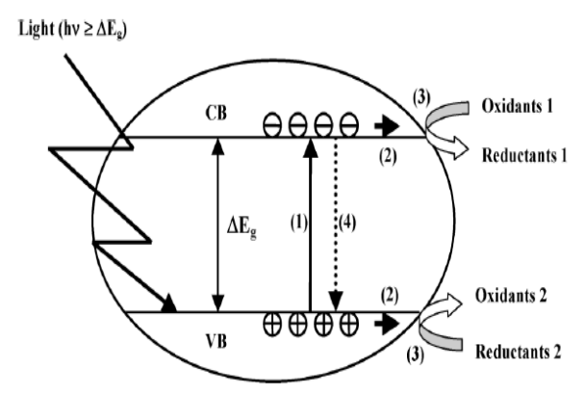

Scheme 1.

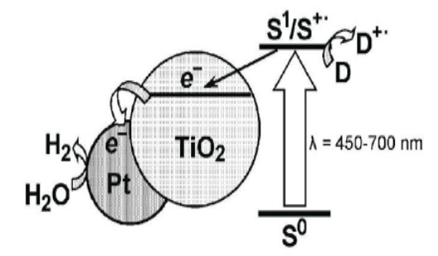

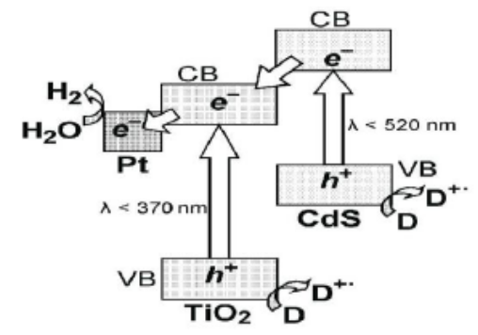
Scheme 2.

Scheme 3.

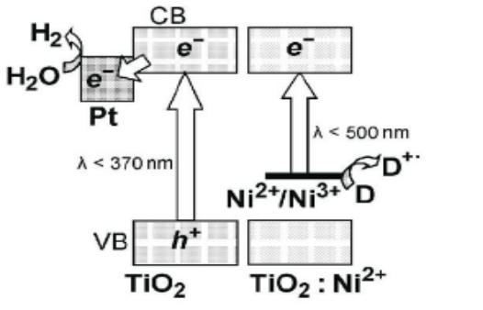

Scheme 4
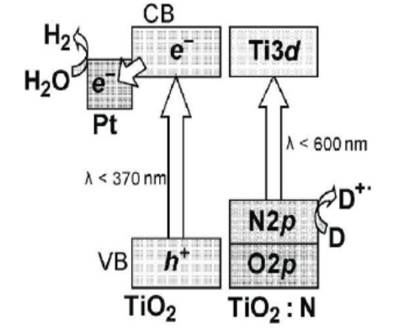

Scheme 5
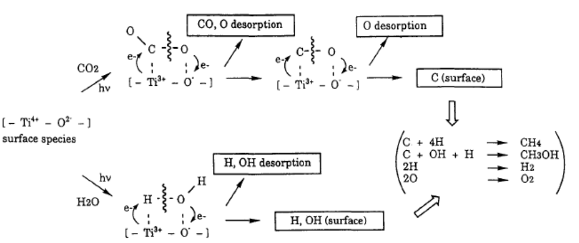

Scheme 6

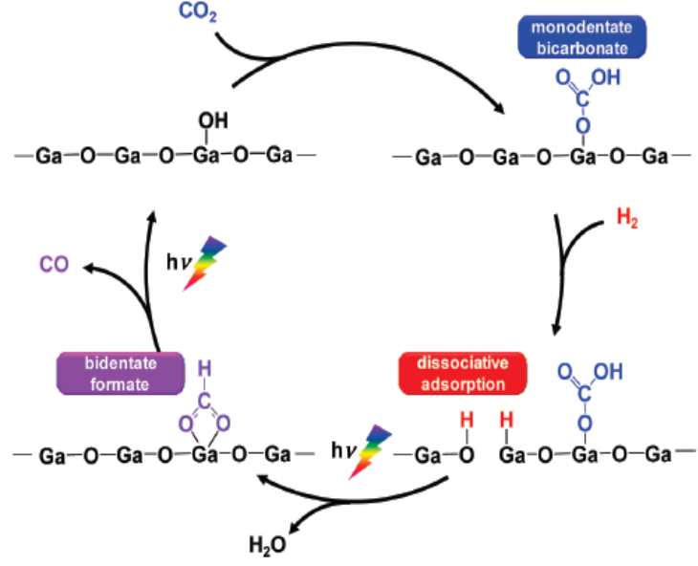

Scheme 7

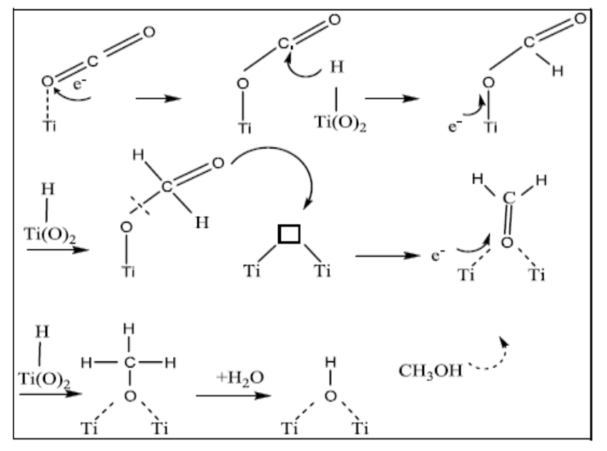

Scheme 8

Figures
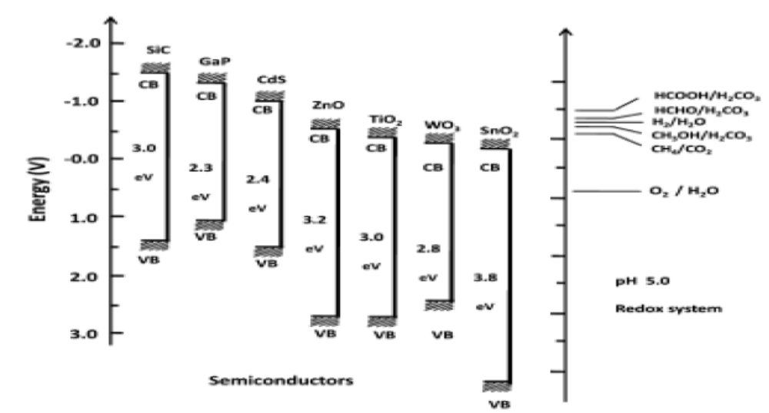

Figure 1.

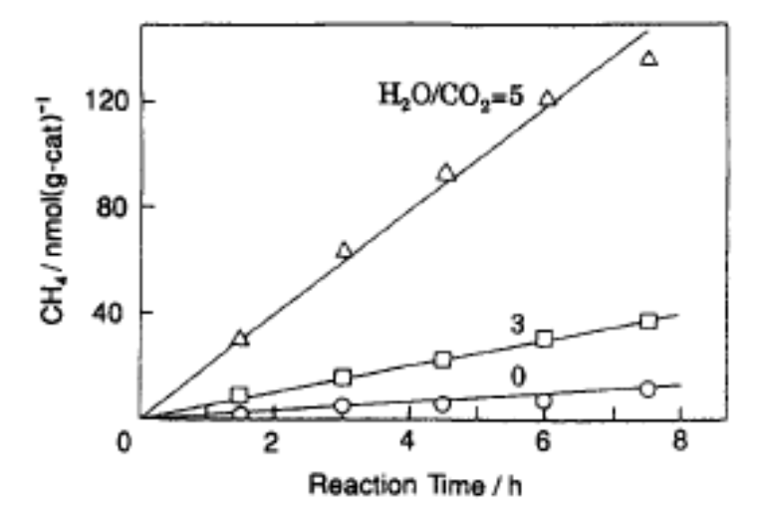

Figure 2

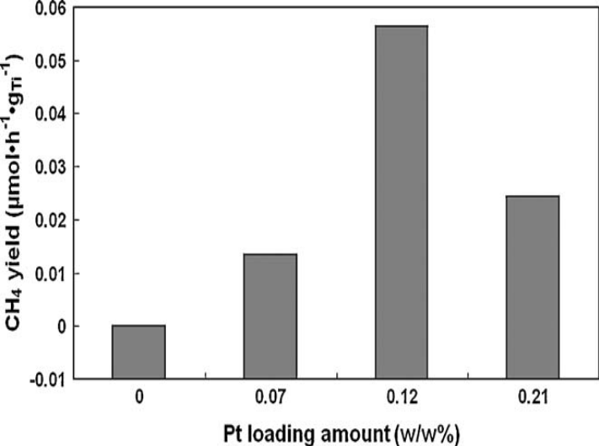

Figure 3

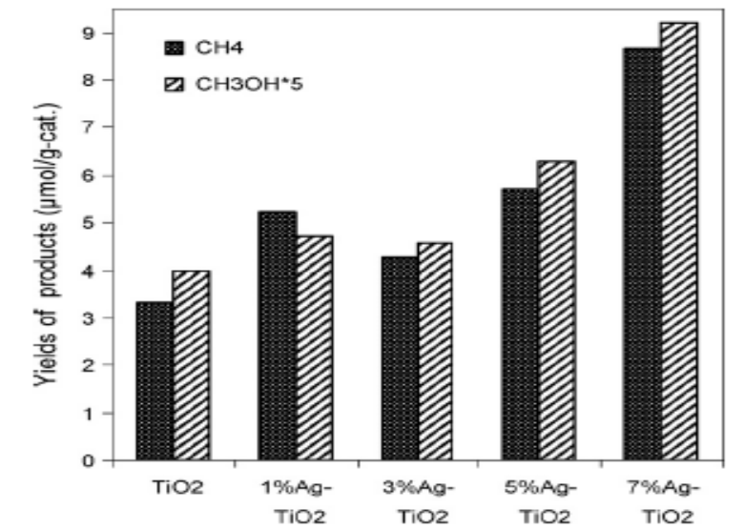

Figure 4

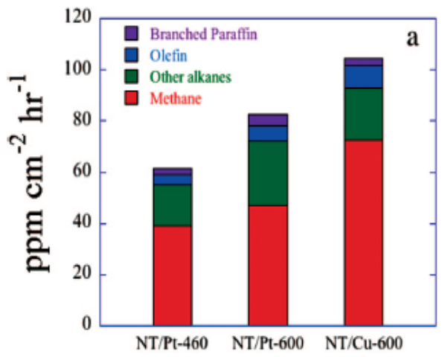

Figure 5
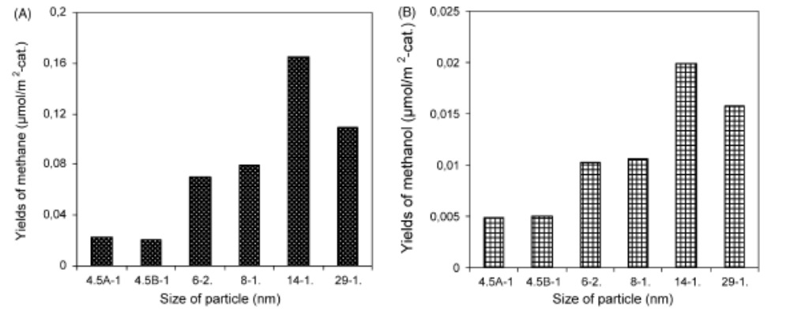

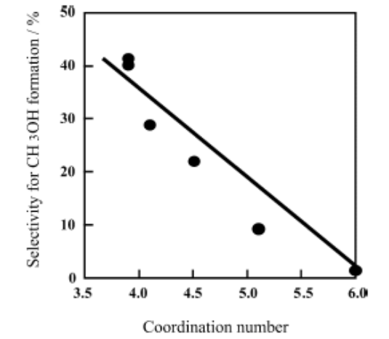
Figure 6

Figure 7
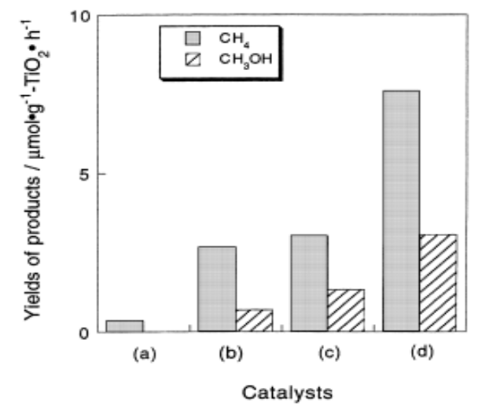

Figure 8

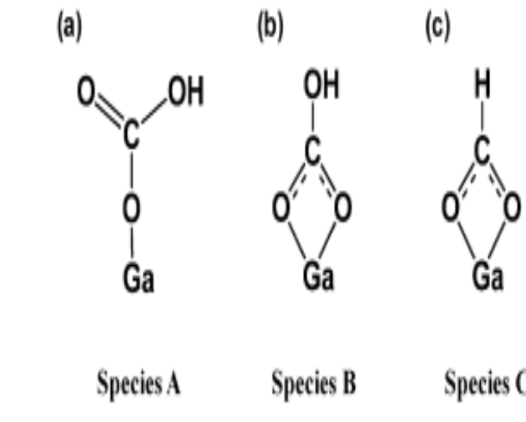

Figure 9

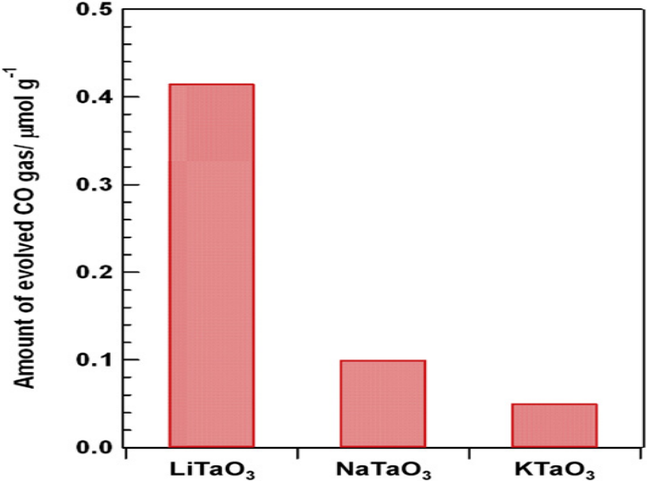

Figure 10

Scheme Captions:

Scheme.1. Schematic representation of the “band gap model” (1) Photo induced
electron– hole pair creation; (2) charge migration to the surface; (3) redox reactions;
(4) recombination. VB and CB represent valence band and conduction band,
respectively. (Reproduced from Ref.2 with permission from Taylor & Francis
Ltd., Copy right 2007)

Scheme.2. Diagram of the operation of the photocatalytic system for the release of
hydrogen from water based on metal–semiconductor structures and a dye–sensitizer.
Legend: S0, S1, and S+ are the sensitizer in the ground, excited, and one electron
oxidized states of the dye, respectively. (Reproduced from Ref.6 with permission
from Springer Science & Business Media, Copy right 2009)

Scheme.3. Diagram of the spatial separation of the photo generated charges in the
CdS/TiO₂ hetero structure and the formation of hydrogen during the action of visible
light. (Reproduced from Ref.6 with permission from Springer Science & Business
Media, Copy right 2009)

Scheme.4. Diagram of the operation of the Photo catalytic system for the release of
hydrogen from an aqueous solution of electron donor D with the participation of
titanium dioxide doped with Ni²⁺ (TiO2:Ni²⁺). (Reproduced from Ref.6 with
permission from Springer Science & Business Media, Copy right 2009)

Scheme.5. Diagram of the operation of the Photocatalytic system for the release of
hydrogen from an aqueous solution of electron donor D with the participation of
titanium dioxide doped with nitrogen (TiO₂:N). (Reproduced from Ref.6 with
permission from Springer Science & Business Media, Copy right 2009)

Scheme.6. Schematic representation of the photocatalytic reduction of CO₂ with H₂O on
anchored titanium dioxide. (Reproduced from Ref.7 with permission from Elsevier,
Copy right 1995)*

Scheme.7. Mechanism of photocatalytic reduction of CO₂ over Ga₂O₃ in presence of hydrogen.
(Reproduced from Ref.44 with permission from American Chemical Society, Copy
right 2010)

Scheme. 8. Proposed mechanism of photcatalytic CO₂ reduction over TiO₂.
(Reproduced from Ref.58 with permission from Springer Science & Business Media,
Copy right 2009)

Figure Captions

Fig.1. Conduction band and valence band potentials of semiconductor photocatalysts relative to
energy levels of the redox couples in water. (Reproduced from Ref.15 with permission
from Macmillian Publisher Limited, Copy right 1979)*

Fig.2. The time profiles of the photocatalytic reaction of CO₂ (0.05 mmolg⁻¹) and H₂O to produce
CH₄ on titanium dioxide anchored on PVG and the effect of H₂O to CO₂ ration on the
yields of the products. Numbers represent the ratio of H₂O to CO₂. (Reproduced from
Ref.7 with permission from Elsevier, Copy right 1995)*

Fig.3. Effect of Pt metal content in Pt/TO-NP on methane yield for photocatalytic reduction of
CO₂ after 7-h irradiation at 323K H₂O/CO₂= 0.02. (Reproduced from Ref.25 with
permission from Elsevier, Copy right 2009)

Fig.4. Dependence of product yields on Ag content in Ag/TiO₂ (after 24 hrs).
(Reproduced from Ref.28 with permission from Elsevier, Copy right 2010)

Fig.5. N doped TiO₂ nanotube arrays with Pt (NT/Pt) & Cu (NT/Pt) co-catalysts, 460 or 600°C
annealed as indicated- Hydrocarbon generation rate. (Reproduced from Ref.24 with
permission from American Chemical Society, Copy right 2009)

Fig.6. (A &B) Dependence of product yields on particle size of titania (after 24 hrs irradiation)
(Reproduced from Ref.35 with permission from Elsevier, Copy right 2009)

Fig.7. The relationship between the selectivity of methanol formation in the reduction of CO₂
with H₂O and the co-ordination number of TiO₂ species determined by XAFS
investigation. (Reproduced from Ref.38 with permission from Elsevier, Copy right 2003)

Fig.8. Yields of CH₄ and CH₃OH in the photocatalytic reduction of CO₂ with H₂O on TiO₂
powder (a), TS-1 (b), Ti-MCM-41 (c) & Ti-MCM-48 (d) zeolite catalysts.
(Reproduced from Ref.39 with permission from Elsevier, Copy right 1998)

Fig.9. Adsorbed CO₂ species on Ga₂O₃- A- Mono-dentate bicarbonate B-Bidentate bicarbonate
C- Bi-dentate formate. (Reproduced from Ref.44 with permission from American
Chemical Society, Copy right 2010)

Fig.10. Amount of evolved CO gas for the photo photocatalytic reduction of CO₂ with external
H₂ as a reductant over ATaO3 (A = Li, Na, K) after 24 h of photoirradiation.
(Reproduced from Ref.45 with permission from Elsevier, Copy right 2010)

Tables
Table 1
BiVO₄ | Production rate ª/μmolh⁻¹ | 300W Xe arc lamp with UV cut off filter | 300 W Xe arc lamp without UV cut off filter | 36W fluorescent lamp
Monoclinic | Ethanol | 21.6 | 406.6 | 2.3
 | Methanol | 0 | 0 | 1.8
Tetragonal | Ethanol | 1.1 | 4.9 | 0.6
 | Methanol | 0 | 0 | 0.6
ª The rate was determined on the basis of the average production
rate after 80 min of irradiation

Table 2
Catalyst | Product yield (μ moles/g. catalyst)
 | HCOOH | CH₃OH | HCHO | Total organic carbon
TiO₂ | 221 |  | - | 221
1wt%CoPc/TiO₂ | 450.6 | 12.1 | 38.5 | 501.2
0.7% in-situ  CoPc/TiO₂ | 1487 | 93 | 134.3 | 1714

Table 3

 | Production rateª [μmol(gcat)⁻¹ h⁻¹]
 | Ethylene | Methane
Cu(0.5 wt%)-Fe(0.5 wt%)₂/glass plate | 0.049 | 0.060
Cu(0.5 wt%)-Fe(0.5 wt%)/TiO₂/optical fiber | 0.575 | 0.914
N3-dye- Cu(0.5 wt%)-Fe(0.5 wt%)/TiO₂/glass plate | 0.033 | 0.148
N3-dye- Cu(0.5 wt%)-Fe(0.5 wt%)/TiO₂/optical fiber | 0.562 | 0.847
ª Production rates were determined on the basis of the average value after 4h of irradiation. The artificial light was in the wavelength range of 320-500 nm with intensity of 225 mW cm⁻².

Table Captions

Table.1. Rates of methanol & ethanol formation with radiations of different wavelengths
(Reproduced from Ref. 15 with permission from Elsevier, Copyright, 2009)
Table.2. Product profile for photoreduction of CO₂ on TiO₂-CoPc system (Reproduced from
Ref.40 with permission from Elsevier, Copyright, 2009)
Table.3. Production rate of methane and ethylene over TiO2 based-catalysts under artificial
light- Influence of the type of photo reactor on reaction rate (Reproduced from Ref.49
with permission from Elsevier, Copyright 2008)

