Reflections on the Electrochemical Reduction of Carbon dioxide on Metallic Surfaces
B. Viswanathan
National Centre for Catalysis Research, Indian Institute of Technology Madras, Chennai 600 036
Abstract
It is known that carbon dioxide undergoes electrochemical reduction to a variety of products like CO, hydrocarbons and alcohols on metallic surfaces and the nature of the metal has a role to play in the observed selectivity of products. The rationalization of the results obtained on different metallic surfaces and accounting the selectivity normally reported have been the points of contention in literature. This presentation examines these aspects from the point of view of the surface activation of carbon dioxide and proposes a site specific and geometry constrained adsorption of carbon dioxide as the possible reason for the variation in the results reported in literature.
Introduction
The activation and conversion to value added chemicals of molecules like carbon dioxide, carbon monoxide and dinitrogen have been challenging¹⁻³. The most striking common feature among these molecules is the fact that the frontier orbitals of these molecules are not of bonding character⁴ . It is therefore necessary to adopt alternate methods of activation of these molecules to convert them into other useful energetic molecules⁵. However, if one were to succeed in activating these molecules, it provides a means for energy storage, a concept which is fascinating and also rewarding. The scope and breadth of this presentation is to examine the electrochemical activation of carbon dioxide into some useful low carbon number fuels and molecules⁶.
Scibioh and Viswanathan⁷ have examined the question ‘is carbon dioxide a matter of pollution or profit?’ According to them, the question is not how to remove or reduce this emission, but how to make use of this enormous emission for environmental and economic benefit? There are several motivations for producing chemicals from carbon dioxide whenever possible. (1) carbon dioxide is a cheap, non-toxic feedstock that can frequently replace toxic chemicals like phosgene or isocyanates (2) Carbon dioxide is a nearly renewable feedstock (3) New chemicals like polymers can be produced from carbon dioxide (4) Alternate routes for the existing processes may become efficient and economical if this feed stock is employed (5) Chemicals from carbon source could have some positive impact on carbon balance⁸.
A variety of reactions including some industrial processes like urea and cyclic carbonates and polycarbonates are possible with carbon dioxide⁹. A simple pictorial reaction scheme for possible conversion processes of carbon dioxide is given in Fig.1. It is seen that alcohols, hydrocarbons, fuel precursor (CO) and a variety of value added chemicals like urea, carbonates and bicarbonates can be produced by the transformation of carbon dioxide and hence it is on longer to be considered as means of pollution but should be taken as a valuable feed stock. The most predominant reaction is carbon dioxide insertion, though a variety of other reactions are also indicated in the reaction scheme given in Fig.1.
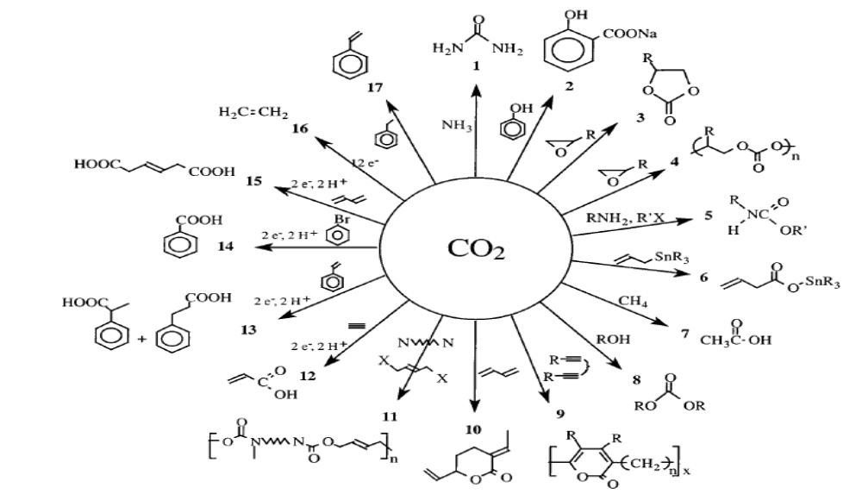
Fig.1. Some possible chemical transformations of carbon dioxide [reproduced from ref 7]
Electrochemical Reduction of Carbon dioxide
Unlike chemicals that derive value from their intrinsic chemical and physical properties, the value of fuels is in their energy content and the ease with which they are stored and transported. Currently no fuels are produced by the reduction of CO₂ because returning CO₂ to useful state on the same scale as its current production rates is possibly beyond our current scientific and technical ability. However, electrochemical reduction of carbon dioxide in conjunction with the decomposition of water is one attractive proposition, since the electrochemical reduction may be considered as the sum of the corresponding hydrogenation reactions and the water splitting reaction. Typical representative list of such reactions is given in Table 1.
Even though activation of carbon dioxide and its subsequent conversion to fuels and chemicals can be achieved by radiochemical, photochemical, photo-electrochemical, biochemical, bio-photo-electrochemical and thermo- chemical methods, electrochemical routes have been examined extensively in literature^{10,-12}. The electrochemical reduction process utilizes only gaseous carbon dioxide and possibly hydrogen from aqueous electrolytes and yields a variety of hydrocarbon products as stated earlier with oxygen as the gaseous non polluting product. The high Faradaic efficiency that can be achieved and the possibility of carrying out the reaction around room temperature are the two factors in favour of this route. The possibility of in situ production of fuels, like methane and methanol and also the utilization of the green house gas for production of profitable chemicals make the electrochemical reduction of carbon dioxide promising and attractive¹³ .
Table. 1. Typical electrochemical carbon dioxide reduction in conjunction with water decomposition reaction[some of the data reproduced from ref 7]
Reaction | ΔEº (V) | ΔGº (kcal/mol)
H₂O → H₂ + 0.5O₂ | 1.23 | 56.7
CO₂ + H₂ → HCOOH |  | 5.1
CO₂ + H₂O → HCOOH + 0.5O₂ | 1.34 | 61.8
CO₂ + H₂ → CO + H₂O |  | 4.6
CO₂ → CO + 0.5O₂ | 1.33 | 61.3
CO₂ + 3H₂ → CH₃OH + H₂O |  | - 4.1
CO₂ + 4H₂ → CH₃OH + 2 H₂O |  | -31.3
CO₂ + 2 H₂O → CH₃OH + 1.5O₂ | 1.20 | 166
CO₂ + 2 H₂O → CH₄ + 2 O₂ | 1.06 | 195

Reactions of Relevance for the Electrochemical Reduction of Carbon dioxide
The reactions of relevance are listed below in combination with the water decomposition reaction at pH = 7, since hydrogen evolution is the predominant reaction in acid medium and in alkaline medium carbon dioxide does not exist. Direct one electron reduction of carbon dioxide requires high negative potential due to large reorganization energy between linear molecule and bent radical anion⁴.
CO₂ + e⁻ → CO₂⁻ (-1.90 V)
CO₂ + H₂O + 2e⁻ → HCOO⁻ + OH⁻ (-0.43V)
CO₂ + H₂O + 2e⁻ → CO + 2OH⁻ (-0.52V)
CO₂ + 6H₂O + 8e⁻ → CH₄ + 8OH⁻ (-0.25V)
2CO₂ + 8H₂O + 12e⁻ → C₂H₄ + 12OH⁻ (-0 .34V)
2CO ₂+9H₂ O+12e⁻ → C₂H₅OH +12OH⁻ (-0.33V)
3CO₂ + 13H₂O + 18e⁻→ C₃H₇ OH + 18OH⁻(-0.32V)
2H₂O + 2e⁻→ 2OH⁻ + H₂ (-0.41V)
It is inferred that compared to direct reduction of carbon dioxide, the reduction of carbon dioxide in the presence of water decomposition appears to be favourable for the formation of small molecule fuels or fuel precursor like carbon monoxide. If one were to operate in this mode, this will be the reverse reaction of the anode reaction of the fuel cell operating with that fuel or it can also be conceived that the electrical energy is converted into the chemical energy. This is similar to electrochemical water decomposition being considered as the reverse of hydrogen-oxygen fuel cell reaction. Since the Gibbs free energy is always positive for most of the reactions in this sequence involving carbon dioxide with the added over voltage which is of the order of 1Volt, the water decomposition reaction becomes a competing reaction. Therefore, the type of product formed on metallic electrodes for carbon dioxide reduction depends on the overvoltage for hydrogen evolution on the metallic surface. For example, on mercury surfaces where the hydrogen evolution overvoltage is high, formate is the most preferred product in carbon dioxide reduction.
The metallic electrodes can be grouped into four groups as follows for carbon dioxide reduction¹⁴
- Metals like Pb, Hg, In, Sn, Cd, Tl and Bi with high hydrogen evolution overvoltage, promote the formation of formate.
- Metals like Au, Ag,Pd,Ga and Zn with medium HER (Hydrogen Evolution Reaction) overvoltage with simultaneous weak adsorption of CO promote the formation of fuel precursor CO from the reduction of CO₂.
- Metals like Ni, Fe, Pt, Ti Co, Rh and Ir which have low hydrogen overvoltage but exhibit strong CO adsorption, the major product is hydrogen.
- Other metals like Cu, where the major product of reduction of CO₂ is hydrocarbons (CH₄) and alcohols.
Activation of Carbon dioxide on metallic Surfaces
In essence, the activation of carbon dioxide on metallic surfaces could be coordination through the carbon or oxygen centres or involving mixed coordination on single or multiple sites. Electrochemical reduction of carbon dioxide on a variety of metal surfaces has been studied. Among the various metals studied, copper electrodes have been shown to catalyze the reduction of CO₂ to methane in bicarbonate solutions with current efficiency of nearly 65%^{7,}. In spite of the fact that the over potentials are large of the order of 1.5 V, this is a remarkable transformation in which eight electrons are transferred to CO₂ with cleavage of two C-O bonds and formation of four C-H bonds and the reaction is thought to involve coordinated CO as an intermediate and to overcome poisoning of the electrode under catalytic conditions. Under slightly different conditions, CO₂ can also be reduced to ethylene at Cu electrodes¹⁵.
Homogeneous electro-catalysts typically catalyze CO₂ reduction by two electrons to either formate or CO together with H₂ formation. However, for some catalysts, CO₂ reduction occurs with current efficiencies close to 100%, even in acidic solutions. This indicates high selectivity for CO₂ reduction over the more thermodynamically favored reduction of protons to H₂. For example, the reduction of CO₂ to CO by nickel cyclam catalysts occurs with nearly 100% current efficiency in water at pH 4.1, and CO₂ is reduced to CO in 0.02M HBF₄ in dimethylformamide solutions with current efficiencies⁷ greater than 95%. In addition, some of these catalysts operate at low over-potentials so that the conversion of electrical to chemical energy is highly efficient. The selectivity in these cases appears to arise from the preferential reaction of 17-electron intermediates with CO₂ rather than protons.
This selectivity of reduced forms of the catalyst for H⁺ versus CO₂ also appears to determine the nature of the CO₂ reduction product observed. If the reduced form of the catalysts reacts with CO₂ to form an M-CO₂ complex, protonation yields a metallocarboxylic acid; further reaction can then produce CO by C-O bond cleavage to form hydroxide or water. Thus, reaction of a reduced form of the catalyst with CO₂, as opposed to protons, leads to CO formation. If the reduced form of the catalyst reacts with protons to form a hydride complex, subsequent reaction of the hydride with CO₂ leads to formate production; these two possibilities are illustrated in Scheme 2.

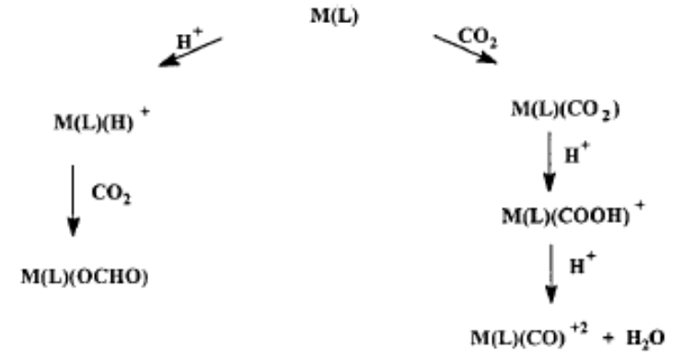
Scheme 2. Pathways for the Competing Interaction of Low-Valent Catalysts with Protons or CO₂
It is unusual for homogeneous catalysts to form reduction products that require more than two electrons. However, it has been reported that the formation of glycolate (HOCH₂COO⁻), glyoxylate (OCHCOO⁻), formic acid, formaldehyde, and methanol as CO₂ reduction products using [Ru(tpy)(bpy)-(CO)]²⁺ complexes as electro-catalysts (bpy = 2,2’- bipyridine, and tpy = 2,2’:6’,2’’-terpyridine)¹⁶. Although turnover numbers were not known for these reduced species, their formation projects the possibility that a single-site catalyst can result in multi-electron reductions of CO₂ and even C-C bond formation. The relatively mild conditions and low over-potentials required for some of the homogeneous catalysts make them attractive; however, a number of barriers must be overcome before useful catalysts are made available for fuel production.
At this stage, it is necessary that one deals with the activation of carbon dioxide on metallic surfaces. Even though one can visualize associative adsorption of CO₂ with either carbon, oxygen or mixed centres on single or multiple sites, the most probable mode of adsorption would be a dissociative adsorption involving a CO_{ads} type species. This species if it desorbed as such gives the fuel precursor and if it undergoes further hydrogenation with the hydrogen evolved from water then accounts for the other observed products like hydrocarbons and alcohols. Therefore, the essential concept of activation of CO₂ has to be clearly formulated. This requires a description of the molecular orbitals of CO₂. The essential orbitals contributing to the molecular orbitals are the 2s and 2p orbitals of carbon and oxygen. The three 1s obitals of carbon and two oxygen atoms remain basically unchanged in the molecule and are designated as 1σ_{g}, 2σ_{g} and 1σ_{u}. The 2s and 2p_{x} orbitals of carbon and oxygen directed along the molecular axis give rise to 3σ_{g}, 4σ_{g}, 5σ_{g} and 2σ_{u}, 3σ_{u}, and 4σ_{u}. The 2p_{y} and 2p_{z} give rise to three doubly degenerate π orbitals designated as 1 π_{g,} , 1 π_{u} and 2 π_{u}. The 22 electrons in CO₂ are distributed, 6 in core σ orbitals arising from 1s levels and the remaining 16 are distributed in four sigma orbitals and two doubly degenerate Pi orbitals. The highest occupied molecular orbital is 1π_{g} and the lowest unoccupied molecular orbital is 2π_{u} orbital. The energetic positions of the sigma orbitals do not change considerably as the molecule undergoes distortion from linear geometry to bent geometry. However, the energies of π-orbitals show pronounced alterations on going from linear geometry to bent geometry and also the degeneracies of these orbitals are also lifted. This is normal since the charge density in the π orbitlas are concentrated between the two bonding centres in a lateral disposition. The bending of the molecule from linear geometry though affects the degeneracy of 1π_{u} and 1π_{g} the energy difference between the two split orbitals is not high. However, the degeneracy of 2π_{u} is lost and the two resulting orbitals are designated as 2b₁ which has almost the same energy as in the linear molecule in the bent configuration and the other component is designated as 6a₁ whose energy falls sharply as compared to that in the linear molecule. Electron occupancy in this molecular orbital can give rise to a bent configuration. The relative energy positions of the orbitals of carbon dioxide at two geometries namely the bond angle is either 180º or 90º are shown in Fig.2.
The essential point in the activation of carbon monoxide and dinitrogen is the population of the anti-bonding π orbitals which facilitates the dissociation of the molecule. In the case of carbon dioxide, this population of anti-bonding states leads to the change in the bonding angle and hence the adsorption site has to have specific geometry. Though this is not similar to the bidentate binding of CO it shows that the sites activating these molecules have to have specific geometry and orientation. In the case of carbon dioxide activation, the carbon and one of the oxygen centres of this molecule has to be activated with the bond being not 180º. This imposes some geometrical restrictions on the site on which carbon dioxide molecule can be activated.

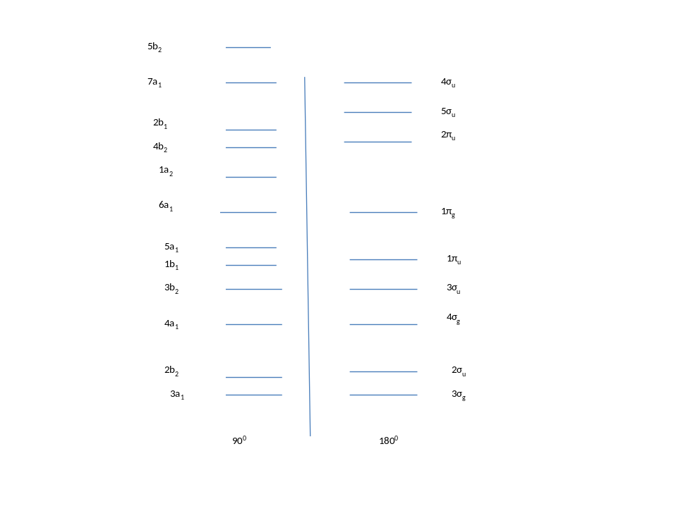
Fig.2. The relative positions of the energy levels of orbitals of carbon dioxide at 180⁰ and 90⁰ . The point to note is that some orbitals have lost their degeneracy when the bond angle is decreasing from 180⁰. The data plotted from ref 4]
Though, it is known that the reaction CO₂ + e⁻ → CO₂⁻ (-1.90 V) is not thermodynamically favourable, it may become probable in the adsorbed configuration wherein the CO₂ is adsorbed on the metallic surfaces by multi-point adsorption. Among the various multipoint adsorption configurations for CO₂, the one involving the carbon and one of the oxygen appears to be the most probable based on a variety of spectroscopic experimental IR¹⁷, HREELS and XPS^{4,12} data which show that this adsorbed species mostly manifest somewhat like adsorbed CO (not in the conventional carbonyl type) species and adsorbed oxygen.
Several studies have been reported on the activation of carbon dioxide on metallic surfaces. In general, either mixed carbon-oxygen or pure oxygen coordination have been recognized as the probable mode of adsorption than pure carbon coordination. In all these theoretical studies the consistent result is that the carbon dioxide molecule is bent on adsorption and the bond angle is less than 180⁰.
It is interesting to refer to the DFT study of carbon dioxide reduction to hydrocarbons on copper surfaces ¹⁸. This report identifies the reaction path on the basis of the construction of potential energy profiles and has shown that stripping of the oxygen and also insertion of hydrogen are the steps controlling the reaction. The oxygen containing species like CHO prefers to dissociate to form CH rather than to form CH₂O. This study also favours the postulate that was made in this paper that CO₂ activation has to take place through carbon and one of the oxygen atoms of carbon dioxide on a site of suitable geometry for the bent configration. If this were to be true, the subsequent hydrogen addition will take place with the elimination of oxygen in the bent geometry accounting for the formation of hydrocarbons from carbon dioxide. This aspect may be the essential difference between hydrogenation of carbon monoxide and carbon dioxide.
In Fig 3 some of the possible multi-point interaction of carbon dioxide on metallic surfaces are given.
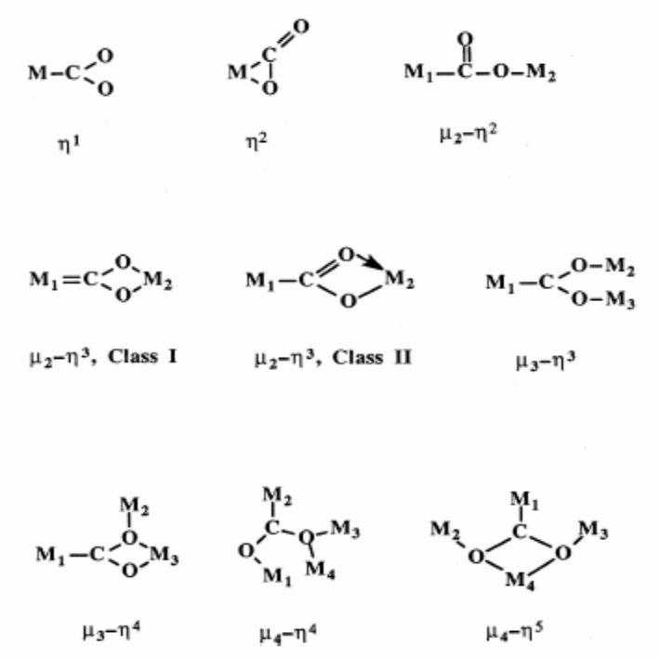
Fig.3. Some of the possible modes of activation of carbon dioxide involving multi-point of adsorption on metallic surfaces [From ref [8]]
It was shown that direct carbon metal interaction alone is not energetically favourable. On this basis and also from the projections of the molecular orbitals, one of the possible modes of activation of carbon dioxide is shown in Fig.4. Since direct coordination through carbon is repulsive in nature, the activation through carbon and oxygen is envisaged. In this mode of activation it may be possible that the carbon–oxygen bond may be activated and thus the CO₂ molecule may undergo reduction.
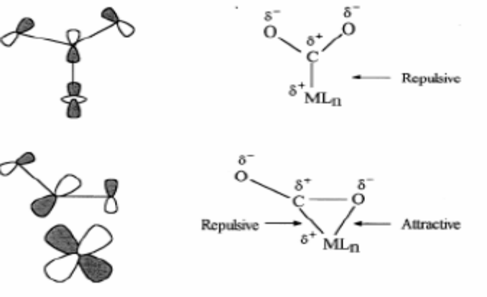
Fig.4. The possible interaction of the molecular orbital of carbon dioxide with metal orbitals.
The activation of carbon dioxide can be achieved as stated earlier by a variety of methods. Even though it is not our intention to outline all the possible methods of activation of carbon dioxide, it is essential to know some basic concepts of this process. The direct thermal decomposition of carbon dioxide to carbon monoxide is an endothermic process with the net free energy change of (ΔGº) of 257 kJ/mol and for 100% conversion a temperature of 3348 K may be required since at this temperature only the ΔGº becomes zero. There are other possibilities like thermo-chemical and other means and these are not within the scope of this article. From the electrochemical point of view, the conversion of carbon dioxide can be achieved in combination with the electrolysis of water. As stated, a wide range of products starting from CO to more complex pure and oxygenated hydrocarbons of high energy content can be directly formed. However, the voltage to be applied for the simple carbon dioxide splitting is 1.33 V at 298 K. The thermo-neutral voltage is 1.47 V which is nearly the same as that for water electrolysis. However for effective splitting, one has to add electrode overvoltage and ohmic losses, and a voltage of nearly 2 V or more is required to promote this reaction in aqueous electrolytes. This will possibly account for the selectivity observed with different metals and also why only certain metallic surfaces could promote electrochemical reduction of carbon dioxide.
In aqueous electrolytes, (Sodium or potassium bicarbonate) the reduction process for water decomposition and reduction of carbon dioxide require almost the same voltage (-0.41 V for H⁺/H₂O while for CO₂/CO the value is -0.52 V at pH = 7) and hence compete with each other and hence the normal Faradaic efficiency for carbon dioxide reduction is lower since the hydrogen evolution reaction is the preferred reaction. Therefore it is clear that the net Faradaic efficiency for carbon dioxide reduction will depend on various factors, essentially with the catalytic activity of the electrode, the potentials applied, the pH and nature of electrolyte employed, the effective concentration of carbon dioxide near the electrode surface and the consequences like mass transport, ionic and buffer strength and other associated factors.
Among all the factors mentioned, the influence of nature of the electrode appears to be overwhelming. In the literature, the relevance of factors like the orientation of the crystal lattices (accounting for the preferential adsorption of substrate CO₂ and intermediates) surface architecture (roughness, stepped surface, porosity and defects) surface crystallography (dislocations and vacancies) electronic configurations (s, p, or d metals) has been emphasized. Since this is not easily obtained on many metallic surfaces, the water decomposition and hydrogen evolution reaction predominates on most of the metallic surfaces. Possibly, based on the above parameters only the metals have been grouped into four classes outlined elsewhere in this article, though as stated the hydrogen overvoltage and CO adsorption strength can also be considered as basis for this classification.
Though we have classified the metal electrodes on the basis of the thermodynamic control in the form of hydrogen overvoltage and CO adsorption strength, the geometrical factors can also contribute to the observed selectivity of the products formed. The activation of carbon dioxide on metallic sites has been visualized in a number of ways. The possible modes of activation of carbon dioxide are assembled in figure 3.

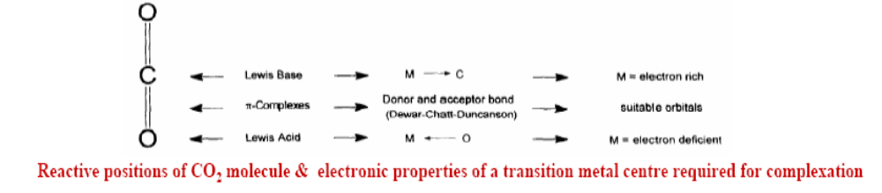
Adsorption of carbon dioxide in undistorted without bond angle variation can give rise to the following adsorption modes.

O = C = O M – O = C = O M₁ – O = C = O – M₂
M M
Some of the other possible modes of activation of Carbon dioxide have been already given in this article. Though there are a variety of adsorption modes, it should be remarked that those adsorption modes of carbon dioxide where the bond angle deviates from 180⁰ alone will be able to yield useful products. This means that though carbon dioxide can be adsorbed in a number of ways, the three linear forms shown in the above picture will not yield useful reduced products. This imposes some restrictions on the geometry of the adsorption site. The path for reduction of carbon dioxide most possibly involves activating both the carbon and one of the oxygen atoms of carbon dioxide and at the same time the adsorption strengths are not strong so that subsequent hydrogenation and desorption of the hydrogenated product is feasible. This can impose some geometrical restrictions on the activation centre on metallic surfaces either in the form of some certain exposed planes or presence of stepped sites.
The objective of this report is to provide fundamental understanding at the molecular level CO₂ reduction so that the catalyst design becomes possible. There have been persistent statements in the literature which explicitly demonstrated that economic difficulties and physical limitations have to be overcome before CO₂ utilization becomes a viable process.
From early days till 1980s the studies on electrochemical reduction of CO₂ have been mainly centered around amalgamated electrons (Cu, Zn and Pb) for the formation for formic acid. Even though starting from 1980, various other electrodes including semiconductors have been examined, the current efficiencies were remarkably low. The first report on highly efficient copper electrodes for hydrocarbon formation from CO₂ reduction was that of Hori et al^{19,20}.
In aqueous medium, the electrochemical reduction of carbon dioxide involves, the oxidation of water at the anode, and the electrons released are utilized in the reduction of carbon dioxide at the cathode to generate hydrocarbons and alcohols. Since the reduction potential of carbon dioxide is close to that water reduction, on most surfaces, hydrogen evolution may predominate over CO₂ reduction so that the catalyst chosen should have high over potential for hydrogen reduction allowing H⁺ transfer steps selectively for formation of reduction products of CO₂. In the periodic table (Fig. 5) one can see the approximate values of hydrogen evolution current efficiencies (%) in KHCO₃ solutions around 273 K at -2.2 V. It is seen that on most of the metals , hydrogen evolution predominates over the CO₂ reduction reaction. Only on a limited number of metallic surfaces, other reduction products like CO, HCOOH and hydrocarbons (mostly CH₄, and C₂H₄, and C₂H₆) are formed.
Since copper appears to have unique place in carbon dioxide reduction, there have been a number of studies reported on this system. Kaneco and his coworkers²¹⁻²³ in a series of investigations have studied carbon dioxide reduction on copper surfaces in different media to produce with high Faradaic efficiencies for a variety of products like formic acid, methane, ethylene and carbon monoxide. It has been shown that the surface treatment, physical form and the method of preparation of copper have profound effect on the electro catalytic properties for the reduction of carbon dioxide. It has been established in literature that copper is the vital component for the reduction of carbon dioxide, though the actual nature of the active sites and their geometrical orientation are still not yet been established. Even though CO₂ is reduced on typical (100),(110) and (111) planes of copper, Hori et al^{19,20} showed that on (100) planes ethylene is the preferred product while on (111) planes the product is predominantly methane. However on (110) planes both products are formed.
Based on the heat of adsorption measurements, it has also been shown that the presence of Cu(I) species as Cu₂O may be responsible for methanol formation. In the literature the role of Cu⁺ sites on the formation of hydrocarbons has been debated with respect to the adsorption geometry of CO fragment, as well as with the energetics of adsorption intermediate species like HCOO, CH₂+CH . Copper loaded on ZnO showed higher Faradaic efficiencies for the formation of methane and ethylene, this being attributed to the preferential stabilization and dispersion of Cu⁺ sites on ZnO. These interface sites may possibly promote the non linear adsorption of CO₂ in addition to sustaining these active sites from poisoning by impurities.
Beck et al²⁴ in a recent publication have shown the comparative cost of various kinds of energy storage media and has demonstrated the utility of electrochemical reduction of carbon dioxide.
Epilogue
All these results lend credence to the postulate given in this presentation that only those sites which can activate carbon dioxide in a bent geometry is capable of producing fuels and such surfaces have to be geometrically and configurationally ascertained to be present on the metallic surface for effecting electrochemical reduction of carbon dioxide. It may be possible with the modern methods of architecting surfaces, metallic electrodes of geometry can be made routinely for a viable carbon dioxide to fuels process development. It is also the electric field gradient that are possible may be cumulatively adding to the efficiency of the process though at present this has not yet been realized.
References

- S.Ishi and B.Viswanathan, (1987), Adsorption of carbon monoxide on metal surfaces, J.Sci.Ind.Res., 46, 541 67.
- C.N.R. Rao, G. Ranga Rao, Nature of nitrogen adsorbed on transition metal surfaces as revealed by electron spectroscopy and cognate techniques, Surface Science Reports 13 (1991) 221-263.
- http://gcep.stanford.edu/pdfs/ChEHeXOTnf3dHH5qjYRXMA/16_Viswanathan_10_12_trans.pdf
- Freund H J and Roberts M W, Surface Science Reports, 25 (1996) 225.
- Gattrell, Gupta N & Co,A, Energy conversion and Management 48 (2007) 1255.
- http://www.facebook.com/pages/Electro-Reduction-of-Carbon-Dioxide/138929552797415
- Scibioh M A & Viswanathan B, Consulting Ahead, 1 (2007)59.
- Scibioh M A & Viswanathan B, Proc Indian Natn Sci Acad, 70A (2004) 407.
- Maria Jitaru, Journal of the University of chemical Technology and Metallurgy, 42, (2007) 333.
- Sullivan B P, Krist K & Guard H E (Eds) Electrochemical and Electro-catalytic reactions of carbon dioxide, ElsevIer, Amsterdam (1993).
- Hori Y, Electrochemical CO reduction at Metal Electrodes, Springer, New York 2008, Vol 42.
- Minh Tuyen H Le, Ms Thesis, Louisiana State University (2011).
- Hudson, M R, www2.potsdam.edu/exochemistry/electrorednco2.pdf
- Wenzhen Li, Chapter 5. Electro-catalytic reduction of CO₂ to small organic molecule fuels on metal catalysts, 55-76, in ACS Book: Advances in CO₂ Conversion and Utilization, Editor: Yun Hang Hu, 2010.
- Cattrell M, Gupta N & Co A, J Electroanal Chem, 594 (2006) 1
- Zuofeng Chen, Chuncheng Chen, David R. Weinberg, Peng Kang, Javier J. Concepcion, Daniel P. Harrison, Maurice S. Brookhart, and Thomas J. Meyer, Chem Commun, (2011) DOI 10.1039/C1CC15071E.
- Janusz Ryczkowski, Catalysis Today 68 (2001) 263–381
- Ou Li-Hui & Chen Sheng-Li, J Electrochemistry 17 (2011)155.
- Hori Y, Kikuchi S, & Suzuki, Chemistry Letters (1985) 1695-1698.
- Hori, Y, Kikuchi A, Murata S, Suzuki, Chem. Lett. (1986) 897 - 898.
- Kaneco S, Liba, K, Ohta,K, Mizuno T & Akira, Electrochimica Acta, 44(1998) 573.
- Kaneco S, Iwao R, Liba K, Ohta K & Mizuno T, Energy, 23 (1998) 1107.
- Kaeco S, Lbiza,K, Hiei K, Ohta K, Mizuno T, & Suzuki T, Electrchimical Acta, 44 (1999) 4701.
- Beck J, Johnson R and Naya T, Electrochemical conversion of carbon dioxide to hydrocarbon fuels, EME580 Spring 2010; http://www.ems.psu.edu/~elsworth/courses/egee580/2010/Final%20Reports/co2_electrochem.pdf

Legend to Fig 5

Fig.5. Periodic Table showing the efficiencies of various metals for the electrochemical reduction of CO₂.



