Facile and Selective synthesis of 1,2-disubstituted benzimidazoles using copper oxide/Bentonite K-10 composite – A reusable heterogeneous catalyst
Deepa S. And Nagaraju N.*

*Department of Chemistry, Catalysis Research Laboratory, St. Joseph’s College Research Centre, 36. Lalbagh Road, Shanthi Nagar, Bangalore 560027, India.
Phone (+91) 80 2221 1429, e mail: nagarajun@yahoo.com

Abstract: Cu (II) oxide supported on Bentonite K-10 has been found to be a selective catalyst for the synthesis of 1-benzyl-2-phenyl-1H-1,3-benzimidazole via condensation of o-phenylenediamine and benzaldehyde. Simple procedure, inexpensive and non toxic reagents, low reaction time, high yield of the product, catalyst reusability makes this a useful synthetic protocol. Cu (II) oxide has improved the yield of the product under mild reflux conditions. Powder X-ray Diffraction (PXRD) studies indicated the presence of Cu (II) oxide in the Bentonite K-10/metal oxide composite. The UV-Visible diffuse reflectance spectral analysis of CuO-Bentonite K-10 sample indicated the absence of oligonuclear [Cu-O-Cu]_{n} species. The total acidity of the composite was evaluated by potentiometric titration using n-butyl amine as the base. Compared to Bentonite K-10, the copper oxide containing composite was found to be superior in their catalytic activity in the condensation reaction. The higher activity is attributed to the surface acidity as well as the Cu(II) species.
Keywords: 1-benzyl-2-phenyl-1H-1,3-benzimidazole, CuO/ Bentonite K-10 composite, PXRD, UV-DRS, acidity, potentiometric titration.
1. Introduction
Molecules having benzimidazole as a basic structural unit are commercially used in several therapeutic agents such as anticancer, antiulcerative, antihypertensive, antiviral, antifungal, antitumor, antihistaminic and an entire class of anthelminthic agents in veterinarian medicine[1,2]. Appropriately 1,2-disubstituted benzimidazoles are used as agonists against c-butyric acid A receptor (GABAA) [3]. Moreover, they display thrombin inhibitory activity [4a] and antibacterial activity against gram-positive bacteria [4b].
The available methods of preparation for 1,2-disubstituted benzimidazoles involves the direct reductive amination (DRA) of carbonyl compounds[5], N-arylation of amines with aryl halides [6] and direct one-step condensation of o-phenylenediamines(OPDA) with aldehydes under the influence of different acid catalysts [7]. The drawbacks of the former two methods include the use of reductants in more than stoichiometric amounts as well as use of carbon monoxide, strong acidic and harsh reaction conditions. The direct one pot condensation method however shows poor selectivity in terms of N-1substitution, which results in the formation of two compounds i.e., the formation of 2-substituted benzimidazole along with 1, 2-disubstituted benzimidazole as a mixture.
Supported copper oxide based catalysts has been extensively used in the oxidation of methanol [8], benzene [9], phenol [10], carbonmonoxide [11]. Nano crystalline CuO has been successfully used as an effective catalyst in the asymmetric aldol condensation [12]. In the present paper, we report the use of Cu(II)O supported on Bentonite K-10 as a selective catalyst for the condensation reaction between 1,2-phenylenediamine and benzaldehyde to selectively yield 1-benzyl-2-phenyl-1H-1,3-benzimidazole.
2. Catalyst preparation and catalytic test
100 g of Bentonite K-10 was suspended in 1 litre of de-ionized water and stirred on a magnetic stirrer for 4 hours at 60-70ºC. After 4 h, the suspension was left overnight undisturbed. The supernatant solution was decanted and the solid was dried at 120ºC in a hot air oven for 12 h. This washed clay was used in the preparation of copper oxide/Bentonite K-10 samples and this sample is labeled as clay-120. A portion of this sample (5 g) was calcined at 350ºC in a muffle furnace and labeled as clay-350. The Cu (II) oxide supported on Bentonite K-10 was prepared by wet impregnation method. 18 g of clay-120 was taken in a pestle and to this required amount of Cu(NO₃)₂.3H₂O predissolved in minimum amount of water was added and mixed thoroughly with a mortar. The resultant solid was dried at 120⁰C for 12 h and this sample was labeled as WI-120. 5 g of this sample was calcined in a muffle furnace for 3 hours at 350ºC. The calcined sample was labeled as WI-350.
The condensation reaction between OPDA and benzaldehyde was performed under mild reflux conditions. In a typical experiment, 1.08g (10 mmol) of OPDA and 2.1mL (21mmol) of benzaldehyde were taken in a round bottom flask and a defined amount (100 mg) of the catalyst was added to the reaction mixture (scheme 1). The mixture was refluxed at 50ºC for 1 h. The products of the reaction mixture were analyzed by TLC and later confirmed using GC-MS.
3. Results and Discussion
3.1. Physico-chemical features
In the XRD pattern of Clay-120, one reflection was observed in the region 2º<2θ<8º. This value corresponds to the 5.73º (2θ) value from which the interlamellar distance was found to be 15.42Ǻ. In clay-350, the d₀₀₁ peak was not present indicating the collapse of the laminar structure of the clay material and the relative intensity of the peaks decreased showing poor crystallinity of the calcined clay. In the WI-350 sample, the increase in the relative intensity of most of the peaks indicates the presence of Cu(II) species (Table 1). On comparing with the JCPDS (File No.02-1041, the three strong lines being at 2.52Ǻ, 2.30Ǻ and 1.37Ǻ), it can be said that CuO was present in the prepared composite with three strong lines at 2.53Ǻ, 2.33Ǻ and 1.38Ǻ. The slight variation in the d-spacing values is due to the possible interaction of the copper oxide in the composite (Fig.1).
Acidity of the catalysts used was determined by potentiometric titration (13). WI-350 showed higher acidity compared to clay-120 and clay-350 (Fig.2). Acidic properties of clay composite stems from the terminal hydroxyl groups, bridging oxygen’s and from the dissociation of interlayer water molecules co-ordinated to the exchangeable cations.
A band between 220-240nm which is attributed to charge transfer transitions between mononuclear Cu²⁺ ion and oxygen indicating the presence of CuO in the prepared WI-350. The Broad band between 300-600nm indicates the absence of any charge transfer transitions between Cu²⁺ and oxygen in oligonuclear [Cu-O-Cu]_{n} species in WI-350 when compared to the clay-120 and clay-350 (Fig.3).
3.2. Catalytic properties
The catalytic performances of clay-120, clay-350 and WI-350 were evaluated in condensation reaction under the following optimized conditions: T_{reaction}= 50ºC, reaction time 1 hour, OPDA/Benzaldehyde molar ratio =1:2, catalyst = 0.1g. The results are summarized in Table 2. The WI-350 composite gave high yield of 1,2-disubstituted benzimidazole only. By contrast clay-120 and clay-350 gave a mixture of 2-substituted benzimidazole along with 1,2-disubstituted benzimidazole. These catalytic performances and the variation of acidity as determined by potentiometric titration suggest that the high density of strong acid sites present on WI-350 composite is much more effective and readily available than the pool of weaker acid sites in the clay counterparts. The regenerated catalyst after filtration was dried at 120ºC in a hot air oven for 5 hours and used in successive reactions. Possible reaction mechanism involves the formation of dibenzylidene-o-phenylenediamine which is protonated by the WI-350 catalyst followed by ring closure resulting in the formation of the five membered ring. 1,3-hydride transfer and deprotonation results in the formation of the product (scheme-2).
In conclusion, CuO/Bentonite K-10 prepared by the wet impregnation method is an effective and selective catalyst for the synthesis of 1-benzyl-2-phenyl-1H-1,3-benzimidazole when compared to Bentonite K-10 alone involving facile work up procedure and catalyst regenerability. A reaction mechanism for the same has been proposed. The synthesis of other 2-aryl-1-arylmethyl-1H-1,3-Benzimidazoles is in progress.
References
1. P. N. Preston, Benzimidazoles and Congeneric Tri-cyclic Compounds, Parts 1 and 2; Wiley:New York, vol. 40 (1981) and references therein.
2. P. N. Preston, Chem.Rev. 74 (1974) p. 279.
3. J. L. Falc_o, M. Pique´, M. Gonz_alez, I. Buira, E. Me´ndez, J. Terencio, C. Pe´rez, M. Prı´ncep, A. Palomer and A. Guglietta, Eur. J. Med. Chem. 41 (2006), p.985.
4. (a) K. Takeuchi, J. A. Bastian, D. S. Gifford-Moore, R. W. Harper, S. C. Miller, J. T. Mullaney, D. J. Sall, G. F. Smith, M. Zhang and M. J. Fisher, Bioorg. Med. Chem. Lett. 10 (2000), p.2347.
(b) H. Go¨ ker, S. O¨ zden, S. Yıldız, D. W. Boykin, Eur. J. Med. Chem. 40 (2005), p-1062.
5. D. Guo, H. He, J. Xu, H. Jiang, Org. Lett. 10 (2008), p. 4513–4516.
6. V. I. Tararov, R. Kadyrov, T. H. Riermeier, A. Bo¨ rner, Chem. Commun. (2000), p.1867.
7. R. Varala, A. Nasreen, R. Enugala, S. R. Adapa, Tetrahedron Lett. 48 (2007), p.69.
8. Hsien-Chang Yang, L. Feg-Wen Chang, Selva Roselin, Journal of Molecular Catalysis A: Chemical 276 (2007) p.184.
9. K.M. Parida , Dharitri Rath, Applied Catalysis A: General, 321 (2007), p.101.
10. Qiang Wu, Xijun Hu, Po Lock Yue, Xiu Song Zhao, Gao Qing Lu, Applied Catalysis B: Environmental, 32 (2001), p.151.
11. J.L. Cao, Y. Wang, T.Y. Zhang, S.-H. Wu and Z.-Y. Yuan, Appl. Catal. B, 78 (2008), p. 120.
12. M. Lakshmi Kantam, Thekkathu Ramani, K. Lakkoju Chakrapani and Vijay Kumar. Tetrahedron Letters 49 (2008), p.1498.
13. P. Pushpaletha, S. Rugmini and M. Lalithambika, Applied Clay Science, 30 (2005), p-141.

Scheme, Figures and Tables
Scheme 1
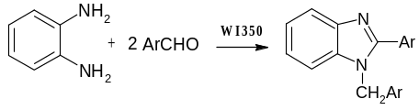
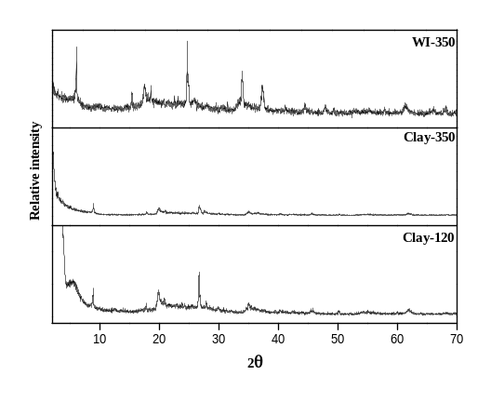Fig.1. PXRD Patterns of Clay-120, Clay-350 and WI-350

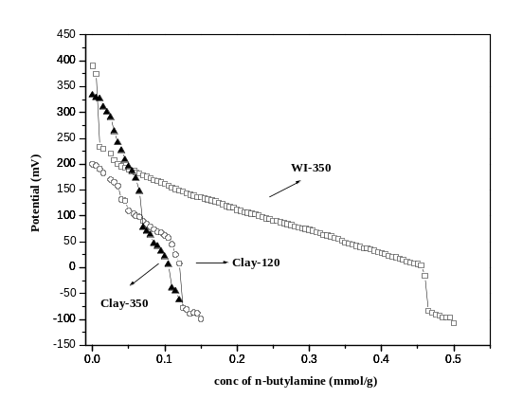Fig.2. Acidity distribution curves of Clay-120, Clay-350 and WI-350

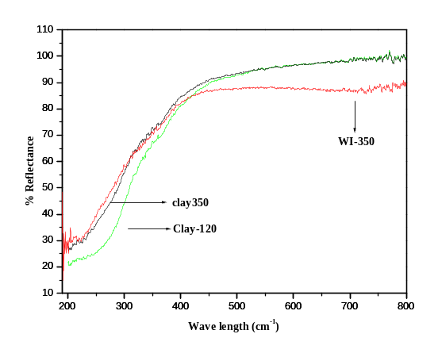Fig.3. UV-DRS of WI-350

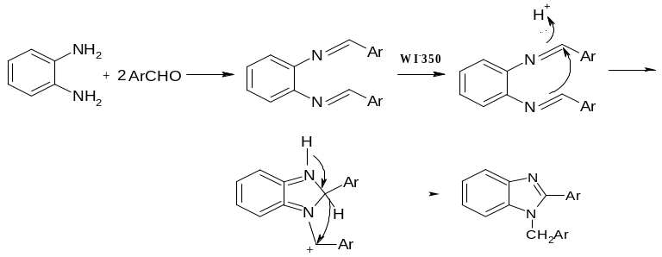Scheme 2

Table.1. d-spacing values and relative intensities of the catalyst material

Clay-120
d(Ǻ) | 15.42 | 9.92 | 4.98 | 4.47 | 4.26 | 3.34 | 3.19 | 2.56 | 1.98 | 1.82 | 1.67 | 1.49
I/I_{o} | 304 | 230 | 115 | 208 | 146 | 345 | 94 | 110 | 68 | 46 | 35 | 64
Clay-350
d(Ǻ) | - | 9.90 | 4.96 | 4.46 | - | 3.34 | - | 2.56 | 1.99 | 1.82 | 1.67 | 1.50 | 2.45 | 3.82
I/I_{o} | - | 141 | 50 | 95 | - | 124 | - | 58 | 36 | 24 | 38 | 35 | 44 | 49
WI-350
d(Ǻ) | - | 9.97 | 4.98 | 4.49 | 4.26 | 3.34 | - | 2.53 | 1.99 | 1.86 |  | 1.50 | 1.39 | 2.33 | 1.37
I/I_{o} | - | 326 | 132 | 164 | 157 | 351 | - | 220 | 81 | 89 |  | 82 | 66 | 159 | 80

Table.2. Catalytic activity of clay-120, clay-350 and WI-350

Catalyst | Products obtained | Isolated yield* (%)
Clay-120 | 1-benzyl-2-phenyl-1H-1,3-benzimidazole and  2-phenyl benzimidazole | 30
Clay-350 | 1-benzyl-2-phenyl-1H-1,3-benzimidazole and  2-phenyl benzimidzole | 45
WI-350 | 1-benzyl-2-phenyl-1H-1,3-benzimidazole | 85

*Isolated yield is the yield of 1,2-disubstituted benzimidazole obtained after column chromatography
(Elent 1:5 – EtOAc: Pet.ether)

