Selective production of liquid fuels from renewable: One pot sequential multifunctional catalysis in water
Churchil A. Antonyraj and S. Kannan*
Discipline of Inorganic Materials & Catalysis, Central Salt and Marine Chemicals Research Institute (Council of Scientific & Industrial Research), GB Marg, Bhavnagar – 364 021, Gujarat, INDIA
*Dr.S.Kannan: FAX: +91-278-2567562 E-mail: skannan@csmcri.org
Abstract
Production of liquid alkanes from renewable is an important topic of energy research. Liquid alkanes can be potentially used as fuels, in particular for aviation, unlike the other oxygenated fuels such as ethanol, butanol, biodiesel etc. Oxygenated fuels pose modifications in engine design possess lesser energy density while liquid alkanes can be used with existing technologies and have higher energy density. Production of liquid alkanes from cellulose has an advantage of non-interference with food. We have synthesized palladium containing MgAl layered double hydroxides (LDHs) with varying palladium content by co-precipitation and characterized by diverse physicochemical techniques. One pot sequential aldol condensation-hydrogenation of furfural with acetone (see scheme below) was done using these materials and their heated forms as multifunctional catalysts in water as solvent. Palladium concentration and parametric variations studies were done to obtain high conversion and selectivity. 5 % Pd containing calcined LDH showed 100 % conversion with 83 % C₁₃ product selectivity under optimized conditions. This is the first report that claims the selective formation of C₁₃ alcohols (which in turn can be converted to alkanes) from furfural.
Keywords
Liquid alkanes; Renewable fuels; Layered double hydroxides (LDH); Palladium

1. Introduction
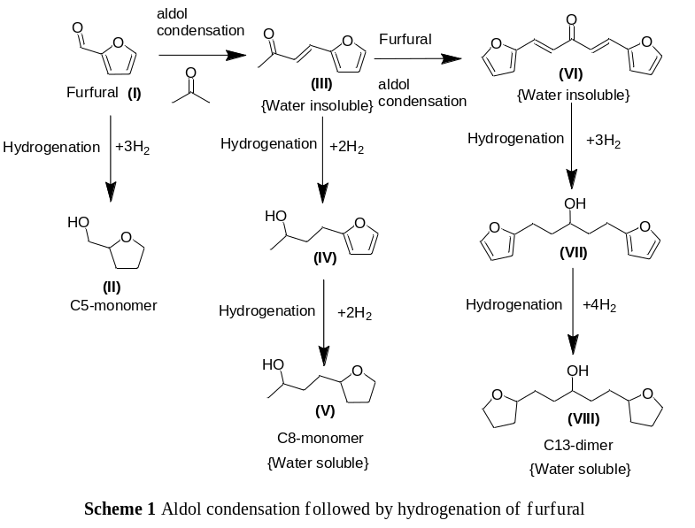A report claims that the worldwide reserves of oil are sufficient to supply energy and chemicals for only about another 40 years, causing widening concerns on our sustainablity¹. While hydrogen fuel-cell driven vehicles are striving to find a way, attention on biofuels and batteries are staging a strong comeback besides exploring to obtain energy using solar or wind². The production of energy from biomass has the potential to generate lower green house gas emissions compared to the fossil fuels, as the CO₂ released during fuel burning for energy is consumed during the subsequent biomass re-growth. Focus has been paid recently on the use edible biomass (like starch, corn, sugarcane etc.) to produce fuels and chemicals; however they should primarily be used as a source of food in view of increasing population. Hence the fuel (mainly ethanol) production needs to meet major changes in agricultural practices for food, feed and export demands. The International Energy Agency projected in 2007 that world energy demands would raise by 45% by 2030. If one were to project forward the predicted growth in renewable energy, we may get around 17% of it coming by 2030. Lignocellulosic and cellulosic biomasses are the two promising non-edible options available as renewable for making fuels and chemicals. Cellulose is neither soluble in water nor digestible for humans because of its robust structure composed of β-1,4-glycosidic bonds of d-glucose. Lignocellulosic is recalcitrant abundant biomass consist of cellulose (35-50 %), hemicelluloses (25-30 %) and lignin (15-30 %). The annual net yield of photosynthesis is 1.8 trillion tons, approximately 40% of which is cellulose³. Tremendous efforts are being pursued throughout the globe to produce chemicals from such biomass; the high content of oxygenated functional groups in such biomass is an advantage for the production of chemicals, however a hurdle for producing fuels albeit produced such as bio-alcohols (mainly ethanol). Although oxygenated fuels obtained from biomass are generally free from sulfur and aromatics they produce high emission of PAHs (poly aromatic hydrocarbons) and soot; to apply these materials as fuel for automobiles needs significant alteration in the automobile engineering⁴. Further, the energy density of ethanol (6.1 kWhL⁻¹) is much lesser than standard gasoline (8.8 kWhL⁻¹) and diesel fuel (9.7 kWhL⁻¹)⁵. Besides this, ethanol also has several other limitations like high volatility, contamination by the absorption of water from atmosphere⁶ and possess poor overall energy efficiency (ratio of heating value of alcohol to energy required to produce alcohol) of about 1.1 to 1.3. The production of liquid alkanes with carbon number C₇ to C₁₃ from cellulose through furfural (Scheme 1) is an interesting alternative that have several advantages like high boiling point and higher energy efficiency (ratio is 2.1)¹. Further, conversion of cellulose or lignocelluloses to biofuels or chemicals will not impose a negative impact on food supplies⁷. Several reports are available to synthesize furan compounds from cellulose and sugars⁸⁻¹². Production of hydrocarbon fuels by the condensation of acetone and hydroxymethyl furfural (HMF) is one of the interesting approaches¹³. The challenge however remains here is the selective conversion to desired products in the perspective of both atom and price economy; available materials for the synthesis of water soluble alcohols failed to produce selectively C₈ or C₁₃ alcohols through the above reaction^{14,15}. Recently Crossley et al. showed the selective production of C₈ alcohols from biomass derived furfural using Pd/SWNT-SiO₂ catalyst at water/oil interface catalyst¹⁶. Herein we report the selective synthesis of C₁₃ alcohols from the condensation of furfural and acetone at a molar ratio of 1:1 using noble metal modified calcined layered double hydroxides (LDHs) as multifunctional catalysts and this is the first time to the best of our knowledge wherein selective synthesis of C₁₃ alcohols was achieved at very less furfural:acetone mole ratio¹⁷.
2. Experimental
Palladium containing LDHs were synthesized by co-precipitation method. Extreme care was taken to control the Pd content of the materials. Calcination of these materials was done at 700 ºC in static air. The materials were characterized by PXRD, FT-IR, TGA and ICP measurements. One pot condensation-hydrogenation reaction was carried out at various pressures and temperatures in a high pressure static reactor (Reaction Engineers, R-201 series), wherein the substrate, solvent and catalyst were added at once. The condensation reaction was done at 80 ºC at 10 bar N₂ pressure for 5 h while hydrogenation was done at 120 ºC at 50 bar H₂ pressure for 24 h. The contents were cooled to room temperature and the pressure was released and the products were analyzed by GC and GC-MS.
3. Results and discussion
Palladium containing LDHs (Layered double hydroxides) with Pd/M(II) atomic ratio of 0.5/99.5, 1/99, 2/98, and 5/95 were synthesized using co-precipitation method. Both as-synthesized and calcined materials were tested for this consecutive reaction and found that calcined materials were more active as compared to as-synthesized materials. Parametric variations such as time, solvent, catalyst weight ratio, temperature and pressure variation studies were done to obtain high conversion of furfural. Once we found that the entire conversion of furfural is achieved (as the condensed product is insoluble in water), subsequent hydrogenation was carried out in the same reactor without removing the contents from the reactor. Figure 1 shows the reaction mixture after the hydrogenation at various pressures, over 2 % palladium containing LDH. This figure shows that 50 bar H₂ pressure is necessary for the complete hydrogenation of the condensed products that dissolved in water. Table 1 shows the catalytic activity of the synthesized materials calcined at 700 ºC.
Table 1 One-pot sequential catalysis over Pd containing calcined LDHs
Product | PdMgAl-0.5-CLDH | PdMgAl-1-CLDH | PdMgAl-2-CLDH | PdMgAl-5-CLDH
I | 0 | 0 | 0 | 0
II | 3.9 | 3.6 | 2.6 | 4.5
III | 18.1 | 3.4 | 5.4 | 0
IV | 22.4 | 20.8 | 21.3 | 5.7
V | 3.7 | 1 | 1.8 | 6.5
VI | 19.1 | 10.3 | 10.7 | 0
VII | 31.5 | 57.4 | 54.7 | 42
VIII | 1.2 | 3.5 | 3.4 | 41.2
*Fufural : Acetone 1:1 (0.0136 mol), Solvent 38 ml, Catalyst 346 mg, Step-1: 80 ºC, 10 bar N₂ for 5 h ; Step-2:120 ºC, 50 bar H₂ for 24 h
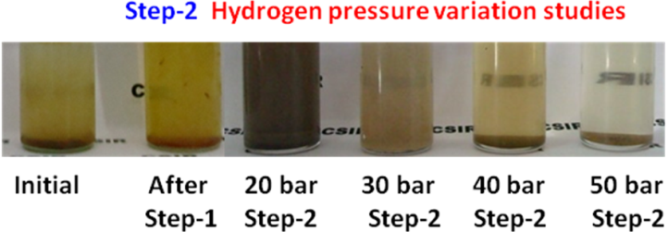
Figure 1Nature of reaction mixture at different hydrogen pressures
All catalysts showed the complete conversion of furfural. As the palladium concentrations in the catalyst increased the formation of hydrogenated product increased. For 0.5% substitution of Pd gave 51 % C₁₃ selectivity with 64 % of hydrogenated product while 5% Pd substitution gave 83 % C₁₃ product selectivity with 100 % hydrogenated product. In other words, as the palladium concentration increased the product selectivity towards the C₁₃ product was also increased. This confirms that the presence of Pd in LDH matrix not only affect on the hydrogenation reactivity but also facilitate the selective formation of C₁₃ condensed product.
4. Conclusion
In conclusion one pot consecutive aldol condensation and hydrogenation of furfual with acetone was carried out using Pd containing calcined LDHs as multifunctional catalysts. Pd content of the material is critical wherein increasing the Pd concentration enhanced the selectivity of the hydrogenated product with preferential formation of C₁₃ product. We have achieved 100 % conversion of furfural with 83 % C₁₃ product selectivity. Thus obtained water soluble alcohols after the reaction can be converted into liquid alkanes using Pt-based hydrogenation catalysts.
Acknowledgements
The authors thank Council of Scientific & Industrial Research (CSIR), New Delhi for the financial assistance under Network Program NWP0010. CAA thanks CSIR, New Delhi for a Senior Research Fellowship.
References
- J.N. Chheda, G.W. Huber, J.A. Dumesic, Angew. Chem. Int. Ed. 46 (2007) 7164.
- J. Tollefson, Nature 464 (2010) 1262.
- L.T. Fan, M.M. Gharpuray, Y.-H. Lee, Cellulose Hydrolysis, Springer, Berlin, 1987.
- K. Kohse-Hoinghaus, P. Oßwald, T.A. Cool, T. Kasper, N. Hansen, F. Qi, C.K. Westbrook, P.R. Westmoreland, Angew. Chem. Int. Ed. 49 (2010) 3572.
- M. Mascal, E.B. Nikitin, Angew. Chem. Int. Ed. 47 (2008) 7924.
- Y.R. Leshkov, C.J. Barrett, Z.Y. Liu, J.A. Dumesic, Nature 447 (2007) 982.
- N. Ji, T. Zhang, M. Zhang, A. Wang, H. Wang, H. Wang, X. Wang, J.G. Chen, Angew. Chem. Int. Ed. 47 (2008) 8510.
- Y.R. Leshkov, J.N. Chheda, J.A. Dumesic, Science 312 (2006) 1933.
- H. Zhao, J.E. Holladay, H. Brown, Z.C. Zhang, Science 316 (2007) 1597.
- R. Rinaldi, R. Palkovits, F. Schuth, Angew. Chem. Int. Ed. 47 (2008) 8047.
- Y. Su, H.M. Brown, X. Huang, X. Zhou, J.E. Amonette, Z.C. Zhang, Appl. Catal. A Gen. 361 (2009) 117.
- J.B. Binder, R.T. Raines, Proc. Natl. Acad. Sci. 107 (2010) 4516.
- J.N. Chheda, J.A. Dumesic, Catal. Today 123 (2007) 59.
- C.J. Barrett, J.N. Chheda, G.W. Huber, J.A. Dumesic, Appl. Catal. B Environ. 66 (2006) 111.
- W. Xu, X. Liu, J. Ren, P. Zhang, Y. Wang, Y. Guo, Y. Guo, G. Lu, Catal. Commun. 11 (2010) 721.
- S. Crossley, J. Faria, M. Shen, D.E. Resasco, Science 327 (2010) 68.
- H. Liu, W. Xu, X. Liu, Y. Guo, Y. Guo, G. Lu, Y. Wang, Kinetics and Catal. 51 (2010) 75.

