In-situ encapsulated RhCl(TPPTS)₃ into the hexagonal mesoporous silica for hydroformylation of vinyl esters
N. Sudheesh, Amit K. Chaturvedi and Ram S. Shukla*
Discipline of Inorganic Materials and Catalysis, Central Salt and Marine Chemicals Research Institute, Council of Scientific and Industrial Research (CSIR), G. B. Marg, Bhavnagar 364 002, Gujarat, India
* Corresponding Author: Phone No +91 278 2567760, rshukla@csmcri.org
Abstract: RhCl(TPPTS)₃ (TPPTS = m-trisulphonato triphenyl phosphine) was encapsulated into the mesopores of hexagonal mesoporous silica (HMS) by insitu method. The catalyst was characterized by PXRD, ³¹P-CPMAS NMR, FT-IR, N₂ sorption, TGA, SEM and ICP techniques. The synthesized heterogeneous catalyst was evaluated for hydroformylation of vinyl esters. The conversion levels of >99% was obtained with high selectivity to iso-aldehyde with small amounts of corresponding acid and propanal.
Keywords: Hydroformylation, vinyl esters, hexagonal mesoporous silica, heterogeneous catalysis
1. Introduction
Hydroformylation is one of the most important methods for the functionalization of olefinic double bond [1]. Hydroformylation of vinyl esters is important because the route is versatile for the synthesis of commercially important products [2-5]. In general, the vinyl acetate hydroformylation was done in homogeneous conditions [6, 7]. Homogeneous process has the drawback of separation and recycling of the catalyst. Hence development of a heterogeneous catalyst system for the hydroformylation of vinyl esters has a potential concern to overcome the drawbacks of the homogeneous counterpart. We have attempted the insitu encapsulation of RhCl(TPPTS)₃ (TPPTS = m-trisulphonato triphenyl phosphine) into the pores of HMS and investigated the encapsulated material for the hydroformylation of vinyl esters.
2. Experimental
2.1 Catalyst synthesis
The catalyst was synthesized by the modification of the method reported elsewhere [1]. The synthesis of the catalyst was done by dissolving 0.0027mol of dodecyl amine in a mixture of 0.0909 mol of ethanol and 0.296 mol of deionised water. To this stirring solution 0.07 mmol of the RhCl(TPPTS)₃ was added. TEOS (0.01 mol) was added in drop to this solution. Stirring was continued for 1 h and a pale yellow precipitate formed was kept for 18 h for aging at RT. The yellow precipitate was filtered and dried in vacuum at RT. The catalyst was named as Rh-TPPTS-HMS.
3. Results & discussion
3.1. Catalyst characterization
The catalyst was characterized for the formation of HMS by P-XRD and is shown in Fig. 1. It showed an intense reflection near 2.0° of 2θ corresponding to the (1 0 0) plane corresponding to HMS.
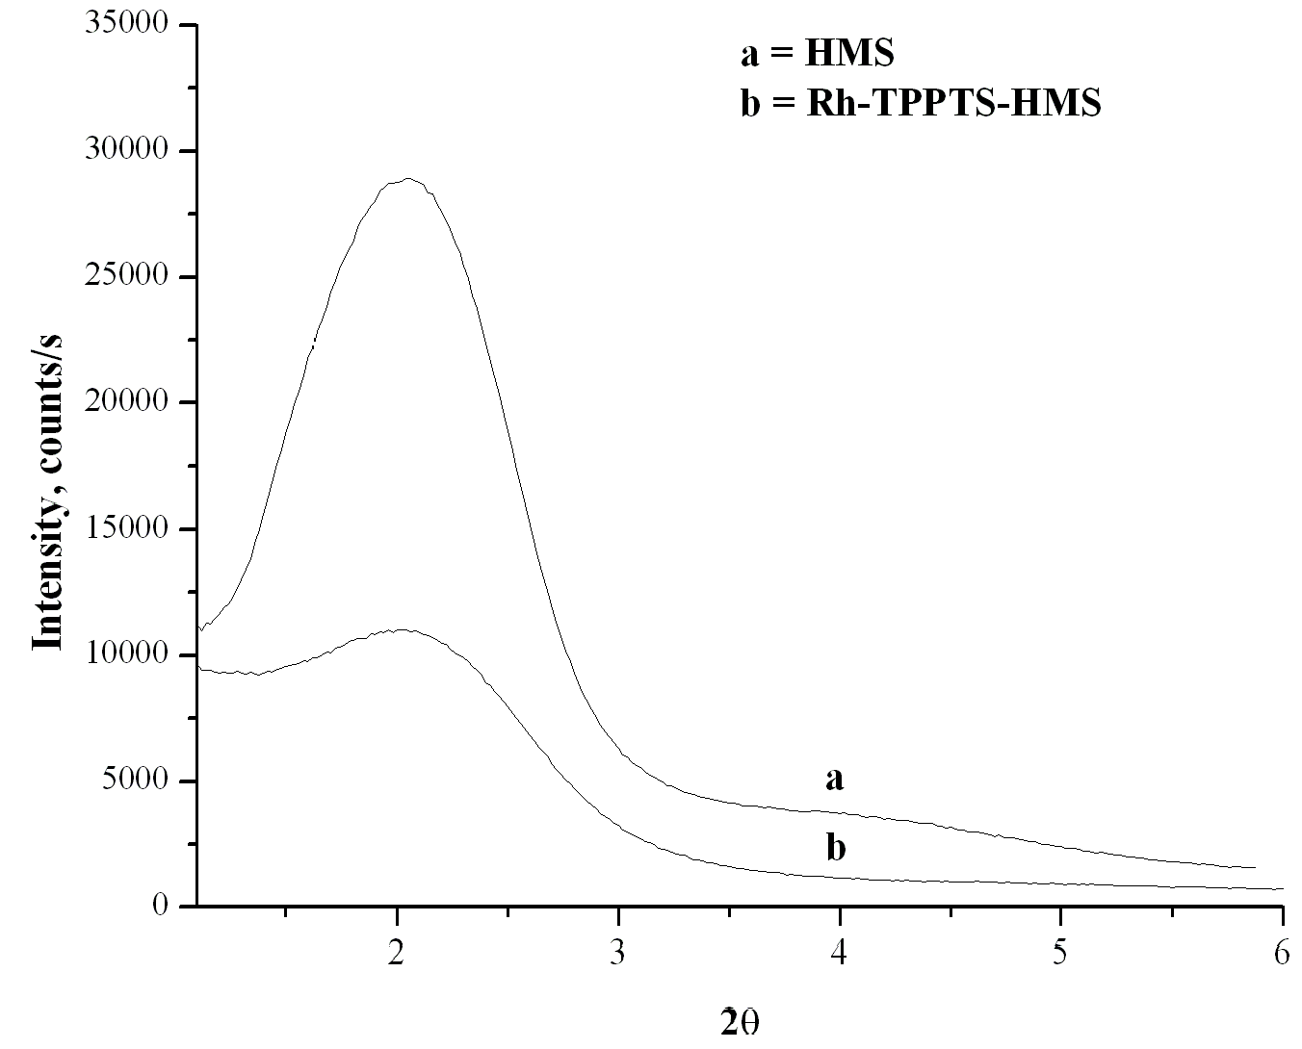
Fig. 1. PXRD of HMS and Rh-TPPTS-HMS
The ³¹P-NMR was taken to confirm that the complex has been encapsulated without decomposition. Rh-TPPTS-HMS catalyst was analyzed by ³¹P-CPMAS NMR. Rh-TPPTS-HMS showed these peaks at 31.12 and 26.04 confirming that the complex has been encapsulated without decomposition. The N₂ sorption isotherm has been depicted in Fig. 2. The surface area of HMS and Rh-TPPTS-HMS were 136.54 and 59.85 m²/g respectively. The surface area was decreased when the pores were occupied with the encapsulated RhCl(TPPTS)₃ confirming that the complex has been encapsulated in the pores of HMS.
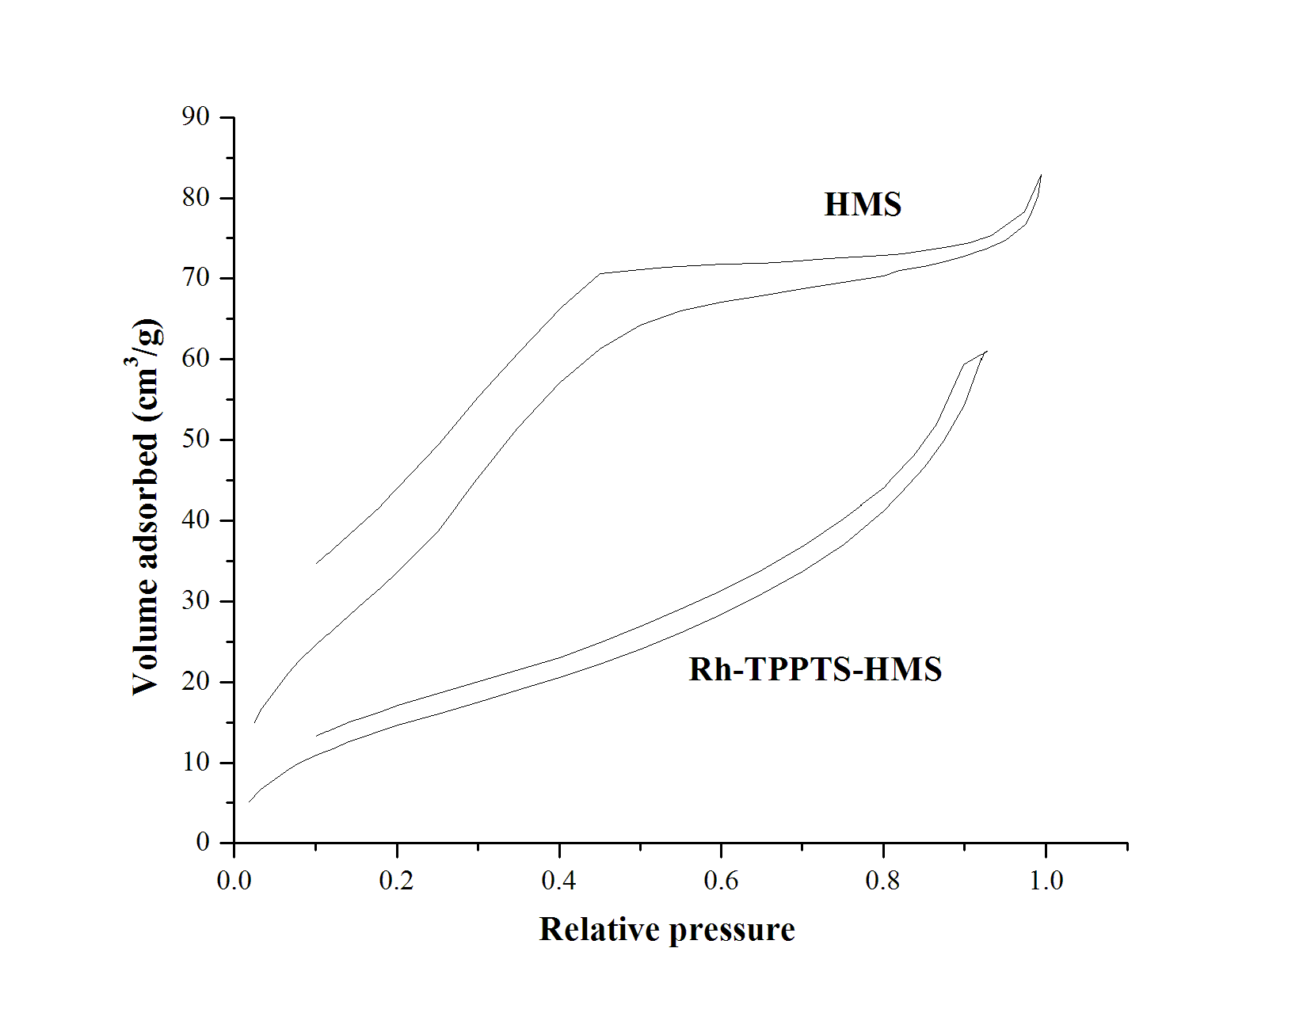
Fig. 2. N₂ sorption isotherm
3.2. Hydroformylation of vinyl esters
Hydroformylation of vinyl esters were carried out and the results were given in Table 1. The catalyst was found to be efficient for the hydroformylation of vinyl esters. All the studied vinyl esters gave 100 % conversion with high selectivity to iso-aldehyde. Formation of normal aldehyde was not observed however a small amount of corresponding acid and propanal was found to be formed in each case.

Table 1. Hydroformylation of vinyl esters
Entry | Substrate | Time, h | % Conversion | % Selectivity
 |  |  |  | Iso-aldehyde | Other
1 | Vinyl acetate | 12 | 100 | 94 | 6
2 | Vinyl propionate | 12 | 100 | 93 | 7
3 | Vinyl butyrate | 12 | 100 | 91 | 9
4 | Vinyl benzoate | 12 | 100 | 88 | 12
Reaction conditions: substrate = 23.3 mmol, catalyst = 50 mg, syn gas = 40 bar, temp. = 100 °C, solvent = toluene (50 mL)
4. Conclusions
RhCl(TPPTS)₃ was encapsulated by insitu technique into the pores of HMS. The catalyst was characterized and evaluated for hydroformylation of vinyl esters and found to be selective for the formation of iso-aldehyde.
Acknowledgments
Authors thank Council of Scientific and Industrial Research (CSIR) New Delhi, India for financial supports for Network Project for the Development of Specialty Inorganic Materials for Diverse Applications. NS acknowledges CSIR, New Delhi for the award of Senior Research Fellowship.
References
- N. Sudheesh, S. K. Sharma, R. S. Shukla, R. V. Jasra, J. Mol. Catal. A Chem., 296 (2008) 61–70.
- Y. L. Borole, R. V. Chaudhari, Ind. Eng. Chem. Res. 44 (2005) 9601–9608.
- P. J. Thomas, A. T. Axtell, J. Klosin, W. Peng, C. L. Rand, T. P. Clark, C. R. Landis, K. A. Abboud, Org. Lett., 9 (2007) 2665–2658.
- H. B. Tinker, US Patent 4 072 709 (1978) to Monsanto Company.
- G. Fremy, E. Monflier, J. Carpentier, Y. Castanet, A. Mortreux, J. Mol. Catal. A: Chem. 129 (1998) 35–40.
- T. Horiuchi, E. Shirakawa, K. Nozaki, H. Takaya, Organometallics 16 (1997) 2981–2986.
- N. R. Vautravers, D. J. Cole-Hamilton, Chem. Commun. (2009) 92–94.

