Catalytic hydrogenation of aromatic nitro compounds using polymer–supported palladium-2-methylimidazole complex

Abstract
Polymer–supported palladium-2-methylimidazole complex catalyst has been synthesized using chloromethylated polystyrene beads cross-linked with 6.5% divinylbenzene as support and was characterized by elemental analysis, IR spectroscopy, TG analysis, XPS, SEM, bulk density and surface studies by BET method. Swelling studies in different solvents was also investigated. The synthesized catalyst was used for hydrogenation of nitrobenzene and few of its derivatives under ambient conditions. Results reveal that the electronic as well as steric effect of the substituent control the rate of hydrogenation of nitro group in the studied substrates and a linear relationship exists between the reactivity of substrates and Hammett substituent constant The reaction kinetics was studied by varying the catalyst, substrate concentration and temperature. A plausible hydrogenation mechanism has been proposed. The catalyst was recycled six times without any loss in activity and metal leaching.
Key words:
Transition metal complexes, Polymer-supported palladium-2-methylimidazole complex catalyst, hydrogenation, aromatic nitro compounds.
*Corresponding author E-mail: gayathritvr@yahoo.co.in
Tel. number: +91-080-22961348.

1. Introduction:
Aromatic amines which are important intermediates for the synthesis of various chemicals are generally prepared by hydrogenation of aromatic nitro compounds. Transition metal complexes have been found to catalyze hydrogenation of various nitro compounds in homogeneous medium [1-4]. As transition-metal complexes are often expensive to prepare and recent interest in development of environmentally benign synthesis has evoked interest in development of polymer-supported metal complex catalysts. These catalysts offer a number of advantages over traditional solution phase reactions where the catalyst can be easily recovered from reaction mixture by simple filtration and can be recycled. A variety of solids are used as supports to immobilize catalysts on them. Among them polymers which are chemically inert, non-toxic, stable and recyclable are important. Selection of suitable polymer support for synthetic use is essential. Anchor metal complexes on the polymer supports are reported and successfully used as catalysts for hydrogenation, oxidation, dehalogenation, epoxidation, polymerisation etc,. [5-10]. In this context chloromethylated polystyrene beads cross-linked with 6.5% divinylbenzene which contain highly reactive chloromethyl functional group can be readily converted to other functional group or by attaching a ligand metal salts can be anchored on to it to form a supported metal complex catalyst. By changing the ligands and metal salts a wide range of supported metal complex catalysts can be prepared which can be used for different reactions [11-14]. Recently we have used various polymer supported catalysts for hydrogenation of olefins, nitro compounds and Schiff bases. [15-17].

Present work has been focused on synthesis and characterization of polymer-supported palladium 2-methylimidazole complex catalyst and its use as heterogeneous catalyst for hydrogenation of various aromatic nitro compounds under ambient conditions [18-20]. The influence of various parameters such as concentration of catalyst and substrate, temperature on the rate of reaction was studied. Based on the results a plausible hydrogenation mechanism has been proposed. The dependency of substrate reactivity on substitution of nitrobenzene with few functional groups has been examined [18]. The catalyst was recycled six times without any loss of efficiency or leaching of metal.
2. Experimental
2.1 Materials, Methods and Equipment
Chloromethylated polystyrene beads cross-linked with 6.5% divinylbenzene (PS-DVB) was obtained as a gift by Thermax India Ltd, Pune, India. Palladium chloride was procured from Arora Matthey Ltd, India. All the substrates and solvents were purified before use. The IR spectra were recorded using a Shimadzu FTIR-8500S spectrometer and far-IR spectra by using a Perkin Elmer-Spectrum 1000 FTIR spectrometer. Surface area was measured using a Nova 1000 instrument in nitrogen atmosphere. TGA studies were carried out using a Perkin Elmer-Diamond instrument under inert atmosphere. Scanning electron micrographs were recorded on a Leica S440i. HPLC studies were recorded using a Shimadzu-Prominence 2A with C18 column and UV detector. GC-MS were recorded with a Shimadzu GC-MS instrument. C, H and N analyses were carried out using a Thermo Finnegan Eager 300 and a Elementar Vario EL III, Carlo Erba 1108. Palladium content was determined using a GBC Avanta-PM atomic absorption spectrophotometer. Photoelectron spectra were recorded on a ESCA-3000 electron spectrometer, equipped with a hemispherical electron analyzer using the Al K_{α} radiation (1486.6 eV) X-ray source. The neat complex [Pd(MeImz)₂Cl₂] (MeImz = 2-Methylimidazole) was prepared according to a literature method [21].
2.2 Preparation of the polymer-supported palladium-2-methylimidazole catalyst
Functionalisation of PS-DVB was carried out by treating PS-DVB with 2-methylimidazole , in a mixture of 1:1 toluene and acetonitrile on a hot water bath maintained at 50ºC for 60 hours [18].The functionalised beads were filtered and washed by Soxhlet extraction using ethanol as a solvent. The beads were treated with ethanolic solution of palladium chloride at 50⁰Cfor 10 hours. Beads were filtered and finally washed by Soxhlet extraction using ethanol and dried (Scheme 1) [22, 23]. The polymer supported complex was activated by treating with ethanolic solution of sodium borohydride, washed several times with methanol and vacuum-dried [24].
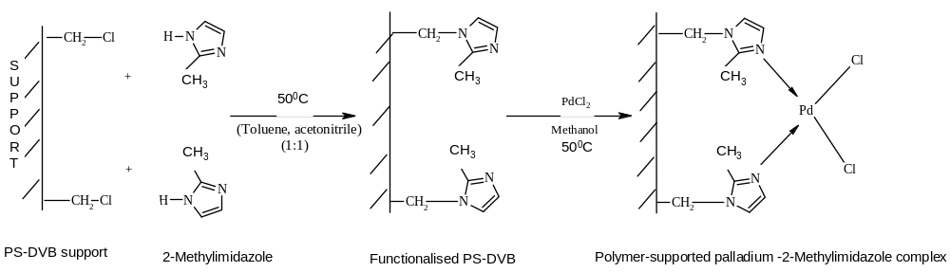
Scheme 1. Preparation of the polymer-supported palladium-2-methylimidazole catalyst.

2.3 Hydrogenation procedure
All the reactions were carried out using methanol as a solvent at 596 mm Hg hydrogen pressure in a glass reactor. In a typical experiment, the catalyst was added along with the solvent into the reactor, flushed with hydrogen and evacuated. A known quantity of the substrate was injected and the system was opened to hydrogen gas burette. The reaction was monitored by hydrogen uptake at different intervals of time [24]. The reaction mixture was then filtered, evaporated to dryness and the resulting solid was recrystallized. Products obtained were identified using HPLC, IR spectra and GC-MS [26]. A blank reaction was also carried out for all the substrates without using the catalyst.
Abbreviations:
PS-DVB: Chloromethylated polystyrene beads cross-linked with 6.5% divinylbenzene, PSMeimz: PS-DVB functionalised with 2-methylimidazole, PSPdMeimz: PSMeimz treated with palladium chloride, PSPdMeimz-actv.: PSPdMeimz treated with methanolic solution of sodium borohydride, PSPdMeimz -rec: Recycled catalyst, [Pd(MeImz)₂Cl₂] (MeImz = 2-Methylimidazole), NB: nitrobenzene, PNA: p-nitroaniline, PNP: p-nitrophenol, PNT: p-nitrotoluene, PNBA: p-nitrobenzoic acid, PDNB: p-dinitrobenzene and PCNB: p-chloronitrobenzene.
3. Results and discussion
3.1 Characterization of the catalyst
Catalysts that are prepared need to be characterized before use and various experimental techniques are used for this purpose.

3.1.1 Surface area and porosity of the catalyst
In heterogeneous catalysis the reaction occur on the surface. Solid catalysts are generally porous in nature and the pores play a very important role in their adsorption behavior [27]. They have large surface area due to their porous nature .Surface area and porosity of a supported catalyst was determined by BET method at all stages of catalyst preparation and is tabulated along with apparent bulk density in Table1. Changes in surface area, pore volume and pore diameter after functionalisation and activation of the catalyst was observed which may be due to surface reconstruction and blocking in pores of the polymer-support. No significant changes were observed after recycling which indicates that agglomeration of active species has not taken place during recycling. Bulk density of the support has increased due to functionalisation and anchoring of metal salt on it.

Table 1.

Physical properties of polymer-support and polymer supported catalyst.
 | Pore volume  (cm³/g) | Surface area  (m²/g) | Pore diameter  Å | Apparent bulk density  (g/cm³)
PS-DVB | 0.042 | 28 | 59.67 | 0.323
PSMeimz | 0.052 | 22 | 48.12 | 0.332
PSPdMeimz | 0.029 | 27 | 44.25 | 0.487
PSPdMeimz-actv. | 0.030 | 22 | 54.20 | 0.489
PSPdMeimz–rec. | 0.035 | 22 | 47.45 | 0.468

3.1.2 SEM
Scanning electron micrographs of PS-DVB (Figure1.a) and PSPdMeimz-actv (Figure1.b) were taken to study the surface of the polymer support and the catalyst [28]. Change in morphology of the activated catalyst was observed when compared with the support. The morphological changes could be due to reconstruction of the surface during catalyst preparation. .

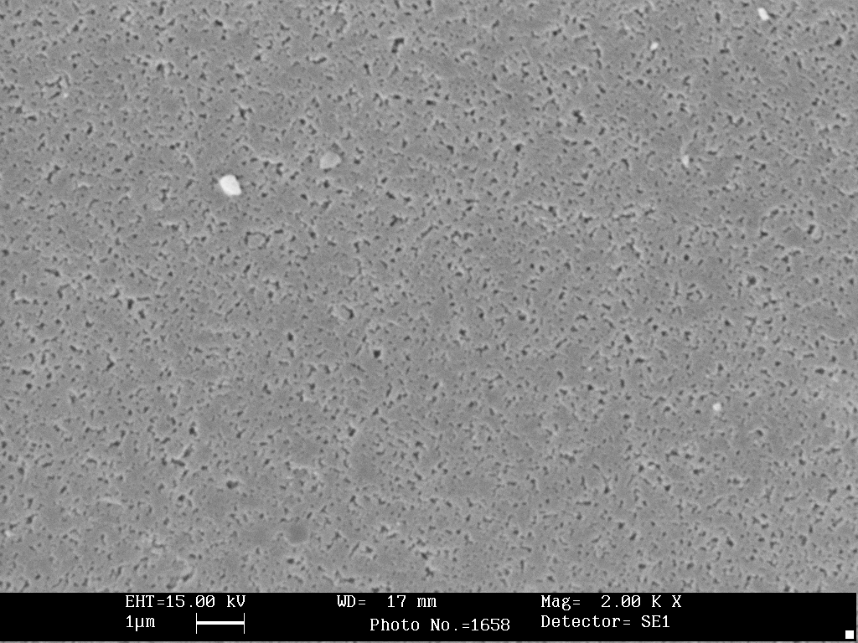
Figure 1.a. Scanning electron micrograph of PS-DVB.

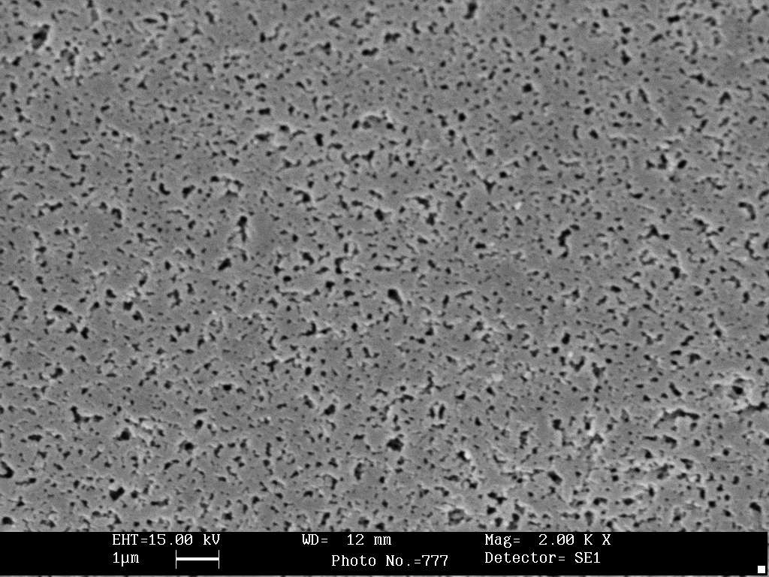
Figure 1.b. Scanning electron micrograph PSPdMeimz-actv.

3.1.3. TGA studies
Thermal stability of the catalyst was studied by TG analyses in an inert atmosphere with heating rate of 10ºC/min up to 500ºC. The TGA curve for PSPdMeimz-actv. is shown in Figure 2. The weight loss below 100ºC is due to the moisture content which was found to be 13%. No significant weight loss has been observed till 225ºC. No changes in TGA were observed after recycling the catalyst [29].
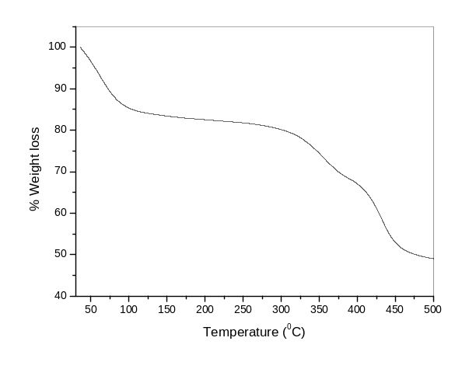
Figure 2. TGA curve of PSPdMeimz-actv.

3.1.4 Swelling studies
Swelling studies for polymer-supported catalyst was carried out in different solvents at room temperature [9]. Swelling of the catalyst was found to be maximum in methanol.
3.1.5 Elemental analysis
Elemental analysis at different stages of preparation of the catalyst was carried out and the data are tabulated in Table 2. Presence of nitrogen in PSMeimz determined the extent of functionalisation of PS-DVB. Palladium content was determined by stripping the bound palladium complex from the support and analyzed using atomic absorption spectrophotometer. Palladium content remained almost unchanged even after recycling the catalyst for six cycles.

Table 2.
Elemental analysis of polymer support and polymer-supported catalyst.
 | % C | % H | % N | % Pd
PS-DVB | 69.50 | 5.78 | - | -
PSMeimz | 57.86 | 5.37 | 8.02 | -
PSPdMeimz | 54.59 | 5.64 | 6.01 | 12.29
PSPdMeimz-actv: | 55.54 | 5.22 | 7.01 | 12.27
PSPdMeimz -rec | 55.28 | 6.43 | 7.11 | 12.00

3.1.6 Infrared spectral studies
The IR spectra of PS-DVB, PSMeimz, PSPdMeimz, PSPdMeimz-actv., PSPdMeimz-rec and [Pd(MeImz)₂Cl₂ were recorded in nujol and a comparative study was made (Figure 3). The peak at 1265 cm⁻¹ for PS-DVB due to – CH₂Cl (Spectrum A) has decreased in intensity on functionalisation [30]. The peak at 3170 cm⁻¹ corresponding to υ_{N-H} of 2-methylimidazole disappeared on functionalisation indicating the bonding of 2-methylimidazole to the support through – CH₂ –. The decrease in intensity of band at 833 cm⁻¹ corresponding to υ_{C-Cl} of PS-DVB after functionalisation further confirms the bonding of 2-methylimidazole with PS-DVB (Spectrum B). [Pd(MeImz)₂Cl₂] exhibited υ_{N-H} at 3304 cm⁻¹ (Spectrum F). This peak is not found in the polymer supported complex catalyst since the complex has bonded to polymer support through nitrogen. No significant changes in the spectral features were observed for PSPdMeimz (Spectrum C) , PSPdMeimz-actv. and PSPdMeimz-rec. A high intense peak at 326 cm⁻¹ in the far-IR spectrum recorded for PSPdMeimz-actv. has been assigned to Pd-Cl stretching.
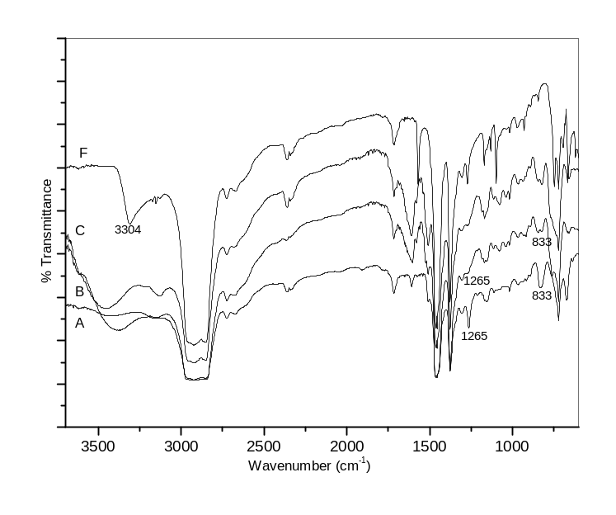

Figure 3. IR - spectra of (A) PS-DVB, (B) PSMeimz. , (C) PSPdMeimz. , (F) [Pd(MeImz)₂Cl₂].

3.1.7. XPS Studies
To find the oxidation state of the metal in PSPdMeimz.and PSPdMeimz-actv. XPS were taken (Figure 4). PSPdMeimz. exhibited two peaks with binding energies 337.7 eV (3d_{5/2}) and 342.9 (3d_{3/2}) indicating the +2 oxidation state of palladium (Spectrum C). For PSPdMeimz-actv. the peaks were found at 337.9 (3d_{5/2}) and 343.0 (3d_{3/2}) indicating the presence of palladium in +2 oxidation state (Spectrum D) [24, 31].



Figure 4. XPS spectra of (C) PSPdMeimz. and (D) PSPdMeimz-actv.

3.2 Hydrogenation reaction
When palladium-2methylimidazole complex was used as catalyst for hydrogenation of nitro compounds, it resulted in separation of metal from the reaction mixture during the course of the reaction. When the polymer-supported palladium-2-methylimidazole catalyst was used for the reduction of nitrobenzene and few of its derivatives it was found that during the reaction metal does not leach out from the polymer support and was found to be intact even after recycling for six times. Since the swelling of the catalyst and the solubility of hydrogen is maximum in methanol all the reactions were carried out using methanol as solvent at 596 mm Hg of hydrogen pressure. Since the activity of the activated catalyst (D) was more compared to (C), the activated catalyst was used for hydrogenation reactions [24]. The products were identified by HPLC, GC-MS and IR spectral studies [26]. To determine the effect of substitution at the para position of nitrobenzene on hydrogenation, few derivatives with -NH_{2,} -OH, -CH_{3,} -COOH and -NO₂ groups were chosen [14, 18]. The steric effect of substituents on rate of hydrogenation was studied by comparing the hydrogenation rate of different isomers of nitroaniline and nitrobenzoic acid [32]. When PCNB was used as the substrate, during the hydrogenation dechlorination was observed giving aniline as the product [33]. Hence the effect of chloro group on the rate could not be determined.
Scheme 2. Hydrogenation of aromatic nitro compounds
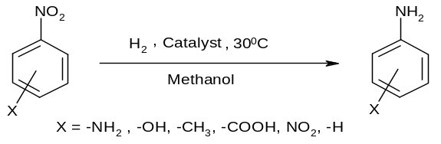

Kinetic studies
The kinetics of hydrogenation of the few nitro aromatics were studied by following the hydrogen uptake at 596 mm Hg hydrogen pressure. The rate of hydrogenation was calculated from the slope after plotting the volume of hydrogen uptake by the substrate as a function of time [34]. The dependency of the rate on variables like catalyst, substrate concentration and temperature was studied in detail for all the substrates.
3.2.1 Effect of catalyst concentration
The influence of catalyst concentration on the rate of hydrogenation was carried out over a range of 1.46x10⁻³ to 5.92x10⁻³ mol dm⁻³ Pd at constant substrate concentration of 33.3 x10⁻³ mol dm⁻³ at a temperature of 30ºC with 596 mm Hg hydrogen pressure using methanol as solvent. The plot of log (initial rate) against log [Catalyst] is depicted in Figure 5. Order of the reaction determined from the slope of the plot showed that all the substrates followed first order kinetics [35].
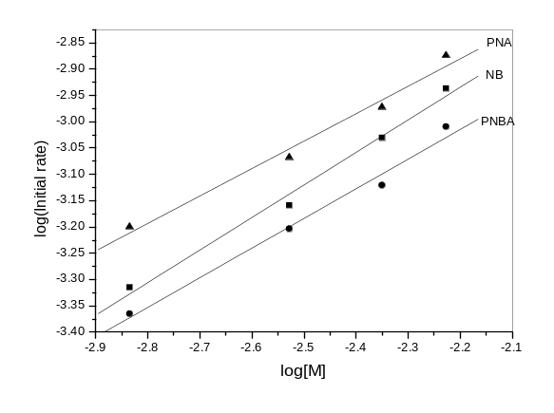
Figure 5. Dependency of rate of hydrogenation on [catalyst]
3.2.2 Effect of substrate concentration
The influence of substrate concentration on the rate of the reaction was studied in the range of 3.33.x10⁻³ to 33.3x10⁻³ mol dm⁻³ of substrate at 30ºC and at 596 mm Hg hydrogen pressure with a constant catalyst concentration of 5.92x10⁻³ mol dm⁻³ Pd for all the substrates in methanol. The plot of log (initial rate) against log [substrate] is given in Figure 6. Order of the reaction in this concentration range for all the substrates was found to follow first order [36].
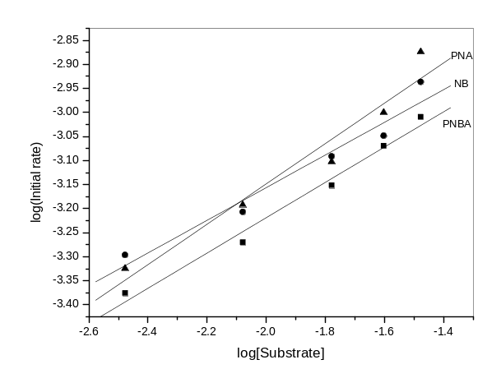

Figure 6. Dependency of rate of hydrogenation on [substrate].
Based on the results obtained, a probable mechanism is proposed for the hydrogenation reaction (Scheme 3).
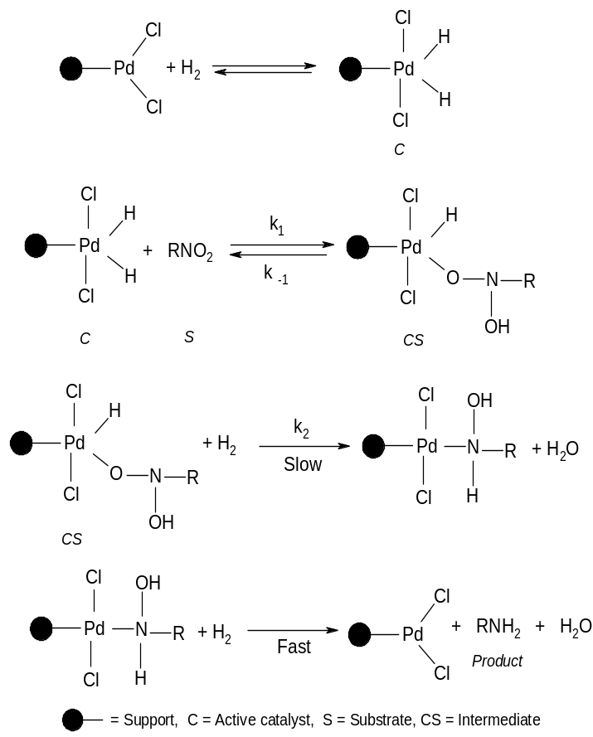
A rate law derived for the above mechanism is given in equation 1.
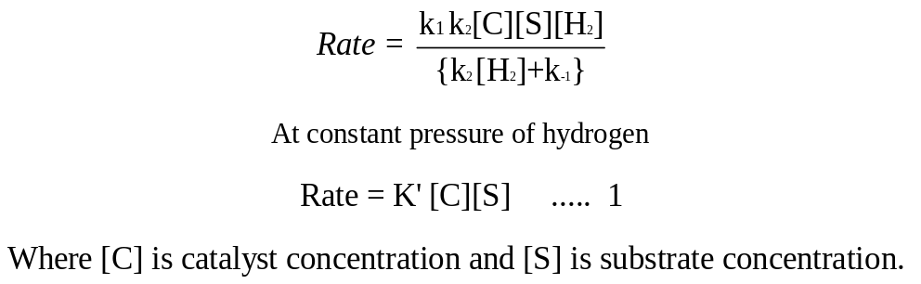
The nearly parallel relationship in Figure 6 indicates that the mechanism of hydrogenation is the same for the studied substituted systems [37].

.3.2.3 Dependency of the rate on Temperature
Rate of hydrogenation reactions for all the substrates were studied in the range of 30ºC to 45 ºC with a constant catalyst concentration of 5.92x10⁻³ mol dm⁻³ Pd, substrate concentration of 33.3x10⁻³ mol dm⁻³ in methanol at 596 mm Hg pressure of hydrogen. The rate of the reaction was found to be dependent on temperature (T) of the system. Activation energy and activation entropy were calculated from the slope of Arrhenius plot of log(initial rate) against 1/T (Figure 7) [26,4]. The results are tabulated in the Table 3.
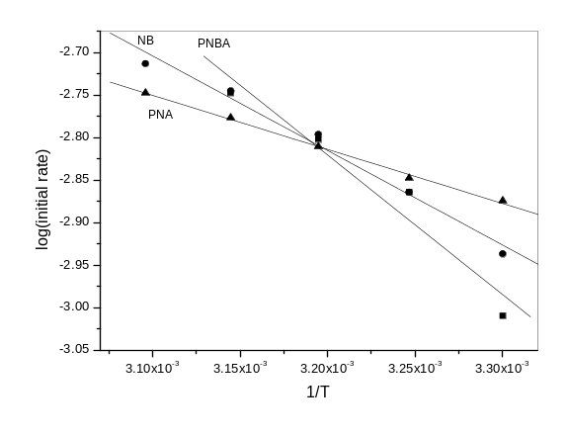
Figure 7: Effect of temperature – Arrhenius plot.
Table 3.
Activation energy, Activation entropy values for hydrogenation
 | NB | PNA | PNBA
Activation energy (kJ/mol) | 21.06 | 12.07 | 26.11
Activation entropy (J/Kmol) | -274.13 | -302.93 | -258.35

Activation energy values indicates higher activity of the catalyst. The lower activation entropy indicates low mobility of the substrate molecules. Substrate molecules when bonded to the catalyst surface have lost all translational degrees of freedom and probably gained only three vibrational degrees of freedom [37,38]. Further, activation of the substrate with the catalyst may be due to localization of the substrate on the catalyst surface and this localized interaction may be necessary for the hydrogenation reaction.
3.2.4. Dependency of substrate reactivity and the substituents.
In this part of the work an attempt was made to survey the applicability of linear relationship between reactivity of substrates and Hammett substitutent constant.
.All the reactions were carried out with a constant 5.92x10⁻³ mol dm⁻³ Pd, 33.3 x10⁻³ mol dm⁻³ substrate concentration at a temperature of 30ºC with 596 mm Hg hydrogen pressure using methanol as solvent. The reactivity of nitro group in substituted nitro aromatics may depend both on the presence of electron-releasing or electron-donating groups attached to the aromatic ring and from the steric effect contributed by the attached group. When the hydrogenation of nitrobenzene was studied by varying the para substituents with different groups like –NH_{2,} -OH, -CH_{3,} -COOH and –NO₂, it was observed that the order of rate of hydrogenation was nitrate compounds with electron-donating groups > nitrobenzene > nitrate compounds with electron-withdrawing groups. The results indicate that electron-withdrawing groups are not favorable to activate the nitro group in the benzene ring to undergo hydrogenation. A linear relationship (Figure 8) exists when log (initial rate) was plotted against Hammett substitutent constant (σ_{para}). [37-41] .
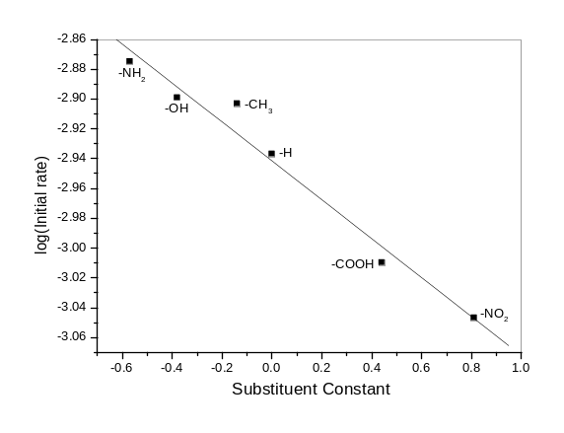
Figure 8. Relationship between Hammett substitutent constant and catalytic activity.

The comparative study of different isomers of nitroaniline and nitrobenzoic acid shows that the hydrogenation rate is in the order of para- > ortho- > meta- substituted isomers (Figure 9). This trend may be due to the reason that introduction of substitutent in the meta position and ortho position hinders the preference of close approach of the substrate molecule to the surface of the catalyst due to steric hindrance during hydrogenation. It can be concluded that the electronic effect as well as steric effect of the substitutent controls the rate of hydrogenation of nitro group in the studied substrates [32, 42].
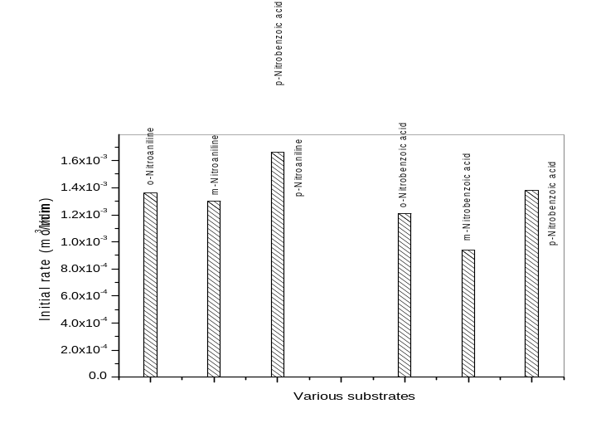
Figure 9. Relative hydrogenation rate for isomers of nitroaniline and nitrobenzoic acid.
3.2.5. Sequential hydrogenation of m-Dinitrobenzene
The hydrogenation of m-Dinitrobenzene (MDNB) was carried out with 5.93x10⁻³ mol dm⁻³ Pd, 33.3 x10⁻³ mol dm⁻³ MDNB at a temperature of 30ºC with 596 mm Hg hydrogen pressure using methanol as solvent (Figure 10). In the initial stages (50 min.) the reaction was highly selective for m-nitroaniline and only a very small amount of m- phenylenediamine was formed. At later stages when most of the MDNB is reacted, m-nitroaniline was reduced to m- phenylenediamine. Preferential adsorption affinity of MDNB with catalyst to that of m-nitroaniline could be responsible for the preferred hydrogenation of MDNB to m-nitroaniline in the system [1, 43].
.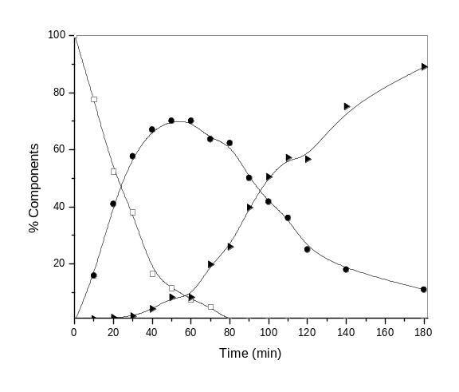
Figure 10. Sequential hydrogenation of m-Dinitrobenzene. ( -□- m-Dinitrobenzene, -●- m-nitroaniline, -►- m- Phenylenediamine).
Percentage conversion of various substrates with supported palladium-2-methylimidazole complex catalyst is listed in table 4. All the reactions were carried out with a constant 5.92x10⁻³ mol dm⁻³ Pd, 33.3 x10⁻³ mol dm⁻³ substrate concentration at a temperature of 30ºC with 596 mm Hg hydrogen pressure using methanol as solvent.

Substrates | Products | Time (min) | Percentage conversion ª
Nitrobenzene | Aniline | 180 | 72
p-Nitroaniline | p-Phenylenediamine | 100 | 70
o-Nitroaniline | o-Phenylenediamine | 120 | 70
m-Nitroaniline | m-Phenylenediamine | 120 | 82
p-Nitrophenol | p-aminophenol | 100 | 79
m-Nitrophenol | m-Aminophenol | 120 | 80
p-Nitrotoluene | p-Toluidine | 70 | 72
p-Nitrobenzoic acid | p-Aminobenzoic acid | 100 | 75
o-Nitrobenzoic acid | o-Aminobenzoic acid | 100 | 80
m-Nitrobenzoic acid | m-Aminobenzoic acid | 120 | 80
m-Dinitrobenzene | m-Phenylenediamine | 180 | 84
ª Conversion based on the HPLC analysis.
Table4. Percentage conversion of various substrates with supported palladium-2-methylimidazole complex catalyst.

- Test for metal leaching from polymer support and recycling efficiency of the catalyst.
One of the main objectives of synthesizing polymer supported metal complex catalyst is to recycle the catalyst. The catalyst was reused for six cycles at a constant catalyst concentration of 59.2x10⁻⁴ mol dm⁻³ Pd, PNBA concentration of 33.3x10⁻³ mol dm⁻³ at 30ºC with 596 mm Hg of hydrogen pressure. There was no change in the percentage of palladium in the catalyst when metal estimation was carried out at the end of first cycle and at the end of sixth cycle. Further, no traces of palladium were found in the reaction mixture at the end of the reaction. These results support that metal does not leach from the catalyst. These results indicate that the initial rate remained almost constant for over six cycles without any loss in efficiency of the catalyst.
- Conclusion
Synthesized polymer–supported palladium-2-methylimidazole complex under ambient conditions can be used successfully to hydrogenate nitrobenzene and few of its derivatives to their corresponding amines. Recycling experiments show that no metal leaching occurred and the catalyst maintains its activity for over six cycles. Reactivity of nitro group is dependent on the nature and position of the substitutent in the benzene ring. Results indicate that electron-donor groups in para- position of nitrobenzene enhance the rate and the electron-withdrawing groups hinder the nitro group hydrogenation. When PCNB was used as substrate, both hydrogenation and dechlorination resulting in formation of aniline, proceeds simultaneously. Sequential hydrogenation of nitro group was observed when MDNB was used as substrate.
Acknowledgment
Authors wish to thank UGC for the DRS Programme, Thermax India Ltd, Pune, India for providing the PS-DVB, Prof. B. K. Sadashiva,. Liquid Crystals Lab, RRI, Bangalore and CDRI, Lucknow for C, H and N analyses and STIC, Cochin for TGA.
V.Udayakumar thanks Sree Siddaganga Education Society, Sree Siddaganga Math, Tumkur, Karnataka, India, for extending support for doctoral studies.

References:
[1] John F. Knifton, J. Org. Chem. 41 (1976) 1200-1206.
[2] Alexander V. Bulatov, Michail L.Khidekel, Transition Met. Chem. 5 (1980) 123.
[3] John F. Knifton, J. Org. Chem. 40 (1975) 519-520.
[4] John F. Knifton, J. Org. Chem. 38 (1973) 3296-3301.
[5] Moris Eisen, Jochanan Blum, J. Mol. Catal. 56 (1989) 329-337.
[6] D.T. Thompson, Platinum Met. Rev. 39 (1995) 108-111.
[7] A.P.Wright, M. E.Davis, Chem. Rev. 102 (2002) 3589-3614.
[8] Maurizio Benaglia, Alessandra Puglisi, Franco Cozzi, Chem. Rev. 103 (2003),
3401-3429.
[9] Pierluigi Barbaro, Francesca Linguori, Chem. Rev. 109 (2009) 515-529.
[10] Michael R.Buchmeiser, Chem. Rev. 109 (2009) 303-321.
[11] Federica Benvenuti, Corlo Carlini, Mario Marchionna, Anna Maria Raspolli
Galletti, Glauco Sbrana, J. Mol. Catal. A: Chem. 145 (1999) 221-228.
[12] Russell S Drago, John Gaul, Alan Zonbeck, Darel K.Straub, J. Am. Chem. Soc.
102 (1980) 1033-1038.
[13] Harold S Bruner, J. Am. Oil Chem. Soc. 49 (1972) 533-534.
[14] Eduadro Baralt , Norman Holy, J. Org. Chem. 49 (1984) 2626-2627.
[15] S.Alexander, V.Udayakumar, V.Gayathri, J. Mol. Catal. A-Chemical, 314
(2009) 21-27.
[16] V.Udayakumar, S.Alexander, V.Gayathri, Shivakumaraiah, K.R.Patil,
B.Viswanathan . J. Mol. Catal. A-Chemical, J. Mol. Catal. A-Chemical, 317
(2010) 111-117.
[17] Alexander. S. (2009) Catalytic studies using polymer supported transition metal
complexes. Ph.D. Thesis, Bangalore University, India.
[18] Zhengkun Yu, Shijian Liao, Yun Xu, Bin Yang, Daorong Yu, J. Mol. Catal. A:
Chem.120 (1997) 247- 255.
[19] Ruihu Wang, Melissa M.Piekarski, Jean’ne M.Shreeve, Org. Biomol. Chem. 4
(2006) 1878-1886.
[20] Wen Chen, Yuanyuan Zhang, Liangbo Zhu, Jingbo Lan, Rugang Xie, Jingsong
You, J. Am. Chem. Soc. 129 (2007) 13879-13886.
[21] M.Jose Camazon, Amparo Alvarez-Valdes, Jose R. Masuguer, M.Carme
Navarro-Ranninger, Transition Met. Chem..11 (1986) 226-229.
[22] Hui-Seng Han, Shu-Nin Jiang, Mei-Huang, Ying-Yan Jiang, Polym. Adv.
Technol. 7 (1996) 701-706.s
[23] A.V.Bulatov, A.N.Kitaigorodskii, A.V.Letuchaya, A.T.Nikitaev, A.N.Shupik,
M.L.Khidekel, Russ. Chem. Bull. 30,(1981) 702-704.
[24] P.C.Selvaraj and V. Mahadevan, J. Polym. Sci. Part A: Polym. Chem. 35 (1997)
105-122.
[25] David E.Bergbreiter, Bushi Chen, Thomas J.Lynch, J. Org. Chem. 48 (1983)
4179-4186.
[26] C.V.Rode, M.J.Vaidya, R.Jaganathan, R.V.Chaudhari, Chem. Eng. Sci. 56
(2001) 1299-1304.
[27] D.K.Chakrabarthy, B.Viswanathan, Heterogeneous Catalysis, First edition, New
Age International (P) Limited, Publication, 2008. Chapter 4, page 53.
[28] Yasuhiro Uozumi, Catal. Surv. Asia. 9 (2005) 269-278.
[29] W.Trakarnpruk, W.Kanjina, Thammasat Int. J. Sc. Tech. 13 (2008) 1-10.
[30] Hui-Gong Tang, David C. Sherrington, Polymer. 34 (1993) 2821-2829.
[31] J.A. Diaz-Aunon, J.Garcia-Martinez, M.C.Roman- Martinez, C.Salinas- Martinez
de Lecea, Catal. Lett. 76 (2001) 41-43.
[32] Shengang Xu, Xiangali Xi, Jun Shi, Shaokui Cao, J. Mol. Catal. A: Chem. 160
(2000) 287-292.
[33] NIU Shao-feng, ZHOU Hong-Yi, AoXu-ping, Xu Xin-hua, Lou Zhan-hua, J
Zhejiang Univ. Sci. B, 7 (2006) 548-552.

[34] Ping Lu, Naoki Toshima, Bull. Chem. Soc. Jpn.73 (2000) 751-758.

[35] I.I.Obraztsova, N.K.Eremenko, Yu.N.Velyakinn, Kinet. Catal. 49 (2008) 401-
406.
[36] Hsien-Cheng Yao, P.H.Emmett, J. Am. Chem. Soc. 83 (1961) 796 -799.
[37] Toshio Uchijima, Yajuro Ishida, Nobuo Uemitsu, Yikio Yoneda, J. Catal., 29
(1973) 60-66.
[38] Teiji Chihara, Kazunori Tanaka, Bull. Chem. Soc. Jpn., 52 (1979) 507-511.
[39] Isao Mochida, Yukio Yoneda, J. Catal., 7 (1967) 386-392.
[40] V.M.Belosov, T.A.Palchevskaya, L.V.Bogutskaya, React. Kinet. Catal. Lett. 36
(1988) 369-374.
[41] Akira Sugimori, Bull. Chem. Soc. Jpn. 34 (1961) 407-411.

[42] Shaoki Cao, Sailong Xu, Shengang, Polym. Adv. Technol.10 (1999) 43-47.
[43] Yingxin Liu, Zuojun Wei, Shuguang Deng, Jiyan Zhang, J. Chem. Technol.
Biotechnol. 84 (2009) 1381-1389.

