Nanocomposite Membranes for DMFC Applications

M. Helenª, B. Viswanathan^{a,}*, S. Srinivasa Murthy^{b}

ª National Center for Catalysis Research (NCCR), Department of Chemistry,
^{b} Department of Mechanical Engineering,
Indian Institute of Technology Madras (IITM), Chennai- 600 036, INDIA
∗ Corresponding author. Tel.: 091-44-22574241; Fax: 091-44-22575245
E-mail address: bvnathan@iitm.ac.in

Abstract

Fuel cells are emerging as an alternate energy source for mobile and stationary applications. The main impediment for commercialization is due to prohibitively high cost of the major component of the fuel cells namely, catalysts employed in either of the electrodes and membrane. Literature on proton conducting membranes is mostly centered around Nafion® in spite of its well-known limitations like high cost (~1000 $/m), low performance under low humidity and at high temperature conditions and high fuel crossover. The successful performance of a fuel cell depends critically on the role played by the membranes. Nanostructured inorganic-organic composite proton conducting membranes have received attention due to their extraordinary properties stemming from synergism between the properties of two different building blocks [1,2]. Polymers of interest to form hybrid membranes include polyvinyl alcohol (PVA) in view of its film-forming capacities [3,4]. Electrolyte membranes with low methanol permeability for possible direct methanol fuel cell (DMFC) applications were fabricated through blending of polyvinyl alcohol (PVA) - polyacrylonitrile (PAN) and by cross-linking with glutaraldehyde. Nanosized cesium salt (Fig. 1) of different heteropolyacids such as phosphomolybdic acid (PMA), phosphotungstic acid (PWA) and silicotungstic acid (SWA) were incorporated into the polymer network as the proton conducting additives to form nanocomposite membrane materials. The fabrication and characterization of these organic–inorganic nanocomposite membranes and their suitability for their use in DMFCs will be discussed.
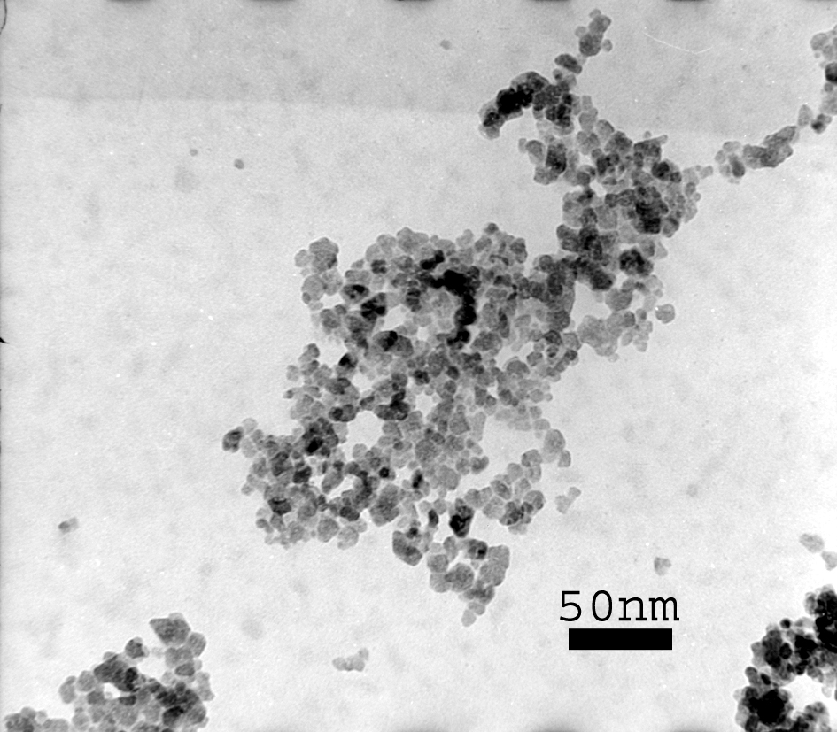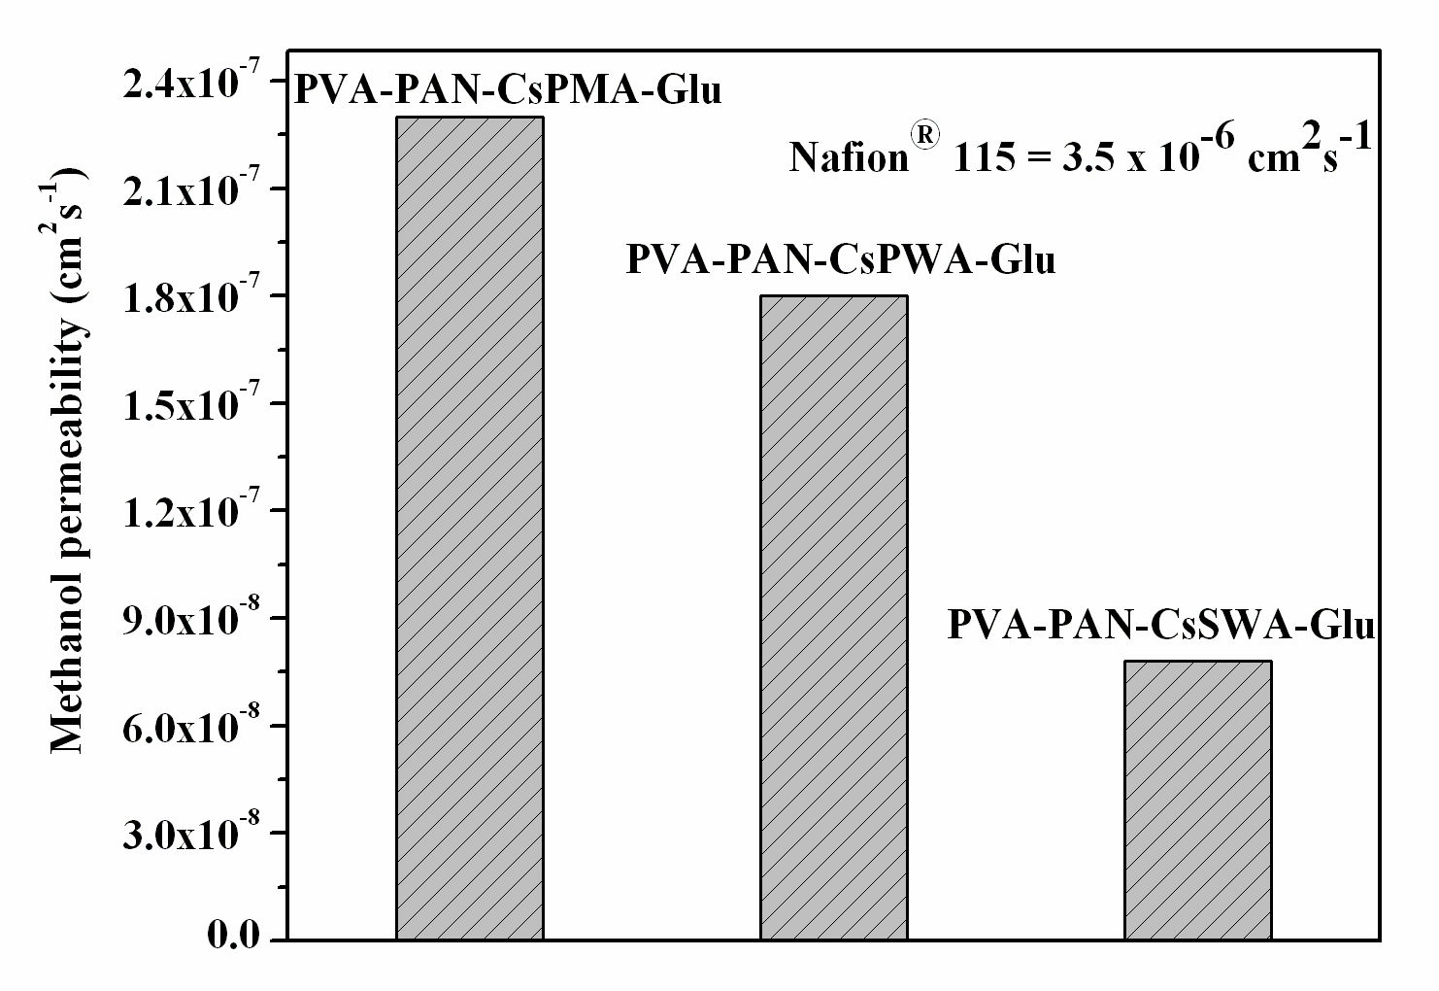
Fig.1 Fig.2

All fabricated composite polymer membranes exhibited excellent swelling and thermal stability with desired proton conductivity in the range of 10⁻³ S cm⁻¹ at 30 °C and ~ 40 % RH. The interpenetrating network formed by the blending of PVA with PAN lead to an order of decrease in methanol crossover compared to state of the art Nafion®115 membrane employed for DMFC applications (Fig 2). The fabricated nanocomposite membranes have the potential advantage to be employed as electrolyte membrane for DMFCs due to their lower methanol permeability which is an insurmountable difficulty found with Nafion® membrane in DMFCs.

References
- G. Alberti and M. Casciola, Annu. Rev. Mater. Res, 2003, 33, 129.
- B. Viswanathan and M. Helen, Bull. Catal. Soc. India, 2007, 6, 50.
- M. Helen, B. Viswanathan and S. Srinivasa Murthy, J. Power Sources, 2006, 163, 433.
- M. Helen, B. Viswanathan and S. Srinivasa Murthy, J. Membr. Sci., 2007, 292, 98.

