A historiographic analysis of fuel cell research in Asia – China racing ahead

Subbiah Arunachalam^{a*} and B Viswanathan^{b}

ªM S Swaminathan Research Foundation, Chennai 600 113, India
^{b}National Centre for Catalysis Research, Indian Institute of Technology Madras,
Chennai 600 036, India

Abstract.
Fuel cell research in China, India, Japan, Singapore, South Korea and Taiwan, over the years 1983-2007 is analysed and compared with that in USA for number of papers, document type, journals used and international collaboration. For India and China we have also identified the key researchers and institutions. Using HistCite, the visualization technique developed by Garfield and colleagues, we have constructed the historiographs for India and China based on both local citation scores (LCS) and global citation scores (GCS), and identified key papers. We find that the knowledge flow among different Asian countries is rather limited and that China has something to offer to India. The thrust in China is in developing noble metal nanoparticle catalysts supported on carbon nanotubes and the thrust in India is in the area of direct methanol fuel cells. In India A K Shukla is the single most significant contributor to fuel cell research: He is an author of 14 of the 50 nodes in the India LCS historiograph.

====

Not many inventions have had to wait as long as fuel cells to be exploited. The invention in 1839 of a device to produce electricity from hydrogen and oxygen by Sir William Robert Grove, a Welsh judge, remained virtually untapped and bereft of any development for more than a hundred years, until the beginning of the space race in the 1960s. It attracted wider attention following the oil crisis. Recent concerns of climate change and environmental degradation and the rise in price of all forms of energy have given fuel cell research an impetus, and the hope is that fuel cells will eventually be used widely both as stationary and as portable energy sources to power automobiles, homes, and electronic devices such as laptops, mobile phones, Walkman and MP3 players.¹
* Present address: Flat No. 1, Raagas Apts, 66 Venkatakrishna Road, Manadiaveli, Chennai 600 028, India. <subbiah.arunachalam@gmail.com>.
Till about the turn of the century, Japan was the only Asian country to have some significant presence in fuel cell research largely thanks to the interest shown by Japanese automobile and consumer electronics industries. In the past seven years fuel cell research has picked up in other Asian countries as well, especially China and South Korea and to a lesser extent in Taiwan and India.
In this paper we have attempted to quantify the contributions made by six Asian countries, viz. China, India, Japan, Singapore, South Korea and Taiwan, to the literature of fuel cell research, and tried to trace the evolution of the field through citation-based historiographs, using HistCite developed by Garfield and colleagues.²
Most scientometric studies on fuel cell research have looked at corporate research and patenting. For example, the white paper on the hydrogen revolution brought out by Thomson Scientific Ltd in October 2004 showed that patenting was rising rapidly in the field of fuel cells – from around 870 in 1999 to over 4,000 in 2003 – and that Japan was a major player.¹ Alan Pilkington used patent data to identify main players, both inventors and firms, active in fuel cell innovation.³⁻⁵ Emmanuel Hassan looked at the evolution of the knowledge structure of fuel cells using both patent and publication data.⁶ Jonathan Butler surveyed current developments in fuel cells in India.⁷

Data and analysis
We used the Science Citation Index Expanded part of Web of Science as our source of data. We used the names of different countries in the address field and the following words in the topic field: "fuel cell" OR "fuel cells" OR PEMFC OR MCFC OR PAFC OR SOFC OR DMFC. We had to omit AFC (for alkaline fuel cells) from our search strategy as it picked up a very large number of papers in areas ranging from enology to electrical engineering and geology, where AFC stands for acceleration feedback control, adaptive feedforward cancellation, adaptive fuzzy controller, affinity chromatograph, antral follicle count, alternative forced choice, and so on. We did not restrict the years or document types. We made standard bibliometric analysis using the data downloaded from Web of Science and then did a HistCite analysis on the data for India and China.

Growth of fuel cell research in Asia
The numbers of papers published from different countries during 1983-2007 are shown in Figure 1. The United States is the undoubted leader, followed by Japan, China, South Korea and Germany.

The growth of fuel cell research in several Asian countries, USA and the world as a whole is shown in Table 1 as a time series of number of papers published annually over a period of 15 years. There has been a dramatic rise in fuel cell research only in the new millennium in all the countries considered. Although in the early years – up to 2000 – there was not much of a difference in the annual publication outputs of Japan and USA, in 2006, USA accounted for 24% of the world’s publications as against Japan’s less than 11%. Indeed, People’s Republic of China had overtaken Japan in 2006. [But Japanese companies, especially the three leading automobile companies (Toyota, Honda and Nissan), are obtaining very large number of fuel cell related patents every year]. India was ahead of China and South Korea till 1997, but in later years both China and South Korea raced ahead of India. In the 15 years considered here, India’s share is less than 10% of the share of USA and less than 24% of the share of People’s Republic of China. South Korea has published more than twice the number of papers from India and the relatively small Taiwan has recorded a larger annual publication output than India since 2005. Even the tiny city state of Singapore has a publication output comparable to that of India.

Arunachalam had shown six years ago that China was racing ahead of India in all of science, chemistry and mathematics, as seen from papers indexed in Science Citation Index, Chemical Abstracts, and MathSciNet.⁸ What is significant is that China is far ahead of India in niche areas such as fuel cells and nanotechnology also.⁹

Document types and journals used
Table 2 provides data on the distribution of publications by document type. More than a third of the reviews have come from the United States. With 16 reviews out of a total of 477 papers India has accounted for almost the same percent of reviews as USA - much higher than that of other Asian countries. US also accounts for a large majority of meeting abstracts. This could be partly because Web of Science indexes the abstracts of papers presented at meetings of the American Chemical Society and other American societies but not at many conferences held outside the United States.

The journals used most often by fuel cell researchers in Asia as well as USA are listed in Table 3 along with their 2006 impact factors. Virtually researchers from all the countries considered publish most of their work in the same set of international journals such as Journal of Power Sources, Solid State Ionics and Electrochimica Acta with some minor variations in the extent of use. Electrochemistry journals dominate the list, followed by energy and materials science journals. Certain national journals are used predominantly by researchers from the concerned country. Of course there are some exceptions: Japanese researchers have published 21 papers in Chemical Communications [UK, 2006 impact factor 4,520] and Chinese researchers have published 21 papers in Carbon [Elsevier, 2006 impact factor 3.884]. As fuel cell is a hot field of research, papers in the field tend to appear in high impact factor journals: 1,349 papers have appeared in journals with impact factors higher than 3.000, and 458 papers have appeared in journals with an impact factor in the range 2.500 – 3.000.

Collaboration
The extent of international collaboration as seen from coauthored papers is presented in Table 4. USA has collaborated often with South Korea, China, Japan, Canada, Germany and Italy. Japanese researchers have coauthored papers with mainly researchers from USA, China, South Korea and Australia. China has collaborated often with USA, Japan, Canada, Singapore and Germany. South Korea’s research partners include USA, Japan, India and China. Indian researchers have collaborated often with researchers based in USA, South Korea, Germany, and Japan. Overall, the share of papers resulting from international collaboration is much less for India than all other countries considered here.

Distribution by institution
Table 5 provides data on the contribution made by Indian and Chinese institutions. Indian Institute of Science, Bangalore, tops the list (for India) with 63 papers which were cited 1314 times. Two CSIR laboratories, viz. Central Electrochemical Research Institute (56 papers) and National Chemical Laboratory (21 papers) and two Indian Institutes of Technology, viz. IIT Madras (40 papers) and IIT Delhi (27 papers), have also published moderately in this field. No other Indian laboratory has published more than 20 papers during 1983-2007. In all, higher educational institutions including universities and colleges have published 264 papers and the laboratories of the Council of Scientific and Industrial Research have published 134 papers. SPIC Science Foundation, a non-profit organization has published 19 papers. The Government-owned Bharat Heavy Electrical Ltd (3 papers) and the Defence contracting company High Energy Batteries India Ltd (2 papers) are the only Indian companies to have any research presence in the area of fuel cells. This is in stark contrast to what is happening in Japan where both automobile companies and other major industrial houses are very active in fuel cell research and innovation. Laboratories belonging to India’s Department of Atomic Energy has published 35 papers: Tata Institute of Fundamental Research (5 papers), Bhabha Atomic Research Centre (17 papers) and Indira Gandhi Centre for Atomic Research, Kalpakkam (13 papers).

Chinese Academy of Sciences leads the field in China with 564 papers during 1983-2007, followed by Tsing Hua University (153 papers), Harbin Institute of Technology (140 papers), University of Science and Technology, China (113 papers), Jilin University (116 papers) and Shanghai Jiao Tong University (101 papers). In about 90% of papers published from China there is at least one Chinese author from a higher educational institution. In contrast university researchers in India are authors in only about 55% of Indian papers.

Prominent Indian and Chinese researchers
Prof. A K Shukla (Indian Institute of Science and Central Electrochemical Research Institute) is the most prolific Indian researcher in this field. He has published 51 papers from India during 1983-2007 and these were cited 1171 times for an average of 23 citations per paper. Apart from these, Shukla has also published four papers from the University of Newcastle upon Tyne which have been cited 172 times. But these are not attributed to India in this study as they do not have an Indian address in the byline. If these are included Shukla’s figures will be 55 papers, 1343 citations and average of 24.4 citations per paper. B Viswanathan of IIT Madras (24 papers and 192 citations), R Pattabhiraman of CECRI, Karaikudi (22 papers and 62 citations), I A Raj of CECRI (22 papers and 48 citations) and K S Dathathreyan of SPIC Science Foundation (21 papers and 135 citations) are the other Indian researchers who have published more than 20 papers. The first Indian paper in this field came from the Central Electrochemical Research Institute [Pattabhiraman R, Venkatesan V K and Udupa H V K, 1981.] In fact, CECRI could have made its debut several years earlier had the project been entrusted to someone with greater flair for experimental work, say knowledgeable insiders. Girijesh Govil of TIFR was the next to write a paper in this field. He wrote two papers on biochemical fuel cells, one in 1982 (J Indian Chem Soc) and the other in 1983 (Int J Quantum Chem). Prof. K S V Santhanam and colleagues of TIFR, Bombay, had published a paper in Advanced Materials in 1999 and it has been cited 169 times so far. In this paper and in another paper Prof. Santhanam wrote after he started working in the USA, Prof. P M Ajayan, the well-known nanotechnology researcher, is a coauthor. A paper by Ravikumar and Shukla in the Journal of the Electrochemical Society, 1996, has been cited 169 times so far. Five of Shukla’s papers, not counting the papers he authored from Newcastle upon Tyne, have won 50 or more citations and 16 papers have won 30 or more citations.

Since the first Indian paper in fuel cell research appeared in 1981 from CECRI, there has been at least one paper from India every year. The first Chinese paper appeared in 1986 in International Journal of Hydrogen Energy. The second paper from China had not appeared till 1991. And yet today, despite their late start, the Chinese are way ahead of India. There are at least 13 institutions in China which have published 50 or more papers in the period we have studied. In contrast, only two Indian institutions have published more than 50 papers. Fifty institutions in China have published 10 or more papers, whereas only 13 Indian institutions have done so. More than 180 Chinese authors have published 10 or more papers as against 13 from India; Only one Indian author has published more than 50 papers and five more than 20 as against 11 Chinese authors with 50 or more papers and 66 with 20 or more papers. B L Yi (98 papers and 718 citations), G Y Meng (91 papers and 431 citations), Q Xin (87 papers and 1,208 citations), G Q Sun (82 papers and 1,134 citations), and W Z Li (33 papers and 948 citations) are among the most prolific authors of papers on fuel cells in China. Some Chinese authors have a very high citations/ paper score: For example, Zhou W J, a coauthor of Li W Z, has authored 25 papers and received 888 citations. Zhou Z H has 31 papers which have won 773 citations. Hsing I M has 31 papers and 476 citations.
Papers from USA have been cited relatively more often than papers from India and China. The 4,899 fuel cell research papers from USA have received 73,631 citations for an average of 15 and a h-index of 110. Eleven papers are cited 300 times or more, 53 are cited more than 150 times, 127 are cited 100 times or more, 195 are cited 75 times or more. And 367 are cited 50 or more times.

Historiographs for fuel cell research in India
We have attempted to trace the evolution of fuel cell research in India and China through constructing historiographs using HistCite software (developed by Eugene Garfield and colleagues) in conjunction with Web of Science.

We consider all of India’s 477 fuel cell papers. We include all the references quoted in these 477 papers. We add all the papers that have cited these 477 papers as well as all the references quoted in those citing papers. The resulting aggregate is called the Fuel cell India collection. The collection is exported to HistCite to obtain a large list of 2,851 papers and 60,615 cited references along with their local and global citation scores (LCS and GCS). The local citation score for a paper denotes the number of times the paper is cited within the Fuel cell India collection, and the global citation score denotes all citations to the paper (found in Web of Science). Thus LCS will always be a subset of GCS. HistCite enables one to draw a citation network among highly cited papers from which one gets a feel for the evolution of the subject (or research front) over the years.
What HistCite does is to reduce the clutter: In the huge population of papers and citations that constitute the Fuel Cell India collection, one would not get anywhere if one tried to view all the citation links. By clever use of algorithms and networking tools HistCite prunes many of the not so important links and leaves one with a manageable and compact scientograph.
Fig.2 is the historiograph of fuel cell research in India based on the 50 most highly cited papers in the Fuel cells India collection based on their global citation scores. Fig. 3 is a similar historiograph but based on the local citation scores (LCS). Both of them cover the period 1988-2005, although we collected data on fuel cell research from 1983. The papers published up to 1987 have not found a place in these historiographs, indicating that they have not proved to be very significant.
In both these historiographs, the story begins with a paper by Roger Parsons and T VanderNoot in Journal of Electroanalytical Chemistry published in 1988. Five of the 49 other highly cited papers in the Fuel Cells India collection have quoted this paper, which has reviewed the electrochemical literature during 1981-1987 on the oxidation of small organic molecules as potential fuels for fuel cells. The paper also discussed the nature of the poisoning species and intermediates and suggested areas of future research. In the GCS historiograph, the Parsons paper was cited by papers 145 (Hamnett), 197 (Wasmus), 231 (McNicol), 315 (Carrette) and 616 (Antolini). In the LCS historiograph, the 1988 Parsons paper was cited by 145 (Hamnett), 190 (Shukla), 197 (Wasmus), 251 (Arico) and 616 (Antolini).
The prominent nodes in the GCS historiograph are 98 (Ravikumar, 10 citation links), 145 (Hamnett, 8 links), 153 (Gotz, 4 links), 154 (Liu, 6 links), 195 (Britto, 13 links), 197 (Wasmus, 7 links), 239 (Heinzel, 4 links) and 353 (Luo, 5 links).
The prominent nodes in the LCS historiograph are 67 (Shukla, 10 links), 68 (Arico, 7 links), 98 (Ravikumar, 14 links), 114 (Arico, 6 links), 190 (Shukla, 6 links), 195 (Britto, 4 links).
In paper No. 68 (1994), Shukla and colleagues from Indian Institute of Science and Italy studied the electrooxidation of methanol in sulphuric acid electrolyte on a platinized carbon electrode with several functional group characteristics and found that small amounts of functional groups exhibit higher catalytic activity than large concentrations of acid/base functional groups. This paper has received 38 citations so far. Again in 1994, the Indo-Italian team of researchers continued with their investigation of methanol oxidation, but this time on carbon-supported platinum-tin electrodes in sulphuric acid [Paper No. 79, J Power Sources, 39 citations].
Paper No. 98 by M K Ravikumar and A K Shukla, published in Journal of the Electrochemical Society (1990) is a key paper in this field and is quoted by ten other highly cited papers. In this paper, the authors reported on the performance of a liquid-feed direct methanol fuel cell employing a proton-exchange membrane electrolyte and showed that methanol crossover across the polymer electrolyte at concentrations over 2M methanol affected the performance of the cell. This paper has been cited 169 times so far.
Paper No. 115 by Arico et al. (J Electrochem Soc, 1996) is about a vapour-feed direct methanol fuel cell based on a solid polymer electrolyte and employing ‘platinum-ruthenium on carbon’ catalyst for methanol oxidation and ‘platinum on carbon’ catalyst for oxygen reduction. This paper has been cited 102 times.
In 1997, A Hamnett wrote a paper on the mechanism of electrocatalysis of methanol oxidation on platinum and platinum-containing alloys (in Catalysis Today) and showed that critical performance parameters for commercial exploitation were achievable with appropriate catalytic formulations and cell designs. This paper has received 196 citations so far.
Liu et al. from the Illinois Institute of Technology compared the performance of supported and unsupported catalysts in direct methanol fuel cells. Their paper in Electrochimica Acta (paper No. 154) has been cited 89 times.
Paper No. 198 is the most cited paper in this collection. This review of methanol oxidation and direct methanol fuel cells by Wasmus and Kuver in J Electroanal Chem has received more than 370 citations so far. This status report focuses on fundamental and applied electrochemistry aspects of DMFC and emphasizes strategies and approaches rather than individual results.
Paper No. 353 by Luo et al. from Beijing is basically on electrochemical and electrocatalytic behaviour of single-wall carbon nanotube film on a glassy carbon electrode. This paper is cited over 300 times.

Shukla’s work in fuel cells
In the LCS historiograph of India, 24 of the 50 papers are from India and in 14 of them A K Shukla is an author. In view of the prominent role played by Shukla in fuel cell research in India, we constructed historiographs (not shown here) based on his 55 papers which were cited 1,343 times. The HistCite data consisted of 943 records and 17,322 cited references. Shukla’s main interest is direct methanol oxidation and measurement of performance of single cells. The prominent nodes in the GCS historiograph are papers by Roger Parsons (1988), Ravikumar and Shukla (1996), Hamnett (1997), Wasmus and Kuver (1999), and Gotz (1998). The prominent nodes in the LCS historiograph are Parsons (1988), Shukla (1994), Arico (1994), Shukla (1995), Shukla (1995), Ravikumar (1996), Arico (1996), and Shukla (1999). In the LCS historiograph constructed from the Shukla fuel cell collection, 16 of the thirty papers were authored by Shukla. In contrast in the GCS-based historiograph, only one paper was authored by Shukla. Also, in all these papers by Shukla we find that LCS and GCS were the same, indicating that virtually the entire influence of Shukla’s work remains within the domain of fuel cell research. We notice a similar trend in the nano science work of C N R Rao (unpublished results). In both cases we found that there is a considerable difference between the LCS and GCS of papers by other prominent researchers which appear in the Indian collection of both fuel cell research and nano research.
Shukla has collaborated with 68 coauthors from 17 institutions spread over six countries. Five of his coauthors have collaborated with Shukla in seven or more papers, and eight scientists have coauthored at least in five papers with Shukla. Shukla has published his fuel cell papers mostly in the mainstream journals: J Power Sources (18), Appl Electrochem (9), and J Electroanal Chem and J Electrochem Soc (4 each). Seven of the 55 papers of Shukla have been cited 50 times or more often; 11 of them 40 times or more; 17 of them 30 times or more; and 25 of them 20 times or more. Shukla’s h-index for his fuel cell research is 23.

Historiographs for fuel cell research in China
Fig. 4 and Fig. 5 are the historiographs constructed from the Fuel cells China collection consisting of 6,216 records and 110,479 cited references. Fig.4 is based on GCS and Fig. 5 is based on LCS. In both these, the first key paper is the 1999 review on DMFC by Wasmus (Paper No. 52). In both these figures the following nodes are found to be prominent: 52, 167, 238, 309 and 621. In addition, node numbers 54, 145 and 495 also seem to be important from the GCS historiograph.
In paper No. 167, Bessel (2001) demonstrated the superiority of carbon nanofibres over Vulcan-72 carbon as support for platinum-loaded electrodes for direct methanol oxidation, as they led to proper crystallographic orientation of the active platinum crystallites.
In paper 238, Li et al. reported that a highly dispersed platinum nanoparticle catalyst supported on carbon nanotubes, employed as the cathode for a DMFC, led to higher activity of the oxygen reduction reaction and better performance of the DMFC, as compared to the catalysts supported on commercial carbons.
In paper 309, Liu et al. (2002) demonstrated the better performance of platinum
deposited on multiwall carbon nanotube by electroless method in direct methanol
oxidation.
Paper No. 495 is again on methanol oxidation, this time by a bimetallic catalyst.
Zhang (2003) showed that Pt-Ru nanoparticles supported on a carbon electrode
possessed high dispersion and high catalytic activity for methanol oxidation at room
temperature.
In paper 621, Li (2003) showed that platinum crystallites formed by reduction with ethylene glycol and formaldehyde on multiwall carbon nanotubes were more active than the system based on Vulcan XC-72. This difference in catalytic performance was attributed to a greater dispersion of the supported platinum particles on multi-wall nanotube support.
Tu et al. (paper 54, 1999) showed that perovskite oxides based on lanthanum, strontium, cobalt and iron showed the best catalytic activity for oxygen reduction.
In paper 145, Cheng (2001) makes an overview of the potential of carbon nanotubes for hydrogen storage from both experimental and theoretical points of view.
Knowledge flow in the region
While much of the thrust in India is on direct methanol fuel cells, the thrust in China is mainly on the development of metallic nanoparticle catalysts supported on carbon nanotube electrodes. As the catalysts used in fuel cells involve expensive noble metals like platinum and ruthenium, it is important to reduce the amount of the metal used and yet increase the catalytic efficiency in order to make fuel cells cost effective and competitive to petroleum and other sources of energy. Indeed, the goal is to reduce the loading of noble metals by an order of magnitude and to enhance preferential orientation of crystallites.
An analysis of the country of origin of the highly cited papers that find a place in the historiographs of different countries can give an idea of cross-national knowledge flows. The LCS historiograph of India has 24 papers (out of 50) from India, five from South Korea, four from China, one from Japan, seven from USA, seven from England and six from Germany. Remember that some of these nodes may also have authors from other countries, as there is much international collaboration in this field. The GCS historiograph of India has eight nodes from China, three from India, two each from South Korea and Japan, 18 from USA, and five each from England and Germany. Clearly the work carried out in the West continues to be of great relevance to fuel cell research in India as seen from the number of nodes from the West in the GCS historiogrpah. It is also seen that work carried out in China is also of great relevance to Indian researchers as evidenced by the eight nodes from China as against three from India in the GCS historiograph.
In the LCS historiograph of fuel cell research in China 32 of the 50 highly cited papers are from China, 11 from USA, four from Germany and two from Japan and one from India. In the GCS historiograph for China, 12 of the 50 the nodes are from China, 15 from USA, eight from Germany, three from Japan and two from England and one from India. Clearly Work done in India has very limited influence on work carried out in China. Work done in the West continues to be of great relevance to Chinese research in this area.
With the data presented here we are unable to evaluate the flow of knowledge from Japan. For one thing, we have not constructed the LCS and GCS historiographs for Japanese fuel cell research. For another, in this field Japan is more into patenting than into publishing in research journals. We have not so far examined the patent literature and its use in such studies.
That China is far ahead of India in this field as well is amply clear, and these results could have been known several years ago, but a project proposal from CECRI for comparing electrochemistry research in India and China was rejected by NISSAT, a unit of the Department of Scientific and Industrial Research, as an ignorant (or biased) member of the advisory panel of NISSAT was not sure if China was really doing well in electrochemistry.

Acknowledgement
We are grateful to Dr Eugene Garfield for providing the HistCite software and to Soren Paris who helped one of us to learn how to use it. We are indebted to Prof. A K Shukla for valuable discussion and to Ms Thulasi Krishna Rao and Mr Subbiah Gunasekaran for help in data collection. Part of the work was carried out when one of us (SA) was visiting the National Institute of Advanced Studies, Bangalore, on an invitation from Prof. S Ranganathan, as part of a project funded by the US Office of Naval Research. SA is also grateful to Prof. N V Joshi for inviting him to be a visiting scholar at the National Centre for Science Information, Indian Institute of Science, Bangalore.

References
- The hydrogen revolution: An evaluation of patent trends in the fuel cell industry, a White Paper, Thomson Scientific Ltd, Philadelphia, October 2004.
- Garfield G, Soren W P and Stock W G, HistCite: A software tool for informetric analysis of citation linkage, Information, 57, 2006, 391-400. Also see www.histcite.com.
- Pilkington A, Technology portfolio alignment as an indicator of commercialization: An investigation of fuel cell patenting, Technovation, 24, 2004, 761-771.
- Pilkington A and Liston-Heyes C, Inventive concentration: An analysis of fuel
cell patents, Science and Public Policy, 31, 2004, 15-25.
- Pilkington A, Key inventors and key firms in fuel cell development: A patent
Analysis, Research Paper Series, School of Management, Royal Holloway, University of London, #SoM-0605, 2006, pp.17.
6. Hassan E, The evolution of knowledge structure of fuel cells, Scientometrics, 62,
2005, 223-238.
7. Butler J, 2007 Patent Review Q3, Fuel Cell Today,
http://www.fuelcelltoday.com/ online/survey?survey=2007-11%2F2007-Q3-
Patent-Review-Free
- Arunachalam S, Is science in India on the decline?, Current Science, 83, 2002, 107-108.
- Arunachalam S, Current Science, 94, 2008, 848-849.

Table 1. Distribution of publications on fuel cells from selected countries and the world by year [Data from Web of Science]

Year | World | India | China | South  Korea | Japan | Taiwan | Singa-  pore | USA
1993  1994  1995  1996  1997  1998  1999  2000  2001  2002  2003  2004  2005  2006  2007*  1983-2007 | 215  302  302  459  400  556  599  775  859  1164  1437  2126  2469  3502  3270*  19468 | 8  6  5  9  11  13  23  13  23  28  26  52  55  85  97*  477 | 1  1  2  6  5  16  29  27  46  90  130  221  318  561  591*  2048 | 2  5  6  17  10  21  21  32  44  67  81  149  129  275  211*  1072 | 51  73  73  115  79  92  101  126  112  176  208  293  316  372  324*  2777 | 1  4  1  4  -  3  3  7  3  11  21  36  66  144  134*  438 | -  -  -  -  1  1  1  2  6  14  24  34  42  58  52*  236 | 61  61  67  99  79  113  113  142  190  303  392  601  705  820  772*  4899

* Data for 2007 not complete

Table 2. Distribution of publications on fuel cells by document type
[Data from Web of Science 1983-2007]

Paper  type | World | India | China | South  Korea | Japan | Taiwan | Singa-  pore | USA
Article  Review  Meeting  abstract  Note  Letter  Total | 17295  501  561  99  153  19468* | 448  16  7  4  2  477 | 1987  32  10  2  11  2048* | 1036  15  11  0  5  1072* | 2647  34  30  40  14  2777* | 434  -  2  -  2  438 | 229  4  1  -  1  236* | 4142  170  451  16  53  4899*
*includes editorial, correction and other types of documents

Table 4. Extent of international collaboration in the field of fuel cells
 | India | China | South  Korea | Japan | Taiwan | Singa-  pore | USA
India  Peoples Republic of China  South Korea  USA  Germany  Japan  Italy  England  Switzerland  Portugal  Australia  Taiwan  Canada  France  Mexico  Denmark  Israel  Belgium  Russia  Singapore  Slovakia  Spain  Sweden  New Zealand | 477  3  23  23  19  15  14  13  13  5  4  4  3  3  3  2  2  1  1  1  1  1  1 | 3  2048  22  81  47  53  5  16  -  6  12  10  49  14  -  8  -  3  2  47  -  4  23 | 23  22  1072  96  8  29  11  9?  -  -  3  1  5  -  1  -  -  -  1  -  -  -  - | 15  53  29  70  13  2777  8  12  9  -  24  3  13  9  1  5  -  1  2  -  -  1  4  14 | 4  10  1  21  2  3  -  1  -  -  2  438  7  -  1  -  -  -  1  -  -  -  2  - | 1  47  -  8  -  -  1  13  -  -  6  -  1  -  -  -  -  -  -  236  -  -  2  - | 23  81  96  4912  57  70  54  36  23  4  13  21  68  47  7  15  4  3  14  8  -  20  4  10

Table 5. Distribution of papers from India and China by institution
Institution [India] | No. of papers |  | Institution [China] | No. of papers
Indian Institute of Science | 63 |  | Chinese Acad Sci | 565
Cent Electrochem Res Inst | 56 |  | Tsing Hua University | 149
Indian Inst Technol Madras | 40 |  | Harbin Inst Technol | 139
India Inst Technol Delhi | 27 |  | Univ Sci & Technol China | 133
National Chemical Laboratory | 21 |  | Jilin University | 116
SPIC Science Foundation | 19 |  | Shanghai Jiao Tong Univ | 101
Bhabha Atomic Res Centre | 17 |  | Hong Kong Univ Sci Technol | 78
Indian Inst Chem Technol | 14 |  | Tianjin University | 70
Central Glass Ceramic Res Inst | 13 |  | Xiamen University | 69
Indian Inst Technol Bombay | 13 |  | Sun Yat Sen University | 60
Central Salt Marine Chem Res Inst | 11 |  | Dalian University of Technol | 52

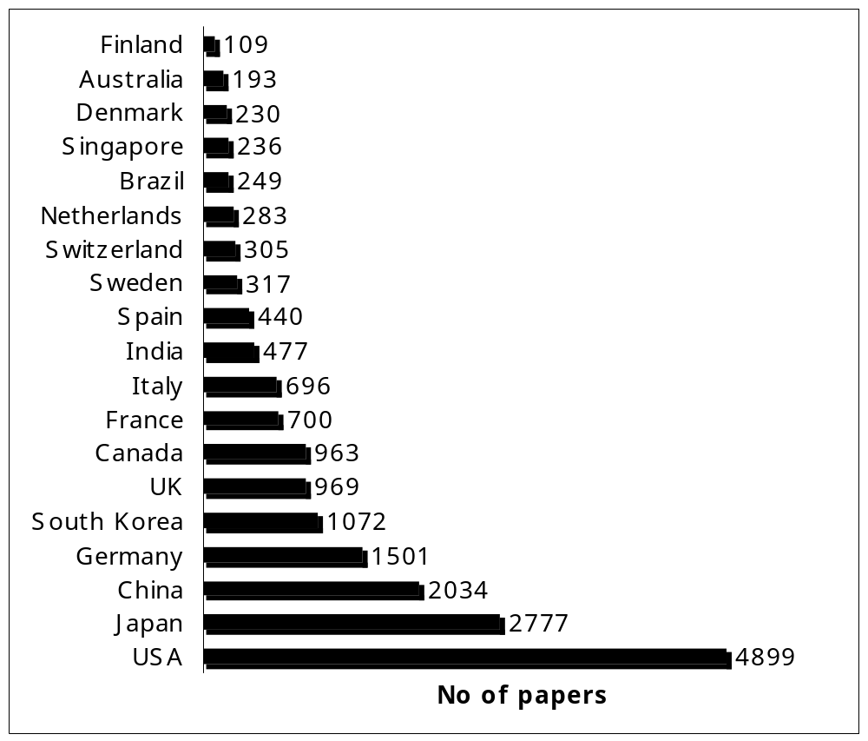

Fig. 1. Number of fuel cell papers from different countries, 1983-2007
[Data from Web of Science 1983-2007]

India Fuel Cells LCS
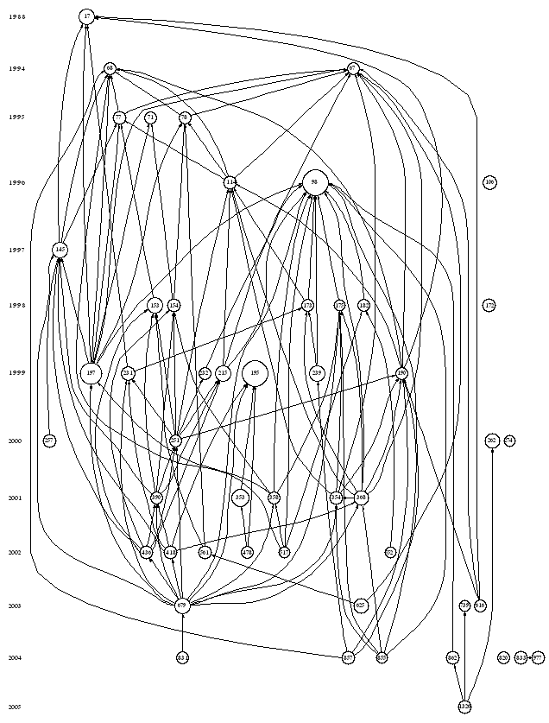
Fig. 2. The historiograph of fuel cells research in India based on local citation scores.
Nodes: 50, Links: 120 LCS, top 50; Min: 36, Max: 169 (LCS scaled)
 |  |  | LCS | GCS
1. | 17 | PARSONS R, 1988, J ELECTROANAL CHEM, V257, P9 | 72 | 637
2. | 67 | SHUKLA AK, 1994, J ELECTROCHEM SOC, V141, P1517 | 38 | 38
3. | 68 | ARICO AS, 1994, J POWER SOURCES, V50, P295 | 39 | 39
4. | 71 | KUMAR GS, 1995, ELECTROCHIM ACTA, V40, P285 | 38 | 38
5. | 77 | SHUKLA AK, 1995, J APPL ELECTROCHEM, V25, P528 | 50 | 50
6. | 78 | ARICO AS, 1995, J POWER SOURCES, V55, P159 | 43 | 76
7. | 98 | Ravikumar MK, 1996, J ELECTROCHEM SOC, V143, P2601 | 169 | 169
8. | 106 | Quadakkers WJ, 1996, SOLID STATE IONICS, V91, P55 | 51 | 51
9. | 114 | Arico AS, 1996, J ELECTROCHEM SOC, V143, P3950 | 44 | 102
10. | 145 | Hamnett A, 1997, CATAL TODAY, V38, P445 | 66 | 192
11. | 153 | Gotz M, 1998, ELECTROCHIM ACTA, V43, P3637 | 66 | 183
12. | 154 | Liu L, 1998, ELECTROCHIM ACTA, V43, P3657 | 49 | 88
13. | 172 | Aruna ST, 1998, SOLID STATE IONICS, V111, P45 | 47 | 47
14. | 173 | Kuver A, 1998, J POWER SOURCES, V74, P211 | 41 | 73
15. | 175 | Reeve RW, 1998, J ELECTROCHEM SOC, V145, P3463 | 37 | 68
16. | 182 | Shukla AK, 1998, J POWER SOURCES, V76, P54 | 43 | 43
17. | 190 | Shukla AK, 1999, APPL SURF SCI, V137, P20 | 41 | 41
18. | 195 | Britto PJ, 1999, ADVAN MATER, V11, P154 | 169 | 169
19. | 197 | Wasmus S, 1999, J ELECTROANAL CHEM, V461, P14 | 129 | 359
20. | 215 | Arico AS, 1999, J APPL ELECTROCHEM, V29, P671 | 68 | 68
21. | 231 | McNicol BD, 1999, J POWER SOURCES, V83, P15 | 55 | 133
22. | 232 | Scott K, 1999, J POWER SOURCES, V83, P204 | 43 | 107
23. | 239 | Heinzel A, 1999, J POWER SOURCES, V84, P70 | 73 | 205
24. | 251 | Arico AS, 2000, ELECTROCHIM ACTA, V45, P4319 | 40 | 61
25. | 257 | Ren XM, 2000, J ELECTROCHEM SOC, V147, P466 | 49 | 162
26. | 262 | Jordan LR, 2000, J POWER SOURCES, V86, P250 | 65 | 65
27. | 274 | Jordan LR, 2000, J APPL ELECTROCHEM, V30, P641 | 36 | 36
28. | 353 | Luo HX, 2001, ANAL CHEM, V73, P915 | 75 | 301
29. | 354 | Arico AS, 2001, APPL SURF SCI, V172, P33 | 49 | 51
30. | 358 | Neergat M, 2001, J APPL ELECTROCHEM, V31, P373 | 43 | 44
31. | 368 | Shukla AK, 2001, J ELECTROANAL CHEM, V504, P111 | 65 | 66
32. | 390 | Steigerwalt ES, 2001, J PHYS CHEM B, V105, P8097 | 43 | 114
33. | 418 | Li WZ, 2002, CARBON, V40, P791 | 48 | 109
34. | 436 | Steigerwalt ES, 2002, J PHYS CHEM B, V106, P760 | 44 | 113
35. | 478 | Wang JX, 2002, ANAL CHEM, V74, P1993 | 41 | 287
36. | 517 | Shukla AK, 2002, ELECTROCHIM ACTA, V47, P3401 | 36 | 36
37. | 552 | Gurau B, 2002, J POWER SOURCES, V112, P339 | 37 | 86
38. | 561 | Rajesh B, 2002, FUEL, V81, P2177 | 46 | 46
39. | 616 | Antolini E, 2003, MATER CHEM PHYS, V78, P563 | 43 | 111
40. | 625 | Rajesh B, 2003, J PHYS CHEM B, V107, P2701 | 58 | 58
41. | 679 | Li WZ, 2003, J PHYS CHEM B, V107, P6292 | 68 | 177
42. | 739 | Smitha B, 2003, J MEMBRANE SCI, V225, P63 | 36 | 36
43. | 820 | Ratnasamy P, 2004, J CATAL, V221, P455 | 41 | 41
44. | 831 | Wang C, 2004, NANO LETT, V4, P345 | 43 | 110
45. | 833 | Einsla BR, 2004, J POLYM SCI A-POLYM CHEM, V42, P862 | 45 | 45
46. | 855 | Shukla AK, 2004, J ELECTROANAL CHEM, V563, P181 | 37 | 37
47. | 857 | Dillon R, 2004, J POWER SOURCES, V127, P112 | 45 | 113
48. | 862 | Smitha B, 2004, MACROMOLECULES, V37, P2233 | 47 | 47
49. | 977 | Hickner MA, 2004, CHEM REV, V104, P4587 | 44 | 229
50. | 1326 | Smitha B, 2005, J MEMBRANE SCI, V259, P10 | 44 | 44

India Fuel Cells GCS
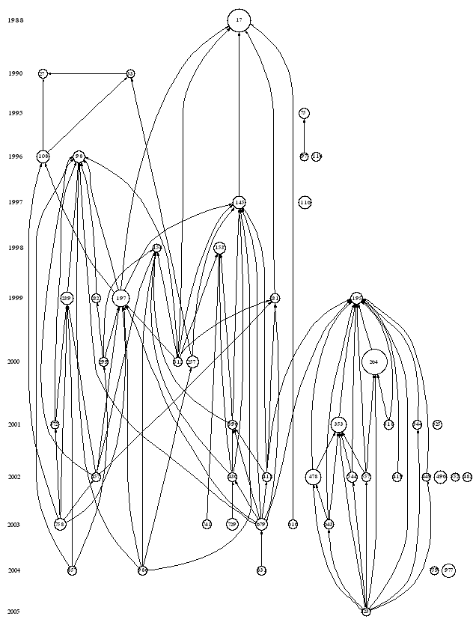
Fig, 3. The historiograph of fuel cells research in India based on global citation scores
Nodes: 50, Links: 93 GCS, top 50; Min: 82, Max: 725 (GCS scaled)
 |  |  | LCS | GCS
1. | 17 | PARSONS R, 1988, J ELECTROANAL CHEM, V257, P9 | 72 | 637
2. | 27 | VERBRUGGE MW, 1990, J ELECTROCHEM SOC, V137, P886 | 19 | 104
3. | 33 | VERBRUGGE MW, 1990, J ELECTROCHEM SOC, V137, P3770 | 9 | 82
4. | 75 | IWAHARA H, 1995, SOLID STATE IONICS, V77, P289 | 13 | 154
5. | 97 | Iwahara H, 1996, SOLID STATE IONICS, V86-8, P9 | 0 | 94
6. | 98 | Ravikumar MK, 1996, J ELECTROCHEM SOC, V143, P2601 | 169 | 169
7. | 108 | HeitnerWirguin C, 1996, J MEMBRANE SCI, V120, P1 | 19 | 199
8. | 114 | Arico AS, 1996, J ELECTROCHEM SOC, V143, P3950 | 44 | 102
9. | 116 | Radovic LR, 1997, CHEM PHYS CARB, V25, P243 | 0 | 205
10. | 145 | Hamnett A, 1997, CATAL TODAY, V38, P445 | 66 | 192
11. | 153 | Gotz M, 1998, ELECTROCHIM ACTA, V43, P3637 | 66 | 183
12. | 154 | Liu L, 1998, ELECTROCHIM ACTA, V43, P3657 | 49 | 88
13. | 195 | Britto PJ, 1999, ADVAN MATER, V11, P154 | 169 | 169
14. | 197 | Wasmus S, 1999, J ELECTROANAL CHEM, V461, P14 | 129 | 359
15. | 231 | McNicol BD, 1999, J POWER SOURCES, V83, P15 | 55 | 133
16. | 232 | Scott K, 1999, J POWER SOURCES, V83, P204 | 43 | 107
17. | 239 | Heinzel A, 1999, J POWER SOURCES, V84, P70 | 73 | 205
18. | 257 | Ren XM, 2000, J ELECTROCHEM SOC, V147, P466 | 49 | 162
19. | 264 | Collins PG, 2000, SCIENCE, V287, P1801 | 21 | 725
20. | 299 | Kelley SC, 2000, ELECTROCHEM SOLID STATE LETT, V3, P407 | 19 | 101
21. | 315 | Carrette L, 2000, CHEMPHYSCHEM, V1, P162 | 25 | 109
22. | 318 | Ajayan PM, 2001, TOP APPL PHYS, V80, P391 | 5 | 125
23. | 325 | Rolison DR, 2001, J MATER CHEM, V11, P963 | 0 | 97
24. | 344 | Nugent JM, 2001, NANO LETT, V1, P87 | 23 | 110
25. | 353 | Luo HX, 2001, ANAL CHEM, V73, P915 | 75 | 301
26. | 372 | Choi WC, 2001, J POWER SOURCES, V96, P411 | 28 | 94
27. | 390 | Steigerwalt ES, 2001, J PHYS CHEM B, V105, P8097 | 43 | 114
28. | 418 | Li WZ, 2002, CARBON, V40, P791 | 48 | 109
29. | 419 | Frackowiak E, 2002, CARBON, V40, P1775 | 8 | 104
30. | 436 | Steigerwalt ES, 2002, J PHYS CHEM B, V106, P760 | 44 | 113
31. | 449 | Wang JX, 2002, ELECTROANAL, V14, P225 | 20 | 93
32. | 457 | Jorissen L, 2002, J POWER SOURCES, V105, P267 | 32 | 102
33. | 478 | Wang JX, 2002, ANAL CHEM, V74, P1993 | 41 | 287
34. | 483 | Chaubey A, 2002, BIOSENS BIOELECTRON, V17, P441 | 2 | 103
35. | 496 | Jin W, 2002, ANAL CHIM ACTA, V461, P1 | 5 | 199
36. | 544 | Azamian BR, 2002, J AM CHEM SOC, V124, P12664 | 15 | 139
37. | 552 | Gurau B, 2002, J POWER SOURCES, V112, P339 | 37 | 86
38. | 557 | Zhao Q, 2002, ELECTROANAL, V14, P1609 | 16 | 113
39. | 616 | Antolini E, 2003, MATER CHEM PHYS, V78, P563 | 43 | 111
40. | 643 | Yu X, 2003, ELECTROCHEM COMMUN, V5, P408 | 16 | 117
41. | 679 | Li WZ, 2003, J PHYS CHEM B, V107, P6292 | 68 | 177
42. | 729 | Serp P, 2003, APPL CATAL A-GEN, V253, P337 | 29 | 187
43. | 741 | Zhou WJ, 2003, APPL CATAL B-ENVIRON, V46, P273 | 29 | 101
44. | 758 | Li QF, 2003, CHEM MATER, V15, P4896 | 28 | 182
45. | 759 | Liang HP, 2004, ANGEW CHEM INT ED, V43, P1540 | 9 | 87
46. | 831 | Wang C, 2004, NANO LETT, V4, P345 | 43 | 110
47. | 857 | Dillon R, 2004, J POWER SOURCES, V127, P112 | 45 | 113
48. | 977 | Hickner MA, 2004, CHEM REV, V104, P4587 | 44 | 229
49. | 980 | Wang CY, 2004, CHEM REV, V104, P4727 | 19 | 112
50. | 1237 | Gooding JJ, 2005, ELECTROCHIM ACTA, V50, P3049 | 11 | 91

China Fuel Cell - LCS
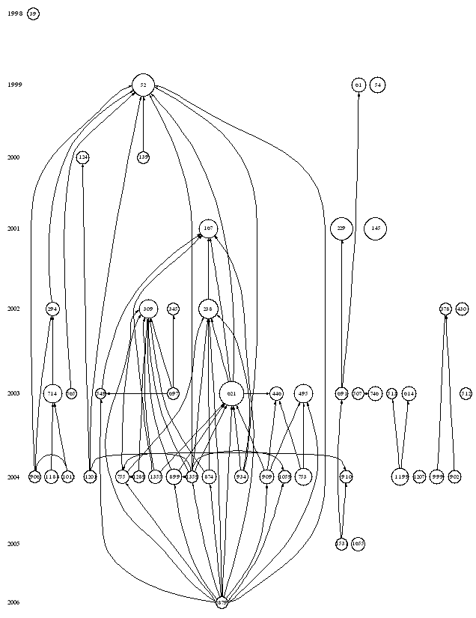
Fig.4. The historiograph of fuel cells research in China based on local citation scores
Nodes: 50, Links: 69 LCS, top 50; Min: 38, Max: 177 (LCS scaled)
 |  |  | LCS | GCS
1. | 39 | Wang SZ, 1998, J ELECTROCHEM SOC, V145, P1932 | 40 | 40
2. | 52 | Wasmus S, 1999, J ELECTROANAL CHEM, V461, P14 | 143 | 359
3. | 54 | Tu HY, 1999, SOLID STATE IONICS, V117, P277 | 74 | 73
4. | 61 | Cheng XL, 1999, J POWER SOURCES, V79, P75 | 68 | 68
5. | 124 | Hsing IM, 2000, CHEM ENG SCI, V55, P4209 | 47 | 47
6. | 139 | Carrette L, 2000, CHEMPHYSCHEM, V1, P162 | 43 | 109
7. | 145 | Cheng HM, 2001, CARBON, V39, P1447 | 140 | 140
8. | 167 | Bessel CA, 2001, J PHYS CHEM B, V105, P1115 | 98 | 154
9. | 229 | Steele BCH, 2001, NATURE, V414, P345 | 141 | 484
10. | 238 | Li WZ, 2002, CARBON, V40, P791 | 109 | 109
11. | 294 | Wei ZB, 2002, J POWER SOURCES, V106, P364 | 56 | 57
12. | 309 | Liu ZL, 2002, LANGMUIR, V18, P4054 | 104 | 145
13. | 345 | Wang X, 2002, ELECTROCHIM ACTA, V47, P2981 | 44 | 44
14. | 378 | Dimitrova P, 2002, J ELECTROANAL CHEM, V532, P75 | 44 | 75
15. | 430 | Shao ZG, 2002, J MEMBRANE SCI, V210, P147 | 52 | 52
16. | 446 | Zhou ZH, 2003, CHEM COMMUN, P394 | 55 | 56
17. | 495 | Zhang X, 2003, CHEM MATER, V15, P451 | 99 | 100
18. | 507 | Li L, 2003, MATER LETT, V57, P1406 | 41 | 41
19. | 512 | Liu FQ, 2003, J MEMBRANE SCI, V212, P213 | 40 | 40
20. | 513 | Gao Y, 2003, J POLYM SCI A-POLYM CHEM, V41, P497 | 38 | 36
21. | 549 | Rajesh B, 2003, J PHYS CHEM B, V107, P2701 | 39 | 58
22. | 565 | Ma ZQ, 2003, J MEMBRANE SCI, V215, P327 | 38 | 38
23. | 614 | Yin Y, 2003, POLYMER, V44, P4509 | 61 | 61
24. | 621 | Li WZ, 2003, J PHYS CHEM B, V107, P6292 | 177 | 177
25. | 691 | Yu JR, 2003, J POWER SOURCES, V124, P40 | 49 | 49
26. | 697 | Prabhuram J, 2003, J PHYS CHEM B, V107, P11057 | 40 | 39
27. | 714 | Zhou WJ, 2003, APPL CATAL B-ENVIRON, V46, P273 | 101 | 101
28. | 746 | Li L, 2003, J MEMBRANE SCI, V226, P159 | 61 | 61
29. | 753 | Liang HP, 2004, ANGEW CHEM INT ED, V43, P1540 | 87 | 87
30. | 755 | Tang H, 2004, CARBON, V42, P191 | 59 | 60
31. | 874 | Liu ZL, 2004, LANGMUIR, V20, P181 | 66 | 75
32. | 899 | Wang C, 2004, NANO LETT, V4, P345 | 70 | 110
33. | 902 | Shao ZG, 2004, J MEMBRANE SCI, V229, P43 | 50 | 50
34. | 906 | Zhou WJ, 2004, J POWER SOURCES, V126, P16 | 44 | 44
35. | 909 | Chan KY, 2004, J MATER CHEM, V14, P505 | 65 | 66
36. | 910 | Lu GQ, 2004, ELECTROCHIM ACTA, V49, P821 | 47 | 70
37. | 934 | Li WZ, 2004, ELECTROCHIM ACTA, V49, P1045 | 59 | 60
38. | 999 | Gil M, 2004, J MEMBRANE SCI, V234, P75 | 61 | 61
39. | 1012 | Zhou WJ, 2004, J POWER SOURCES, V131, P217 | 40 | 40
40. | 1059 | He ZB, 2004, MATER CHEM PHYS, V85, P396 | 49 | 49
41. | 1188 | Lamy C, 2004, ELECTROCHIM ACTA, V49, P3901 | 54 | 65
42. | 1199 | Hickner MA, 2004, CHEM REV, V104, P4587 | 94 | 229
43. | 1201 | Wang CY, 2004, CHEM REV, V104, P4727 | 49 | 112
44. | 1207 | He ZB, 2004, DIAM RELAT MATER, V13, P1764 | 48 | 48
45. | 1289 | Guo DJ, 2004, J ELECTROANAL CHEM, V573, P197 | 40 | 40
46. | 1355 | Xing YC, 2004, J PHYS CHEM B, V108, P19255 | 59 | 73
47. | 1359 | Girishkumar G, 2004, J PHYS CHEM B, V108, P19960 | 43 | 61
48. | 1531 | Yang H, 2005, J POWER SOURCES, V139, P79 | 43 | 43
49. | 1655 | Gasteiger HA, 2005, APPL CATAL B-ENVIRON, V56, P9 | 54 | 130
50. | 2879 | Liu HS, 2006, J POWER SOURCES, V155, P95 | 45 | 52

China Fuel Cells - GCS
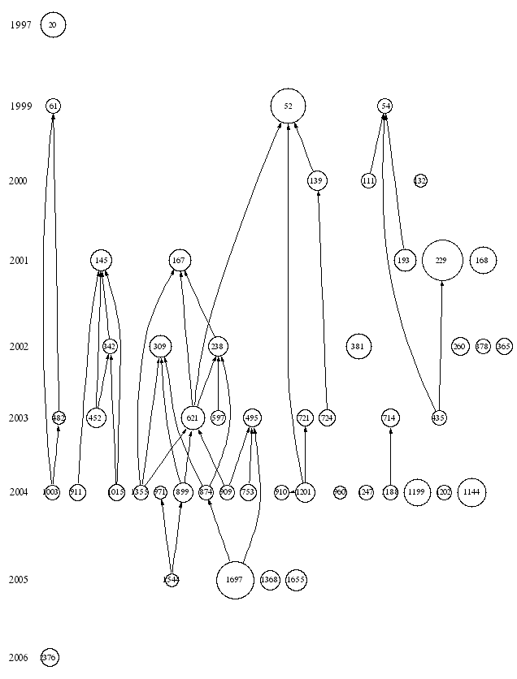
Fig. 5. The historiograph of fuel cells research in China based on global citation scores
Nodes: 50, Links: 38 GCS, top 50; Min: 61, Max: 484 (GCS scaled)
 |  |  | LCS | GCS
1. | 20 | Radovic LR, 1997, CHEM PHYS CARB, V25, P243 | 9 | 205
2. | 52 | Wasmus S, 1999, J ELECTROANAL CHEM, V461, P14 | 143 | 359
3. | 54 | Tu HY, 1999, SOLID STATE IONICS, V117, P277 | 74 | 73
4. | 61 | Cheng XL, 1999, J POWER SOURCES, V79, P75 | 68 | 68
5. | 111 | Matsuzaki Y, 2000, SOLID STATE IONICS, V132, P261 | 14 | 69
6. | 132 | Schoonman J, 2000, SOLID STATE IONICS, V135, P5 | 4 | 61
7. | 139 | Carrette L, 2000, CHEMPHYSCHEM, V1, P162 | 43 | 109
8. | 145 | Cheng HM, 2001, CARBON, V39, P1447 | 140 | 140
9. | 167 | Bessel CA, 2001, J PHYS CHEM B, V105, P1115 | 98 | 154
10. | 168 | Feng SH, 2001, ACCOUNT CHEM RES, V34, P239 | 1 | 214
11. | 193 | Pena MA, 2001, CHEM REV, V101, P1981 | 11 | 158
12. | 229 | Steele BCH, 2001, NATURE, V414, P345 | 141 | 484
13. | 238 | Li WZ, 2002, CARBON, V40, P791 | 109 | 109
14. | 260 | Hirscher M, 2002, J ALLOYS COMPOUNDS, V330, P654 | 18 | 100
15. | 309 | Liu ZL, 2002, LANGMUIR, V18, P4054 | 104 | 145
16. | 342 | Ma RZ, 2002, J AM CHEM SOC, V124, P7672 | 8 | 75
17. | 365 | Jusys Z, 2002, ELECTROCHIM ACTA, V47, P3693 | 31 | 79
18. | 378 | Dimitrova P, 2002, J ELECTROANAL CHEM, V532, P75 | 44 | 75
19. | 381 | Tian ZQ, 2002, J PHYS CHEM B, V106, P9463 | 20 | 205
20. | 435 | Brandon NP, 2003, ANNU REV MATER RES, V33, P183 | 31 | 72
21. | 452 | Rao CNR, 2003, DALTON TRANS, P1 | 0 | 119
22. | 482 | Qi ZG, 2003, J POWER SOURCES, V113, P37 | 33 | 62
23. | 495 | Zhang X, 2003, CHEM MATER, V15, P451 | 99 | 100
24. | 597 | Sherigara BS, 2003, ELECTROANAL, V15, P753 | 6 | 65
25. | 621 | Li WZ, 2003, J PHYS CHEM B, V107, P6292 | 177 | 177
26. | 714 | Zhou WJ, 2003, APPL CATAL B-ENVIRON, V46, P273 | 101 | 101
27. | 721 | Tuber K, 2003, J POWER SOURCES, V124, P403 | 34 | 78
28. | 724 | Haile SM, 2003, ACTA MATER, V51, P5981 | 27 | 78
29. | 753 | Liang HP, 2004, ANGEW CHEM INT ED, V43, P1540 | 87 | 87
30. | 874 | Liu ZL, 2004, LANGMUIR, V20, P181 | 66 | 75
31. | 899 | Wang C, 2004, NANO LETT, V4, P345 | 70 | 110
32. | 909 | Chan KY, 2004, J MATER CHEM, V14, P505 | 65 | 66
33. | 910 | Lu GQ, 2004, ELECTROCHIM ACTA, V49, P821 | 47 | 70
34. | 911 | Ichikawa T, 2004, J ALLOYS COMPOUNDS, V365, P271 | 3 | 87
35. | 960 | Gedanken A, 2004, ULTRASON SONOCHEMISTRY, V11, P47 | 1 | 62
36. | 971 | Xu Y, 2004, J AM CHEM SOC, V126, P4717 | 11 | 62
37. | 1003 | Litster S, 2004, J POWER SOURCES, V130, P61 | 33 | 73
38. | 1015 | Seayad AM, 2004, ADVAN MATER, V16, P765 | 10 | 80
39. | 1144 | Cushing BL, 2004, CHEM REV, V104, P3893 | 10 | 255
40. | 1188 | Lamy C, 2004, ELECTROCHIM ACTA, V49, P3901 | 54 | 65
41. | 1199 | Hickner MA, 2004, CHEM REV, V104, P4587 | 94 | 229
42. | 1201 | Wang CY, 2004, CHEM REV, V104, P4727 | 49 | 112
43. | 1202 | Adler SB, 2004, CHEM REV, V104, P4791 | 22 | 68
44. | 1247 | Kharton VV, 2004, SOLID STATE IONICS, V174, P135 | 14 | 72
45. | 1355 | Xing YC, 2004, J PHYS CHEM B, V108, P19255 | 59 | 73
46. | 1368 | Astruc D, 2005, ANGEW CHEM INT ED, V44, P7852 | 4 | 121
47. | 1544 | Fernandez JL, 2005, J AM CHEM SOC, V127, P357 | 22 | 62
48. | 1655 | Gasteiger HA, 2005, APPL CATAL B-ENVIRON, V56, P9 | 54 | 130
49. | 1697 | Burda C, 2005, CHEM REV, V105, P1025 | 27 | 434
50. | 2376 | Hashmi ASK, 2006, ANGEW CHEM INT ED, V45, P7896 | 3 | 105

Table 3. Distribution of publications on fuel cells by journal

Journal title | IF*  2006 | India | China | S.Korea | Japan | Taiwan | Singa-  pore | USA | World
Journal of Power Sources  Solid State Ionics  Electrochimica Acta  International Journal of Hydrogen Energy  Journal of Applied Electrochemistry  Journal of Electroanalytical Chemistry  Journal of Materials Science  Journal of the Electrochemical Society  Abstracts of Papers of the Am Chem.Soc  Journal of Membrane Science  Materials Chemistry and Physics  Applied Catalysis A  Ceramics International  Journal of Physical Chemistry B  Journal of Am Ceramic Soc  Catalysis Letters  Materials Letters  Electrochemical and Solid State Letters  Journal of Alloys and compounds  Electrochemistry Communications  Journal of Physical Chemistry C  Korean Journal of Chem Engg  Macromolecular Research  J Ind & Engg Chemistry  Bulletin of Korean Chemical Society  Journal of Microbiology and Biotechnology  Catalysis Today  Journal of Electroceramics  J New Mater for Electrochem Systems  Journal of European Ceramic Soc  Chem J Chinese Universities  Acta Physico Chimica Sinica  Chinese J Catalysis  Rare Metal Materials and Engineering  Acta Chimica Sinica  Chinese J Inorg Chem  J Inorg Materials  Progress in Chemistry  Journal of Rare Earths  Carbon  Rare Metals  Denki Kagaku  Electrochemistry  J Ceramic Soc Japan  Nippon Kagaku Kaishi  J Chem Eng Japan  Kagaku Kogaku Ronbunshu  Chemistry Letters  Chemical Communications  Bulletin of Electrochemistry  Indian Journal of Chemistry Sec A  Bulletin of Materials Science  Journal of Solid State Chemistry  Ionics | 3.521  2.190  2.955  2.612  1.409  2.339  0.999  2.387  -  3.442  1.657  2.630  1.128  4.115  1.396  1.772  1.353  2.009  1.250  3.484  --  0.808  1.166  0.957  0.950  2.037  2.148  1.157  1.095  1.576  0.724  --  0.659  0.251  0.783  0.583  0.377  0.520  0.368  3.884  0.378  --  0.574  0.997  --  0.594  0.294  1.734  4.520  0.259  0.631  0.522  2.107  0.305 | 81  14  13  12  12  8  8  8  7  7  7  7  6  6  6  5  5  4  4  3  3  19  9  7  7  6 | 346  62  100  39  18  20  13  42  12  56  15  14  12  30  -  8  22  33  42  82  20  60  53  51  51  37  33  33  28  26  21  21 | 288  37  67  22  9  10  10  45  10  36  15  7  -  15  -  10  -  -  7  18  -  24  19  17  14  14  13  12  11  11  3 | 257  306  90  46  32  43  14  306  13  23  -  41  -  24  28  11  -  63  35  35  -  192  157  44  37  35  35  32  21 | 157  3  10  15  3  2  3  15  2  13  8  3  1  7  3  3  -  3  4  5  4  3  3 | 49  16  9  6  5  2  3  19  1  4  -  3  -  8  -  -  2  10  2  12  -  1  5  2  2 | 789  189  141  133  38  44  18  704  348  52  -  42  -  116  53  20  7  135  19  33  -  38  6 | 3073  1116  741  549  306  261  134  1472  420  280  63  194  268  138  71  57  299  131  271  92

