A REPORT ON
ADSORPTIVE DESULPHURIZATION

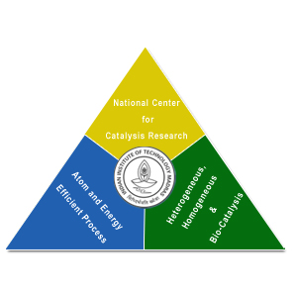

Project Closure Report

submitted to

Ms. CHENNAI PETROLEUM CORPORATION LIMITED

By

NATIONAL CENTRE FOR CATALYSIS RESEARCH
INDIAN INSTITUTE OF TECHNOLOGY, MADRAS
CHENNAI – 600 036
SEPTEMBER, 2007

Content

S. No. | Content | Page No.
 | Executive Summary | 8
1 | The stated Objective and methodology | 12
2 | Project objectives and evolved Methodology | 15
3 | Adsorbent systems studied | 18
4 | Modification and evaluation of activated Carbon | 21
5 | Carbon materials subjected to critical Evaluation | 37
6 | Exploitation of Nuchar carbon as sorbent for S in CBR raw diesel | 39
7 | Exploitation of Calgon carbon as sorbent for S in CBR raw diesel | 45
8 | Regeneration studies on Calgon carbon | 58
9 | Recommendations | 66
10 | References | 71
 | Annexure | 73

List of Figures

Figure | Title | Page No.
1 | N₂ adsorption-desorption isotherms of Adsorbent carbon as received and adsorbent carbon activated with K₂CO₃ (C:K₂CO₃ = 1 :3, 800 ºC, 2 h, N₂ atm.)
2 | N₂ adsorption-desorption isotherms of Adsorbent carbon as received and adsorbent carbon activated with oxalic acid, sodium oxalate, citric acid, sodium citrate, tartaric acid, sodium tartarate and sodium potassium tartarate (C :Activating agent = 1 :1 (wt./wt.%), at 800 ºC for 2 h in N₂ atm.)
3 | Effect of oxygen content (wt.%) of the activating agent on the specific surface area of adsorbent carbon as received
4 | XRD pattern of Adsorbent carbon as received and adsorbent carbon activated with sodium carbonate, oxalic acid, sodium oxalate, citric acid, sodium citrate, tartaric acid, sodium tartarate and sodium potassium tartarate (C:Activating agent = 1 :1 (wt./wt.%), at 800 ºC for 2 h in N₂ atm.)
5 | (a) Effect of oxygent content (wt.%) of the activating agent on the crystallinity of the modified activated carbon  (b) Effect of oxygen content (wt.%) of the activating agent on the specific surface area of the modified activated carbon
6 | Effect of crystallinity (%) of the adsorbent carbon activated with different activating agents on the specific surface area
7 | SEM images of (a & b) Adsorbent carbon as received and (c & d) Adsorbent carbon activated with K₂CO₃
8 | Structure of surface oxygen groups
9 | FT-IR spectrum of adsorbent carbon as received
10 | FT-IR spectra of adsorbent carbon functionalized with amine
11 | Plot of amount of S removed in ppm Vs amount of CBR raw diesel treated per gram of adsorbent carbon as received and adsorbent carbon modified
12 | Plot of amount of S removed in ppm Vs amount of CBR raw diesel treated per gram of adsorbent carbon as received and adsorbent carbon activated in Ar at 800 ºC for 2 h under different conditions of flow rate of the feed
13 | XRD pattern of Nuchar Carbon as received
14 | FT – IR spectrum of Nuchar carbon as received
15 | EPR spectrum of Nuchar activated carbon as received recorded at room temperature on an X-band spectrometer
16 | TGA curves of Nuchar activated carbon recorded in air and N₂ atmospheres at a heating rate of 20 ºC/min
17 | XRD pattern of (a) Calgon carbon as received, (b) Calgon carbon HNO₃ treated and (c) Calgon carbon HNO₃ treated and Ar activated
18 | N₂ adsorption-desorption isotherm of Calgon carbon as received (Specific surface area = 1014 m²/g, Pore volume = 0.5875 cc/g )
19 | FT-IR spectra of (a) Calgon carbon as received, (b) Calgon carbon treated with nitric acid and (c) Calgon carbon treated with nitric acid followed by Ar activation at 800 ºC for 2 h in N₂ atmosphere
20 | EPR spectra of Calgon carbon as received, calgon carbon treated with HNO₃ and Calgon carbon treated with HNO₃ followed by Ar activation
21 | Thermogravimetric curves of Calgon carbon as received, calgon carbon treated with HNO₃ and calgon carbon treated with HNO₃ followed by Ar activation
22 | Plot of S removed from feed Vs amount of calgon carbon used
23 | Break through curve on 100 g calgon carbon as received through which CBR raw diesel is passed
24 | Plot of S removal capacity of fresh Vs toluene regenerated sorbent (10 g calgon carbon as received)
25 | Plot of S removal capacity of fresh Vs H₂ regenerated sorbent (5.0 g calgon carbon treated with HNO₃ and activated in Ar atmosphere)

List of Tables

Table | Title | Page No.
1 | CBR raw diesel – Significant properties
2 | Textural and physical properties of some selected carbon materials
3 | Comparison of the textural properties of adsorbent carbon as received and adsorbent carbon activated with K₂CO₃
4 | Effect of oxygen content (wt.%) of the activating agent on the specific surface area (m²/g) of the adsorbent carbon (Specific surface area value of adsorbent carbon as received = 950 m²/g)
5 | Effect of oxygen content (wt.%) of the activating agent on the crystallinity (%) of the activated carbon
6 | Effect of crystallinity (%) of adsorbent carbon (as received and activated with different activating agents) on the specific surface area
7 | S sorption capacity of adsorbent and modified adsorbent activated carbon materials
8 | Effect of flow rate of the feed on the S removal capacity of Adsorbent carbon as received and adsorbent carbon activated with Ar
9 | S sorbing ability of different Carbon materials
10 | Assignment of frequency of the absorption band (cm⁻¹) to the source of the infrared signal
11 | S sorption capacity of Nuchar as received (5.0 g batch)
12 | S sorption capacity of Nuchar as received (5.0 g batch) – Evaluation of reporducibility
13 | Assignment of frequency of absorption band (cm⁻¹) to the source of infrared signal
14 | g values of EPR signals resulting from Calgon and modified Calgon carbon samples
15 | S sorption capacity of Calgon carbon as received (5.0, 10.0 and 15.0 g batches)
16 | S sorption capacity of Calgon carbon treated with HNO₃ (5.0, 10.0 and 15.0 g batches)
17 | S sorption capacity of Calgon carbon treatead with HNO₃ and activated with Ar (5.0, 10.0 and 15.0 g batches)
18 | S adsorption studies on 4.11 wt. % Cu on Calgon carbon HNO₃ treated and Ar activated
19 | Comparison of the S sorption capacity of Calgon carbon as received (CC1), Calgon carbon treated with HNO₃, Calgon carbon treated with HNO₃ followed by Ar activation and 4.11 wt.% Cu supported on Calgon carbon treated with HNO₃ followed by Ar activation
20 | S adsorption studies on 100 g calgon carbon as received
21 | S content removed from the spent sorbent by Toluene used for regneration
22 | S sorption capacity of toluene regenerated Calgon carbon as received 10.0 g
23 | Comparison of performance of fresh and regenerated sorbent (5.0 g calgon carbon treated with HNO₃ followed by Ar activation)
24 | Regeneration of 5.0 g calgon carbon treated with HNO₃ and activated in Ar atmosphere (with 100 ml Toluene)
25 | Regeneration of 5.0 g calgon carbon treated with HNO₃ and activated in Ar atmosphere (with 200 ml Toluene)
26 | S sorption capacity of H₂ gas regenerated 5.0 g Calgon carbon treated with HNO₃ and activated in Ar atmosphere
27 | Evaluation of Toluene regeneration of spent sorbent (100 g Calgon carbon as received)
28 | Comparison of the performance of fresh and regenerated sorbent (100 g Calgon carbon as received)

List of Flow sheets

Table | Title | Page No.
1 | Method of activation of adsorbent carbon
2 | Amine functionalization of adsorbent carbon with ethylene glycol
3 | Systematic Procedure for the nitric acid treatment of Calgon carbon as received
4 | Systematic Procedure for the nitric acid treatment of Calgon carbon as received followed by Ar activation
5 | Step wise procedure for the preparation of 4.11 wt. % Cu/Calgon carbon activated with HNO₃ followed by Ar activation
6 | Toluene (250 ml) regeneration of spent sorbent (10 g Calgon as received)
7 | H₂ based regeneration of spent sorbent (5.0 g Calgon carbon treated with HNO₃ followed by Ar activation)
8 | Toluene (500 ml) regeneration of spent sorbent (100 g Calgon as received)

EXECUTIVE SUMMARY

Executive Summary

The regulation on sulfur in diesel has become stringent and the maximum sulfur content in diesel is reduced to less than 15 ppmw in U.S from 2006 . In India, the sulfur specification is gradually made stringent and will be introducing Bharat Stage IV norm of 50 ppm sulfur by 2010 in select metros and BS III norm of 350 ppm in rest of India. The hydrodesulphurisation units which were implemented in many refineries in India are being revamped to meet the new norms.

Alternate methods of desulfurisation of diesel is being explored worldwide with a view of the increasing severity of Diesel HDS units required to meet the specifications. The increased severity is mainly due to the presence of refractory sulfur compounds. The most difficult sulfur compound namely 4,6 Dimethyl Dibenzothiophene is present in greater than 100 ppm in many diesel fuels. The alternate method of desulfurisation which are extensively reported are Oxidative and Adsorptive desulfurisation. The oxidative desulfurisation is very selective in converting the refractory sulfur compounds to sulfones but suffers from the disadvantage of using an expensive oxidant and using an extraction process for removal of sulfones.

The Adsorptive desulfurisation using zeolite as adsorbent looks less attractive option as it requires Hydrogen for producing fuels meeting Euro III/ IV norms. In the present study the results obtained on Adsorptive desulfurisation of SR diesel from a low sulfur crude using Modified Activated Carbons are reported..

The Activated Carbons obtained from different commercial sources were used in this study. Suitable modification procedures were developed to increase the surface area of the carbon materials and also to introduce surface functional groups which can modify the adsorption characteristics of carbon materials. The adsorbents were extensively characterized before and after modification using FT- IR, XRD, ESR and other surface characterization techniques.

The studies on adsorbent were carried out using SR diesel from the Cauvery Basin Refinery Distillation unit. The SR diesel was characterized using GC-PFPD unit for analyzing the type of sulfur compounds present in the fraction.

The adsorption studies were carried out in laboratory using 5/10 grams of the adsorbent and the sulfur removal was monitored continuously. The studies were also carried out at 100 grams level of the adsorbent. The regeneration of the adsorbent saturated with sulfur compounds was also studied in detail. Solvent regeneration using toluene was found to be effective in reusing the adsorbent. The studies indicate that adsorbents (activated carbons) suitably modified with treatment with nitric acid and subsequent treatment in Argon can remove sulphur compounds from diesel fuel.

The efficacy of the removal of sulphur and also the regeneration of the adsorbent has been established by repeated studies.

These studies have also been extended to some of the carbons that have been generated from natural sources. The utility of the methods developed for activation of the carbon has been established for the carbon from natural sources.

The studies not only provided opportunities for adopting carbon materials as adsorbent for sulphur compounds but also have opened up some fundamental studies on the activation of carbon materials. The scientific information on the oxygen content of the activator and also the optimum level of oxygen content for activating carbon are some new knowledge generated in this study.

1.0 THE STATED OBJECTIVE AND METHODOLOGY

The stated aim of the Project

The aim of the project is to develop an alternate cheaper desulphurization process that utilizes special adsorbents capable of desulphurizing diesel with an S-content in the range of 500-1000 ppm to 50 ppm of S or below. The feed could be SR feed of the Narimanam or BH or PYIII type or blends with S-content in the range of 500-1000 ppm. The adsorbent should be capable of desulphurizing the feed at mild operating conditions, eg., low pressure (5-10 bar) and low temperatures (less than 250 ºC). Besides, the adsorbent should also be easily regenerable under modest conditions of temperature and pressure by either solvent, or hydrogen or air.

PROPOSED METHODOLOGY

1. Screening of the adsorbents using fixed bed reactors. Analysis of the desulphurized products for S-content. The feed should contain 500-1000 ppm sulphur.

2. Establish appropriate activation procedures for the chosen adsorbents with a view to increase the surface area, adsorptive capacity and also formulate suitable characterization procedures for the chosen adsorbent.

3. Establish a protocol for the regeneration of the selected sorbents. The regeneration may be based on solvent, hydrogen, air, or oxygen. The regenerations will be carried out in-situ in the fixed bed reactors or externally if batch reactors are used. Carry out repeated adsorption and regeneration of the sorbents to establish their life.

4. Identification of the most suitable sorbent based on these studies and work out economically viable process for adsorptive desulphurization.

2. PROJECT OBJECTIVES AND EVOLVED METHODOLOGY

To start, we have redefined our objectives, over all and technical objectives in simpler terms and they are given below

1. Objectives:
- Desulphurization based on adsorption
- Feed can be Narimanam or BH or PY III
- Mild operating conditions low pressure and low temperature
- Adsorbent should be regenerable under modest conditions of temperature or solvent or air or hydrogen

1.1 Overall objective:

To develop a regenerable adsorbent to reduce sulfur in SR Diesel (CBR) from about 737 ppm to less than 200 ppm.

1.2 Technical Objectives:

1.2.1. Desirable features and functions of the adsorbent :

- High selectivity for sulfur compounds removal –scientific rationale for selection of materials
- Good regenerabililty characteristics
- Feasibility for continuous operation for long duration
- Operate at low to moderate temperature/pressure (T = 40 – 250 ºC; P = 1 - 10 bars)

The methodology to be followed was also redefined for the proper execution of the project. The developed methodology is given in this section.

2. Methodology Proposed:

(i) Initial studies to be carried out on carbon based adsorbents (6 months)
(ii) Further studies using porous inorganic materials (zeolites and metal substituted
zeolite systems) as adsorbents.

2.1 Methodology to be Adopted:

(i) As the initial studies on activated carbon materials as adsorbents showed promising
results all experimental studies till date were confined to carbon based materials.

(ii) Evaluation of adsorbents in larger scale

(iii) Regeneration procedures based on solvent and also alternate regeneration procedures to be developed

2.2 The following strategies served as basis for the screening of suitable carbon based adsorbents:

1) Methodology to increase adsorption capacity for S-compounds to be developed
i) Increase surface area of commercial carbons by chemical/physical treatments
ii) Improving the efficiency of carbon adsorbents by functionalization – affinity for
sulphur compounds
2) New sources of carbon materials to be identified

2.2.1 Need for Carbon activation (modification):

- To increase the textural characteristics of the commercial carbons
- To improve the adsorption centres – creation of some active sites
- Generation of Functional groups
- Modification of the existing functional groups

3. ADSORBENT SYSTEMS STUDIED

3.1. Characteristics of CBR Diesel: The feed chosen is the CBR diesel. The characteristics of this diesel have been assembled in Table 1.

Table 1. CBR raw diesel – Significant properties

Property | Value
Flash point, ºC | 86
Aniline point, ºC | 80
Viscosity at 40 ºC, | 4.59
Pour point, ºC | +3.0
Total Sulphur, ppm | 737
Density at 15 ºC, g/cc | 0.8555
Cetane Index | 53

3.2. Carbon Materials - An Evaluation:

Before choosing the carbon to be used as adsorbent, it was considered necessary to formulate the essential physical properties of the carbon materials. Accordingly, a few of the typical carbon materials that were available were considered and their textural properties were compared.

3.2.1 Comparison of physical and textural properties of some specific carbon materials:

The textural properties of a variety of specific carbon materials are compared with those of the activated carbon materials generated from natural sources, namely, Calotropis Gigantea and Borassus Flabellifera. These properties are assembled in Table 2. The two carbon materials produced from lignocellulosic materials stand out and have an edge over all other commercial carbon materials in terms of value of specific surface area.

Table 2. Textural and physical properties of some selected carbon materials

Carbon | Specific surface area (m²/g) | Density (g/cc) | Pore Volume (cc/g)
CDX 975 | 215 | 0.23 | 0.28
Vulcan XC 72 R | 224 | 0.33 | 0.46
Black Pearl 2000 | 1012 | 0.15 | 1.15
Adsorbent carbon as received | 950 | 0.51 | 0.45
Calgon carbon as received | 1014 | 0.57 | 0.59
Activated Carbon from Calotropis Gigantea | 1291 | 0.28 | 0.73
Activated Carbon from Borassus Flabellifera | 1070 | 0.26 | 0.55

3.2.2 Carbon materials tested as adsorbent

1. Two new activated carbon materials possessing high specific surface area values were produced from plant sources, namely, Calotropis Gigantea and Borassus Flabellifera. The details of the methods of preparation, characterization and applications can be found in [1]. The afore mentioned activated carbon materials were evaluated for S removal from CBR raw diesel. The activated carbons derived from the natural sources with desired pore structure and surface area are expected to be potential adsorbents for aromatic sulphur compounds and hence supposed to be useful in the desulphurization of different petroleum fractions.

2. Adsorbent carbon as received (commercially available) and modified Adsorbent carbon were evaluated for S removal from CBR raw diesel (Suppliers: Adsorbent Carbons Pvt. Ltd., C/92 Sipcot Industrial Complex, Tuticorin – 628008, India, Ph. No. 914612340047, Fax. 914612340975)

3. Calgon carbon as received (CC1) and modified Calgon carbon were evaluated for S removal from CBR raw diesel (from Calgon Carbon (Tianjin) Co., Ltd.,)

4. Nuchar carbon as received was tested for S sorption from CBR raw diesel (from MeadWestvaco Corporation, Specialty Chemicals Division, Carbon Department, Washington street, VA, Covington, USA 24426, Phone: 540-969-3700, FAX: 540-965-0230).

5. IG 18 - 18 x 40 mesh 60 CTC, (Indo German Carbon Limited, XI/20, Chembakassery Jn., Alwaye – 683 101, Kerala, India, Phone: 91-484-2620095, Fax: 91-484-2627867).

6. IG 12 - Indo German Carbon Limited, 12 x 40 mesh 60 CTC (Indo German Carbon Limited, XI/20, Chembakassery Jn., Alwaye – 683 101, Kerala, India, Phone: 91-484-2620095, Fax: 91-484-2627867).

7. IG 8 - Indo German Carbon Limited 8 x 30 mesh 60 CTC (from Indo German Carbon Limited, XI/20, Chembakassery Jn., Alwaye – 683 101, Kerala, India, Phone: 91-484-2620095, Fax: 91-484-2627867).

8. AC 4 – Coconut shells based Activated Carbon, ACG – 50 Mesh size 4 x 8 ; 500 g
(from Active Carbon India Pvt. Ltd., G-1, K-5, Kimtee Colony, Road No. 12, Banjara Hills, Hyderabad – 034, A.P., Phone 040-23324884, Fax. 040-23324886)

9. AC 6 - Coconut shells Activated Carbon, ACG – 50 Mesh size 6 x 12 ; 500 g (from Active Carbon India Pvt. Ltd., G-1, K-5, Kimtee Colony, Road No. 12, Banjara Hills, Hyderabad – 034, A.P., Phone 040-23324884, Fax. 040-23324886)

10. AC 12 - Coconut shells Activated Carbon, ACG – 50 Mesh size 12 x 30 ; 500 g (from Active Carbon India Pvt. Ltd., G-1, K-5, Kimtee Colony, Road No. 12, Banjara Hills, Hyderabad – 034, A.P., Phone 040-23324884, Fax. 040-23324886)

11. 60 CTC 12 x 30 - Activated carbon from Sud Chemie India Pvt. Ltd.

12. 60 CTC 4 x 8 - Activated carbon from Sud Chemie India Pvt. Ltd.

4.0 MODIFICATION AND EVALUATION OF ACTIVATED CARBON

4. Exploitation of Adsorbent carbon as sorbent for S in CBR raw diesel

4.1. Modification of adsorbent carbon as received

4.1.1 Activation of adsorbent carbon with K₂CO₃ - Improvement of textural properties

In a typical synthetic procedure 50 g adsorbent cabon as received is physically mixed with 150 g of K₂CO₃. The mixture is placed in an alumina tube. The alumina tube with the material is located in a tubular furnace. N₂ atmosphere is maintained in the alumina tube containing the sample. The temperature of the furnace is raised from room temperature to 800 ºC. The sample is allowed to be heated at 800 ºC for 2 h followed by cooling to room temperature and subsequently treated with Conc. HCl. The wt./wt. (%) of activated material to HCl being 1:5. The sample is filtered and washed with excess distilled water and dried in furnace at 200 ºC for 2 h. From simplicity the steps involved in the process are depicted in Flow Sheet 1.

Adsorbent carbon as received from CPCL (50 g) (950 m²/g)

K₂CO₃ (150 g)

C: K₂CO₃ = 1:3 (wt./wt.%)

Mixed and ground in a mortor to get fine powder (200 g)

Placed in a cylindrical alumina tube of length 24” and internal diameter 1.5”
Mixed and ground in a mortor to get fine powder (200 g)

Alumina tube with sample is closed at both ends with rubber corks and is placed in a tubular furnace

Resulting sample treated with conc. HCl for 1 h

Temp = 800 ºC
Time = 2 h
Atmosphere = Nitrogen

Resulting sample is treated with conc. HCl for 1 h

Washing with excess distilled water

Activated adsorbent carbon (1229 m²/g)

Flow Sheet 1. Method of activation of adsorbent carbon

Thermo chemical activation of adsorbent carbon with K₂CO₃ significantly increased the specific surface area (and pore volume) from 950 m²/g (0.45 cc/g) to 1230 m²/g (0.61 cc/g) and the details are shown in Table 3. Nearly 300 m²/g increment in specific surface area of adsorbent carbon is achieved with activation with K₂CO₃ .
Table 3. Comparison of the textural properties of adsorbent carbon as received and adsorbent carbon activated with K₂CO₃

Sample | Specific Surface Area (m²/g) | Pore Volume  (cc/g)
Adsorbent carbon as received | 950 | 0.45
Adsorbent carbon activated with K₂CO₃ at 800 ºC for 2 h in N₂ atm (C:K₂CO₃ = 1:3 (wt./wt.%)) | 1230 | 0.61

4.1.2 Sorptometry - Evaluation of texture and porosity

The nature and type of isotherm of adsorbent carbon as received and adsorbent carbon activated are shown in Fig. 1. Both the aforementioned carbon samples exhibit type I isotherm characteristic of microporous architecture.

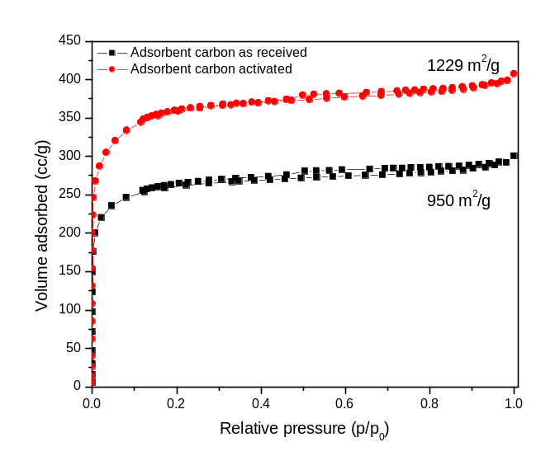

Fig. 1. N₂ adsorption-desorption isotherms of Adsorbent carbon as received and adsorbent carbon activated with K₂CO₃ (C:K₂CO₃ = 1 :3, 800 ºC, 2 h, N₂ atm.)

In addition to K₂CO₃, many new activating agents namely oxalic acid, citric acid, tartaric acid, sodium oxalate, sodium citrate and sodium tartarate were exploited for the first time. The method of activation is same as that depicted in Flow sheet I except that the ratio of adsorbent carbon to activating agent is 1:1 (wt./wt. %) rather than 1:3 (wt./wt. %) as in the case of K₂CO₃ activation. The N₂ adsorption-desorption isotherms recorded on adsorbent carbon activated with oxalic acid, sodium oxalate, citric acid, sodium citrate, tartaric acid, sodium tatarate and sodium potassium tartarate are show in Fig. 2. Adsorbent carbon activated with all the afore mentioned activating agents showed Type I adsorption isotherms characteristic of microporous nature of the material. The specific surface area and pore volume values derived from the isotherms in Fig. 2. are summarized in Table 4.

From the preceding studies, it was found that sodium oxalate is the best activating agent in improving the specific surface area and pore volume.

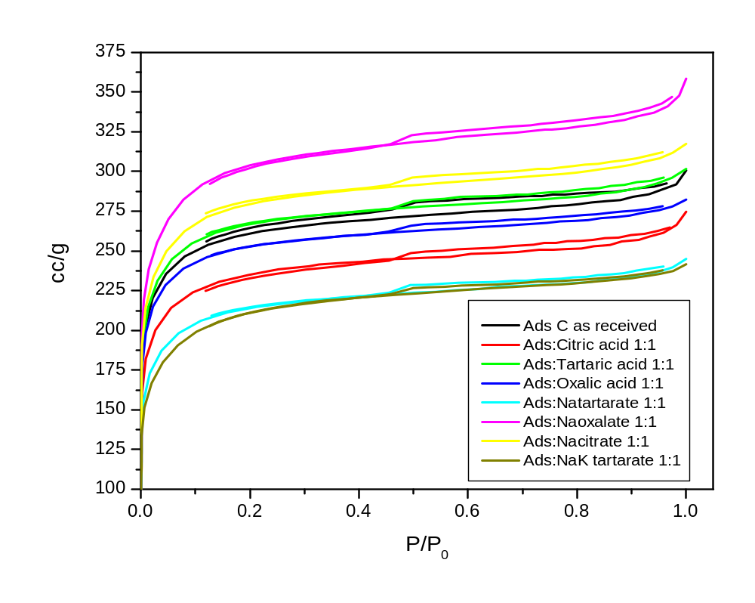Fig. 2. N₂ adsorption-desorption isotherms of Adsorbent carbon as received and adsorbent carbon activated with oxalic acid, sodium oxalate, citric acid, sodium citrate, tartaric acid, sodium tartarate and sodium potassium tartarate (C :Activating agent = 1 :1 (wt./wt.%), at 800 ºC for 2 h in N₂ atm.)

Table 4. Effect of oxygen content (wt.%) of the activating agent on the specific surface area (m²/g) of the adsorbent carbon (Specific surface area value of adsorbent carbon as received = 950 m²/g)
Activating agent | Oxygen content (wt.%) | Specific surface area (m²/g) | Pore Volume (cc/g)
Sodium acetate | 39.02 | 795 | 0.37
Sodium potassium tartarate | 45.71 | 756 | 0.37
Sodium oxalate | 47.76 | 1123 | 0.54
Sodium citrate | 48.96 | 1019 | 0.48
Sodium tartarate | 49.48 | 785 | 0.37
Citric acid | 60.9 | 842 | 0.41
Tartaric acid | 64.0 | 961 | 0.46
Oxalic acid | 71.1 | 932 | 0.43

The effect of oxygen content (wt.%) of the activating agent on the specific surface area is shown in Fig. 3. Oxygen content of the activating agent appears to be not only critical but also a sensitive parameter effecting the specific surface area of the activated carbon material. The optimum value of the oxygen content of the activating agent should be between 47-48 wt. % so as to obtain the best possible increment in the specific surface area and pore volume values.

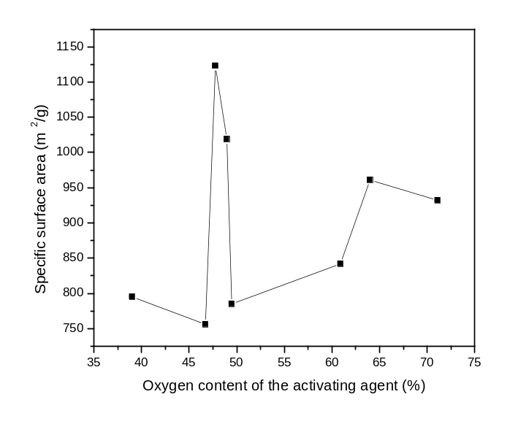

Fig. 3. Effect of oxygen content (wt.%) of the activating agent on the specific surface area of adsorbent carbon as received

4.1.3 XRD studies – Structure and Crystallinity of Adsorbent and Modified Adsorbent Carbon
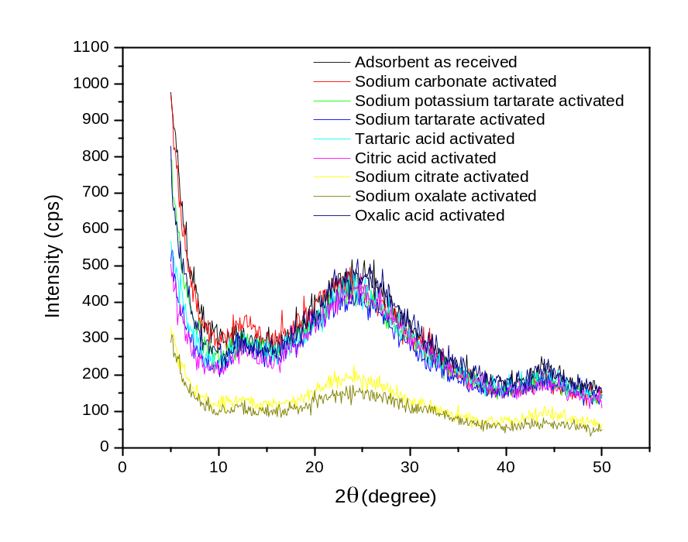

Fig. 4. XRD pattern of Adsorbent carbon as received and adsorbent carbon activated with sodium carbonate, oxalic acid, sodium oxalate, citric acid, sodium citrate, tartaric acid, sodium tartarate and sodium potassium tartarate (C:Activating agent = 1 :1 (wt./wt.%), at 800 ºC for 2 h in N₂ atm.)
The structure and crystallinity of the adsorbent carbon as received and adsorbent carbon activated with sodium carbonate, oxalic acid, sodium oxalate, citric acid, sodium citrate, tartaric acid, sodium tartarate and sodium potassium tartarate are evaluated by XRD studies and the corresponding X-ray diffractograms are shown in Fig. 4. Two intense and broad diffraction peaks are centered at around 2θ values of 12 and 25. The former peak indicate regular hexagonal ordering in the carbon structure. Another strong peak centered around 25 degrees is identified as the (002) peak of a graphitic carbon. This peak indicates the degree of graphitization and the intensity of this peak can be taken as a measure of the degree of crystallinity. Irrespective of the type and nature of the activating agent used, the structural features of the carbon remained unaltered. But there is a remarkable change in the degree of crystallinity with the amount of oxygen content (wt.%) of the activating agent as shown in Table 5 and depicted in Fig. 5 (a). The crystallinity of the activated carbon material is inversely related to the specific surface area value as depicted in Figs. 5 (a) and (b).

Table. 5. Effect of oxygen content (wt.%) of the activating agent on the crystallinity (%) of the activated carbon
S. No. | Activating agent | Oxygen content (wt.%) | % crystallinity (relative to Adsorbent carbon as received) | Specific surface area (m²/g)
1 | Adsorbent carbon as received | - | 100 | 950
2 | Sodium potassium tartarate | 45.71 | 85.6 | 756
3 | Sodium oxalate | 47.76 | 35.6 | 1123
4 | Sodium citrate | 48.96 | 37.0 | 1019
5 | Sodium tartarate | 49.48 | 88.9 | 785
6 | Citric acid | 60.9 | 81.7 | 842
7 | Tartaric acid | 64.0 | 71.6 | 961
8 | Oxalic acid | 71.1 | 94.0 | 932

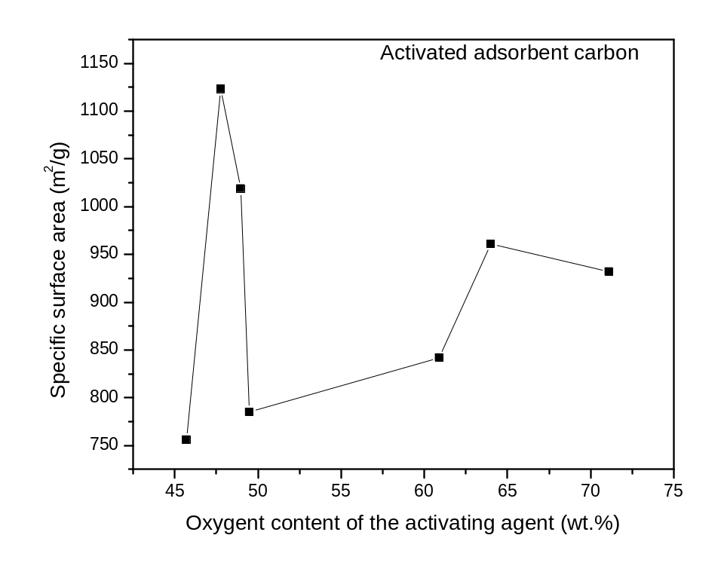

Fig. 5 (a). Effect of oxygen content (wt.%) of the activating agent on the crystallinity of the modified activated carbon

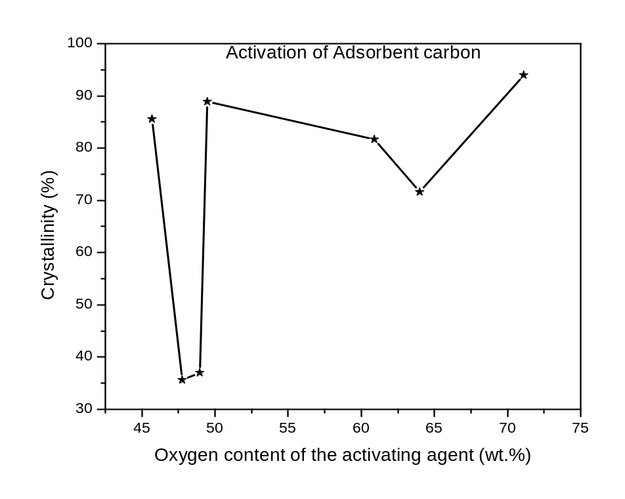

Fig. 5 (b). Effect of oxygen content (wt.%) of the activating agent on the specific surface area of the modified activated carbon
Upon activation the crystallinity of the adsorbent carbon as received decreased drastically. Adsorbent carbon activated with sodium oxalate exhibited least crystallinity and adsorbent carbon as received exhibited highest crystallinity. The values of % crystallinity obtained with other activating agents namely sodium citrate, tartaric acid, citric acid, sodium potassium tartarate, sodium tartarate and oxalic acid are in between the crytallinity values of sodium oxalate activated adsorbent carbon and adsorbent carbon as receive are summarized in Table 6. A decreasing trend in specific surface area values with an increase in crystallinity is observed.

Table 6. Effect of crystallinity (%) of adsorbent carbon (as received and activated with different activating agents) on the specific surface area
S. No. | Activating agent | % crystallinity (relative to Adsorbent carbon as received) | Specific surface area (m²/g)
1 | Sodium oxalate | 35.6 | 1123
2 | Sodium citrate | 37.0 | 1019
3 | Tartaric acid | 71.6 | 961
4 | Citric acid | 81.7 | 842
5 | Sodium potassium tartarate | 85.6 | 756
6 | Sodium tartarate | 88.9 | 785
7 | Oxalic acid | 94.0 | 932
8 | Adsorbent carbon as received | 100 | 950

A plot of the variation of specific surface area with crystallinity (%) was depicted in Fig. 6. From the afore mentioned studies, it is understood that lower the crystallinity of the activated carbon material higher will be the specific surface area.

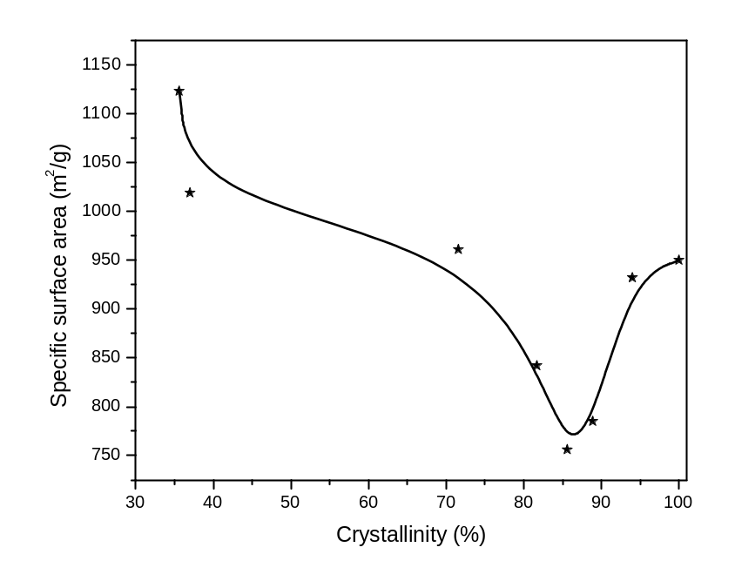

Fig. 6. Effect of crystallinity (%) of the adsorbent carbon activated with different activating agents on the specific surface area

4.1.4 SEM analysis – Morphology study
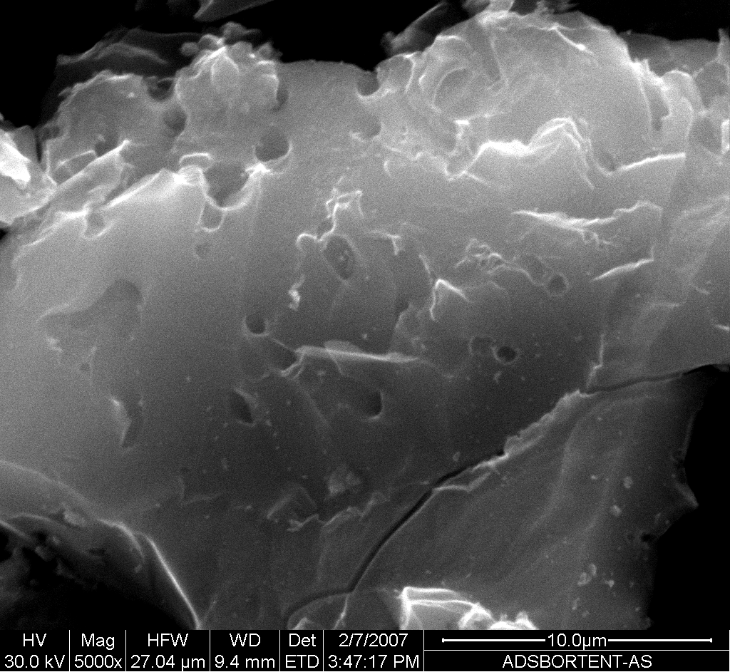
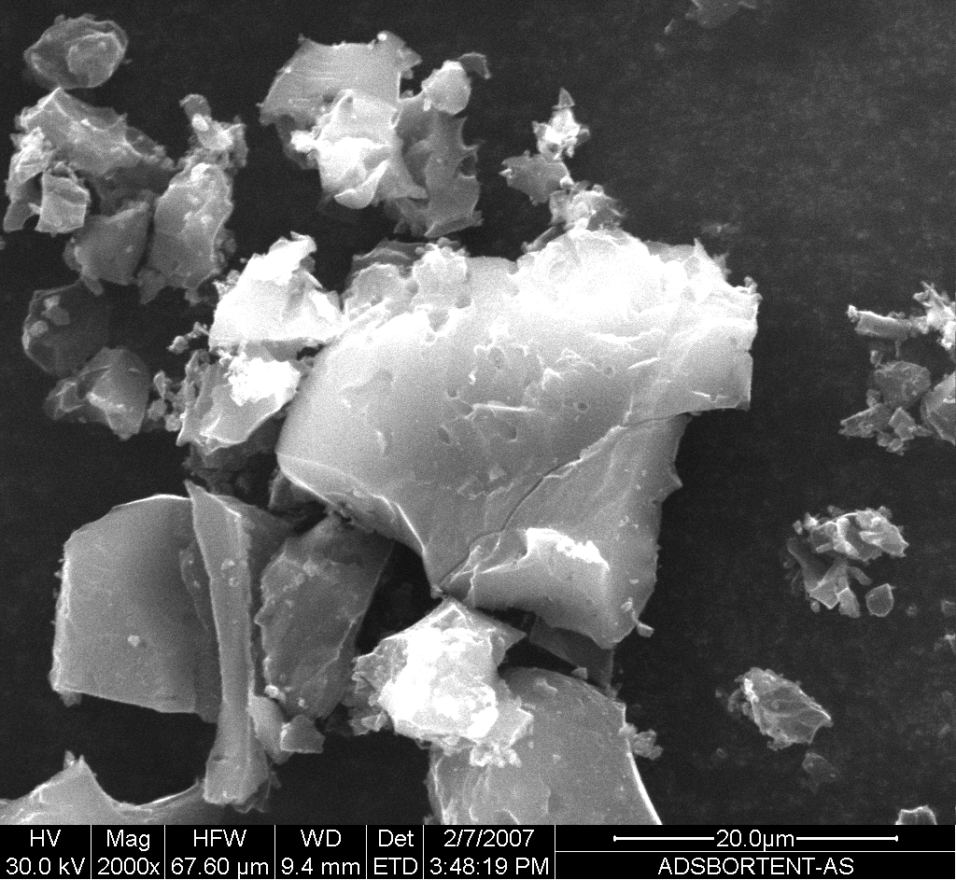

(a) (b)
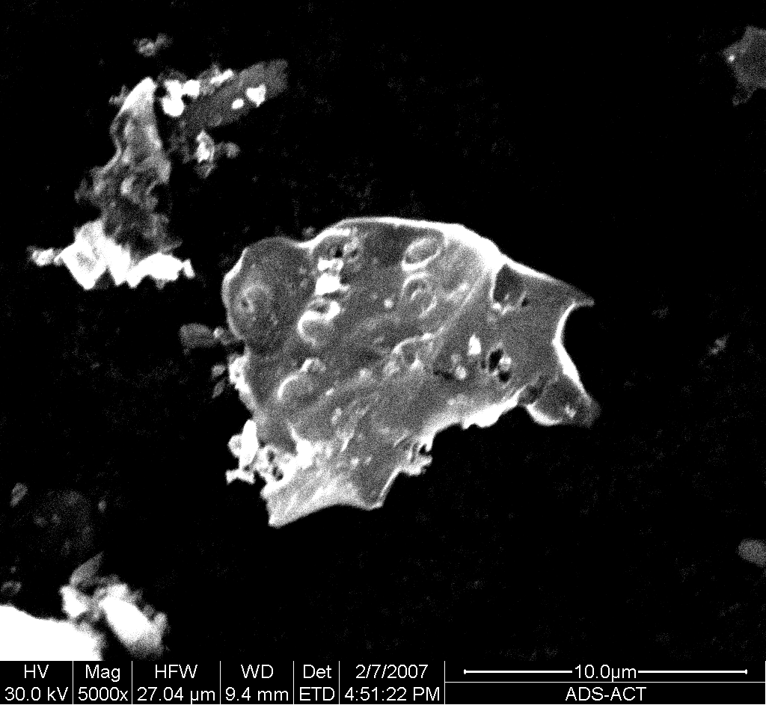
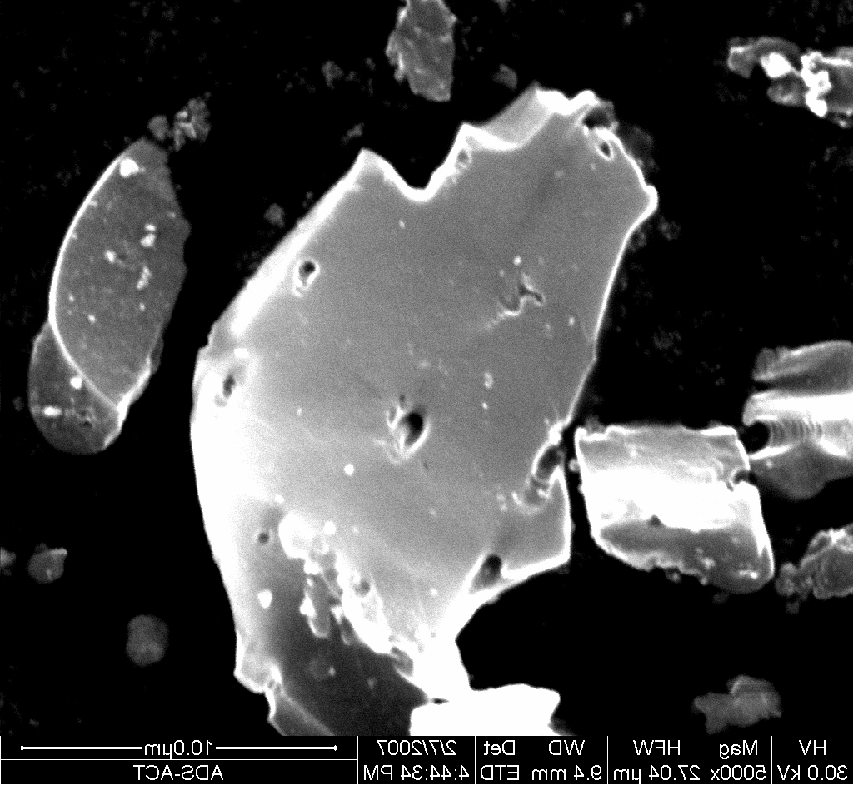

(c) (d)

Fig. 7. SEM images of (a & b) Adsorbent carbon as received and (c & d) Adsorbent carbon activated with K₂CO₃

The surface of the adsorbent carbon as received is rough and heterogeneous with kinks and steps Fig. 7. (a & b). Upon activation with K₂CO₃, the surface became smooth. Also some incipient pores are also seen in Fig. 7. (c & d).

4.1.5. Study of surface functionality - FT – IR studies

Carbon materials possesses rich surface chemistry. A variety of C-O functional groups are present on the surface of carbon. Typical examples of the C-O functional groups are shown below in Fig. 8. The functional groups are inter convertible, in other words can be easily altered. Desired functional groups can be easily introduced both chemically as well as by anchoring.

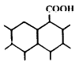
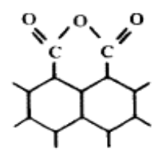
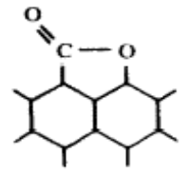
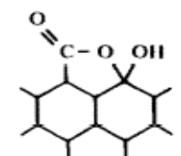
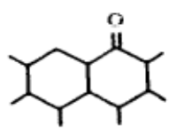
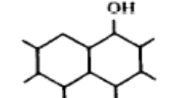
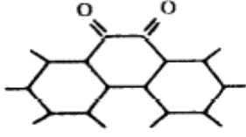
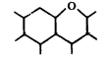
Lactol
Hydroxyl

Carbonyl

Carboxyl

Lactone

Quinone
Carboxyl anhydride

Xanthene or ether

Fig. 8. Structure of surface oxygen groups

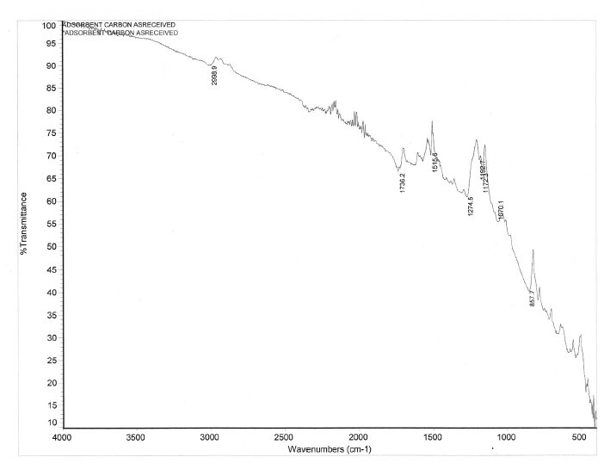
1736 cm⁻¹ - C=O stretch in carbonyl group
1274 cm⁻¹ -C-O-C stretch in ether

Fig. 9. FT-IR spectrum of adsorbent carbon as received

4.1.5.1 Amine functionalization of adsorbent carbon

The surface of the adsorbent carbon as received is examined for the type of functional groups present. From the FT-IR spectrum (Fig. 9.) it is evident that C=O (carbonyl) (1737 cm⁻¹) and C-O-C (ether) (1274 cm⁻¹) functional groups are present on the surface of the adsorbent carbon as received.
Attempts were made to functionalize the surface of the adsorbent carbon with nitrogen containing functions groups like NH₂. One such example where in ethylene diamine is used to anchor –NH₂ groups on to the carbon surface is depicted in Flow sheet X.
Ethylene diamine (125 g)
Adsorbent Carbon as received (25 g)
Carbon : Amine = 1:5 (wt./wt.%)
Continuous refluxing for 12 h
Temp. = 100 ºC
Filtration
Excess amine removed by washing
with distilled water
Dried in oven at 120 ºC
Amine functionalized carbon
(Used as adsorbent for sulphur compounds)

Flow sheet 2. Amine functionalization of adsorbent carbon with ethylene glycol

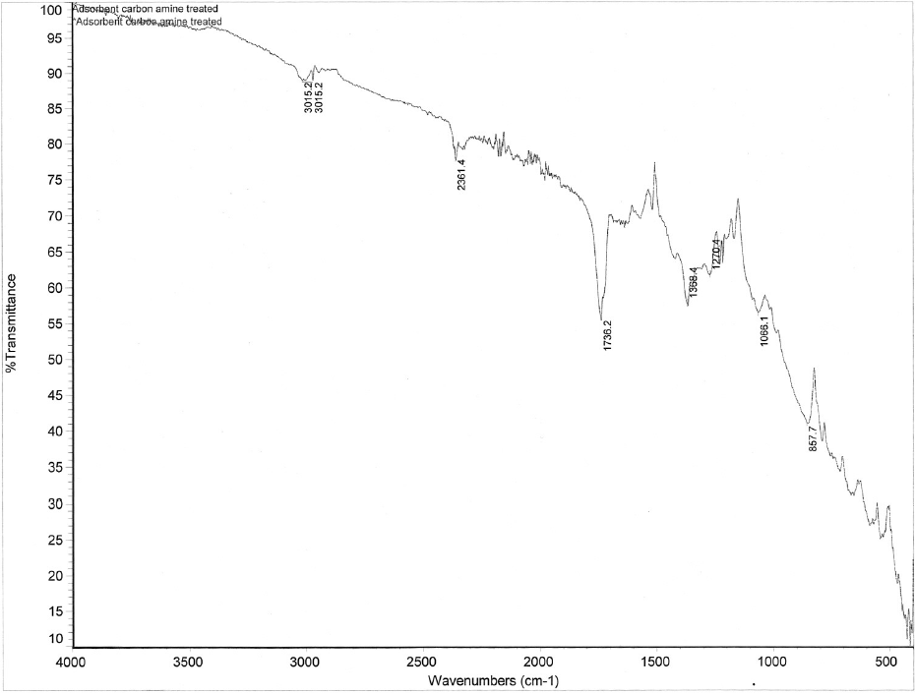
1368 cm⁻¹ – C-N stretching of aromatic amine
3015 cm^{-1 –} N-H stretch of primary amine
coupled doublet (two weak absorption bands)
1736 cm⁻¹ – C=O stretch in carbonyl group
1270 cm⁻¹ – C-O-C- stretch in ether

Fig. 10. FT-IR spectra of adsorbent carbon functionalized with amine

In order to verify whether the carbon surface is functionalized with amine the sample was subjected to FT-IR analysis and the corresponding spectrum is shown in Fig. 10. Upon amine functionalization in addition to the generation of –NH group C=O group became more pronounced compared to the unfunctionalized carbon. The bands characteristic of –NH and C-N stretching were seen on the surface of the amine functionalized carbon. Such groups are expected to enhance the S sorption capacity of the carbon material.

4.2. Evaluation of sorption capacity of adsorbent carbon and modified adsorbent carbon

The activated carbon materials namely adsorbent carbon as received, adsorbent carbon activated with K₂CO₃ and adsorbent carbon functionalized with amine were tested for S removal from CBR raw diesel.
In each case 5.0 g of activated carbon is packed in a glass column of length 50 cm and internal diameter 1.5 cm. The sorbent is placed in the middle of the glass column. Either sides of the sorbent are packed with glass beads. CBR raw diesel is fed onto the sorbent bed through a glass burette which is located vertically above the sorbent column. The product eluted at the outlet is collected in the steps of 15 ml each till feed value of the S content is observed in the product.

4.2.1. Evaluation of methods of column packing and, adsorbent bed composition

(a) Packing column by sand witching sorbent between glass beads on either sides
(b) Packing column with carbon and glass bead mixture with different Carbon to glass beads ratios by weight. Such a packing of column with a mixture of sorbent and glass beads facilitate smooth flow of the feed with less hindrance. The product is eluted at a relatively lower time.
To see whether type of packing the sorbent in the column has an effect on the S removal capacity, same amount of adsorbent carbon as received (5.0 g) is mixed with known wt. of glass beads. The column is then packed with the mixture of activated carbon and glass beads. This mode of packing offer free flow to the diesel.

4.2.2. Operation conditions

Table 7. S sorption capacity of adsorbent and modified adsorbent activated carbon materials
ml-diesel/g adsorbent | S content removed from CBR raw diesel (ppm)
ml-diesel/g adsorbent | Adsorbent carbon as received | Adsorbent carbon Activated with K₂CO₃ | Adsorbent carbon functionalized with amine | Adsorbent carbon as received mixed with glass beads
3 | 229 | 242 | 171 | 196
6 | 93 | 116 | 88 | 74
9 | 35 | 37 | 35 | -
12 | 26 | 11 | 16 | -
15 | 15 | 16 | 21 | -
18 | 17 | 17 | 16 | -
21 | 14 | 10 | 2 | -

Sorbents used: Adsorbent carbon as received, adsorbent carbon activated with K₂CO₃ and adsorbent carbon functionalized
Amount of sorbent: 5.0 g
Diesel feed: CBR raw (S content – 676 ppm)

The S removal ability of adsorbent carbon as received, adsorbent carbon activated with K₂CO₃ and adsorbent carbon functionalized with amine and adsorbent carbon as received mixed with 70 g glass beads were summarized in Table 7 and pictorially represented in Fig. 11.

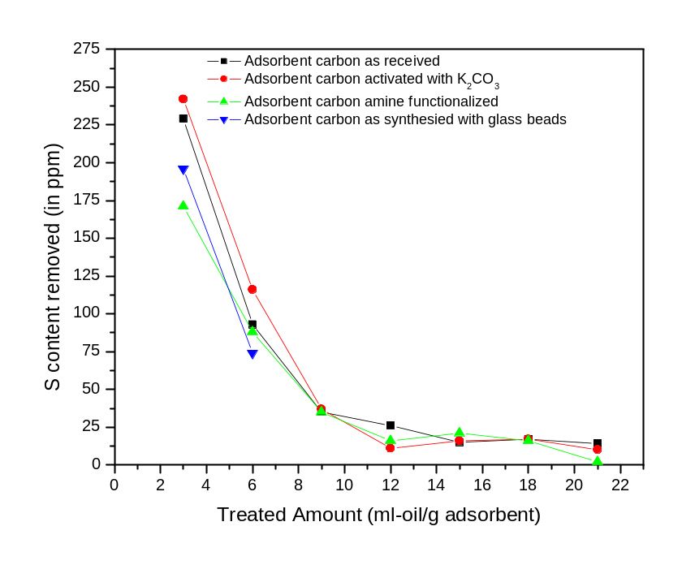

Fig. 11. Plot of amount of S removed in ppm Vs amount of CBR raw diesel treated per gram of adsorbent carbon as received and adsorbent carbon modified

From the experimental results summarized in Table 7. and plotted in Fig. 11. it can be stated that among adsorbent carbon as received, adsorbent carbon activated with K₂CO₃ and adsorbent carbon functionalized with amine, K₂CO₃ activated adsorbent carbon showed better performance not only in terms of cycle life but also in terms of S removal by removing 242 ppm sulphur from the feed. The respective values for adsorbent carbon as received and adsorbent carbon functionalized with amine are 229 and 171 ppm. Amine functionalization of the adsorbent carbon did not result in the improvement in S sorption capacity.

Also sand witching the sorbent between glass beads on either sides in the column is better mode of column packing rather than mixing the sorbent with glass beads and packing the column with the mixture of activated carbon and glass beads.

4.2.3 Evaluation of the effect of flow rate of feed, the sorbent bed preactivation on the S sorption capacity of Adsorbent carbon

(i) Sorbent bed is preactivated by passing N₂ gas through the column placed in a tubular furnace in vertical direction at 250 ºC for 2 h. Diesel is fed into the column after bringing back the same to room temperature.
(ii) The CBR raw diesel is fed on to the sorbent bed at different flow rates (0.06, 0.14 and
0.25 ml/h)
(iii) Adsorbent carbon as received is subjected to thermal activation (at 800 ºC for 2 h) in inert atmosphere (Ar atmosphere) to see whether such an activation enhances the S sorption.

Adsorbent carbon as received (5.0 g) is employed to study of the effect of flow rate of diesel feed and use of multiple glass columns on S removal. Two different flow rates namely 0.25 and 0.14 ml/h are employed. The values of S content (ppm) removed by sorbent packed in glass column I (Run I) at a flow rate of 0.25 ml/h are placed in 2nd column of Table 8. The diesel product obtained in Run I is passed through glass column II with similar flow rate and the same amount of adsorbent carbon as received. This is Run II. In Run II, the diesel product is collected in 15 ml batches. The samples collected in each batch were subjected to S analysis. The amount of S removed in Run II is placed in 3rd Column of Table 8. Comparison of data in 2nd and 3rd columns of Table 8 indicate an improvement in S removal from 170 to 219 ppm as the number of columns with sorbent used increased from 1 to 2.This imply that greater the number of sorbent columns greater will be the S removal.
Also when the flow rate of the feed (product obtained in Run I) in Run II is reduced from 0.25 ml/h (3rd column of Table 8) to 0.14 ml/h (4th column of Table 8), the amount of S removed increased from 219 to 245 ppm implying that the flow rate of the feed has an effect on the amount of S that can be removed. Lower the flow rate of the feed higher is the amount of S removed.

Table 8. Effect of flow rate of the feed on the S removal capacity of Adsorbent carbon as received and adsorbent carbon activated with Ar
ml-diesel/g adsorbent | S content removed from CBR raw diesel (ppm)
ml-diesel/g adsorbent | Adsorbent as received (5.0 g),  0.25 ml /h | Adsorbent as received (5.0 g)  0.25 ml/h,  Run II | Adsorbent as received (5.0 g)  0.14 ml/h,  Run II | Adsorbent carbon activated in Ar, 800 ºC, 2 h  (0.06 ml/h)
3 | 170 | 219 | 245 | 225
6 | 63 | 146 | 169 | 120
9 | 44 | 102 | 114 | 69
12 | 40 | 80 | 61 | 41
15 | 43 | 55 | 44 | 10
18 | 26 | 35 | 22 | 19

In addition to studying the effect of multiple sorbent columns and flow rate of the feed, the effect of thermal activation of the adsorbent carbon in inert atmosphere (Ar) on S sorption is also evaluated and the corresponding data is presented in 5th column of Table 8. The flow rate of the feed employed is 0.06 ml/h when the adsorbent carbon activated in Ar atmosphere at 800 ºC for 2 h is used as sorbent. Comparison of data in 3rd and 5th column of Table 8 indicate that Ar activation of the adsorbent carbon as received combined with decrease in flow rate of the feed from 0.25 ml/h to 0.06 ml/h improved S removal from 170 ppm to 225 ppm.

The S removal trends on adsorbent carbon as received (Run I, 0.25 ml/h), adsorbent carbon as received (Run II, 0.25 ml/h and 0.14 ml/h) and adsorbent carbon activated at 800 ºC for 2 h in Ar atmosphere (0.06 ml/h) are shown in Fig. 12. In all the afore mentioned cases the amount of sorbent is 0.5 g. The S removal trends in Fig. 12. reveal that adsorbent carbon as received (Run II, 0.14 ml/h) exhibited better performance compared to other sorbents and modes of operation employed in the study.

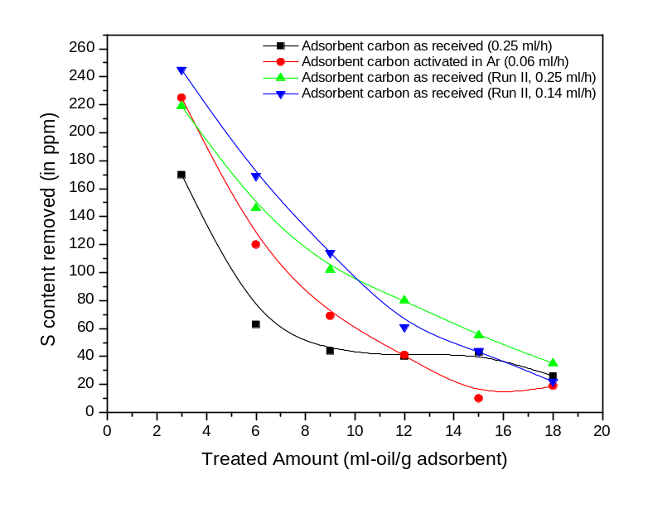

Fig. 12. Plot of amount of S removed in ppm Vs amount of CBR raw diesel treated per gram of adsorbent carbon as received and adsorbent carbon activated in Ar at 800 ºC for 2 h under different conditions of flow rate of the feed

5. Evaluation of S sorption capacity of Commercial Activated Carbon Materials
(Bare or As received)

Table 9. S sorbing ability of different Carbon materials
S. No. | Sorbent name | *ml-diesel treated/g of adsorbent | S removed (ppm)
1 | IG 18 | 4 | 134
2 | IG 12 | 4 | 81
3 | IG 8 | 4 | 76
4 | AC 4 | 4 | 12
5 | AC 6 | 4 | 73
6 | AC 12 | 4 | 92
7 | Calgon carbon as received | 4 | 181
8 | Adsorbent carbon | 4 | 229
9 | Nuchar as received | 4 | 588
* 20 ml initial product collected from the column packed with 5.0 activated carbon and analyzed for S analysis

The potential of a variety of commercial activated carbon materials with varying textural and physico chemical properties was tested and the initial S removal values are summarized in Table 9. In a typical experiment the glass column is packed with 5.0 g of sorbent (IG 18, IG 12, IG 8, AC 4, AC 6, AC 12, Calgon carbon as received, Adsorbent and Nuchar as received). Deisel is fed on to the sorbent bed packed in the glass column with glass beads on either sides through a burette. The first 20 ml product collected at the bottom of the column (out let) is analyzed for S and the S content removed by each of the sorbents tested in placed in Table 9. From the afore mentioned study three commercial carbon materials namely Calgon carbon as received, Nuchar and Adsorbent were chosen since their performance is outstanding in terms of S removal.

5.0. Carbon Materials subjected to Critical Evaluation

5.1. Carbon Materials subjected to Critical Evaluation

1. Calgon carbon as received

2. Calgon carbon modified
- Calgon carbon treated with HNO₃ (CC1 HNO₃)
b. Calgon carbon treated with HNO₃ followed by Ar activation
(CC1 HNO₃ Ar)
c. 4.11 wt.% Cu loaded CC1 HNO₃ Ar

3. Nuchar as received

6. EXPLOITATION OF NUCHAR CARBON AS SORBENT FOR S IN CBR RAW DIESEL

6. Exploitation of Nuchar carbon as sorbent for S in CBR raw diesel

6.1. Characterization

6.1.1. XRD studies
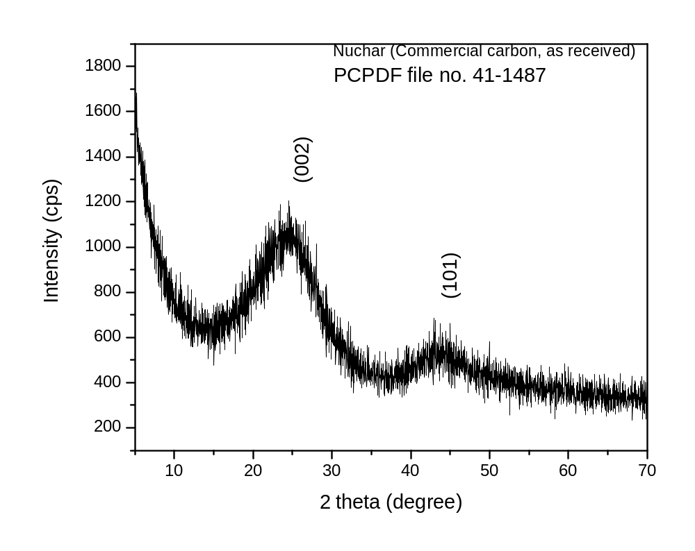

Fig. 13. XRD pattern of Nuchar Carbon as received

The X-ray diffraction pattern of Nuchar as received is shown in Fig. 13. Two intense peaks centered around 2θ values of 24.5 and 44 can be indexed to a hexagonal graphite lattice (PCPDF file No. 41-1487).

6.1.2. FT-IR study

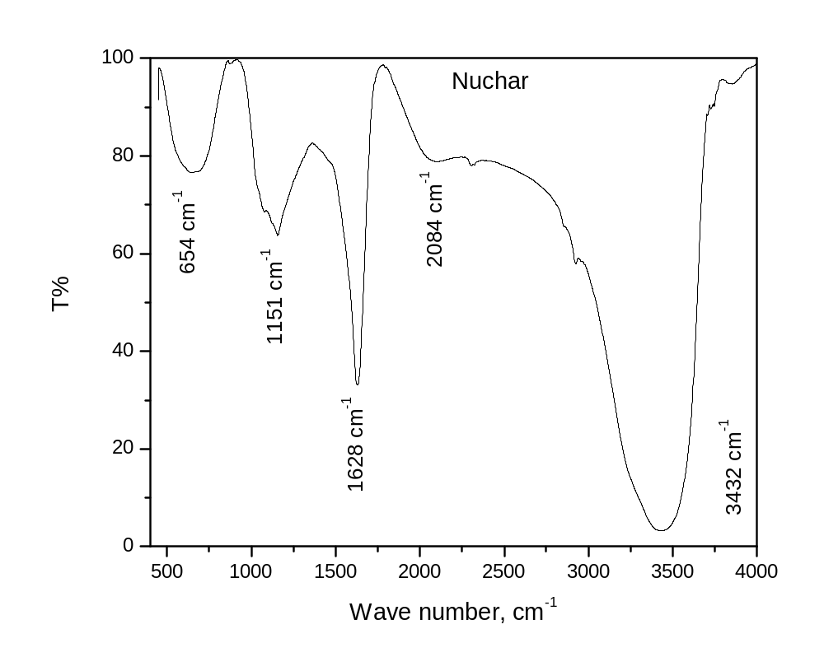

Fig. 14. FT – IR spectrum of Nuchar carbon as received

Table 10. Assignment of frequency of the absorption band (cm⁻¹) to the source of the infrared signal
S. No. | Frequency of the absorption band (cm⁻¹) | Source of infrared signal | Reference
1 | 1151 | C-O stretching vibration in phenolic structure | Ishizaki et al., Carbon  19 (1981) 409  Moreno-Castilla et al., Carbon  35 (1997) 1619
2 | 1628 | Strong band is due to the aromatic C=C stretching enhanced by the presence of polar functional groups | Puziy et al., Carbon 41 (2003) 1181  Moreno-Castilla et al., Carbon  35 (1997) 1619
3 | 3432 | -OH stretching mode of hydroxyl group and adsorbed water | Puzy et al., Carbon 41 (2003) 1181

From FT-IR analysis, it was found that aromatic rings with hydroxyl groups are present predominantly through out the structure of Nuchar carbon. The FT-IR spectrum of Nuchar activated carbon as received is shown in Fig. 14. The important information pertaining to the surface functionality of Nuchar activated carbon is summarized in Table 10 with relevant references from literature.

The surface of Nuchar activated carbon contains oxygen rich functional groups. The characteristic FT-IR bands centered at frequencies 1151, 1628, and 3432 correspond to C-O stretching vibration in phenolic structure, strong band due to aromatic C=C stretching enhanced by the presence of polar functional groups, -OH stretching mode of hydroxyl group and adsorbed water. Thus aromatic ring structures with hydroxyl groups are present predominantly through out the structure of Nuchar carbon.

6.1.3. Electron Paramagnetic Resonance (EPR) spectroscopic analysis

EPR spectroscopy is the most elegant and nondestructive technique to study the samples containing unpaired electrons. The electron spins in carbon are sensitive probes of their microscopic environment. Also such spins provide information on the chemical processes occurring on carbon surface. One of the views of the origin of paramagnetism in carbon samples is that the fused ring aromatic structures in the char may contain odd number of carbon atoms and this in turn gives rise to unpaired spin.

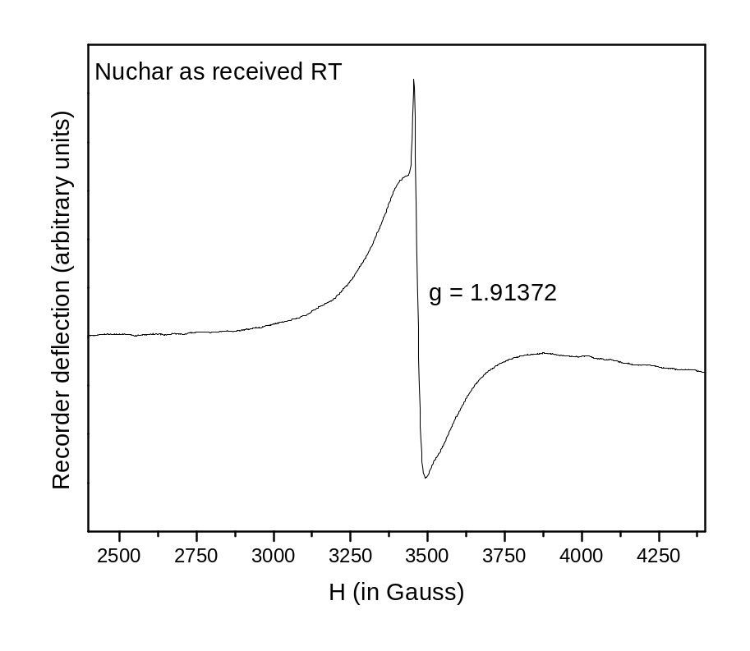

Fig. 15. EPR spectrum of Nuchar activated carbon as received recorded at room temperature on an X-band spectrometer

The EPR spectrum of Nuchar activated carbon is shown in Fig. 15. The presence of unpaired electrons is undoubtedly indicated by the EPR spectrum. A narrow and very intense line is observed with a g value of 1.91372 authenticating the presence of organic (aromatic units) paramagnetic centers. But a free electron will have a g value of 2.00232. Deviation of the g value exhibited by Nuchar (1.91372) from that of free electron value (2.0023) may be due to larger crystallite size. The line shape and width also carries some useful information pertaining to the microstructure of carbon material under investigation. The narrow EPR signal with small line width indicates the existence of larger aromatic units [2].

6.1.4. Thermal analysis

Nuchar activated carbon is stable up to 550 ºC even in air as indicated by the TGA curve shown in Fig. 16.
Calgon carbon (50.0 g)
Conc. HNO₃ (250.0 g)
Carbon:Acid = 1:5 (wt./wt.%)
Refluxing at 60 ºC for 2 h in RB flask
Filtering, washing and drying at 110 ºC for 2 h (CC1 HNO₃)
Thermal activation in Ar atm. at 800 ºC for 2 h
HNO₃ treated Ar activated Calgon carbon (CC1 HNO₃ Ar)

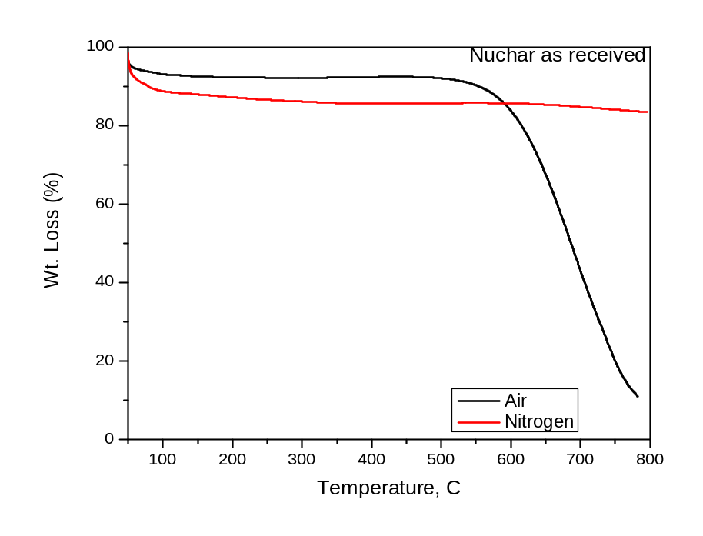

Fig. 16. TGA curves of Nuchar activated carbon recorded in air and N₂ atmospheres at a heating rate of 20 ºC/min

6.1.5. Sulphur sorption capacity of Nuchar activated carbon as received

S sorption potential of Nuchar activated carbon is analyzed with 5.0 g sorbent. Remarkable leap in the S removal is achieved as indicated by the data in Table 11. 545 ppm of S removal was obtained leaving behind on 192 ppm S in the product diesel collected at the out let on 5.0 g Nuchar carbon as received. But the fine particle nature of the carbon offered restriction to free flow of the diesel and increased the time of elution of the product. To check the reproducibility of the outstanding performance of Nuchar activated carbon the same experiment is repeated and the S removal values obtained are shown in Table 12. Even in the second trial 588 ppm of S is removed from the diesel by Nuchar sorbent.

Table 11. S sorption capacity of Nuchar as received (5.0 g batch)

ml-diesel treated/g of adsorbent | S in the product  (S content removed), in ppm
4 | 192 (545)
8 | 442 (295)

6.1.5.1. Test for reproducibility

Table 12. S sorption capacity of Nuchar as received (5.0 g batch) – Evaluation of reproducibility
ml-diesel treated/g of adsorbent | S in the product  (S content removed), in ppm
4 | 149 (588)

7. Exploitation of Calgon carbon as sorbent for S in CBR raw diesel

7. Exploitation of Calgon carbon as sorbent for S in CBR raw diesel

i. HNO₃ treatment of Calgon carbon as received
ii. HNO₃ treatment of Calgon carbon as received followed by Ar activation at 800 ºC for
2 h
iii. Supporting 4.11 wt.% Cu on Calgon carbon treated with HNO₃ and activated in Ar
atmosphere at 800 ºC for 2 h

7.1. Methods of modification of Calgon carbon as received

7.1.1. Nitric acid treatment of Calgon carbon as received (CC1 HNO₃)

Calgon carbon (50.0 g)
Conc. HNO₃ (250.0 g)

Refluxing at 60 ºC for 2 h in RB flask

Carbon:Acid = 1:5 (wt./wt.%)

Filtering, washing and drying at 110 ºC for 2 h (CC1 HNO₃)

Nitric acid treated calgon carbon (CC1 HNO₃)

Flow sheet 3. Systematic Procedure for the nitric acid treatment of Calgon carbon as received

7.1.2. Nitric acid treatment of Calgon carbon as received followed Ar activation (CC1 HNO₃ Ar)

Calgon carbon (50.0 g)
Conc. HNO₃ (250.0 g)
Carbon:Acid = 1:5 (wt./wt.%)
Refluxing at 60 ºC for 2 h in RB flask
Filtering, washing and drying at 110 ºC for 2 h (CC1 HNO₃)
Thermal activation in Ar atm. at 800 ºC for 2 h
HNO₃ treated Ar activated Calgon carbon (CC1 HNO₃ Ar)

Flow sheet 4. Systematic Procedure for the nitric acid treatment of Calgon carbon as received followed by Ar activation

7.1.3. Modification of HNO₃ treated Ar activated Calgon carbon as received with transition metal on the surface

7.1.3.1. Preparation of 4.11 wt. % Cu on Calgon carbon HNO₃ treated and Ar activated:
0.2 M Cu(NO₃)₂ 200 ml (in MeOH)
48.29 g Calgon carbon HNO₃ treated and Ar activated
Washed with excess distilled water, solution decanted
Stirred overnight at RT

Cu(NO₃)₂ on calgon carbon activated
Filtrate analyzed for Cu by titrimetry
4.11 wt.% Cu/Calgon carbon activated
Reduction in H₂ atm; 500 ºC for 8 h

Flow sheet 5. Step wise procedure for the preparation of 4.11 wt. % Cu/Calgon carbon activated with HNO₃ followed by Ar activation

7.2. Characterization of Calgon carbon as received and Calgon carbon modified

7.2.1. XRD studies:

XRD is a powerful technique for examining the detailed microstructure of carbonaceous materials. The XRD analysis was carried out on powder samples to investigate the structural changes in modified calgon carbon relative to as received calgon carbon sample. The X-ray diffraction patterns of the above mentioned carbon materials were shown in Fig. 17. The diffraction peaks typical of carbonaceous materials are seen. The original long range of the as received calgon carbon is unperturbed or retained even after either treatment with HNO₃ or HNO₃ treatment followed by Ar activation.
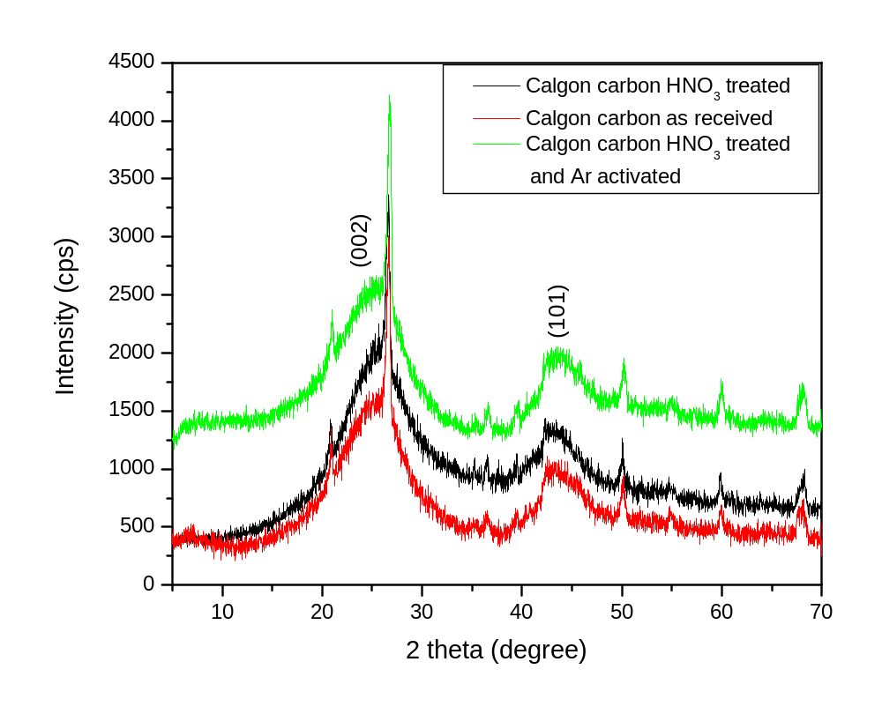
Fig. 17. XRD pattern of (a) Calgon carbon as received, (b) Calgon carbon HNO₃ treated and (c) Calgon carbon HNO₃ treated and Ar activated

7.2.2. Sorptometric studies:

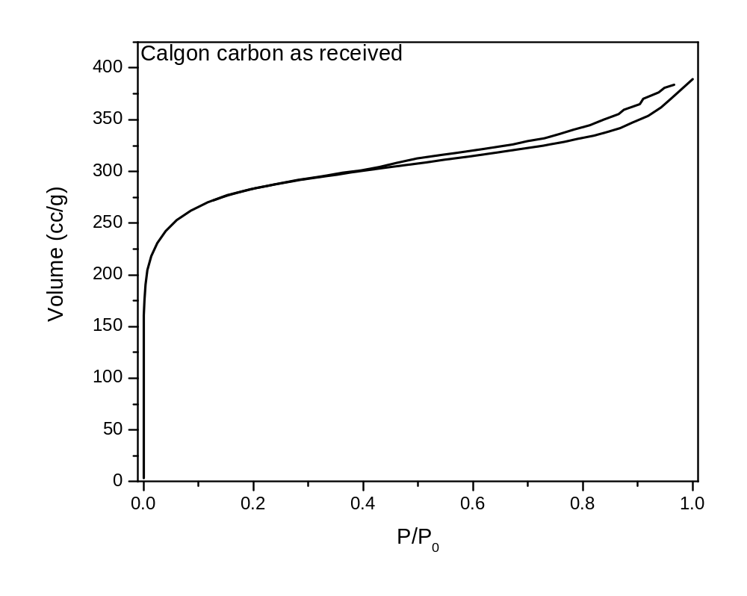
Fig. 18. N₂ adsorption-desorption isotherm of Calgon carbon as received (Specific surface area = 1014 m²/g, Pore volume = 0.5875 cc/g )

N₂ Adsorption-desorption isotherm of Calgon carbon as received is shown in Fig. 18. The specific surface area and pore volume of Calgon carbon as received are 1014 and 0.5875 cc/g respectively.

.2.3 FT-IR spectroscopic study:

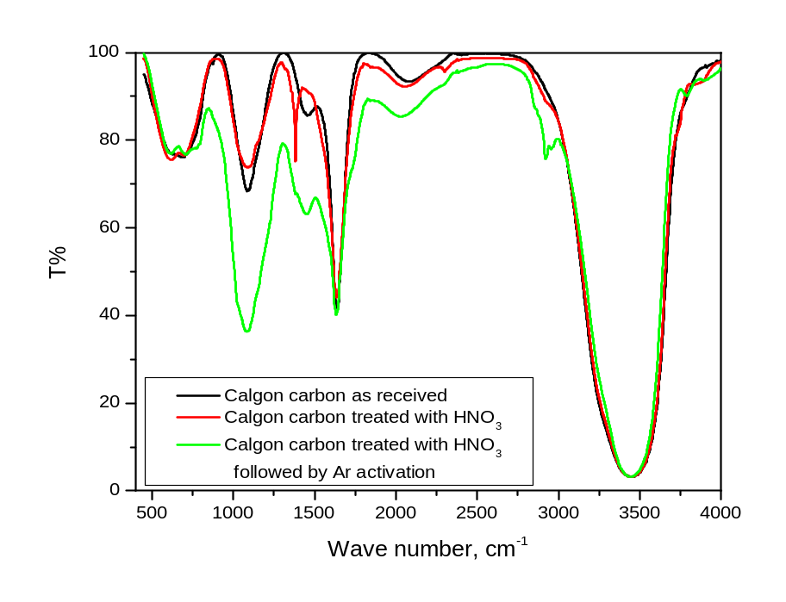

Fig. 19. FT-IR spectra of (a) Calgon carbon as received, (b) Calgon carbon treated with nitric acid and (c) Calgon carbon treated with nitric acid followed by Ar activation at 800 ºC for 2 h in N₂ atmosphere

HNO₃ treatment followed by Ar activation resulted in an increase in the intensity of the bands centered around 1080 and 1450 cm⁻¹ indicating an increase in the amounts of oxygen surface functional groups namely phenolic (C-O stretching and O-H bending). The intensity of the band centered around 1630 cm⁻¹ also showed a steep raise indicating enhancement in the aromatic C=C groups (carbonization). The presence of aliphatic CH₂ stretching is evidenced only in calgon carbon treated with HNO₃ and activated in Ar atmosphere.

Table 13. Assignment of frequency of absorption band (cm⁻¹) to the source of infrared signal
Frequency of absorption band (cm⁻¹) | Assignment
Frequency of absorption band (cm⁻¹) | Calgon as received | Calgon HNO₃ treated | Calgon HNO₃ treated and Ar activated
1085, 1088 | C-O stretching in phenolic structures | C-O stretching in phenolic structures | C-O stretching in phenolic structures
1378, 1453, 1456 | OH in plane bending vibration of phenol | OH in plane bending vibration of phenol | OH in plane bending vibration of phenol
1635, 1638 | Strong band  due to aromatic  ring C=C stretching enhanced by the presence of polar functional groups | Strong band  due to aromatic  ring C=C stretching  enhanced by the presence of polar functional groups | Strong band  due to aromatic  ring C=C stretching enhanced by the presence of polar functional groups
2921 | - | - | Aliphatic CH₂ stretching
3440, 3443 | OH stretch in phenol | OH stretch in phenol | OH stretch in phenol

7.2.4. Electron Paramagnetic Resonance (EPR) Spectroscopic study of Calgon carbon as received and modified calgon carbon:

EPR spectroscopy is a unique nondestructive technique that aids the study of the properties of paramagnetic centers of the carbon materials.
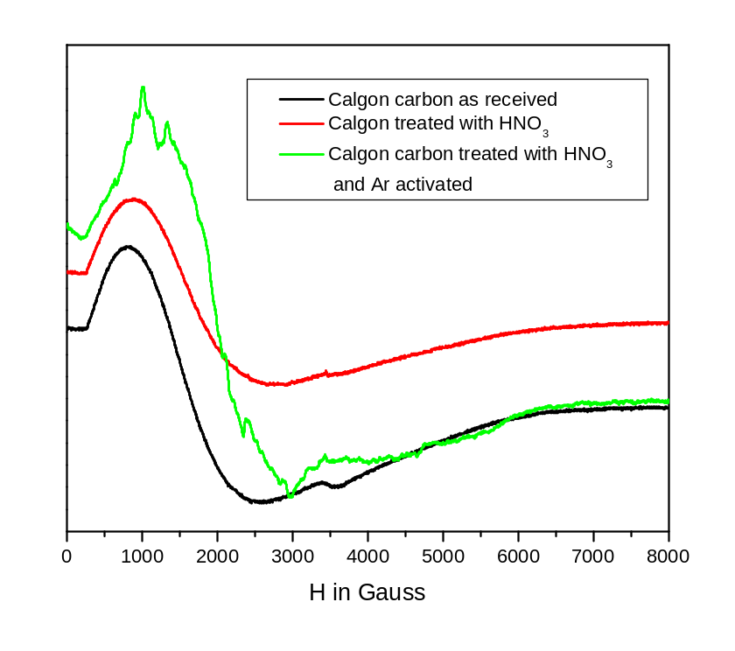

Fig. 20. EPR spectra of Calgon carbon as received, calgon carbon treated with HNO₃ and Calgon carbon treated with HNO₃ followed by Ar activation

7.2.4.1. Analysis of EPR spectra of Calgon and modified calgon carbon samples:

Unlike the EPR signal of Nuchar carbon as shown in Fig. 6. Whose origin was attributed to the organic species, the signal resulting from calgon as well as modified calgon carbon signals (Fig. 20.) is due to paramagnetic Fe³⁺ ions. The g values corresponding to the broad intense EPR signals from Calgon carbon as received; Calgon carbon treated with HNO₃ and Calgon carbon treated with HNO₃ and activated in Ar atmosphere are shown in Table 14.

Table 14. g values of EPR signals resulting from Calgon and modified Calgon carbon samples

Carbon sample | g value
Calgon carbon as received | 4.05600
Calgon carbon treated with HNO₃ | 3.92028
Calgon carbon treated with HNO₃ and activated in Ar atmosphere | 3.27433

7.2.5. Thermal properties of Calgon and modified calgon carbons

Thermo gravimetric curves recorded on Calgon carbon as received, calgon carbon treated with HNO₃ and calgon carbon treated with HNO₃ and activated in Ar atmosphere are shown in Fig. 21. It is found that both HNO₃ treatment and HNO3 treatment followed by Ar activation have contrasting effect on the thermal stability of the calgon carbon material as received. The thermal stability deteriorated upon HNO₃ treatment. Where as when the HNO3 treated calgon carbon material is subjected to activation in Ar atmosphere the resulting material is thermally more stable than the parent calgon carbon as received?
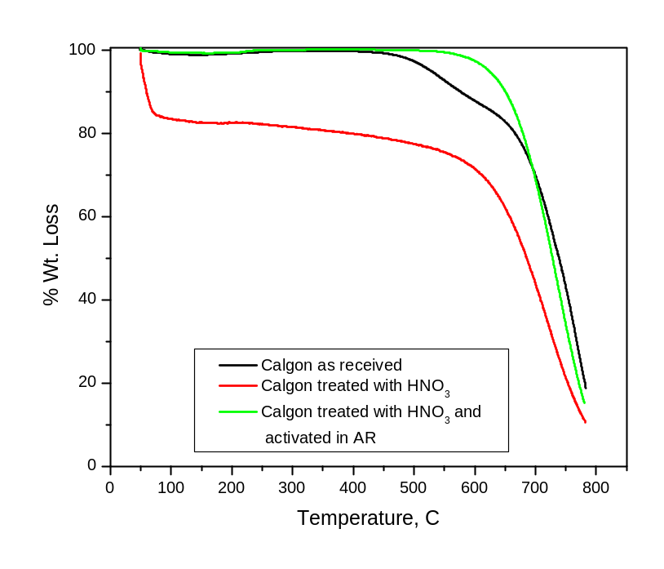

Fig. 21. Thermo gravimetric curves of Calgon carbon as received, calgon carbon treated
with HNO₃ and calgon carbon treated with HNO₃ followed by Ar activation

7.3. Exploitation of Calgon carbon as received and modified calgon carbon materials for S adsorption
7.3.1. Evaluation of Sulphur sorption ability of 5.0 g, 10.0 g and 15.0 g calgon carbon as received
Table 15. S sorption capacity of Calgon carbon as received (5.0, 10.0 and 15.0 g batches)

Calgon carbon as received | S content in the product ( S removed) in ppm
*Batch No. | 5.0 g | 10.0 g | 15.0 g
1 | 556 (181) | 366 (371) | 286 (451)
2 | 667 (70) | 552 (185) | 457 (280)
3 | 721 (16) | 615 (122) | 627 (110)
4 | 720 (17) | 673 (64) | 707 (30)
5 |  | 684 (53) | 646 (91)
6 |  | 710 (27) | 694 (43)
7 |  | 720 (17) | 715 (22)
8 |  | 729 (8)
9 |  | 732 (5)
10 |  | 735 (2)
* 20 ml product collected in each batch
Calgon carbon as received after thorough characterization was exploited for the sorption of S from CBR raw diesel. The sorption studies on this sorbent were carried out in three batch scales, namely, 5.0, 10.0 and 15.0 g. S sorption increased linearly as the amount of sorbent employed increased from 5 to 15 g. The data on the S removal with amount of sorbent is summarized in Table 15 and depicted pictorially in Fig. 22.
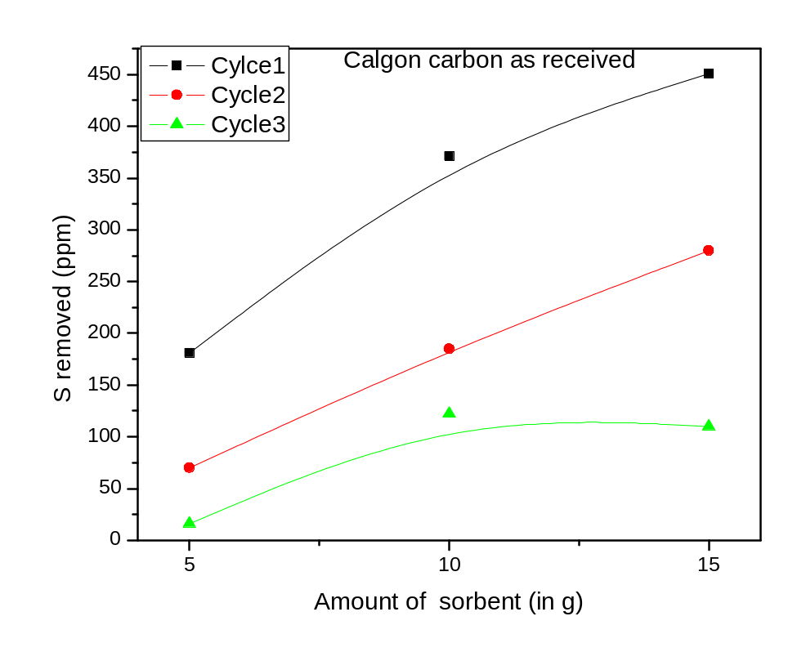

Fig. 22. Plot of S removed from feed Vs amount of calgon carbon used

Based on the sorption studies on varying amounts of Calgon carbon as received estimation is made on the amount of sorbent required for S removal form known volume of CBR raw diesel and the details are shown below:

Some Estimates on the amount of sorbent required for the process:

- 10³ liters of CBR crude will require for one pass removal of sulphur upto 200 ppm about 250 kilograms of carbon
- If it were to be multiple towers (say 2 towers) with possible regeneration then it will be of the order of 50 kilograms for tower.

7.3.2. Evaluation of Sulphur sorption ability of 5.0 g, 10.0 g and 15.0 ^{g} calgon carbon treated with HNO₃

The performance of HNO₃ treated Calgon carbon in adsorbing S from CBR raw diesel is evaluated. The amount of sorbent (Calgon carbon treated with HNO₃) was varied. 5.0, 10.0 and 15.0 g batches were studied and the data derived there from are summarized in Table 16. Increase in amount of sorbent showed the same trend in the S sorption as observed in the previous study on Calgon carbon as received, the difference being HNO₃ treatment improved the S sorption capacity of Calgon carbon as received.
Table 16. S sorption capacity of Calgon carbon treated with HNO₃ (5.0, 10.0 and 15.0 g batches)
Calgon carbon HNO₃ treated | S content in the product ( S removed) in ppm
*Batch No. | 5.0 g | 10.0 g | 15.0 g
1 | 457 (280) | 359 (378) | 249 (488)
2 | 627 (110) | 603 (164) | 580 (157)
3 | 707 (30) | 678 (59) | 582 (155)
4 | 703 (34) | 725 (12) | 644 (93)
5 | 733 (4) | 763 (0) | 705 (32)
6 | 634 (103) | 748 (0) | 767 (0)
7 | 677 (60) | 771 (0) | 681 (56)
8 | 689 (48) | 760 (0)
9 |  | 774 (0)
10 |  | 789 (0)

* 20 ml product collected in each batch

7.3.3. Evaluation of Sulphur sorption ability of 5.0 g, 10.0 g and 15.0 g Calgon carbon treated with HNO₃ followed by Ar activation at 800 ºC for 2 h

The potential of HNO₃ treated Ar activated Calgon carbon material was evaluated for different amounts of sorbents, namely, 5.0, 10.0 and 15.0 g and the corresponding data pertaining to S content in the product is shown in Table 17. Interestingly, in a single stretch the S content in the CBR raw diesel was drastically reduced from 737 ppm to 118 ppm removing 619 ppm of S with the sorbent employed in this case being 15.0 g Calgon carbon treated with HNO₃ and Ar activated.

Table 17. S sorption capacity of Calgon carbon treated with HNO₃ and activated with Ar (5.0, 10.0 and 15.0 g batches)

Calgon carbon HNO₃ treated and Ar activated | S content in the product ( S removed) in ppm
*Batch No. | 5.0 g | 10.0 g | 15.0 g
1 | 397 (340) | 338 (399) | 118 (619)
2 | 618 (119) | 529 (208) | 405 (332)
3 | 658 (79) | 573 (164) | 615 (122)
4 | 729 (8) | 686 (51) | 624 (113)
5 | 739 (0) | 738 (0) | 659 (78)
6 |  | 744 (0) | 655 (82)
7 |  | 750 (0) | 705 (32)
8 |  | 751 (0) | 728 (9)
9 |  | 774 (0)
10 |  | 765 (0)
* 20 ml product collected in each batch

7.3.4. Evaluation of Sulphur sorption ability of 4.11 wt. % Cu on Calgon carbon HNO₃ treated and Ar activated

S sorption property of 4.11 wt. % Cu loaded Calgon carbon treated with HNO₃ and activated in Ar atmosphere is analyzed and the result is shown in Table 18. In a typical experiment 10.0 g Cu supported Calgon carbon treated with HNO₃ and activated in Ar atmosphere is packed in a glass column. CBR raw diesel is fed onto the sorbent bed in the column through a burette. The product is collected at the bottom of the reactor (column) in the batches of 20 ml each and analyzed for S content. The first 20 ml product collected contained 415 ppm of Sulphur indicating a sorption of 322 ppm of S by the Cu loaded Calgon carbon (treated with HNO₃ and activated in Ar atmosphere). It is to be noted that this value of 322 ppm is lower than the value of 399 ppm which is the S removal obtained on Calgon carbon treated with HNO₃ and activated in Ar atmosphere and with out any Cu loading. Thus Cu loading has not improved/enhanced the S sorption ability of Calgon carbon treated with HNO₃ and activated in Ar atmosphere.

Table 18. S adsorption studies on 4.11 wt. % Cu on Calgon carbon HNO₃ treated and Ar activated

S. No. | ml-diesel/g adsorbent | S content in the product  (S content removed (in ppm)
1 | 3 | 415 (322)
2 | 6 | 598 (139)

7.3.5. S sorption capacity Calgon carbon Vs Modified calgon carbon – A comparaison

A comparison of the performance of Calgon carbon and also Calgon carbon modified in three different ways as described in section 7.1. , namely by treating Calgon carbon with HNO₃, treating calgon carbon as received with HNO₃ and subsequent activation in Ar atmosphere and the third method of modification being loading 4.11 wt.% Cu on calgon carbon treated with HNO₃ and activated in Ar atmosphere. A summary of the S sorption studies carried out on the four afore mentioned sorbents is placed in Table 19. Among the sorbents studied, calgon cabon treated with HNO₃ followed by Ar activation stand out with the maximum amount of S that can be removed being 619 ppm from the initial 20 ml of diesel being passed onto the sorbent.

Table 19. Comparison of the S sorption capacity of Calgon carbon as received (CC1), Calgon carbon treated with HNO3, Calgon carbon treated with HNO₃ followed by Ar activation and 4.11 wt. % Cu supported on Calgon carbon treated with HNO₃ followed by Ar activation
Sorbent Amount | 5.0 g | 10 g | 15 g
Sorbent Type | S removed (ppm)
CC1 | 181 | 371 | 451
CC1 HNO₃ | 280 | 378 | 488
CC1 HNO₃ Ar | 340 | 399 | 619
CC1 HNO₃ Ar Cu | - | 322 | -

7.4. S sorption studies on 100 g scale (Sorbent: Calgon carbon as received)

7.4.1. Studies on scaling up to 100 g batch with Calgon carbon as received

In addition to the evaluation of 5.0, 10.0 and 15.0 g batches of calgon carbon as received for S sorption, the desulphurization process was scaled up to 100 g and proportionate increment in S sorption capacity is noticed as indicated in Table 20. The S removal trend observed (Fig. 23) for 100 g carbon carbon as received is similar to those of 5.0, 10.0 and 15.0 g batches studied under section 7.3.1.
Table 20. S adsorption studies on 100 g calgon carbon as received

S. No. | ml-diesel/g adsorbent | S content in the product (S content removed)  (in ppm)
1 | 0.2 | 137 (600)
2 | 0.4 | 192 (545)
3 | 0.6 | 233 (504)
4 | 0.8 | 302 (435)
5 | 1.0 | 302 (435)
6 | 1.25 | 313 (424)
7 | 1.45 | 317 (420)
8 | 1.6 | 379 (358)
9 | 1.8 | 444 (293)
10 | 2.0 | 457 (280)
11 | 2.2 | 479 (258)
12 | 2.4 | 520 (217)
13 | 2.6 | 557 (180)
14 | 2.8 | 567 (170)
15 | 3.0 | 519 (218)
16 | 3.2 | 532 (205)
17 | 3.4 | 548 (189)

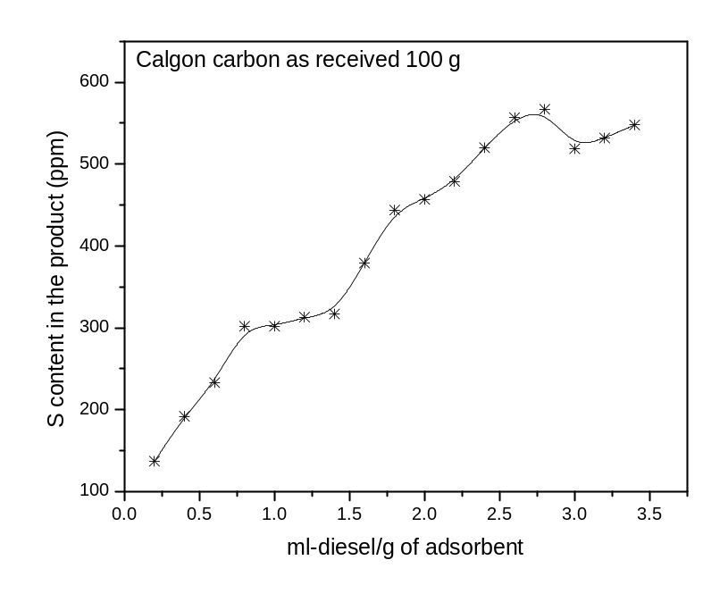

Fig. 23. Break through curve on 100 g calgon carbon as received through which CBR raw diesel is passed
Toluene desorbed from the catalyst bed is collected at the out let in the steps of 100 ml each and labelled as T1, T2, T3, T4 and T5 and submitted for S analysis

8. Regeneration studies on Calgon carbon

8. Regeneration studies on Calgon carbon

i. Solvent based regeneration
ii. Gas based regeneration

8.1. Regeneration study on 10.0 g Calgon carbon (as received) spent sorbent:

8.1.1. Method of regeneration

The systematic procedure adopted for the regeneration of 10.0 g spent sorbent (Calgon carbon as received) using 250 ml Toluene as solvent for S removal from the carbon surface is shown in Flow sheet 6. The regeneration process is carried out at room temperature and at atmospheric pressure. S free and thiophene free toluene is used for the purpose of regeneration.

Spent sorbent - 10.0 g calgon carbon as received (CC110g)
(Which was used as sorbent for S compounds in CBR raw diesel?)

Toluene (sulphur free and thiophene free) (250 ml) is passed
through the column with spent sorbent for 12 h

The column containing regenerated sorbent is dried in oven
at 200 ºC for 2 h

Column with regenerated sorbent cooled to RT and
Subsequently used as sorbent for S removal (CC110gTR)

Flow sheet 6. Toluene (250 ml) regeneration of spent sorbent (10 g Calgon as received)

8.1.2. Monitoring the effectiveness of S removal from Spent sorbent (10 g calgon carbon as received)

Amount of toluene used for regeneration of 10 g calgon carbon as received through which 189 ml CBR raw diesel is passed and 854 ppm sulphur is adsorbed.

Table 21. S content removed from the spent sorbent by Toluene used for regeneration

S. No. | Code | ml-toluene/g spent sorbent | S content of the desorbed toluene (ppm)
1 | T1 | 3 | 508
2 | T2 | 7 | 92
3 | T3 | 11 | 47
4 | T4 | 13 | 33
5 | T5 | 15 | 27
6 | T6 | 18 | 25
7 | T7 | 21 | 24
8 | T8 | 25 | 19

8.1.3. Evaluation of S sorption capacity of regenerated sorbent (10.0 g calgon carbon as received)

The reusability of the spent sorbent (10.0 g calgon carbon as received) regenerated by the method described in section 8.1.1. is tested and a comparison of the S sorption potential of fresh as well as regenerated sorbents is presented in Table 22. Data in Table 22 indicate that the performance of regenerated sorbent is as good as the fresh sorbent. This in turn authentifies the effectiveness of the regeneration process developed. The data shown in Table 22 is represented pictorially.

Table 22. S sorption capacity of toluene regenerated Calgon carbon as received 10.0 g

10.0 g Calgon as received | S content in the product (in ppm)
ml-diesel/g adsorbent | Fresh sorbent | Regenerated sorbent
2 | 366 | 301
4 | 552 | 519
6 | 615 | 633
8 | 673 | 699
10 | 684 | 756
12 | 710 | 759
14 | 720 | 764
16 | 729 | 774
18 | 732 | 779
20 | 735 | 772

The regenerated sorbent removes S on a par with the fresh sorbent (10.0 g Calgon carbon as received) as shown in Fig. 24. Thus the process of regeneration developed (Section 8.1.1) is simple unique, effective, economic and environmentally benign.
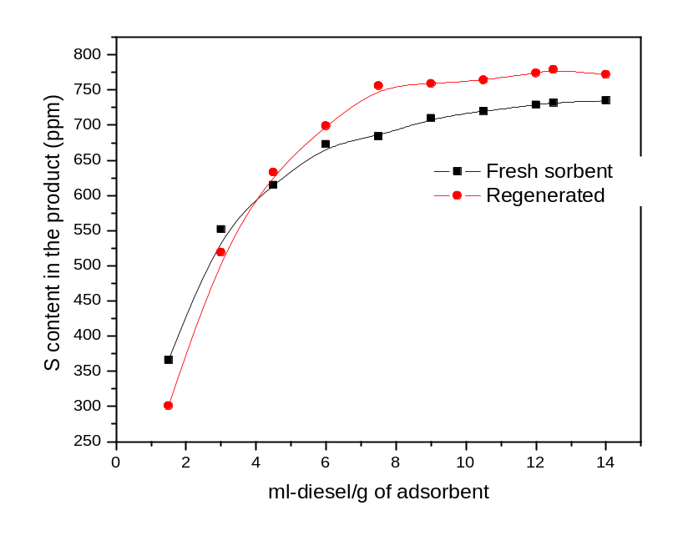

Fig. 24. Plot of S removal capacity of fresh Vs toluene regenerated sorbent (10 g calgon carbon as received)

8.2. Regeneration study on Spent sorbent (5.0 g Calgon carbon treated with HNO₃ followed by Ar activation, CC1HNO₃Ar)

Spend sorbent of 5.0 g calgon carbon treated with HNO₃ and Ar activated is regenerated with toluene and a comparison of the performance of fresh and regenerated sorbents is shown in Table 23. As indicated in Table 23, the sorbent (5.0 g Calgon carbon treated with HNO₃ followed by Ar activation) is reused for 4 times with 4 regenerations between each subsequent use. Each of the regeneration processes is carried out by flushing the sorbent bed with 100 ml toluene. Even after regeneration for the fourth time the sorbent is capable of removing 187 ppm of S from the feed indicating the effectiveness of toluene regeneration.

Table 23. Comparison of performance of fresh and regenerated sorbent (5.0 g calgon carbon treated with HNO₃ followed by Ar activation)

5.0 g CC1HNO₃Ar | S content in the product (S removed), in ppm
ml-diesel/g adsorbent | Fresh sorbent | I Regeneration | II Regeneration | III Regeneration | IV regeneration
4 | 397 (340) | 487 (250) | 491 (246) | 461 (276) | 550 (187)

8.2.1. Estimation of the amount of Toluene required for regenerating 5.0 spent sorbent (Calgon carbon treated with HNO₃ followed by Ar activation)

With the objective of knowing the minimum amount of toluene needed to achieved desired levels of effective regeneration, the spent sorbent (5.0 g calgon carbon treated with HNO₃ followed by Ar activation) in two columns is separately regenerated with both 100 ml toluene and 200 ml toluene. A comparison of the performance of fresh as well as the sorbents regenerated with 100 and 200 ml toluene is shown in Table 24 and 25 respectively. Analysis of the data indicates that 100 ml toluene is sufficient to regenerate 5.0 g spent sorbent.

Table 24. Regeneration of 5.0 g calgon carbon treated with HNO₃ and activated in Ar atmosphere (with 100 ml Toluene)

5.0 g CC1 HNO₃ Ar | S content in the product (S removed) (in ppm)
ml-diesel/g adsorbent | Fresh sorbent | Regenerated sorbent  (with 100 ml Toluene)
4 | 354 (383) | 401 (354)
Table 25. Regeneration of 5.0 g calgon carbon treated with HNO₃ and activated in Ar atmosphere (with 200 ml Toluene)
5.0 g CC1 HNO₃ Ar | S content in the product (S removed) (in ppm)
ml-diesel/g adsorbent | Fresh sorbent | Regenerated sorbent  (with 200 ml Toluene)
4 | 389 (348) | 410 (327)

8.3. Gas based regeneration studies on the spent sorbent of 5.0 g calgon carbon treated with HNO₃ and activated with Ar
8.3.1. Method of gas based regeneration
The step wise procedure adopted to regenerate the sorbent (5.0 g Calgon carbon treated with HNO₃ and activated in Ar atmosphere) is depicted in the Flow sheet 7.
Spent sorbent - 5.0 g calgon carbon treated with Conc. HNO₃
followed by Ar activation (CC1HNO₃Ar)
( which has been used as sorbent for S compounds in CBR raw diesel)
Spent sorbent - 5.0 g calgon carbon treated with Conc. HNO₃
followed by Ar activation (CC1HNO₃Ar)
( which has been used as sorbent for S compounds in CBR raw diesel)
After the process of desulphurization, the sorbent removed from column,
placed in an alumina boat
Alumina boat with spent sorbent is placed in a tubular furnace;
Temperature of the furnace is raised from RT to 500 ºC and
Kept at the temperature for 8 h;
Spent sorbent - 5.0 g calgon carbon treated with Conc. HNO₃
Followed by Ar activation (CC1HNO₃Ar)
(Which has been used as sorbent for S compounds in CBR raw diesel?)
After the process of desulphurization, the sorbent removed from column,
Placed in an alumina boat

After the process of desulphurization, the sorbent removed from column,
placed in an alumina boat

Alumina boat with spent sorbent is placed in a tubular furnace;
temperature of the furnace is raised from RT to 500 ºC and
kept at the temperature for 8 h;

All through the thermal treatment H₂ atm. is maintained in
the tubular furnace (till the temp. of the furnace is brought down to RT)

The regenerated sorbent (CC1HNO₃ArH) thus obtained is employed as sorbent for
successive studies

Flow Sheet 7. H₂ based regeneration of spent sorbent (5.0 g Calgon carbon treated with
HNO₃ followed by Ar activation)

8.3.2. Evaluation of S sorption capacity of H2 regenerated sorbent (5.0 g calgon carbon treated with HNO₃ followed by Ar activation)

The usefulness of H₂ regeneration is evaluated by comparing the performance of fresh as well as the spent sorbent regenerated by H₂ regeneration described in section 8.3.1. The data obtained from S sorption studies on fresh and the regenerated sorbent are summarized in Table 26 and the same are represented pictorially in Fig. 25.

Table 26. S sorption capacity of H2 gas regenerated 5.0 g Calgon carbon treated with HNO3 and activated in Ar atmosphere

5.0 g Calgon treated with HNO₃ and activated in Ar atmosphere | S content in the product (S removed) (in ppm)
ml-diesel/g adsorbent | Fresh sorbent | Regenerated sorbent
4 | 397 (340) | 469 (268)
8 | 618 (119) | 613 (124)
12 | 658 (79) | 621 (116)
16 | 729 (8) | 743 (0)
20 | 739 (0) | 757 (0)
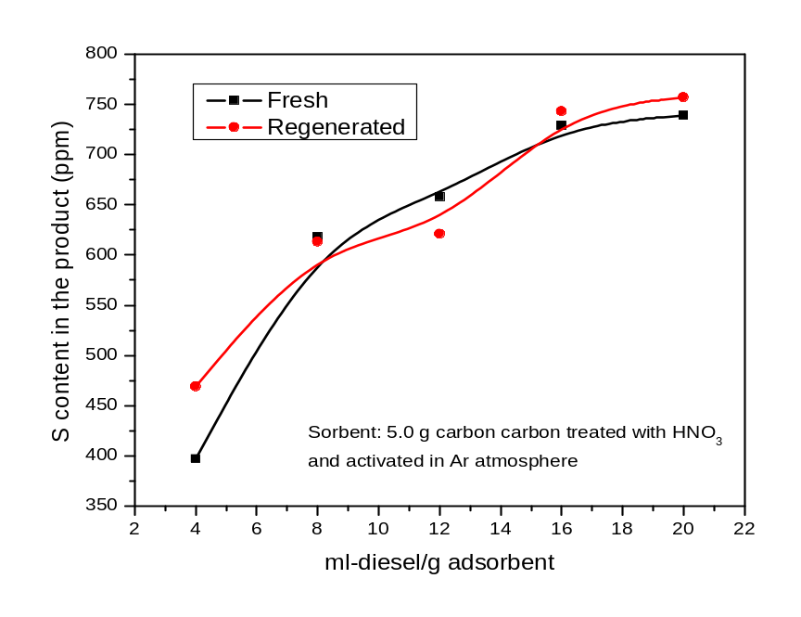

Fig. 25. Plot of S removal capacity of fresh Vs H₂ regenerated sorbent (5.0 g calgon carbon treated with HNO₃ and activated in Ar atmosphere)

The performance of H₂ regenerated spent sorbent was found to be as good as the fresh sorbent (5.0 g calgon carbon treated with HNO₃ and activated in Ar atmosphere) as observed from the curves in Fig. 25 implying that the method of H₂ regeneration is one of the promising ways of renewing the surface of the spent sorbent.

8.4. Toluene (500 ml) regeneration of spent sorbent (100 g calgon carbon as received)

8.4.1. Method of regeneration of spent sorbent 100 g Calgon carbon (as received) with 500 ml Toluene:
Diesel (CBR raw is fed into the column with 100 g calgon carbon
as received) through a burette till break through in S value is achieved

To regenerate the sorbent bed the carbon bed is flushed with 500 ml
toluene fed in to the column through a burette

Toluene desorbed from the catalyst bed is collected at the out let
in the steps of 100 ml each and labelled as T1, T2, T3, T4 and T5
and analyzed for S analysis

S content in T1, T2, T3, T4 and T5 being analyzed

Flow Sheet 8. Toluene (500 ml) regeneration of spent sorbent (100 g Calgon as received)

The systematic procedure followed for regenerating the spent sorbent (100 g calgon carbon as received) is depicted step wise in the Flow Sheet 8.

8.4.2. Effectiveness of Toluene in the regeneration of spent sorbent (100 g calgon as received)

The values of the amount of S removed (in ppm) by flushing the 100 g spent sorbent of calgon carbon as received are summarized in Table 26. The initial 100 ml of Toluene that is passed through the spent sorbent is capable of removing large amount of S (757 ppm) indicating that the method of regeneration is effective and the conditions of regeneration are modest.

Table 27. Evaluation of Toluene regeneration of spent sorbent (100 g Calgon carbon as received)
S. No. | Toluene eluted out of the sorbent bed | *Sulfur present in the toluene eluted out of the sorbent (ppm)
1 | T1 | 757
2 | T2 | 275
3 | T3
4 | T4
5 | T5

8.4.3. Evaluation of S sorption capacity of regenerated sorbent (100 g calgon carbon as received)

The adsorptive desulphurization process was successfully scaled up to 100 g batch from 5.0, 10.0 and 15.0 g batches. The details of the performance of 100 g batch are presented in section 7.4.1. The sorbent used in section 7.4.1. For the removal of S is regenerated by adopting the procedure described in section 8.3.1.

To evaluate the effectiveness of the regeneration process of 100 g batch, the regenerated sorbent is reused for S removal and a comparison of the performance of the fresh and regenerated sorbent (100 g calgon carbon as received) is shown in Table 27.

Table 28. Comparison of the performance of fresh and regenerated sorbent (100 g Calgon carbon as received)
S. No. | 100 g Calgon as received | S content in the product (in ppm)
S. No. | ml-diesel/g adsorbent | Fresh sorbent | Regenerated sorbent*
1 | 0.2 | 137 (600)
2 | 0.4 | 192 (545)
3 | 0.6 | 233 (504)
4 | 0.8 | 302 (435)
5 | 1.0 | 302 (435)
6 | 1.20 | 313 (424)
7 | 1.40 | 317 (420)
8 | 1.60 | 379 (358)
9 | 1.8 | 444 (293)
10 | 2.0 | 457 (280)
11 | 2.2 | 479 (258)
12 | 2.4 | 520 (217)
13 | 2.6 | 557 (180)
14 | 2.8 | 567 (170)
15 | 3.0 | 519 (218)
16 | 3.2 | 532 (205)
17 | 3.4 | 548 (189)

RECOMMENDATIONS

The flowing aspects of this study need further investigation

- The feasibility of these studies for scale up at 1000 gram scale and also at higher levels should be examined. This work can be carried out with the active participation of R and D of CPCL and NCCR.
- The regeneration procedure demonstrated has also to be tested and established that it can be scaled up for full scale reactors.
- It is possible to recover the sulphur from the regenerated liquid feed stock into value added products and CPCL and NCCR can work out a methodology for this. This exercise can run parallel to the scaling up studies so that it can be also adopted once the process is put into operation.
- There are a few other scientific aspects of these studies which can be carried out by both CPCL R and D and NCCR.
- It may be possible to constantly improve the characteristics of the adsorbent and these studies can be taken up simultaneously so that improvements can be constantly incorporated.

The recommendations can be implemented fully or partly depending on the needs and accordingly the NCCR can be asked to submit proposals for the study.

A road map has been prepared and the same is attached to this report.

12th Oct. 2007

ADSORPTIVE DESULFURIZATION OF DIESEL

( Sponsored Project at NCCR, IIT M )

ROADMAP FOR PROJECT COMPLETION

S.No | ACTIVITY | SCHEDULE
1 | IIT M to activate one Kg of Activated Carbon for studies at CPCL R&D | 15TH Nov. ‘07
2 | Experimental set up for evaluating the performance of the modified carbon on continuous basis at CPCL R&D with available 500 ml reactor, dosing pumps etc., (as per the attached figure) | 15th Nov. ‘07
3 | Testing the performance of adsorbent in the experimental set up on a continuous basis in batch mode to establish the following :  - Progression of Adsorption  - Breakthrough point  - Regeneration step -1 (Solvent leaching)  - Regeneration step-2 (Nitogen stripping to make adsorbent solvent free)  - Re use of Adsorbent  - No. of cycles  - Regenerability of Adsorbents  - Solvent recovery studies | 15th Dec. ‘07
4 | 1 to 2 Kg reactor with specific l x d ratio will be firmed up from the initial results of the studies in the above experimental set up. | 15th Dec. ‘07
5 | Repeat studies as listed in 3 with newly fabricated reactor. | 30th Dec. ‘07
6 | Design a Demo Unit with multiple adsorption bed and taking administrative approval. | 31st Jan. ‘08
7 | Fabrication, Installation and commissioning of Demonstration Unit with multiple adsorption bed to operate in swing mode. | 31st May ‘08
8 | Operation of Demo Unit on continuous basis | 31st July ‘08
9 | Preparation of a design package for an Adsorptive Desulphurization Unit to treat CBR diesel. Collaboration with a design consultant for the design and commissioning of the Unit. | August ‘08

Note : Evaluation of IIT M developed adsorbent on continuous basis is detailed above. If the results are not upto the desired levels, NCCR will be carrying out further modifications to achieve the targeted performance.

CM (R&D) Dr.B.Viswanathan
CPCL Project Co-ordinator
NCCR, IIT M

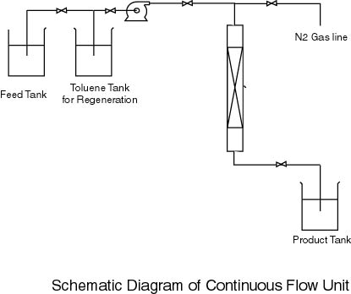

REFERENCES

1. B. Viswanathan, P. Indra Neel, T. K. Varadarajan,
A Process for the preparation of Activated Carbon from Botanical Sources,
Indian Patent File No. 376 CHE 2007.

2. Kim Kinoshita, Carbon – Electrochemical and Physicochemical Properties, John Wiley &
Sons, 1988.

ANNEXURE

LITERATURE REPORT

Annexure:

Adsorptive removal of S from petroleum fuels, especially diesel

Literature survey:
A survey of the literature on adsorptive removal of S-compounds from petroleum liquids reveals that a large number of adsorbents have been tried out of the adsorption of petroleum fuels, such as gasoline, jet fuel and diesel. The adsorbents investigated have been ion-exchanged zeolites (typically faujasites exchanged with Ag, Cu, Ce, Zn or Ni ions), supported transition metals (typically Ni on alumina or silica-alumina or layered double hydroxides), alumina, mixed oxides (mainly doped cerium oxide, CeO₂-TiO₂), supported metal salts (CuCl/alumina), sulfided Co-Mo-alumina, activated carbon, Ni-alloys and granular Raney Ni. A list of references is attached in the form of two tables. A summary of the work contained in each of the reference is also included in the tables.
An analysis of the literature, leads us to the following conclusions. S-compounds can adsorb on the surface of the adsorbent in two ways) by direct metal-sulfur bonding or ii) by π-complexation. Supported-metals (eg. Ni/silica) and metal sulfides (sulfided Co-Mo-alumina) adsorb the S-compounds through interaction of the S directly with the metal atom. These adsorbents, therefore suffer from steric effects when β-substituted dibenzothiphenes are involved [18, 27] and have a lower capacity for adsorption of the refractory compounds. The adsorption capacity of the supported metal system (Ni-silica-alumina) increases when the adsorption is carried out at a higher temperature (200°)[12], presumably due to reaction of the S-compound with the metal to form a surface metal sulfide.
Adsorbents such as Cu-Y, Ni-Y and Zn-Y and carbon adsorb by π-complexation. These adsorbents do not suffer from steric hindrance and generally adsorb 4,6-DMDBT more. For example, the adsorption of the sterically hindered 4,6-DMDBT is more compared to DBT over activated C. Alumina has a similar adsorptive capacity for both compounds [12]. The adsorption capacity of Cu(I)-Y increases when it is prepared by a vapour-phase ion exchange procedure[8]. Also, when a short bed of alumina or carbon is placed above the Cu-Y bed, the adsorption capacity for S increases, presumably because the large (and more basic) molecules that compete with the S-compounds are preferentially adsorbed on the guard-bed. The highest capacity of S-adsorption reported is 12.2mg/g of adsorbent for alumina/Cu(I)-Y, 8.9 mg/g for Cu(I)-Y and 7.2mg/g of S for break-through of S-compounds (<1ppm S in product). The studies have been carried out over commercial diesel (297 ppm) in case 1 and 2, and using a model diesel (687 ppm) in case 3.
An important and obvious conclusion of the studies is that strong competition with other aromatic compounds exists when the adsorption mode is by π-complexation [16], but not expected when M-S interaction is involved. Similarly, strongly polar compounds like H₂O, oxygenates, like MTBE and ethanol also affect the adsorption capacity. These compounds are also likely to affect both type of sorbents, though the effect on the those adsorbing by the π-complexation is expected to be more. Generally, removal of S from lighter fuels is more than for the heavier ones. A S-adsorption capacity of 14.6, 12.2 and 8.9mg/g has been reported for gasoline, jet fuel and diesel, respectively, over Cu(I)-Y[4,11].
Various regeneration procedures, such as solvent wash, typically toluene, air regeneration and reduction [6, 7, and 21], H₂ regeneration [23] and ultrasound assisted solvent extraction [13], have been proposed. After air regeneration and reduction 97% recovery of activity was reported with alumina/Cu(I)-Y[10]. However, activity after multiple regenerations has not been reported. Hence, the economic feasibility of these adsorbents cannot be estimated. It should be noted that adsorption by π-complexation is likely to be more reversible than adsorption through M-S bond formation and hence simple solvent extraction methods or slightly raising the temperature should be sufficient for regeneration of the used adsorbent. When surface metal sulfides are formed with decomposition of the S-compound (reactive adsorption, as is likely when adsorption is done at higher temperatures) or strong M-S occurs (without decomposition of the S-compound), the only modes of regeneration that are possible are high temperature air or H₂ treatment.
Much of the work has been done with commercial low S diesel (mostly deep desulfurized material) or with model diesel that do not have much aromatics. Besides, most of the studies are intended to produce oils with <1ppm S suitable as fuels for fuel cell applications. In our studies, we plan to use a SR feedstock with a large amount of aromatics. Some of the aromatic compounds may be highly basic and the S-compounds will have to compete with these for adsorption. However, our goal is only to partially desulfurize the feed. These considerations will have to be taken into account in designing a suitable adsorbent.

List of References
Table 1. Summary and other details of the publications in this area
Sr. No. | Journal | Authors | Title | Summary
1. | Applied Catalysis A: General 227 (2002) 265-278 | S. Mikhail, T. Zaki, L. Khalil | Desulfurization by an economically adsorption technique | Adsorption of DMDS/cyclohexane over charcoal, H-bentonite, H-kaolinite and cement kiln dust. From adsorption isotherms, H-bentonite most active; 2.8mg DMDS/g sample in a solution of 42.5mgDMDS/ml cyclohexane.
2. | Catalysis Today 77 (2002) 107-118 | X. Ma, L. Sun, C. Song | A new approach to deep desulfurization of gasoline, diesel fuel and jet fuel by selective adsorption for ultra-clean fuels and for fuel cell applications | Transition metal supported on silica used as sorbent. Model diesel containing DBT and 4,6-DMDBT (Total S = 576 ppm) used in studies. Adsorption capacity 4.5 ml for <1ppm S and about 15 ml for 250 ppm S in product. Adsorption capacity for DBT & DMDBT similar.
3. | Ind. Eng. Chem. Res. 42 (2003) 5293-5304 | S. Velu, X. Mu, C. Song | Selective adsorption for removing sulfur from jet fuel over zeolite-based adsorbents | Cu, Ni, Zn, Pd and Ce-Y zeolites used for adsorptive desulfurization of a model jet fuel and a real jet fuel (JP-8). Ce(38%wt)-Y was the best adsorbent (10mg/g for model JF with 510 ppm S and 4.5mg/g for JP-8 with 750 ppm S). Ce-Y exhibited higher selectivity for S-compounds compared to aromatics. Ce-S interaction suggested.
4. | Science 301 (2003) 79-81 | R.T. Yang, A.J. Hernandez-Maldonado, F.H. Yang | Desulfurization of transportation fuels with zeolites under ambient conditions | Cu⁺ and Ag⁺-Y used as adsorbent. π-complexation suggested. S-content reduced from 430ppm to <0.2 ppm from a commercial diesel at an adsorption capacity of 34 ml/g of sorbent.
5. | US Patent. No: 6558533 (2003) | S.R. Schmidt, R.F. Wormsbecher, R.H. Harding | Process for sulfur removal from hydrocarbon liquids | Desulfurization of petroleum oils using Raney Ni-catalyst granules prepared by extrusion of Ni-Al alloy with polymers, calcining and dissolving Al with NaOH.
6. | AIChE journal 50 (2004) 791-801 | A.J. Hernandez-Maldonado, R.T. Yang | New sorbents for desulfurization of diesel fuels via π complexation | Commercial diesel (297ppm S) used. Adsorption breakthrough followed the order: AC-Cu(I)Y > Cu(I)Y > Selexsorb alumina > CuCl/alumina > activated C (AC). AC-Cu(I)Y desulfurizes 30ml /g at average S-content of 0.15ppm S. Regeneration of adsorbent with air at 350°C followed by auto-reduction of Cu suggested.
7. | Angew. Chem. Int. Ed. 43 (2004) 1004-1004 | A.J. Hernandez-Maldonado, R.T. Yang | Denitrogenation of transportation fuels by zeolites at ambient temperature and pressure | Cu(I)Y denitrogenates diesel (83 ppm N) to 0.1 ppm N with 43 ml adsorption capacity. Regeneration of adsorbent with air at 350°C followed by auto-reduction of Cu suggested.
8. | J. Am. Chem. Soc., 126 (2004) 992-993 | A.J. Hernandez-Maldonado, R.T. Yang | Desulfurization of diesel fuels by adsorption via π complexation with vapor phase exchanged Cu(I)-Y zeolites | Cu(I)Y prepared by vapour-phase ion-exchange. This has a greater capacity for S-adsorption from diesel (40ml/g for S from diesel -297 ppm-). S-loading is 5 molecules /unit cell compared to 3/uc for the low temperature loading of Cu (see reference no. 8).
9. | Ind. Eng. Chem. Res., 43 (2004) 6142 | A.J. Hernandez-Maldonado, R.T. Yang, W. Cannella | Desulfurization of commercial jet fuels by adsorption via π-complexation with vapour phase ion exchanged Cu(I)-Y zeolites | A layered bed of 25% alumina and Cu(I)-Y is capable of desulfurizing 50 ml of jet fuel (JP-8) with 364 ppm S to <1ppm S per gram of sorbent.
10. | Ind. Eng. Chem. Res., 43 (2004) 769 | A.J. Hernandez-Maldonado, S.D. Stamatis, R.T. Yang, A.J. He, W. Cannella | New sorbents for desulfurizing of diesel fuels via π-complexation: Layered beds and regeneration. | CDX alumina (25%)/Cu-Y bed desulfurizes 41 ml of diesel fuel (297ppmS) to < 1ppm per g of adsorbent. After regeneration in air at 350°C, the recovery of activity was 97%.
11. | Appl. Catal. B 56 (2005) 111-126 | A.J. Hernandez-Maldonado, F.H. Yang, G. Qi, R.T. Yang | Desulfurization of transportation fuels by π complexation sorbents: Cu(I), Ni(II), and Zn(II)-zeolites | Activity order is; Cu-Y (VPIE) > Ni (II)-Y (SSIE) > Ni (II)-X (SSIE) > Zn (II)-X (LPIE) > Zn (II)-Y (LPIE). Cu(I)-Y (VPIE) has adsorption capacities of 0.395 and 0.278 mmol S/g sorbent for commercial jet fuel (364 ppm S) and diesel (297 ppm S).
12. | Appl. Catal. B 56 (2005) 137-147 | X. Ma, S. Velu, J.H. Kim, C. Song | Deep desulfurization of gasoline by selective adsorption over solid adsorbents and impact of analytical methods on ppm-level sulfur quantification for fuel cell applications | Commercial gasoline (305 ppm S) used. Cu(I)-Y had an adsorption capacity of 0.22 mg S/g of adsorbent and Ni(55wt%)/silica-alumina had a capacity of 0.37mgS/g (for <1 ppm S in product). The breakthrough capacity of S was increased by 38% at 200°C. The capacity of Ni-adsorbent for 10ppm S in product was 7.3 mgS/g
13. | Appl. Catal. B 61 (2005) 212-218 | A.J. Hernandez-Maldonado, G. Qi, R.T. Yang | Desulfurization of commercial fuels by π complexation: monolayer CuCl/γ-Al₂O₃ | CuCl/γ-alumina used as adsorbent. Jet fuel (364 ppm S) and diesel (140 ppm S0 used as feeds. CuCl/γ-alumina removed 0.94 and 1.8 mg S /g of sorbent for diesel and 6.4 and 11.2 mg S/g sorbent for Jet fuel. Ultrasound assisted solvent regeneration of the adsorbent suggested.
14. | J. Colloid Interface Science 298 (2006) 535-542 | M. Xue, R. Chitrakar, K. Sakane, T. Hirotsu, K. Ooi, Y. Yoshimura, M. Toba, Q. Feng | Preparation of cerium-loaded Y-zeolites for removal of organic sulfur compounds from hydrodesulfurizated gasoline and diesel oil | Ce(IV)-Y prepared by liquid-phase and solid-phase ion-exchange methods. Studies carried out on HDS- treated diesel (1.87 ppm S and 0.73 ppm H₂S) and thiphene loaded gasoline (5ppm S). Batch mode studies decrease S to <0.001ppm.
15. | Catalysis Today 116 (2006) 512-518 | Y. Li, F.H. Yang, G. Qi, R.T. Yang | Effects of oxygenates and moisture on adsorptive desulfurization of liquid fuels with Cu(I) zeolite | Oxygenates in fuel (like ethanol, MTBE) could adsorb strongly on adsorbents used for desulfurization and reduce S-adsorption capacity. The adsorption strength on Cu(I)-Y is water > ethano l> MTBE > thiophene.
16. | J. Colloid Interface Science 301 (2006) 395-401 | F. Tian, W. Wu, Z. Jiang, C. Liang,Y. Yang, P. Ying, X. Sun, T. Cai, C. Li | The study of thiophene adsorption onto La(III)-exchanged zeolite NaY by FT-IR spectroscopy | Adsorption of thiophene on Na and La-Y. Adsorption on La is by La-S bonding and on Na, it is by π- complexation. Benzene has a grater effect on adsorption of thiophene on Na than on La.
17. | Appl. Catal. A 311 (2006) 58-65 | D.L. King, C. Faz | Desulfurization of Tier 2 gasoline by divalent copper-exchanged zeolite Y | Gasoline (<30ppm S) free of oxygenates and additives was used. Cu(II)-H-Y desulfurized ~60ml/g of adsorbent to ~3ppm S.
18. | Catal. Today 111(2006) 74 -83 | J.H. Kim, X. Ma, A. Zhou, C. Song | Ultra-deep desulfurization and denitrogenation of diesel fuel by selective adsorption over three different adsorbents: a study on adsorptive selectivity and mechanism | Model diesel used. DBT and 4,6-DMDBT, total S was 687 ppm. Total N was 303 ppm. Adsorbents studied were alumina, carbon (Nuchar SA with SA of 1843m²/g) and Ni/silica-alumina. Activated C was the best with 7.15mg of S and 14.94 mg of N at breakthrough and 16.29mg (S) and 18.37mg (N) for saturation (per g of adsorbent).

Table 2. Presentations based on chemical abstracts
No | Journal/Symposium/Patent | Authors | Title | Summary
19 | Hwahak Konghak 43 (2005 )588 (Korean) | J.G. Park, H.C. Ko, V.M. Bhandari, Y.Lee, J-N Kim | Desulfurization of diesel by selective adsorption of S-compounds over zeolite and activated carbon | Cu²⁺ and Ni²⁺ - Y and C were used as adsorbents. Model diesel fuel contg. BT, DBT and 4,6-DMDBT (each 50ppm in n-octane) were studied. Zeolites lost activity in comm. diesel (186 ppm). C showed reasonable capacity for S-compounds (15ml/g for comm. diesel). S-adsorption on Ni-Y decreased with benzene content of model diesel, but C was insensitive.
20 | Energy & Fuels, 19 (2005) 1116 | S.Velu, X. Ma, C.Song, M.Namazian, S.Sethuraman, G. Venkataraman, | Desulfurization of JP-8 jet fuel by selective adsorption over a Ni-based adsorbent for micro solid oxide fuel cells. | JP-8 (736 ppm S) and light fractionated JP-8 (380 ppm S) desulfurized over Ni/silica-alumina. Use of fractionated feed not containing 2,3,7-TMBT improved adsorbent capacity by 2.5 times. Ni/silica-alumina with particles sizes of 0.15 and 0.25 mm offered a S-break through capacity of ~11.5 mg/g adsorbent without pressure drop. High S-adsorption capacity could be achieved when overall aspect ratio, axial aspect ratio and radial aspect ratio were ~60, 3000 and 100 respectively.
21 | Preprints, ACS Divn. Fuel Chem. 49 (2) (2004) 511. | S.Watanabe, X.Ma, C. Song | Selective S-removal from liquid hydrocarbons over regenerable CeO₂₋TiO₂ adsorbents for fuel cell applications | High surface area CeO₂-TiO₂ bimetallic oxides with various molar ratios and model gasoline (430 ppm S) used. Regenerability of the adsorbents was tested. Mixture of oxides was better than the individual oxides. Regeneration could be done at 375°C in air.
22 | Preprints, ACS Divn. Petrol Chem. 49 (3) (2004) 313. | S.Velu, X. Ma, C. Song | Promotional effect of K on the adsorptive DS of transportation fuels over K-exchanged NiY zeolites | K-Ni-Y zeolites better for adsorptive desulfurization than H-Ni-Y.
23 | Preprints, ACS Divn. Fuel Chem. 48 (2) (2003) 526. | S.Velu, S. Watanabe, X. Ma, C. Song | Regenerable adsorbents for adsorptive DS of transportation fuels for fuel cell applications | Regenerable adsorbents based on zeolites, mesoporous materials, activated C and supported metals developed for DS in fuels. Model fuel with 4,6-DMDBT used. Adsorbent (eg. Ni based) regenerated by regeneration with H₂ at 500°C
24 | Preprints, ACS Divn. Fuel Chem. 49 (2) (2004) 575. | J. Clemons, S.Velu, X. Ma, C. Song | ADS of transportation fuels over Ni-based adsorbents derived from LDH. | NiZnAl-LDH tested for DS of diesel and jet fuel (520 ppm S). Adsorbent is more active for jet fuel.
25 | Preprints, ACS Divn. Petrol Chem. 49 (3) (2004) 329. | A. Zhou, . Ma, C. Song | Deep desulfurization of diesel fuels by selective adsorption with activated carbons | Activated C and modified C used. Ads. capacity of C increased with equil. concn. of S in liq. phase. Higher ads. cap. for alkyl-DBT than DBT. Acid treatment of C increased ads. cap., but not sel. for S.
26 | Preprints, ACS Divn. Fuel Chem. 48 (2) (2003) 688. | X. Ma, S.Velu, C.Song, M.Namazian, | ADS of JP-8 jet fuel and its light fraction over Ni-based adsorbents for fuel cell applications | High surface area Ni-alumina catalysts were used. High ads. cap. and sel. to S noted. Ads. cap. depended on adsorbent and ads. condition. BT with R in 7-position showed low adsorp. Sel.
27 | Preprints, ACS Divn. Fuel Chem. 48 (2) (2003) 522. | X.Ma, L. Sun, C.Song | ADS of diesel fuel over metal sulfide based adsorbent. | Co-Mo-Alumina-sulfided used as adsorbents for model diesel containing. DBT, 4MDBT and 46DMDBT (total 200 and 486 ppm S). Sel. for ads. increased as: 46DMDBT< 4MDBT < DBT. Ads. cap. was 0.65 mg S/g with breakthrough at 0.77mg/g.
28 | Patent app. WO2003016436 A1 (2003) | B.Zong, X.Meng, H.Lin,X,Zhang,X.Mu,E. Min | Process for ADS of distillates | Amorphous alloy adsorbent containing. Ni (with Al, Fe etc.)-fluid bed reactor
29 | Patent No: WO 2003/068892 A3 | C. Song, X. Ma, M.J. Sprague, V. Subramani | Deep desulfurization of hydrocarbon fuels | Process for reducing S from gasoline, diesel and jet fuels by adsorptive desulfurization. The product is of such low S-content that it can be used for fuel cells.
30 | Patent No: WO 03/020850 A3 | R.T. Yang, F.H. Yang, A. Takahashi, A.J. Hernandez-Maldonado | Selective sorbents for purification of hydrocarbons | Patent for Ag and Cu-Y zeolites as adsorbents for removal of thiophene from benzene.
31 | Preprints, ACS Divn. Fuel Chem. 48 (2) (2003) 693. | S.Velu, X.Ma, C.Song | Mechanistic investigations on the adsorption of organic S compounds over solid adsorbents in the ADS of transportation fuels | Y containing various metals and mixed metal oxide supported adsorbents used with model gasoline containing 270 ppm S. Depending on the nature of the adsorbent, thiophenic S compounds formed either pi-complexes or M-S bonds. S-removal by pi-complexation was less selective due to competitive adsorption by aromatics and olefins.
32 | Preprints, ACS Divn. Fuel Chem. 48 (2) (2003) 695. | S.Watanabe, S.Velu, X.Ma, C.Song | New ceria based adsorbents for removing S from gasoline for fuel cell applications | Ce- based adsorbents prepared by urea gelation method. 10-40 at.% ceria were loaded. Dopant metals were Sr, La, Zr, V, etc. Model gasoline studies. All adsorbents removed S, but ceria containing 10 at.% La was found most effective for thiophenic S-compounds
33 | Preprints, ACS Divn. Petrol. Chem. 48 (2) (2003) 58. | S.Velu, X.Ma, C.Song | Fuel cell grade gasoline production by selective adsorption for removing S | Zeolite based and mixed metal oxide based and supported metals tested over comm.. gasoline (210 ppm S). A supported metal adsorbent removed S to <1 ppm at >150°C under ambient pressure without H₂.
34 | Preprints, ACS Divn. Petrol. Chem. 48 (2) (2003) 56. | S.Velu, S. watanabe, X.Ma, J. Sun, C.Song | Development of selective adsorbents for removing S from gasoline for fuel cell applications | Ce-zeolites with promoters used for adsorption of thiophene. ADS of 380 ppm S model feed to < 1ppm occurred.

